如何配置室内机收到呼叫时，触发Alarm output

How to configure the indoor station to trigger alarm output when it receives a call

1. 首先，需要确保室内机已经成功注册上门口机，配置文档可参考：

First of all, it is necessary to ensure that the indoor station has been successfully registered with the door station. Please refer to the following configuration documents:



1. 室内机有两个Alarm output接口，确保正确连线

The indoor station has two alarm output interfaces and please make sure you connect correctly.

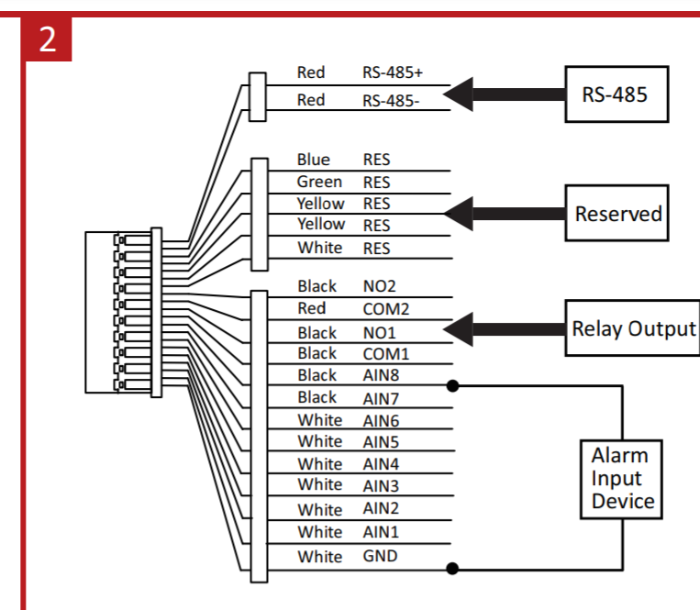

1. 在4200上打开室内机的远程远程配置界面，选择relay输出

Open the remote configuration interface of the indoor station on 4200 and select calling linkage to configure.

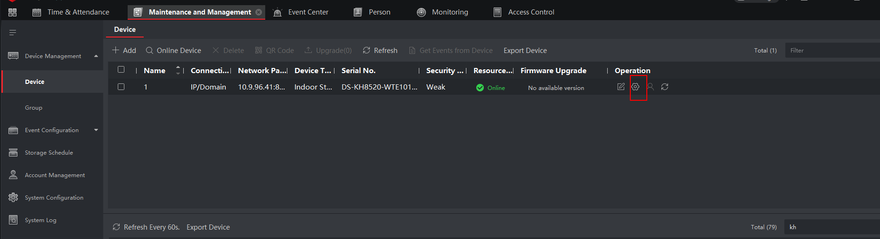

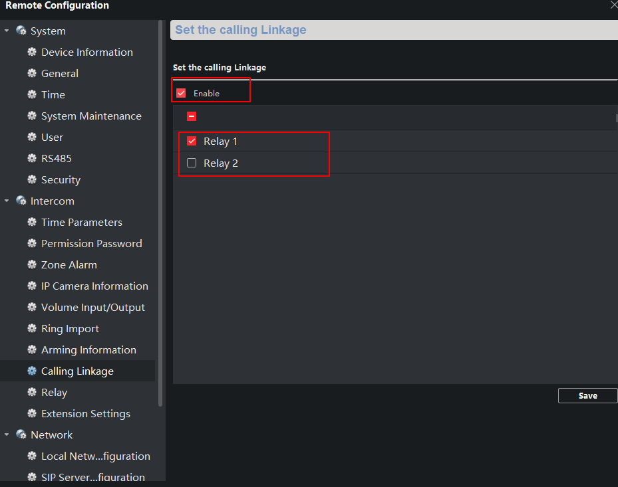

1. 配置完成后，当室内机收到呼叫时，会自动触发output。实际应用场景比如：接一个bell,但收到呼叫时，能够听到很响的bell铃声。

After configuration, when the indoor station receives a call, it will automatically trigger output. Practical application scenarios can be like: the indoor station connects a bell and when it receive a call, you can hear a very loud bell ring.