**How to configure door phone to call indoor station**

**How to configure door phone to call indoor station**

1. **Change the device type of door station**

Login the door station’s configuration, change the device type as Doorphone, then save.

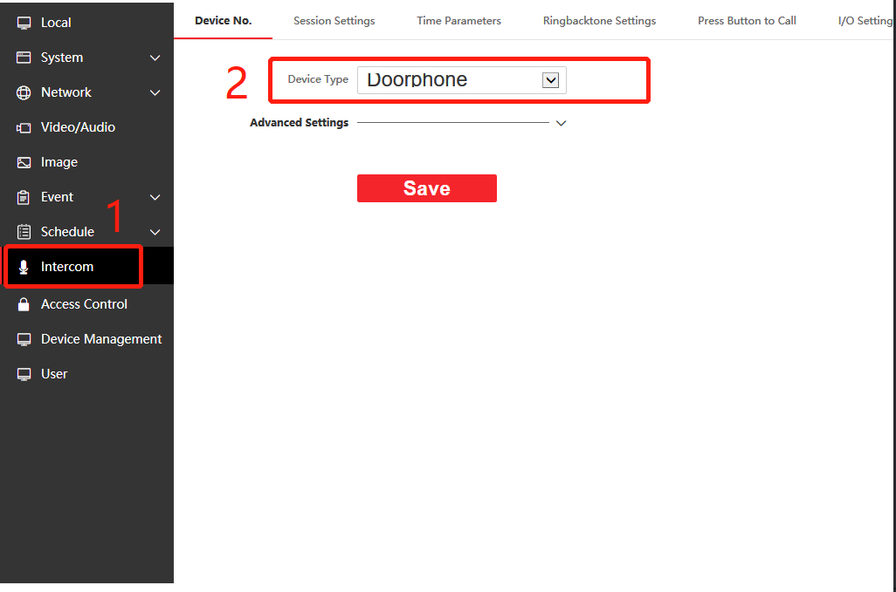

1. **Configure the door phone to indoor station**

Enter the indoor station’s remote configuration, **Network** > **Group network setting** >

**Doorphone IP address,** input the door phone’s IP, then save

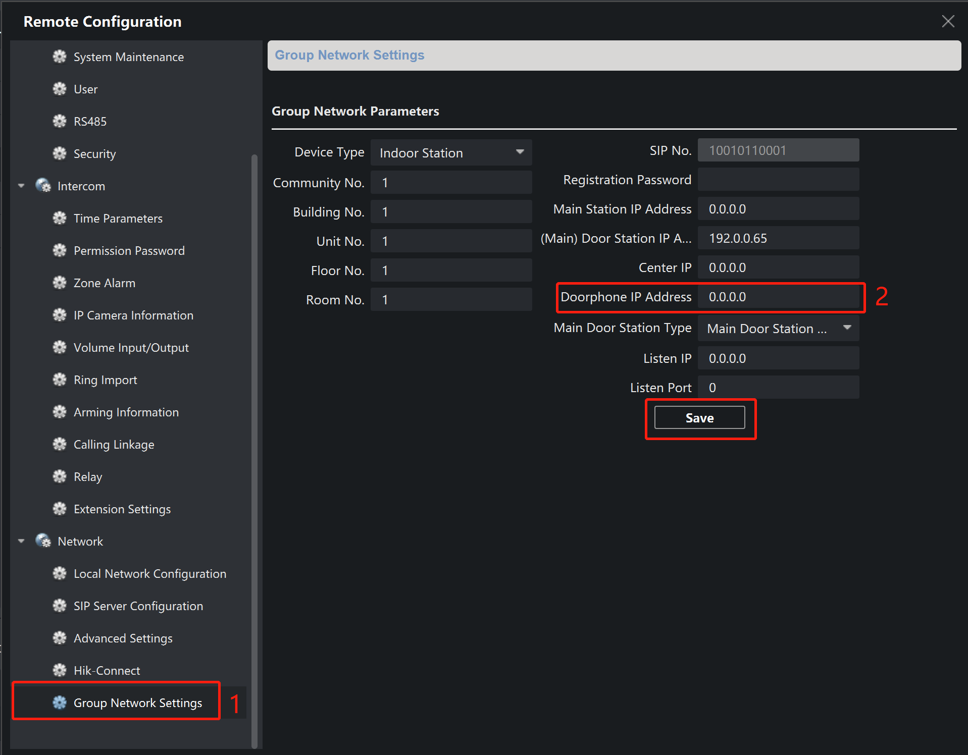

1. **Input indoor station’s information to door phone**

Enter the door phone’s remote configuration **Device Management > Device list > Add**, input the indoor station’s information, then save, and wait the **Network Status** change to **Online**

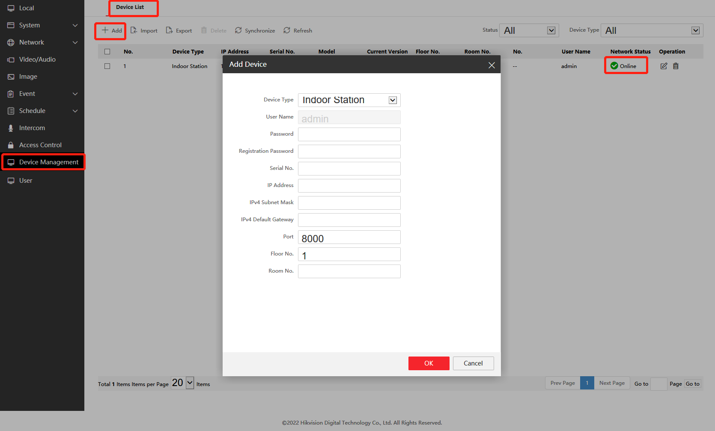

***Note:***

Make sure your door station can change device type to doorphone