**How to add alarm devices to Android Indoor Station**

**Preparation**

1. This guide takes

|  |  |  |
| --- | --- | --- |
| Type | Model | Version |
| Indoor Station | DS-KH9310-IME1 | V2.1.22_210616 |

As examples to introduce How to add alarm devices to Android Indoor Station.

**How to add alarm devices to Android Indoor Station**

1. **Add the alarm devices to Hik-connect app.**
   1. Please refer to the attached document about how to add the alarm device to Hik-connect APP



1. **add alarm devices to Android Indoor Station**
   1. The Hik-connect app is hidden by default and we can choose to show the Hik-connect App.

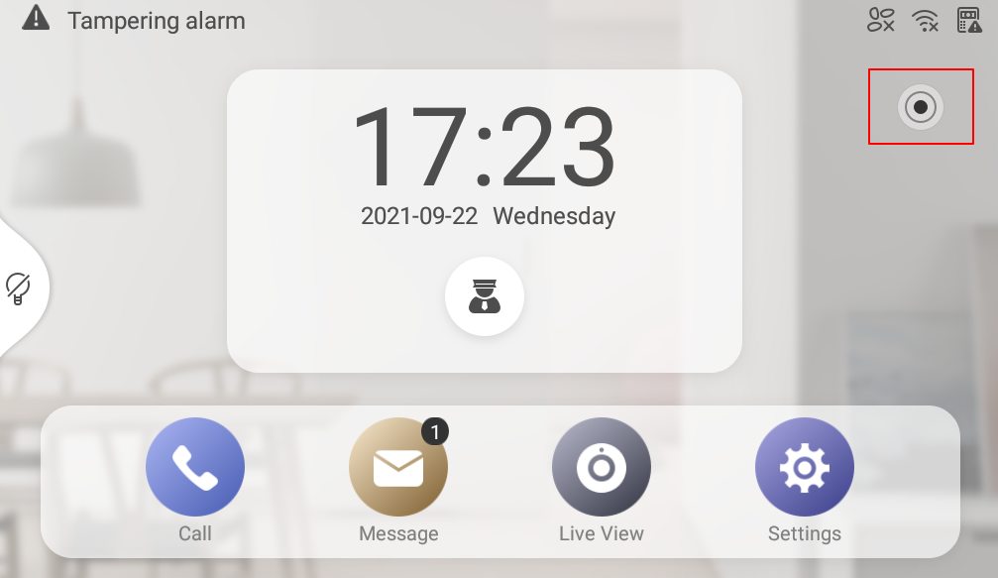

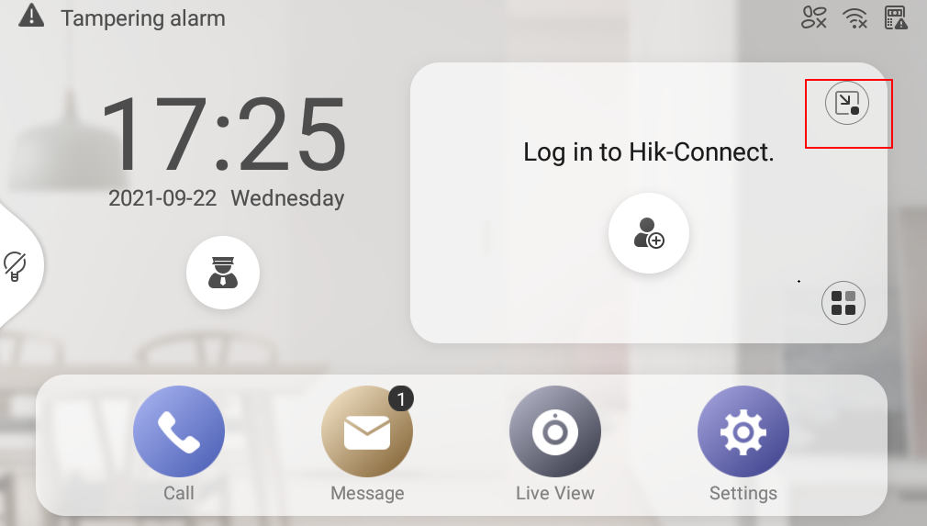

* 1. Log in to the Hik-connect account which has added the alarm device and the alarm device will show automatically.

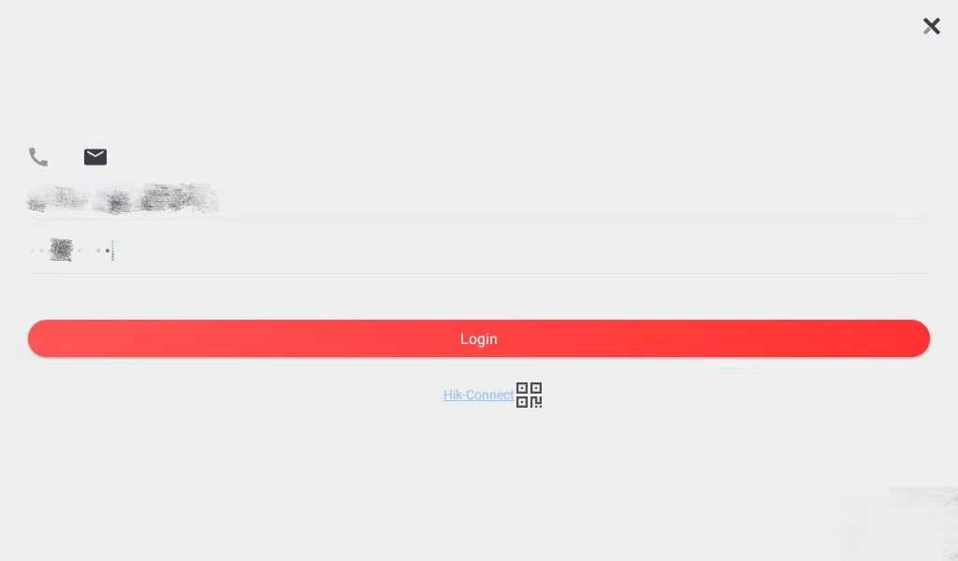

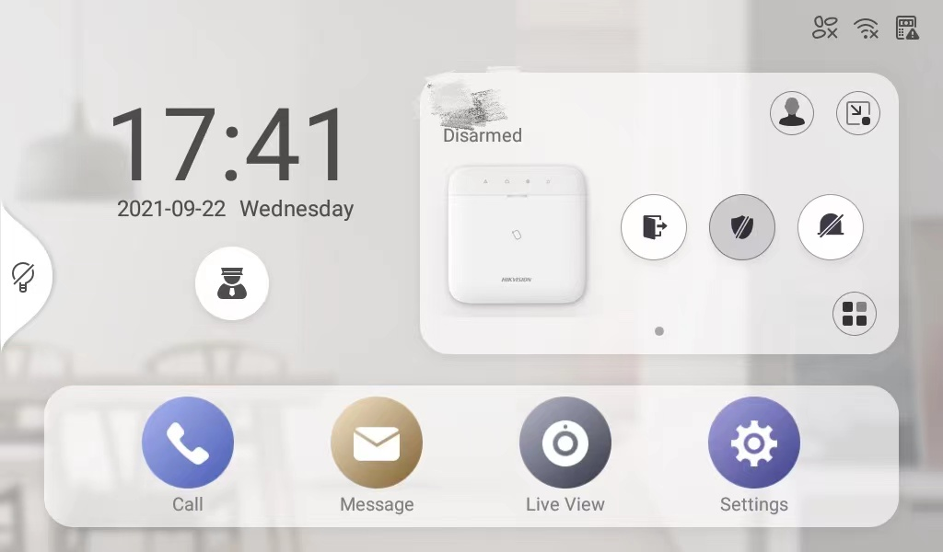

* 1. We can configure the alarm device in the Android Indoor Station as we do in Hik-connect APP

