**How to add a single Sub-door station to**

**the Main door station**

**Preparation**

1. This guide takes

|  |  |  |
| --- | --- | --- |
| Type | Model | Version |
| Door station | DS-KD8003-IME1/IME2 | V2.2.50_210728 |
| KV(-B) Station | DS-KV6103-PE1(B)、DS-KV6113-PE1(B)、DS-KV6113-WPE1(B)、DS-KV8113-WME1(B)、DS-KV8213-WME1(B)、DS-KV8413-WME1(B) | V2.2.50_210630 |
| KB8113 | DS-KB8113 | V2.2.51_210630 |

As examples to introduce register sub-door station to main door station.

2. Software: iVMS-4200 Version 3.6.0.6

**How to add a single sub-door station to the main door station**

**Method 1 (configure Sub Door Station through the Main door station interface)**

1. **Add Devices on iVMS-4200**
   1. Search for online devices and add the door station on iVMS-4200, enter username and password, and then confirm that the device is online.

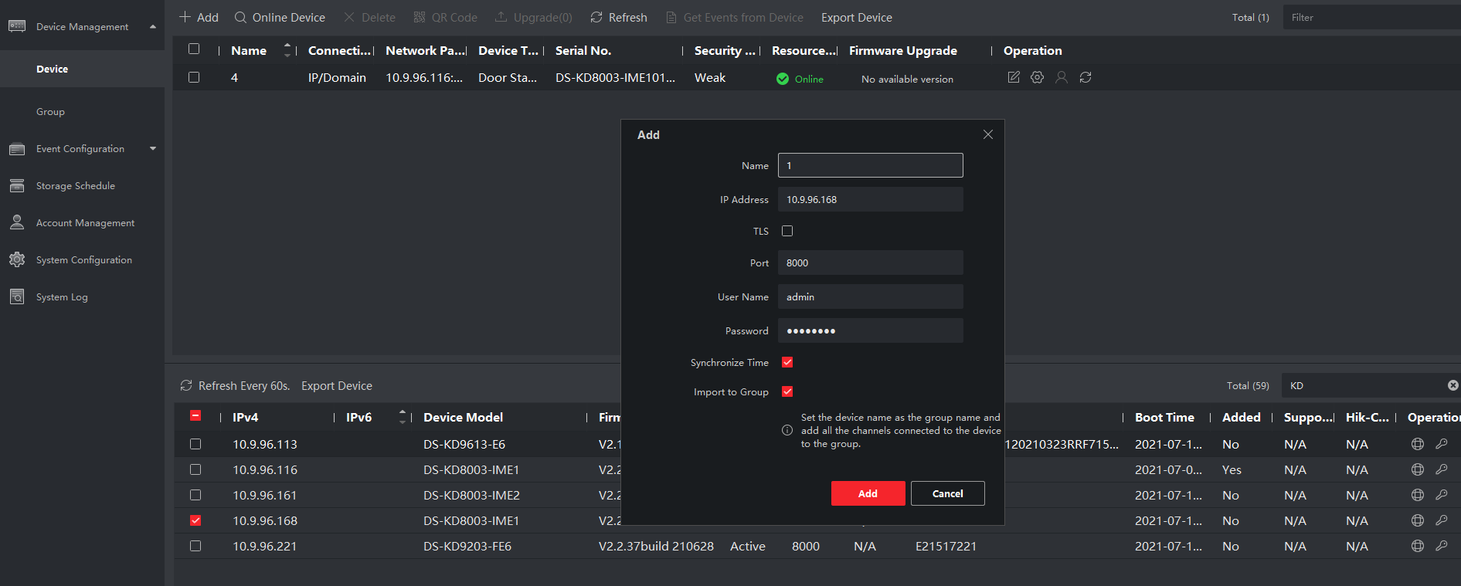

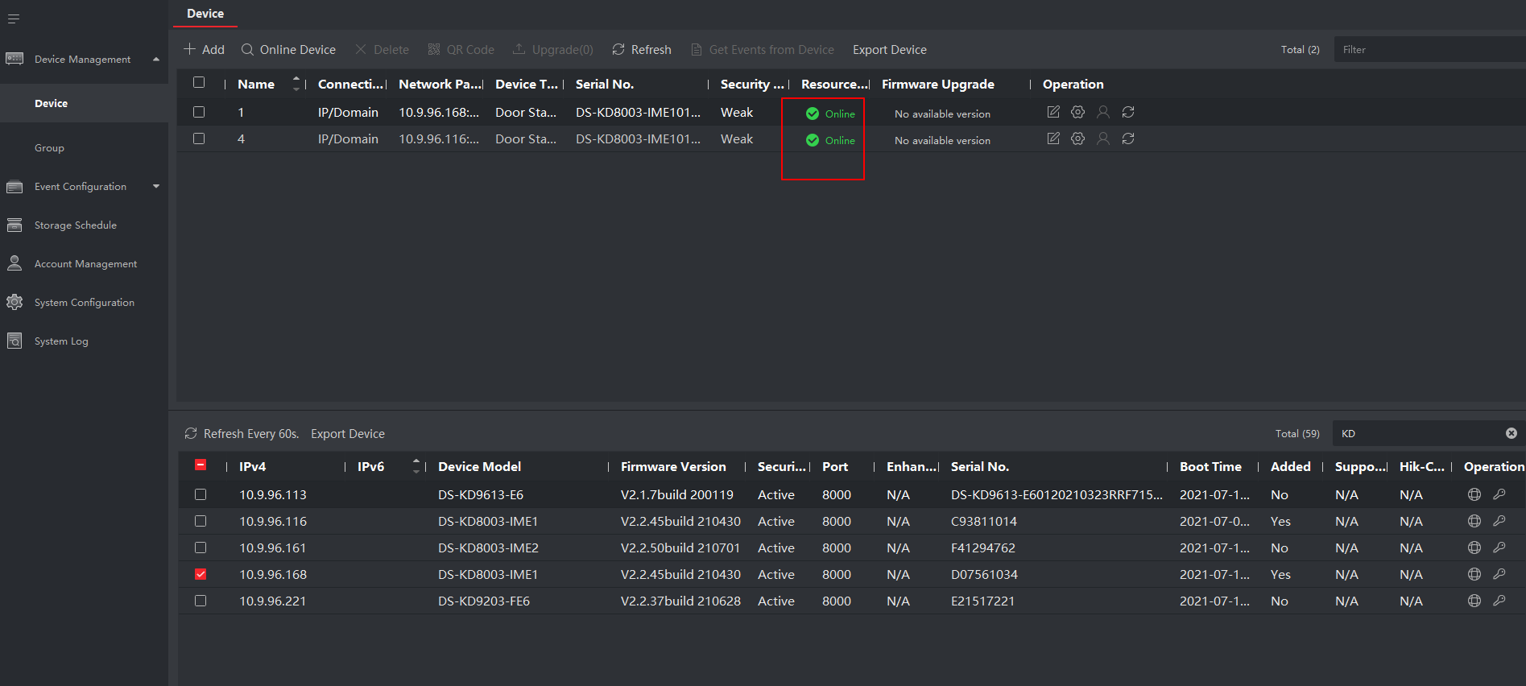

1. **Register Sub Door Station to Door station on Main Door Station Remote Configuration interface**
   1. Go to **Configuration** of Main Door Station-> **Device Management ->Add**, set the Device Type as **Sub Door Station**, fill in the necessary info of the device. The registration password must be consistent with that of the Sub Door Station, which is configured when the Sub Door Station is activated. The port is 8000.

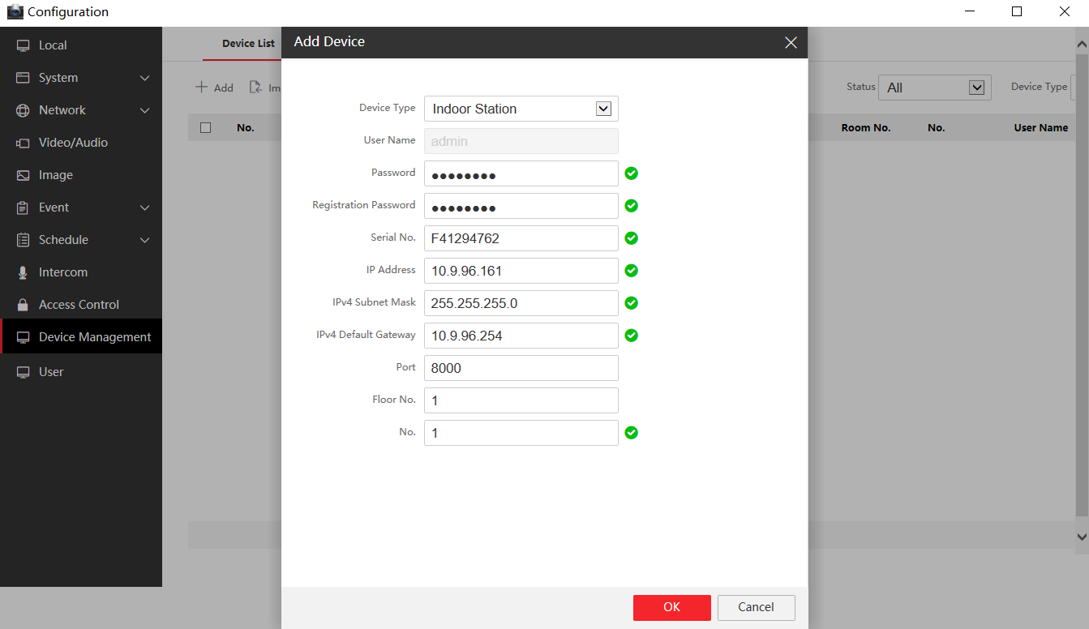

* 1. After we complete the device info, you will see the page as shown below.

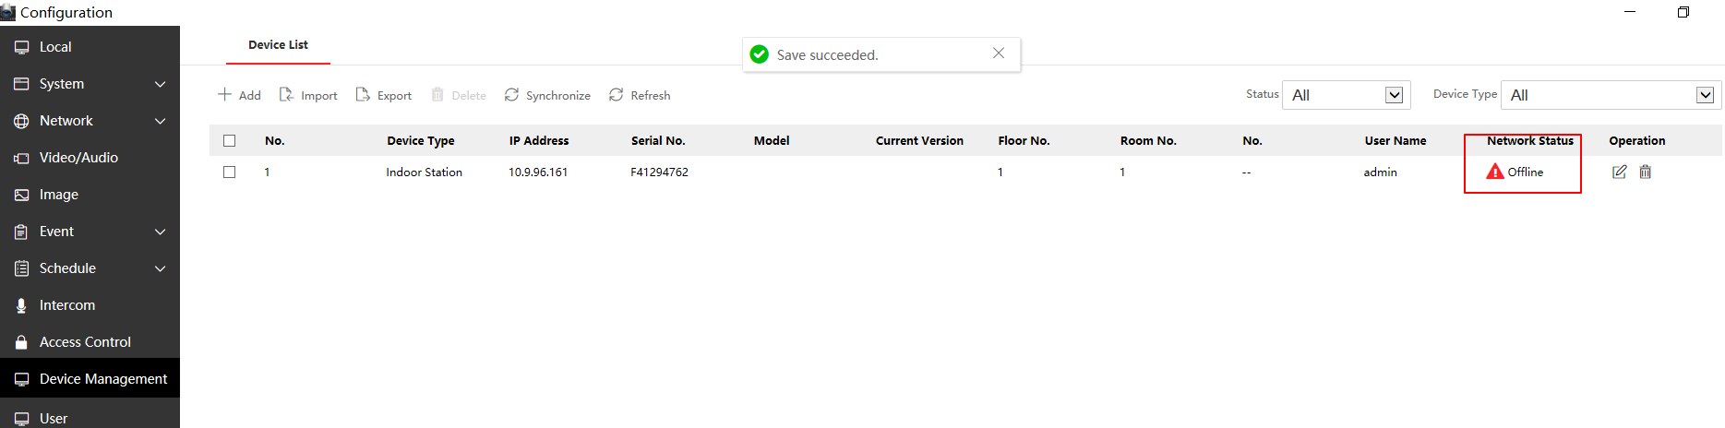

* 1. Wait 5 to 10 minutes, and the devices will be online.

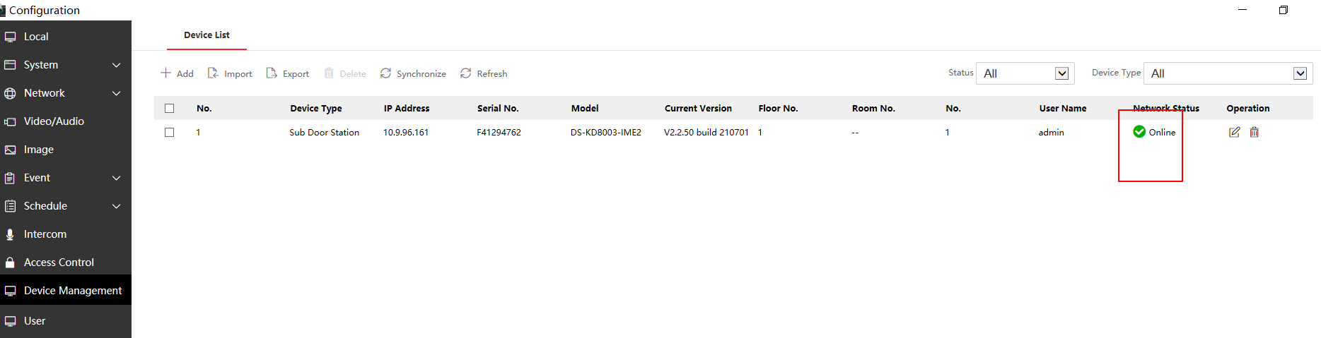

**Method 2 (configure Sub Door Station through the Sub Door Station interface)**

1. **Add Devices on iVMS-4200**
   1. Search for online devices and add the door station on iVMS-4200, enter username and password, and then confirm that the device is online.





1. **Register Sub Door Station to Door station on Sub Door Station Remote Configuration interface**
   1. Go to **Intercom** of Sub Door Station **-> Session Settings**, fill in the registration password and Main Door Station IP and save the configuration.

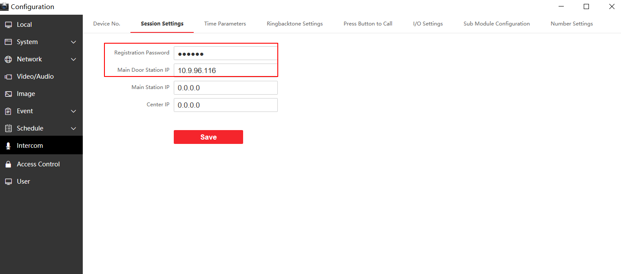

* 1. And we can check the registration result in the Device Management interface of Main Door Station.



Notice：

1) After the Sub Door Station successfully registers with the Main Door Station, once its information (such as device IP, door station No.) is modified or the Sub Door Station reset to default, the Sub Door Station will fail to register and will display offline on the Device Management of the Main Door Station. If you want to modify the information of Sub Door Station, you should delete the Sub Door Station on the Device Management of Main Door Station first and register the Sub Door Station again after modification.

2) After the Sub Door Station successfully registers with the Main Door Station, once the information of Main Door Station is modified, you should synchronize the information to all devices on the Device Management interface through Synchronize function.

a、check the information of Sub Door Station

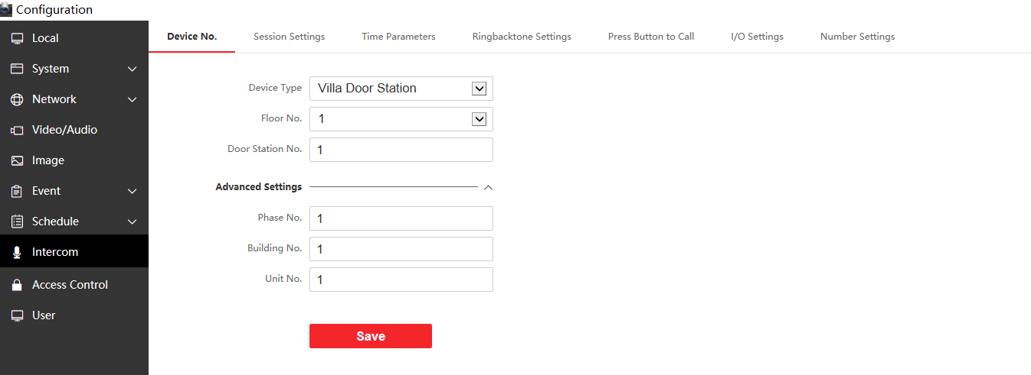

b、register the Sub Door Station to Main Door Station

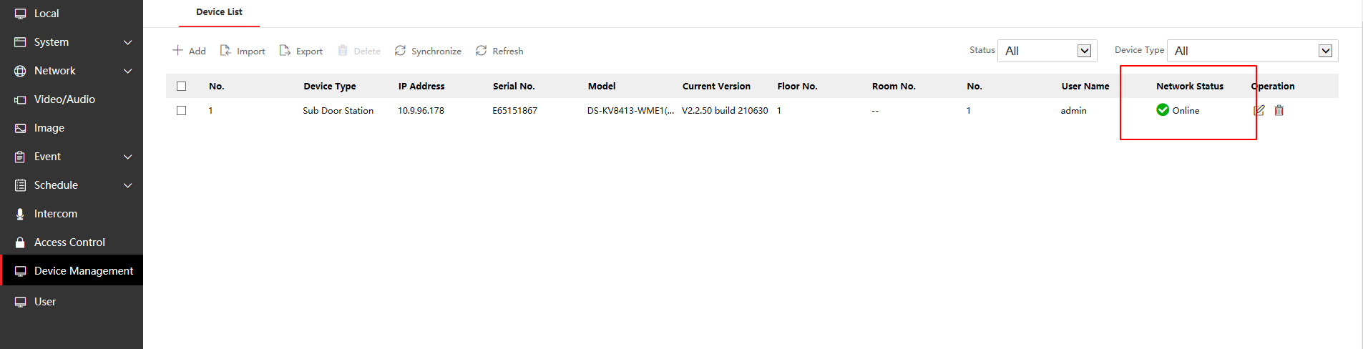

c、change the information of Main Door Station (change Unit No. from 1 to 2)

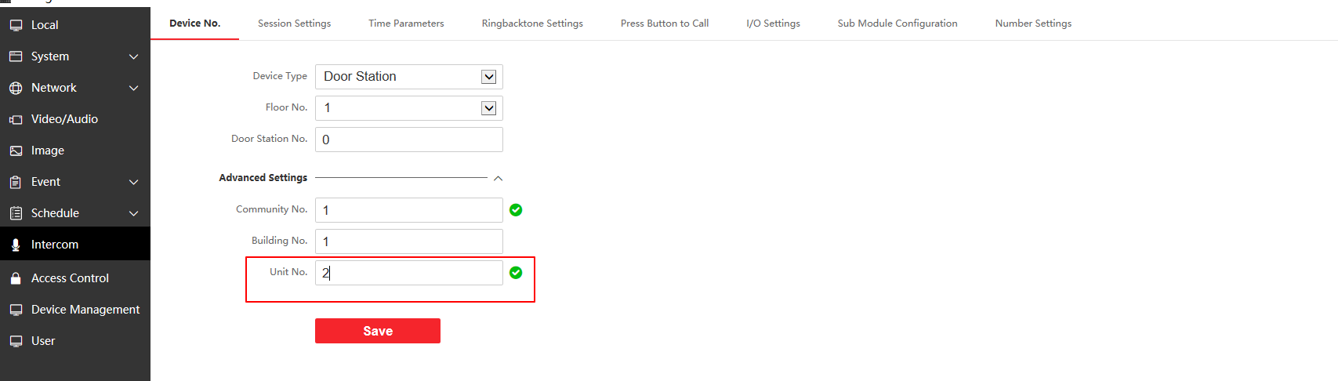

d、check the registration result of sub door station

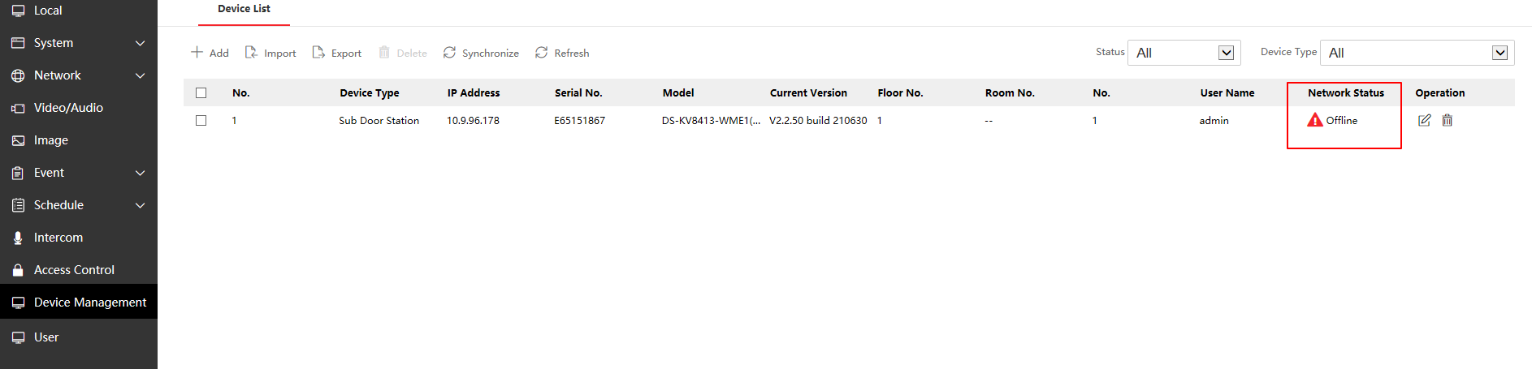

e、after Synchronization, the sub door station will be online again.

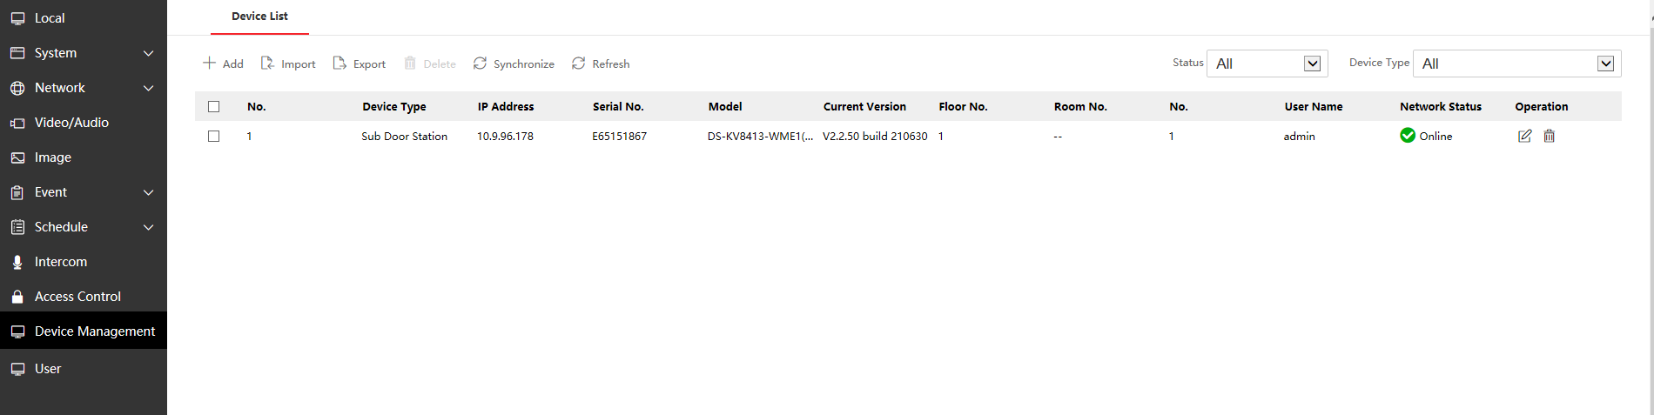

f、the information of sub door station has changed.

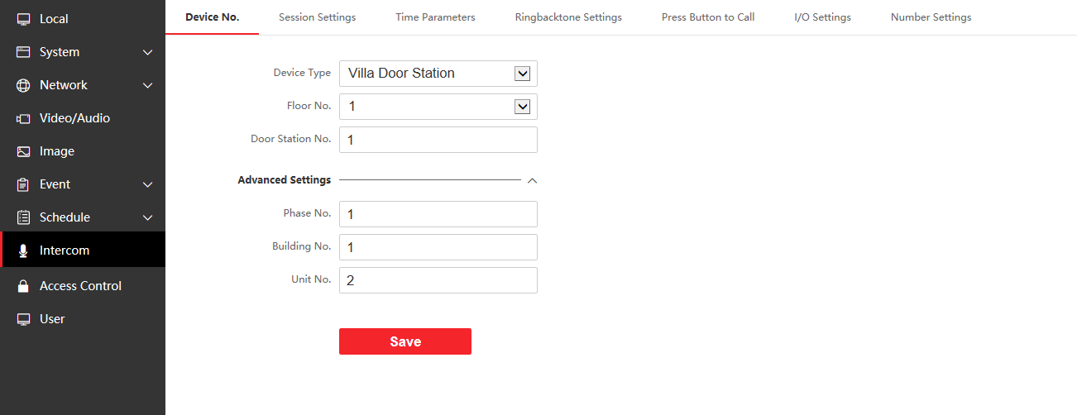

3) After the Sub Door Station A successfully registers with the Main Door Station, if a Sub Door Station B with the same Door station NO. as Sub Door Station A is registered on Main Door Station, the configuration can be saved successfully while the information of Sub Door Station B will not display on the Main Door Station which means the registration is unsuccessful.

To be summarized:

1) It is better to check whether the information of Sub Door Station has displayed on the Device Management interface of Main Door Station before you configure the registration.

2) Whenever you want to change the information of sub door station you should delete it on the Device Management interface of Main Door Station at first.