We can install 3rd party APP on Android indoor station, but currently there is a 100MB size limitation in IVMS V3.7.1.5 or earlier version. Then we can install 3rd APP which has more than 100MB with ADB tool.

Please prepare MicroUSB cable, RS232 cable in advance.

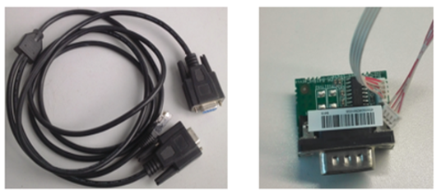

1. Connect RS232 and MicroUSB cable between device and PC

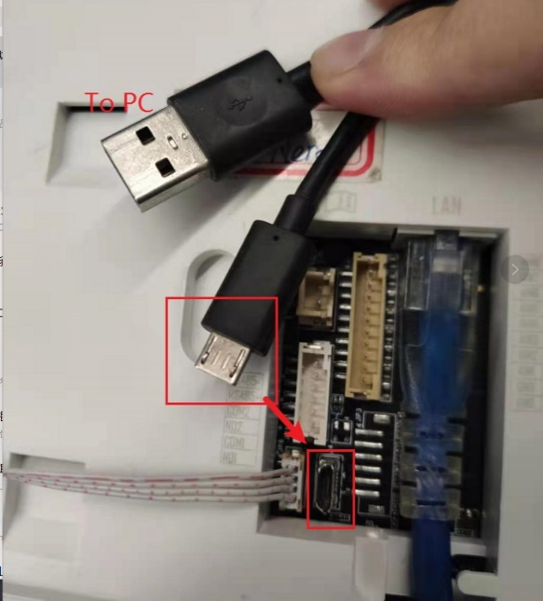

1. Install DriverAssitant_v4.91 on PC

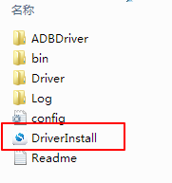

1. Run secureCRT, Xshell or MobaXterm, after device power on and start normally, input Debug, and password to input debug mode.

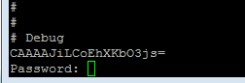

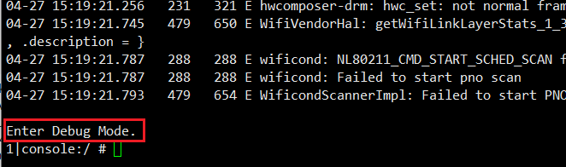

1. Input setprop sys.usb.config adb to enable ADB mode

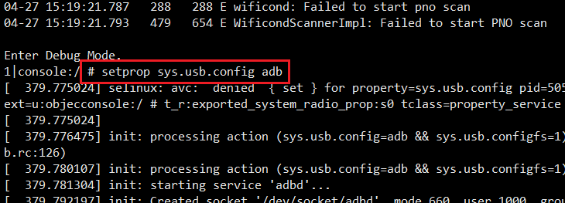

1. Input am start com.android.settings and device will enter original Android system

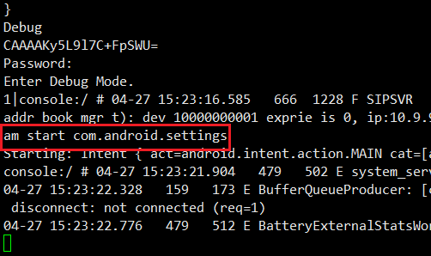

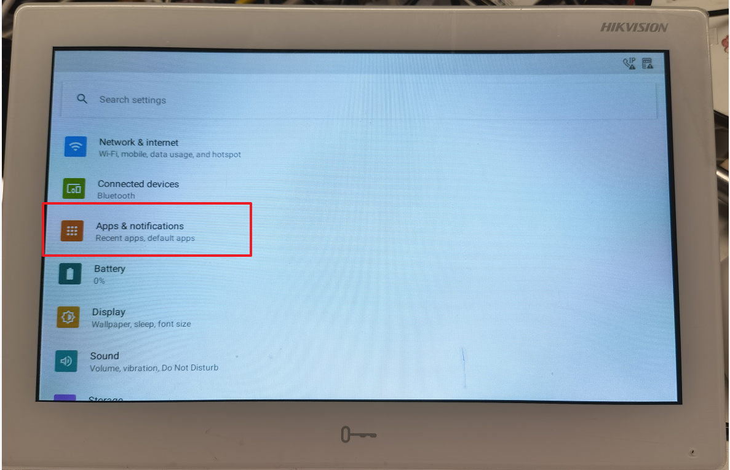

1. Select APP & Notifications, then you can find the total APP quantity in device.

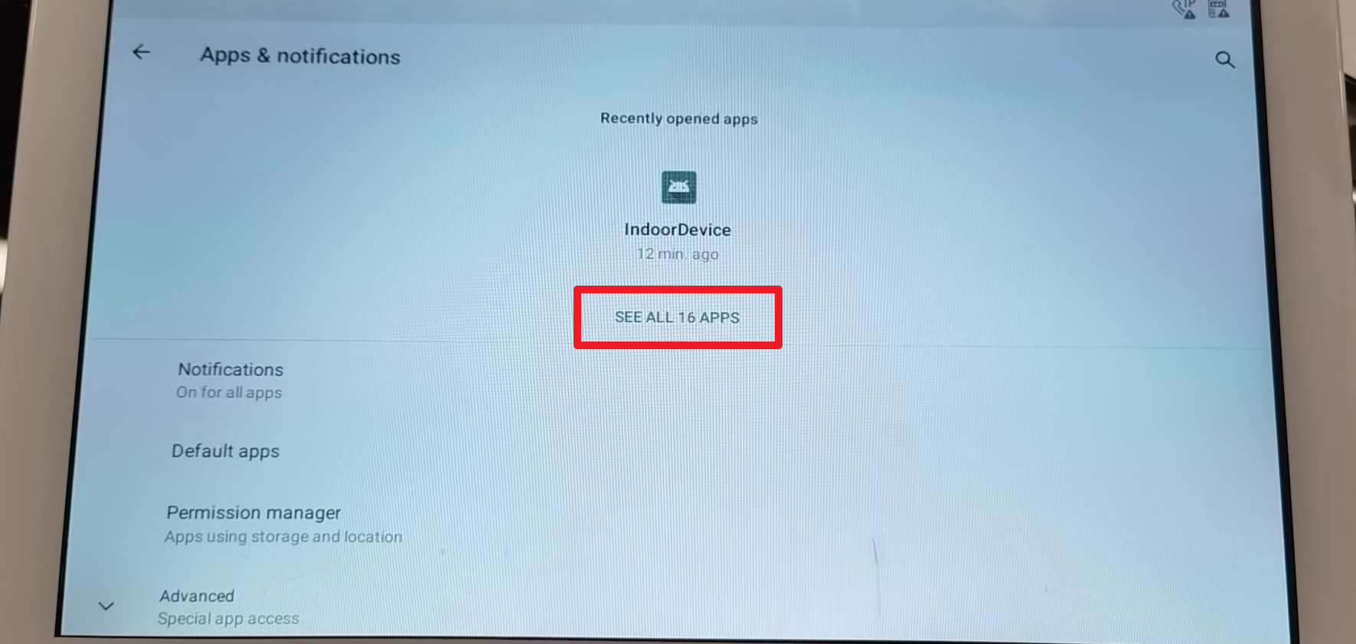

1. Unzip adb.zip

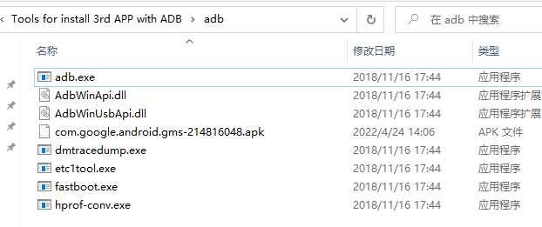

1. then press Shift key and right click mouse at the blank place, select open Powershell window here.

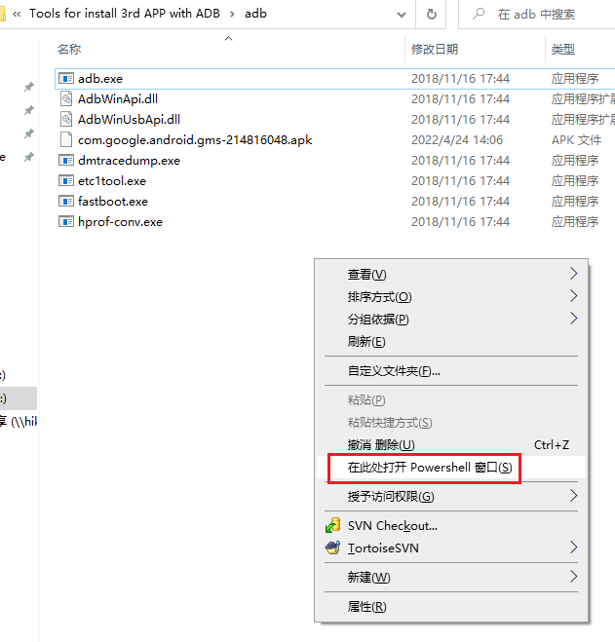

1. Press Enter and input .\adb install (there is a space after install) , then drag the 3rd APP apk file to the window, then press Enter

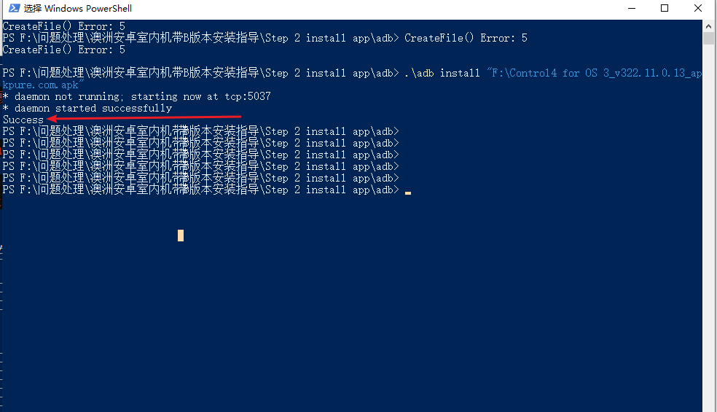

1. After it prompt success, then you can find the quantity add 1 compared before.

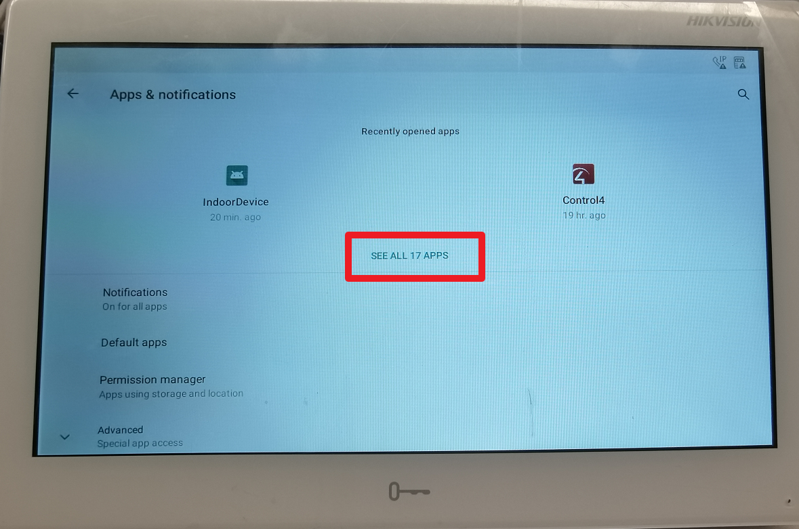

1. After 3rd APP installation finish, please reboot the indoor station to exit the original Android system and enter video intercom APP again.

**Note:** the indoor station doesn’t support google service because of policy limitation, if the 3rd APP requires google service to work normally, please follow the guidance in below link to install GMS CORE service in advance

Please follow the guidance, all APP in this article can be installed as the front way.

<https://github.com/microg/GmsCore/wiki/Installation>