1. Install driver file DriverInstall.exe in PC，then connect RS232 cable from device to PC

The driver files are different for different model.

For DS-KH9310&9510, please install DriverAssitant_v4.5, for DS-KH9310(B)&9510(B), please install DriverAssitant_v4.91

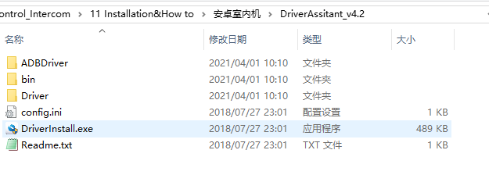

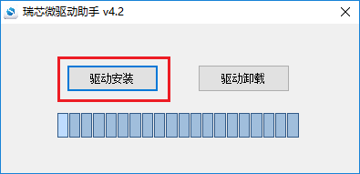 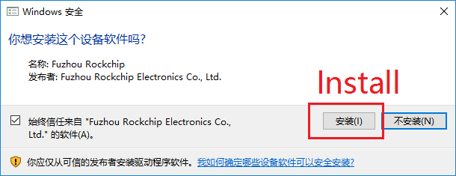

1. Open SecureCRT software and connect to device,

For KH9310&9510, press b on PC keyboard and power on the device, when the print stops, delete the redundant b, leave only one and press Enter to enter uboot mode, you will see HKVS# after success

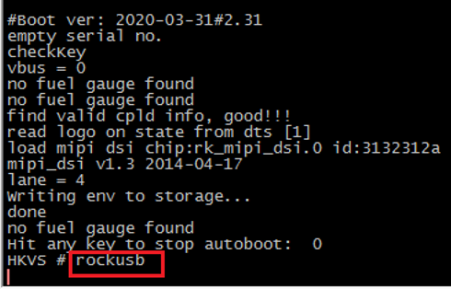

For KH9310(B)&9510(B), press u and Enter to enter upgrade mode

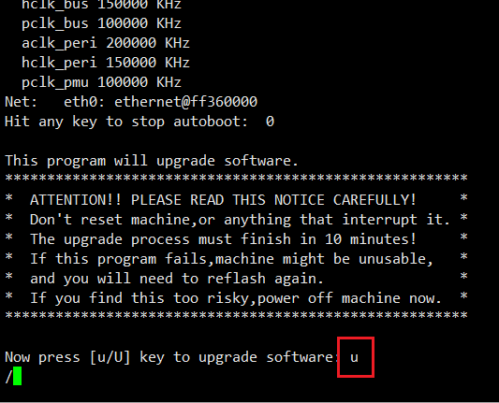

1. Open AndroidTool.exe tool, connect MicroUSB cable(prepare in advance) between device and PC，it will show 发现一个LOADER设备 in the bottom of tool.

For DS-KH9310&9510, please run AndroidTool_Release_v2.54, for DS-KH9310(B)&9510(B), please run AndroidTool_Release_v2.71

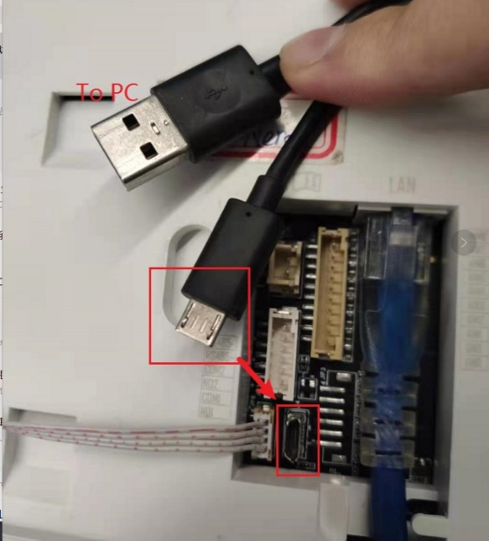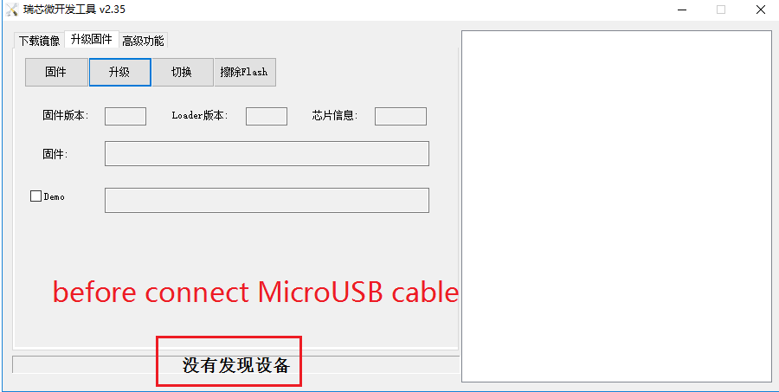

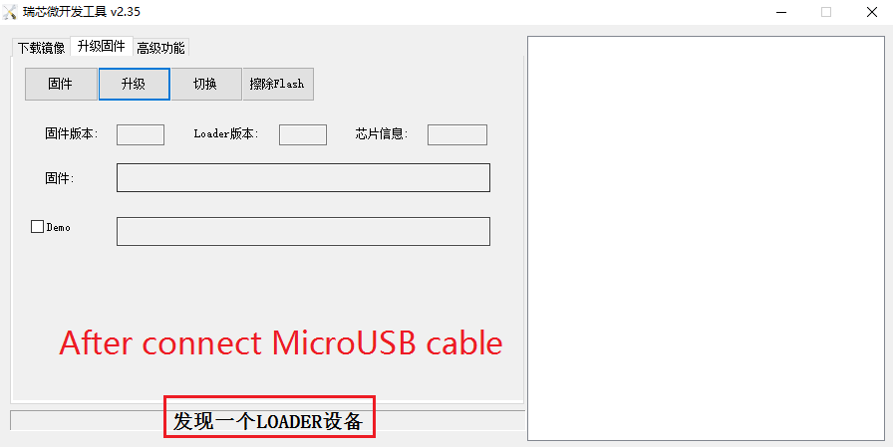

1. Select file Factory.img, click “升级” to start upgrade

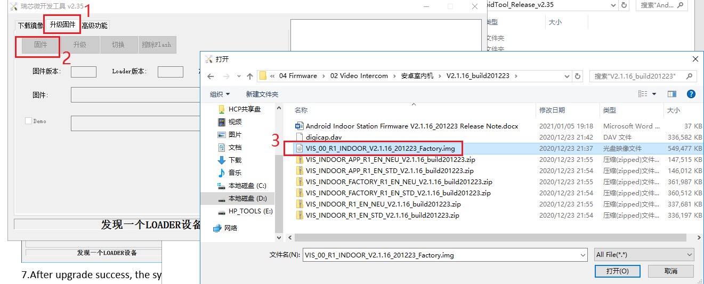

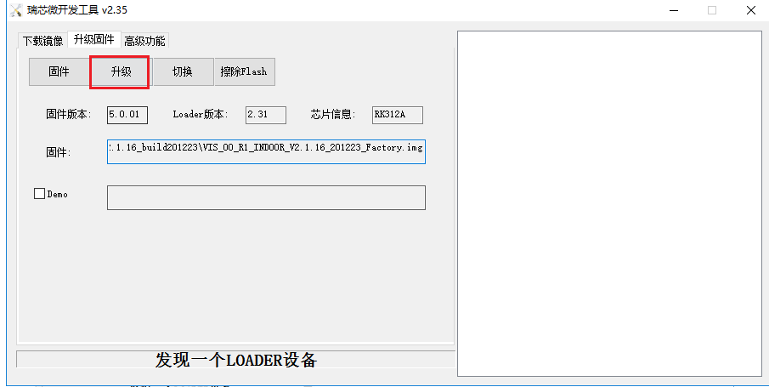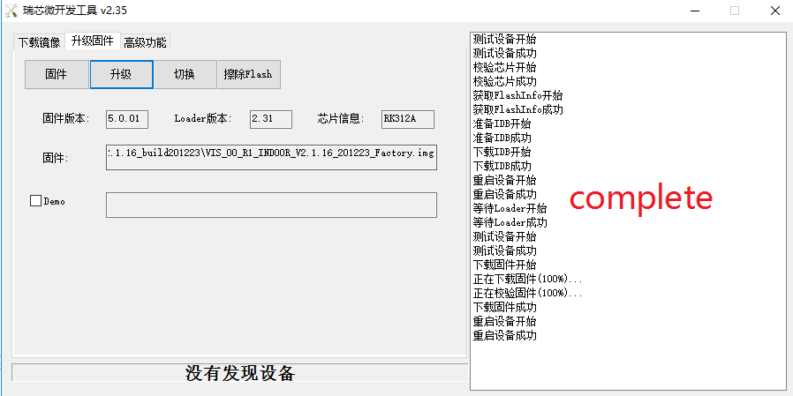

7.After upgrade success, the system will reboot automatically.

8.Wait about 3-5 mins, device will play a test video (test mode), please press the left down and right bottom corner of the screen at the same time, then it will prompt a Chinese prompt window to exit the test mode, select the left option. Then device will reboot automatically again, after that it will enter activation interface.