Installation and Configuration Guide for iDS 7series Face Counting Camera

Contents
Installation and Configuration Guide for iDS 7series Face Counting Camera 1
Chapter1. Installation specification 3
1.1 Installation 3
1.2 The Selection of Camera Lens 5
1.3 Installation Position and Lens Query Table 6
1.4 The Installation Requirement of Camera 6
Chapter2 Camera Configuration 8
2.1 Configure the parameter via IE browser【Quick Start】 8
2.2 Configure the parameter via IE browser【Completely Configuration with Full Function Descriptions】 12

Chapter1. Installation specification

Installation
The accuracy rate of face recognition is great involved with installation location, ambient light (such as too dark, too bright) and so on. In order to ensure the better effect, it raises some installation suggestions as follows:

- Installation position should be the standard passageways or the Entrances/ Exits, which insures the direction of traffic is particular and capture the Enter/Leave personnel’ faces in the direction.
- Choose the stable lighting condition with adequate illumination. Light compensation is necessary to ensure the facial features are visible under the condition of insufficient light or backlight.

Example of standard scenario:
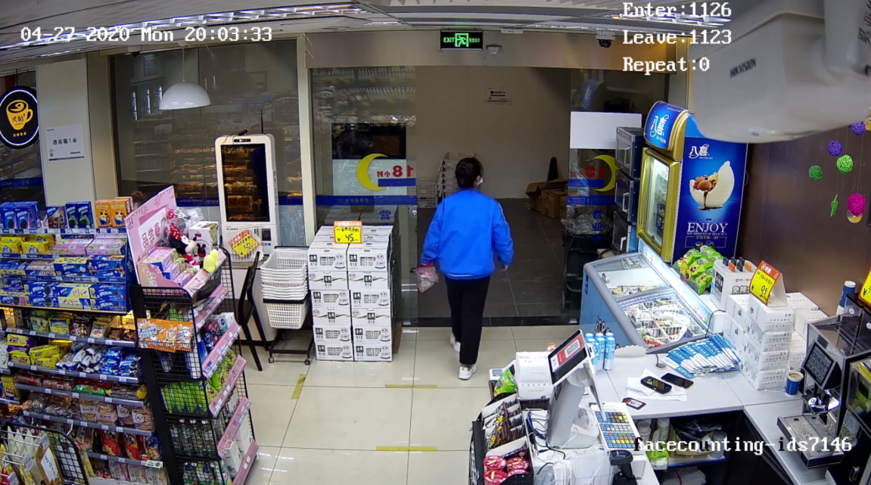

Example of unsuitable scenario:
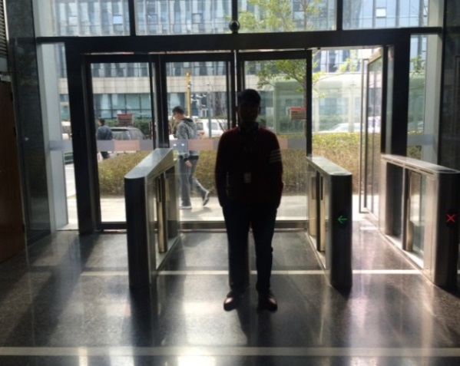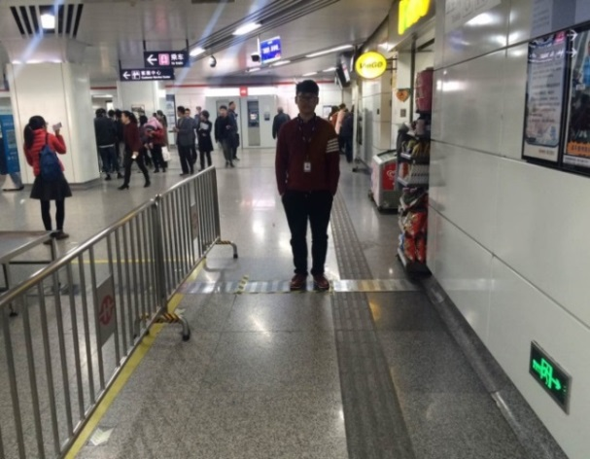
Backlight Lack of light
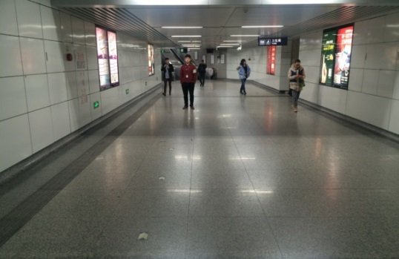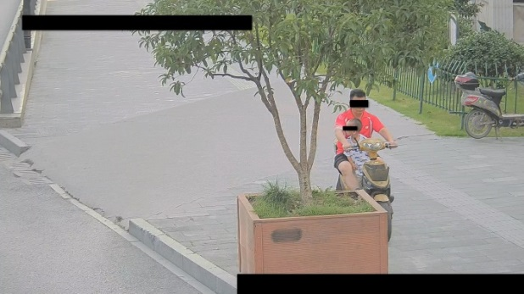
The scenario is too wide Incline installation, with shelter
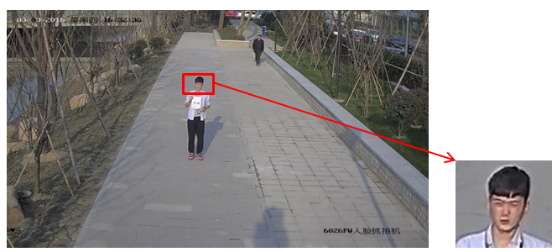
The scenario is too large and the face recognition rate is low

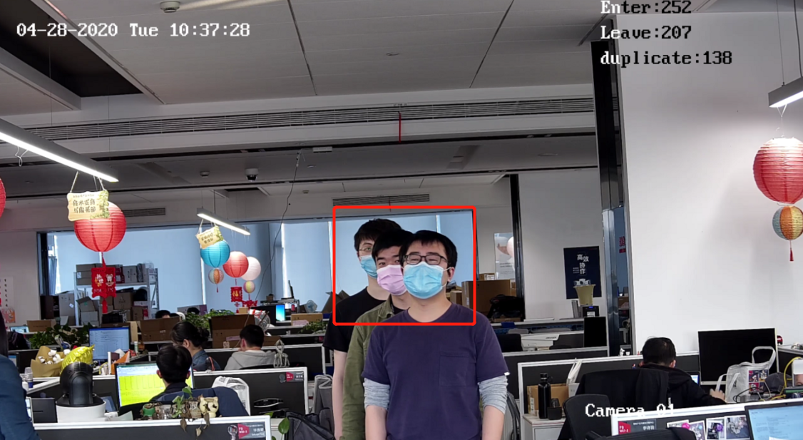
Too many faces tamper each other

The Selection of Camera Lens
- Different cameras, lens focal lengths and monitoring widths are key points for the different monitoring distance and installation. The conversion relation between them is as follows:
- The selection of lens focal length： 8426 Face Recognition camera
The selection of lens focal length： 2MP Bullet Face capture camera (1)
- The height of camera： (2)
- D : The monitoring distance
- The height below the head sets as average value 1.5 m
- α is the elevation angle
- Elevation angle is recommended as 10°, ≈0.18，≈0.27，≈0.36

The Installation Requirement of Camera
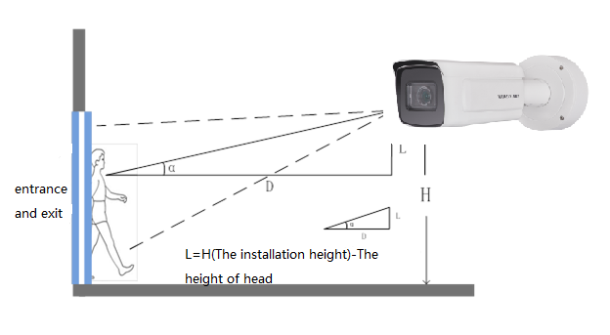
The installation diagram
The installation position selection specification of face capture camera is as follows:
- The camera should be installed in the front of passageway and capture the positive face. The horizontal angle of deflection had better be less than 25 °.
- The installation of camera needs an elevation angle, which avoids the situation that the rear face is obscured when the tandem persons go through the passageway. The vertically elevation angle should meet the below requirement: α=15±5°.
- It requires that the covered PD (Pupil Distance) pixels needs to be larger than 40 pixels to distinguish the face details from the captured image. The practical width of face detection should be less than or equal to 3 meters with 2MP camera.
- Make sure that there is no shelter between the camera lens and the passageway.

Installation Position and Lens Query Table
For iDS 7 series face capture camera:
Camera Model | Monitoring Width W | Lens Focal Length | Monitoring Distance | Installation Height of Camera | Elevation angle α°
2MP | 2.5m | 2.8-12mm | 2.8m | 2.0m | 15°
2MP | 2.5m | 2.8-12mm | 4.1m | 2.2m | 10°
2MP | 2.5m | 8-32mm | 2.8m | 2.0m | 10°
2MP | 2.5m | 8-32mm | 5.6m | 2.5m | 10°
2MP | 2.5m | 8-32mm | 8.3m | 3.0m | 10°
2MP | 2.5m | 8-32mm | 11.1m | 3.5m | 10°
4MP | 4.5m | 2.8-12mm | 2.2m | 2.1m | 15°
4MP | 4.5m | 2.8-12mm | 3.4m | 2.4m | 15°
4MP | 4.5m | 3.8-16mm | 3.0m | 2.3m | 15°
4MP | 4.5m | 3.8-16mm | 4.5m | 2.7m | 15°
4MP | 4.5m | 8-32mm | 4.9m | 2.8m | 15°
4MP | 4.5m | 8-32mm | 6.7m | 3.3m | 15°
4MP | 4.5m | 8-32mm | 9.7m | 4.1m | 15°
4MP | 4.5m | 8-32mm | 13.4m | 5.1m | 15°
4MP | 4.5m | 11-40mm | 6.3m | 3.2m | 15°
4MP | 4.5m | 11-40mm | 9.3m | 4.0m | 15°
4MP | 4.5m | 11-40mm | 13.1m | 5.0m | 15°
4MP | 4.5m | 11-40mm | 16.8m | 6.0m | 15°
8MP | 7.3m | 2.8-12mm | 3.7m | 2.5m | 15°
8MP | 7.3m | 2.8-12mm | 5.6m | 3.0m | 15°
8MP | 7.3m | 3.8-16mm | 3.4m | 2.4m | 15°
8MP | 7.3m | 3.8-16mm | 6.3m | 3.2m | 15°
8MP | 7.3m | 3.8-16mm | 9.3m | 4.0m | 15°
8MP | 7.3m | 8-32mm | 6.7m | 3.3m | 15°
8MP | 7.3m | 8-32mm | 8.6m | 3.8m | 15°
8MP | 7.3m | 8-32mm | 12.7m | 4.9m | 15°
8MP | 7.3m | 8-32mm | 16.4m | 5.9m | 15°
8MP | 7.3m | 11-40mm | 9.3m | 4.0m | 15°
8MP | 7.3m | 11-40mm | 11.2m | 4.5m | 15°
8MP | 7.3m | 11-40mm | 13.4m | 5.1m | 15°
8MP | 7.3m | 11-40mm | 16.8m | 6.0m | 15°
12MP | 10.5m | 2.8-12mm | 5.5m | 2.5m | 15°
12MP | 10.5m | 2.8-12mm | 8.3m | 3.0m | 15°
12MP | 10.5m | 3.8-16mm | 2.7m | 2.0m | 15°
12MP | 10.5m | 3.8-16mm | 7.0m | 2.7m | 15°
12MP | 10.5m | 3.8-16mm | 11.1m | 3.5m | 15°
12MP | 10.5m | 11-40mm | 7.6m | 2.8m | 15°
12MP | 10.5m | 11-40mm | 14m | 4.0m | 15°
12MP | 10.5m | 11-40mm | 20m | 5.1m | 15°
12MP | 10.5m | 11-40mm | 27.7m | 6.5m | 15°

Chapter2 Camera Configuration

2.1 Configure the parameter via IE browser【Quick Start】
Step 1: Enter [configuration]-[local], Enable [Rules]. Then Click “Save” when finishing the configuration, as shown in the below picture:
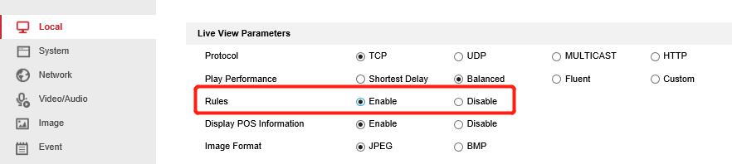

Step 2: Go to [System]-[System Settings]-[VCA Resource]. If the VCA resource is not Face Counting mode, switch to Face Counting mode. Switch VCA resource will take effect after reboot.
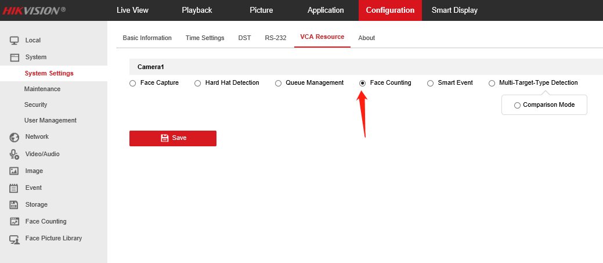
Step 3: Go to [Face Counting]-[Overlay & Capture] – [Background Picture Settings]. Enable Background Upload.
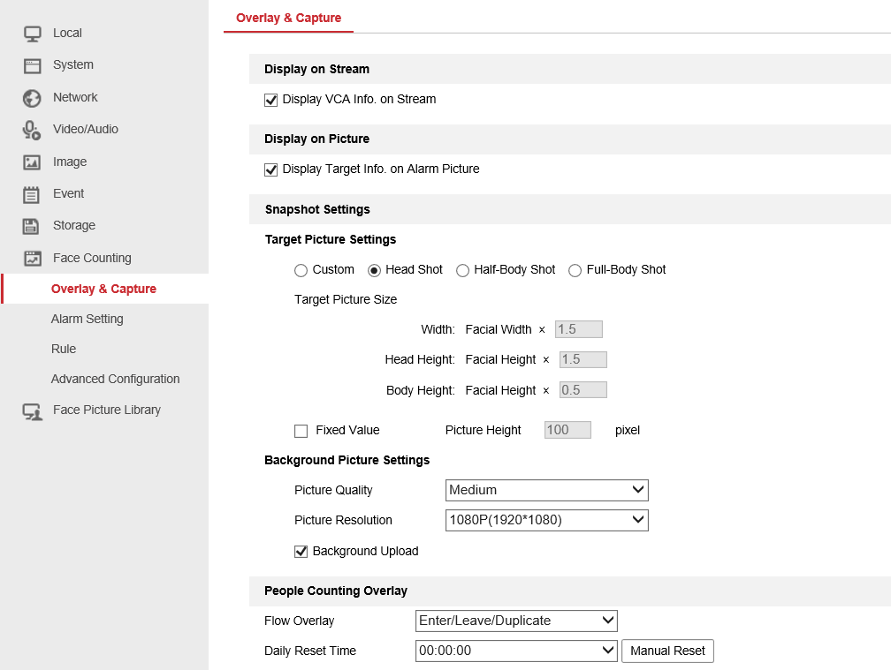
Step 4: Go to [Face Counting]-[Alarm Setting]-[Alarm Uploading]. Enable the People Counting Alarm. Enable the other alarms if you want.

Step 5: Go to [Face Counting]-[Alarm Setting]-[Face Picture Library]. Select the target face picture library that you want to remove directly from face counting【The number of Entry will always add, but will not upload the attribute data】. Then enable the People Counting Deduplication.
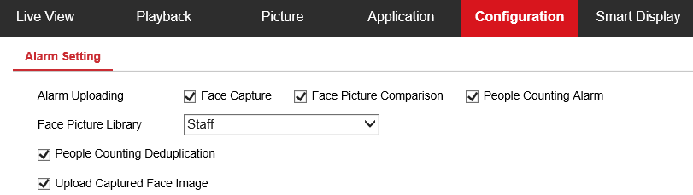

Step 6: Go to [Face Counting] – [Rule]. Adjust People Counting Deduplication time as the scenario needs.
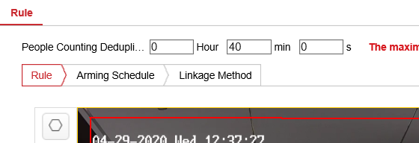

Step 7: Draw the rules and read the descriptions below.
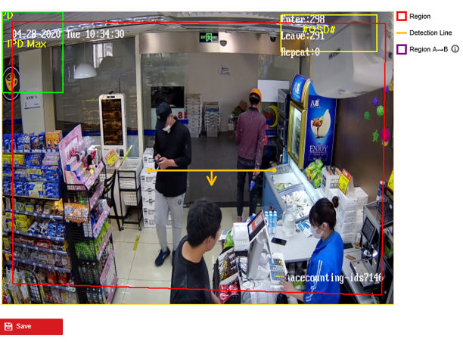
In the detection scene, there may be situations where the target side enters the scene without passing through the trigger line. The detection method of area A and B can solve this problem.
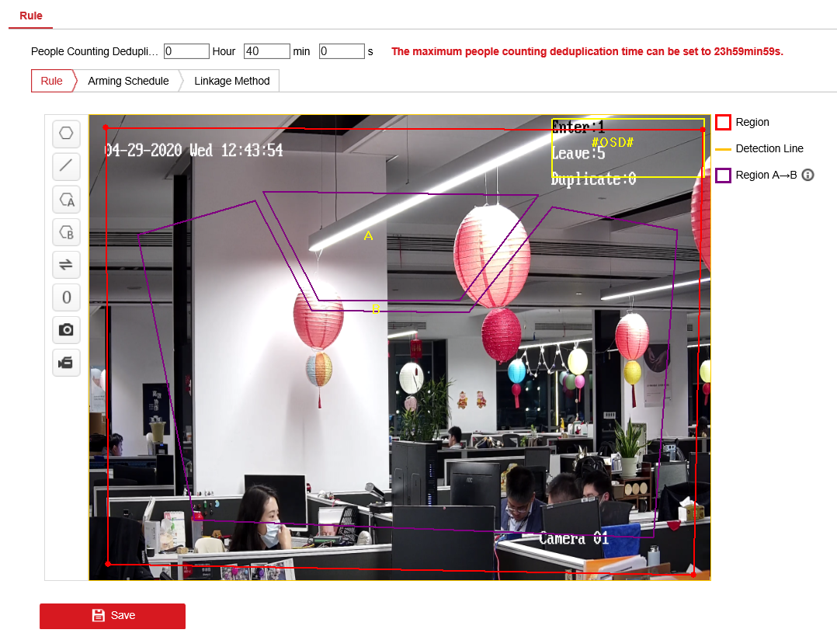
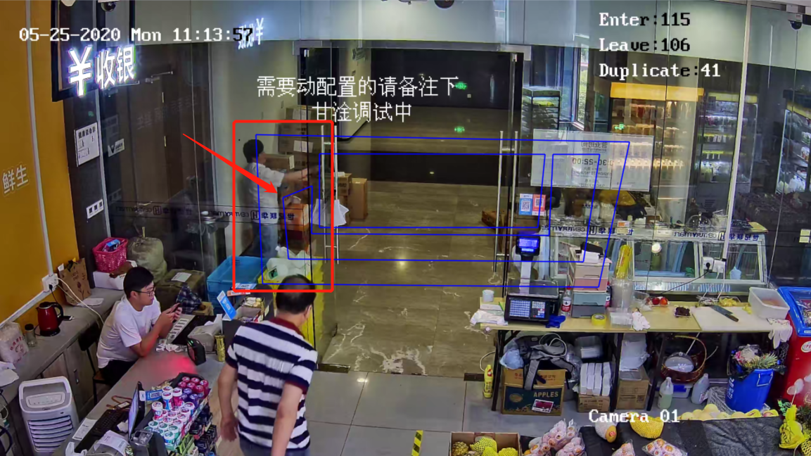
If the scenario has the transparent wall like picture below, it may cause the area A&B method losing its accuracy when the pedestrian walk through. We recommend using advertisement papers to cover the edge of rule box.

Step 8: Go to [Face Counting] – [Advanced Configuration] – [People Counting]. Switch the Data Statistics Cycle to the required period and remain the Algorithm Validity as the default. Check the Real-Time Upload Data and click it on.
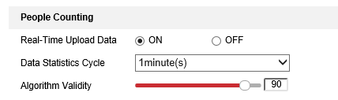

2.2 Configure the parameter via IE browser【Completely Configuration with Full Function Descriptions】
Step 1: Enter [configuration]-[local], Enable [Rules]. Then Click “Save” when finishing the configuration, as shown in the below picture:

Step 2: Go to [System]-[System Settings]-[VCA Resource]. If the VCA resource is not Face Counting mode, switch to Face Counting mode. Switch VCA resource will take effect after reboot.

Step 3: Go to [configuration] – [Face Picture Library]. Create face picture library and add face pictures in the library. iDS7 series can support 3 libraries up to 90000 pictures.
Here are the requirements for face picture in database:
1) 40 <Min. Pupil Distance <300 (recommend 60) pixels.
2) 20KB <Photo Size< 300KB
3) Format: JPG, JPEG
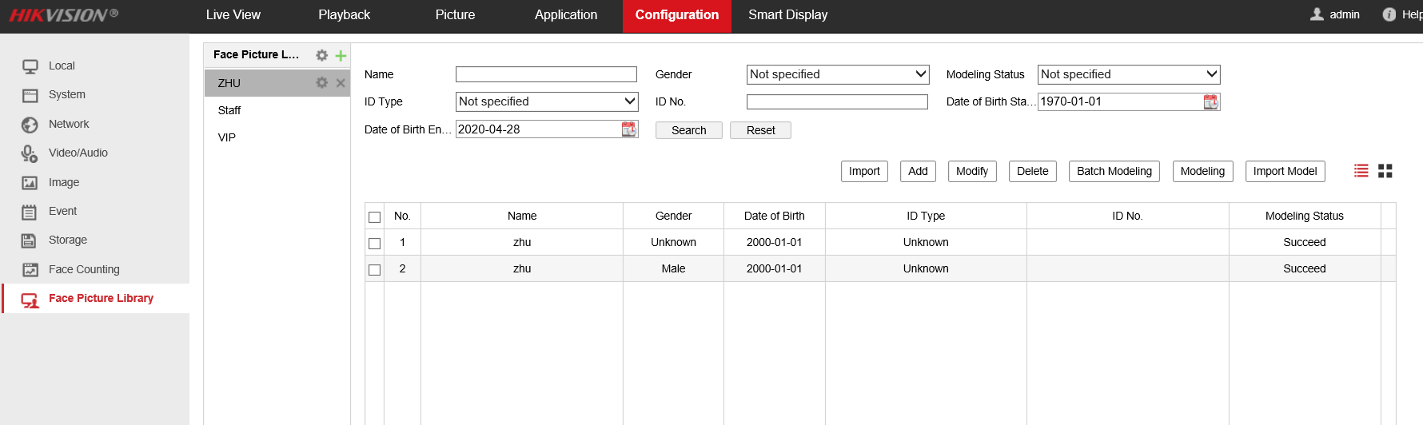

Notes:
You can select one picture to add or a file that contains multiple pictures to import pictures in batch.
The web interface don’t support custom tags except name and gender for database. You can add custom tags via web or iVMS.
The picture added to the database should has only one face.

Step 4: Go to [Face Counting]-[Overlay & Capture]. Enable Display VCA info. on Stream and enable Display Target Info. on Alarm Picture. Then adjust the Snapshot Settings to the demand effects or just choose the default settings.

Step 5: Go to [Face Counting]-[Overlay & Capture] – [Background Picture Settings]. Enable Background Upload.
【Display VCA info. on Stream】
This option will overlay the VCA information into the code stream.

【Display Target Info. on Alarm Picture】
This option will overlay the warning target information on the warning picture.

【Snapshot Settings】
[Custom] Custom target capture settings.
[Head Shot] Preset head photo of captured target.
[Half-Body Shot] Preset half shot of the target.
[Full-Body Shot] Preset full body photos of captured target
[Target Picture Size] According to the width and height of the target's face, the capture scale is defined, which can be modified only in custom mode.
[Fixed Value] Capture image will be limited to pixels with fixed height setting
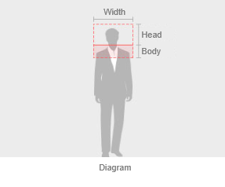
【Background Picture Settings】
[Picture Quality] The capture quality of the large background image of the captured character is divided into low, medium and high. Note that the settings here will not affect the image size of the face capture image. The size of the face capture image is determined by the face details, and the quality cannot be adjusted.

[Picture Resolution] Select the capture resolution of the large background image, the high-quality capture of 2MP resolution takes up about 300KB of storage, and the high-quality capture of 4mp resolution takes up about 750kb of storage.
Tips: the Deepinmind device will compress the received large background image higher than 1080p to 1080p for storage.

[Background Upload] Upload the background picture to NVR, platform, etc. Please check it is on if there is no special case.

【People Counting Overlay】
[Flow Overlay] Here you can set the pattern of counting OSD information in the upper right corner of the screen.
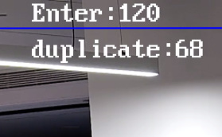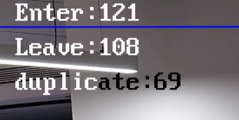
[Daily Reset Time] Here you can set the time point for automatic reset of daily count data (cannot cancel the reset).

【Camera】
[Device No.] Here, you can set the device no. of the lower OSD in the snapshot and you can enable the display in the options below.

[Camera Info.] Here, you can set the Camera Info. of the lower OSD in the snapshot and you can enable the display in the options below.

【Text Overlay】
Whether the device No. and camera info. Set above and the OSD information of the capture time can be displayed at the bottom of the capture image.
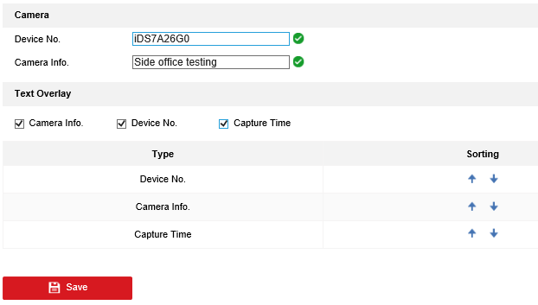

Step 6: Go to [Face Counting]-[Alarm Setting]-[Alarm Uploading]. Enable the People Counting Alarm. Enable the other alarms if you want.

Step 7: Go to [Face Counting]-[Alarm Setting]-[Face Picture Library]. Select the target face picture library that you want to remove directly from face counting【The number of Entry will always add, but will not upload the attribute data】. Then enable the People Counting Deduplication.

Step 8: Enable the Upload Captured Face Image. Then configure the Arming Schedule & Linkage Method to set the alarm sending time period and the linkage action at the same time.
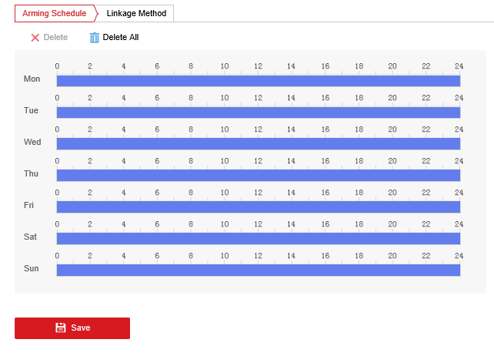
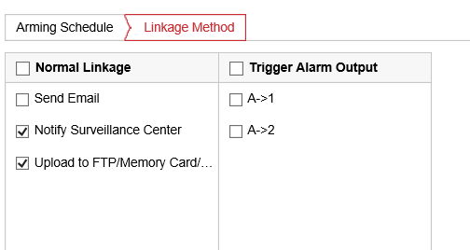
【Alarm Uploading】
[Face Capture] When the face capture is triggered, an alarm will be given. If you need to send the capture image, you need to check the option below.

[Face Picture Comparison] Alarm will be given during face comparison, and the comparison results and pictures will be reported.

[People Counting Alarm] When the face counting is triggered, it will alarm and report the count alarm. The detailed configuration of this alarm item is in advanced configuration.

[Face Picture Library] Select the target face picture library that you want to remove directly from face counting, and select after configuration in face picture library. The selected face picture library here is the target of direct invalid counting after matching.

[People Counting Deduplication] Enable this option to activate target de-duplication in the face picture library selected above.

[Upload Captured Face Image] Enable this option to upload the captured face picture to the platform or iVMS. It is suggested to be set on always.
Step 9: Go to [Face Counting] – [Rule]. Adjust People Counting Deduplication time as the scenario needs.
Step 10: Draw the rules and read the descriptions below.
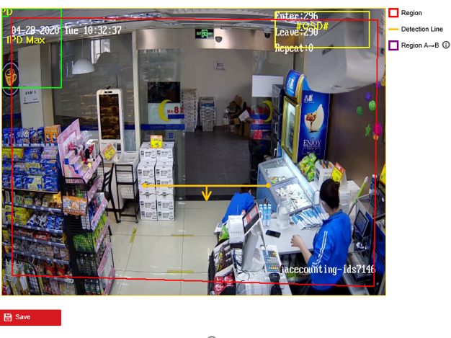
【Rule】
[Draw Region] Click several times to draw the area where you want to count faces. Right click to confirm the area.

[Draw line] After clicking, you can drag the dots on both sides to adjust the direction of the line. When the human shoulder model of the target crosses the line, it is determined to enter or leave.
In the detection scene, there may be situations where the target side enters the scene without passing through the trigger line. The detection method of area A and B can solve this problem.
[Draw region A & Draw region B] When the human shoulder model of the target is moved from area A to area B, the face count is triggered. This detection method cannot be changed from area A to area B by default. You can click the swap button below to change area a and area B to achieve the effect.

 [Change Direction] It can change the direction of detection line or area A and B.

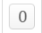[Reset Counter] Click to reset the statistics in OSD to 0.

If the scenario has the transparent wall like picture below, it may cause the area A&B method losing its accuracy when the pedestrian walk through. We recommend using advertisement papers to cover the edge of rule box.

Step 11: Configure this option to set the face counting guarding time period and the linkage action at the same time.
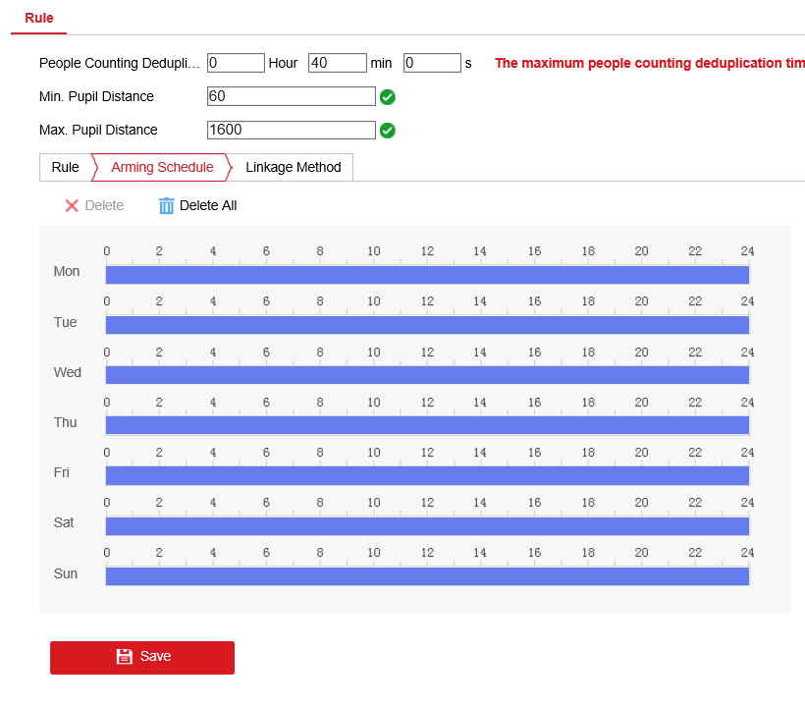
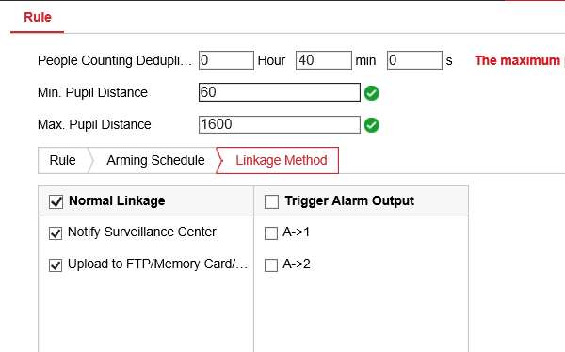

Step 12: Go to [Face Counting] – [Advanced Configuration] – [Capture Parameters]. Set Capture Threshold to 10. Enable Face Exposure if the scenario’s light is not enough.
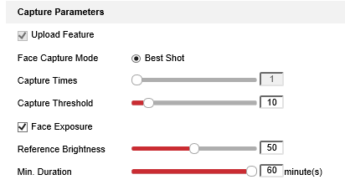
【Capture Parameters】
[Capture times] The number of snaps after face recognition is 1 by default in face counting mode and cannot be changed.

[Capture Threshold] The lower this option is, the lower the capturing effect required for capturing, which may lead to poor capturing effect and false recognition. Recommended setting is 10 and adjust as the scenario requests.

[Face Exposure] After enabling the face exposure, the camera will automatically adjust the exposure when recognizing the face, so as to make the face fill more light.

[Reference Brightness] Relative exposure value.

[Min.Duration] Minimum duration: during the set period, the exposure parameters will not be changed after one exposure, so as to prevent repeated exposure changes of screen brightness

Step 13: Go to [Face Counting] – [Advanced Configuration] – [People Counting]. Switch the Data Statistics Cycle to the required period and remain the Algorithm Validity as the default.

【People Counting】
[Real-Time Upload Data] Real time data upload. When this option is enabled, the alarm data will be sent every time the face count is triggered. If there is no requirement, it is recommended to enable it. Disable it will cause the HCP can’t show the properties immediately.

[Data Statistics Cycle] Data upload cycle. The settings here are different from the real time upload data above. Whether real time upload data is enabled or not, the access information in this period will be reported at the set time.

[Algorithm Validity] Algorithm sensitivity here you can adjust the sensitivity of the face counting algorithm. The higher the sensitivity, the easier to trigger the counting.

【Restore Parameters】
[Restore Defaults] Restore advanced parameters to default.

