# How to add Synology NAS to NVR

### 1. Background：

For the requirements of storing NVR recording to Synology NAS, we make this guidance for our users, below Synology NAS model is DS-220, NVR is DS-9632NI-I8. The configuration on other Synology NAS and Hikvision backend devices are almost the same.

### 2. Power on Synology NAS：

Add HDD to NA, connect the network cable, power on the NAS.

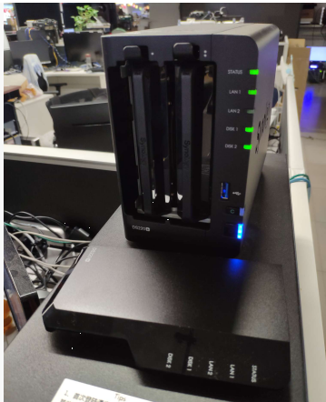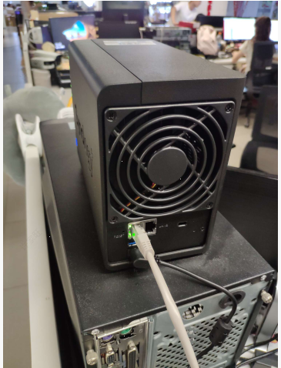

### 3. Configuration on NAS and NVR

#### 3.1 Log in Synology NAS

Input NAS IP address to web browser, then input the username and password to log in the NAS.

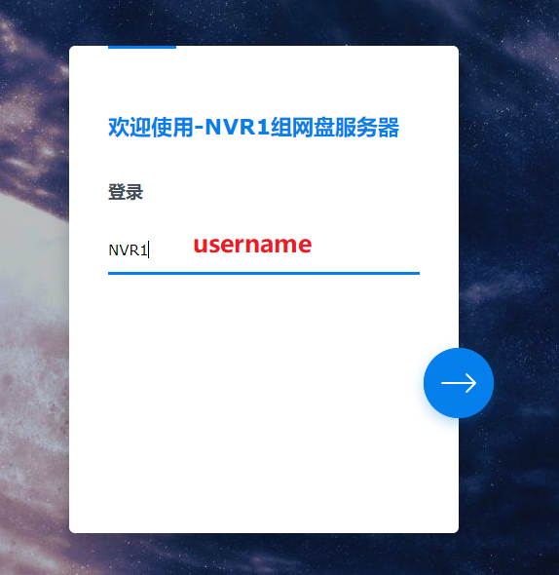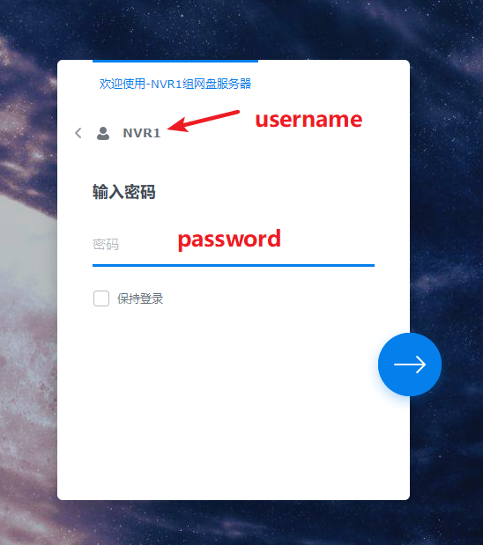

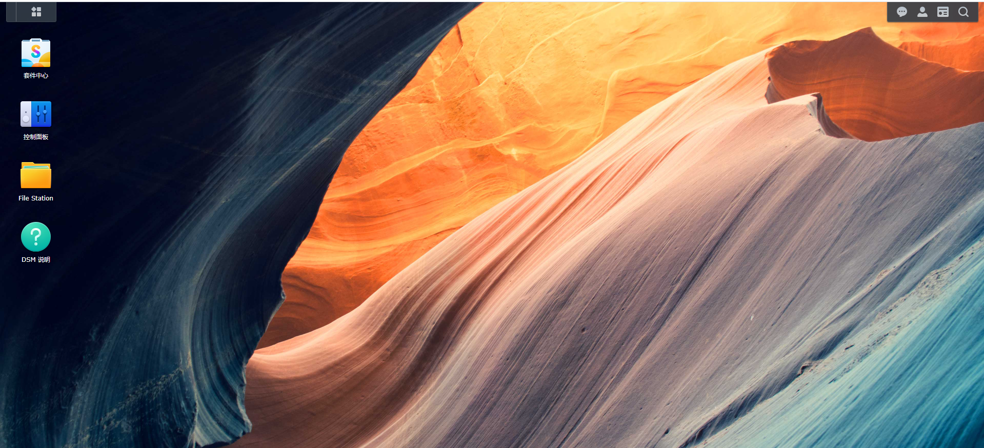

#### 3.2 Configure NAS

**①Enable NFS**

Go to **Desktop**/**Control** **Panel**./**File** **Service**/**NFS**, enable **NFS service**.

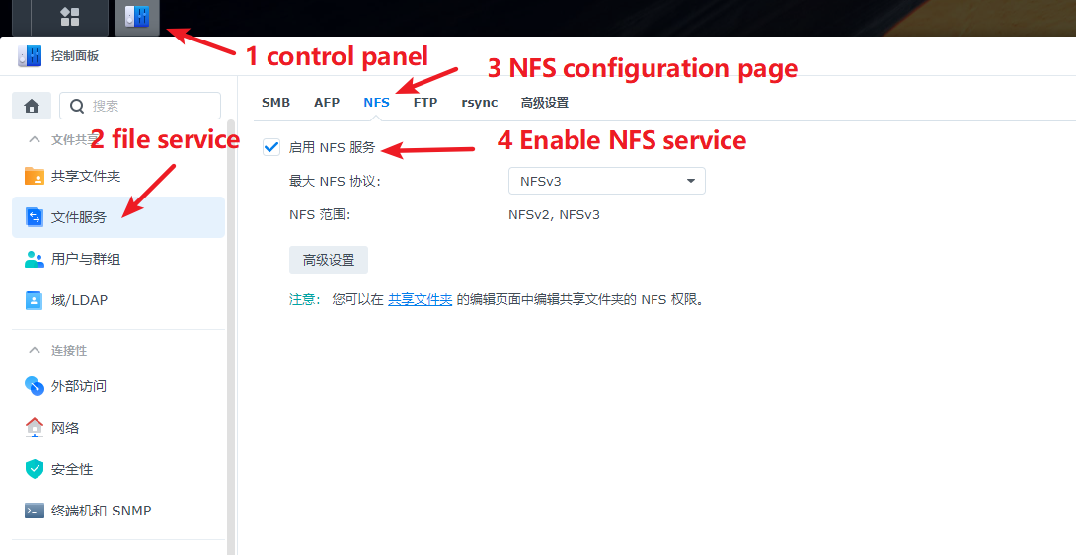

**② Create a folder under Share Folder Path**

This step is to create the storage folder to store NVR recording.

Go to **Desktop**/**Control Panel**/**Share Folder**, new a folder. Click next for all steps except storage capacity setting.

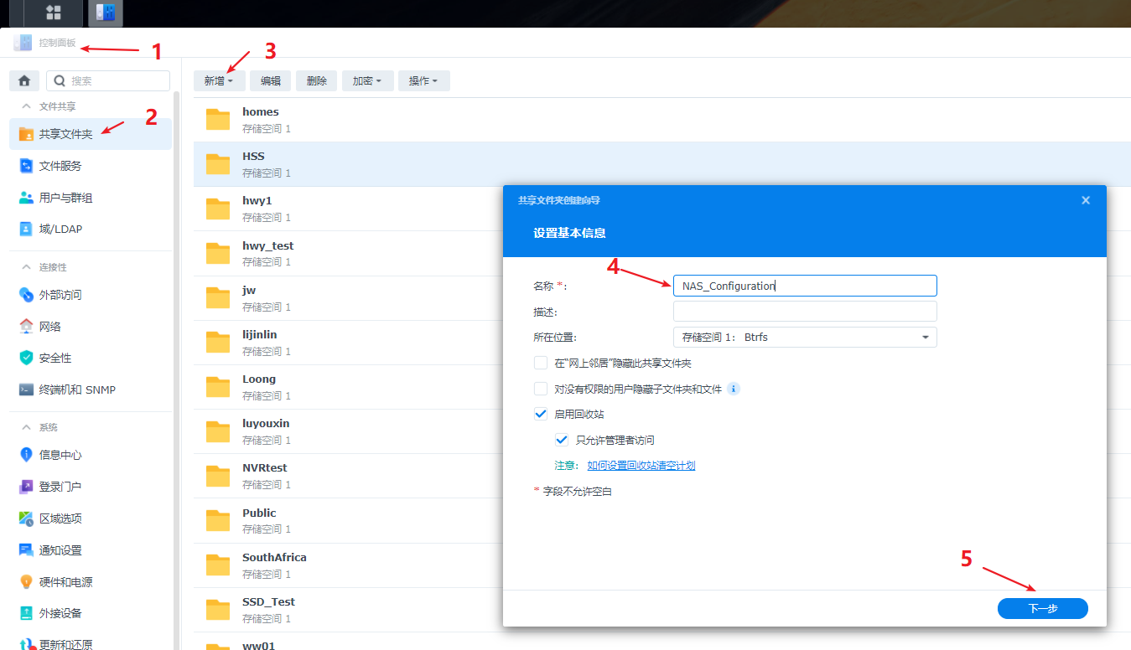

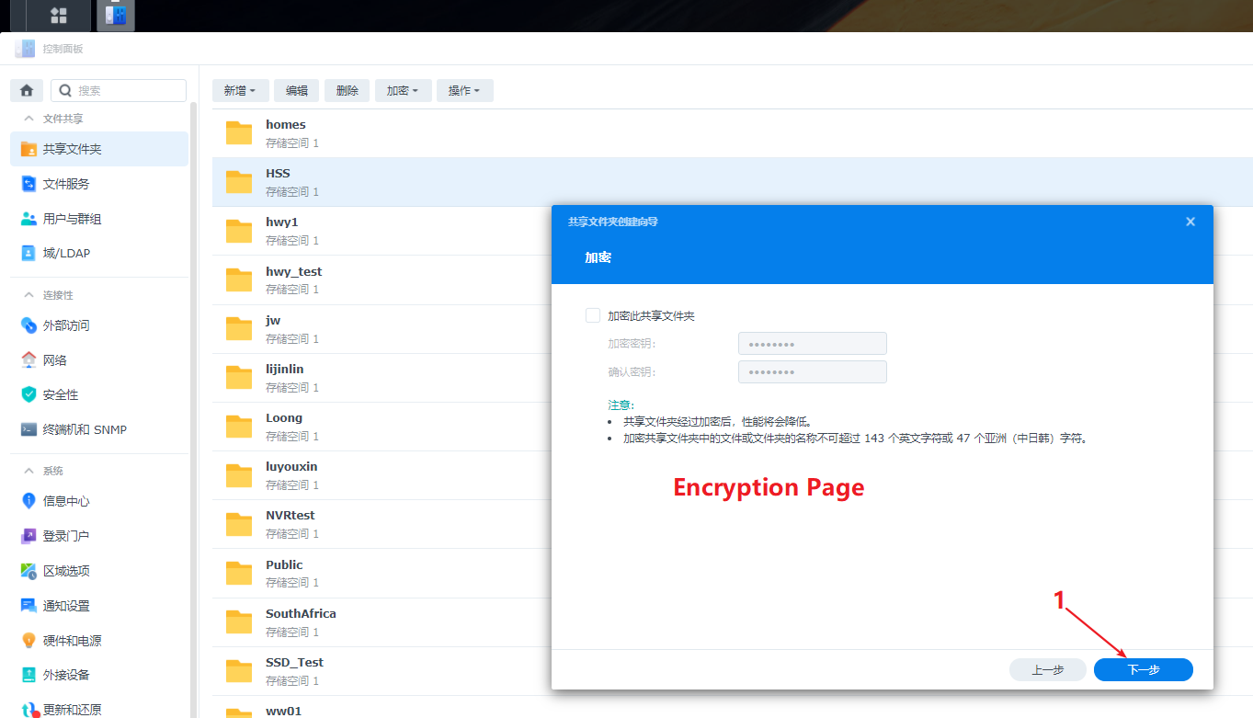

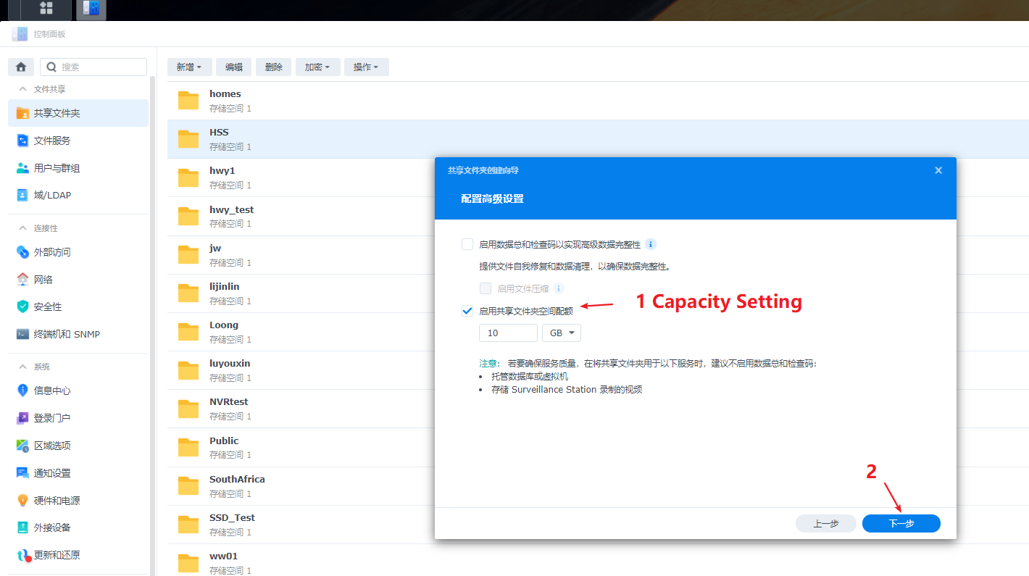

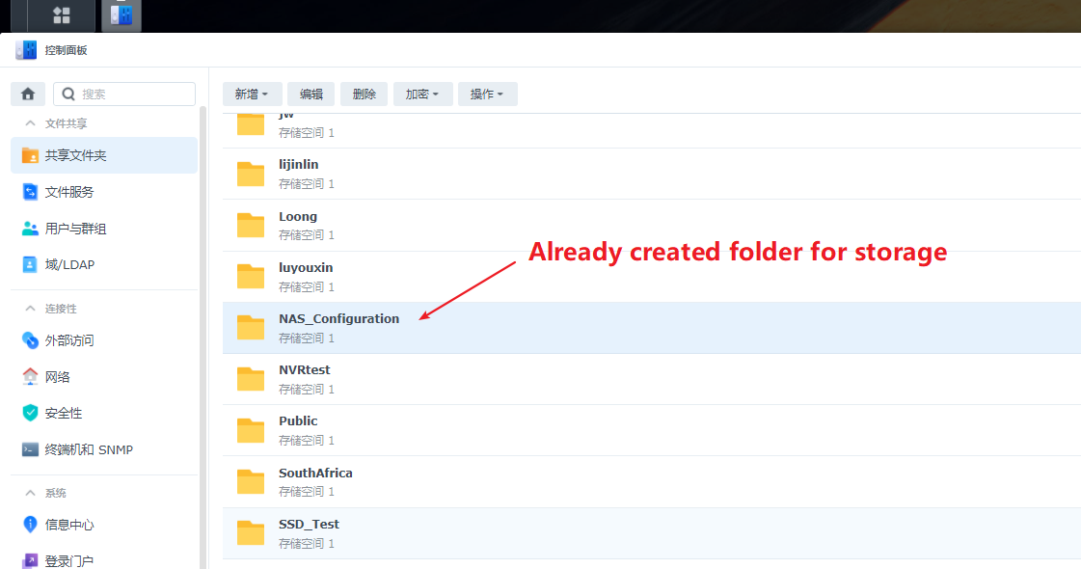

**③ Set IP address access for NVR**

The NAS share folder created in step-2 can’t be detected by NVR now. You should configure the NFS access rights for it.

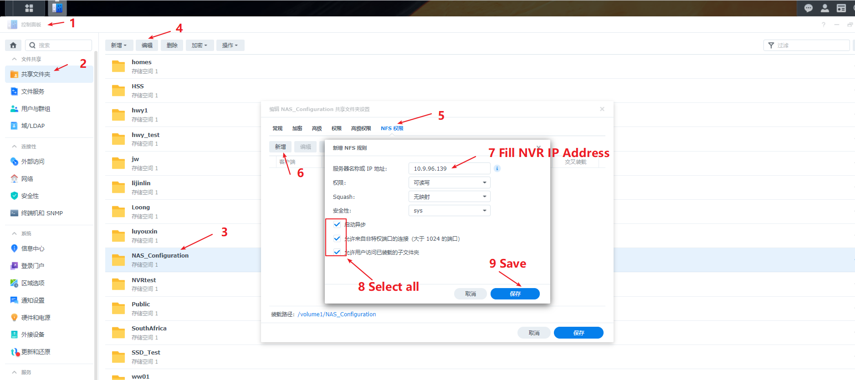

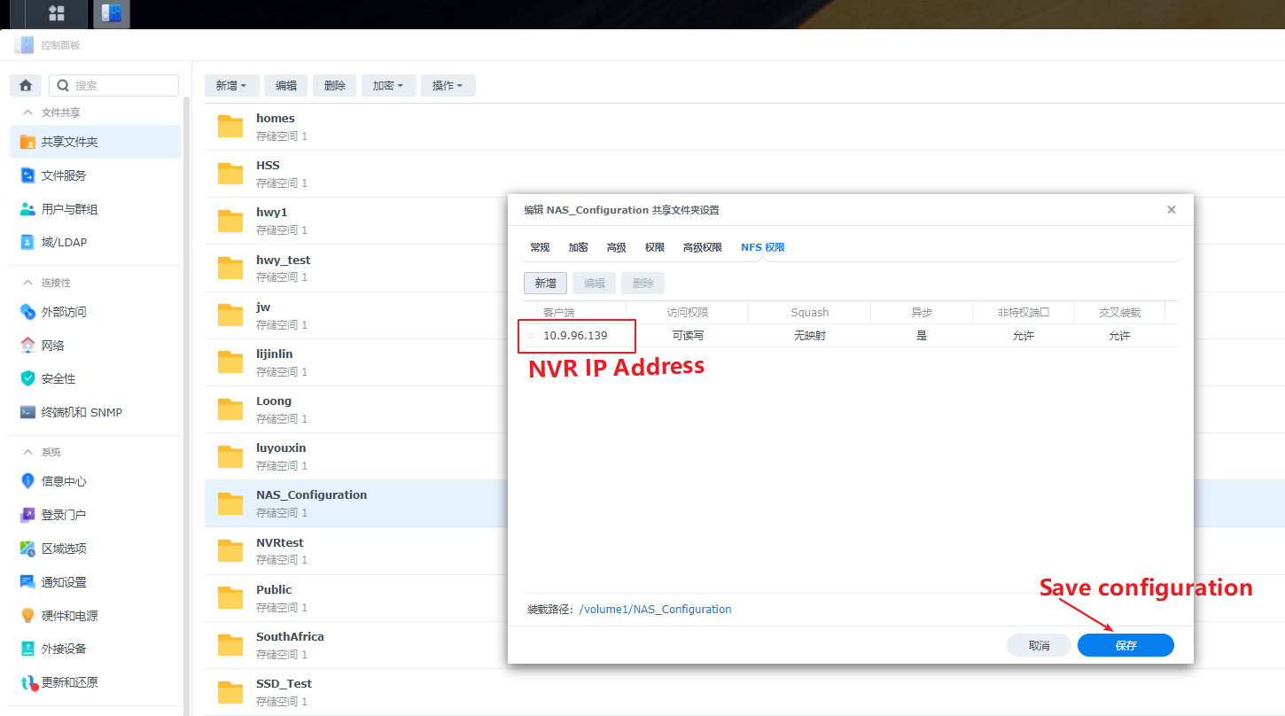

**④ Add the NAS to NVR**

Go to NVR local GUI or log in NVR web page(take webpage as example), configure as below screenshot, then NVR video will be store to NAS.

