# AX PRO Wireless Panel FAQ

目录

AX PRO Wireless Panel FAQ 1

**一、** **Panel configuration** 3

**1.** **Incorrect account or password when logging into AX Pro from the web side** 3

2. **Why the panel can’t connect the EZIVZ cloud when insert the SIM card?** 3

**3.** **Why does panel continue to play the voice of operation/fault/alarm events after the panel is disarmed?** 3

4. **Tamper alarm and normal alarm will be stopped after 90S** 4

**5.** **What about the Frequency Jamming Alarm** 4

**6.** **Is it possible to make sure that the ax pro is silent from the factory and after install you can choose whether it starts making noise about tamper or not. now it is pretty much always on alarm** 5

**7.** **Could you please tell me where the 7S video linked by the thermal imaging camera is stored? Does the thermal imaging camera need to plug in the SD CARD?** 5

**8.** **Can the IPC under the same HIK-Connect account, which is not on a LAN, be added to the panel for triggering?** 5

**9.** **Can IPC under the same hik-connect account, which is not on a LAN, be added to the panel and triggered via hik-proconnect?** 5

**10.** **AxPro is linked with IPC, do you have 7S video?** 5

**11.** **IP Receiver Pro is a protocol or a platform or a software or a website** 5

12. **Do both 868MHz and 433MHz protocols support transmission of 1600 meters?** 5

**二、** **Web Interface** 5

**三、** **IVMS4200** 5

**1. Could not save configuration or wrong interface after adding AXPRO in IVMS4200?** 5

**四、** **SIM CARD** 6

**1. When the AXPRO is connected to WiFi, LAN and SIM card network at the same time, which network mode is preferred?** 6

**2. Can this 2 sim cards operate simultaneously?** 6

**五、** **Hik-Connect** 6

**1.** **After the HIK-Connect alarm, only the alarm message can be received, and the Playback column is gray?** 6

**2.** **Ax pro is deleted from the hik-connect account, it will be unbind automatically and then can be added to another Hik-connect account, right?** 6

**六、** **Wireless peripherals** 7

1. Triggered the outdoor wireless sounder tamper, but the alarm does not ring 7

2. When using the PIR-CAM to trigger the alarm, the snapshot cannot be seen in the event received on Hik-Connect. 7

3. When you are arming the system via keypad, if the detector detects someone within the detection zone, the arm will fail right? 7

4. Does repeater wants mains power? How long will it work using batteries power? 7

5. Can your arm area 1, 2, 3? Via keyboard and disarm only area 3 by 1 user? 7

6. Can we add the smart tag to the specific user? 7

7. How to clearing alarm when there is alarm using keypad? 7

8. AX PRO + IVMS does it work? And how should we add it to HCP and IVMS (through hik-connect or ISUP)? 7

9. Can we receive tamper alarm, when device isn't armed? 7

10. Without using keypad, can we arm and disarm? 7

11. Are AX HUB and AX Pro detectors compatible with each other? 7

12. Is there a limit to the number of detectors in the Repeaters of AX Pro? 7

13. Can we connect a wired IR-Detector to magnetic contact? 7

14. Can we get the chime function from wired detector connected to magnetic contact? 7

15. Can other devices than magnet use chime function? 7

16. Can we disable all sound from the central unit (need to be hidden and no sound is allowed) 8

17. Can we get voice prompt and indication of disarming timer etc from indoor siren? (or any other device) 8

**FAQ:**

1. **Panel configuration**
2. **Incorrect account or password when logging into AX Pro from the web side**

A: When you log in to AXPRO on the Web side, the account and password are the account and password of Hik-Connect.

1. **Why the panel can’t connect the EZIVZ cloud when insert the SIM card?**

A： 1. First check the bill of the sim card, and then check that the SIM card had network function

2. Then need check the APN of the SIM card

3. The Access Number should be keep the Default number

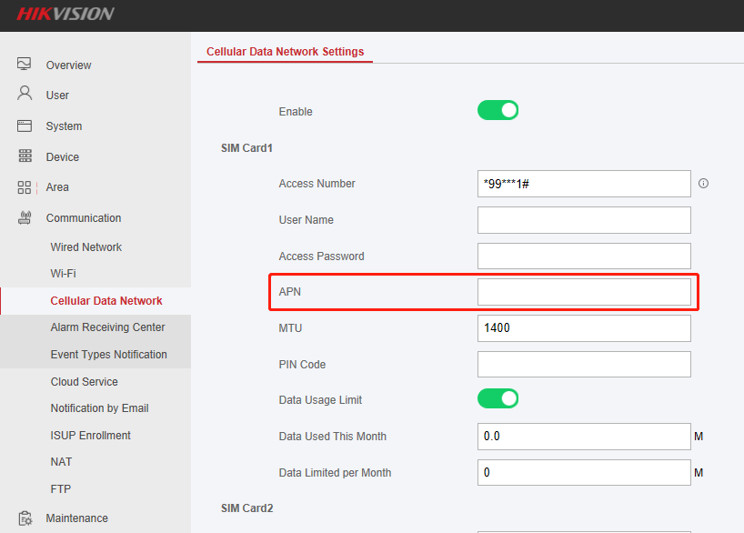

1. **Why does panel continue to play the voice of operation/fault/alarm events after the panel is disarmed?**

A: In order to facilitate the customer to understand the fault of the panel during the arm and disarm, You can turn this off on the Web interface if you don't need it.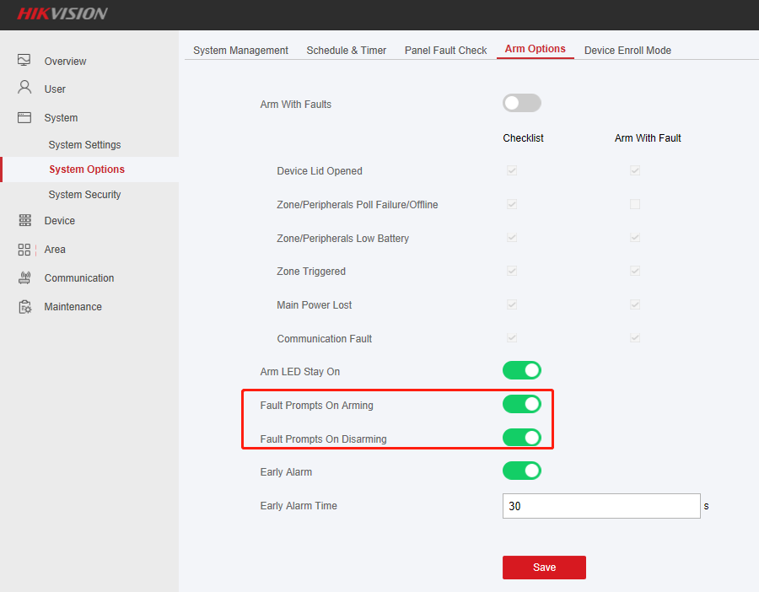

1. **Tamper alarm and normal alarm will be stopped after 90S**

A: We can setting the alarm time from System--System Options--Schedule & Timer--Alarm Duration, Default time is 90s.

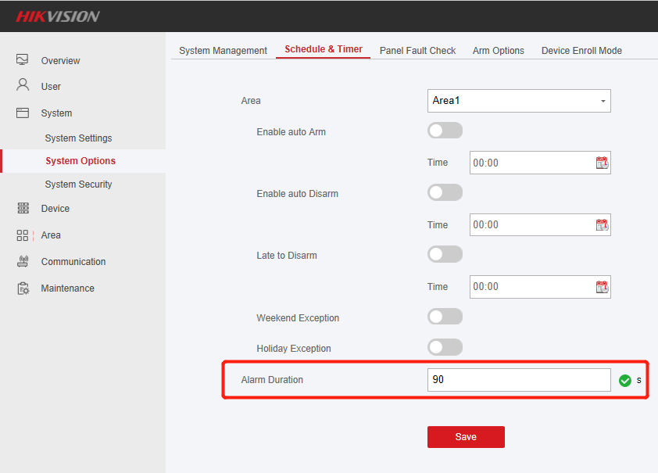

1. **What about the Frequency Jamming Alarm**

A: When the RF signal is too strong on the environment, The Frequency Jamming Alarm will be triggered. You can close the Frequency Jamming detection after the V1.2.3 firmware version.

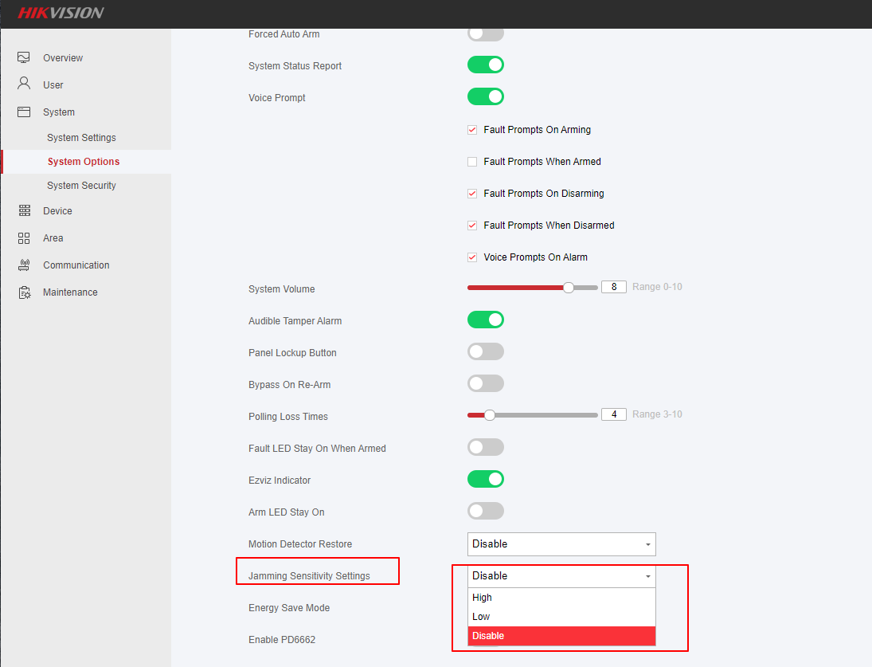

1. **Is it possible to make sure that the ax pro is silent from the factory and after install you can choose whether it starts making noise about tamper or not. now it is pretty much always on alarm**

A: AXPRO voice prompt by factory is required by EN standard, we have configuration already , you can silence it if customers want。

1. **Could you please tell me where the 7S video linked by the thermal imaging camera is stored? Does the thermal imaging camera need to plug in the SD CARD?**

A: AX PRO will acquire the sub-code stream of the camera in real time and store it in a loop in the host. In case of alarm, the 7S video will be packaged and pushed to the mobile APP

1. **Can the IPC under the same HIK-Connect account, which is not on a LAN, be added to the panel for triggering?**

A: It must be on a LAN

1. **Can IPC under the same hik-connect account, which is not on a LAN, be added to the panel and triggered via hik-proconnect?**

A: yes

1. **AxPro is linked with IPC, do you have 7S video?**

A: The HIK-ProConnect linkage is live video. If it is 7S video, it needs to be added to AXPRO on a LAN.

1. **IP Receiver Pro is a protocol or a platform or a software or a website**

A: IP Receiver Pro is software that connects the alarm host to ARC for protocol conversion

1. **Do both 868MHz and 433MHz protocols support transmission of 1600 meters?**

A: Because the certification of 868 and 433 devices has different requirements for antenna design, the transmission distance will be different. The transmission distance of 433 will be relatively short. For the specific transmission distance of each product, please refer to the selection table and SPEC, etc.

1. **Web Interface**
2. **IVMS4200**

**1. Could not save configuration or wrong interface after adding AXPRO in IVMS4200?**

A:Since AXPRO uses ISAPI protocol, port 80 is needed to add to IVMS4200. If port 8000 is used to add to IVMS4200, there will be cause this problem

1. **SIM CARD**

**1. When the AXPRO is connected to WiFi, LAN and SIM card network at the same time, which network mode is preferred?**

A: At the same time, the priority is LAN, WIFI is the second priority, and SIM card network is the lowest priority.

When the device is connected to WIFI and the network cable at the same time, if the wireless network is disconnected (such as the power failure of the wireless router), as the network detection is every 2 minutes, it will take about 1 minute for the disconnected network to be reconnected, and it will take up to 3 minutes for the wired network to be reconnected. Minimum time is 20s.

**2. Can this 2 sim cards operate simultaneously?**

A: Can’t, one is main channel , one is backup

1. **Hik-Connect**
2. **After the HIK-Connect alarm, only the alarm message can be received, and the Playback column is gray?**

A:In the zone configuration interface, link the IPC.

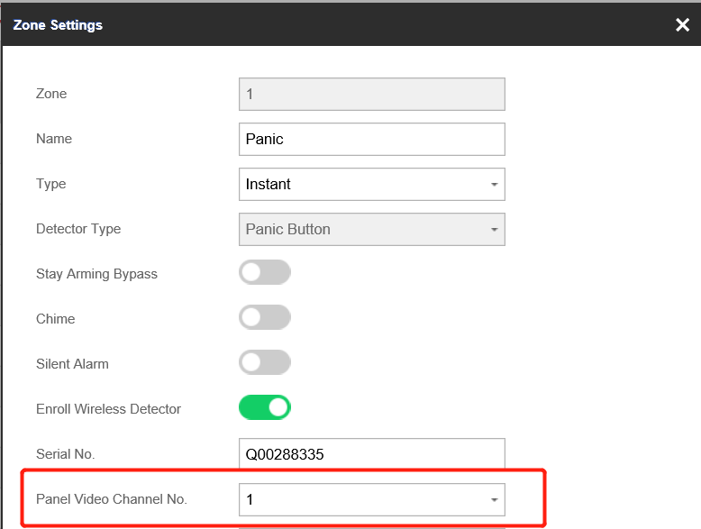

1. **Ax pro is deleted from the hik-connect account, it will be unbind automatically and then can be added to another Hik-connect account, right?**

A: Yes

1. **Wireless peripherals**
2. Triggered the outdoor wireless sounder tamper, but the alarm does not ring

A: When the panel is not armed, triggered the tamper of the outdoor wireless sounder, and the alarm will not detect the tamper alarm at this time. So the alarm doesn't go off.

1. When using the PIR-CAM to trigger the alarm, the snapshot cannot be seen in the event received on Hik-Connect.

A:Click and view immediately after the test is completed. The uploading of the snapshot will be later than the alarm event. It is recommended to wait about one minute to view after the trigger.

1. When you are arming the system via keypad, if the detector detects someone within the detection zone, the arm will fail right?

A：Yes, it fails

1. Does repeater wants mains power? How long will it work using batteries power?

A：Repeater battery backup time is up to 35 hours

1. Can your arm area 1, 2, 3? Via keyboard and disarm only area 3 by 1 user?

A: Yes, you can arm or disarm different areas by keypad, password+#+Area number + ARM or DISARM

1. Can we add the smart tag to the specific user?

A: Tag us under user

1. How to clearing alarm when there is alarm using keypad?

A: Password + 3s long press disarm button means clearing alarm

1. AX PRO + IVMS does it work? And how should we add it to HCP and IVMS (through hik-connect or ISUP)?

A: We can using ISAPI protocol add to IVMS4200, Using ISUP protocol add to HCP.

1. Can we receive tamper alarm, when device isn't armed?

A: Tamper is 24-hour alarm, can't be disarmed unless you login installer account

1. Without using keypad, can we arm and disarm?

A: Yes, We can use key fob, Tag reader, HIk-Connect, WEB interface.

1. Are AX HUB and AX Pro detectors compatible with each other?

A: NO

1. Is there a limit to the number of detectors in the Repeaters of AX Pro?

A: 1. Relay PIR-Cam, a repeater can only connect to 8 PIR-Cam;

2. There is no limit to the number of other detectors/peripherals that can be relayed, as long as they do not exceed the input/output capability level of the host.

1. Can we connect a wired IR-Detector to magnetic contact?

A: yes, magnetic contact DS-PDMCK-EG2-WE supports external wired inputs. Please have a try or check the details in um.

1. Can we get the chime function from wired detector connected to magnetic contact?

A: no, only for magnetic contact function.

1. Can other devices than magnet use chime function?

A: No. please clarify the scenario application.

1. Can we disable all sound from the central unit (need to be hidden and no sound is allowed)

A: Adjust the device volume as 0.

1. Can we get voice prompt and indication of disarming timer etc from indoor siren? (or any other device)

A: Currently no, please feedback more details, let’s check if it can be a requirement.