**如何查看HC 验证码 \** **How to view HC verification code**

介绍：当HC账号添加具有支持Hik-Connect功能的设备时，找不到设备验证码怎么办？本文以可视对讲DS-KH6320-WTE1室内机为例，通过介绍设备本地端、远程设置界面、微信扫一扫、标签页面四种方式查找设备验证码。本文适用于大多数非视频设备查找HC验证码。

**Introduction:** **What should I do if I cannot find the device verification code when I add a device that supports Hik-Connect to my HC account? This article takes the video intercom DS-KH6320-WTE1 indoor station as an example, and finds the device verification code by introducing the local end of the device, remote setting interface, WeChat scan, and tag page. This article is suitable for most non-video equipment to find HC verification code.**

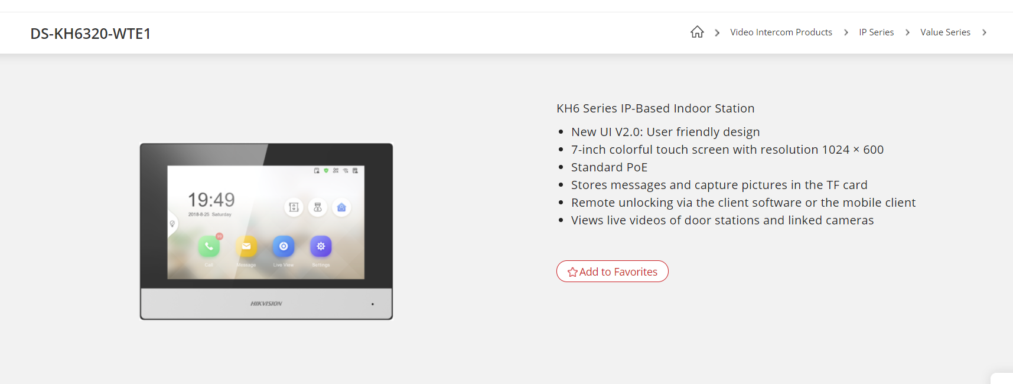

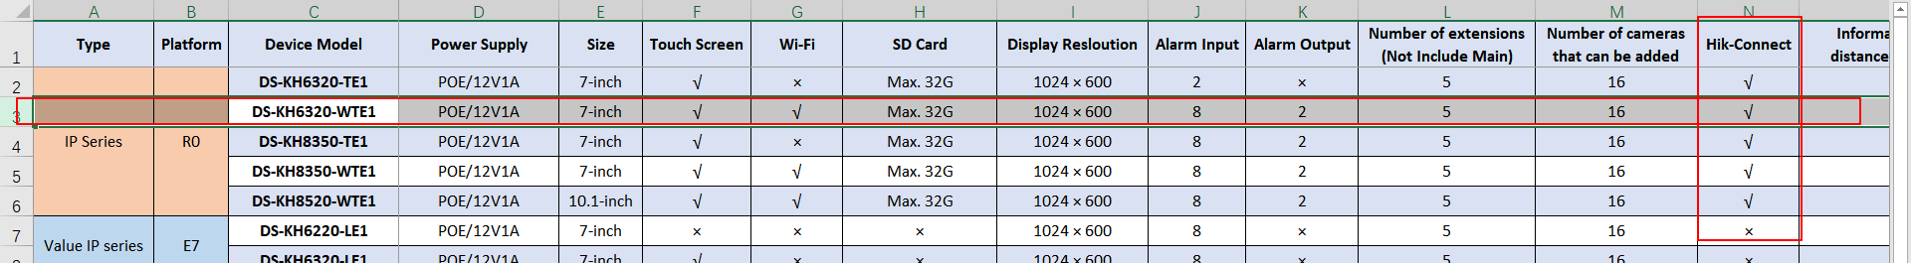

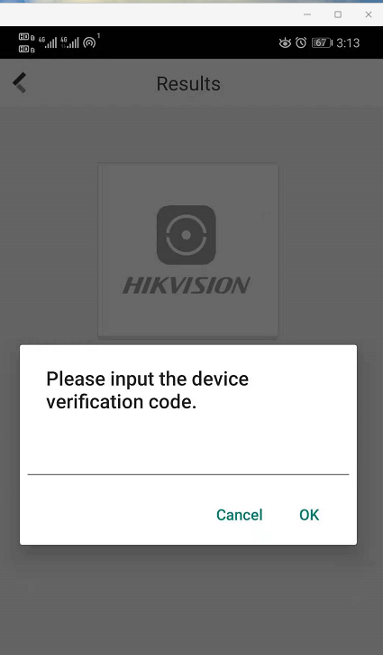

1. **远程配置端查看HC验证码**

首先需要把设备添加到4200，然后点击远程配置，找到hik-connect页面。

First, you need to add the device to the 4200, and then click Remote Configuration to find the hik-connect page.

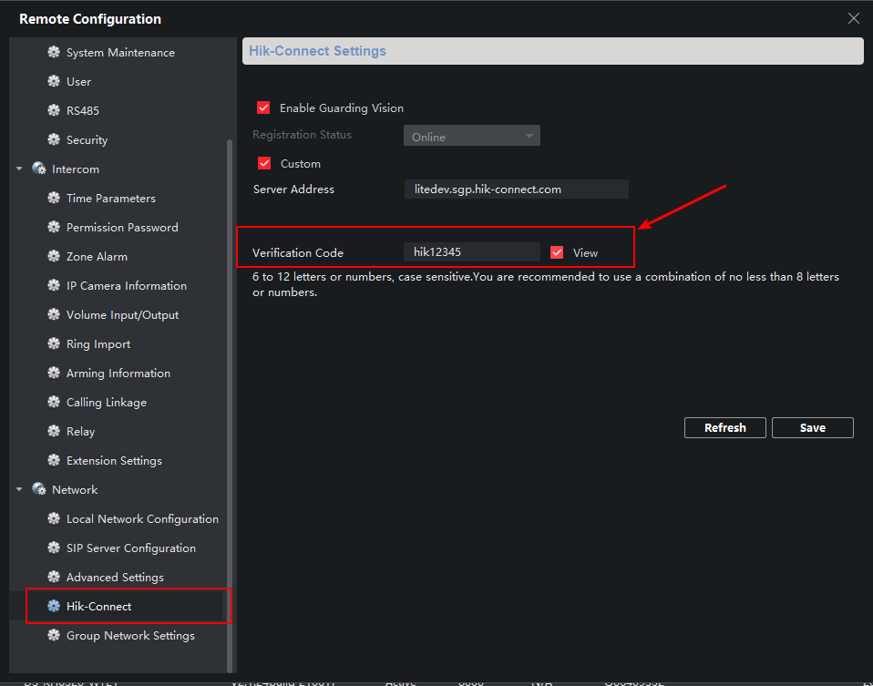

1. **设备本地端查看HC验证码**

在KH6320设备本地端界面查找，路径setting->advanced settings->hik-connect service settings，**可查找到验证码，该验证码支持自定义。**

Search in the local interface of the KH6320 device, path setting>advanced settings->hik-connect service settings, you can find the verification code, which supports customization.

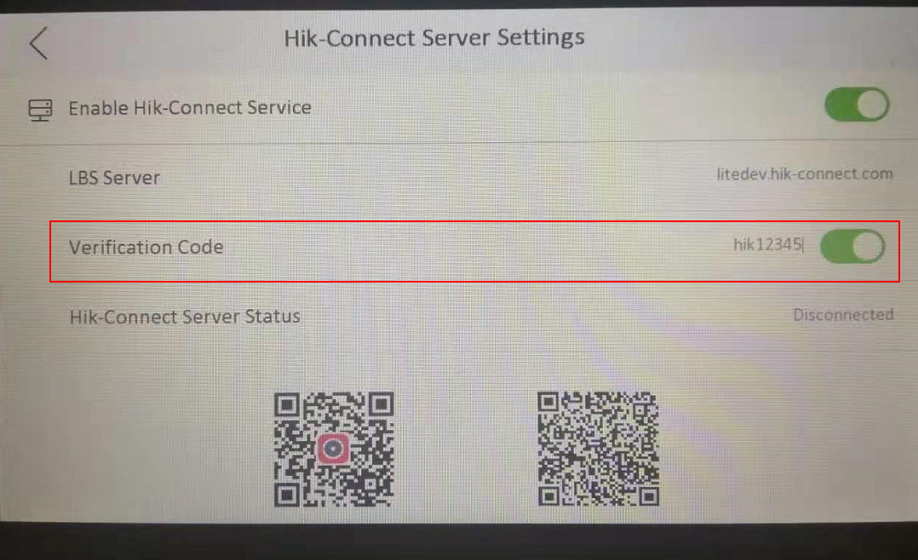

1. **其他门禁、报警设备如何查看验证码 How to check the verification code for other access control and alarm equipment**
2. 通过设备标签查看 View by device label

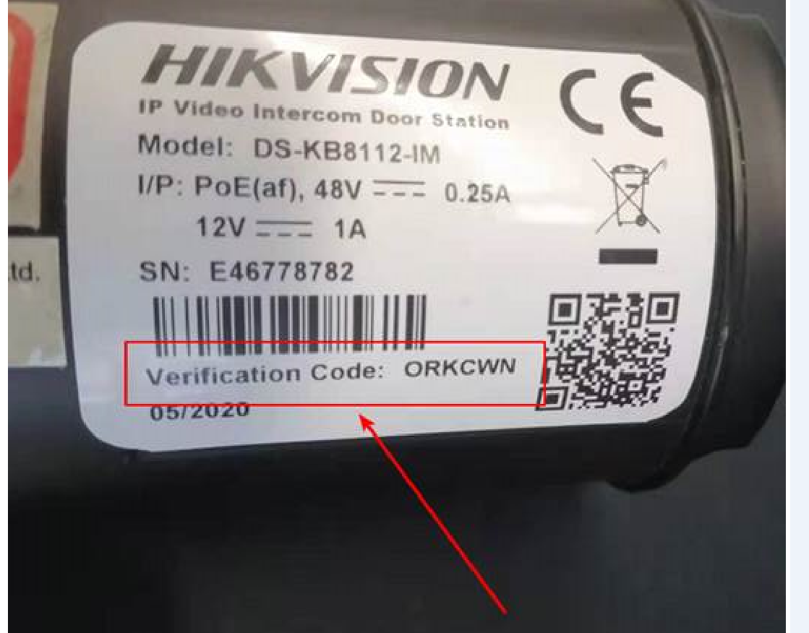

2、通过微信扫描标签二维码 Scan the QR code of the label via WeChat

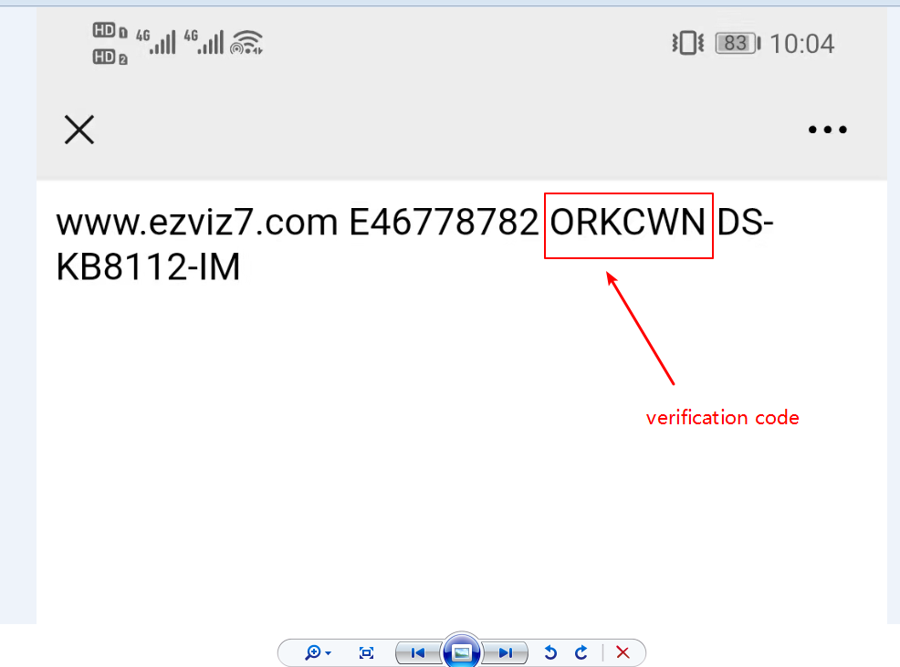

**备注：HC验证码有些设备是固定的，有些是可以再自定义的。最好的方法是在设备网页端或者远程配置端查找HC验证码。如果需要技术支持查找出厂验证码，需要提供序列号。**

**Note: Some devices of HC verification code are fixed, and some can be customized. The best way is to look up the HC verification code on the device web end or remote configuration end. If you need technical support to find the factory verification code, you need to provide the serial number.**