**How to connect the Lock (DS-K4E100)**

**to Access Controller (DS-K2604T)**

**How to connect the Lock (DS-K4E100) to Access Controller (DS-K2604T)**

1. **Take off the cover of the Lock (DS-K4E100)**

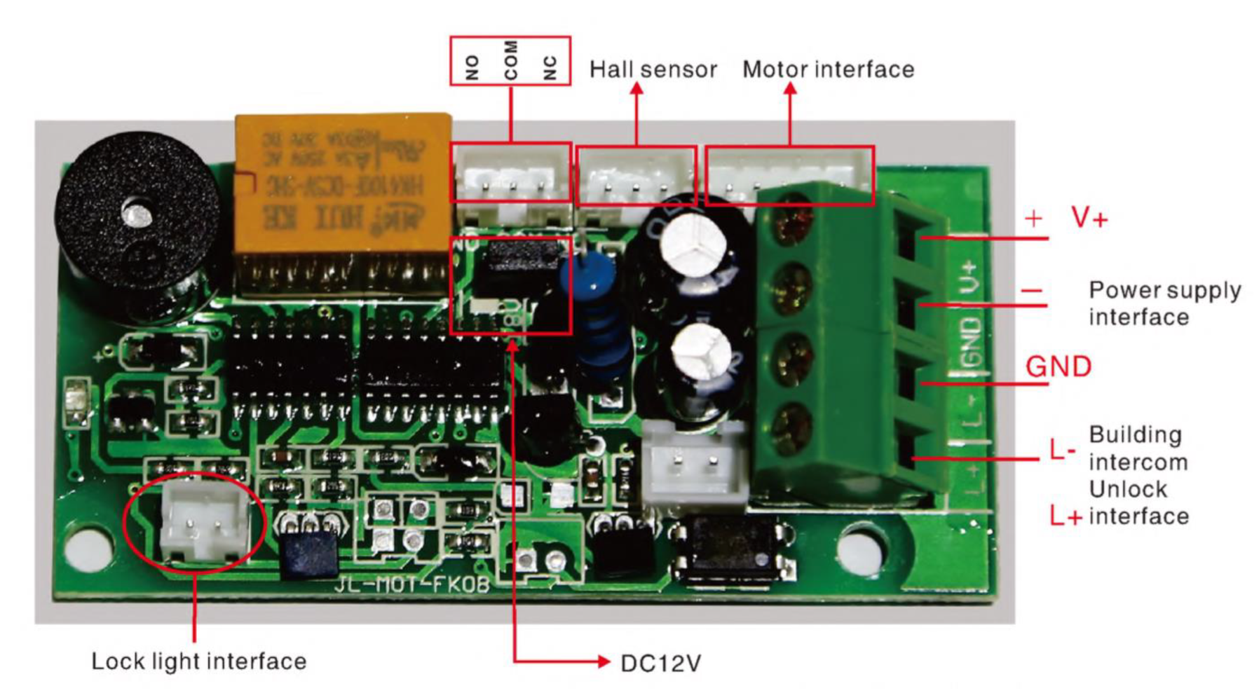

1. **Connect the lock to access controller**

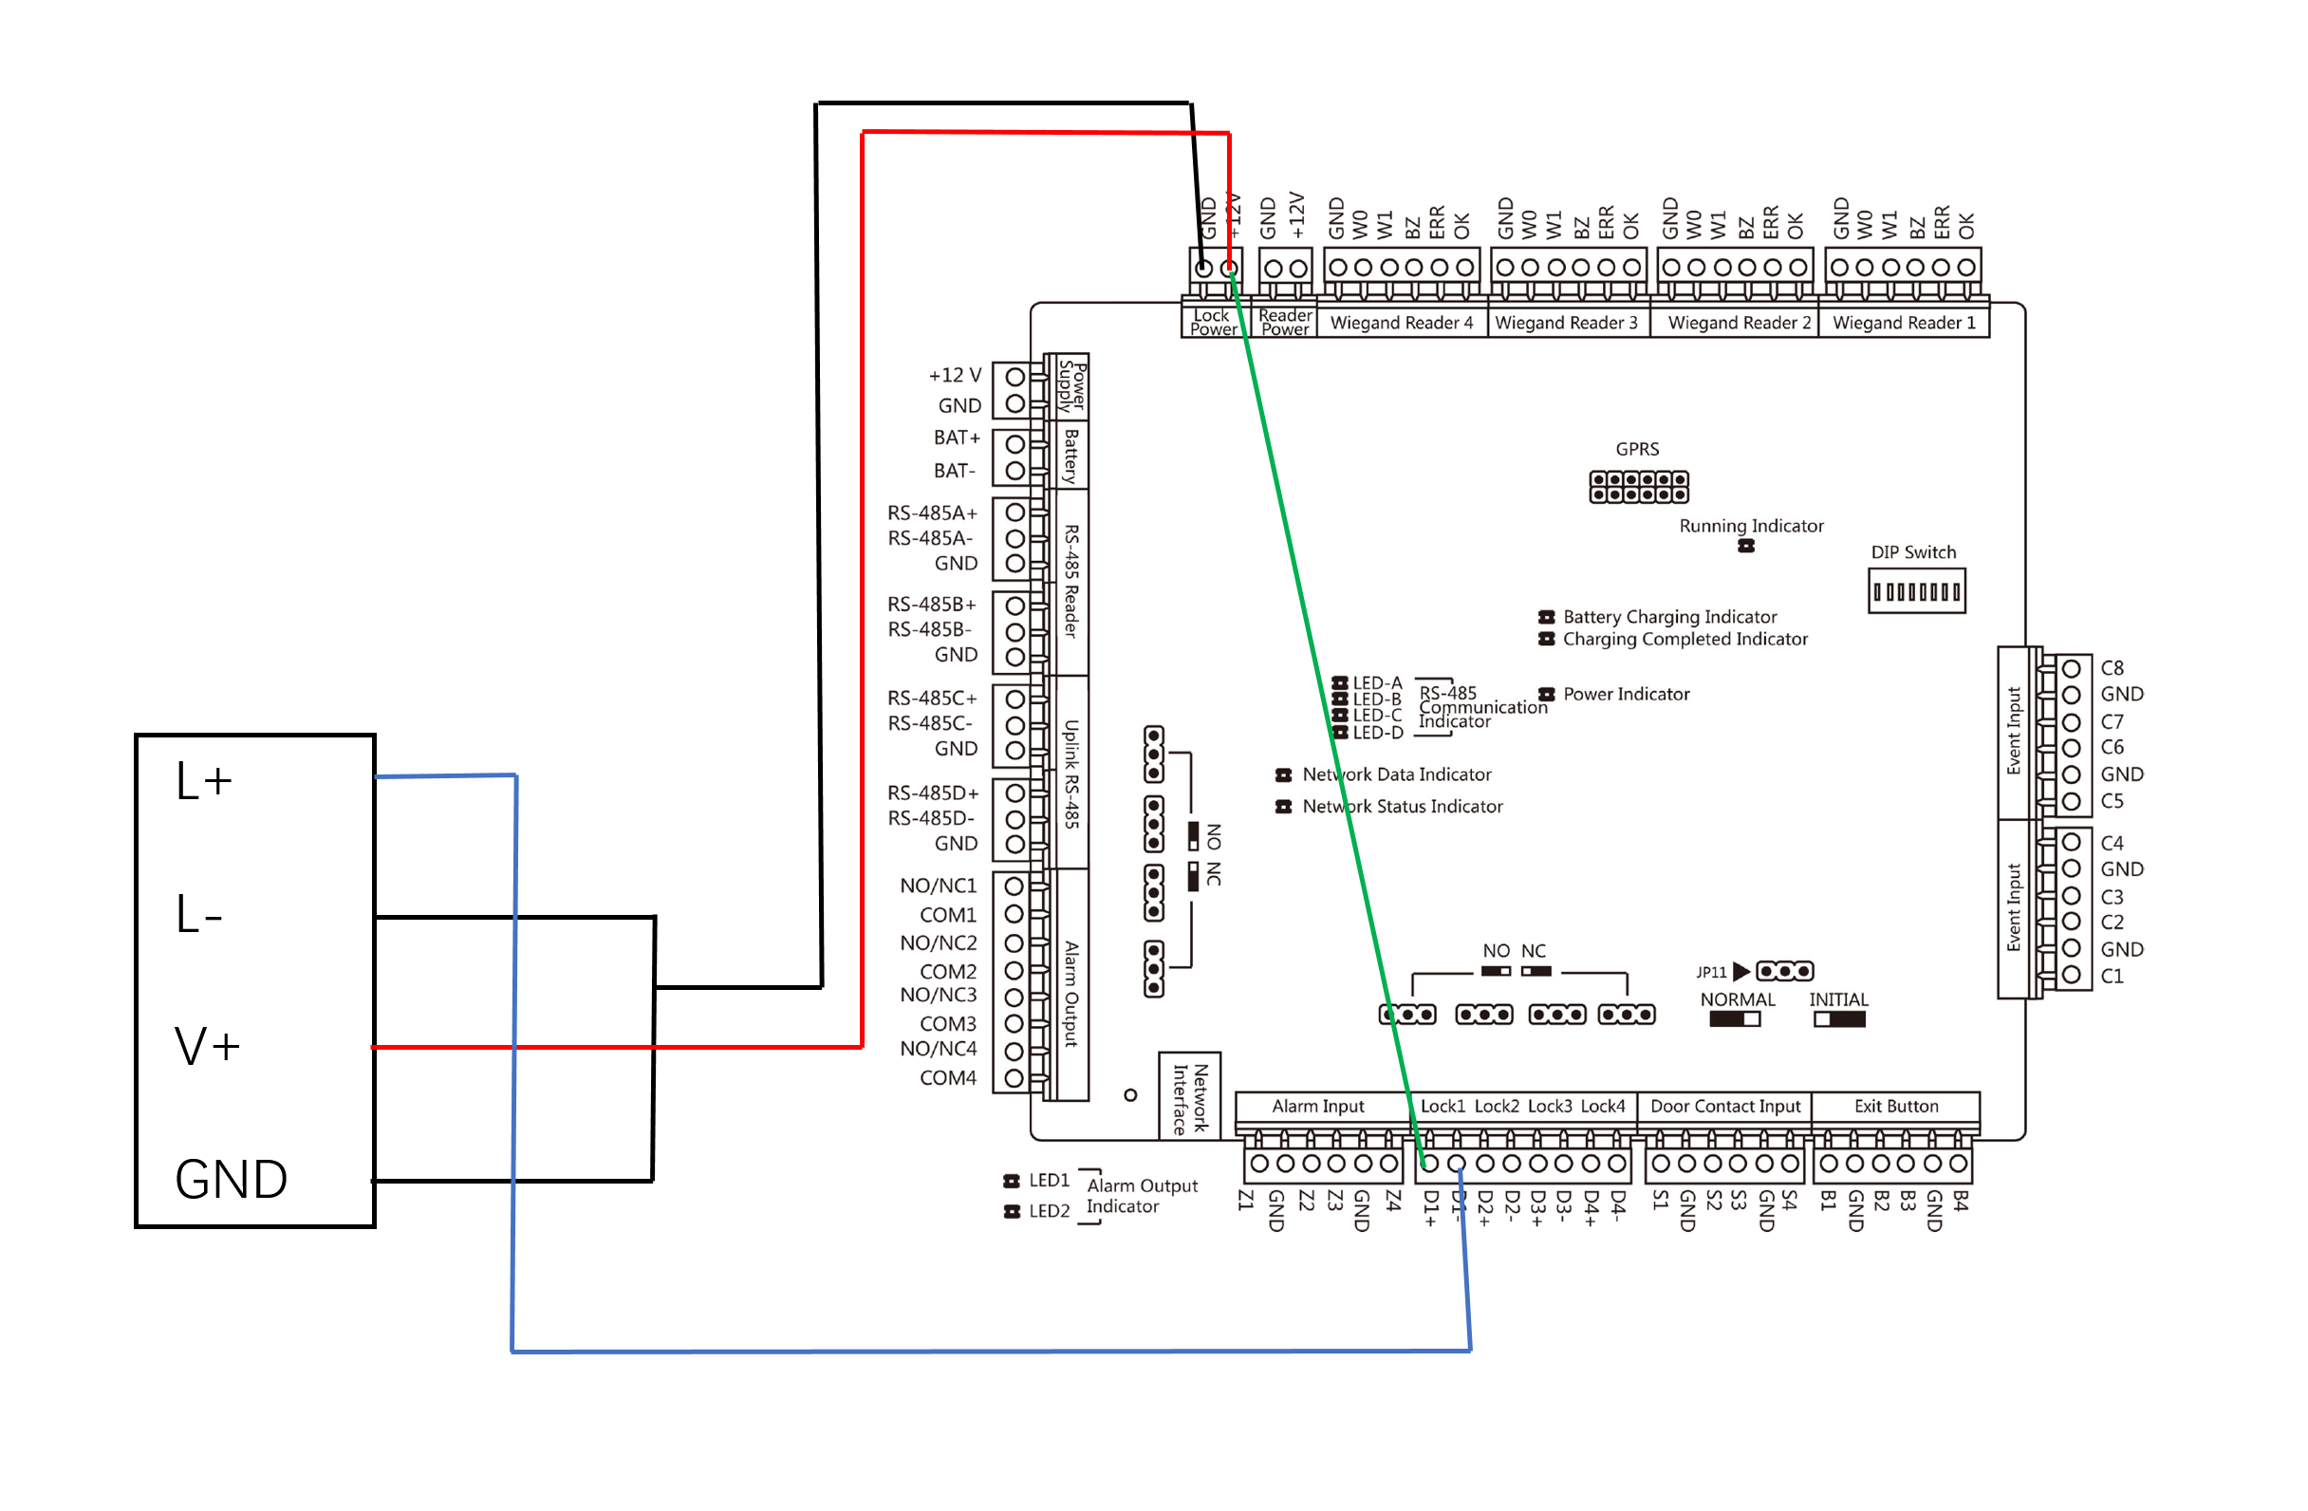

***Note:***

1) The power output power is recommended to be above 12V / 1A.

2) The DS-K4E100 is normally open (The Lock will unlock when L + / L- terminals powered), so K2600 Controller relay need configure to NO / COM output.