**如何配置明眸呼叫室内机\** **How to configure the face recognition terminal to call indoor station**

介绍：明眸设备配置呼叫室内机，本文以型号DS-K1T672MW 版本V3.2.30 build20210609作为例子。适用于其他明眸设备呼叫室内机。

**Introduction: the face recognition terminal is configured with a call indoor station. This article takes the model DS-K1T672MW version V3.2.30 build20210609 as an example. It is suitable for calling the indoor station of other the face recognition terminal.**

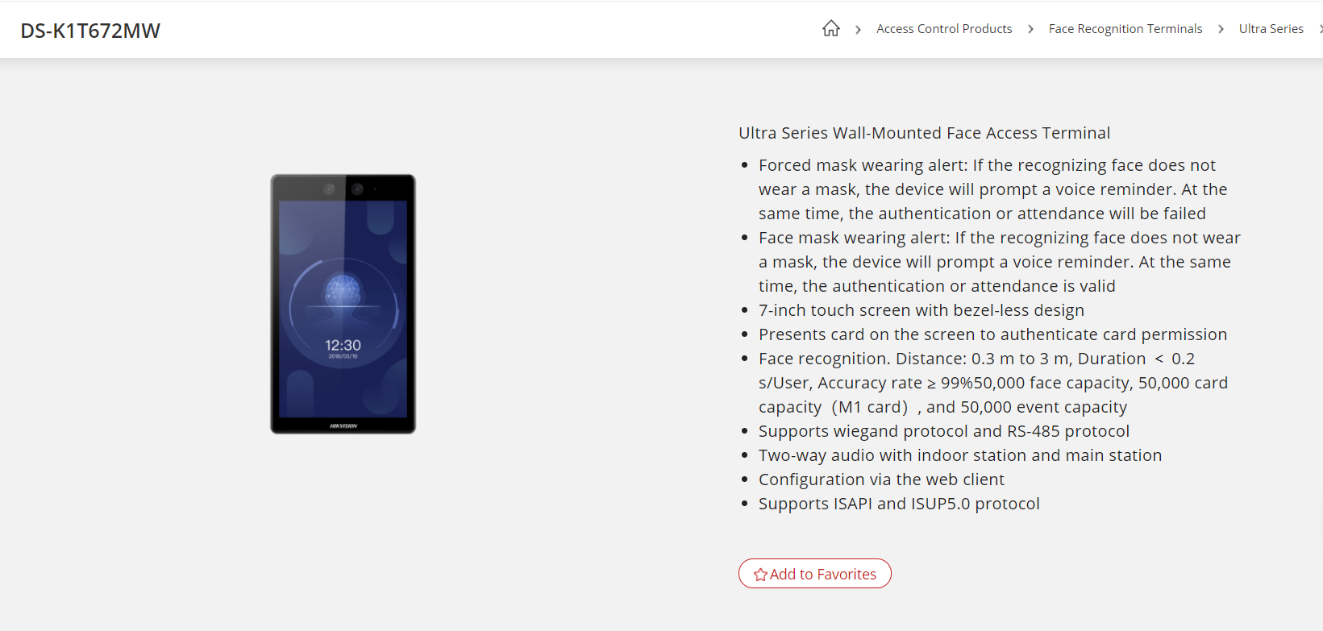

1. **明眸和室内机设置 the face recognition terminal and indoor station settings**

第一步：先登录web端将明眸设置为门口机类型，如下图。

Step 1: First, log in to the web terminal and set the face recognition as the door phone type, as shown below.

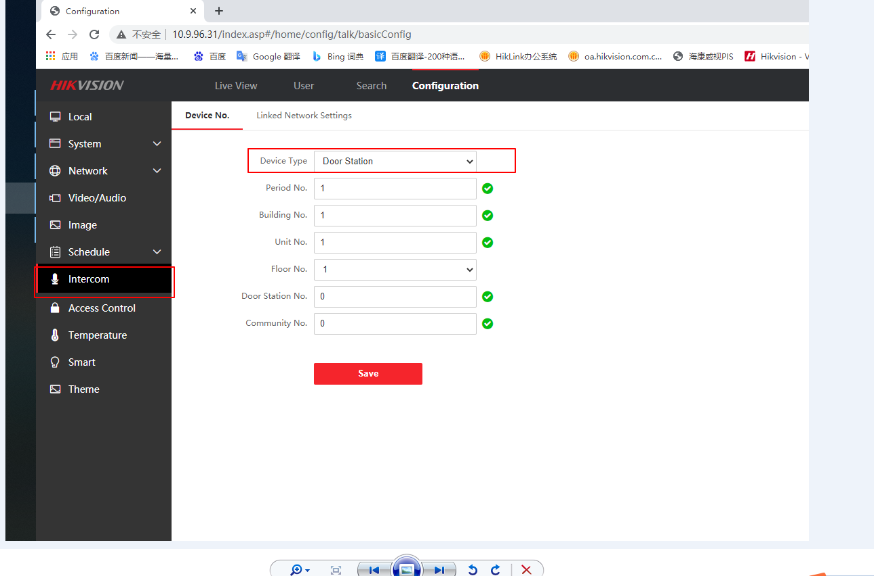

第二步：在明眸设备端将呼叫图标改成呼叫特定房间，路径如下图。

Step 2: Change the call icon to call a specific room on the face recognition terminal, and the path is as shown below.

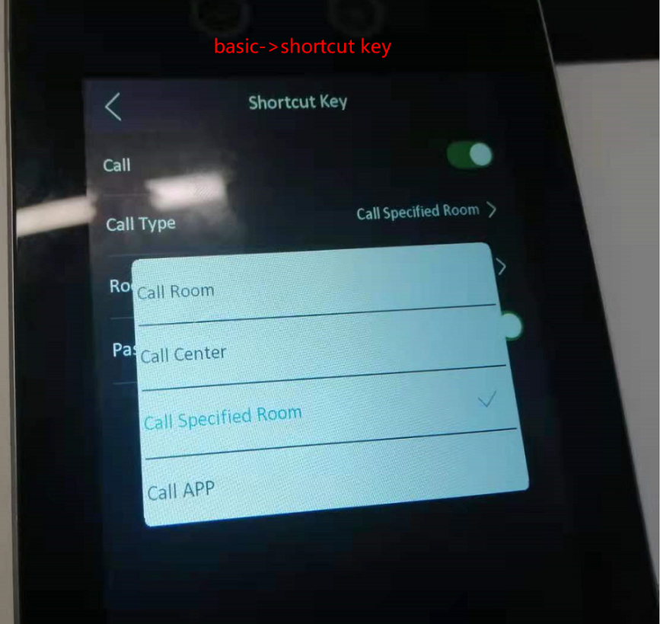

第三步： 室内机的设备管理界面下，填入门口机IP（即明眸IP），如下图。

Step 3: Under the device management interface of the indoor station, fill in the IP of the

Main door station (the IP of face recognition terminal), as shown below.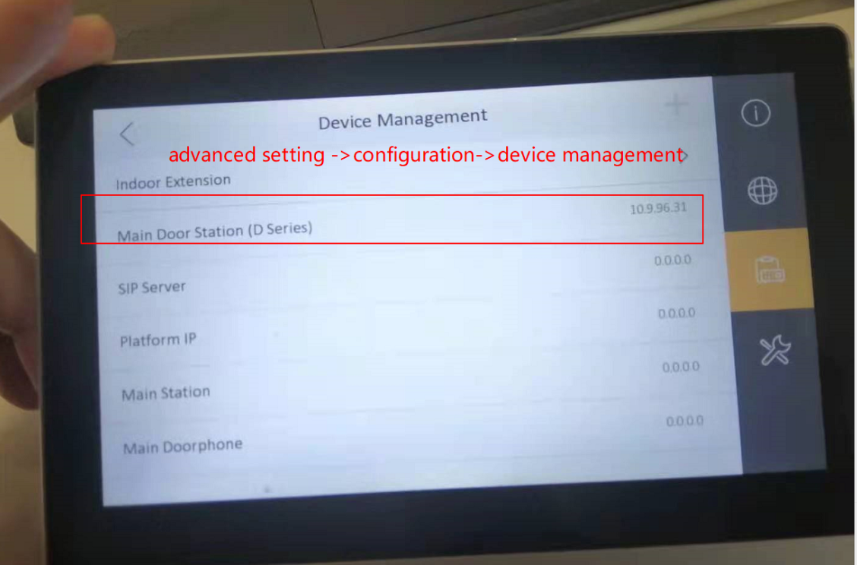

**二、呼叫 Calling**

在明眸端点击呼叫快捷键，即可实现明眸呼叫室内机，如下图。

Click the call shortcut key on the face recognition terminal to realize the face recognition terminal calling the indoor station, as shown below.