Preparation

- A door stations or a villa door station (DS-KV6113 in this document);
- Client software iVMS-4200 (V3.6.1.5 bulid20210831 in this document).
- Card issuer DS-K1F100

Step 1: Add Devices to iVMS-4200
Click Online Device tab to find device and then add the device to iVMS-4200

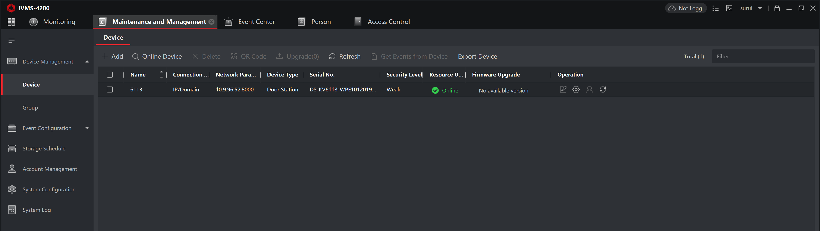

Step 2: Set the door station in iVMS-4200
Choose the door station, click Remote Configuration, Then go to Intercom > Access Control and Elevator Control , click enable Card Encryption Pararmeters, and click Save.

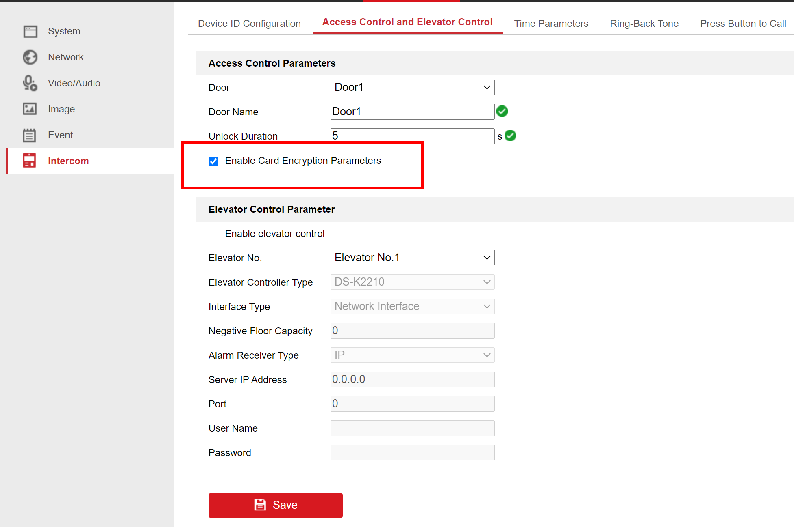

Step 3: Encrypt cards in iVMS-4200

- Add person

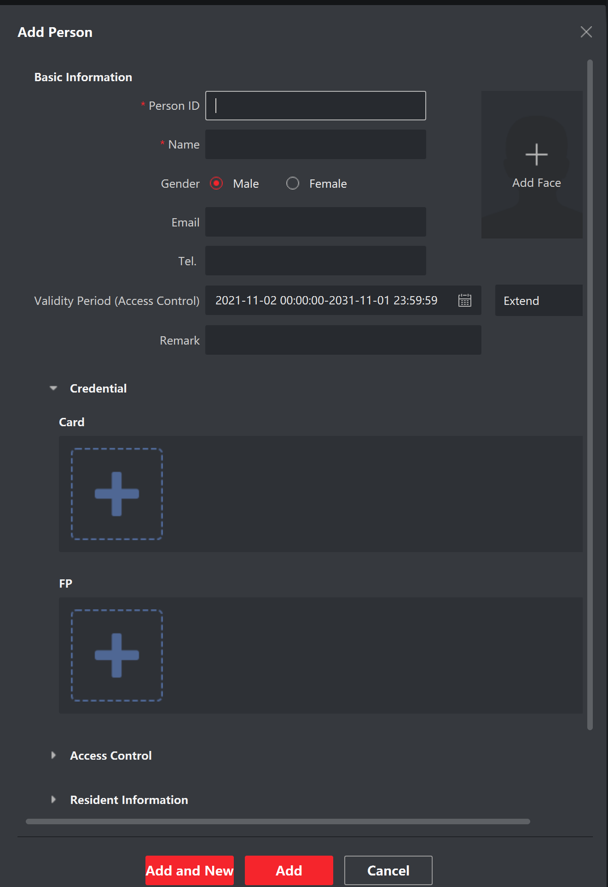

- Click item “card”

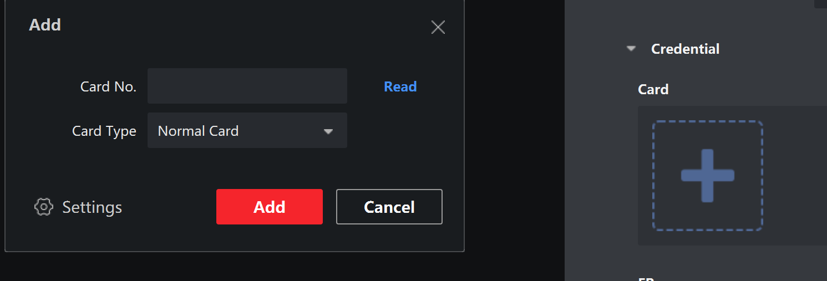

- Click “Settings” to set the cards

Open the M1 Card Encryption, and select the Sector 1, then click OK

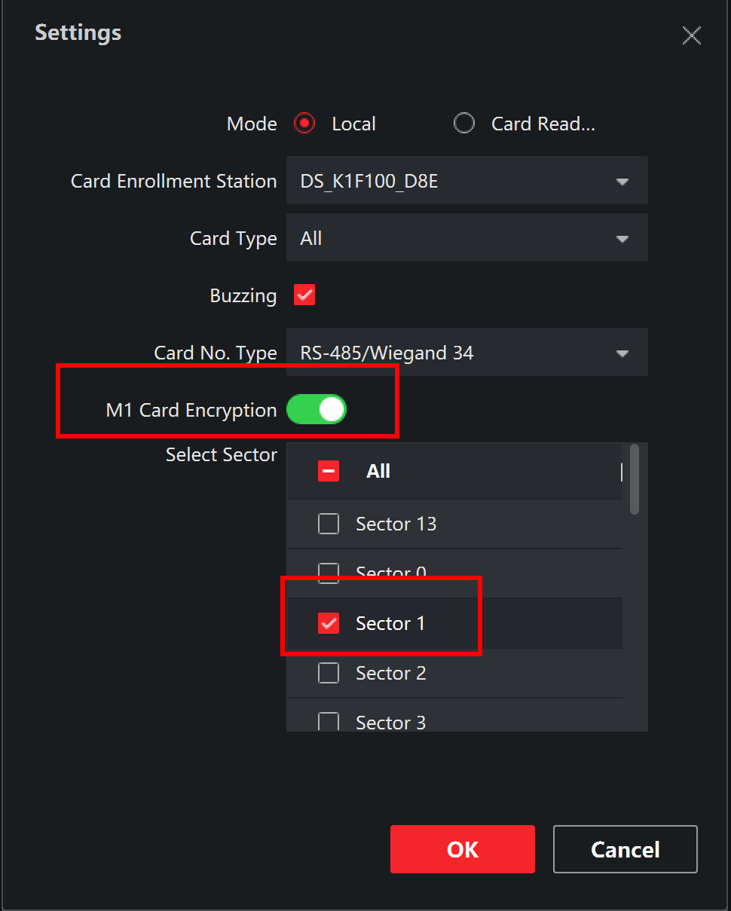

Put the card on the issuer, and click Read to get the card’s number, then click Add

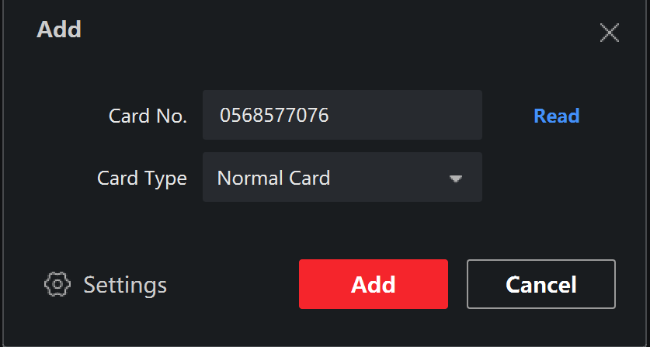

And put the information in Resident Information

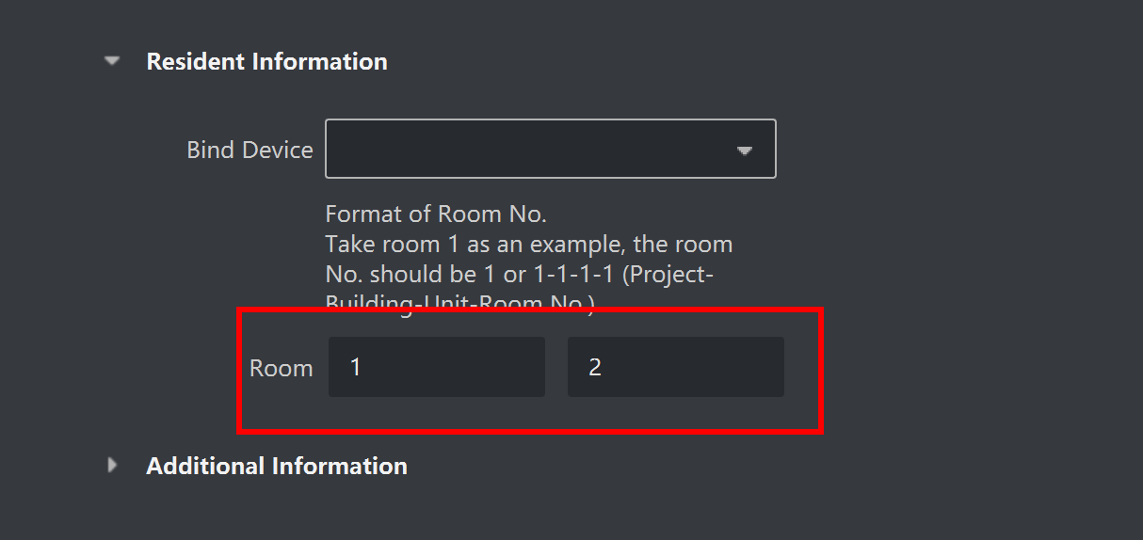

Step 4: Issue cards to door station
Choose Access Control > Authorization > Access Group > Add , to add a new access group and save it ,then apply to the device .

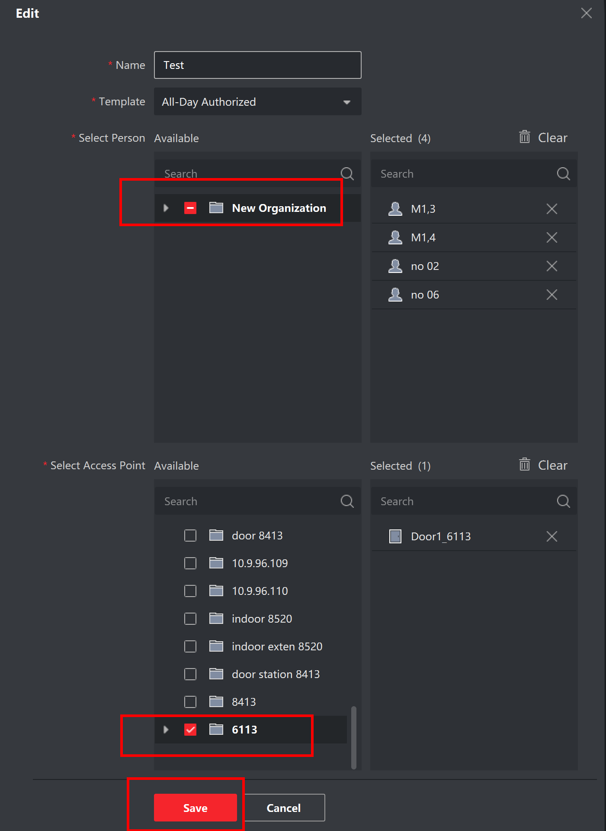

First Choice for Security Professionals
HIKVISION Technical Support

