**How to Configure DS-K1T502 as Main and Sub Door Station on Web Page**

DS-K1T502DBFWX-C * 2

沙木 Sam

**Applicable to**

1. Pro Fingerprint Terminal ：DS-K1T502DBFWX-C *2

**How to Configure DS-K1T502 as Main and Sub Door Station on Its Web Page**

**Key Step 1: Configure one of the DS-K1T502DBFWX-C terminal as sub door station.**

1. Please log in to one of the DS-K1T502DBFWX-C’s web page
2. Please configure this DS-K1T502DBFWX-C as a sub door station terminal (For the convenience of distinguishing, use **A** to represent this terminal), follow these steps:
   1. Please go to **Configuration→ Intercom → Device No. → Door Station No** change to number **1 (Means terminal A Configured as a sub door station)**

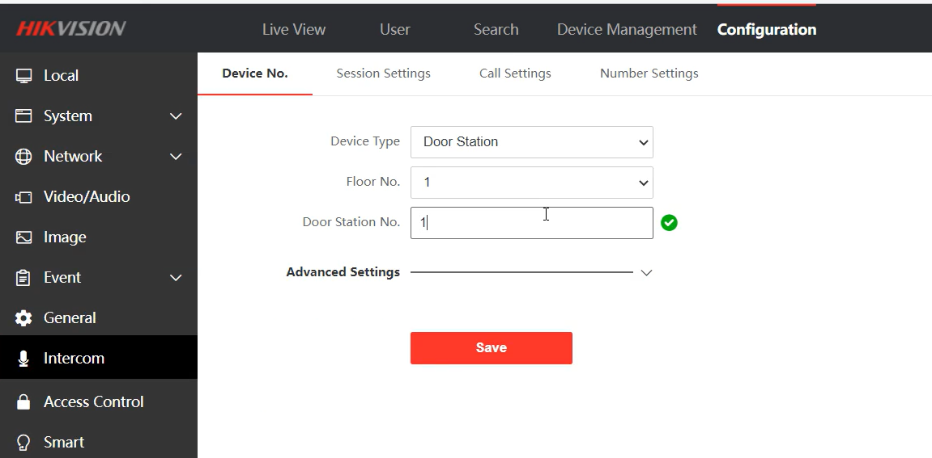

Picture 1

* 1. Shows **Rebooting** after click **Save**, and then automatically exit the device’s web page by itself.

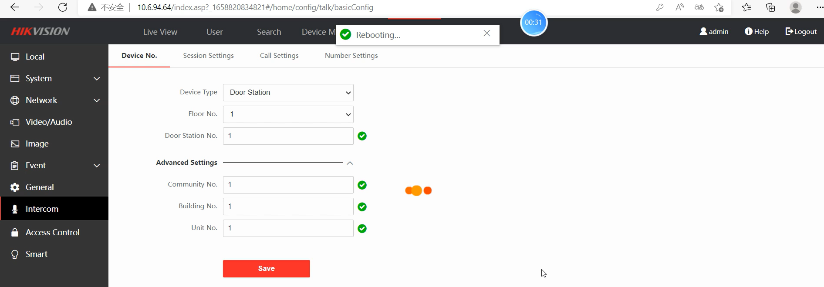

Picture 2

* 1. Then please login to terminal A’s web page again, shows there is no **Device management** bar, means terminal A already configured as a sub door station.

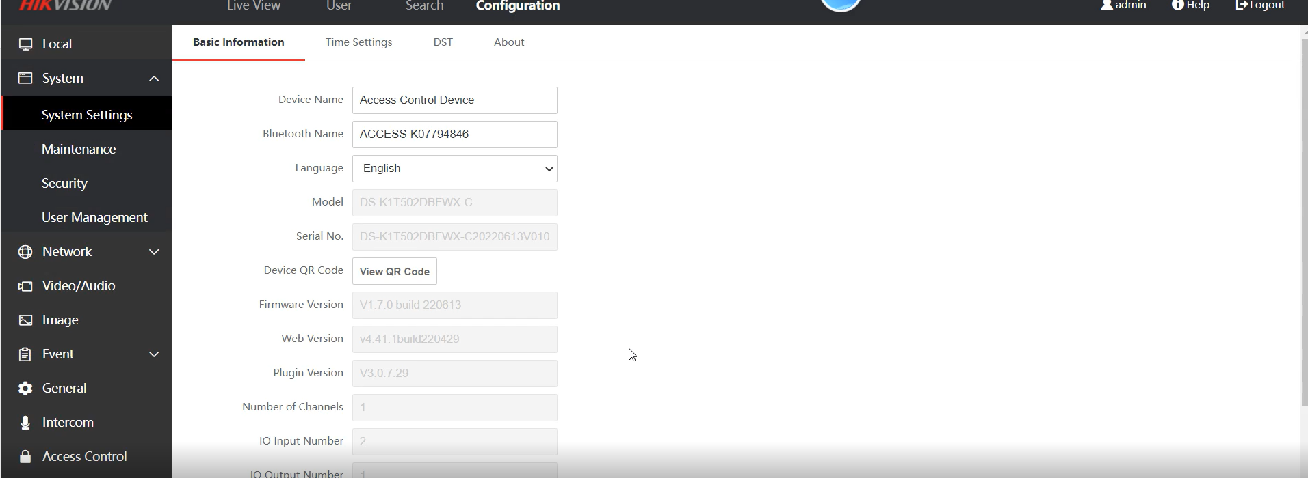

Picture 3

1. Please register the main door station DS-K1T502DBFWX-C terminal (For the convenience of distinguishing, use **B** to represent this terminal) to terminal A sub door station terminal, follow these steps:
   1. Please go to the **Configuration→ Intercom → Session Settings,** fill in the main door’s **Registration Password** and **Main door station IP (**terminal A’s**) →** Click **Save →** will shows **Save Succeeded**

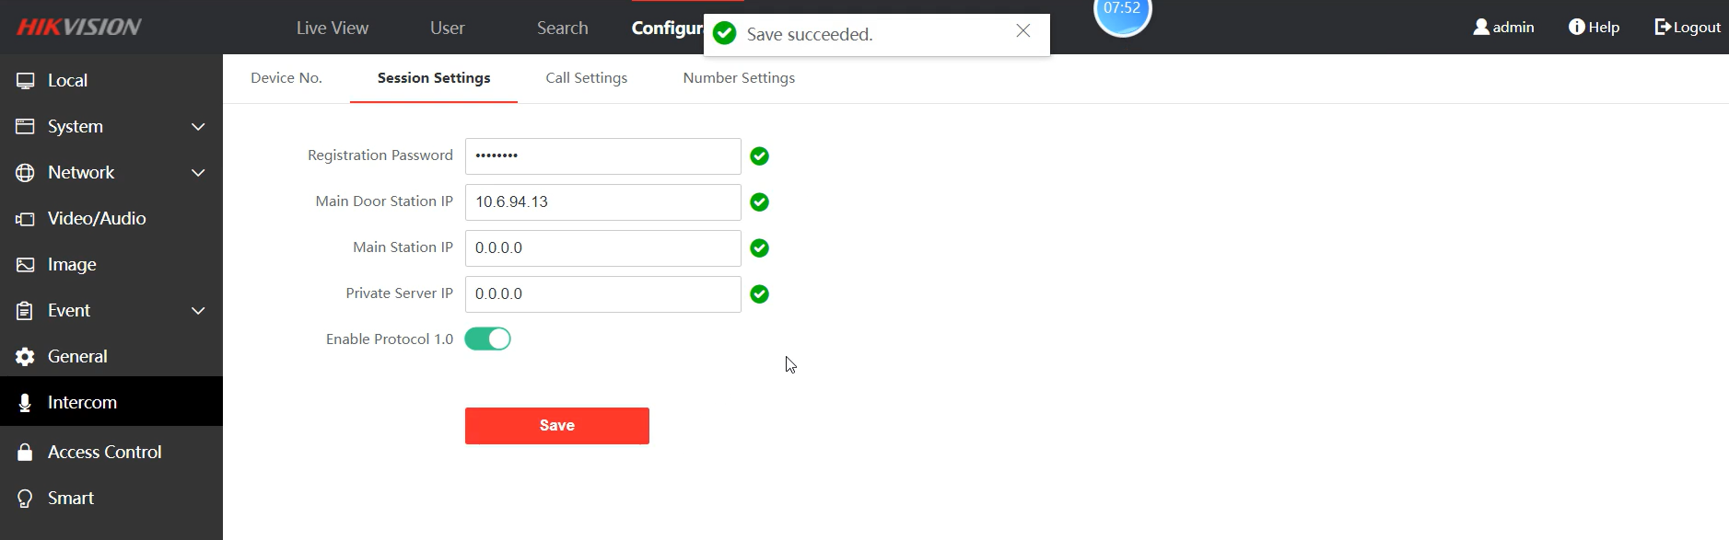

Picture 4

**Key Step 2: Register sub door station terminal to the main door station terminal**

1. Please log in to the terminal B’s web page
2. Please configure terminal B as a main door station terminal, follow these steps:
   1. Please go to **Configuration→ Intercom → Device No. → Door Station No →** keep it to default number **0 (Means this terminal Configured as main door station terminal)**

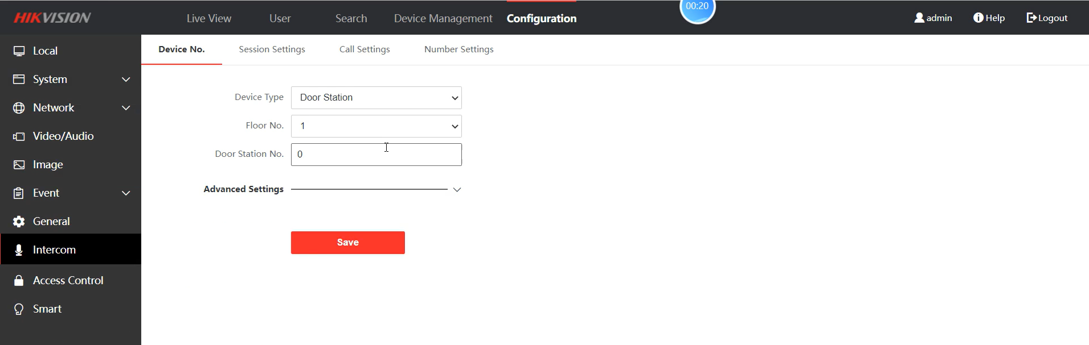

Picture 5

1. Please register sub door station terminal A to the main door station terminal B, follow these steps:
   1. Please go the **Device Management → Device List → Click Add Icon**

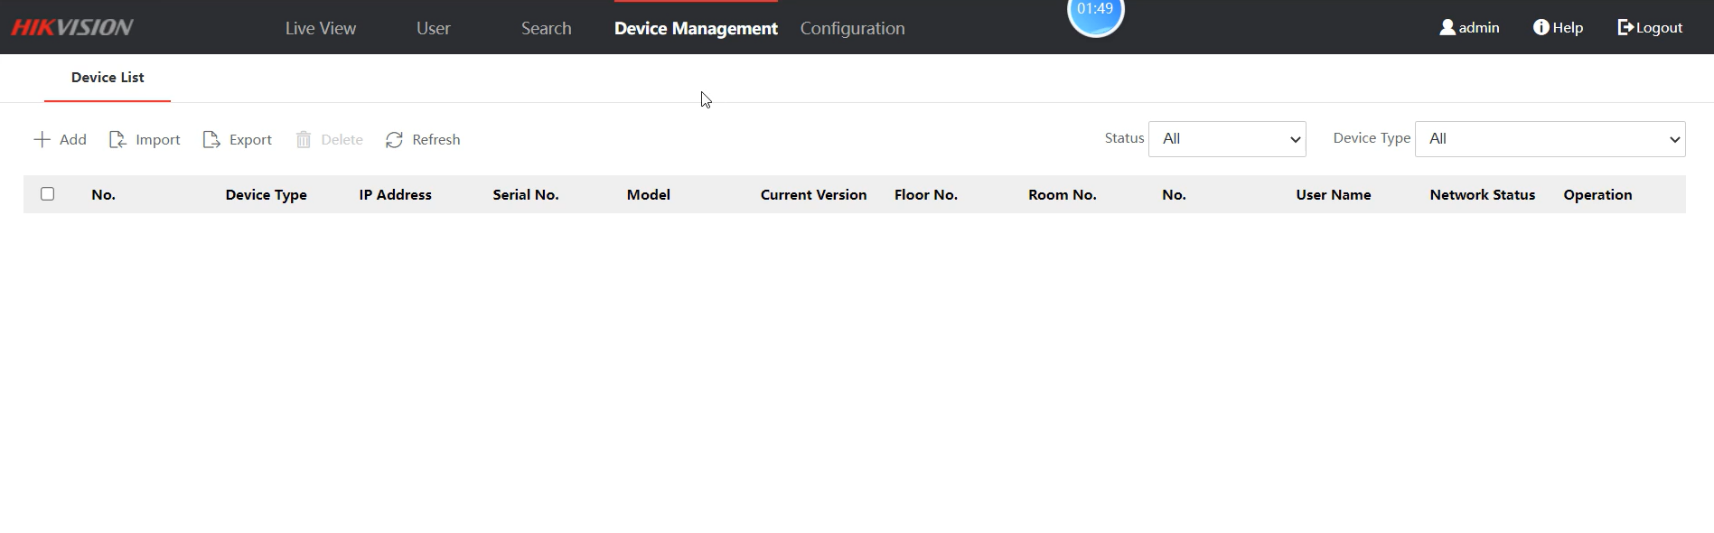

Picture 6

* 1. Please fill in the corresponding sub door station terminal B’s information to the **Edit Device** Pop-ups page, and please remember that the **Device Type** have to be selected as **Sub Door Station**.

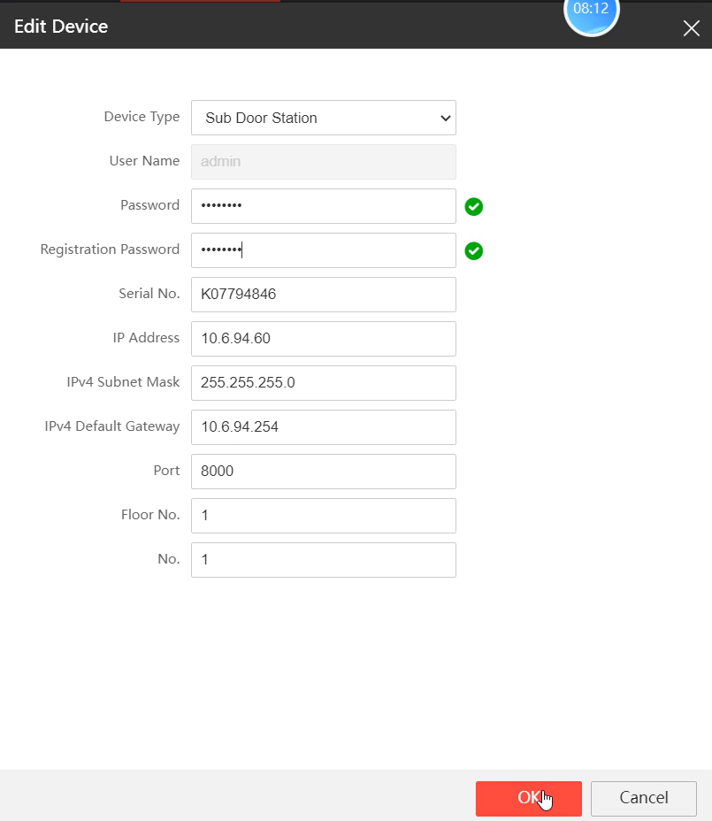

Picture 7

* 1. Check the sub door station’s **Network Status** is **Online** or **Offline**, if the Network Status shows **Online** means registration succeeded.

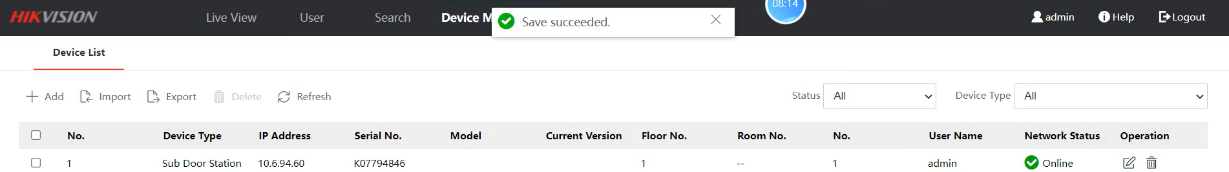

Picture 8

