**如何配置明眸呼叫Hik-Connect\** **How to configure the face recongnition terminal to call Hik-Connect**

介绍：基于有HC功能的明眸设备配置能呼叫手机HC APP，本文以型号DS-K1T642MW 版本V3.2.30 build20210609作为例子。适用于其他明眸支持呼叫HC功能的设备。

**Introduction: Based on the HC function of** **the face recongnition terminal call the mobile HC APP, this article uses the model DS-K1T642MW version V3.2.30 build20210609 as an example. Applicable to other devices that support calling HC function.**

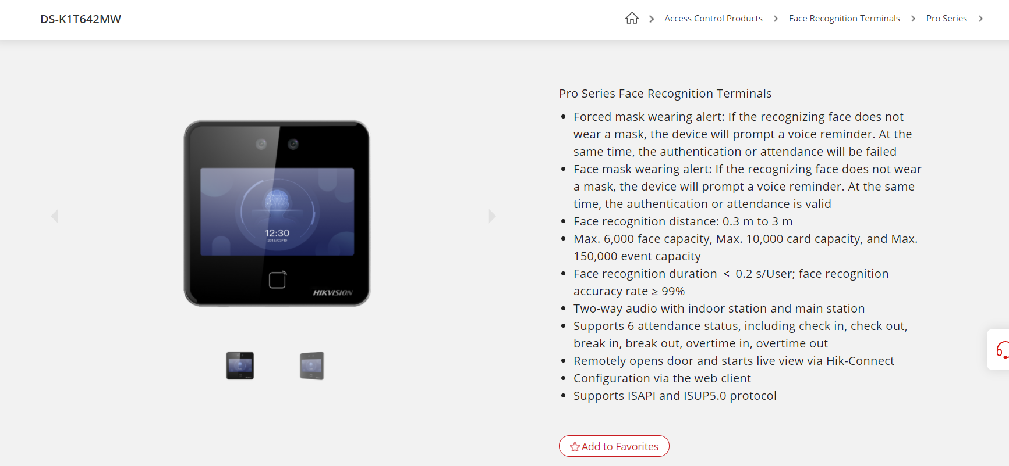

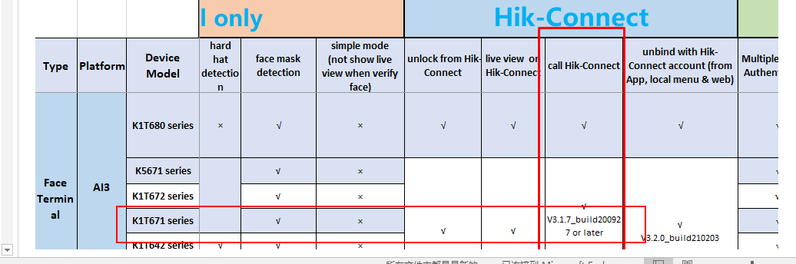

1. **明眸端设置 the face recongnition terminal settings**

第一步：首先需要把设备连接上萤石云，进入设备web端配置使能萤石云，如下图。

Step 1: First, you need to connect the device to EZVIZ Cloud, and enter the device web configuration to enable EZVIZ Cloud. As shown below.

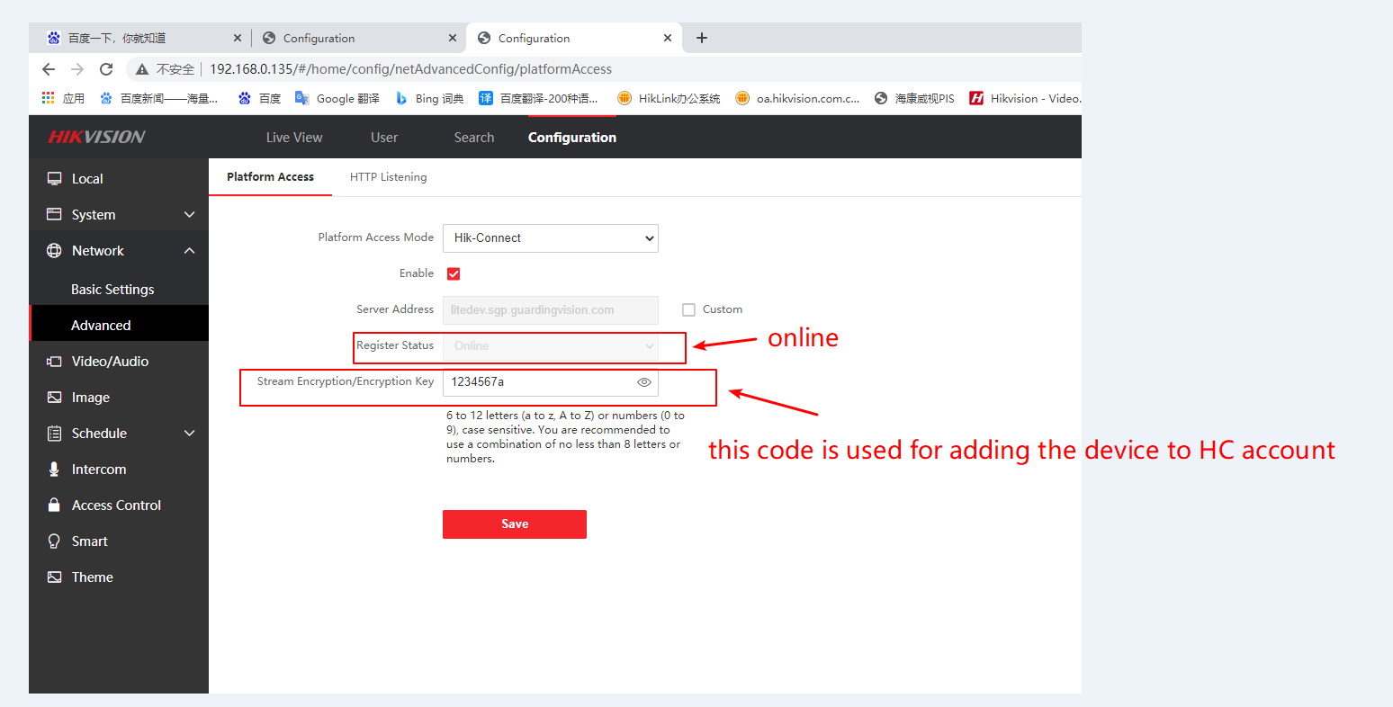

Tips：记住上图萤石云设备验证码，用于后面HC添加设备用。

Tips: Remember the verification code of the EZVIZ Cloud device in the picture above, which is used to add devices to the HC later.

第二步：检查设备是否连接上萤石云，如下图查看萤石云标志，或者看web端萤石云是否注册成功。

Step 2: Check if the device is connected to the EZVIZ Cloud, check the EZVIZ Cloud logo as shown below, or check whether the EZVIZ Cloud on the web is register status online.

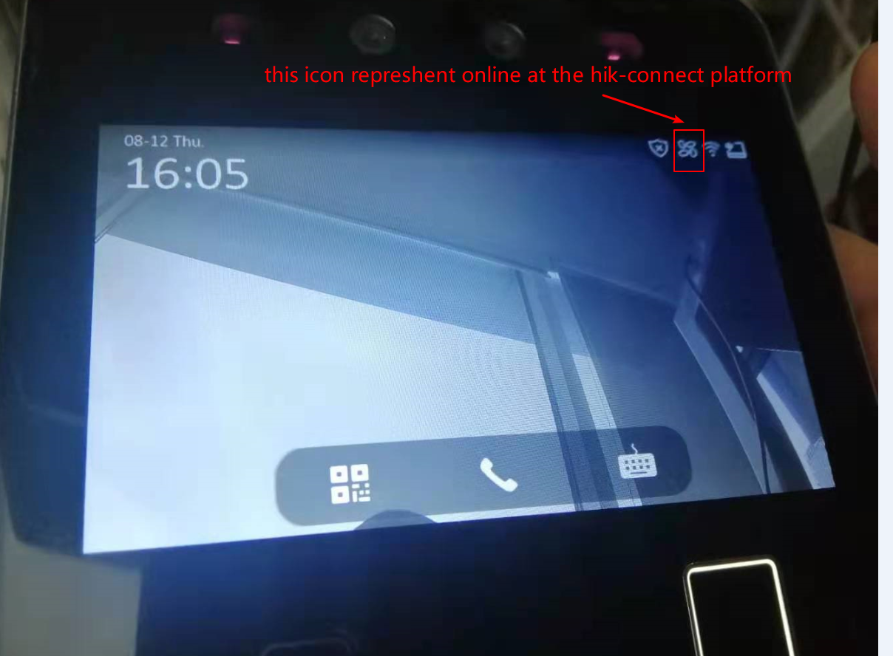

第三步：设备端使能call, 将Call type设置为CALL app.

Step 3: Enable call on the device side and set the Call type to CALL app.

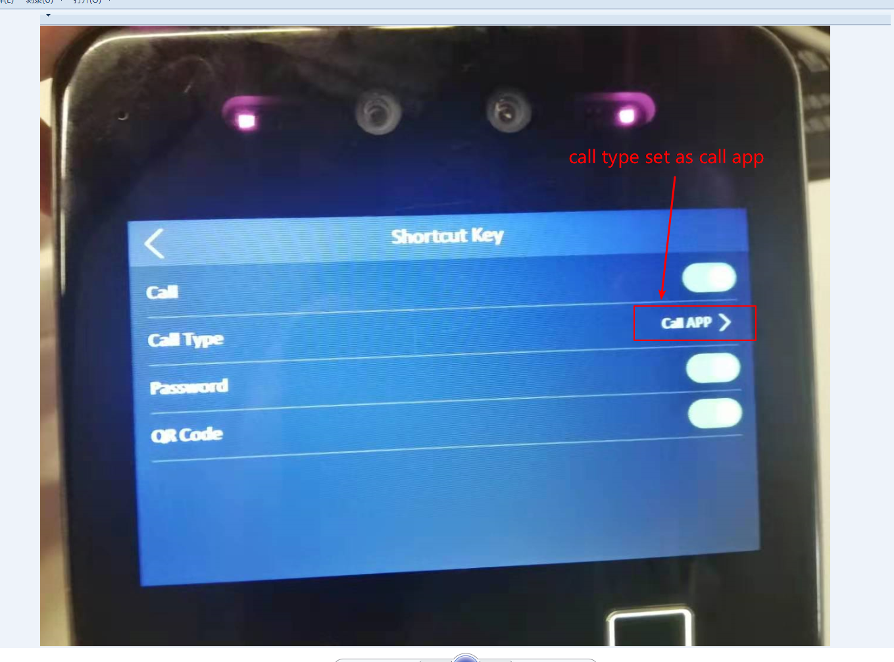

**二、手机端设置 Mobile settings**

第一步：首先打开HC账号，扫描设备二维码，进行设备添加，如下图。

Step 1: Open the HC account first, scan the QR code of the device, and add the device， As shown below.

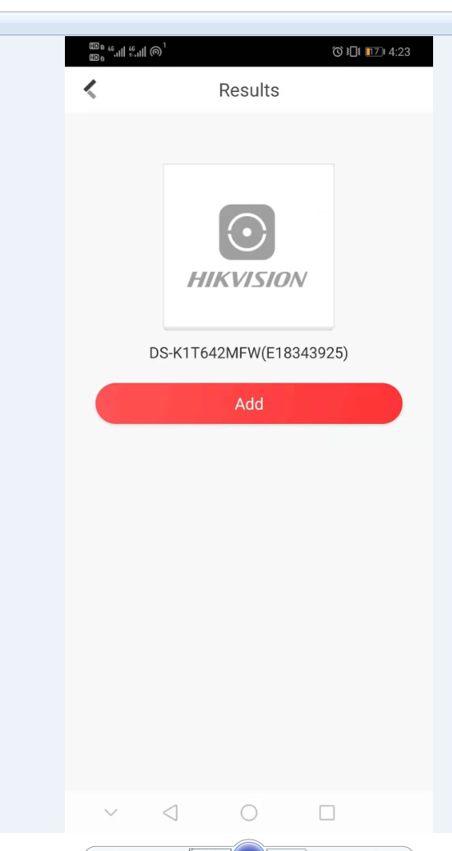

第二步：添加设备时，需要萤石云验证码，这个可以在设备web上查看，如果自定义没有改过，标签会有写验证码，输入即可。

Step 2: When adding a device, you need a EZVIZ cloud verification code. This can be viewed on the device web. If the customization has not been changed, the label will have a verification code written, just enter it.

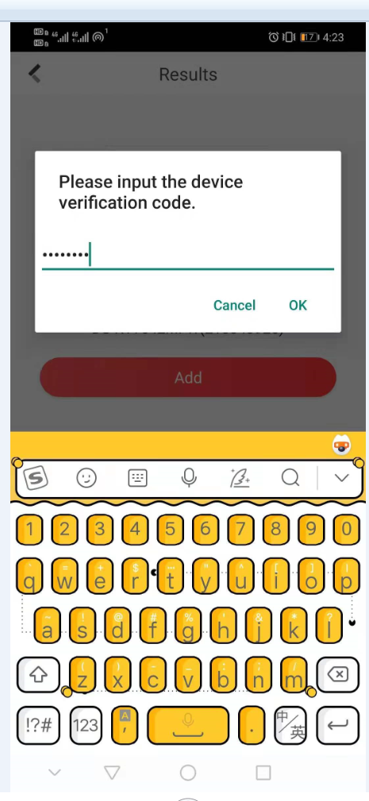

第三步：设备添加成功，并且实现呼叫。

Step 3: The device is added successfully and the call is realized.

