**How to upgrade firmware and change IP for display screening**

Applicable to

**Device:** E&E Screening (Multi-language control panel)

**Configuration Tool:** LED Test Tool V2.01C

**Change IP for display screening**

1. Click Search, search control panel

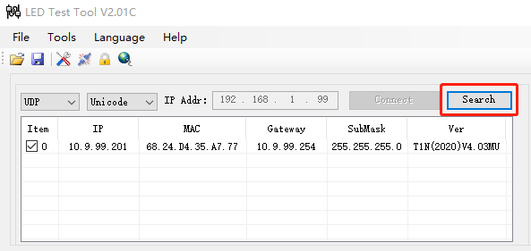

1. After search control panel success, go to Config, find Network parameters interface, input the IP information you allot for the screening

**IP Addr:** you allot for screening

**Subnet Mask:** you allot for screening

**Gateway:** you allot for screening

**MAC Addr:** same with the MAC of screening information you search out

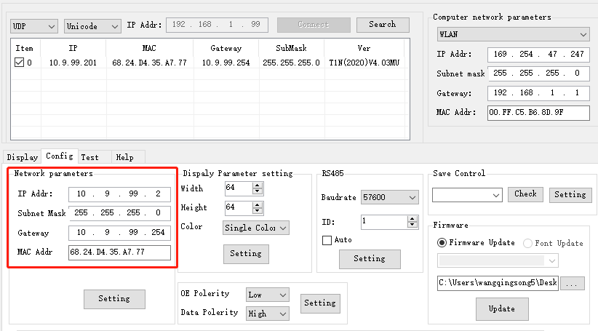

After input all the parameters, click  to set IP and MAC information into screening

**Upgrade firmware for display screening**

1. After search control panel success, go to Config, select Firmware Update, click  to select firmware file, then click  to update firmware

