- Do Not reboot the device after importing the model file. Reboot the device after upgrading the upgrade firmware file.
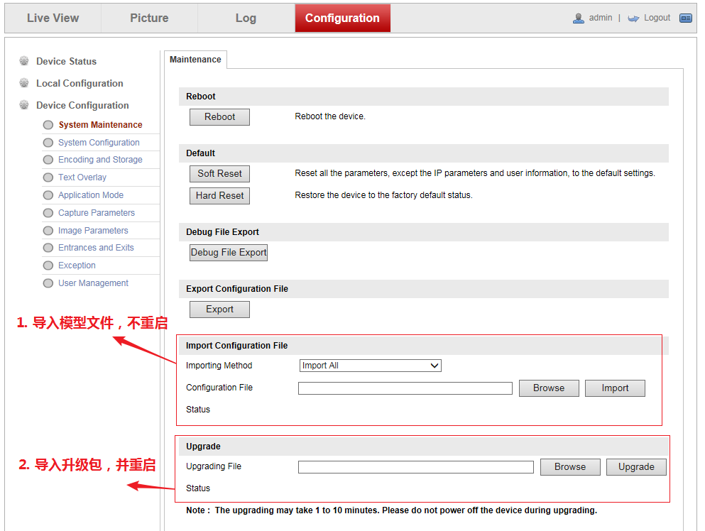
- Import and upgrade the firmware, then reboot the device
- Import model file, do not reboot the device

- Configure DYNDNS
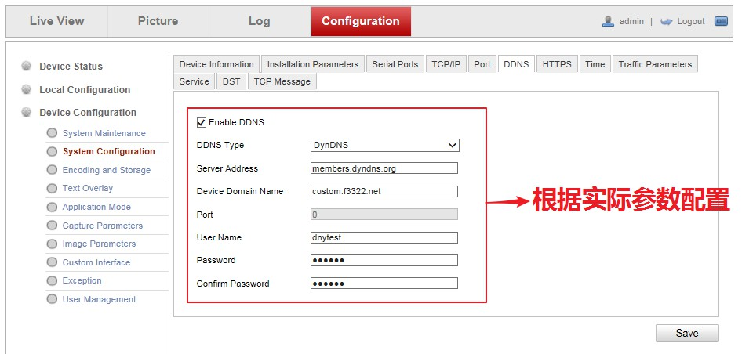
Configure according to actual parameters
Note: Turning on and off DDNS requires Rebooting the device

Model file: ALG_V2.2.0_200604
Firmware file: DZP20210203131_tcm403_a_EN_STD_4.2.5_210204

