

**User Manual of Density Control Solution via People Counting Camera Alone**

**People Counting Camera Configuration**

1. **Product Model**
2. DS-2CD6825G0/C-I(V)(S)
3. **Product Firmware**
4. PJ14PC20200402001_IPCDC_H7_EN_STD_5.5.90_200430
5. **Configuration**
6. Login to the camera web page->Upgrade with the customized firmware. After upgraded, be sure to restore the camera settings.
7. Go to VCA->People Counting->Data Uploading, be sure to turn on real-time upload data.

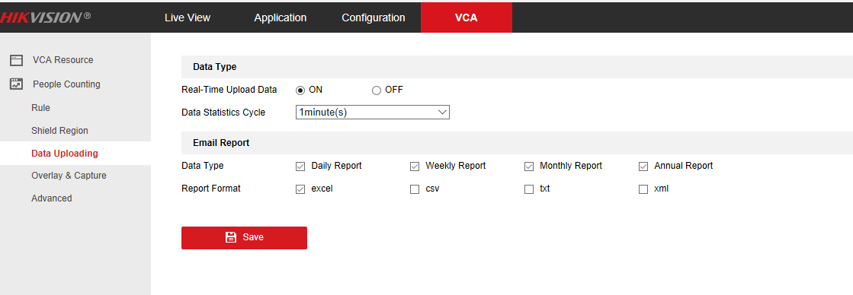

1. Click “Rule” tab to enable People Counting and set up counting rule on the image. Refer to the picture below.
2. Enable privacy to make the live view image black on the monitor.
3. Set up people threshold which is the maximum number of people available.

Note: When the threshold is reached, the alarm output and audio will be triggered automatically till the number of people stayed is below the threshold.

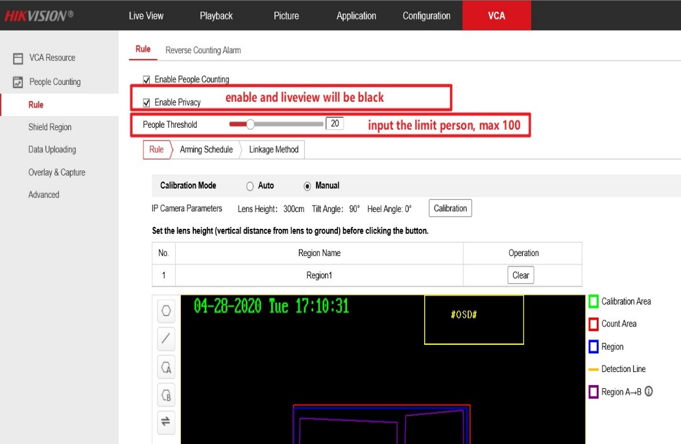

1. Go to Configuration->Image->OSD Settings to define the flow control contents on image
2. Under Text Overlay filed, input the description to be shown on the monitor. Refer to the picture below.

**Field 1: the content will be displayed when the threshold is not reached**

**Field 2: the content will be displayed when the threshold is reached**

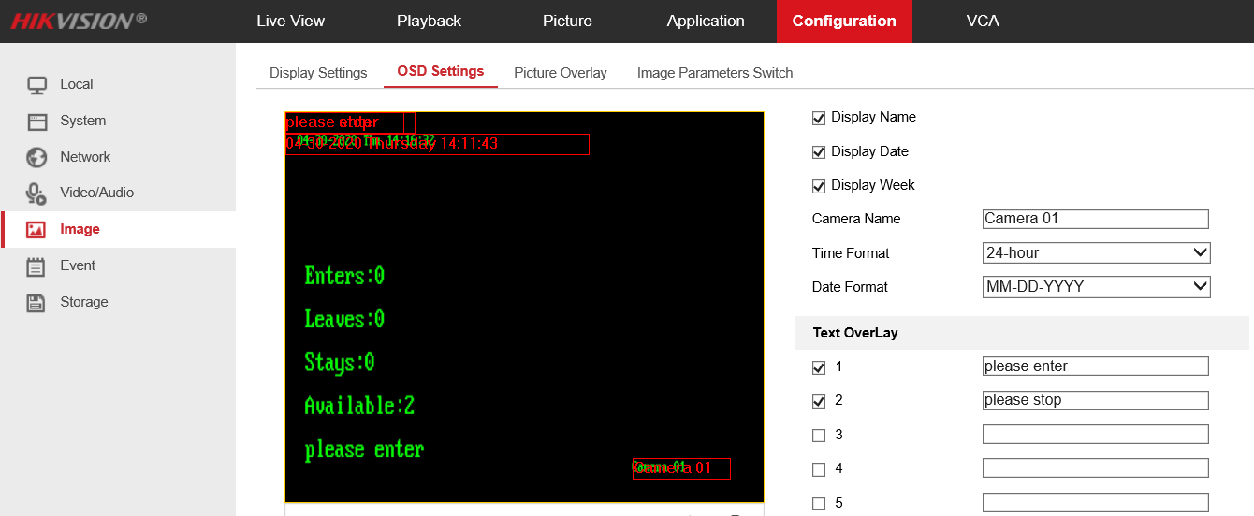

1. (Optional) Upload audio file if you don’t want to use the default audio content “*Please stop entering*”.

Note: please make sure the audio file meets these standards on the screen.

