

**User Manual of Density Control Solution via People Counting Camera and NVR**

**Configuration on People Counting Camera and NVR**

1. **Product Model**
2. iDS-2CD6810F-IV/C
3. DS-2CD6825G0/C-I(V)(S)
4. iDS-2CD7xx6G0-IZS
5. Any I series NVR
6. **Product Firmware**
7. Camera: baseline version
8. NVR: DZ_K51_ML_STD_V4.21.005_200429
9. **Configuration**
10. Login to the camera web page->Go to VCA->People Counting->Rule to define people counting rule and linkage method. Be sure to turn on “real-time upload data”.

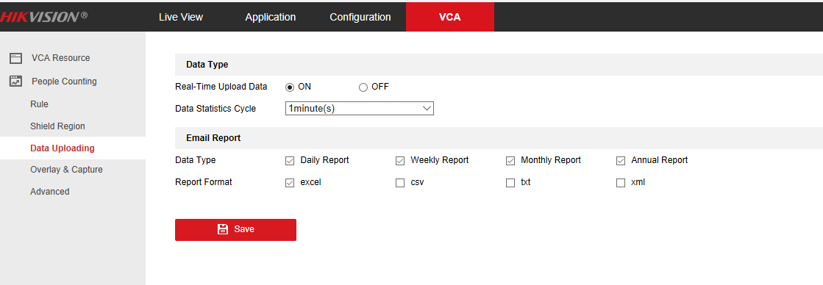

1. Login to NVR local GUI to set up people counting group and rule
2. (Optional) Reset Counting: select time to reset counting every day automatically. This function requires customized camera firmware, as shown below:

iDS-2CD6810F-IV/C: PJ01PC20190403057_E2_BV_EN_STD_5.4.80_190417

DS-2CD6825G0/C-I(V)(S): PJ14PC20200402001_IPCDC_H7_EN_STD_5.5.90_200430

Note: If you don’t want to upgrade the camera to a customized firmware, you can also configure it on the camera webpage.

1. Show group: define which group you want to display on the monitor, if you configured multiple groups. By default, group 1 is selected.
2. Define group number, name and people counting limit which is the maximum number of people available. When the number of people inside is equal to or more than the maximum capacity, an alarm will be triggered.
3. Select people counting camera(s)
4. (Optional) check the alarm output box to trigger alarm output from NVR or camera if it’s connected to third party device, such as traffic light or speaker.

Note: Once triggered, the alarm output signal will not stop until the alarm stops.

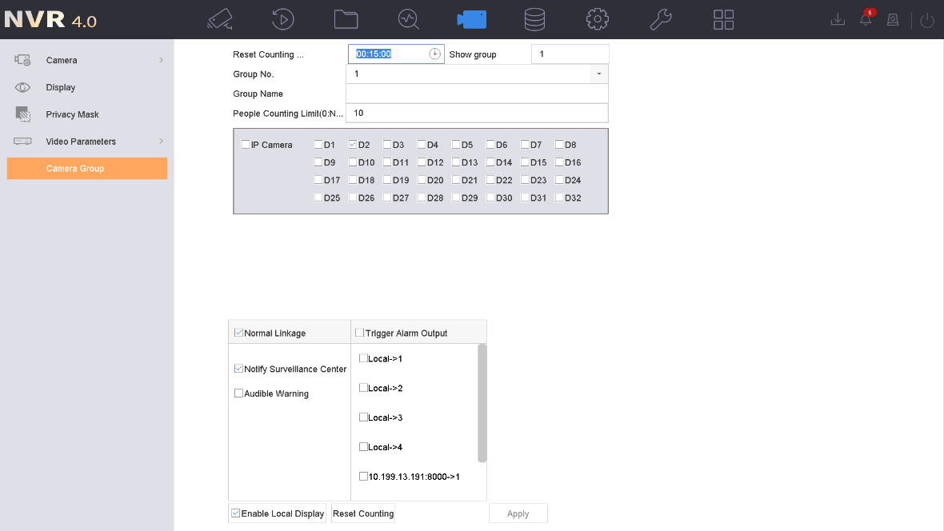

1. (Optional) Enable Local Display. This will show the available capacity on the camera image, so that you can view the number when live view the camera anywhere.
2. (Optional) Modify the people counting number manually if it’s not accurate. Be sure to click “**SetPeopleNum**” button after you input the actual enter and/or exit number.

Note: this function requires the same customized camera firmware as the reset counting feature in step three does.

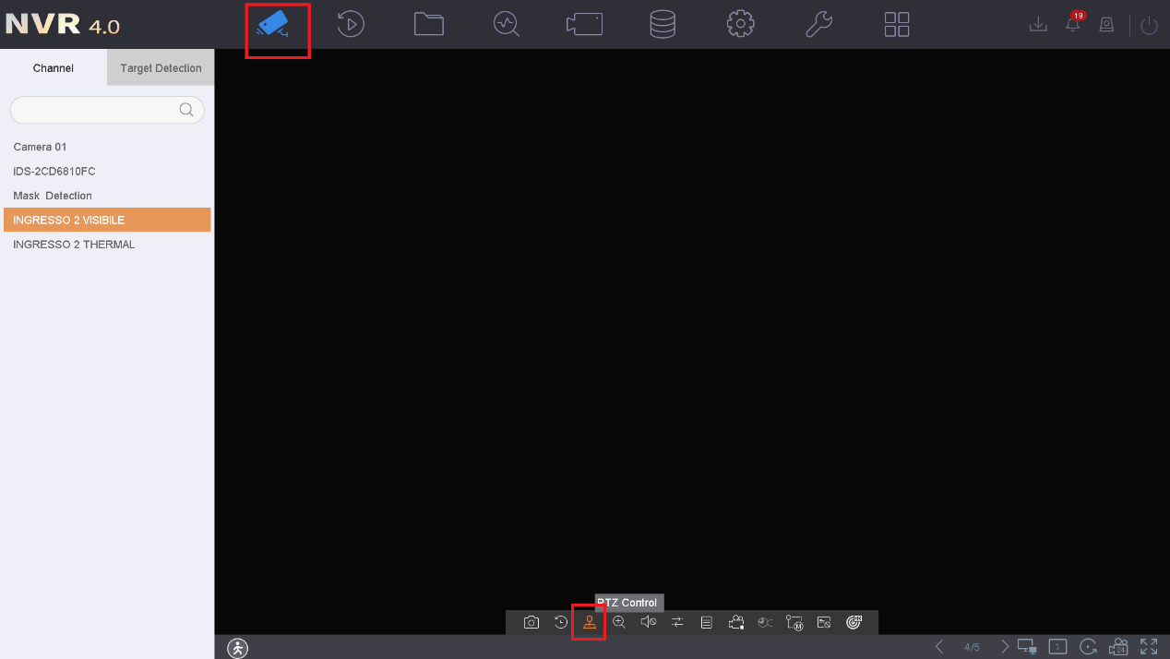

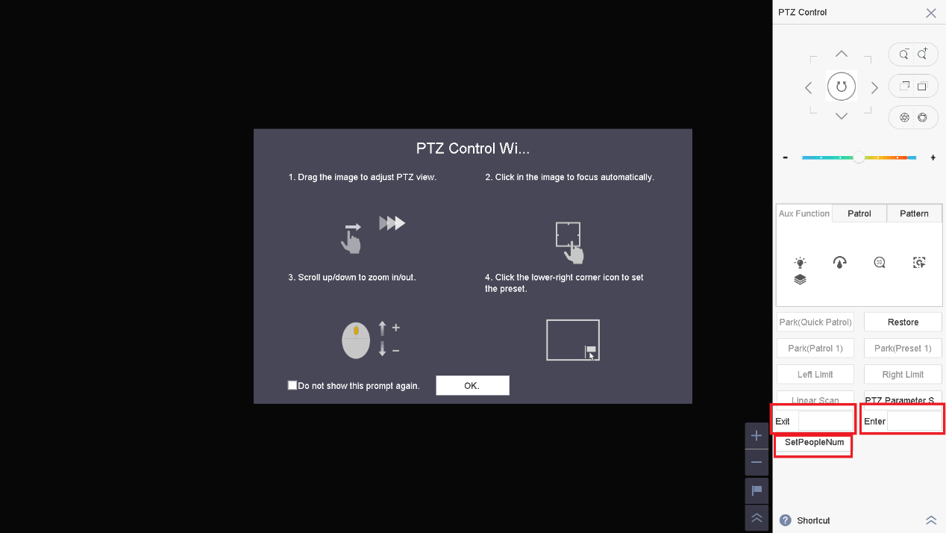

1. Go to NVR local GUI->Live View, click the human icon on the bottom left corner to show density control information.

Note: auxiliary screen doesn’t support displaying the density control information.

