**DS-K1T671TM-3XF MinMoe Temperature Screening**

**Face Recognition Terminal Installation Guide**

|  |  |  |  |
| --- | --- | --- | --- |
| Date | Content | Person | Version |
| 2020/04/26 | Create | Morgen | 1.0 |

Content

1. System structure & Function description 3

2. Installation process 4

3. System implementation considerations 4

3.1 Site survey precautions 4

3.2 Precautions when measuring human temperature 4

4. Preparation before installation 5

4.1 Safety instruction 5

4.2 Device preparation 5

4.3 Site survey 6

5. Installation and configuration 6

5.1 Temperature screening face recognition terminal 6

5.2 Temperature displayed on the screen 9

6. Delivery acceptance 10

7. FAQ: 12

## 1. System structure & Function description

This solution is designed to control the entrance and exit of office building, factory, cell and so on through temperature measurement and face verification, and the event can be managed and monitored on iVMS-4200 client software or HikCentral Professional platform.

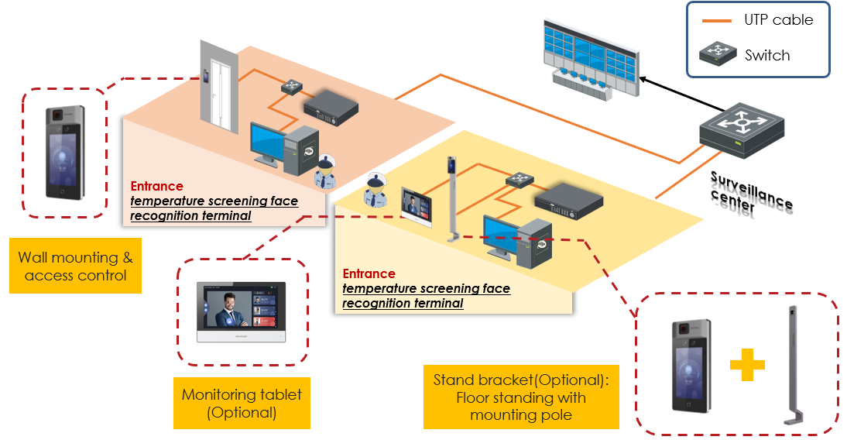

Structure for access control & temperature screening system

* Temperature screening thermographic camera mainly performs rapid preliminary screening by measuring the temperature of the human skin-surface. If the temperature is found to exceed the normal range, medical temperature measurement equipment should be used to conduct secondary screening and confirmation of suspicious personnel. Because the facial skin is exposed to the air and affected by the ambient temperature and the evaporation of sweat, there will be some changes in the skin-surface temperature. It is recommended to wait for 3 to 5 minutes and wait for the body surface temperature to stabilize.

## 2. Installation process

**Preparation before installation**

1. Safety instruction

2. Function instruction

3. Installation site survey

4. Product selection

**Site installation**

1. Installation guide

2. Parameter configuration

3. Device debug

**Project delivery**

1. Delivery acceptance checklist

2. Routine maintenance and recommendations

## 3. System implementation considerations

### 3.1 Site survey precautions

* It is not recommended for outdoor use. It is recommended to install in indoor closed, constant temperature, no wind (including natural wind, air conditioning wind, etc.) and no direct sunlight.
* For indoor use, the indoor ambient temperature must be 10 ~ 35 ° C. If beyond this range, the temperature measurement accuracy of the device cannot be guaranteed.
* When used outdoors (including semi-open scenes such as doorways), human body temperature measurement accuracy cannot be guaranteed steadily, and guests / users should be guided to move the equipment indoors for installation.
* MinMoe face recognition terminal installation requirements: the visible light channel has enough illumination, and avoid backlighting / reflecting / blocking / etc.
* Avoid non-human high-temperature targets and reflective surfaces in the detection scene

The above installation precautions, please explain to the user before the project and should be strictly implement;

### 3.2 Precautions when measuring human temperature

* When an outdoor person first enters the room, they need to take off their hats and lift their bangs. It is recommended to wait for 3 to 5 minutes and wait for the body surface temperature to stabilize.
* When moving from far to near, the temperature measurement results in the vicinity may appear high; the flow guidance line needs to be arranged at the site, when the temperature of the human body is measured at a fixed distance (recommend 0.5 to 1.5 m), person should walk to left or right side to avoid moving toward the device.
* When measuring human body temperature, personnel need to stand at a fixed distance, pass one by one, make a short stop, and face directly to the camera.

The above temperature measurement precautions should be strictly implemented in project site.

## 4. Preparation before installation

Please read and follow the requirements before using the devices.

### 4.1 Safety instruction

**Precautions for use**

* Do not point the device directly to the strong light such as lights and sunlight;
* Please ensure that the thermal camera can dissipate heat normally;
* Please transport, store, and use within the temperature and humidity range indicated in the instruction manual of the thermal camera;
* Please use the factory packaging during transportation, and avoid dropping, heavy pressure, bumping, soaking, etc. during transportation.

**Power requirements**

* Please use a qualified adapter;
* Meet local electrical safety standards;
* Please ensure that the equipment is powered off during the installation and wiring of the equipment;
* During use, please avoid the power and other cables from being heavy pressed, twisted or stepped on;

**Others**

* Do not disassemble the device body without permission;
* Please refer to the actual product, this document is for reference only;

Please contact our technical support for latest version and document.

### 4.2 Device preparation

|  |  |  |
| --- | --- | --- |
| DS-K1T671TM-3XF  302917210 |  | 50,000 faces, 50,000 cards;  ***Wall mounting*** and ***floor standing with mounting pole***. |
| DS-KAB671-B (Optional)  305700583 |  | The mounting pole for DS-K1T671TM-3XF  **Material：**SPCC  **Weight：**6.7 kg (14.8 lb.)  **Dimension (W × H × D)**：  98.5 mm × 1342 mm × 225 mm (3.9" × 52.8" × 8.9")  Including screws, mounting plate, network and power extension cords |
| Recommend tools (not included in the package) | Impact drill, screwdriver, socket | If the equipment does not need to be fixed with expansion screws, no impact drill and sleeve are required |

### 4.3 Site survey

|  |  |  |  |
| --- | --- | --- | --- |
| **Installation site survey** | | | |
| **Project Name** |  | | **Note** |
| **Entrance Name** |  | |  |
| 1 | Installation environment (Indoor, outdoor) |  | Photos and videos for site |
| 2 | Power supply and network cable  (surface installation or bury in the tube) |  |  |
| 3 | Device installation method（surface or with stand） |  |  |

|  |
| --- |
| Note:   1. Take more pictures or record videos for the installation site and ground, pictures and videos for every installation site should be provided. |

## 5. Installation and configuration

### 5.1 Temperature screening face recognition terminal

#### 5.1.1 Device installation with floor stand DS-KAB671-B (optional)

**DS-K1T671TM-3XF** can be installed for temporary (without install expansion screw), or fixed on the ground with optional floor stand **DS-KAB671-B**, instruction as below:

1. Unscrew the two screws on the side of the bottom cover and remove;
2. Install the expansion screws in the package into the holes at the bottom. Make sure the expansion screw is slightly above the ground and secure it with the expansion nut;
3. Move back the bottom cover and screw back the two screws on the side.

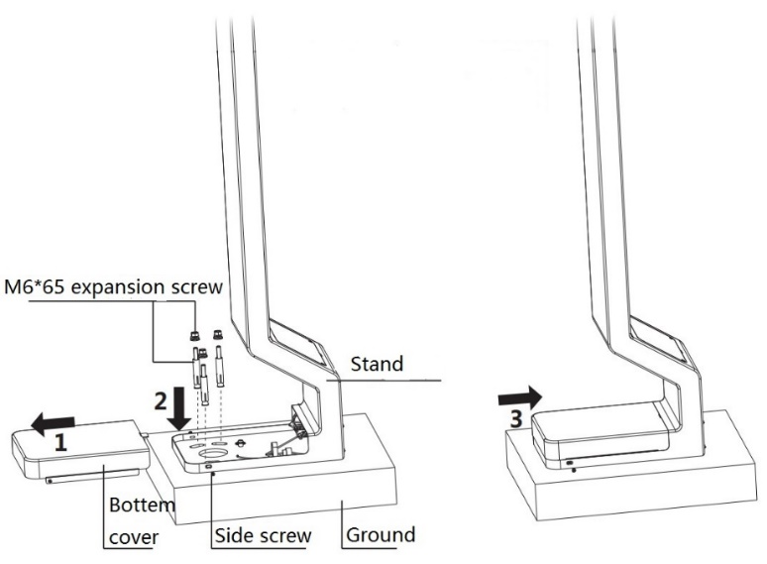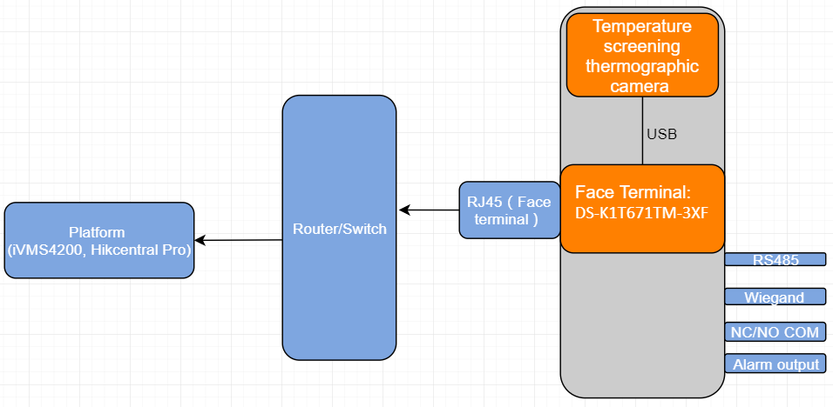

#### Device wiring

1. Install bracket on the stand with 4 screws, connect network, power and other external devices' cables to device interface;

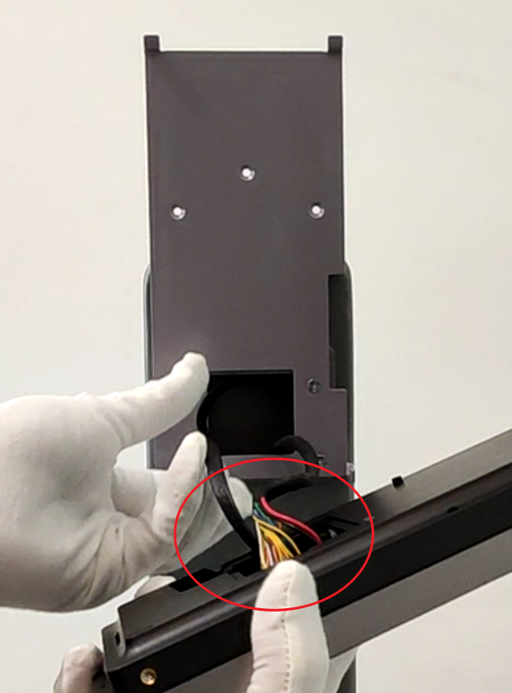 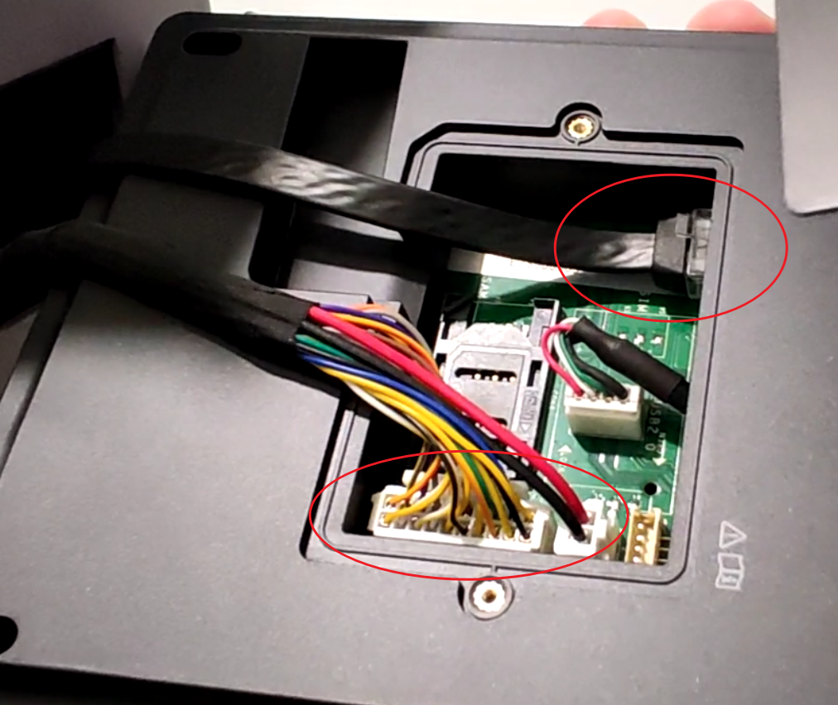

1. Install device on the bracket（unscresw 2 screws on both sides, press device bottom and secure 2 screws）

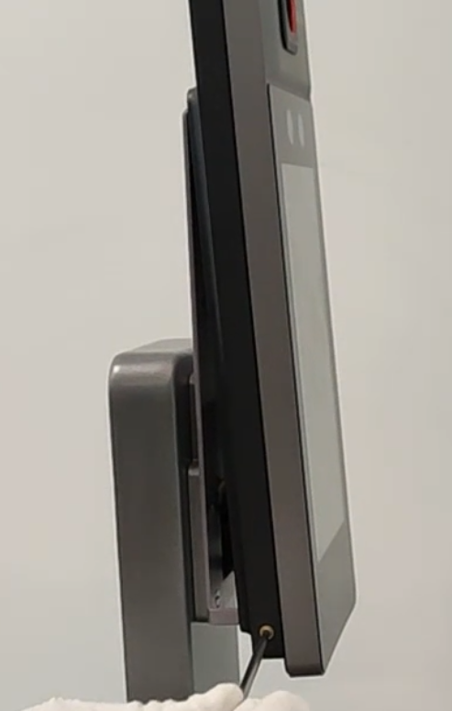 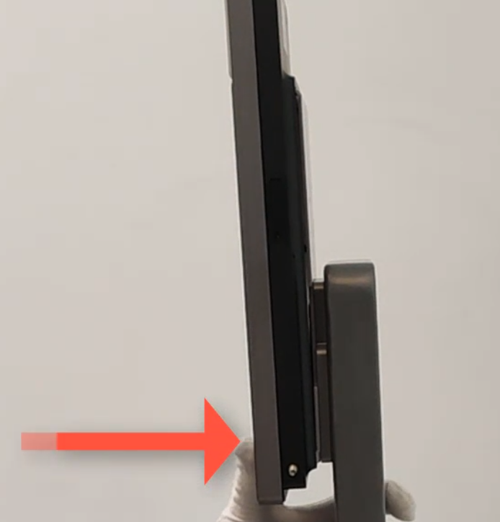

1. Connect 220V AC power cable and power cable to floor stand

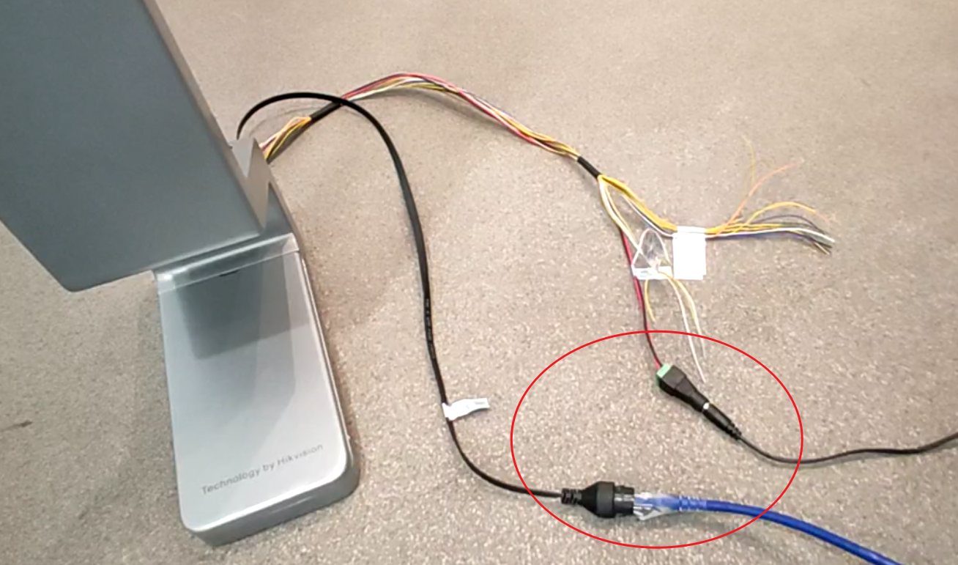

#### Device debugging and configuration

##### Debugging process

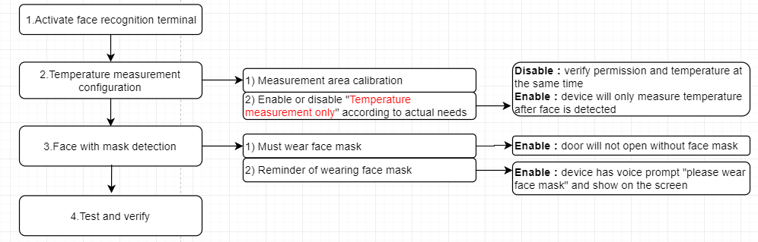

##### Temperature measurement configuration

1. Activate terminal with SADP/iVMS-4200 or from device local UI

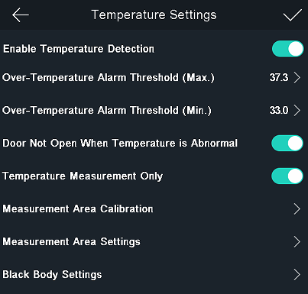 2） Temperature settings

**Default enable**: device will verify face and measure temperature

Reserved function

The parameters have been adjusted at the factory, no need to configure

The parameters have been adjusted at the factory, no need to configure

**Default enable**: temperature measurement only; **Disable**: permission + temperature

**Default enable**: If temperature is not in the normal range, door will not open

If temperature is lower than the value, device will alarm

If temperature is higher than the value, device will alarm

##### Face with mask configuration

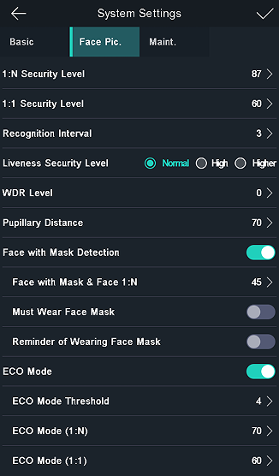

Default **disable**: after enable, device will show prompt and play audio

Default **enable**: must wear face mask or authentication will be failed

1:N : face comparison similarity

Default **disable**: after enable, authentication will not be granted without face mask

### Temperature displayed on the screen

1. Normal face recognition, normal and abnormal body temperature

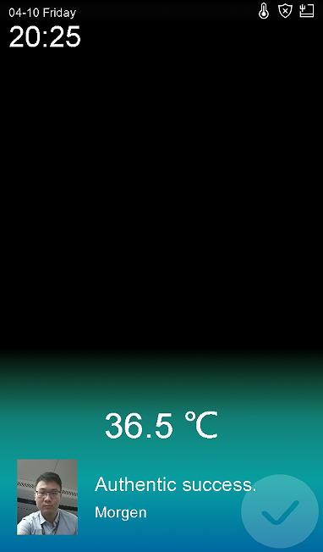 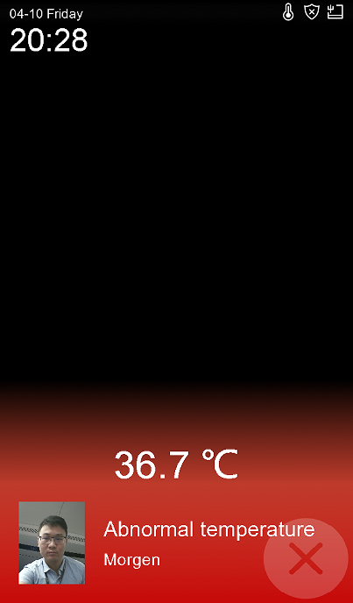

1. Unregistered face (device will prompt Stranger, contact security guard)

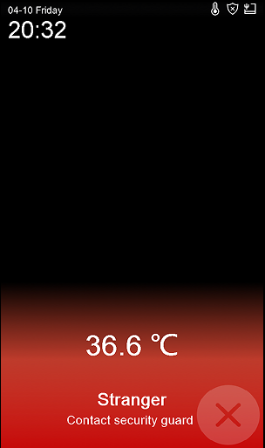

1. After enable temperature only, device will not verify face permission, only check temperature is normal or abnormal, if temperature is normal, authentication will device will output I/O signal.

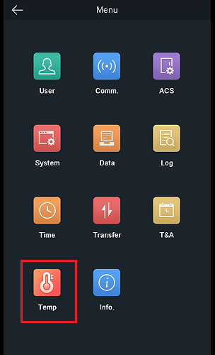 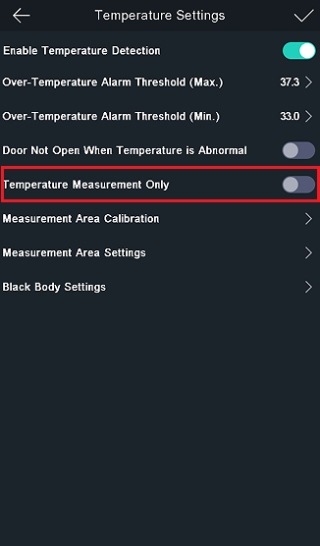 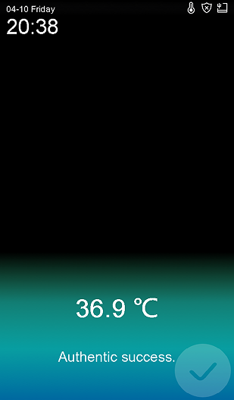 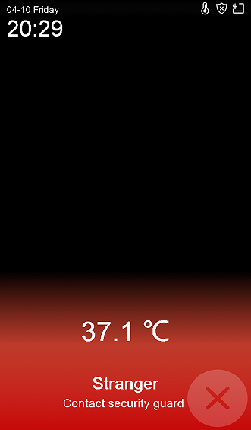

## 6. Delivery acceptance

In order to ensure that the temperature measurement effect and accuracy meet the requirements of customer, after the completion of the project implementation work, on-site installation and construction personnel and commissioning personnel need to complete the corresponding work, check and fill in the installation, commissioning, and delivery acceptance form according to the following table. After checking and filling as required, the acceptance form and related videos / pictures shall be reported. Hikvision technical engineers shall conduct inspection. after the inspection is correct, the delivery acceptance list shall be provided to Party A for signature and retention.

#### 6.1.1 Construction acceptance

|  |  |  |  |
| --- | --- | --- | --- |
| **Construction Acceptance List** | | | |
| **No.** | **Content** | **Meets the standard(√/×)** | **Remark** |
| 1.1 | Whether it is installed in a room with constant temperature, no wind and no direct sunlight |  | Outdoor environment is greatly affected by environmental changes such as temperature, wind, and humidity, which will affect the temperature measurement accuracy of the thermal imaging human surface, it is recommended to be installed in a location with constant temperature, no wind, and no direct sunlight |
| 1.2 | The actual installation environment and location determination |  | Take pictures and record video to confirm |

#### 6.1.2 Commissioning acceptance

|  |  |  |  |
| --- | --- | --- | --- |
| **Commissioning Acceptance List** | | | |
| **No.** | **Content** | **Meets the standard(√/×)** | **Remark** |
| 2.1 | Take pictures of the **ACS** configuration page of the face terminal |  | Take pictures and record video to confirm |
| 2.2 | Take pictures of the **Temperature settings** page of the face terminal |  | Take pictures and record video to confirm |
| 2.3 | Take pictures of the web configuration page of the temperature measurement camera |  | Take pictures and record video to confirm |
| 2.4 | Take video of barrier study mode and normal mode |  | Record video to confirm |

#### 6.1.3 Function acceptance

|  |  |  |  |
| --- | --- | --- | --- |
| **Function Acceptance List** | | | |
| **No.** | **Content** | **Meets the standard(√/×)** | **Remark** |
| 3.1 | Test the temperature measurement effect when the flow of people is large, compare the effect and check the temperature measurement value is accurate, provide 3 minutes of video files. |  | Record video to confirm |
| 3.2 | Take video confirmation of normal temperature and abnormal temperature, test comparison video |  | Record video to confirm |
| 3.3 | Whether the device normally uploads photo capture, temperature and other information |  | Take pictures and record video to confirm |

## 7. FAQ:

1. Temperature module is offline
2. It shows “connecting thermal module exception” after device reboot, because module has longer booting time than face terminal, please wait about 1 minute more during face terminal connecting temperature measurement module.
3. Check whether thermal module is online or offline, if offline, it will prompt on main screen, please check cable connect in the back

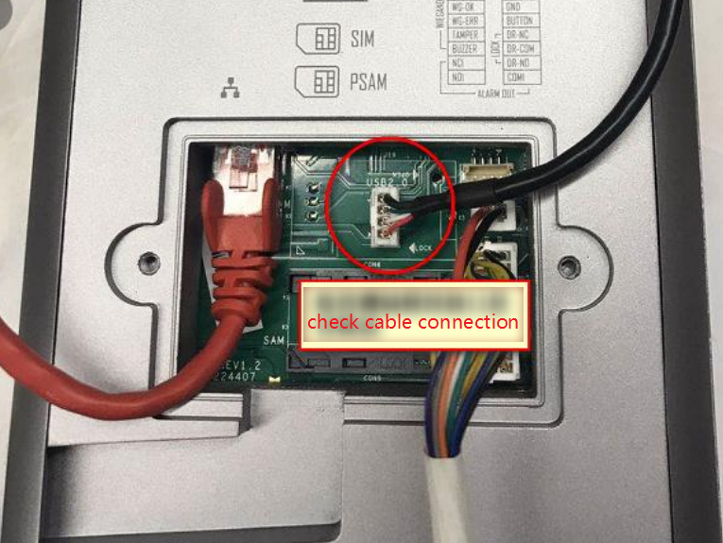

1. Temperature measurement failed
2. Check thermal module is online or offline on main screen

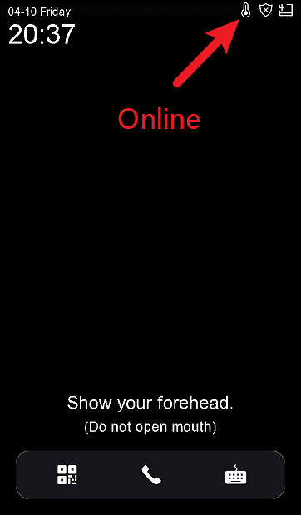

1. Open device menu and check whether terminal can get video stream from thermal camera or not.

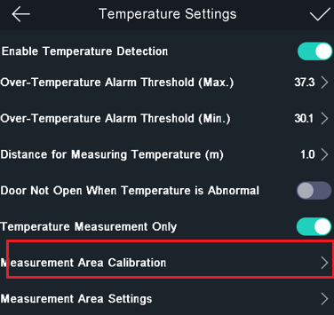 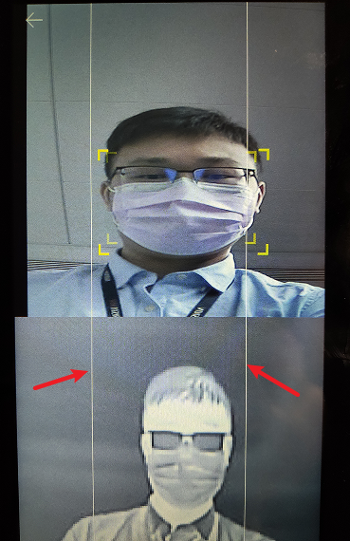

1. Temperature measurement result is not accurate
2. In order to get an accurate temperature, after the device is powered on, you should wait for 90 min to warm the device up.
3. Open mouth and deep exhalation will affect the temperature measurement results
4. Please check and upgrade device and thermal module to latest firmware version
5. Whether device can be used for temperature measurement for strangers.

Enable ***temperature measurement only*** option from device

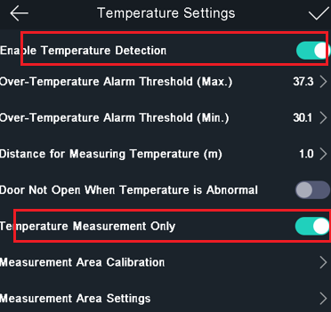

1. Whether device support ehome(ISUP) protocol or not

Limited by protocol, currently only support device network sdk

1. Whether device can be used for time attendance

Yes, device will upload log to iVMS4200 or Hikcentral platform, calculation will be done in the software.

1. Log search and export

Log query from device local, Abnormal temperature will be marked as red.

a. Only registered persons’ authenticated record can be searched.

b. Strangers and temperature measurement only record can’t be searched from local screen.

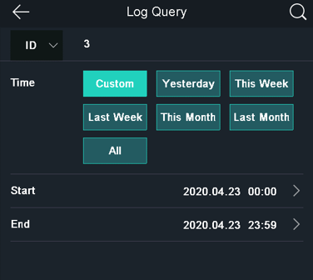 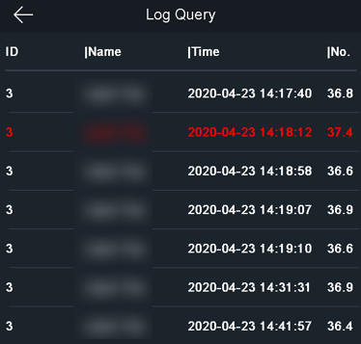

Export from device local to USB drive, CSV format, including employee id, card no, name, time, attendance status, temperature info, overtemperature or not, with mask or not

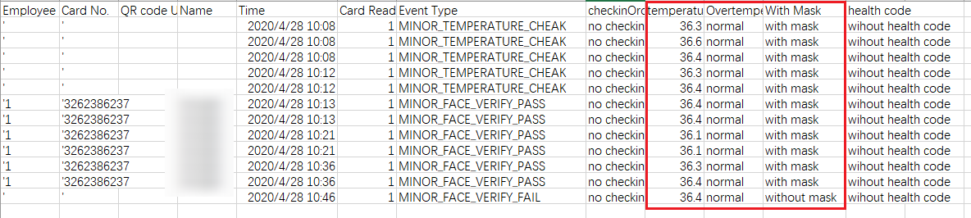

Monitoring will not show temperature information.

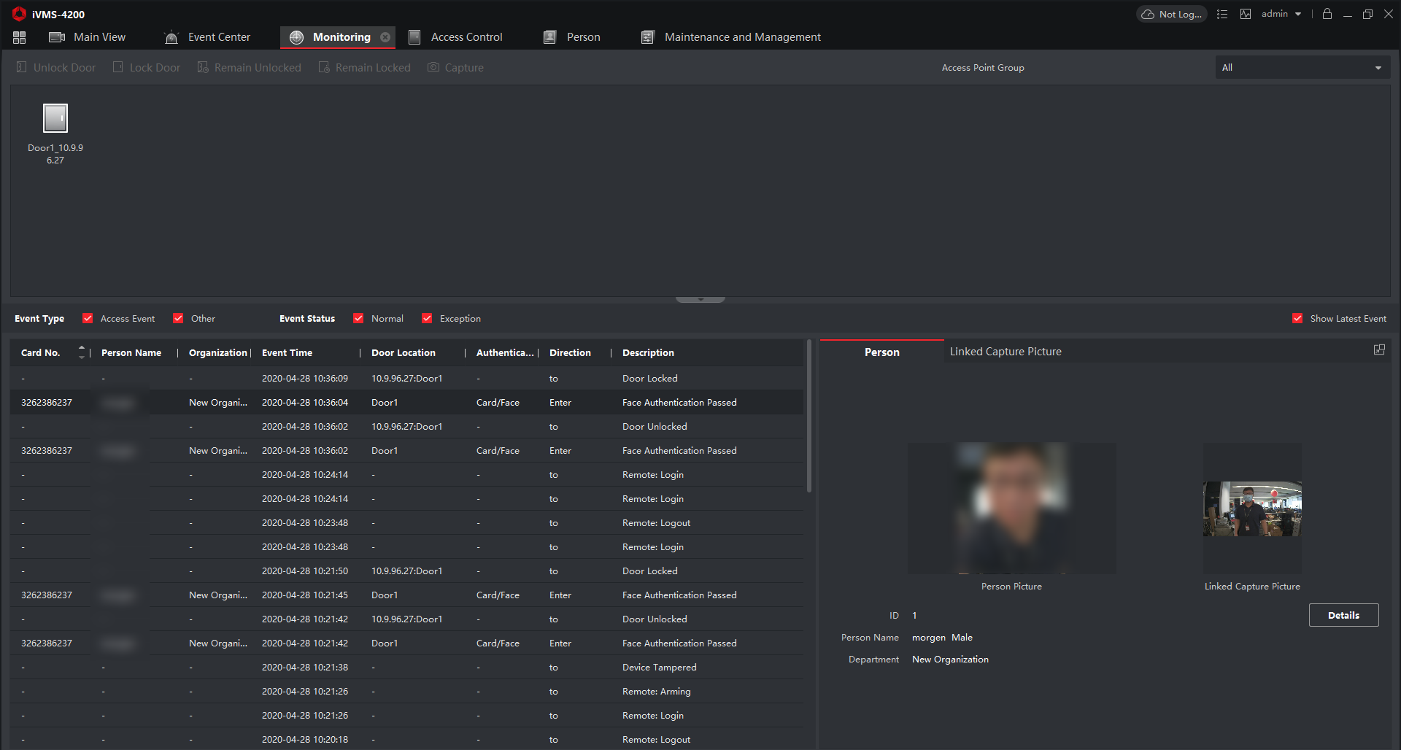

Real time event in Event Center, temperature, captured normal and thermal pictures are available.

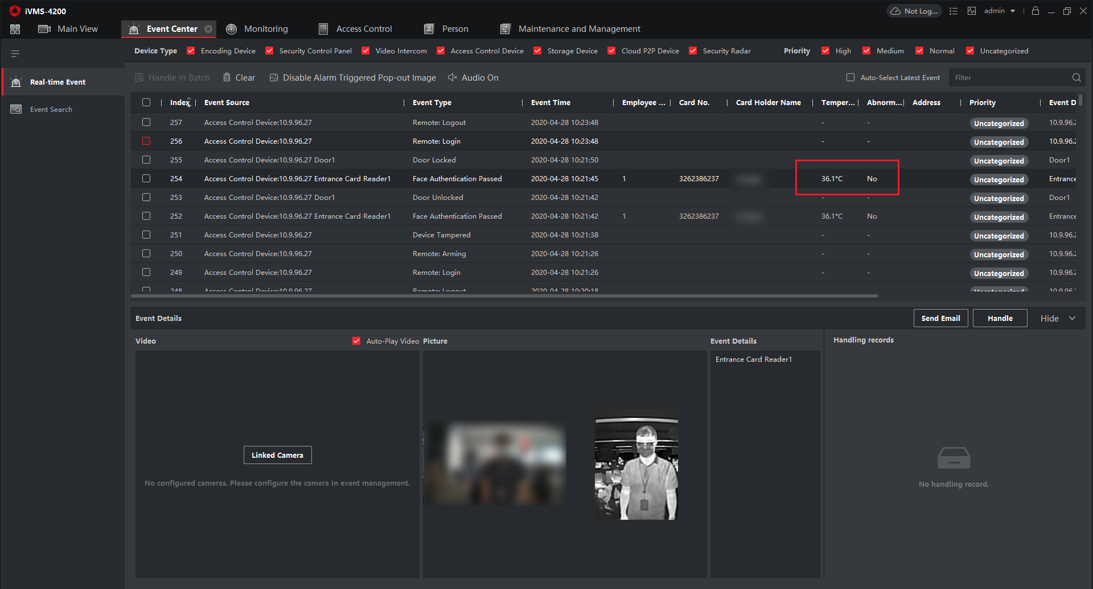

Search event in iVMS-4200, please select *device type* as **Access Control,** then you can find temperature, captured normal and thermal picture (without temperature OSD information)

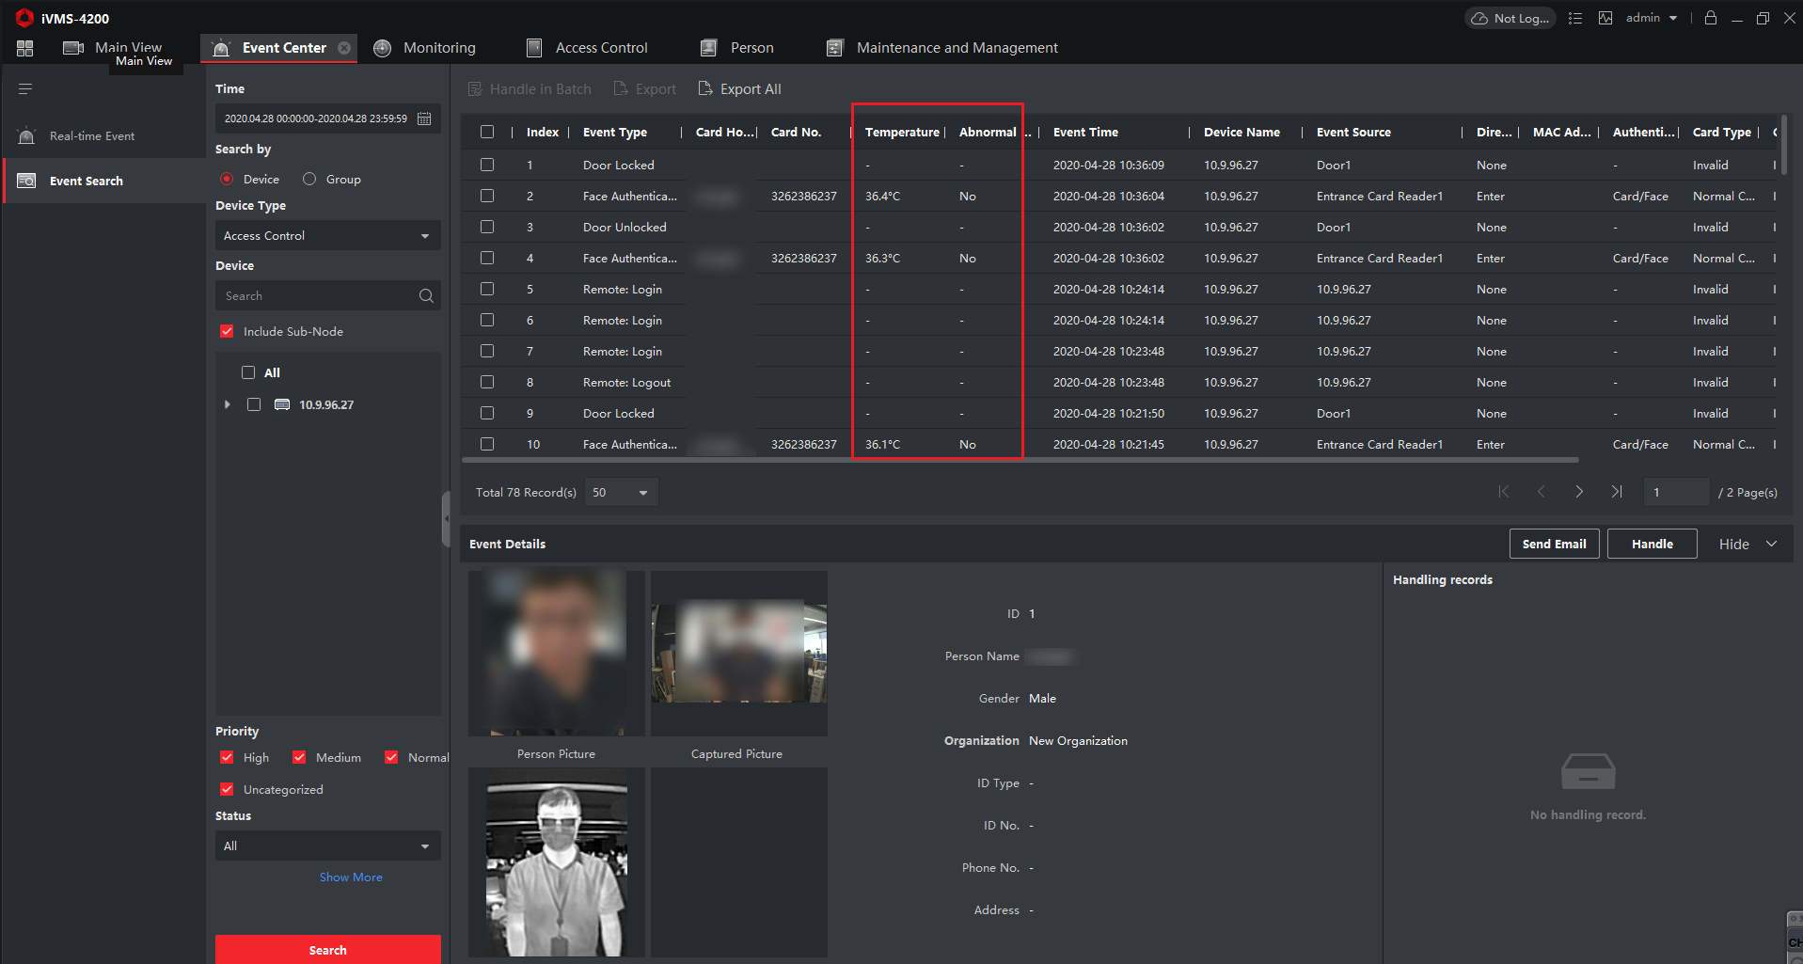

Export captured picture and event from iVMS-4200 to PC, CSV format for event log and captured pictures

