# Application scenario

As following Topology shows, connect TP21B and your PC through a same Wifi.



# Problem

TP21B default IP setting is DHCP, so the IP address will automatically change every time when it is reboots.

# How to change TP21B from DHCP to static IP

1. Connect TP21B to a same WIFI with your PC, and find TP21B current IP address by SADP (also you can find it in TP21B local device information)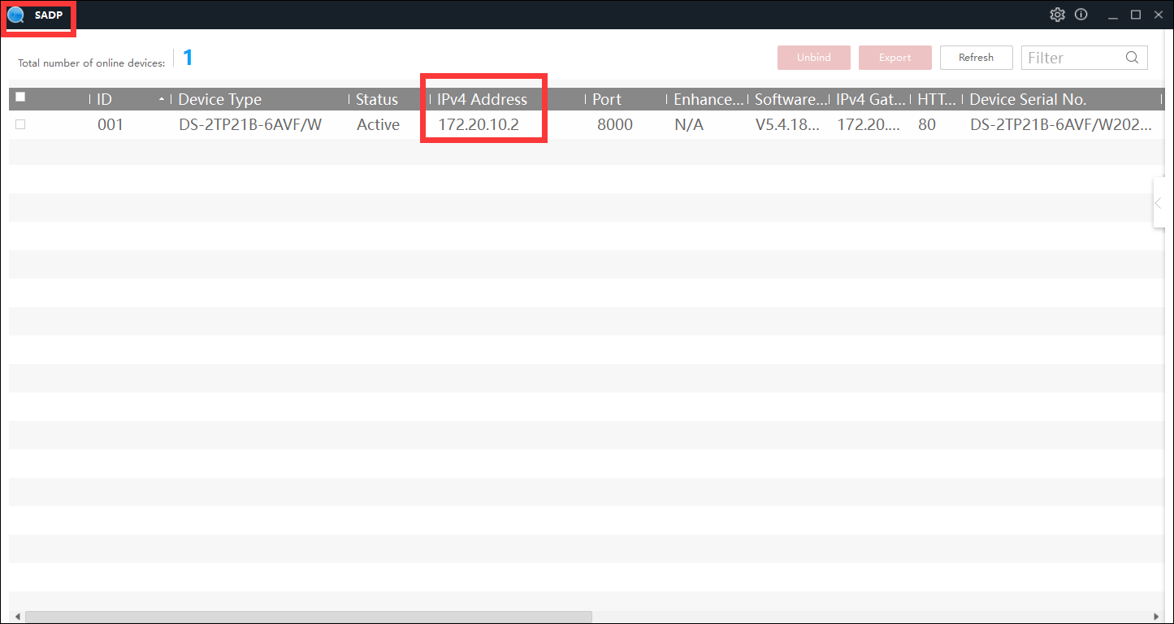

2. Open ClientDemoEn.exe tool

3. Right click the left device tree, add TP21B (input TP21B name, IP address, and password), as shows

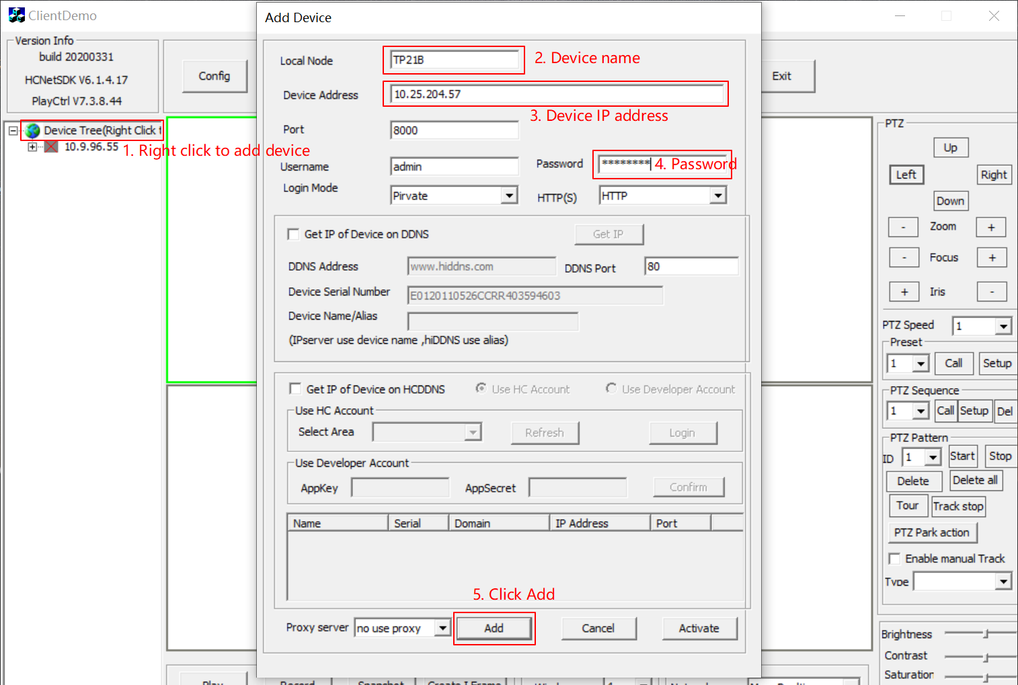

4. Click Config > Network Setup > WIFI, as shows in following picture:

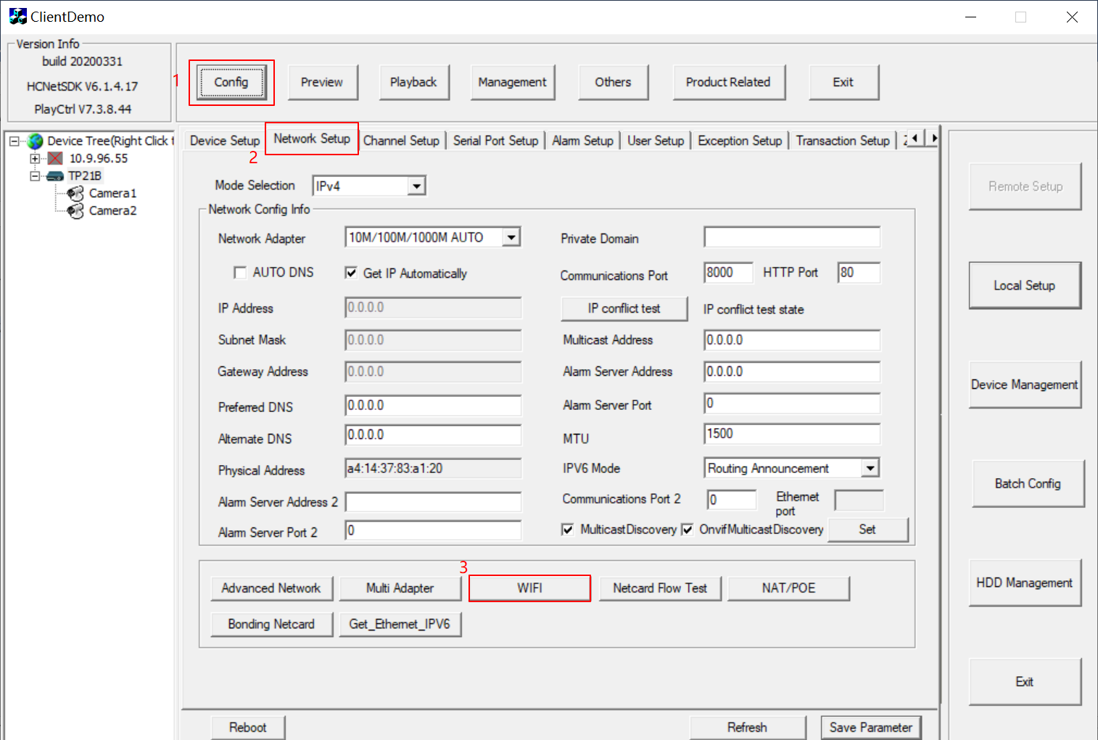

5. Disable DHCP, modify the IP address, DNS, gateway, netmask to what you want, click “save”

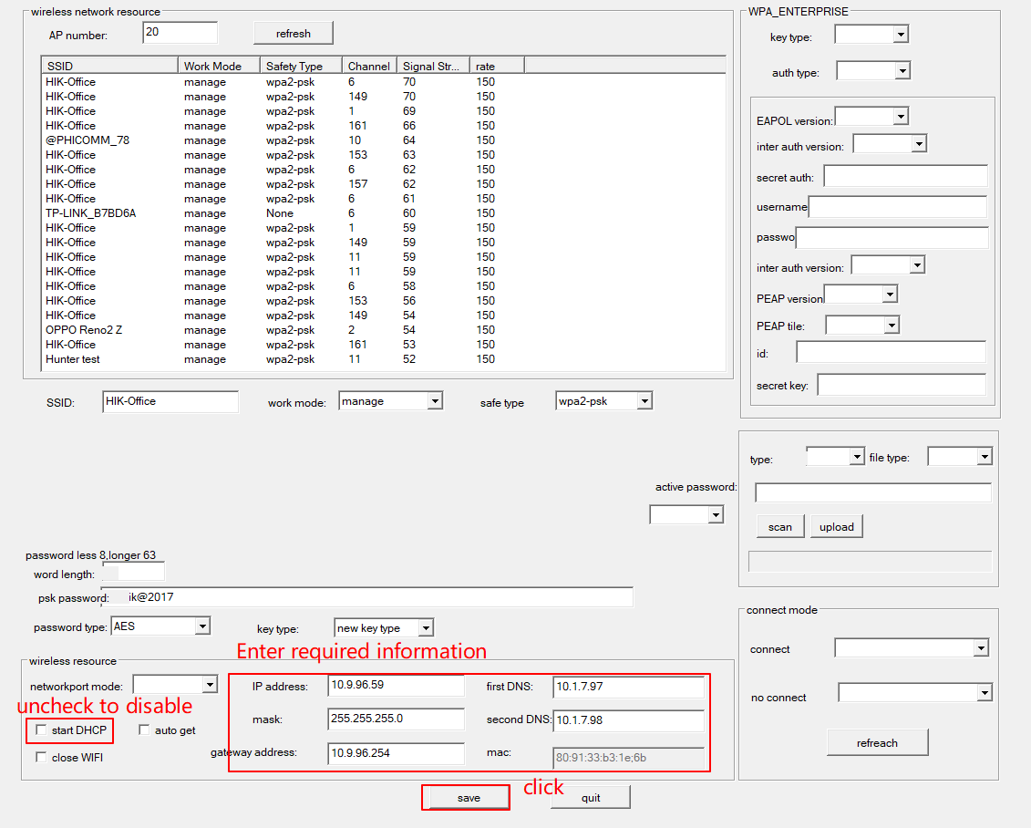

6. Wait for a moment, this window will popup, just click “OK”

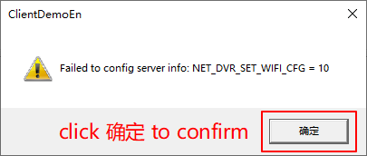

7. TP21B WIFI connection will be automatically closed, you need manually open and add it back to the same WIFI with your PC.

8. Search again by SADP, you will find the IP changed to the static IP you set.

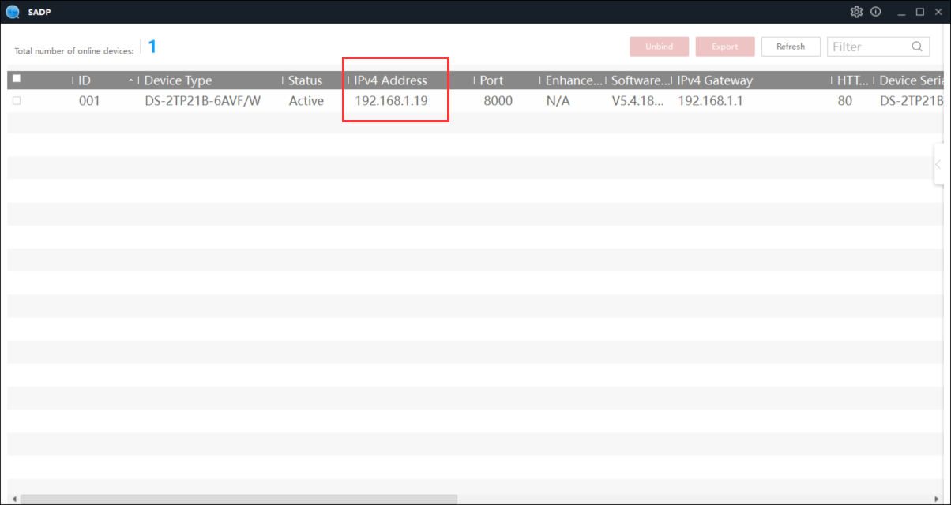

Remarks：

1. Don’t set the static IP to the same segment with your WIFI router, which is easy to make IP conflict happens.
2. ClientDemoEn.exe tool download address:

<https://www.hikvision.com/en/support/download/sdk/device-network-sdk--for-windows-64-bit-/>

