HikCentral Professional Web Client
User Manual

Legal Information
©2020 Hangzhou Hikvision Digital Technology Co., Ltd. All rights reserved.
About this Manual
The Manual includes instructions for using and managing the Product. Pictures, charts, images and all other information hereinafter are for description and explanation only. The information contained in the Manual is subject to change, without notice, due to firmware updates or other reasons. Please find the latest version of this Manual at the Hikvision website (https://www.hikvision.com/).
Please use this Manual with the guidance and assistance of professionals trained in supporting the Product.
Trademarks
 and other Hikvision's trademarks and logos are the properties of Hikvision in various jurisdictions.
Other trademarks and logos mentioned are the properties of their respective owners.
Disclaimer
TO THE MAXIMUM EXTENT PERMITTED BY APPLICABLE LAW, THIS MANUAL AND THE PRODUCT DESCRIBED, WITH ITS HARDWARE, SOFTWARE AND FIRMWARE, ARE PROVIDED “AS IS” AND “WITH ALL FAULTS AND ERRORS”. HIKVISION MAKES NO WARRANTIES, EXPRESS OR IMPLIED, INCLUDING WITHOUT LIMITATION, MERCHANTABILITY, SATISFACTORY QUALITY, OR FITNESS FOR A PARTICULAR PURPOSE. THE USE OF THE PRODUCT BY YOU IS AT YOUR OWN RISK. IN NO EVENT WILL HIKVISION BE LIABLE TO YOU FOR ANY SPECIAL, CONSEQUENTIAL, INCIDENTAL, OR INDIRECT DAMAGES, INCLUDING, AMONG OTHERS, DAMAGES FOR LOSS OF BUSINESS PROFITS, BUSINESS INTERRUPTION, OR LOSS OF DATA, CORRUPTION OF SYSTEMS, OR LOSS OF DOCUMENTATION, WHETHER BASED ON BREACH OF CONTRACT, TORT (INCLUDING NEGLIGENCE), PRODUCT LIABILITY, OR OTHERWISE, IN CONNECTION WITH THE USE OF THE PRODUCT, EVEN IF HIKVISION HAS BEEN ADVISED OF THE POSSIBILITY OF SUCH DAMAGES OR LOSS.
YOU ACKNOWLEDGE THAT THE NATURE OF INTERNET PROVIDES FOR INHERENT SECURITY RISKS, AND HIKVISION SHALL NOT TAKE ANY RESPONSIBILITIES FOR ABNORMAL OPERATION, PRIVACY LEAKAGE OR OTHER DAMAGES RESULTING FROM CYBER-ATTACK, HACKER ATTACK, VIRUS INSPECTION, OR OTHER INTERNET SECURITY RISKS; HOWEVER, HIKVISION WILL PROVIDE TIMELY TECHNICAL SUPPORT IF REQUIRED.
YOU AGREE TO USE THIS PRODUCT IN COMPLIANCE WITH ALL APPLICABLE LAWS, AND YOU ARE SOLELY RESPONSIBLE FOR ENSURING THAT YOUR USE CONFORMS TO THE APPLICABLE LAW. ESPECIALLY, YOU ARE RESPONSIBLE, FOR USING THIS PRODUCT IN A MANNER THAT DOES NOT INFRINGE ON THE RIGHTS OF THIRD PARTIES, INCLUDING WITHOUT LIMITATION, RIGHTS OF PUBLICITY, INTELLECTUAL PROPERTY RIGHTS, OR DATA PROTECTION AND OTHER PRIVACY RIGHTS. YOU SHALL NOT USE THIS PRODUCT FOR ANY PROHIBITED END-USES, INCLUDING THE DEVELOPMENT OR PRODUCTION OF WEAPONS OF MASS DESTRUCTION, THE DEVELOPMENT OR PRODUCTION OF CHEMICAL OR BIOLOGICAL WEAPONS, ANY ACTIVITIES IN THE CONTEXT RELATED TO ANY NUCLEAR EXPLOSIVE OR UNSAFE NUCLEAR FUEL-CYCLE, OR IN SUPPORT OF HUMAN RIGHTS ABUSES.
IN THE EVENT OF ANY CONFLICTS BETWEEN THIS MANUAL AND THE APPLICABLE LAW, THE LATER PREVAILS.
Symbol Conventions
The symbols that may be found in this document are defined as follows.

Symbol | Description
Danger | Indicates a hazardous situation which, if not avoided, will or could result in death or serious injury.
Caution | Indicates a potentially hazardous situation which, if not avoided, could result in equipment damage, data loss, performance degradation, or unexpected results.
Note | Provides additional information to emphasize or supplement important points of the main text.

Contents
Chapter 1 About Web Client 1
1.1 About This Document 1
1.2 Introduction 1
1.3 Home Page Overview 2
1.4 Getting Started 6
Chapter 2 Login 8
2.1 Recommended Running Environment 8
2.2 First Time Login 8
2.2.1 Login for First Time for admin User 8
2.2.2 First Time Login for Normal User 10
2.3 Login via Web Client 11
2.4 Change Password for Reset User 12
2.5 Forgot Password 13
Chapter 3 Web Control 15
Chapter 4 Manage License 16
4.1 Activate License - Online 16
4.2 Activate License - Offline 17
4.3 Update License - Online 19
4.4 Update License - Offline 20
4.5 Deactivate License - Online 22
4.6 Deactivate License - Offline 22
Chapter 5 Manage Resource 25
5.1 Create Password for Inactive Device(s) 25
5.2 Edit Online Device's Network Information 26
5.3 Manage Encoding Device 27
5.3.1 Add Detected Online Device 27
5.3.2 Add Encoding Device by IP Address or Domain Name 34
5.3.3 Add Encoding Devices by IP Segment 38
5.3.4 Add Encoding Devices by Port Segment 42
5.3.5 Add Encoding Device by Hik-Connect 45
5.3.6 Add Encoding Device by Device ID 48
5.3.7 Add Encoding Devices by Device ID Segment 51
5.3.8 Add Encoding Devices in a Batch 52
5.3.9 Limit Bandwidth for Video Downloading 54
5.4 Upgrade Device Firmware 56
5.4.1 Upgrade Device Firmware via Current Web Client 58
5.4.2 Upgrade Device Firmware via EZVIZ Cloud Service 58
5.5 Restore/Reset Device Password 59
5.5.1 Reset Device Password 59
5.5.2 Restore Device's Default Password 60
5.6 Manage Remote Site 61
5.6.1 Add Remote Site by IP Address or Domain Name 61
5.6.2 Add Remote Site Registered to Central System 65
5.6.3 Add Remote Sites in a Batch 67
5.6.4 Back Up Remote Site's Database to Central System 69
5.6.5 Edit Remote Site 70
5.6.6 View Remote Site's Changes 71
5.7 Manage Application Data Server 73
5.8 Manage Recording Server 76
5.8.1 Add pStor 76
5.8.2 Add Hybrid Storage Area Network 78
5.8.3 Add Network Video Recorder 80
5.8.4 Manage Cloud Storage Server 81
5.8.5 Add pStor Cluster Service 84
5.8.6 Set N+1 Hot Spare for Hybrid SAN 86
5.9 Manage Streaming Server 88
5.9.1 Input Certificate Information to Streaming Server 88
5.9.2 Add Streaming Server 89
5.10 Add Security Audit Server 93

Chapter 6 Manage Map 108
6.1 Set GIS Map and Icons 108
6.2 Link E-Map to Area 190
6.3 Search Locations 192
6.4 Locate Sites on Map 192
6.5 Add Hot Spot on Map 193
6.6 Add Hot Region on Map 195
6.7 Add Label on Map 197
6.8 Add Resource Group on Map 198
Chapter 7 Manage Person List 200
7.1 Add Person Group 200
7.2 Add a Person 202
7.3 Batch Add Persons by Importing Person Information File 208
7.4 Import Domain Persons 209
7.5 Batch Add Profiles 212
Chapter 8 Dock Station 370
8.1 Manage Dock Station 370
8.1.1 Add Dock Station by IP/Domain 370
8.1.2 Add Dock Stations by IP Segment 371
8.1.3 Add Dock Stations by Port Segment 372
8.1.4 Add Dock Stations in Batch 373
8.2 Add Dock Station Group 375
Chapter 9 Manage Security Control 378
9.1 Manage Security Control Device 378
9.1.1 Add Detected Online Device 379
9.1.2 Add Security Control Device by IP Address 383
9.1.3 Add Security Control Device by Hik-Connect 385
9.1.4 Add Security Control Devices by IP Segment 387
9.1.5 Add Security Control Devices by Port Segment 388
9.1.6 Add Security Control Device by Device ID 390
9.1.7 Add Security Control Device by Device ID Segment 391
Chapter 10 Manage Role and User 398
10.1 Add Role 398
10.2 Add Normal User 401
10.3 Import Domain Users 404
10.4 Change Password of Current User 406
10.5 Reset Password for Admin User 407
10.6 Reset Password for Normal User 409
10.7 Configure Permission Schedule 410
Chapter 11 Maintenance 412
11.1 Service Manager 412
11.2 Set System Data Backup 413
11.3 Restore Database 415
11.4 Export Configuration File 416
Chapter 12 Manage System Security 417
Chapter 13 System Configuration 418
13.1 Set Site Name 418
13.2 Set User Preference 418
13.3 Set Warning Threshold for Server Usage 419
13.4 Set NTP 420
13.5 Set Active Directory 420
13.6 Enable Receiving Generic Event 423
13.7 Allow for Remote Site Registration 423
13.8 Register to Central System 424
13.9 Device Access Protocol 424
13.10 Set WAN Access 425
13.11 Set Network Timeout 426
13.12 Set Device Access Mode 426
13.13 Set Server NIC 426
13.14 Set Data Retention Period 427
13.18 Enable Evidence Collection 439
13.19 Set Transfer Protocol 440
13.20 Set Camera ID 441
13.21 Export Service Component Certificate 442
13.22 Set Database Password 443
13.23 Set Health Check Frequency 443
13.24 Add Fuzzy Matching Rules for License Plate Search 444
13.25 Configure System Hot Spare 445
13.26 Set Third-Party Integration 445
13.27 Data Interchange 446
13.27.1 Synchronize Card Swiping Records to Third-Party Database 446
13.27.2 Dump Card Swiping Records to Third-Party Database 447
13.28 Reset Device Network Information 447
13.29 Set SUP Upgrade Prompt 448
Chapter 14 Monitoring 449
14.1 Playback 456
14.1.1 Search Video File 456
14.1.2 Play Video File 457
14.2.1 Local Configuration 458
Chapter 15 Important Ports 494

Chapter 1 About Web Client

1.1 About This Document
This user manual is intended for the administrator of the system.
The manual guides you to establish and configure the surveillance system. Follow this manual to perform system activation, access of the system, and configuration of the surveillance task via the provided Web Client, etc. To ensure the properness of usage and stability of the system, refer to the contents below and read the manual carefully before installation and operation.

1.2 Introduction
The system is developed for central management of surveillance system and features flexibility, scalability high reliability, and powerful functions.
The system provides the central management, information sharing, convenient connection, and multi-service cooperation. It is capable of adding devices for management, live view, storage and playback of video files, alarm linkage, access control, time and attendance, face comparison, and so on.
Note
The displayed modules on the home page vary with the License you purchased. For detailed information, contact our technical support.

The complete system contains the following modules. You can install the modules according to actual needs.

Module | Introduction
System Management Service (SYS) | - Provides the unified authentication service for connecting with the clients and servers.  - Provides the centralized management for the users, roles, permissions, devices, and services.  - Provides the configuration interface for surveillance and management module.
Application Data Service (ADS) | Provides data storage and processing.
Streaming Service (Optional) | Provides forwarding and distributing the audio and video data of live view.

The following table shows the provided clients for accessing or managing system.

Client | Introduction
Control Client | Control Client is a C/S software which provides multiple operating functionalities, including real-time live view, PTZ control, video playback and downloading, alarm receiving, log query, and so on.
Web Client | Web Client is a B/S client for managing system. It provides multiple functionalities, including device management, area management, recording schedule settings, event configuration, user management, and so on.
Mobile Client | Mobile Client is the software designed for getting access to the system via Wi-Fi, 3G, and 4G networks with mobile device. It fulfills the functions of the devices connected to the system, such as live view, remote playback, PTZ control, and so on.

1.3 Home Page Overview
The Home page of the Web Client provides an overview of navigation and menu about the function modules. It contains several sections for the modules, such as Configuration, Applications, Wizard, Maintenance, License, etc. You can access the modules you want quickly and conveniently via the Home page.
The HikCentral Professional Web Client is composed of the following modules.
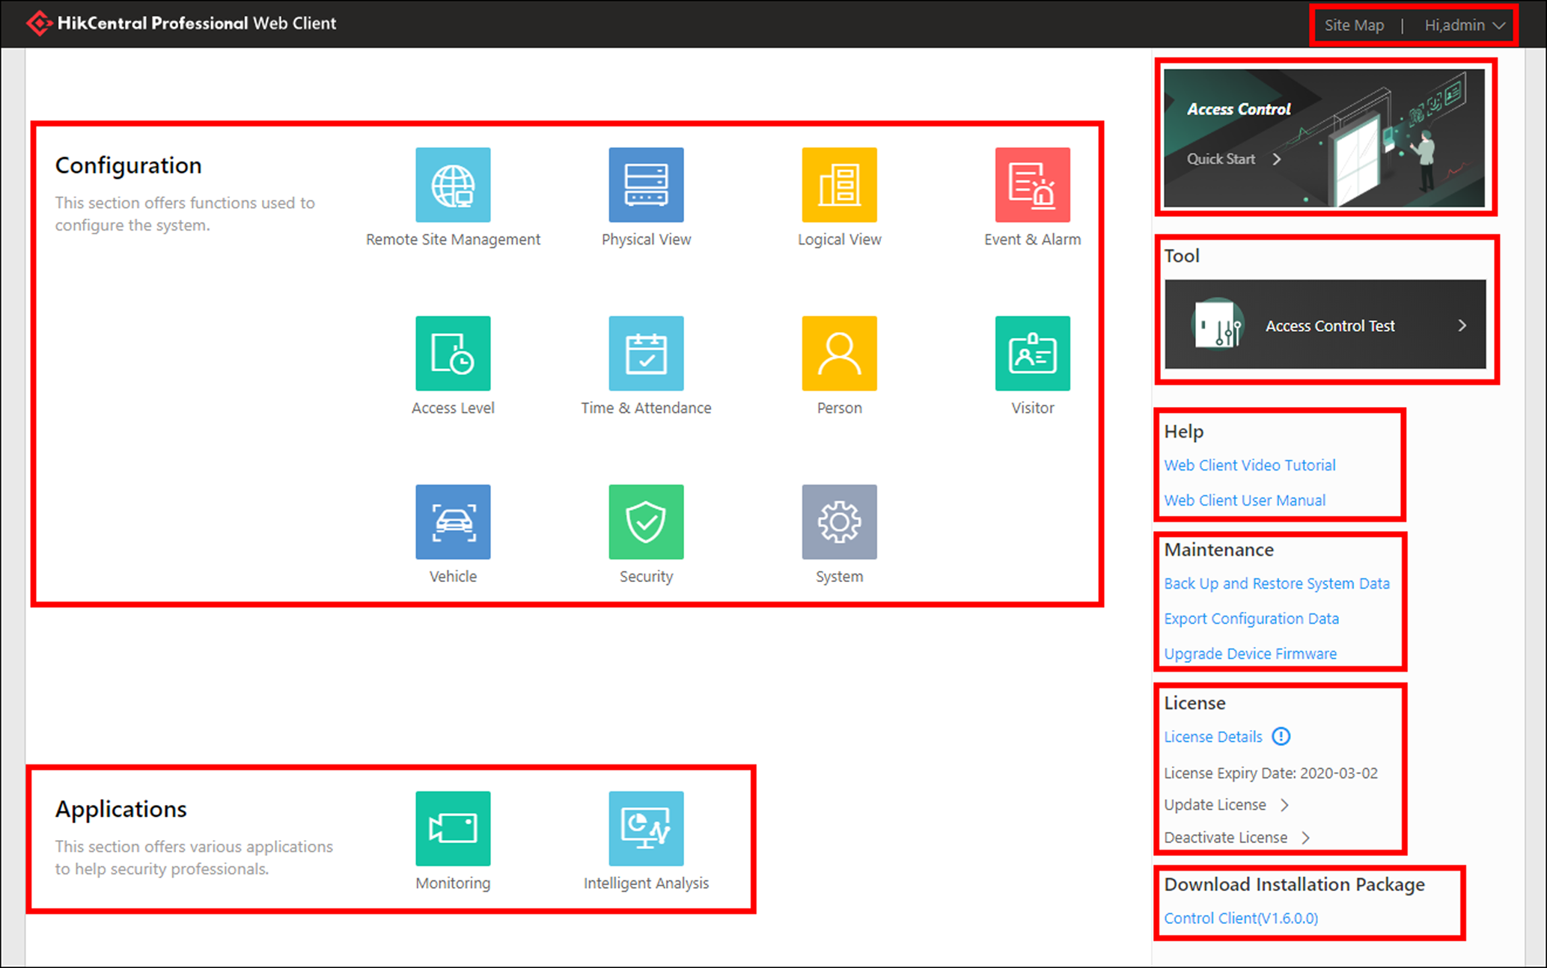
Figure 1-1 Modules on Home Page
Table 1-1 Modules on Home Page
Section | Module | Description
Configuration | Remote Site Management | The Remote Site Management (often short as RSM) module provides federation functions by adding other HikCentral Professional without RSM module to the HikCentral Professional with RSM module as the Remote Site for central management.  For more details, refer to Manage Remote Site.
 | Physical View | The Physical View module provides device management to manage all kinds of devices or servers in the system, such as encoding devices, access control devices, security control devices, etc.  For more details, refer to Manage Resource.
 | Logical View | The Logical View module provides areas to manage the added resources in different groups. You can group the resources into different areas according to the resources' locations.  For more details, refer to Manage Area.
 | Event & Alarm | The Event & Alarm module provides events and alarm settings as well as linkage actions settings.  For more details, refer to Configure Event and Alarm.
 | Access Level | The Access Level module provides defining access permissions that which persons can get access to which doors and floors during the authorized time period.  For more details, refer to Manage Access Level.
 | Person | The Person module provides adding person information to the system for further operations such as access control, face comparison, time and attendance, etc.  For more details, refer to Manage Person List.
 | Visitor | The Visitor module provides an entire process for visitors tour from registration to check-out.  For more details, refer to Manage Visitor.
 | Security | The Security module provides roles and users management and system security settings.  For more details, refer to Manage Role and User and Manage System Security.
 | System | The System module provides setting basic parameters for the system  For more details, refer to System Configuration.
Applications | Monitoring | The Monitoring module provides live view, playback, and local configuration through web browser.  For more details, refer to Monitoring.
Help | Web Client Video Tutorial | View the videos which introduce the configurations on the Web Client.
 | Web Client User Manual | Open the user manual of the Web Client for help. You can enter some keywords to search in the manual.
Maintenance | Back Up and Restore System Data | You can manually back up the data in the system, or configure a schedule to run the backup task regularly.  When an exception occurs, you can restore the database if you have backed up the database.  For more details, refer to Set System Data Backup and Restore Database.
 | Export Configuration Data | You can export and save configuration data to your local PC.  For more details, refer to Export Configuration File.
 | Upgrade Device Firmware | You can upgrade the firmware of the devices added to the system via the current Web Client or EZVIZ Cloud service.  For more details, refer to Upgrade Device Firmware.
License |  | You can view the License details, activate, upgrade, and deactivate the License if needed.  For more details, refer to Manage License.
Download Installation Package |  | Download the installation package of other clients, such as Control Client.
Others | Site Map | The navigation bar of the Web Client. You can access all the modules via the Site Map.
 | Change Password | Change the password of the current user.  For more details, refer to Change Password of Current User.
 | About | Check the version information of the Web Client.  View the License Agreement and Open-Source License Agreement.
 | Logout | Log out of the system and back to the login page.

1.4 Getting Started
The following content describes the tasks typically involved in setting a working system.
Verify Initial Configuration of Devices and other Servers
Before doing anything on system, make sure the devices (camera, DVR, recording server, and so on) you are going to use are correctly installed and connected to the network as specified by the manufacturers. Such initial configuration is required in order to connect the devices to the system via network.
Open Web Client and Login
Refer to Login for First Time for admin User.
Activate License
Refer to Manage License.
Add Devices to System and Configure Area
The system can quickly scan your network for relevant devices (camera, DVR, and so on), and add them to your system. Or you can add the devices by inputting the required information manually. The devices added should be organized into areas for convenient management. Refer to Manage Resource and Manage Area.
Configure Recording Settings
You can record the video files of the cameras on the storage device according to the configured recording schedule. The schedule can be set as continuous, alarm triggered, or command triggered as desired. Refer to Configure Recording.
Configure Event and Alarm
The camera exception, device exception, server exception, and alarm input can trigger linkage actions in the system. Refer to Configure Event and Alarm.
Configure Users
Specify who should be able to access your system, and how. You can set the different permissions for the users to limit the operation of the system. Refer to Manage Role and User.
Architecture of the deployment
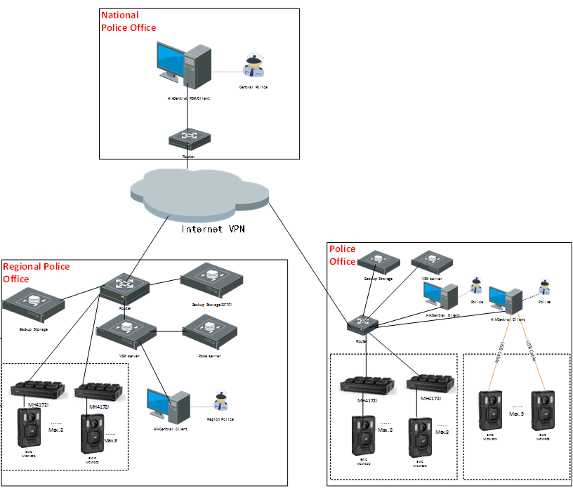
Chapter 2 Login
You can access and configure the system via web browser directly, without installing any client software on the your computer.

2.1 Recommended Running Environment
The following is recommended system requirement for running Web Client.
CPU
Intel Pentium IV 3.0 GHz and above
Memory
1 GB and above
Video Card
RADEON X700 Series
Web Browser
Internet Explorer 10/11 and above, Firefox 57 and above, Google Chrome 61 and above, Safari 11 and above (running on Mac OS X 10.3/10.4).
Note
You should run the web browser as administrator.

2.2 First Time Login
If this is the first time for you to login, you can choose to login as admin or normal user according to your user role.

2.2.1 Login for First Time for admin User
By default, the system predefined the administrator user named admin. When you login via the Web Client for the first time, you are required to create a password for the admin user before you can properly configure and operate the system.
Steps
1. In the address bar of the web browser, enter the address of the PC running SYS service and press Enter key.
Example
If the IP address of PC running SYS is 172.6.21.96, and you should enter http://172.6.21.96 or https://172.6.21.96 in the address bar.
Note
- You should set the transfer protocol before accessing the SYS. For details, refer to Set Transfer Protocol.
- You should set the SYS's IP address before accessing the SYS via WAN. For details, refer to Set WAN Access.

2. Enter the password and confirm password for the admin user in the pop-up Create Password window.
Note
The password strength can be checked by the system and should meet the system requirements. The default minimum password strength should be Medium. For setting minimum password strength, refer to Manage System Security.

Caution
The password strength of the device can be automatically checked. We highly recommend you change the password of your own choosing (using a minimum of 8 characters, including at least three kinds of following categories: upper case letters, lower case letters, numbers, and special characters) in order to increase the security of your product. And we recommend you change your password regularly, especially in the high security system, changing the password monthly or weekly can better protect your product.
Proper configuration of all passwords and other security settings is the responsibility of the installer and/or end-user.

3. Click OK.
Web Client home page displays after you successfully creating the admin password.
Result
After you logging in, the Site Name window opens and you can set the site name for the current system as you want.
Note
You can also set it in System → Site Name. See Set Site Name for details.

2.2.2 First Time Login for Normal User
When you log in to the system as normal user via Web Client for the first time, you should change the initial password and set a new password for login.
Steps
1. In the address bar of the web browser, input the address of the PC running SYS service and press the Enter key.
Example
If the IP address of PC running SYS is 172.6.21.96, and you should enter http://172.6.21.96 or https://172.6.21.96 in the address bar.
Note
You should configure the SYS's IP address in WAN Access of System Configuration before accessing the SYS via WAN. For details, refer to Set WAN Access.

2. Enter the user name and password.
Note
Contact the administrator for the user name and initial password.

3. Click Login and the Change Password window opens.
4. Set a new password and confirm the password.
Note
The password strength can be checked by the system and should meet the system requirements. If password strength is lower than the required minimum strength, you will be asked to change your password. For setting minimum password strength, refer to Manage System Security.

Caution
The password strength of the device can be checked by the system. We highly recommend you change the password of your own choosing (using a minimum of 8 characters, including at least three kinds of following categories: upper case letters, lower case letters, numbers, and special characters) in order to increase the security of your product. And we recommend you reset your password regularly, especially in the high security system, resetting the password monthly or weekly can better protect your product.
Proper configuration of all passwords and other security settings is the responsibility of the installer and/or end-user.

5. Click OK to change the password.
Result
Web Client home page displays after you successfully logging in.

2.3 Login via Web Client
You can access the system via web browser and configure the system.
Steps
1. In the address bar of the web browser, input the address of the PC running SYS service and press Enter key.
Example
If the IP address of PC running SYS is 172.6.21.96, and you should enter http://172.6.21.96 or https://172.6.21.96 in the address bar.
Note
You should configure the SYS's IP address in WAN Access of System Configuration before accessing the SYS via WAN. For details, refer to Set WAN Access.

2. Enter the user name and password.
3. Click Login to log in to the system.
Note
- If failed password attempt of current user is detected, you are required to input the verification code. The failed password attempts from current client, other client, and other address will all require the verification code.
- The failed password attempt and verification code attempt from current client, other client (e.g., Control Client), and other address will all be accumulated. Your IP address will be locked for a specified period of time after specific number of failed password or verification code attempts detected. For setting failed login attempts and locking duration, refer to Manage System Security.
- The account will be frozen for 30 minutes after 5 failed password attempts. The failed password attempts from current client, other clients (e.g., Control Client), and other addresses will all be accumulated.
- The password strength can be checked by the system and should meet the system requirements. If password strength is lower than the required minimum strength, you will be asked to change your password. For setting minimum password strength, refer to Manage System Security.
- If your password is expired, you will be asked to change your password when login. For setting maximum password age, refer to Manage System Security.

Result
Web Client home page displays after you successfully logging in to the system.

2.4 Change Password for Reset User
When the normal user's password is reset by admin user, he/she should change the initial password and set a new password when logging into HikCentral Professional via the Web Client.
Steps
1. In the address bar of the web browser, enter the address of the PC running SYS service and press Enter key.
Example
If the IP address of PC running SYS is 172.6.21.96, and you should enter http://172.6.21.96 or https://172.6.21.96 in the address bar.
Note
You should configure the SYS's IP address in WAN Access of System Configuration before accessing the SYS via WAN. For details, refer to Set WAN Access.

2. Enter the user name and initial password set by the administrator.
3. Click Login and a Change Password window opens.
4. Set a new password and confirm the password.
Note
The password strength can be checked by the system and should meet the system requirements. If password strength is lower than the required minimum strength, you will be asked to change your password. For setting minimum password strength, refer to Manage System Security.

Caution
The password strength of the device can be checked by the system. We highly recommend you change the password of your own choosing (using a minimum of 8 characters, including at least three kinds of following categories: upper case letters, lower case letters, numbers, and special characters) in order to increase the security of your product. And we recommend you reset your password regularly, especially in the high security system, resetting the password monthly or weekly can better protect your product.
Proper configuration of all passwords and other security settings is the responsibility of the installer and/or end-user.

5. Click OK.
Result
Web Client home page displays after you successfully changing the password.

2.5 Forgot Password
If you forgot the your account's password, you can reset the password and set a new password.
Perform this task when you forgot the user's password.
Steps
1. Open the login page.
2. Enter a user name in the User Name field.
3. Click Forgot Password.
4. Set the new password for the user.
- For admin user, enter the activation code, new password, and confirm password in the Reset Password window.
- For normal user, if the email address is set when adding the user and email server is tested successfully, click Get Code, and then you will receive an email with the verification code in your email address. Within 10 minutes, enter the received verification code, new password, and confirm password to set the new password for the normal user.
Note
If the email address is not set for the normal user, contact the admin user to reset the password for you and change the password when login. See Reset Password for Normal User for details.

- For domain user, contact the admin user to reset the password.
Note
The password strength can be checked by the system and should meet the system requirements. If password strength is lower than the required minimum strength, you will be asked to change your password. For setting minimum password strength, refer to Manage System Security.

Caution
The password strength of the device can be automatically checked. We highly recommend you change the password of your own choosing (using a minimum of 8 characters, including at least three kinds of following categories: upper case letters, lower case letters, numbers, and special characters) in order to increase the security of your product. And we recommend you change your password regularly, especially in the high security system, changing the password monthly or weekly can better protect your product.
Proper configuration of all passwords and other security settings is the responsibility of the installer and/or end-user.

5. Click OK.
Chapter 3 Web Control
For accessing the Web Client via web browser, you must install a web control on the PC on which you access the Web Client when performing some functions, e.g., live view, playback, and searching online devices. Web Client automatically asks you to install the web control when you want to access the corresponding functions, and you can follow the prompts to install it on the PC.

Chapter 3 Manage License
After installing HikCentral Professional, you have a temporary License for a specified number of cameras and limited functions. To ensure the proper use of HikCentral Professional, you can activate the SYS to access more functions and manage more devices. If you do not want to activate the SYS now, you can skip this chapter and activate the system later.
Two types of License are available for HikCentral Professional:
- Base: You need to purchase at least one basic License to activate the HikCentral Professional.
- Expansion: If you want to increase the capability of your system (e.g., connect more cameras), you can purchase an expanded License to get additional features.
Note
- Only the admin user can perform the activation, update, and deactivation operation.
- If you encounter any problems during activation, update, and deactivation, please send the server logs to our technical support engineers.

3.1 Activate License - Online
If the SYS server to be activated can properly connect to the Internet, you can activate the SYS server in online mode.
Steps
Note
If you activate the system by the License with server distributed deployment function, you cannot switch the system to server central deployment.

1. Log in to HikCentral Professional via the Web Client. Refer to Login via Web Client.
2. Click Online Activation in the License area to open the License configuration window.
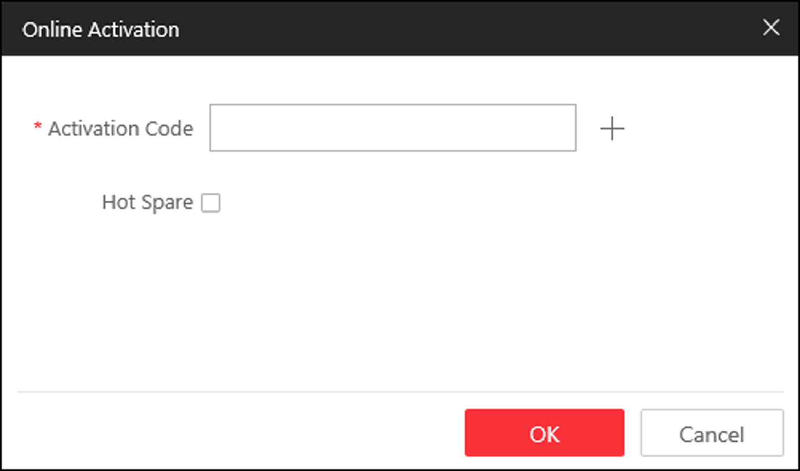
Figure 5-1 Online Activation
3. Enter the activation code received when you purchased your License.
Note
- If you have purchased more than one Licenses, you can click  and enter other activation codes.
- Up to 110 Licenses are allowed in one system.
- The activation code should contain 16 characters or 32 characters (except dashes).

4. Optional: Set the Hot Spare switch to ON and input the required parameters if you want to build a hot spare system.
Note
- You must select Hot Spare mode when you install the system.
- For how to build the hot spare system, please contact our technical support engineers.

5. Click OK and the License Agreement dialog opens.
6. Read the License Agreement.
- If you accept the terms of the License Agreement, check I accept the terms of the agreement and click OK to continue.
- If you do not accept the agreement, click Cancel to cancel the activation.
The activation will start.

3.2 Activate License - Offline
If the SYS server to be activated cannot connect to the Internet, you can activate the License in offline mode.
Steps
Note
If you activate the system by the License with server distributed deployment function, you cannot switch the system to server central deployment.

1. Log in to HikCentral Professional via the Web Client.
2. Click Export the license request file in the License area.
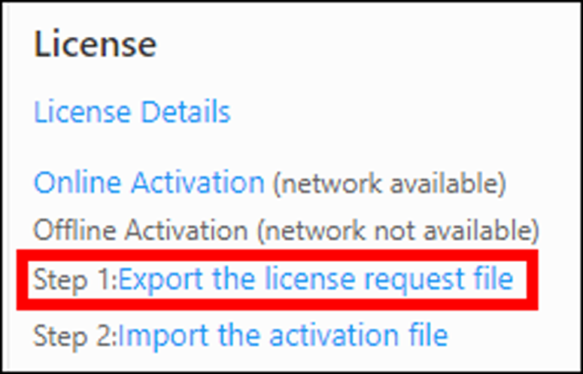
Figure 5-2 Export Request File
3. Enter the activation code received when you purchased your License.
Note
- If you have purchased more than one License, you can click and enter other activation codes.
- Up to 110 Licenses are allowed in one system.
- The activation code should contain 16 characters or 32 characters (except dashes).
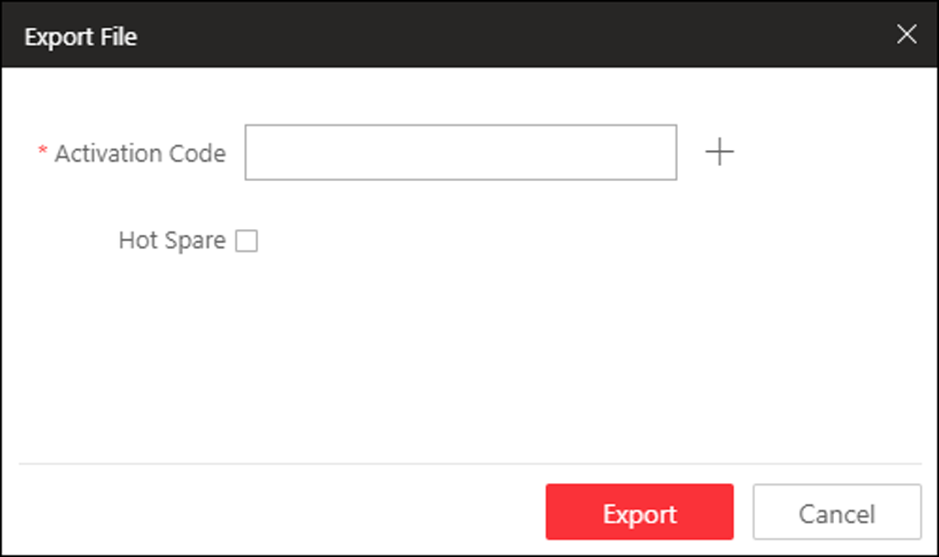
Figure 5-3 Export File

4. Optional: Check Hot Spare and enter the required parameters if you want to build a hot spare system.
Note
- The switch will be displayed if you select Hot Spare mode when installing the system.
- For how to build the hot spare system, please contact Hikvision's technical support engineers.

5. Click Export.
6. In the pop-up License Agreement window, check I accept the terms of the agreement and click OK.
A request file named "ActivationRequestFile.bin" will be downloaded. Save the request file to the proper directory or the removable storage medium (e.g., USB flash disk).
7. Copy the request file to the PC that can connect to the Internet.
8. On the PC which can connect to the Internet, enter the following website: https://license.hikvision.com:8443/#/active.
9. Click  and then select the request file downloaded in Step 6.
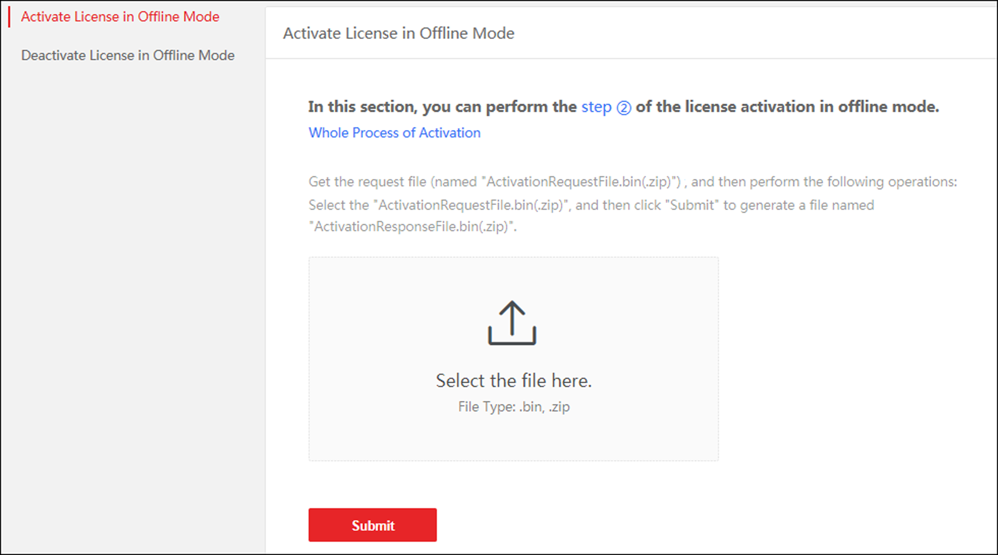
Figure 5-4 Select Request File
10. Click Submit.
A respond file named "ActivationResponseFile.bin" will be downloaded. Save the respond file to the proper directory or the removable storage medium (e.g., USB flash disk).
11. Copy the respond file to the proper directory of the PC that accesses HikCentral Professional via the Web Client.
12. In the License area, click Import the activation file.
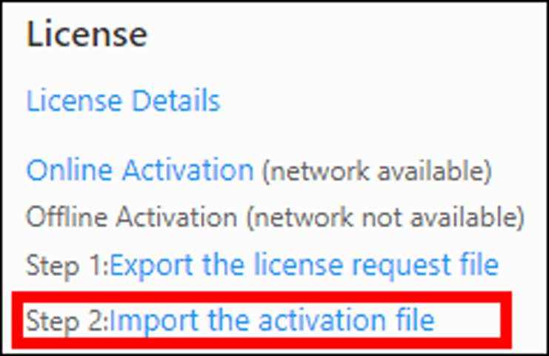
Figure 5-5 Import Respond File
13. Click and select the respond file downloaded in Step 10.
14. Click Import.

3.3 Update License - Online
As your project grows, you may need to increase the connectable number of resources (e.g., cameras) for your HikCentral Professional. If the SYS to be updated can properly connect to the Internet, you can update the License in online mode.
Before You Start
Contact your dealer or our sales team to purchase a License for additional features
Steps
1. Log in to HikCentral Professional via the Web Client. Refer to Login via Web Client for details.
2. Click Update License at the License area to open the update panel.
3. Enter the activation code received when you purchase your License.
Note
- If you have purchased more than one Licenses, you can click and enter other activation codes.
- Up to 110 Licenses are allowed in one system.
- The activation code should contain 16 characters or 32 characters (except dashes).

4. Click Update and the License Agreement dialog opens.
5. Read the License Agreement.
- If you accept the terms of the license agreement, check I accept the terms of the agreement and click OK to continue.
- If you do not accept the agreement, click Cancel to cancel the update.
The activation will start.

3.4 Update License - Offline
As your project grows, you may need to increase the connectable number of cameras for your HikCentral Professional. If the SYS to be updated cannot connect to the Internet, you can update the system in offline mode.
Before You Start
Contact your dealer or our sales team to purchase a License for additional features.
Steps
1. Log in to HikCentral Professional via the Web Client.
2. Click Update License in the License area and click Export the license request file.
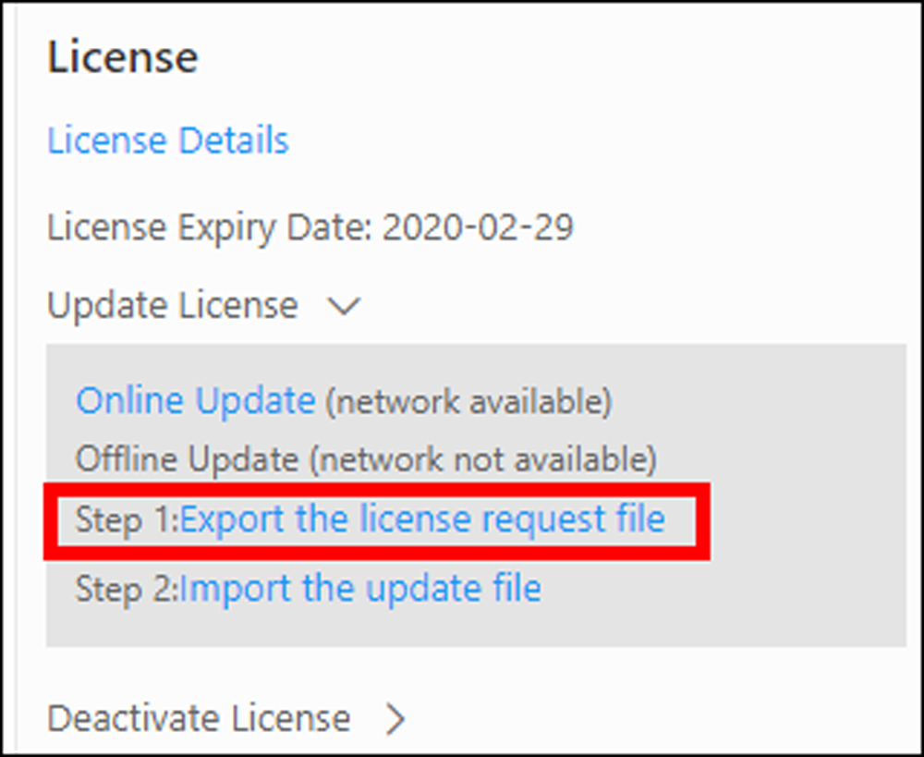
Figure 5-6 Export Request File
3. Enter the activation code of your additional License.
Note
- If you have purchased more than one License, you can click and enter other activation codes.
- Up to 110 Licenses are allowed in one system.
- The activation code should contain 16 characters or 32 characters (except dashes).

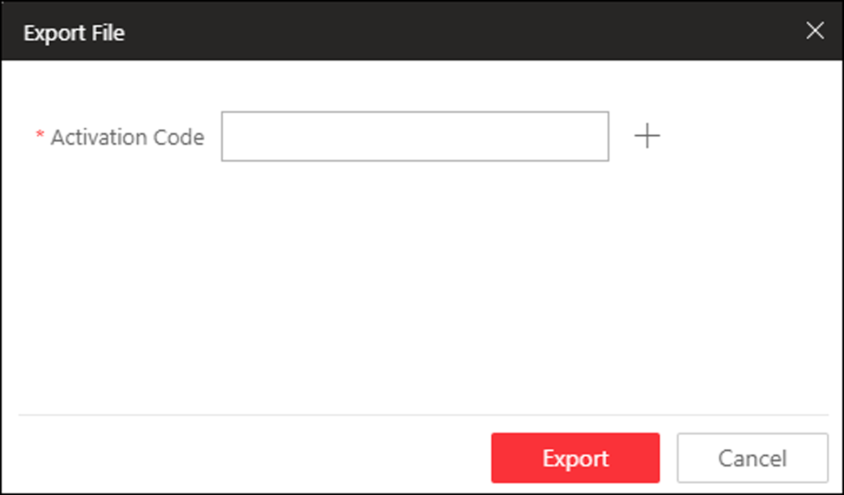
Figure 5-7 Export File
4. Click Export.
5. In the pop-up License Agreement window, check I accept the terms of the agreement and click OK.
A request file named "ActivationRequestFile.bin" will be downloaded. Save the request file to the proper directory or the removable storage medium (e.g., USB flash disk).
6. Copy the request file to the PC that can connect to the Internet.
7. On the PC which can connect to the Internet, enter the following website: https://license.hikvision.com:8443/#/active.
8. Click and then select the request file downloaded in Step 5.
Figure 5-8 Select Request File
9. Click Submit.
A respond file named "ActivationResponseFile.bin" will be downloaded. Save the respond file to the proper directory or the removable storage medium (e.g., USB flash disk).
10. Copy the respond file to the proper directory of the PC that accesses HikCentral Professional via the Web Client.
11. In the License area, click Update License → Import the update file.
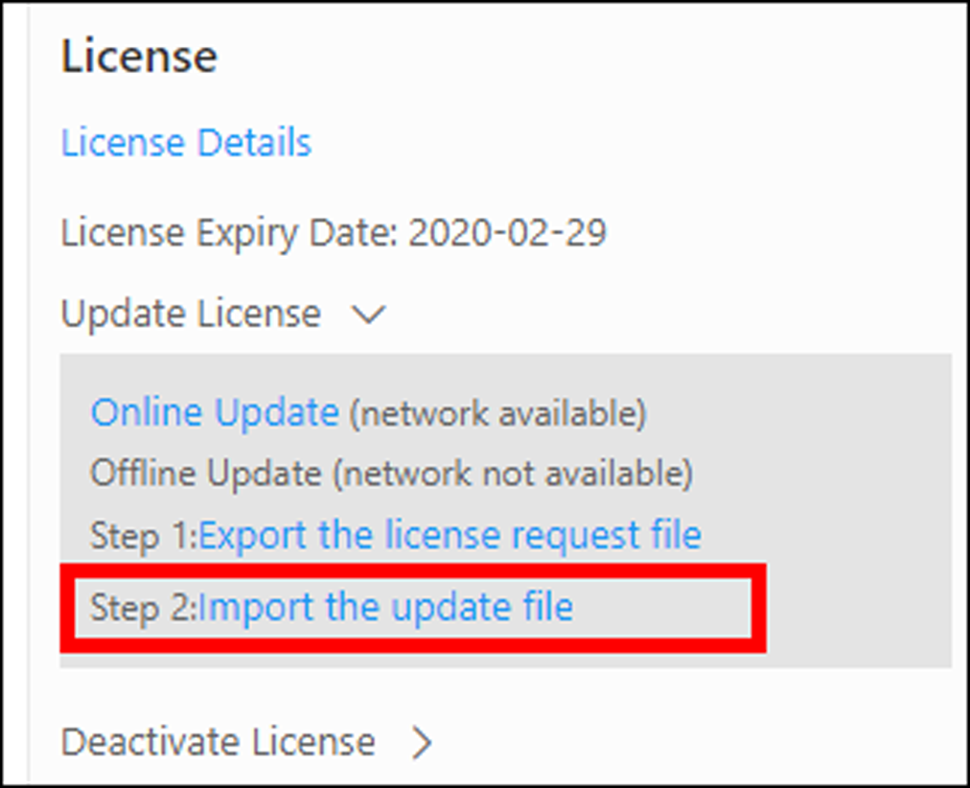
Figure 5-9 Import Respond File
12. Click and select the respond file downloaded in Step 9.
13. Click Import.

3.5 Deactivate License - Online
If you want to run the SYS on another PC or server, you should deactivate the SYS first and then activate the other SYS again. If the SYS to be deactivated can properly connect to the Internet, you can deactivate the License in online mode.
Steps
1. Log in to HikCentral Professional via the Web Client. Refer to Login via Web Client.
2. Click Deactivate License in the License area to open the deactivation panel.
3. Click Online Deactivation and check the activation code(s) to be deactivated.
4. Click OK to deactivate the license.
The deactivation will start.

3.6 Deactivate License - Offline
If you want to run the SYS on another PC or server, you should deactivate the SYS first and then activate the SYS again. If the SYS to be deactivated cannot connect to the Internet, you can deactivate the License in offline mode.
Steps
1. Log in to the HikCentral Professional via Web Client.
2. Click Deactivate License in the License area and click Export the license request file.
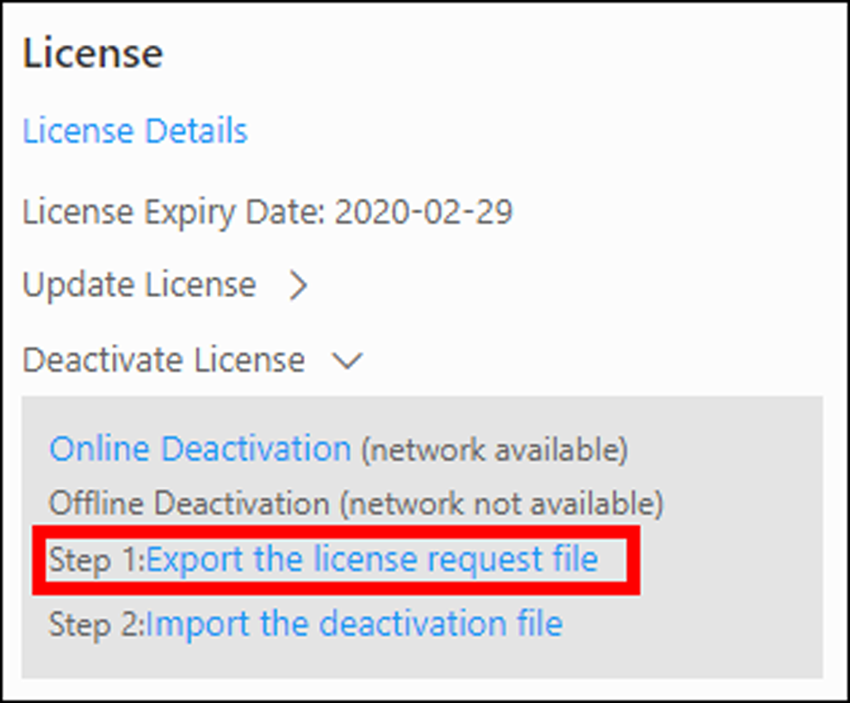
Figure 5-10 Export Request File
3. Select the activation code(s) to be deactivated.
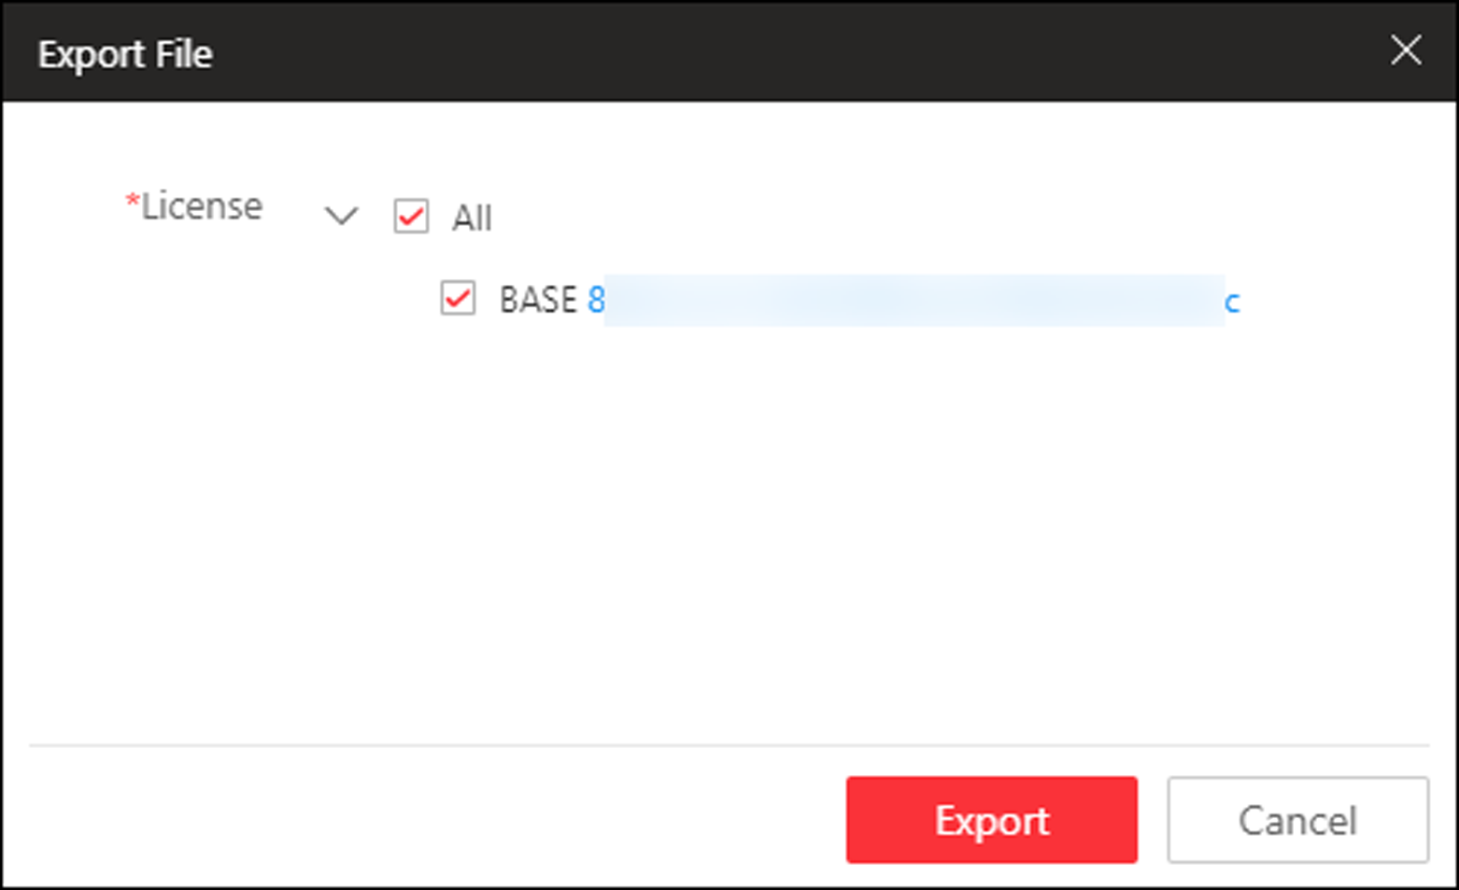
Figure 5-11 Select Activation Code
4. Click Export.
A request file named "DeactivationRequestFile.bin" will be downloaded. Save the request file to the proper directory or the removable storage medium (e.g., USB flash disk).
Note
After exporting the request file, the selected activation codes will be unavailable.

5. Copy the request file to the PC that can connect to the Internet.
6. On the PC which can connect to the Internet, enter the following website: https://license.hikvision.com:8443/#/deactive.
7. Click and then select the request file downloaded in Step 4.
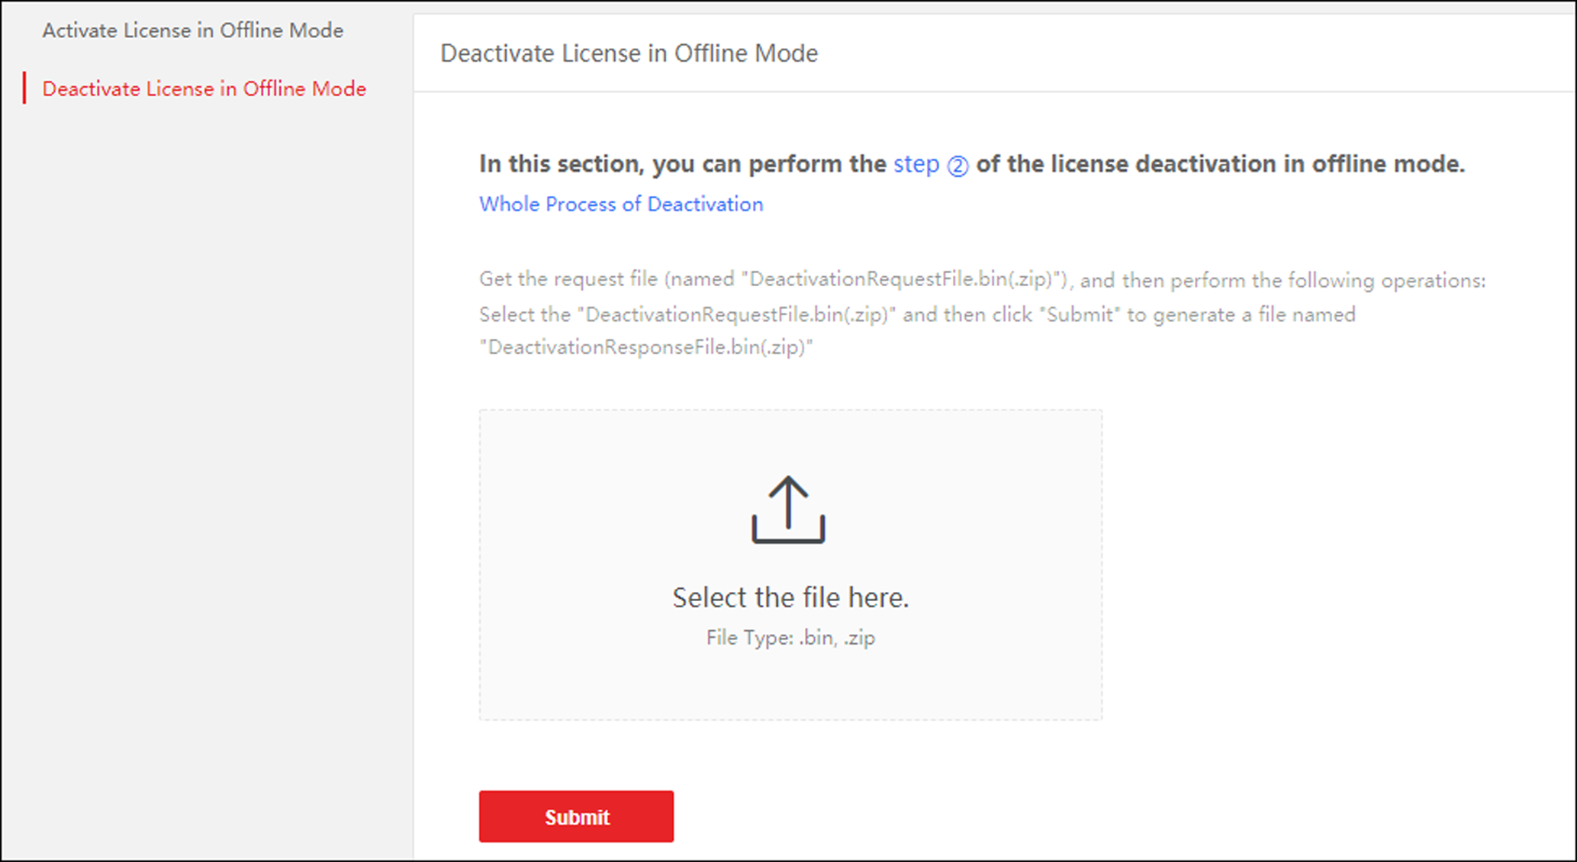
Figure 5-12 Select Request File
8. Click Submit.
A respond file named "DectivationResponseFile.bin" will be downloaded. Save the respond file to the proper directory or the removable storage medium (e.g., USB flash disk).
9. Copy the respond file to the proper directory of the PC that accesses HikCentral Professional via the Web Client.
10. In the License area, click Deactivate License → Import the update file.
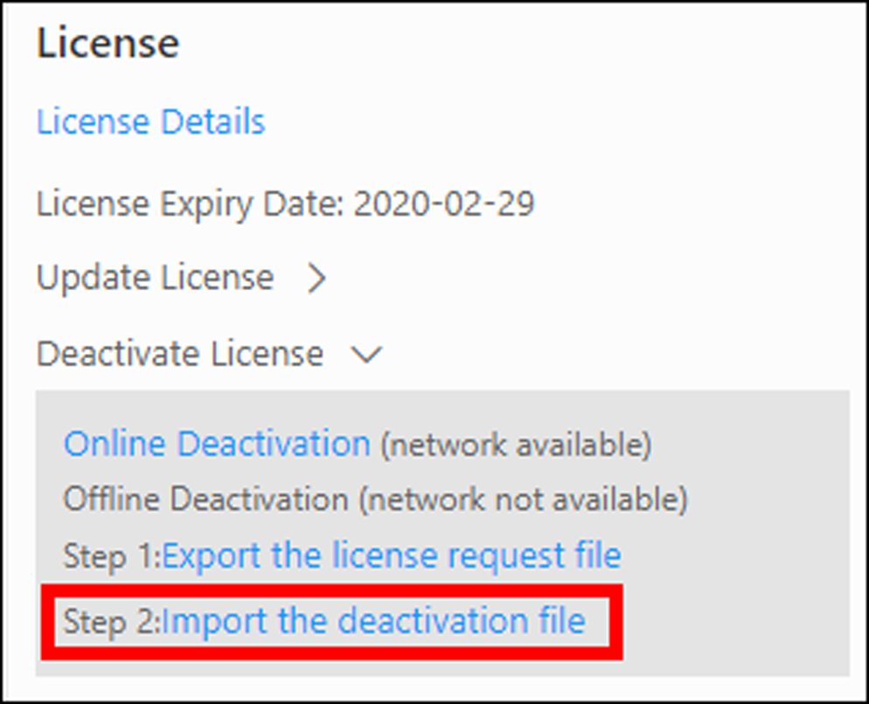
Figure 5-13 Import Respond File
11. Click and select the respond file downloaded in Step 8.
12. Click Import.

Chapter 4 Manage Resource
HikCentral Professional supports multiple resource types, such as encoding device, access control device, Remote Site, decoding device and Smart Wall. After adding them to the system, you can manage them, configure required settings and perform further operations. For example, you can add encoding devices for live view, playback, recording settings, event configuration, etc., add access control devices for access control, time and attendance management, etc., add Remote Site for central management of multiple systems, add Recording Server for storing the videos, add Streaming Server for getting the video data stream from the server, and add Smart Wall for displaying decoded video on smart wall.

4.1 Create Password for Inactive Device(s)
Because of simple default password, the devices may be accessed by the unauthorized user easily. For more security purpose, the default password is not provided for some devices. You are required to create the password to activate them before adding them and performing some operations on them via the system . Besides activating the device one by one, you can also deal with multiple ones at the same time. The devices which are activated in a batch will have the same password.
Before You Start
- Make sure the devices (cameras, DVR, etc.) you are going to use are correctly installed and connected to the network as specified by the manufacturers. Such initial configuration is required in order to be able to connect the devices to the HikCentral Professional via network.
- This function should be supported by the device. Make sure the devices you want to activate support this function.
Perform this task when you need to activate the detected online devices. Here we take creating password for the encoding device as an example.
Steps
1. Click Physical View → Encoding Device to enter the Encoding Device Management page.
Note
- For access control devices, click Physical View → Access Control Device to enter the access control device management page.
- For elevator control devices, click Physical View → Elevator Control Device to enter the elevator control device management page.
- For security control devices, click Physical View → Security Control Device to enter the security control device management page.
- For decoding devices, click Physical View → Smart Wall. On the Decoding Device area, click Add and check Online Devices as Adding Mode.

The detected online devices list in the online device area.
2. View the device status (shown on Security column) and select one or multiple inactive devices.
3. Click  to open the Device Activation window.
4. Create a password in the password field, and confirm the password.
Caution
The password strength of the device can be automatically checked. We highly recommend you change the password of your own choosing (using a minimum of 8 characters, including at least three kinds of following categories: upper case letters, lower case letters, numbers, and special characters) in order to increase the security of your product. And we recommend you change your password regularly, especially in the high security system, changing the password monthly or weekly can better protect your product.
Proper configuration of all passwords and other security settings is the responsibility of the installer and/or end-user.

5. Click Save to create the password for the device.
An Operation completed. message is displayed when the password is set successfully.
6. Click  in the Operation column of the device and change its IP address, subnet mask, and gateway to the same subnet with your computer if you need to add the device to the system. Refer to Edit Online Device's Network Information.

4.2 Edit Online Device's Network Information
The online devices, which have IP addresses in the same local subnet with SYS server or Web Client, can be detected by HikCentral Professional. For the detected online devices, you can edit their network information as desired via HikCentral Professional remotely and conveniently. For example, change the device IP address due to the changes of the network.
Before You Start
For some devices, you must activate it before editing its network information. Refer to Create Password for Inactive Device(s) for details.
Perform this task when you need to edit the network information for the detected online devices. Here we take editing encoding device as an example.
Steps
1. Click Physical View → Encoding Deviceto enter the Encoding Device Management page.
Note
- For access control devices, click Physical View → Access Control Device to enter the access control device management page.
- For security control devices, click Physical View → Security Control Device to enter the security control device management page.
- For decoding devices, click Physical View → Smart Wall. On the Decoding Device area, click Add and check Online Devices as Adding Mode.

2. In the Online Device area, select a network type.
Server Network
The detected online devices in the same local subnet with the SYS server will list in the Online Device area.
Local Network
The detected online devices in the same local subnet with the Web Client will list in the Online Device area.
3. View the device status (shown on Security column) and click  in the Operation column of an active device.
4. Change the required parameters, such as IP address, device port, HTTP port, subnet mask, and gateway.
Note
The parameters may vary for different device types.

5. Click .
6. Enter device's password.
7. Click Save.

4.3 Manage Encoding Device
The encoding devices (e.g., camera, NVR, DVR) can be added to the system for management, including editing and deleting the devices, remote configuration, changing online devices' password, etc. You can also perform further operations based on the added devices, such as live view, video recording, and event settings,

4.3.1 Add Detected Online Device
The system can perform an automated detection for available encoding devices in the network where the Web Client or server is located, which makes the devices' information about themselves (e.g., IP address) recognized by the system. Based on the information, you can add the devices quickly.
You can add one online devices at a time, or add multiple online devices in a batch.
Note
You should install the web control according to the instructions and then the online device detection function is available.

Add a Detected Online Encoding Device
When you want to add one of the detected online devices at present or add a few of these devices with different user names and passwords, you need to select only one device every time to add it to HikCentral Professional. The IP address, port number and user name will be recognized automatically, which may reduce some manual operations in a way.
Before You Start
- Make sure the devices (cameras, DVR, etc.) you are going to use are correctly installed and connected to the network as specified by the manufacturers. Such initial configuration is required in order to be able to connect the devices to the HikCentral Professional via network.
- The devices to be added should be activated. Refer to Create Password for Inactive Device(s) for details about activating devices.
Steps
1. Click Physical View → Encoding Device to enter the Encoding Device Management page.
2. In the Online Device area, select a network type.
Server Network
As the default selection, the detected online devices in the same local subnet with the SYS server will be listed in the Online Device area.
Local Network
The detected online devices in the same local subnet with the Web Client will be listed in the Online Device area.
3. In the Online Device area, select Hikvision Private Protocol/ Hikvision ISUP Protocol/ONVIF Protocol to filter the detected online devices.
Note
Select Hikvision Private Protocol/Hikvision ISUP Protocol to add a Hikvision device and select ONVIF Protocol to add a third-party device.

4. In the Online Device area, select the active device to be added.
5. Click Add to Device List to open the Add Online Device window.
6. Set the required information.
Device Address
The IP address of the device, which is shown automatically.
Device Port
The port number of the device, which is shown automatically. The default port number is 8000.
Mapped Port
This function is only available when you select Hikvision Private Protocol in Step 3. If you want to download pictures from the device, switch Mapped Port to on and enter the picture downloading port. By default, the port No. is 80.
Verify Stream Encryption Key
Switch Verify Stream Encryption Key to on, and enter stream encryption key in Stream Encryption Key on Device field. Then when starting live view or remote playback of the device, the client will verify the key stored in SYS server for security purpose.
Note
This function should be supported by the devices. Refer to the user manual of the device for getting key.

Device Name
Create a descriptive name for the device. For example, you can use an alias that can show the location or feature of the device.
User Name
The user name for administrator account created when activating the device or the added non-admin account such as operator. When adding the device to HikCentral Professional using the non-admin account, your permissions may restrict your access to certain features.
Password
The password required to access the account.
Caution
The password strength of the device can be automatically checked. We highly recommend you change the password of your own choosing (using a minimum of 8 characters, including at least three kinds of following categories: upper case letters, lower case letters, numbers, and special characters) in order to increase the security of your product. And we recommend you change your password regularly, especially in the high security system, changing the password monthly or weekly can better protect your product.
Proper configuration of all passwords and other security settings is the responsibility of the installer and/or end-user.

7. Optional: Select a time zone for the device in drop-down list of Time Zone of Device.
Note
You can check Apply to Device so that when the time zone of the device and the system are not consistent, the system will automatically apply the time zone settings to the device.

8. Optional: Switch Add Channel to Area to on to import the channels of the added devices to an area.
Note
- You can import all the channels including cameras, alarm inputs and alarm outputs, or the specified camera(s) to the corresponding area.
- You can create a new area by the device name or select an existing area.
- If you do not import channels to area, you cannot perform operations such as live view, playback, event settings, etc., for the cameras.

9. Optional: If you choose to add channels to area, select a Streaming Server to get the video stream of the channels via the server.
Note
You can check Wall Display via Streaming Server to get stream via the selected Streaming Server when displaying live view on the smart wall.

10. Optional: If you choose to add channels to area, enable the Video Storage function and select the storage location for recording.
Encoding Device
The video files will be stored in the device according to the configured recording schedule.
Hybrid Storage Area Network
The video files will be stored in the Hybrid Storage Area Network according to the configured recording schedule.
Cloud Storage Server
The video files will be stored in the Cloud Storage Server according to the configured recording schedule.
pStor
According to the configured recording schedule, the video files will be stored in the pStor, which is the storage access service for managing local HDDs and logical disks.
pStor Cluster Service
pStor Cluster Service is a service that can manage multiple pStors. When there are multiple pStors storing a large number of video files, use pStor Cluster Service to manage these pStors.

Note
- For adding the encoding device by domain name, the video files can only be stored in the local storage of the device.
- Configure the Hybrid Storage Area Network, Cloud Storage Server or pStor in advance, or its storage location cannot display in the drop-down list. You can click Add New to add a new Hybrid Storage Area Network, Cloud Storage Server or pStor.

11. Set the quick recording schedule for added channels.
- Check Get Device's Recording Settings to get the recording schedule from the device and the channels of the device will start recording according to the schedule.
- Uncheck Get Device's Recording Settings and set the required information, such as recording schedule template, stream type, etc. Refer to Configure Recording for Cameras on Current Site for details.
12. Click Add.
13. Optional: Perform the following operations after adding the online device.
Remote Configurations | Click  to set the remote configurations of the corresponding device.  Note  For detailed operation steps about remote configuration, see the user manual of the device.
Change Password | Select the added device(s) and click  to change the password for the device(s).  Note  - You can only change the password for online HIKVISION devices currently.  - If the devices have the same password, you can select multiple devices to change the password for them at the same time.

What to do next
For facial recognition camera/ANPR camera/thermal camera (report supported), turn to Home page, click License Details → Configuration → Add, and then select the added cameras as these three types of cameras respectively. Otherwise, these cameras' functions (facial recognition, plate recognition, and temperature report) cannot be performed normally in the system.

Add Detected Online Encoding Devices in a Batch
For the detected online encoding devices, if they have the same user name and password, you can add multiple devices to HikCentral Professional at a time. The devices added by this method will be set as the same channel information, which you can edit later if required.
Before You Start
- Make sure the devices (cameras, DVR, etc.) you are going to use are correctly installed and connected to the network as specified by the manufacturers. Such initial configuration is required in order to be able to connect the devices to the HikCentral Professional via network.
- The devices to be added should be activated. Refer to Create Password for Inactive Device(s) for details about activating devices.
Perform this task when you need to add the detected online devices in a batch.
Steps
1. Click Physical View → Encoding Device to enter the Encoding Device Management page.
2. In the Online Device area, select a network type.
Server Network
As the default selection, the detected online devices in the same local subnet with the SYS server will list in the Online Device area.
Local Network
The detected online devices in the same local subnet with the Web Client will list in the Online Device area.
3. In the Online Device area, select Hikvision Private Protocol/ Hikvision ISUP Protocol/ONVIF Protocol to filter the detected online devices.
Note
Select Hikvision Private Protocol/Hikvision ISUP Protocol to add Hikvision devices and select ONVIF Protocol to add third-party devices.

4. In the Online Device area, check the active devices to be added.
5. Click Add to Device List to open the Add Online Device dialog.
6. Optional: Switch Mapped Port to on and enter the picture downloading port if you want to download pictures from the device.
Note
This function is only available when you select Hikvision Private Protocol in Step 3. By default, the port No. is 80.

7. Optional: Switch Verify Stream Encryption Key to on, and enter stream encryption key in Stream Encryption Key on Device field.
Note
This function should be supported by the devices. Refer to the user manual of the device for getting key.

When starting live view or remote playback of the camera, the client will verify the key stored in SYS server for security purpose.
8. Enter the same user name and password.
User Name
The user name for administrator account created when activating the device or the added non-admin account such as operator. When adding the device to HikCentral Professional using the non-admin account, your permissions may restrict your access to certain features.
Password
The password required to access the account.
Caution
The password strength of the device can be automatically checked. We highly recommend you change the password of your own choosing (using a minimum of 8 characters, including at least three kinds of following categories: upper case letters, lower case letters, numbers, and special characters) in order to increase the security of your product. And we recommend you change your password regularly, especially in the high security system, changing the password monthly or weekly can better protect your product.
Proper configuration of all passwords and other security settings is the responsibility of the installer and/or end-user.

9. Optional: Select a time zone for the device in drop-down list of Time Zone of Device.
Note
You can check Apply to Device so that when the time zone of the device and the system are not consistent, the system will automatically apply the time zone settings to the device.

10. Optional: Switch Add Channel to Area to on to import the channels of the added devices to an area.
Note
- You can import all the channels including cameras, alarm inputs and alarm outputs, or the specified camera(s) to the corresponding area.
- You can create a new area by the device name or select an existing area.
- If you do not import channels to area, you cannot perform operations such as live view, playback, event settings, etc., for the cameras.

11. Optional: Select a Streaming Server to get the video stream of the channels via the server.
Note
You can check Wall Display via Streaming Server to get stream via the selected streaming server when starting live view on the smart wall.

12. Click Add.
13. Optional: Perform the following operations after adding the online devices in a batch.
Remote Configurations | Click to set the remote configurations of the corresponding device.  Note  For details about remote configuration, see the user manual of the device.
Change Password | Select the added device(s) and click to change the password for the device(s).  Note  - You can only change the password for online HIKVISION devices currently.  - If the devices have the same password, you can select multiple devices to change the password for them at the same time.

What to do next
For facial recognition camera/ANPR camera/thermal camera (report supported), turn to Home page, click License Details → Configuration → Add, and then select the added cameras as these three types of cameras respectively. Otherwise, these cameras' functions (facial recognition, plate recognition, and temperature report) cannot be performed normally in the system.

4.3.2 Add Encoding Device by IP Address or Domain Name
When you know the IP address or domain name of a device, you can add it to the system by specifying the IP address (or domain name), user name, password, etc.
Before You Start
Make sure the devices (cameras, DVR, etc.) you are going to use are correctly installed and connected to the network as specified by the manufacturers. Such initial configuration is required in order to be able to connect the devices to the HikCentral Professional via network.
Steps
1. Click Physical View → Encoding Device to enter the Encoding Device Management page.
2. Click Add to enter the Add Encoding Device page.
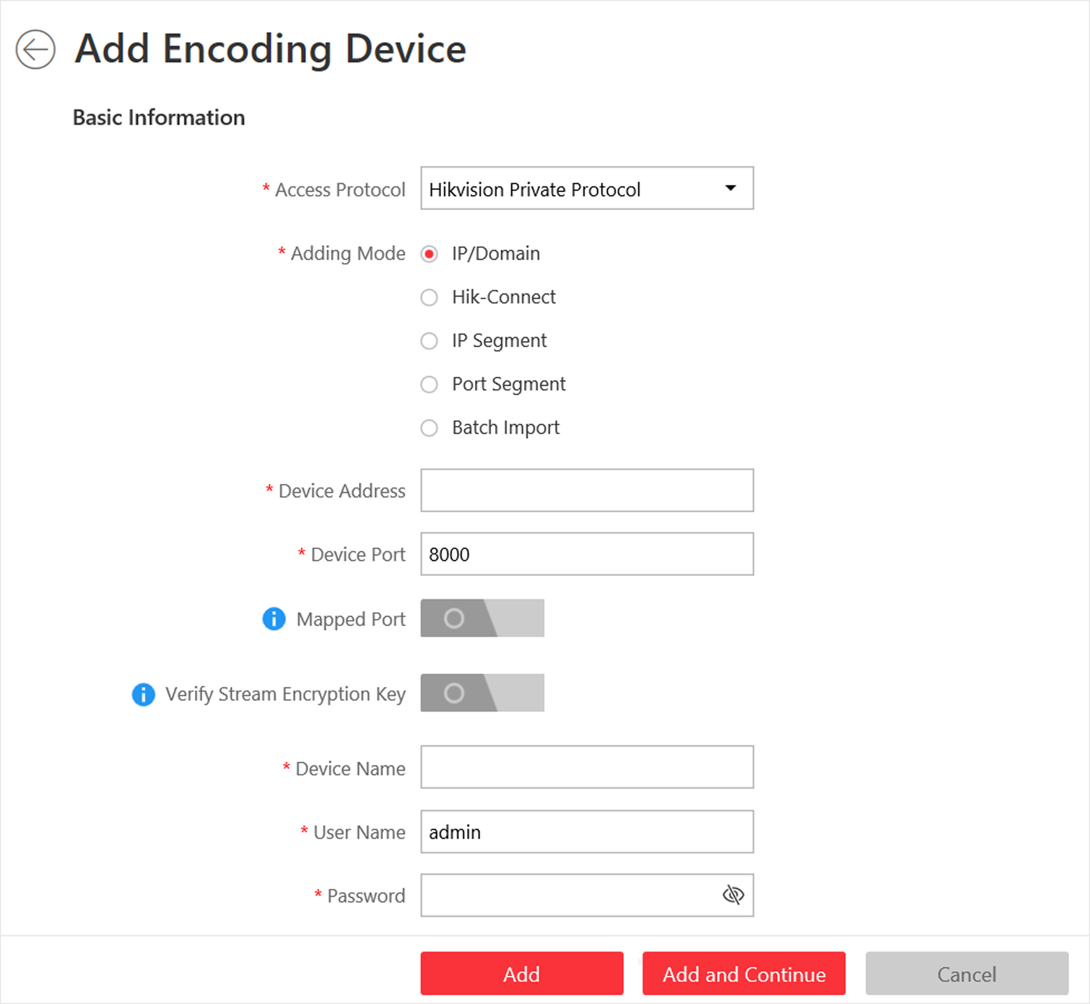
Figure 6-1 Add Encoding Device Page
3. Select Hikvision Private Protocol/ONVIF Protocol as the Access Protocol.
Note
Select Hikvision Private Protocol to add a Hikvision device, while select ONVIF Protocol to add a third-party device.

4. Select IP/Domain as the adding mode.
5. Enter the required information.
Device Address
The IP address or domain name of the device.
Device Port
By default, the device port No. is 8000.
Mapped Port
This function is used for downloading pictures from devices added by Hikvision Private Protocol. Set the Mapped Port switch to on and enter the picture downloading port No. that you have configured in the remote configuration page of the device. The default port No. is 80.

Verify Stream Encryption Key
This button is for Hikvision Private Protocol only. Switch Verify Stream Encryption Key to on, and enter the stream encryption key in the following Stream Encryption Key on Device field. Then when starting live view or remote playback of the device, the client will verify the key stored in SYS server for security purpose.
Note
This function should be supported by the devices. For details about getting the key, refer to the user manual of the device.

Device Name
Create a descriptive name for the device. For example, you can use an alias that can show the location or feature of the device.
Password
The password required to access the account.
Caution
The password strength of the device can be automatically checked. We highly recommend you change the password of your own choosing (using a minimum of 8 characters, including at least three kinds of following categories: upper case letters, lower case letters, numbers, and special characters) in order to increase the security of your product. And we recommend you change your password regularly, especially in the high security system, changing the password monthly or weekly can better protect your product.
Proper configuration of all passwords and other security settings is the responsibility of the installer and/or end-user.

6. Optional: Select a time zone for the device in drop-down list of Time Zone of Device.
Note
You can check Apply to Device so that when the time zone of the device and the system are not consistent, the system will automatically apply the time zone settings to the device.

7. Optional: Switch Add Channel to Area to on to import the channels of the added devices to an area.
Note
- You can import all the channels including cameras, alarm inputs and alarm outputs, or the specified camera(s) to the corresponding area.
- You can create a new area by the device name or select an existing area.
- If you do not import channels to area, you cannot perform operations such as live view, playback, event settings, etc., for the cameras.

8. Optional: If you choose to add channels to area, select a Streaming Server to get the video stream of the channels via the server.
Note
You can check Wall Display via Streaming Server to get stream via the selected Streaming Server when displaying live view on the smart wall.

9. Optional: If you choose to add channels to area, enable the Video Storage function and select the storage location for recording.
Encoding Device
The video files will be stored in the device according to the configured recording schedule.
Hybrid Storage Area Network
The video files will be stored in the Hybrid Storage Area Network according to the configured recording schedule.
Cloud Storage Server
The video files will be stored in the Cloud Storage Server according to the configured recording schedule.
pStor
According to the configured recording schedule, the video files will be stored in the pStor, which is the storage access service for managing local HDDs and logical disks.
pStor Cluster Service
pStor Cluster Service is a service that can manage multiple pStors. When there are multiple pStors storing a large number of video files, use pStor Cluster Service to manage these pStors.

Note
- For adding the encoding device by domain name, the video files can only be stored in the local storage of the device.
- Configure the Hybrid Storage Area Network, Cloud Storage Server or pStor in advance, or its storage location cannot display in the drop-down list. You can click Add New to add a new Hybrid Storage Area Network, Cloud Storage Server or pStor.

10. Set the quick recording schedule for added channels.
- Check Get Device's Recording Settings to get the recording schedule from the device and the channels of the device will start recording according to the schedule.
- Uncheck Get Device's Recording Settings and set the required information, such as recording schedule template, stream type, etc. Refer to Configure Recording for Cameras on Current Site for details.
11. Finish adding the device.
- Click Add to add the encoding device and back to the encoding device list page.
- Click Add and Continue to save the settings and continue to add other encoding devices.
12. Optional: Perform the following operation(s) after adding the devices.
Remote Configurations | Click to set the remote configurations of the corresponding device.  Note  For detailed operation steps for the remote configuration, see the user manual of the device.
Change Password | Select the added device(s) and click to change the password for the device(s).  Note  - You can only change the password for online HIKVISION devices currently.  - If the devices have the same password, you can select multiple devices to change the password for them at the same time.

What to do next
For facial recognition camera/ANPR camera/thermal camera (report supported), turn to Home page, click License Details → Configuration → Add, and then select the added cameras as these three types of cameras respectively. Otherwise, these cameras' functions (facial recognition, plate recognition, and temperature report) cannot be performed normally in the system.

4.3.3 Add Encoding Devices by IP Segment
When multiple encoding devices to be added have the same port number, user name and password, but have different IP addresses within a range, you can select this adding mode, and specify the IP range where your devices are located, and other related parameters. The system will scan from the start IP address to the end IP address for the devices in order to add them quickly.
Before You Start
Make sure the devices (cameras, DVR, etc.) you are going to use are correctly installed and connected to the network as specified by the manufacturers. Such initial configuration is required in order to be able to connect the devices to the HikCentral Professional via network.
Steps
1. Click Physical View → Encoding Device to enter the Encoding Device Management page.
2. Click Add to enter the Add Encoding Device page.
Figure 6-2 Add Encoding Device Page
3. Select Hikvision Private Protocol/ONVIF Protocol as the Access Protocol.
Note
Select Hikvision Private Protocol to add a Hikvision device, while select ONVIF Protocol to add a third-party device.

4. Select IP Segment as the adding mode.
5. Enter the required information.
Device Address
Enter the start IP address and the end IP address where the devices are located.
Device Port
By default, the device port No. is 8000.
Mapped Port
This function is used for downloading pictures from devices added by Hikvision Private Protocol. Set the Mapped Port switch to on and enter the picture downloading port No. that you have configured in the remote configuration page of the device. The default port No. is 80.

Verify Stream Encryption Key
This button is for Hikvision Private Protocol only. You can switch Verify Stream Encryption Key to on, and enter the stream encryption key in the following Stream Encryption Key on Device field. Then when starting live view or remote playback of the device, the client will verify the key stored inSYS server for security purpose.
Note
This function should be supported by the devices. Refer to the User Manual of the device for getting key.

User Name
The user name for administrator created when activating the device or the added non-admin users. When adding the device to HikCentral Professional using the non-admin user, your permissions may restrict your access to certain features.
Password
The password required to access the device.
Caution
The password strength of the device can be automatically checked. We highly recommend you change the password of your own choosing (using a minimum of 8 characters, including at least three kinds of following categories: upper case letters, lower case letters, numbers, and special characters) in order to increase the security of your product. And we recommend you change your password regularly, especially in the high security system, changing the password monthly or weekly can better protect your product.
Proper configuration of all passwords and other security settings is the responsibility of the installer and/or end-user.

6. Optional: Select a time zone for the device in drop-down list of Time Zone of Device.
Note
You can check Apply to Device so that when the time zone of the device and the system are not consistent, the system will automatically apply the time zone settings to the device.

7. Optional: Switch Add Channel to Area to on to import the channels of the added devices to an area.
Note
- You can import all the channels including cameras, alarm inputs and alarm outputs, or the specified camera(s) to the corresponding area.
- You can create a new area by the device name or select an existing area.
- If you do not import channels to area, you cannot perform the live view, playback, event settings, etc., for the channels.

8. Optional: If you choose to add channels to area, select a Streaming Server to get the video stream of the channels via the server.
Note
You can check Wall Display via Streaming Server to get stream via the selected Streaming Server when displaying live view on the smart wall.

9. Set the quick recording schedule for added channels.
- Check Get Device's Recording Settings to get the recording schedule from the device and the channels of the device will start recording according to the schedule.
- Uncheck Get Device's Recording Settings and set the required information, such as recording schedule template, stream type, etc. Refer to Configure Recording for Cameras on Current Site for details.
10. Finish adding the device.
- Click Add to add the devices of which the IP addresses are between the start IP address and end IP address and back to the device list page.
- Click Add and Continue to save the settings and continue to add other encoding devices.
11. Optional: Perform the following operations after adding the devices.
Remote Configurations | Click to set the remote configurations of the corresponding device.  Note  For details about remote configuration, see the user manual of the device.
Change Password | Select the added device(s) and click to change the password for the device(s).  Note  - You can only change the password for online HIKVISION devices currently.  - If the devices have the same password, you can select multiple devices to change the password for them at the same time.

What to do next
For facial recognition camera/ANPR camera/thermal camera (report supported), turn to Home page, click License Details → Configuration → Add, and then select the added cameras as these three types of cameras respectively. Otherwise, these cameras' functions (facial recognition, plate recognition, and temperature report) cannot be performed normally in the system.

4.3.4 Add Encoding Devices by Port Segment
When multiple encoding devices to add have the same IP address, user name and password, but have different port numbers within a range, you can select this adding mode and specify the port range, IP address, user name, password, and other related parameters to add them.
Before You Start
Make sure the devices (cameras, DVR, etc.) you are going to use are correctly installed and connected to the network as specified by the manufacturers. Such initial configuration is required in order to be able to connect the devices to the HikCentral Professional via network.
Steps
1. Click Physical View → Encoding Device to enter the Encoding Device Management page.
2. Click Add to enter the Add Encoding Device page.
Figure 6-3 Add Encoding Device Page
3. Select Hikvision Private Protocol/ONVIF Protocol as the access protocol.
Note
Select Hikvision Private Protocol to add Hikvision devices and select ONVIF Protocol to add third-party devices.

4. Select Port Segment as the adding mode.
5. Enter the required information.
Device Address
Enter the IP address to add the devices which have the same IP address.
Device Port
Enter the start port No. and the end port No.
Mapped Port
This function is used for downloading pictures from devices added by Hikvision Private Protocol. Set the Mapped Port switch to on and enter the picture downloading port No. that you have configured in the remote configuration page of the device. The default port No. is 80.

Verify Stream Encryption Key
This button is for Hikvision Private Protocol only. You can switch Verify Stream Encryption Key to on, and enter the stream encryption key in the following Stream Encryption Key on Device field. Then when starting live view or remote playback of the device, the client will verify the key stored in SYS server for security purpose.
Note
This function should be supported by the devices. Refer to the user manual of the device for getting key.

User Name
The user name for administrator account created when activating the device or the added non-admin account such as operator. When adding the device to HikCentral Professional using the non-admin account, your permissions may restrict your access to certain features.
Password
The password required to access the account.
Caution
The password strength of the device can be automatically checked. We highly recommend you change the password of your own choosing (using a minimum of 8 characters, including at least three kinds of following categories: upper case letters, lower case letters, numbers, and special characters) in order to increase the security of your product. And we recommend you change your password regularly, especially in the high security system, changing the password monthly or weekly can better protect your product.
Proper configuration of all passwords and other security settings is the responsibility of the installer and/or end-user.

6. Optional: Select a time zone for the device in drop-down list of Time Zone of Device.
Note
You can check Apply to Device so that when the time zone of the device and the system are not consistent, the system will automatically apply the time zone settings to the device.

7. Optional: Switch Add Channel to Area to on to import the channels of the added devices to an area.
Note
- You can import all the channels including cameras, alarm inputs and alarm outputs, or the specified camera(s) to the corresponding area.
- You can create a new area by the device name or select an existing area.
- If you do not import channels to area, you cannot perform the live view, playback, event settings, etc., for the channels.

8. Optional: If you choose to add channels to area, select a Streaming Server to get the video stream of the channels via the server.
Note
You can check Wall Display via Streaming Server to get stream via the selected streaming server when displaying live view on the smart wall.

9. Set the quick recording schedule for added channels.
- Check Get Device's Recording Settings to get the recording schedule from the device and the channels of the device will start recording according to the schedule.
- Uncheck Get Device's Recording Settings and set the required information, such as recording schedule template, stream type, etc. Refer to Configure Recording for Cameras on Current Site for details.
10. Finish adding the device.
- Click Add to add the devices of which the port No. is between the start port No. and end port No. and back to the device list page.
- Click Add and Continue to save the settings and continue to add other devices.
11. Optional: Perform the following operations after adding the devices.
Remote Configurations | Click to set the remote configurations of the corresponding device.  Note  For details about remote configuration, see the user manual of the device.
Change Password | Select the added device(s) and click to change the password for the device(s).  Note  - You can only change the password for online HIKVISION devices currently.  - If the devices have the same password, you can select multiple devices to change the password for them at the same time.

What to do next
For facial recognition camera/ANPR camera/thermal camera (report supported), turn to Home page, click License Details → Configuration → Add, and then select the added cameras as these three types of cameras respectively. Otherwise, these cameras' functions (facial recognition, plate recognition, and temperature report) cannot be performed normally in the system.

4.3.5 Add Encoding Device by Hik-Connect
With this adding mode, you can add encoding devices even if the devices do not have fixed IP addresses.
Before You Start
Make sure the devices (cameras, DVR, etc.) you are going to use are correctly installed and connected to the network as specified by the manufacturers. Such initial configuration is required in order to be able to connect the devices to the HikCentral Professional via network.
Perform this task when you need to add device by Hik-Connect.
Steps
1. Click Physical View → Encoding Device to enter the Encoding Device Management page.
2. Click Add to enter the Add Encoding Device page.
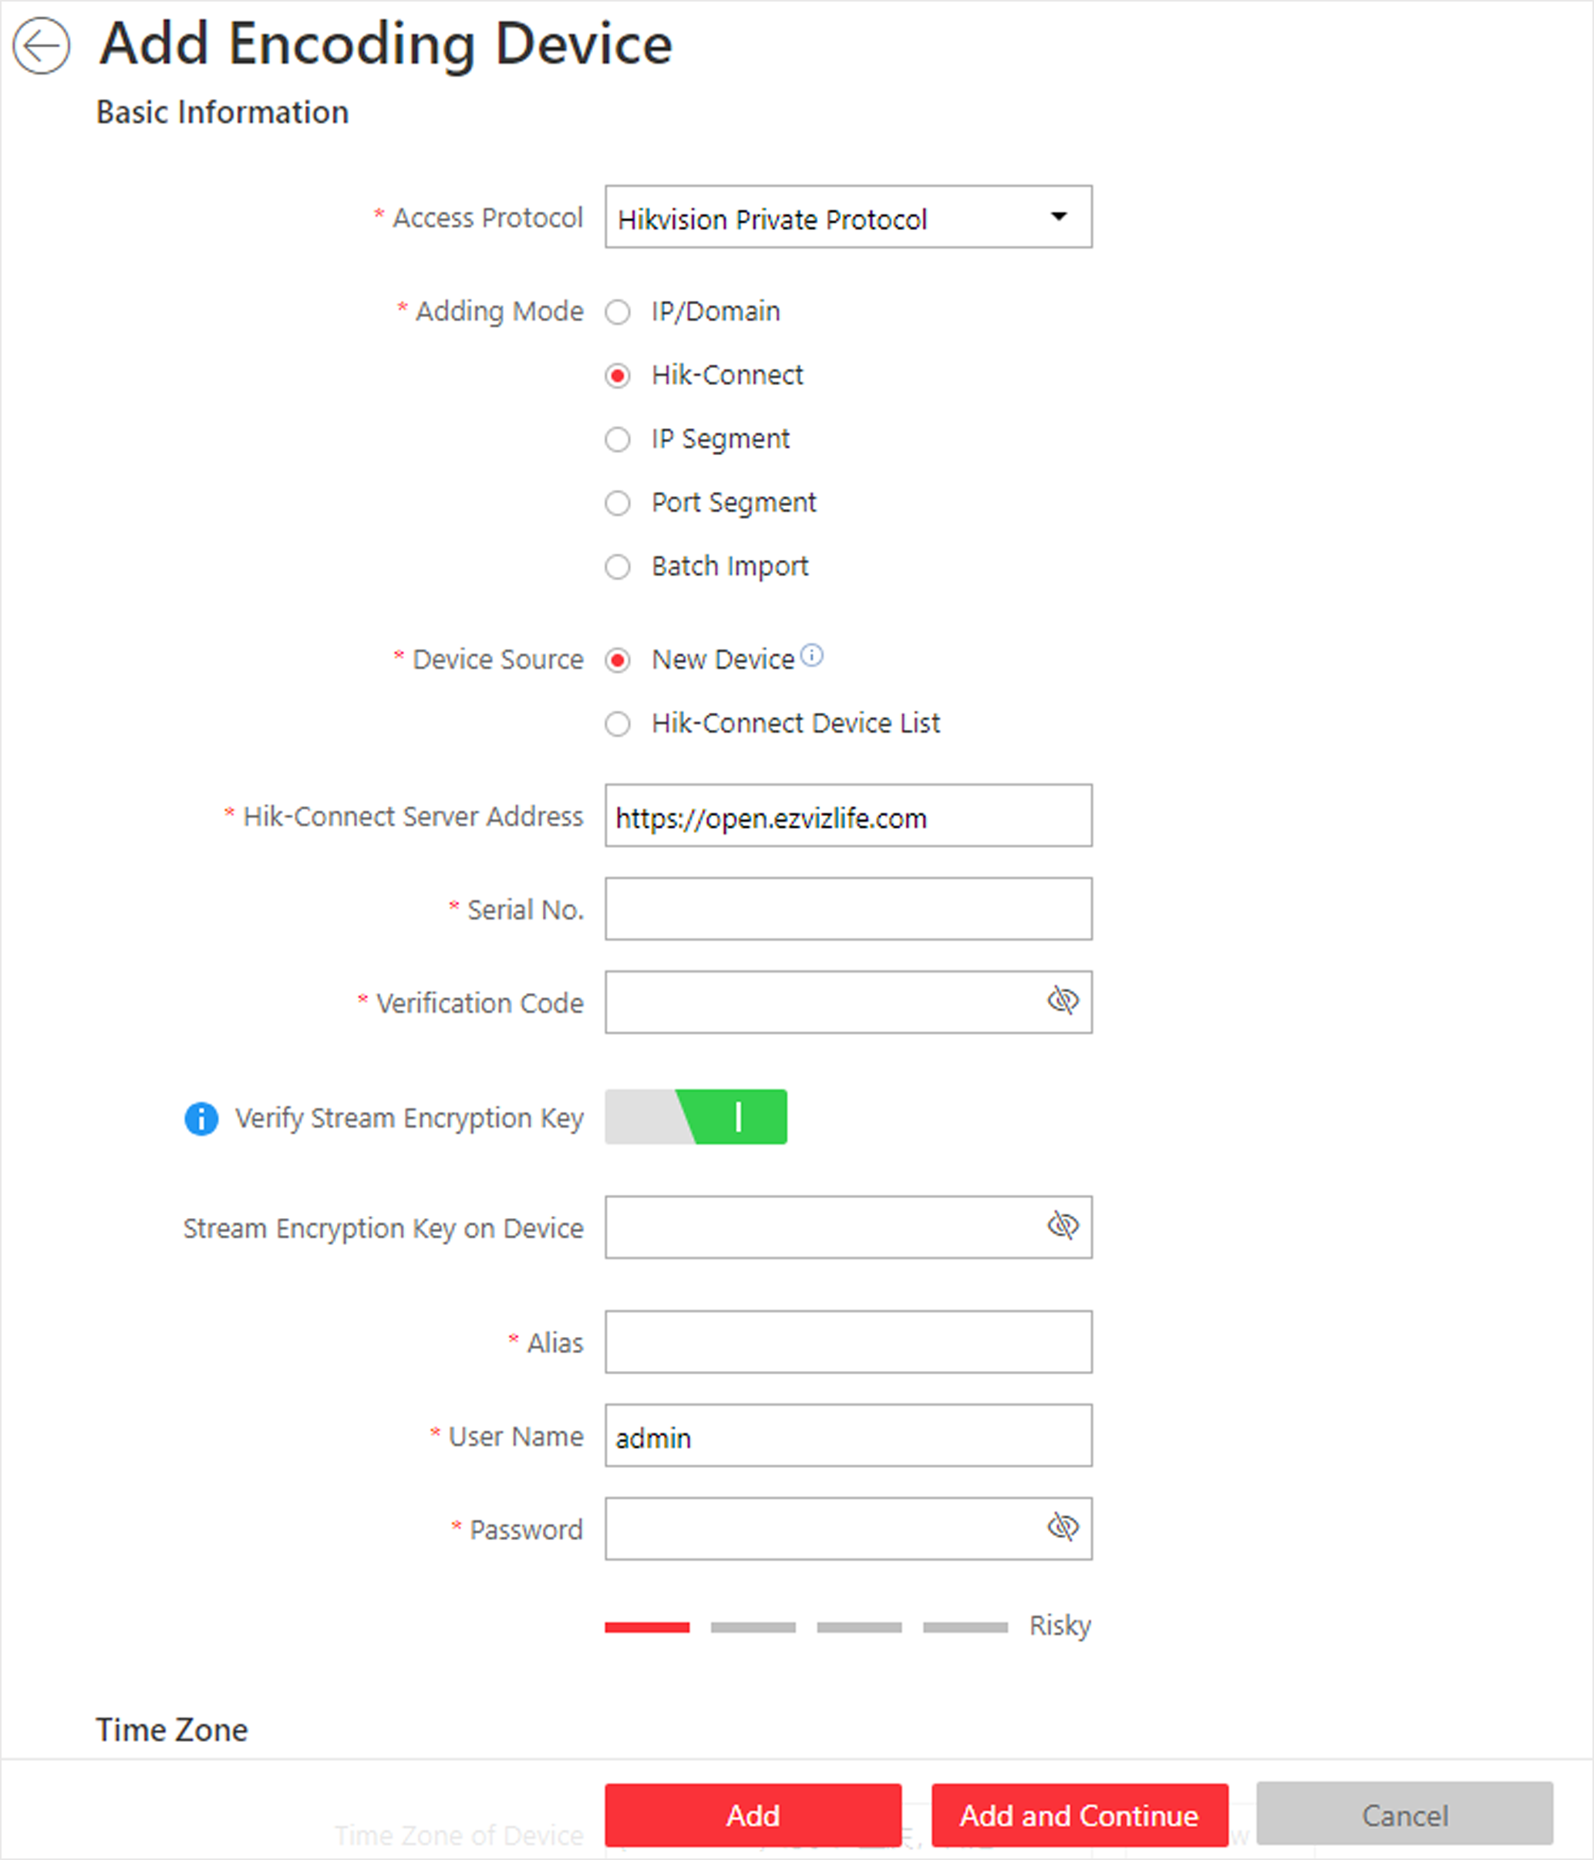
Figure 6-4 Add Encoding Device Page
3. Select Hikvision Private Protocol as the Access Protocol.
4. Select Hik-Connect as the adding mode.
5. Optional: Set the Mapped Port switch to on and enter the picture downloading port No. that you have configured in the remote configuration page of the device. The default port No. is 80.
6. Select a device source.
New Device
Add a new device to HikCentral Professional by Hik-Connect service.
Hik-Connect Device List
For users with a Hik-Connect account, you can add devices managed in your Hik-Connect account to HikCentral Professional in a batch.
7. Enter the required information.
Hik-Connect Server Address
Enter the address of the Hik-Connect service. By default, it's https://open.ezvizlife.com.
Serial No.
Enter the serial No. of the device.
Verification Code
Enter the verification code of the device.
Stream Encryption Key on Device
After switching Verify Stream Encryption Key to on, you should enter stream encryption key in Stream Encryption Key on Device field. Then when starting live view or remote playback of the camera, the client will verify the key stored in the SYS server for security purpose.
Note
This function should be supported by the devices. Refer to user manual of the device.

Device Name
Create a descriptive name for the device. For example, you can use an alias that can show the location or feature of the device.
Caution
The password strength of the device can be automatically checked. We highly recommend you change the password of your own choosing (using a minimum of 8 characters, including at least three kinds of following categories: upper case letters, lower case letters, numbers, and special characters) in order to increase the security of your product. And we recommend you change your password regularly, especially in the high security system, changing the password monthly or weekly can better protect your product.
Proper configuration of all passwords and other security settings is the responsibility of the installer and/or end-user.

8. Optional: Select a time zone for the device in drop-down list of Time Zone of Device.
Note
You can check Apply to Device so that when the time zone of the device and the system are not consistent, the system will automatically apply the time zone settings to the device.

9. Switch Add Channel to Area to on to import the channels of the added devices to an area.
Note
- You can import all the channels including cameras, alarm inputs and alarm outputs, or the specified camera(s) to the corresponding area.
- You can create a new area by the device name or select an existing area.
- If you do not import channels to area, you cannot perform the live view, playback, event settings, etc., for the channels.

10. Optional: If you choose to add channels to area, select a Streaming Server to get the video stream of the channels via the server.
Note
You can check Wall Display via Streaming Server to get stream via the selected Streaming Server when displaying live view on smart wall.

11. Optional: Check Get Device's Recording Settings to get the recording schedule from the device and the channels of the device will start recording according to the schedule.
12. Finish adding the device.
- Click Add to add the encoding device and back to the encoding device list page.
- Click Add and Continue to save the settings and continue to add other encoding devices.
13. Optional: Perform the following operation(s) after adding the devices.
Remote Configurations | Click to set the remote configurations of the corresponding device.  Note  For details about remote configuration, see the user manual of the device.
Change Password | Select the added device(s) and click to change the password for the device(s).  Note  - You can only change the password for online HIKVISION devices currently.  - If the devices have the same password, you can select multiple devices to change the password for them at the same time.

What to do next
For facial recognition camera/ANPR camera/thermal camera (report supported), turn to Home page, click License Details → Configuration → Add, and then select the added cameras as these three types of cameras respectively. Otherwise, these cameras' functions (facial recognition, plate recognition, and temperature report) cannot be performed normally in the system.

4.3.6 Add Encoding Device by Device ID
For the encoding devices supporting ISUP Protocol, you can add them by specifying a predefined device ID, key, etc. This is a cost-effective choice when you need to manage an encoding device without fixed IP address by HikCentral Professional.
Before You Start
- Make sure the encoding devices you are going to use are correctly installed and connected to the network as specified by the manufacturers. Such initial configuration is required in order to be able to connect the devices to the HikCentral Professional via network.
- Before adding devices supporting Hikvision ISUP 2.6/4.0 protocol to the system, you need to set related configuration to allow these devices to access the system. For details, refer to Device Access Protocol.

Steps
1. Click Physical View → Encoding Device to enter the Encoding Device Management page.
2. Click Add to enter the Add Encoding Device page.
3. Select Hikvision ISUP Protocol as the Access Protocol.
4. Select Device ID as the adding mode.
5. Enter the required parameters, including the device ID and device name.
Note
For devices supporting ISUP 5.0 protocol to the system, you should enter the key.

6. Optional: Set Picture Storage switch to on to enable picture storage for the encoding device.
7. Optional: Select the storage location from the drop-down list.
Note
- The pictures uploaded from the devices, such as alarm triggered pictures, captured face pictures and captured plate license pictures, can be stored on the storage location you select.
- You can not configure the storage location for the captured undercarriage pictures, which are stored on the UVSS device.

8. Optional: Select a time zone for the device in drop-down list of Time Zone of Device.
Note
You can check Apply to Device so that when the time zone of the device and the system are not consistent, the system will automatically apply the time zone settings to the device.

9. Optional: Switch Add Channel to Area to ON to import the channels of the added devices to an area.
Note
- You can import all the channels including cameras, alarm inputs and alarm outputs, or the specified camera(s) to the corresponding area.
- For video access control terminal of a device, the camera on the terminal will also be imported to the corresponding area.
- You can create a new area by the device name or select an existing area.
- If you do not import channels to area, you cannot perform operations such as live view, playback, event settings, etc., for the cameras.

10. Optional: If you choose to add channels to area, select a Streaming Server to get the video stream of the channels via the server.
Note
You can check Wall Display via Streaming Server to get stream via the selected Streaming Server when displaying live view on the smart wall.

11. Optional: Check Get Device's Recording Settings to get the recording schedule from the device and the channels of the device will start recording according to the schedule.
12. Finish adding the device.
- Click Add to add the encoding device and back to the encoding device list page.
- Click Add and Continue to save the settings and continue to add other encoding devices.
13. Optional: Perform the following operation(s) after adding the devices.
Remote Configurations | Click to set the remote configurations of the corresponding device.  Note  For detailed operation steps for the remote configuration, see the user manual of the device.
Change Password | Select the added device(s) and click to change the password for the device(s).  Note  - You can only change the password for online HIKVISION devices currently.  - If the devices have the same password, you can select multiple devices to change the password for them at the same time.

4.3.7 Add Encoding Devices by Device ID Segment
If you need to add multiple encoding devices which have no fixed IP addresses and support ISUP Protocol toHikCentral Professional, you can add them to HikCentral Professional at a time after configuring a device ID segment for the devices.
Before You Start
- Make sure the encoding devices you are going to use are correctly installed and connected to the network as specified by the manufacturers. Such initial configuration is required in order to be able to connect the devices to the HikCentral Professional via network.
- Before adding devices supporting ISUP 2.6/4.0 protocol to the system, you need to set related configuration to allow these devices to access the system. For details, refer to Device Access Protocol.

Steps
1. Click Physical View → Encoding Device to enter the Encoding Device Management page.
2. Click Add to enter the Add Encoding Device page.
3. Select Hikvision ISUP Protocol as the Access Protocol.
4. Select Device ID Segment as the adding mode.
5. Enter the required parameters, including the start device ID and end device ID.
Note
For devices supporting ISUP 5.0 protocol to the system, you should enter the key.

6. Optional: Set Picture Storage switch to on to enable picture storage for the encoding device.
7. Optional: Select the storage location from the drop-down list.
Note
- The pictures uploaded from the devices, such as alarm triggered pictures, captured face pictures and captured plate license pictures, can be stored on the storage location you select.
- You can not configure the storage location for the captured undercarriage pictures, which are stored on the UVSS device.

8. Optional: Select a time zone for the device in drop-down list of Time Zone of Device.
Note
You can check Apply to Device so that when the time zone of the device and the system are not consistent, the system will automatically apply the time zone settings to the device.

9. Optional: Switch Add Channel to Area to on to import the channels of the added devices to an area.
Note
- You can import all the channels including cameras, alarm inputs and alarm outputs, or the specified camera(s) to the corresponding area.
- For video access control terminal of a device, the camera on the terminal will also be imported to the corresponding area.
- You can create a new area by the device name or select an existing area.
- If you do not import channels to area, you cannot perform operations such as live view, playback, event settings, etc., for the cameras.

10. Optional: If you choose to add channels to area, select a Streaming Server to get the video stream of the channels via the server.
Note
You can check Wall Display via Streaming Server to get stream via the selected Streaming Server when displaying live view on the smart wall.

11. Optional: Check Get Device's Recording Settings to get the recording schedule from the device and the channels of the device will start recording according to the schedule.
12. Finish adding the device.
- Click Add to add the encoding device and back to the encoding device list page.
- Click Add and Continue to save the settings and continue to add other encoding devices.

4.3.8 Add Encoding Devices in a Batch
When there are a batch of devices to add to HikCentral Professional , you can edit the predefined template containing the required device information, and import it to add multiple devices at a time. This is also a highly effective methods if you set up several similar systems.
Before You Start
Make sure the devices (cameras, DVR, etc.) you are going to use are correctly installed and connected to the network as specified by the manufacturers. Such initial configuration is required in order to be able to connect the devices to the HikCentral Professional via network.
Perform this task when you need to add devices by importing the template which contains information of multiple devices.
Steps
1. Click Physical View → Encoding Device to enter the Encoding Device Management page.
2. Click Add to enter the Add Encoding Device page.
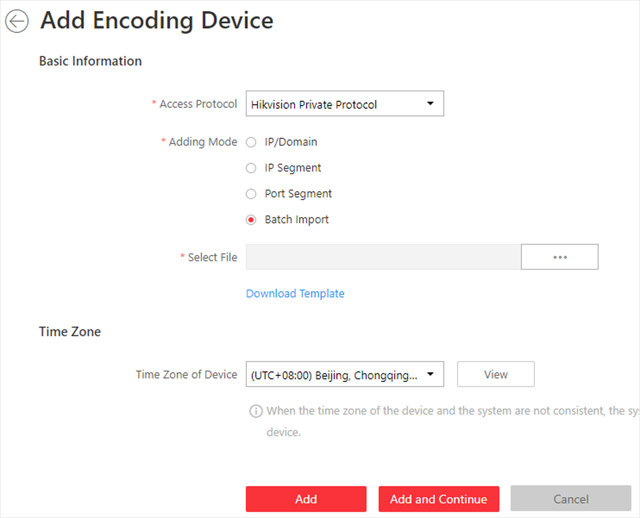
Figure 6-5 Add Encoding Device Page
3. Select Hikvision Private Protocol/Hikvision ISUP Protocol/ as the access protocol.
Note
Select Hikvision Private Protocol/Hikvision ISUP Protocol to add a Hikvision device and select ONVIF Protocol to add a third-party device.

4. Select Batch Import as the adding mode.
5. Click Download Template and save the predefined template (excel file) on your PC.
6. Open the exported template file and enter the required information of the devices to be added on the corresponding column.
7. Click  and select the edited file.
8. Optional: Select a time zone for the device in drop-down list of Time Zone of Device.
Note
You can check Apply to Device so that when the time zone of the device and the system are not consistent, the system will automatically apply the time zone settings to the device.

9. Finish adding devices.
- Click Add to add the devices and go back to the device list page.
- Click Add and Continue to save the settings and continue to add next batch of devices.
10. Optional: Perform the following operation(s) after adding devices in a batch.
Remote Configurations | Click to set the remote configurations of the corresponding device.  Note  For details about remote configuration, see the user manual of the device.
Change Password | Select the added device(s) and click to change the password for the device(s).  Note  - You can only change the password for online HIKVISION devices currently.  - If the devices have the same password, you can select multiple devices to change the password for them at the same time.

What to do next
For facial recognition camera/ANPR camera/thermal camera (report supported), turn to Home page, click License Details → Configuration → Add, and then select the added cameras as these three types of cameras respectively. Otherwise, these cameras' functions (facial recognition, plate recognition, and temperature report) cannot be performed normally in the system.

4.3.9 Limit Bandwidth for Video Downloading
You can limit bandwidth for video downloading of specific NVRs to save on the total bandwidth, thus ensuring the fluency of main features such as live view.
Note
The NVR should be of V4.1.50 or later versions.

Click Physical View → Encoding Device to enter the Encoding Device page and then select encoding device(s) and click Edit Bandwidth for Video Downloading to set the bandwidth upper-limit for video downloading of the selected device(s).

4.4 Upgrade Device Firmware
You can upgrade the firmwares of the devices added to the system via the current Web Client or EZVIZ Cloud service.
Via Current Web Client
The following devices are supported to be upgraded the firmwares via the current Web Client:
Table 6-1 Device List
No. | Device Type
1 | Camera
2 | NVR (Network Video Recorder)
3 | DVR (Digital Video Recorder )
4 | Decoding Device
5 | Access Control Device
6 | Card Reader
7 | Security Control Panel (including Axiom Security Control Panel)
8 | Security Radar
9 | Indoor Station
10 | Dock Station

Note
You can also upgrade the cameras access to the NVR in a batch.

Upgrade Device Firmware via Current Web Client
You can upgrade device firmware via the current Web Client.
Steps
1. Click Upgrade Device Firmware on the Home page to open the Upgrade Device Firmware window.
2. Click Via Current Web Client tab.
3. Set the required information.
Simultaneous Upgrade
Set the maximum number of devices for simultaneous upgrade. For example, if you set the value to 5, up to 5 devices can be selected for batch upgrade.
4. Select a upgrade package from the local PC and then click Next.
The upgradable devices will be displayed.
5. Optional: Filter devices by device type, device firmware version, or device model.
6. Select device(s) and then click Next.
7. Select a upgrade schedule to upgrade the selected device(s).
- Select Upgrade Now from the Upgrade Schedule drop-down list to start upgrade.
- Select Custom from the Upgrade Schedule drop-down list and then customize a time period to upgrade the selected device(s).

4.5 Restore/Reset Device Password
If you forgot the password of the detected online devices, you can restore the device's default password or reset the device's password through the system. Then you can access the device or add it to the system using the password.
For detailed operations of restoring device's default password, refer to Restore Device's Default Password.
For detailed operations of resetting device's password, refer to Reset Device Password.

4.5.1 Reset Device Password
If you have forgotten your password you use to access online device, you can request to have a key file from your technical support and reset the device's password through the system.
Before You Start
- Make sure the devices (cameras, DVR, access control device, etc.) you are going to use are correctly installed and connected to the network as specified by the manufacturers. Such initial configuration is required in order to be able to connect the devices to the HikCentral Professional via network.
- The devices should be activated. Refer to Create Password for Inactive Device(s) for details about activating devices.
Perform this task when you need to reset the device's password. Here we take the encoding device as an example.
Steps
1. Click Physical View → Encoding Device to enter the Encoding Device Management page.
Note
- For access control devices, click Physical View → Access Control Device to enter the access control device management page.
- For decoding devices, click Physical View → Smart Wall. On the Decoding Device area, click Add and check Online Devices as Adding Mode.

The detected online devices list in the Online Device area.
2. In the Online Device area, view the device status (shown on Security column) and click icon  in the Operation column of an active device.
A dialog with import file and export file, password and confirm password fields opens.
3. Click Export to save the device file on your PC.
4. Send the file to our technical engineers.
Note
For the following operations about resetting the password, contact the technical support engineer.

Caution
The password strength of the device can be automatically checked. We highly recommend you change the password of your own choosing (using a minimum of 8 characters, including at least three kinds of following categories: upper case letters, lower case letters, numbers, and special characters) in order to increase the security of your product. And we recommend you change your password regularly, especially in the high security system, changing the password monthly or weekly can better protect your product.
Proper configuration of all passwords and other security settings is the responsibility of the installer and/or end-user.

4.5.2 Restore Device's Default Password
For some encoding devices with old firmware version, if you forgot the password you use to access the online device, you can restore the device's default password through the system and then you must change the default password to a stronger one for better security.
Before You Start
- Make sure the devices (cameras, DVR, etc.) you are going to use are correctly installed and connected to the network as specified by the manufacturers. Such initial configuration is required in order to be able to connect the devices to the HikCentral Professional via network.
- The devices should be activated. Refer to Create Password for Inactive Device(s) for detailed operations about activating devices.
Perform this task when you need to restore the device's default password.
Steps
1. Click Physical View → Encoding Device to enter the Encoding Device Management page.
The detected online devices list in the Online Device area.
2. In the Online Device area, view the device status (shown on Security column) and click in the Operation column of an active device.
A dialog with security code pops up.
3. Enter the security code and restore the default password of the selected device.
Note
Contact our technical support to obtain a security code.

What to do next
You must change this default password to better protect against security risks, such as the unauthorized access by others to the product that may prevent the product from functioning properly and/or lead to other undesirable consequences.
Caution
The password strength of the device can be automatically checked. We highly recommend you change the password of your own choosing (using a minimum of 8 characters, including at least three kinds of following categories: upper case letters, lower case letters, numbers, and special characters) in order to increase the security of your product. And we recommend you change your password regularly, especially in the high security system, changing the password monthly or weekly can better protect your product.
Proper configuration of all passwords and other security settings is the responsibility of the installer and/or end-user.

4.6 Manage Remote Site
You can add other HikCentral Professional without RSM (Remote Site Management) module to the HikCentral Professional with RSM module as the Remote Site for central management.
After adding the Remote Site to the Central System, you can manage the Remote Site's cameras (such as live view and playback), add the Remote Site's configured alarms so that you can manage the alarms via the Central System, and set the recording schedule for the Remote Site's cameras and store the recorded video files in the Recording Server added to the Central System. You can also view the Remote Site's GIS location, hot spot, and hot region settings in Map module.
Remote Site
If the HikCentral Professional doesn't have RSM module (based on the License you purchased), you can add it to the Central System as Remote Site.
Central System
If the HikCentral Professional has RSM module (based on the License you purchased), you can add other Remote Sites to this system. This system and the added Remote Sites are called Central System.
Note
- The system with RSM module cannot be added to other Central System as Remote Site.
- If one Remote Site has been added to one Central System, it cannot be added to other Central System.

4.6.1 Add Remote Site by IP Address or Domain Name
When you know the IP address or domain name of the Remote Site to add, you can add the site to the Central System by specifying the IP address (or domain name), user name, password, and other related parameters.
Perform this task when you need to add Remote Site by IP address or domain name.
Steps
Note
When adding Remote Site, the site's cameras and logical area information are imported to the Central System by default.

1. Click Remote Site Management on home page to open the Remote Site management page.
2. Enter the Add Remote Site page.
- If no Remote Site added, click Add Site to enter the Add Remote Site page.
- If you have already added Remote Site, click  on the left to enter the Add Remote Site page.
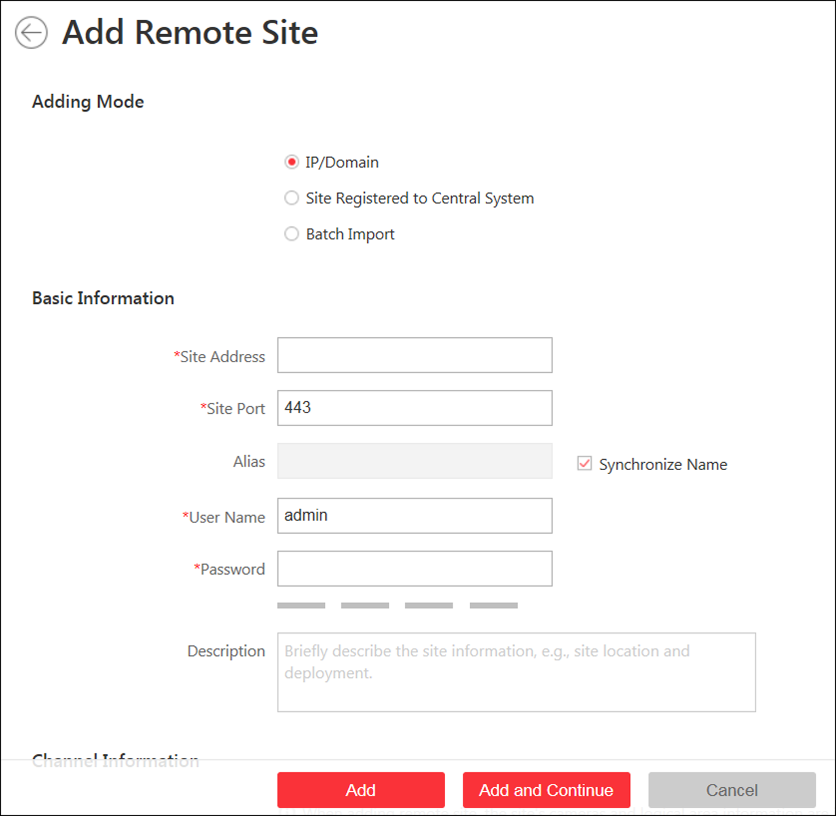
Figure 6-7 Add Remote Site Page
3. Select IP/Domain as the adding mode.
4. Enter the required information.
Site Address
The IP address or domain name of the Remote Site.
Site Port
Enter the port No. of the Remote Site. By default, it's 80.
Alias
Edit a name for the Remote Site as desired. You can check Synchronize Name to synchronize the Remote Site's name automatically.
User Name
The user name for the Remote Site, such as admin user and normal user.
Password
The password required to access the Remote Site.
Description
Optionally, you can enter the descriptive information for the Remote Site, such as location and deployment.

Caution
The password strength of the device can be automatically checked. We highly recommend you change the password of your own choosing (using a minimum of 8 characters, including at least three kinds of following categories: upper case letters, lower case letters, numbers, and special characters) in order to increase the security of your product. And we recommend you change your password regularly, especially in the high security system, changing the password monthly or weekly can better protect your product.
Proper configuration of all passwords and other security settings is the responsibility of the installer and/or end-user.

5. Optional: Enable receiving the alarms configured on the Remote Site.
1) Set the Select Alarm switch to ON to display all the configured alarms on a Remote Site.
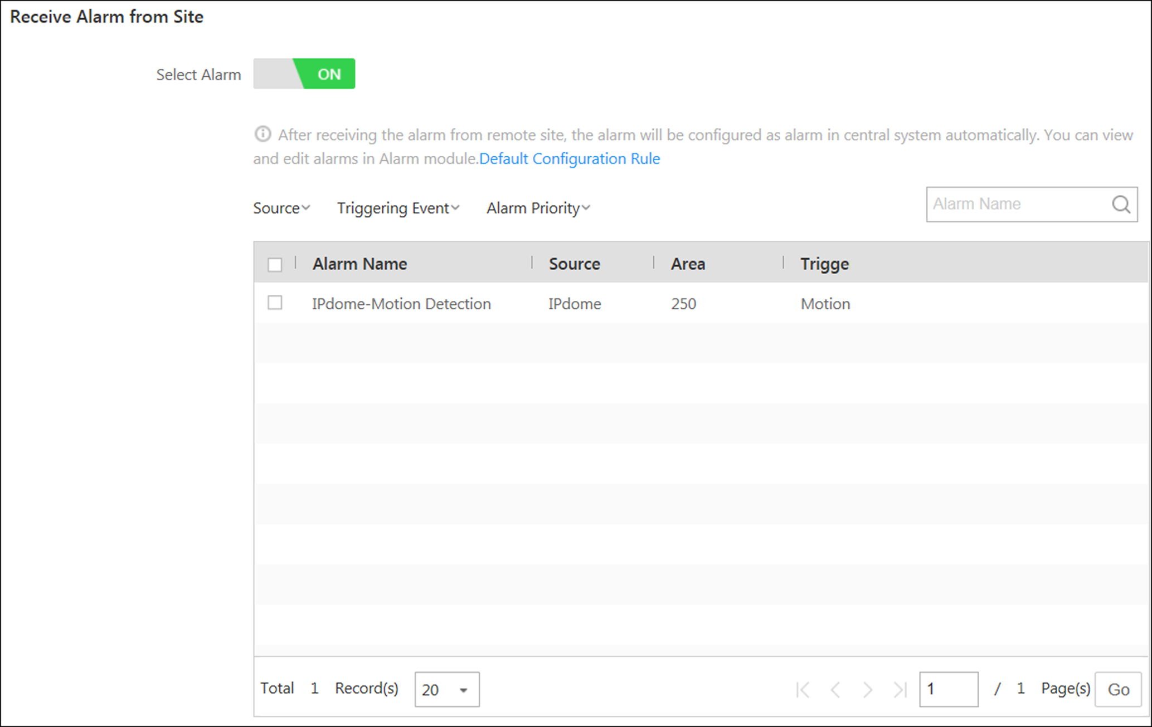
Figure 6-8 Receive Alarm from Site Page
2) Optional: Filter the configured alarms by the alarm source, triggering event, and alarm priority.
3) Select the configured alarm(s).
Note
- After receiving the alarm from Remote Site, the alarm will be configured as alarm in Central System automatically. You can click Default Configuration Rule to view the imported alarms' default settings including alarm name, alarm priority, actions, etc.
- You can view and edit alarms in Alarm module. For details about setting the alarm, refer to .

6. Back up the Remote Sites' database in the Central System and you can set the maximum number of backups and view the database saving path in the Central System.
Max. Number of Backups
Define the maximum number of backup files available on the system.
7. Optional: Enable backing up the Remote Site's database in schedule.
1) Set the Scheduled Database Backup switch to ON.
2) Select how often to back up the database.
Note
If you select Weekly or Monthly for running the backup task, select which day to run.

3) Select what time of a day to start backup.
8. Finish adding the Remote Site.
- Click Add to add the Remote Site and back to the Remote Site list page.
- Click Add and Continue to save the settings and continue to add other Remote Sites.

4.6.2 Add Remote Site Registered to Central System
If the Remote Sites have been registered to the Central System and the Central System also enabled the receiving site registration function, the registered Remote Sites will display in the site list. You can add them to the Central System by entering user names and passwords.
Before You Start
- The Remote Site must be registered to the Central System by itentering the Central System's network parameters (see Register to Central System for details).
- The Central System should enable the receiving site registration function (see Allow for Remote Site Registration for details).
Perform this task when you need to add the site which has registered to the Central System.
Steps
Note
When adding Remote Site, the site's cameras and logical area information are imported to the Central System by default.

1. Click Remote Site Management on home page to enter the Remote Site management page.
2. Enter the adding Remote Site page.
- If no Remote Site added, click Add Site to enter the Add Remote Site page.
- If you have already added Remote Site, click on the left to enter the Add Remote Site page.
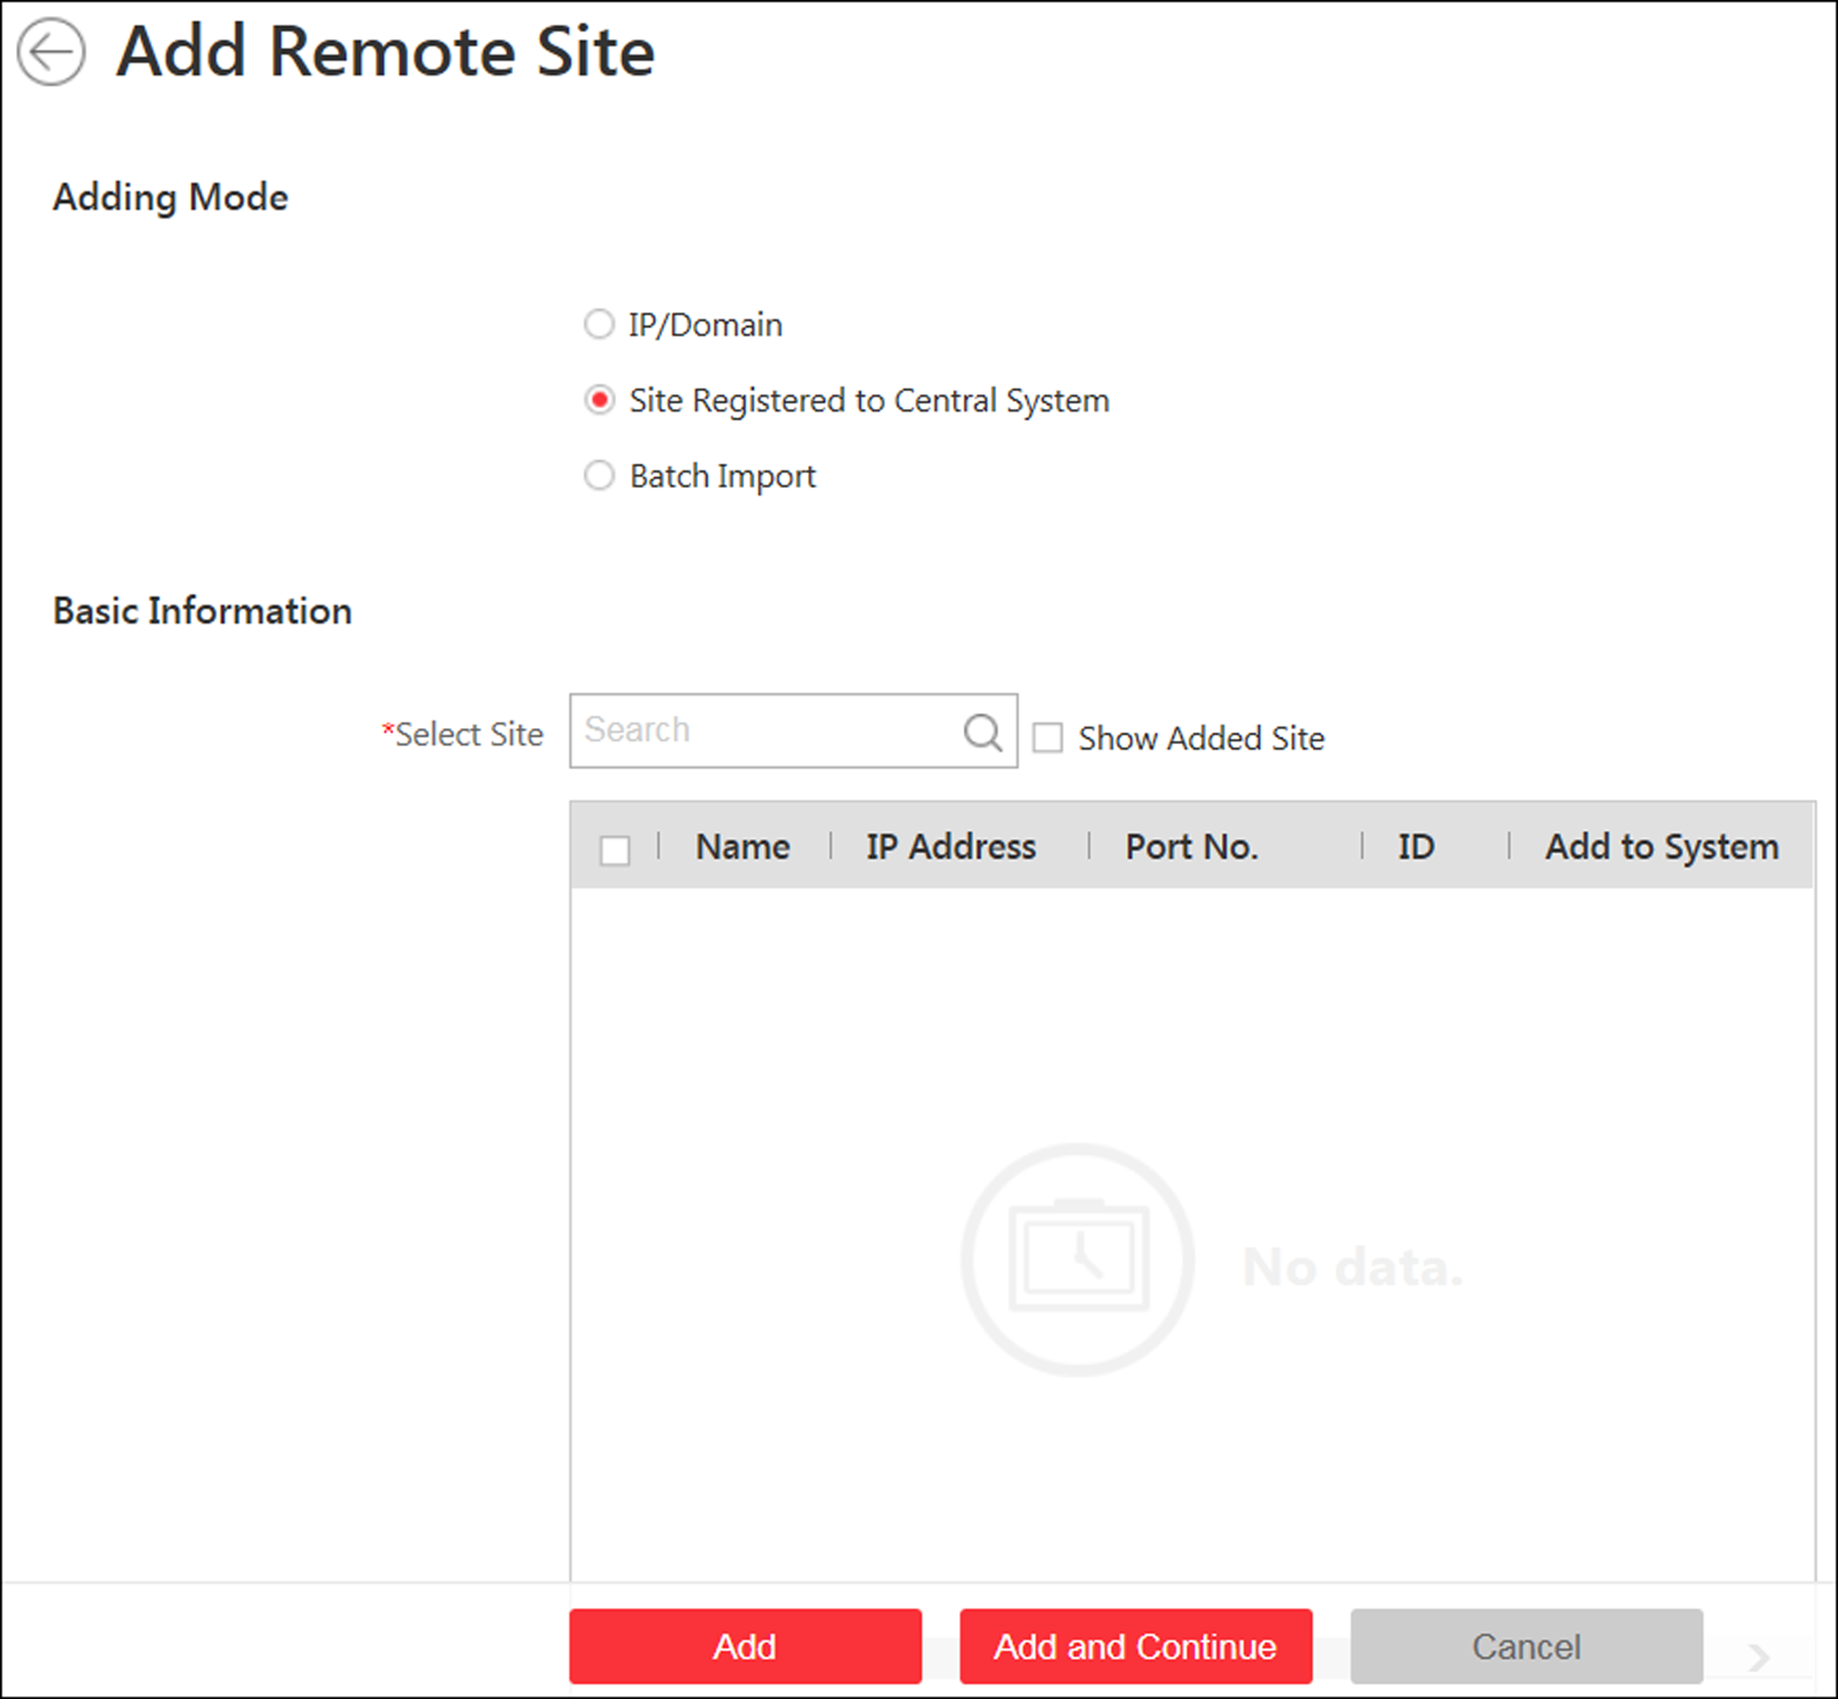
Figure 6-9 Add Remote Site Page
3. Select Site Registered to Central System as the adding mode.
The sites which have already registered to the Central System will display in the list.
4. Select the Remote Site(s) and enter the user name and password of the Remote Site(s).
Caution
The password strength of the device can be automatically checked. We highly recommend you change the password of your own choosing (using a minimum of 8 characters, including at least three kinds of following categories: upper case letters, lower case letters, numbers, and special characters) in order to increase the security of your product. And we recommend you change your password regularly, especially in the high security system, changing the password monthly or weekly can better protect your product.
Proper configuration of all passwords and other security settings is the responsibility of the installer and/or end-user.

5. Back up the Remote Sites' database in the Central System and you can set the maximum number of backups and view the database saving path in the Central System.
Max. Number of Backups
Define the maximum number of backup files available on the system.
Note
The value of maximum number of backups ranges from 1 to 5.

6. Optional: Back up the Remote Site's database in schedule.
1) Set the Scheduled Database Backup switch to ON to enable the scheduled backup.
2) Select how often to back up the database.
Note
If you select Weekly or Monthly for running the backup task, select which day to run.

3) Select what time of the day to start backup.
7. Finish adding Remote Site.
- Click Add to add the Remote Site and back to the Remote Site list page.
- Click Add and Continue to save the settings and continue to add other Remote Sites.

4.6.3 Add Remote Sites in a Batch
When you want to add multiple Remotes Sites at a time for convenience, you can edit the predefined template by entering the sites' parameters and import the template to the Central System to add them.
Steps
Note
When adding Remote Site, the site's cameras and logical area information are imported to the Central System by default.

1. Click Remote Site Management on home page to enter the Remote Site management page.
2. Enter the adding Remote Site page.
- If no Remote Site added, click Add Site to enter the Add Remote Site page.
- If you have already added Remote Site, click on the left to enter the Add Remote Site page.
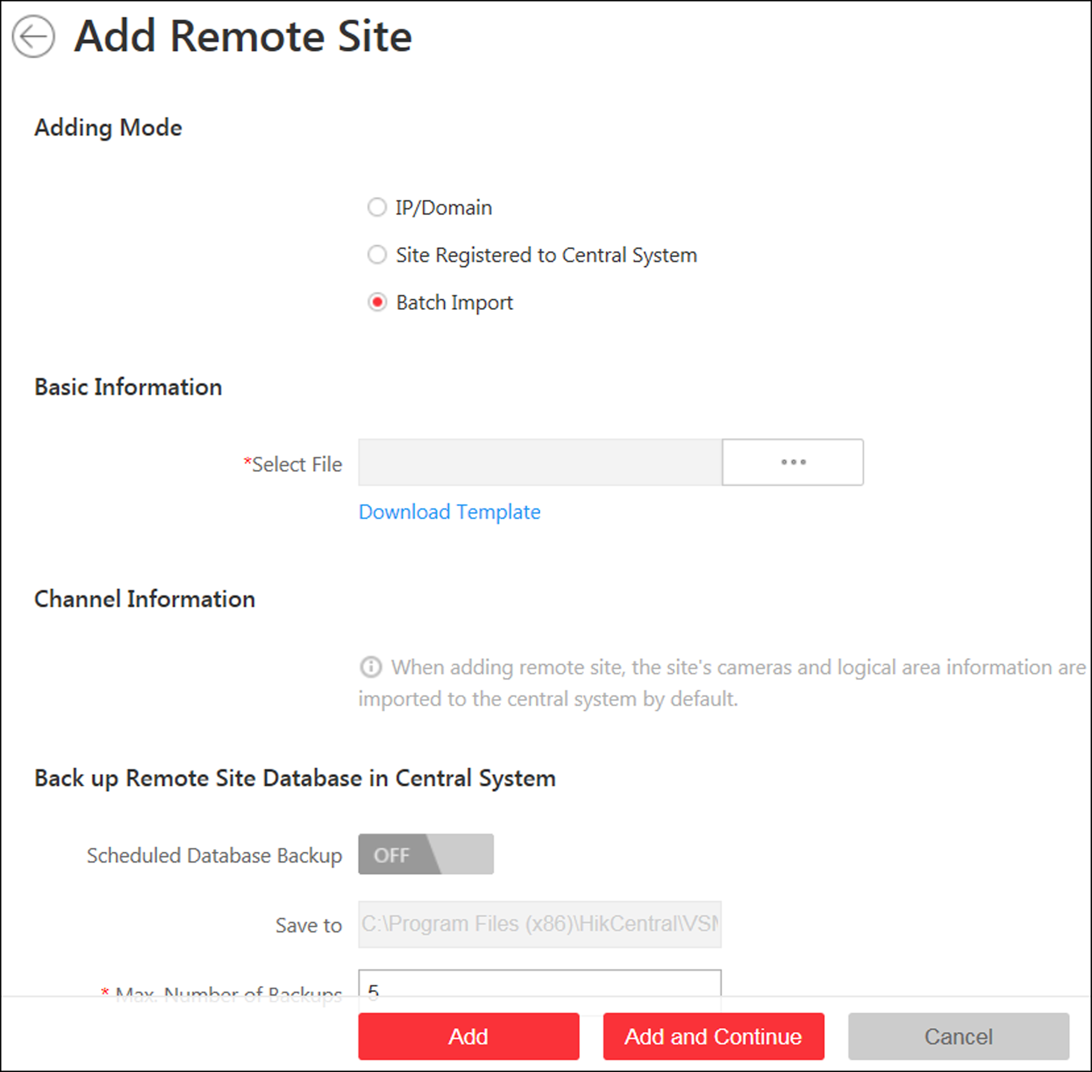
Figure 6-10 Add Remote Site
3. Select Batch Import as the adding mode.
4. Click Download Template and save the predefined template on your PC.
5. Open the exported template file and input the required information of the Remote Sites to be added on the corresponding column.
6. Click and select the template file.
7. Back up the Remote Sites' database in the Central System and you can set the maximum number of backups and view the database saving path in the Central System.
Max. Number of Backups
Define the maximum number of backup files available on the system.
8. Optional: Back up the Remote Site's database in schedule.
1) Set the Scheduled Database Backup switch to ON to enable the scheduled backup.
2) Select how often to back up the database.
Note
If you select Weekly or Monthly for running the backup task, select which day to run.

3) Select what time of the day to start backup.
9. Finish adding Remote Site.
- Click Add to add the Remote Site and back to the Remote Site list page.
- Click Add and Continue to save the settings and continue to add other Remote Sites.

4.6.4 Back Up Remote Site's Database to Central System
After adding the Remote Site, you can back up the database of the Remote Site to the Central System. The database backup can be performed according to the configured schedule or immediately. In case of the data deletion or corruption following a natural or human-induced disaster, you can recover the data to ensure the business continuity.
Perform this task when you need to back up the database of Remote Site in the Central System.
Steps
1. Click Remote Site Management on home page to open the Remote Site management page.
2. In the site list on the left, click the Remote Site name to view its details.
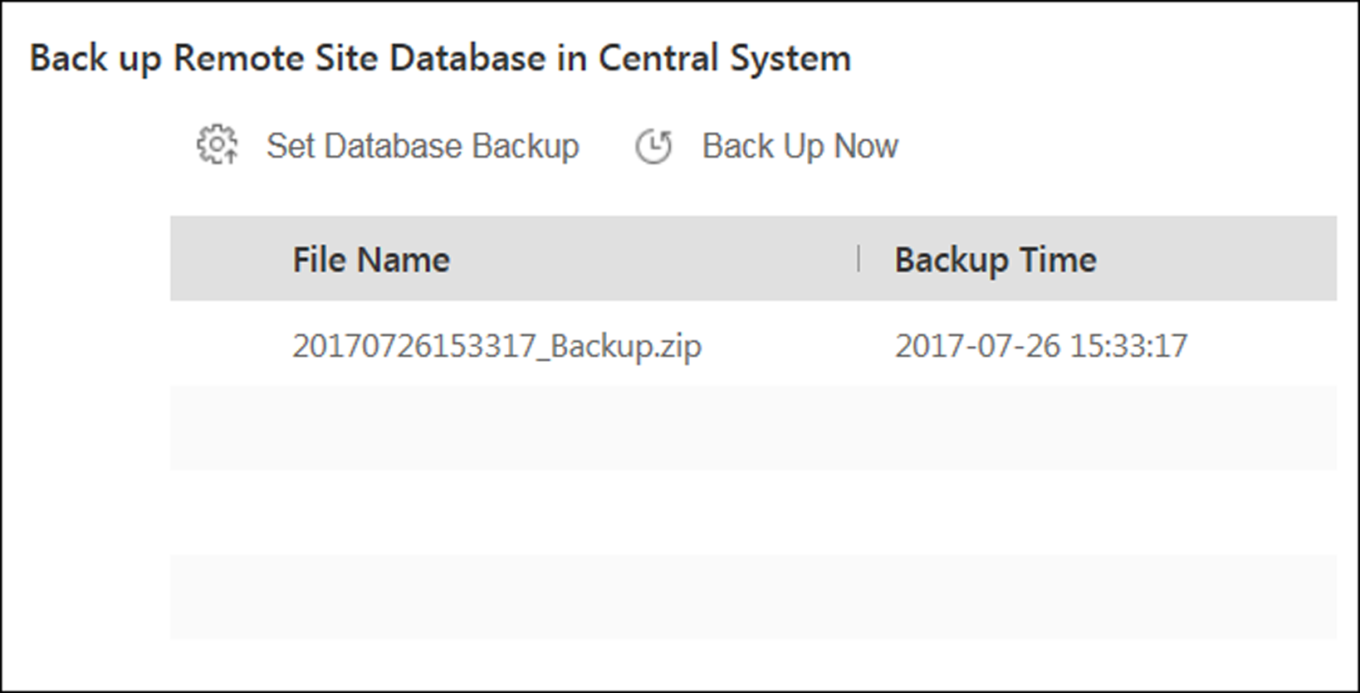
Figure 6-11 Back up Remote Site Database in Central System
3. Click Back Up Now to back up the Remote Site's database manually.
4. Optional: Set the backup parameters and enable scheduled database backup if needed to back up the Remote Site's database regularly.
1) Click Set Database Backup to open the Set Database Backup dialog.
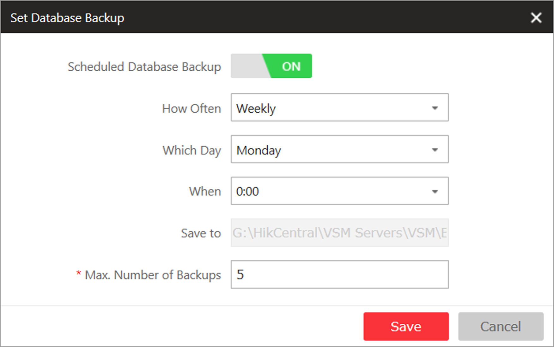
Figure 6-12 Set Database Backup
2) Set the Scheduled Database Backup switch as ON to enable the scheduled backup.
3) Select how often to back up the database.
Note
If you select Weekly or Monthly for running the backup task, select which day to run.

4) Select what time of the day to start backup.
5) Set the Maximum Number of Backups to define the maximum number of backup files available on the system.
Note
The maximum number of the backups should be between 1 to 5.

6) Click Save.
Result
The backup file (including manual backup and scheduled backup) will display in the list, showing the file name and backup time.

4.6.5 Edit Remote Site
After adding the Remote Site, you can view and edit the added Remote Site's information and set its GPS location.
Perform this task when you need to edit the added Remote Site's details.
Steps
1. Click Remote Site Management on home page to open the Remote Site management page.
2. In the site list on the left, click the Remote Site name to view its details.
3. View and edit the basic information of the Remote Site, including IP address, port, alias, etc.
Note
You cannot edit the address and port of the site registered to the Central System.

4. In the original information field, view the Remote Site's site name, system ID, system version, and GPS location.
Note
If the GPS location is not configured, click Configuration to set its location in Map module. See Manage Map for details.

5. Optional: Click Configuration on Site to open the Web Client of the Remote Site and log in for further configuration.
Note
The site must be online if you need to enter its Web Client.

6. Click Save.

4.6.6 View Remote Site's Changes
When there are changed resources on the Remote Site, such as newly added cameras, deleted cameras, and name changed cameras, you can view the changed resources and synchronize the resources in Central System with the Remote Site.
Steps
Note
The site should be online if you need to view the changed resources.

1. Click Remote Site Management on home page to open the Remote Site management page.
2. Click  in the site list on the left to get the latest status of the Remote Sites.
3. Click the site name whose resources are changed to enter its details page.
4. Click Changes of Remote Site to view the changes.
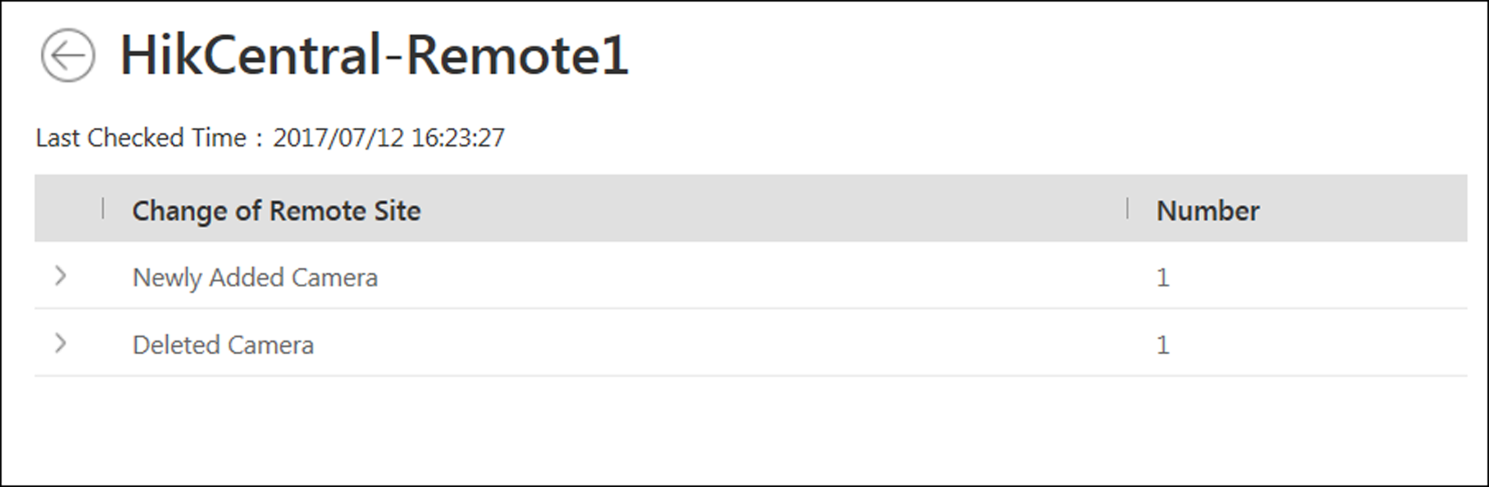
Figure 6-13 Remote Site Management
5. When there are newly added cameras on the site, you can view the added cameras and add them to the area in Central System.
1) If there are some newly added cameras on Remote Site, click Newly Added Camera to expand the newly added camera list.
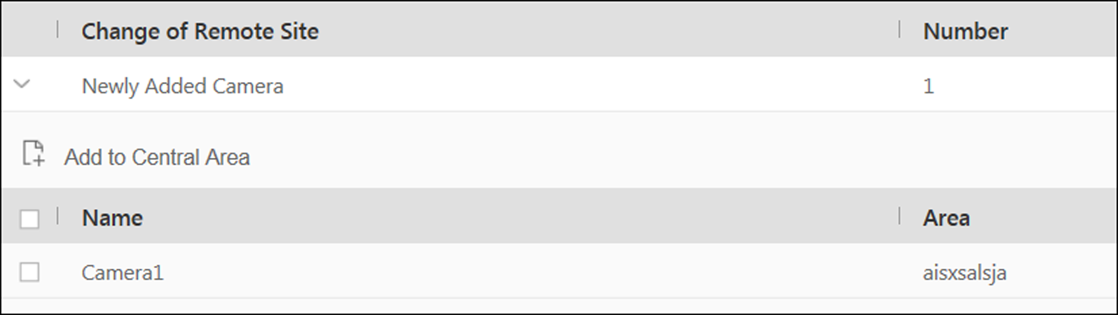
Figure 6-14 Changes of Remote Site
You can view the camera name and area name on the Remote Site.
2) Select the camera(s) and click Add to Central Area to synchronize the newly added cameras to the Central System.
3) Select the area in the Central System.
4) Click Save.
6. When there are some cameras deleted from the site, you can view the deleted cameras and remove them from Central System.
1) If there are some cameras deleted from Remote Site, click Deleted Camera to expand the deleted camera list.
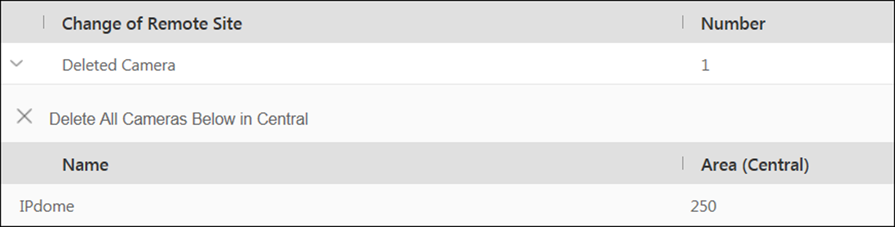
Figure 6-15 Change of Remote Site
You can view the camera name and its area in Central System.
2) Click Delete All Cameras Below in Central to delete the deleted cameras in Central System.
7. When there are some cameras whose names are changed on the site, you can view the name changed cameras and synchronize them to Central System.
1) If the name of camera of Remote Site is changed, click Name Changed Camera to expand the name changed camera list.
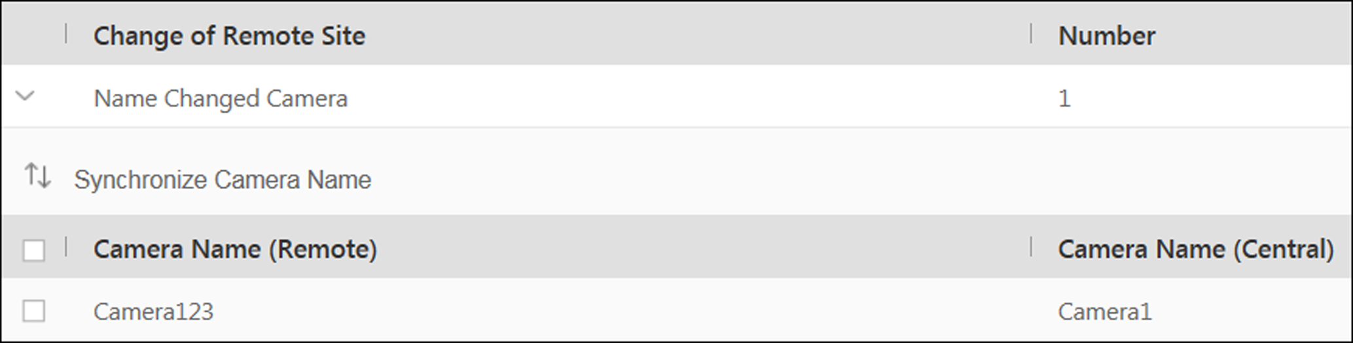
Figure 6-16 Name Changed Camera
You can view the camera names in Remote Site and Central System.
2) Select the cameras and click Synchronize Camera Name to synchronize the camera name in Central System.

4.7 Manage Application Data Server
HikCentral Professional provides distributed deployment for the two core services: System Management Service and Application Data Service. Distributed deployment can improve the system performance and the number of connectable cameras can be increased to 10,000.
Enter Physical View → Application Data Server to enter the application data server management page.
What is Application Data Server?
Application Data Server is the PC running the Application Data Service, which is mainly used for processing and storing the application data of the system. If the system License supports distributed deployment, you need to deploy an Application Data Server independently and add it to the system before any other operations.
What should I do before adding the Application Data Server to the system?
- Make sure the License of your system supports server distributed deployment.
- Download the installation package of Application Data Service and install it on a computer (except the computer running the System Management Service). After installation, run the Application Data Service and then the computer is an Application Data Server.
- You can add another Application Data Server as standby server for data backup redundancy if needed, which can improve the reliability and availability of the system. When the Application Data Server fails, the Application Data Standby Server will take over automatically.
- The Application Data Server, Application Data Standby Server, and the System Management Server should be in the same LAN which is secure and in the same time zone, or the system cannot run properly.
- Make sure the Application Data Server and Application Data Standby Server are online and running properly.
Encrypted Transmission
For data security, the system provides encrypted transmission for the Application Data Server, which encrypts the data transmitted between the Application Data Server and other services or clients.
Note
Only admin user can edit this function and the admin user can only edit it via the Web Client running on the SYS server.

Click System → Security → Transfer Protocol to check Encrypted Transmission to encrypt the data transmission between Application Data Server and System Management Server.
Note
- The SYS server will reboot automatically after changing the clients and SYS server transmission settings.
- All the users logged in will be forced logout during reboot. The reboot takes about one minute and after that, the users can login again.

How to add an Application Data Server?
Before adding the Application Data Server, generate the security certificate on the Web Client running on the SYS server (For details, refer to Export Service Component Certificate), and then enter the certificate information on the Service Manager running on the Application Data Server for authentication. Only after the authentication succeed, the Application Data Server can be added to the system.
Note
Only the admin user has the permission to add Application Data Server and Application Data Standby Server.

In the Application Data Server page, click Add and enter the server's IP address and port to add the server.
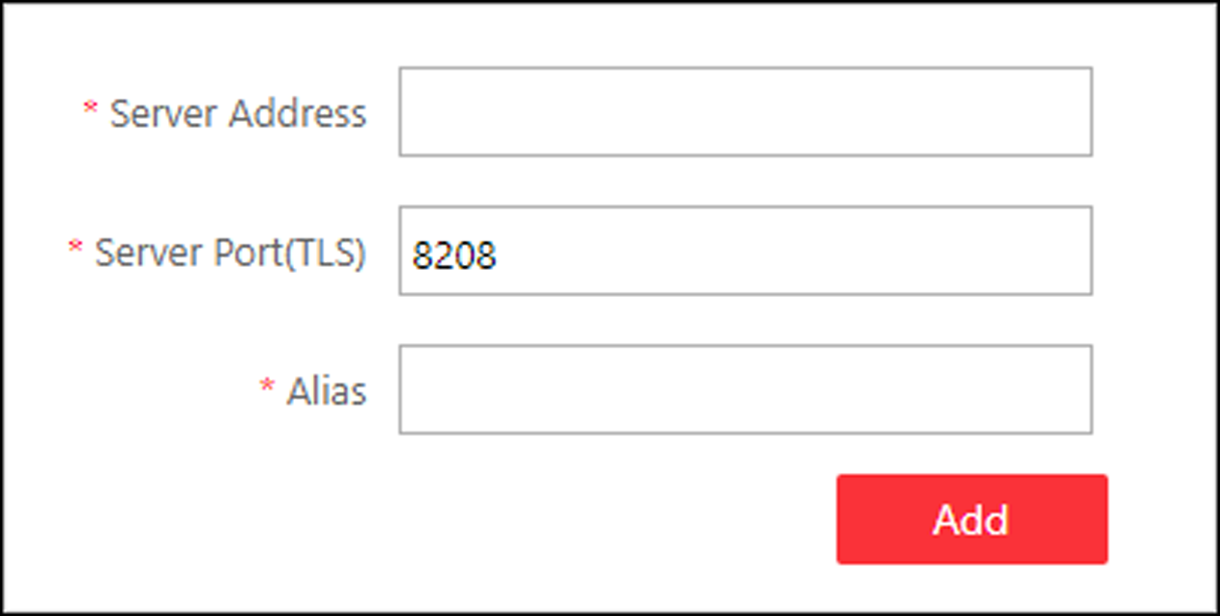
Figure 6-17 Add Application Data Server
After adding the Application Data Server, in Application Data Server page, click Add Standby Server to add an Application Data Standby Server if necessary.
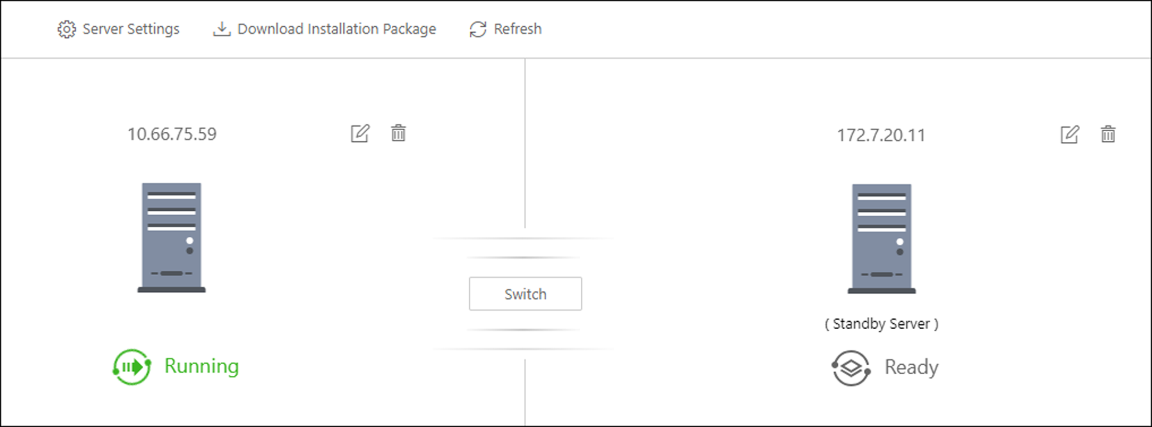
Figure 6-18 Application Data Server Management
Note
Click Refresh to get the latest status of the Application Data Server and Application Data Standby Server.

Set Threshold of Failure Status
If the system disconnects with the Application Data Server or Application Data Standby Server and the disconnection lasts for specified time, the system will regard the server as failure and notify the administrator to maintain it.
In Application Data Server page, click Server Settings and you can set the threshold in Change Status to Failure after Disconnection of field.
For example, if you set the threshold as 10 seconds, and the server disconnects with the system for 10 or more seconds, the server status will turn to failure.
Automatically Switch to Application Data Standby Server
If the Application Data Server fails, the Application Data Standby Server will take over automatically. After that, the original Application Data Standby Server will turn to Application Data Server, and the original Application Data Server will turn to standby server.
Once the Application Data Server and the Application Data Standby Server changes, the status will be refreshed automatically.
You can also click Refresh to get the latest status of the Application Data Server and Application Data Standby Server.
Maintain Server Fault
Note
Only the admin user has the permission to perform the maintenance.

After refreshing manually, if the Application Data Server or Application Data Standby Server fails, the server's status will change to failure and system will display the fault details to help you diagnose the reason. After maintenance, if the system detects the server is running properly, click I've maintained it. and then the servers will turn to normal status.
Manually Switch to Application Data Standby Server
Note
Only the admin user has the permission to switch to Application Data Standby Server.

If the Application Data Server fails but the system cannot detect its fault, or you need to change the server to a better one, you can manually switch the Application Data Server currently in working status to the Application Data Standby Server which is in ready status.
In Application Data Server page, click Switch to switch to the Application Data Standby Server and then the standby server will take over.
Note
During switching, the Application Data Server will be stopped for a while and it will resume after switching.

4.8 Manage Recording Server
You can add the Recording Server to the system for storing the video files. Currently, the Recording Server supports Hybrid Storage Area Network, Cloud Storage Server and pStor. You can also form an N+1 hot spare system with several Hybrid Storage Area Networks to increase the video storage reliability of system.

4.8.1 Add pStor
You can add pStor as Recording Server to the HikCentral Professional for storing the video files and pictures.
Before You Start
Make sure the pStors you are going to use are correctly installed and connected to the network as specified by the manufacturers. Such initial configuration is required in order to be able to connect the devices to the HikCentral Professional via network.
Steps
1. Click Physical View → Recording Server to enter the recording server page.
2. Click Add to enter the adding server page.
3. Select pStor.
4. Enter the network parameters.
Address
The server's IP address in LAN that can communicate with SYS.
Control Port
The control port No. of the pStor. If it is not changed, use the default value.
Network Port
The network port No. of the pStor. If it is not changed, use the default value.
Signaling Gateway Port
The signaling gateway port No. of the pStor. If it is not changed, use the default value.
5. Enter the user's access key and secret key of the pStor for downloading pictures via Control Client.
Note
You can download these two keys on the pStor's Web Client page.

6. Optional: Set the Enable Picture Storage switch to ON for storing pictures in this pStor.
Note
If this function is enabled, you need to set picture downloading port No., which is used to download pictures via Control Client.

7. Optional: If you need to access the server via WAN, set the Enable WAN Access switch to ON and set the corresponding parameters which are available when you access the server via WAN.
8. Enter the alias, user name, and password of the pStor.
Caution
The password strength of the device can be automatically checked. We highly recommend you change the password of your own choosing (using a minimum of 8 characters, including at least three kinds of following categories: upper case letters, lower case letters, numbers, and special characters) in order to increase the security of your product. And we recommend you change your password regularly, especially in the high security system, changing the password monthly or weekly can better protect your product.
Proper configuration of all passwords and other security settings is the responsibility of the installer and/or end-user.

9. Finish adding the server.
- Click Add to add the server and back to the server list page.
- Click Add and Continue to save the settings and continue to add other servers.
10. Optional: Perform the following operations after adding the server:
Edit Server | Click Alias field of the server and you can edit the information of the server and view its storage and camera information.
Delete Server | Select the server(s) from the list, and click Delete to remove the selected server(s).
Configure Server | Click , and the login interface of the pStor displays. You can log in and configure the pStor.

4.8.2 Add Hybrid Storage Area Network
You can add the Hybrid Storage Area Network (hereafter simplyfied as Hybrid SAN) as Recording Server to the HikCentral Professional for storing the video files and pictures.
Before You Start
Make sure the Hybrid Storage Area Networks you are going to use are correctly installed and connected to the network as specified by the manufacturers. Such initial configuration is required in order to be able to connect the devices to the HikCentral Professional via network.
Steps
1. Click Physical View → Recording Server to enter the recording server page.
2. Click Add to enter the Add Recording Server page.
3. Select Hybrid Storage Area Network.
4. Enter the network parameters.
Address
The server's IP address in LAN that can communicate with SYS.
Control Port
The control port No. of the server. If it is not changed, use the default value.
Network Port
The network port No. of the server. If it is not changed, use the default value.
5. Optional: Enable picture storage function for storing pictures in this Hybrid Storage Area Network.
1) Set the Enable Picture Storage switch to ON.
2) Set picture downloading port No. for downloading pictures via Control Client. If the picture downloading port No. is not changed, use the default ones.
3) Set signaling gateway port No.. If the picture downloading port No. is not changed, use the default ones.
4) Enter the access key and secret key.
Note
The access key and secret key are used to download pictures via the Control Client. If required, you can contact our technical support to get them.

6. Optional: If you need to access the server via WAN, set the Enable WAN Access switch to ON and set the corresponding parameters which are available when you access the server via WAN.
7. Enter the alias, user name, and password of the server.
Caution
The password strength of the device can be automatically checked. We highly recommend you change the password of your own choosing (using a minimum of 8 characters, including at least three kinds of following categories: upper case letters, lower case letters, numbers, and special characters) in order to increase the security of your product. And we recommend you change your password regularly, especially in the high security system, changing the password monthly or weekly can better protect your product.
Proper configuration of all passwords and other security settings is the responsibility of the installer and/or end-user.

8. Optional: Set the storage Information.
Custom Video Copy-back
After enabled, the video footage (if exists) recorded within the defined Start Time and End Time on cameras or NVRs managed by the Hybrid SAN will be automatically copied back to the Hybrid SAN.
Note
- The time for starting copy-back could be any time when there exists video footage which meets the above mentioned condition.
- The time period within the start time and end time should be longer than 24 hours, and the end time should NOT be later than 2 hours before.

For example, if the current time is "10:00:00, Oct. 31st", and you have enabled custom video copy-back ( in which you set "2 days before copy-back" as the start time, "2 hours before copy-back" as the end time), the video footage recorded from "10:00:00, Oct. 29th" to "8:00:00, Oct. 31st" on cameras or NVRs managed by the Hybrid SAN will be backed up to the Hybrid SAN.
Video Expiration
Set the expiration time to retain the video footage stored on the Hybrid SAN.
For example, if you set 30 days as the expiration time, the video footage stored on the Hybrid SAN for longer than 30 days will be automatically deleted.
9. Finish adding the server.
- Click Add to add the server and back to the server list page.
- Click Add and Continue to save the settings and continue to add other servers.
10. Optional: Perform the following operations after adding the server:
Edit Server | Click Alias field of the server and you can edit the information of the server and view its storage and camera information.
Delete Server | Select the server(s) from the list, and click Delete to remove the selected server(s).
Configure Server | Click , and the login interface of the Hybrid Storage Area Network displays. You can log in and configure the Hybrid SAN.
One-Touch Configuration | If the Hybrid Storage Area Network has not been configured with storage settings, click  to perform one-touch configuration before you can store the video files of the camera on the Hybrid Storage Area Network.

4.8.3 Add Network Video Recorder
You can add NVR (Network Video Recorder) as a Recording Server to HikCentral Professional for storing video files and pictures.
Before You Start
Make sure the NVR you are going to use are correctly installed and connected to the network as specified by the manufacturers. Such initial configuration is required in order to be able to connect the devices to the system via network.
Steps
1. Click Physical View → Recording Server to enter the recording server page.
2. Click Add to enter the adding server page.
3. Select Network Recording Server as the server type.
4. Set the required information.
Address
The server's IP address in LAN that can communicate with SYS.
Control Port
The control port No. of the NVR. If it is not changed, use the default value.
Network Port
The network port No. of the NVR. If it is not changed, use the default value.
Picture Download Port
The picture downloading port of the NVR. If it not changed, use the default value.
Signaling Gateway Port
The signaling gateway port No. of the NVR. If it is not changed, use the default value.
5. Enter the user's access key and secret key of the NVR for downloading pictures via Control Client.
Note
You can download these two keys on the NVR's Web Client page.

6. Optional: If you need to access the server via WAN, set the Enable WAN Access switch to ON and set the corresponding parameters which are available when you access the server via WAN.
7. Enter the alias, user name, and password of the NVR.
Caution
The password strength of the device can be automatically checked. We highly recommend you change the password of your own choosing (using a minimum of 8 characters, including at least three kinds of following categories: upper case letters, lower case letters, numbers, and special characters) in order to increase the security of your product. And we recommend you change your password regularly, especially in the high security system, changing the password monthly or weekly can better protect your product.
Proper configuration of all passwords and other security settings is the responsibility of the installer and/or end-user.

8. Finish adding the NVR.
- Click Add to add the NVR and back to the server list page.
- Click Add and Continue to save the settings and continue to add other NVRs.
9. Optional: Perform the following operations after adding the NVR:
Edit NVR | Click Alias field of the NVR and you can edit the information of the NVR and view its storage and camera information.
Delete NVR | Select the NVR(s) from the list, and click Delete to remove the selected server(s).
Configure NVR | Click , and the login interface of the NVR will be displayed. You can log in and configure the NVR.

4.8.4 Manage Cloud Storage Server
You can add a Cloud Storage Server as a Recording Server to the HikCentral Professional for storing the video files.

Import Service Component Certificate to Cloud Storage Server
For data security purpose, the Cloud Storage Server's certificate should be same with the SYS server's. Before adding the Cloud Storage Server to the system, you should import the certificate stored in the SYS server to the Cloud Storage Server first.
Before You Start
Make sure the Cloud Storage Server you are going to use are correctly installed and connected to the network as specified by the manufacturers. Such initial configuration is required in order to be able to connect the devices to the HikCentral Professional via network.
Steps
Note
If the service component certificate is updated, you should export the new certificate and import it to the Cloud Storage Server again to update.

1. Click System → Service Component Certificate.
2. Click Export to export the certificate stored in the SYS server.
3. Log in the configuration page of the Cloud Storage Server via web browser.
4. Click System → Configuration → Cloud Configuration.
5. Input the root keys salt and keys component according to the parameters in the certificate you export in Step 3.
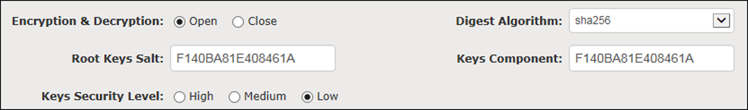
6. Click Set.
What to do next
After importing the certificate to the Clout Storage Server, you can add the server to the system for management. See Add Cloud Storage Server for details.

Add Cloud Storage Server
You can add Cloud Storage Server as Recording Server to the HikCentral Professional for storing the video files and pictures.
Before You Start
- Make sure the Cloud Storage Servers you are going to use are correctly installed and connected to the network as specified by the manufacturers. Such initial configuration is required in order to be able to connect the devices to the HikCentral Professional via network.
- You should import the service component certificate to the Cloud Storage Server first before adding it to the system. See Import Service Component Certificate to Cloud Storage Server for details.
Steps
1. Click Physical View → Recording Server to enter the recording server page.
2. Click Add to enter the adding server page.
3. Select Cloud Storage Server.
4. Enter the network parameters.
Address
The server's IP address in LAN that can communicate with SYS server.
Control Port
The control port No. of the server. If it is not changed, use the default value.
Network Port
The network port No. of the server. If it is not changed, use the default value.
Signaling Gateway Port
The signaling gateway port No. of the server. If it is not changed, use the default value.
5. Enter the user's access key and secret key of the Cloud Storage Server for searching the video files stored in this Cloud Storage Server via the HikCentral Professional Mobile Client or downloading pictures via Control Client.
Note
- You can download these two keys on the Cloud Storage Server's configuration page (click Virtualizing → User Management).

6. Optional: Set the Enable Picture Storage switch to ON for storing pictures in this Cloud Storage Server.
Note
If this function is enabled, you need to set picture downloading port No., which is used to download pictures via Control Client.

7. Optional: If you need to access the server via WAN, set the Enable WAN Access switch to ON and set the corresponding parameters which are available when you access the server via WAN.
8. Enter the alias, user name, and password of the server.
Caution
The password strength of the device can be automatically checked. We highly recommend you change the password of your own choosing (using a minimum of 8 characters, including at least three kinds of following categories: upper case letters, lower case letters, numbers, and special characters) in order to increase the security of your product. And we recommend you change your password regularly, especially in the high security system, changing the password monthly or weekly can better protect your product.
Proper configuration of all passwords and other security settings is the responsibility of the installer and/or end-user.

9. Finish adding the server.
- Click Add to add the server and back to the server list page.
- Click Add and Continue to save the settings and continue to add other servers.
10. Optional: Perform the following operations after adding the server:
Edit Server | Click Alias field of the server and you can edit the information of the server and view its storage and camera information.
Delete Server | Select the server(s) from the list, and click Delete to remove the selected server(s).
Configure Server | Click , and the login interface of the Cloud Storage Server displays. You can log in and configure the Cloud Storage Server.

4.8.5 Add pStor Cluster Service
pStor Cluster Service is a service that can manage multiple pStors and the connected disks of pStors. When there are multiple pStors storing a large number of video files, you can add pStor cluster service to the HikCentral Professional for managing pStors. It is also an efficient way to add multiple pStors.
Before You Start
Make sure the pStor cluster service you are going to use are correctly installed and connected to the network as specified by the manufacturers. Such initial configuration is required in order to be able to connect the devices to the HikCentral Professional via network.
Steps
1. Click Physical View → Recording Server to enter the recording server page.
2. Click Add to enter the Add Recording Server page.
3. Select pStor Cluster Service.
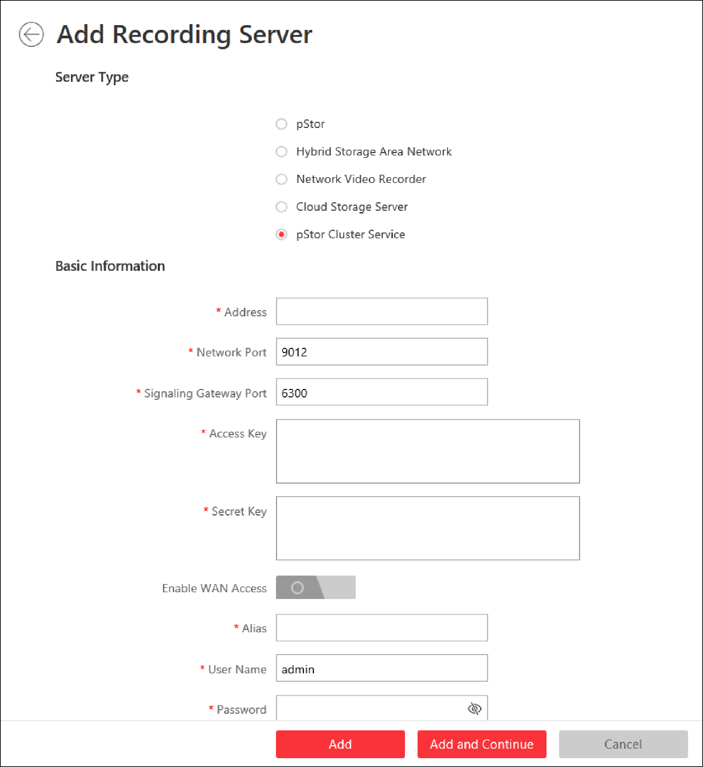
Figure 6-19 Add pStor Cluster Service
4. Enter the required network parameters.
Address
The server's IP address in LAN that can communicate with SYS.
Network Port
The network port No. of the pStor cluster service. If it is not changed, use the default value.
Signaling Gateway Port
The signaling gateway port No. of the pStor cluster service. If it is not changed, use the default value.
5. Enter the user's access key and secret key of the pStor cluster service.

Note
You can download these two keys on the Web Client page (enter device's IP address: 9012 in the browser) of pStor cluster service.

6. Optional: If you need to access the server via WAN, set the Enable WAN Access switch to on and set the corresponding parameters which are available when you access the server via WAN.
7. Enter the device name, user name, and password of the pStor cluster service.
Caution
The password strength of the device can be automatically checked. We highly recommend you change the password of your own choosing (using a minimum of 8 characters, including at least three kinds of following categories: upper case letters, lower case letters, numbers, and special characters) in order to increase the security of your product. And we recommend you change your password regularly, especially in the high security system, changing the password monthly or weekly can better protect your product.
Proper configuration of all passwords and other security settings is the responsibility of the installer and/or end-user.

8. Finish adding the server.
- Click Add to add the server and back to the server list page.
- Click Add and Continue to save the settings and continue to add other servers.
9. Optional: Perform the following operations after adding the server:
Edit Server | Click Name field of the server and you can edit the basic information of the server, view its connected device(s) storage information.
Delete Server | Select the server(s) from the list, and click Delete to remove the selected server(s).
Configure Server | Click to enter the login interface of the pStor cluster service. You can log in and configure the pStor cluster service.

4.8.6 Set N+1 Hot Spare for Hybrid SAN
You can form an N+1 hot spare system with several Recording Servers. The system consists of several host servers and a spare server. When the host server fails, the spare server switches into operation, thus increasing the video storage reliability of HikCentral Professional.
Before You Start
- Make sure the Hybrid Storage Area Networks you are going to use are correctly installed and connected to the network as specified by the manufacturers. Such initial configuration is required in order to be able to connect the devices to the HikCentral Professional via network.
- At least two online Hybrid Storage Area Networks should be added to form an N+1 hot spare system.
Steps
Note
- The N+1 hot spare function is only supported by Hybrid Storage Area Networks and NVRs. For details about configuring N+1 hot spare system with NVRs, see Set N+1 Hot Spare for NVR.
- The spare server cannot be selected for storing videos until it switches to host server.
- The host server cannot be set as a spare server and the spare server cannot be set as a host server.

1. Click Physical View → Recording Server → N+1 Hot Spare to enter the N+1 Configuration page.
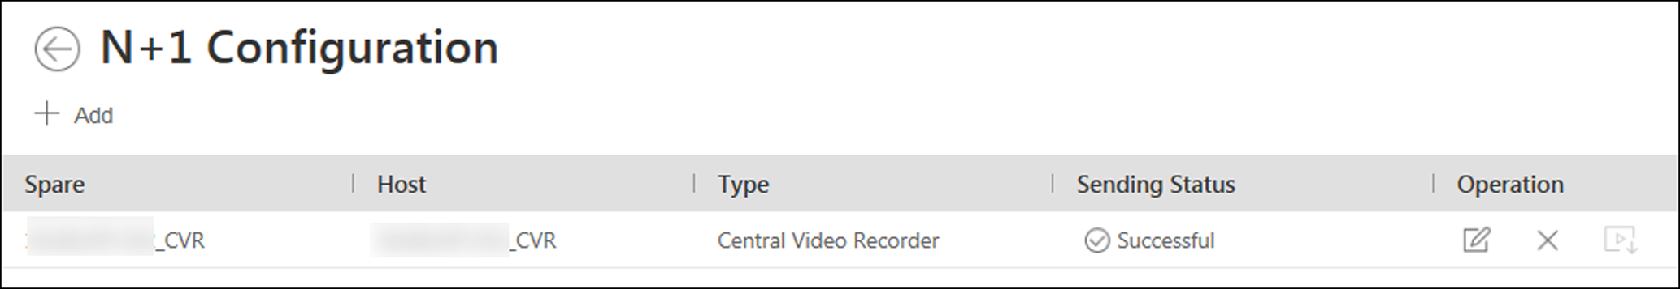
Figure 6-20 N+1 Configuration Page
2. Click Add to set the N+1 hot spare.
3. Select a Hybrid Storage Area Network in the Spare drop-down list to set it as the spare server.
4. Select the Hybrid Storage Area Network(s) in the Host field as the host server(s).
5. Click Add.
Note
The recording schedules configured on the Hybrid Storage Area Network will be deleted after setting it as the spare Recording Server.

6. Optional: After setting the hot spare, you can do one or more of the following:
Edit | Click on the Operation column, and you can edit the spare and host settings.
Delete | Click  on the Operation column to cancel the N+1 hot spare settings.  Note  Canceling the N+1 hot spare will cancel all the host-spare associations and clear the recording schedule on the spare server.

7. Optional: If the host server sending the recording schedule to spare server failed, you can click  on the Operation column to send the recording schedule on the host server to the spare one again.

4.9 Manage Streaming Server
You can add the Streaming Server to the HikCentral Professional to get the video data stream from the Streaming Server, thus to lower the load of the device.
Note
For system which supports Remote Site Management, the cameras imported from Remote Site adopt the Streaming Server configured on the Remote Site by default. You are not required to add the Streaming Server to Central System and configure again.

4.9.1 Input Certificate Information to Streaming Server
For data security purpose, the Streaming Server's certificate should be same with the SYS server's. Before adding the Streaming Server to the system, you should input the certificate information stored in the SYS server to the Streaming Server first.
Steps
Note
If the service component certificate is updated, you should enter the new certificate information to the Streaming Server again to update.

1. Log into the Web Client on the SYS server locally.
You will enter the home page of the Web Client.
2. Enter System → Security → Service Component Certificate.
3. Click Generate beside Certificate between Services in System to generate the security certificate for Streaming Server verification.
Note
You need to enter the account password for verification to generate the security certificate.

4. On the computer which has installed with Streaming Service, open the Service Manager.
5. Click Security Certificate.
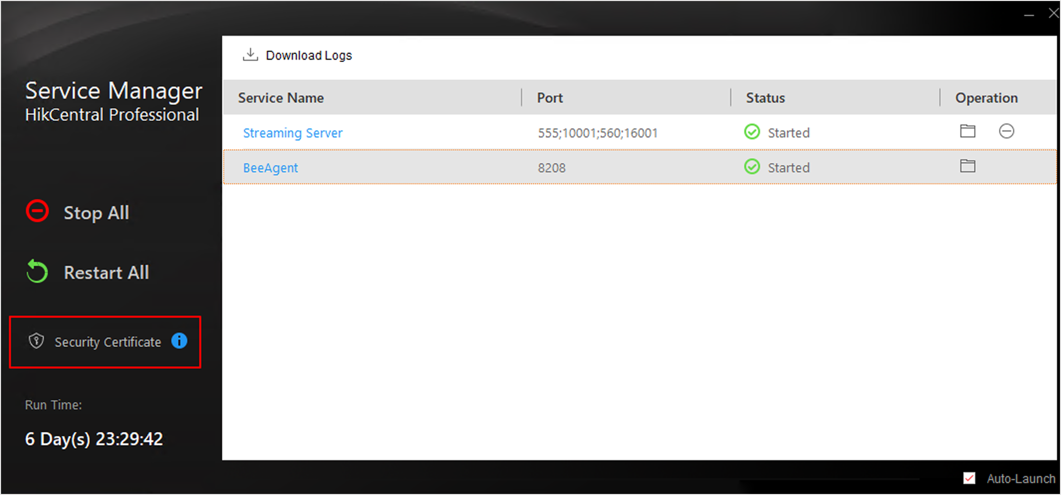
Figure 6-21 Enter Security Certificate
6. Enter the certificate information you generate in step 3.

4.9.2 Add Streaming Server
You can add a Streaming Server to the system to forward the video stream.
Steps
1. Click Physical View → Streaming Server to enter the Streaming Server management page.
2. Click Add to enter the Add Streaming Server page.
3. Enter the required information.
Alias
Create a descriptive name for the server. For example, you can use an alias that can show the location or feature of the server.
Network Location
Select LAN IP Address if the Streaming Server and the SYS server are in the same LAN. Otherwise, select WAN IP Address.
4. Optional: If you need to access the server via WAN, set the Enable WAN Access switch as ON and set the corresponding parameters which are available when you access the server via WAN.
Note
The Enable WAN Access switch is available when you set Network Location as LAN IP Address.

5. Finish adding the Streaming Server.
- Click Add to add the server and back to the server list page.
- Click Add and Continue to save the server and continue to add other servers.
The servers will be displayed on the server list for management after added successfully. You can check the related information of the added servers on the list.

4.10 Add Security Audit Server
You can add the Security Audit Server to the system, to receive the security audit exception logs (e.g., injection attack logs, XSS events) of encoding devices from the server, and trigger related alarms in the system.
Before You Start
Make sure the Security Audit Server you are going to use are correctly installed and connected to the network as specified by the manufacturers. Such initial configuration is required in order to be able to connect the devices to the HikCentral Professional via network.
Steps
Note
Adding security audit server is controlled by the system's license.
Up to 8 security audit servers can be added to the system if the license permits.

1. Click Physical View → Security Audit Server.
2. Click Add to enter the Add Security Audit Server page.

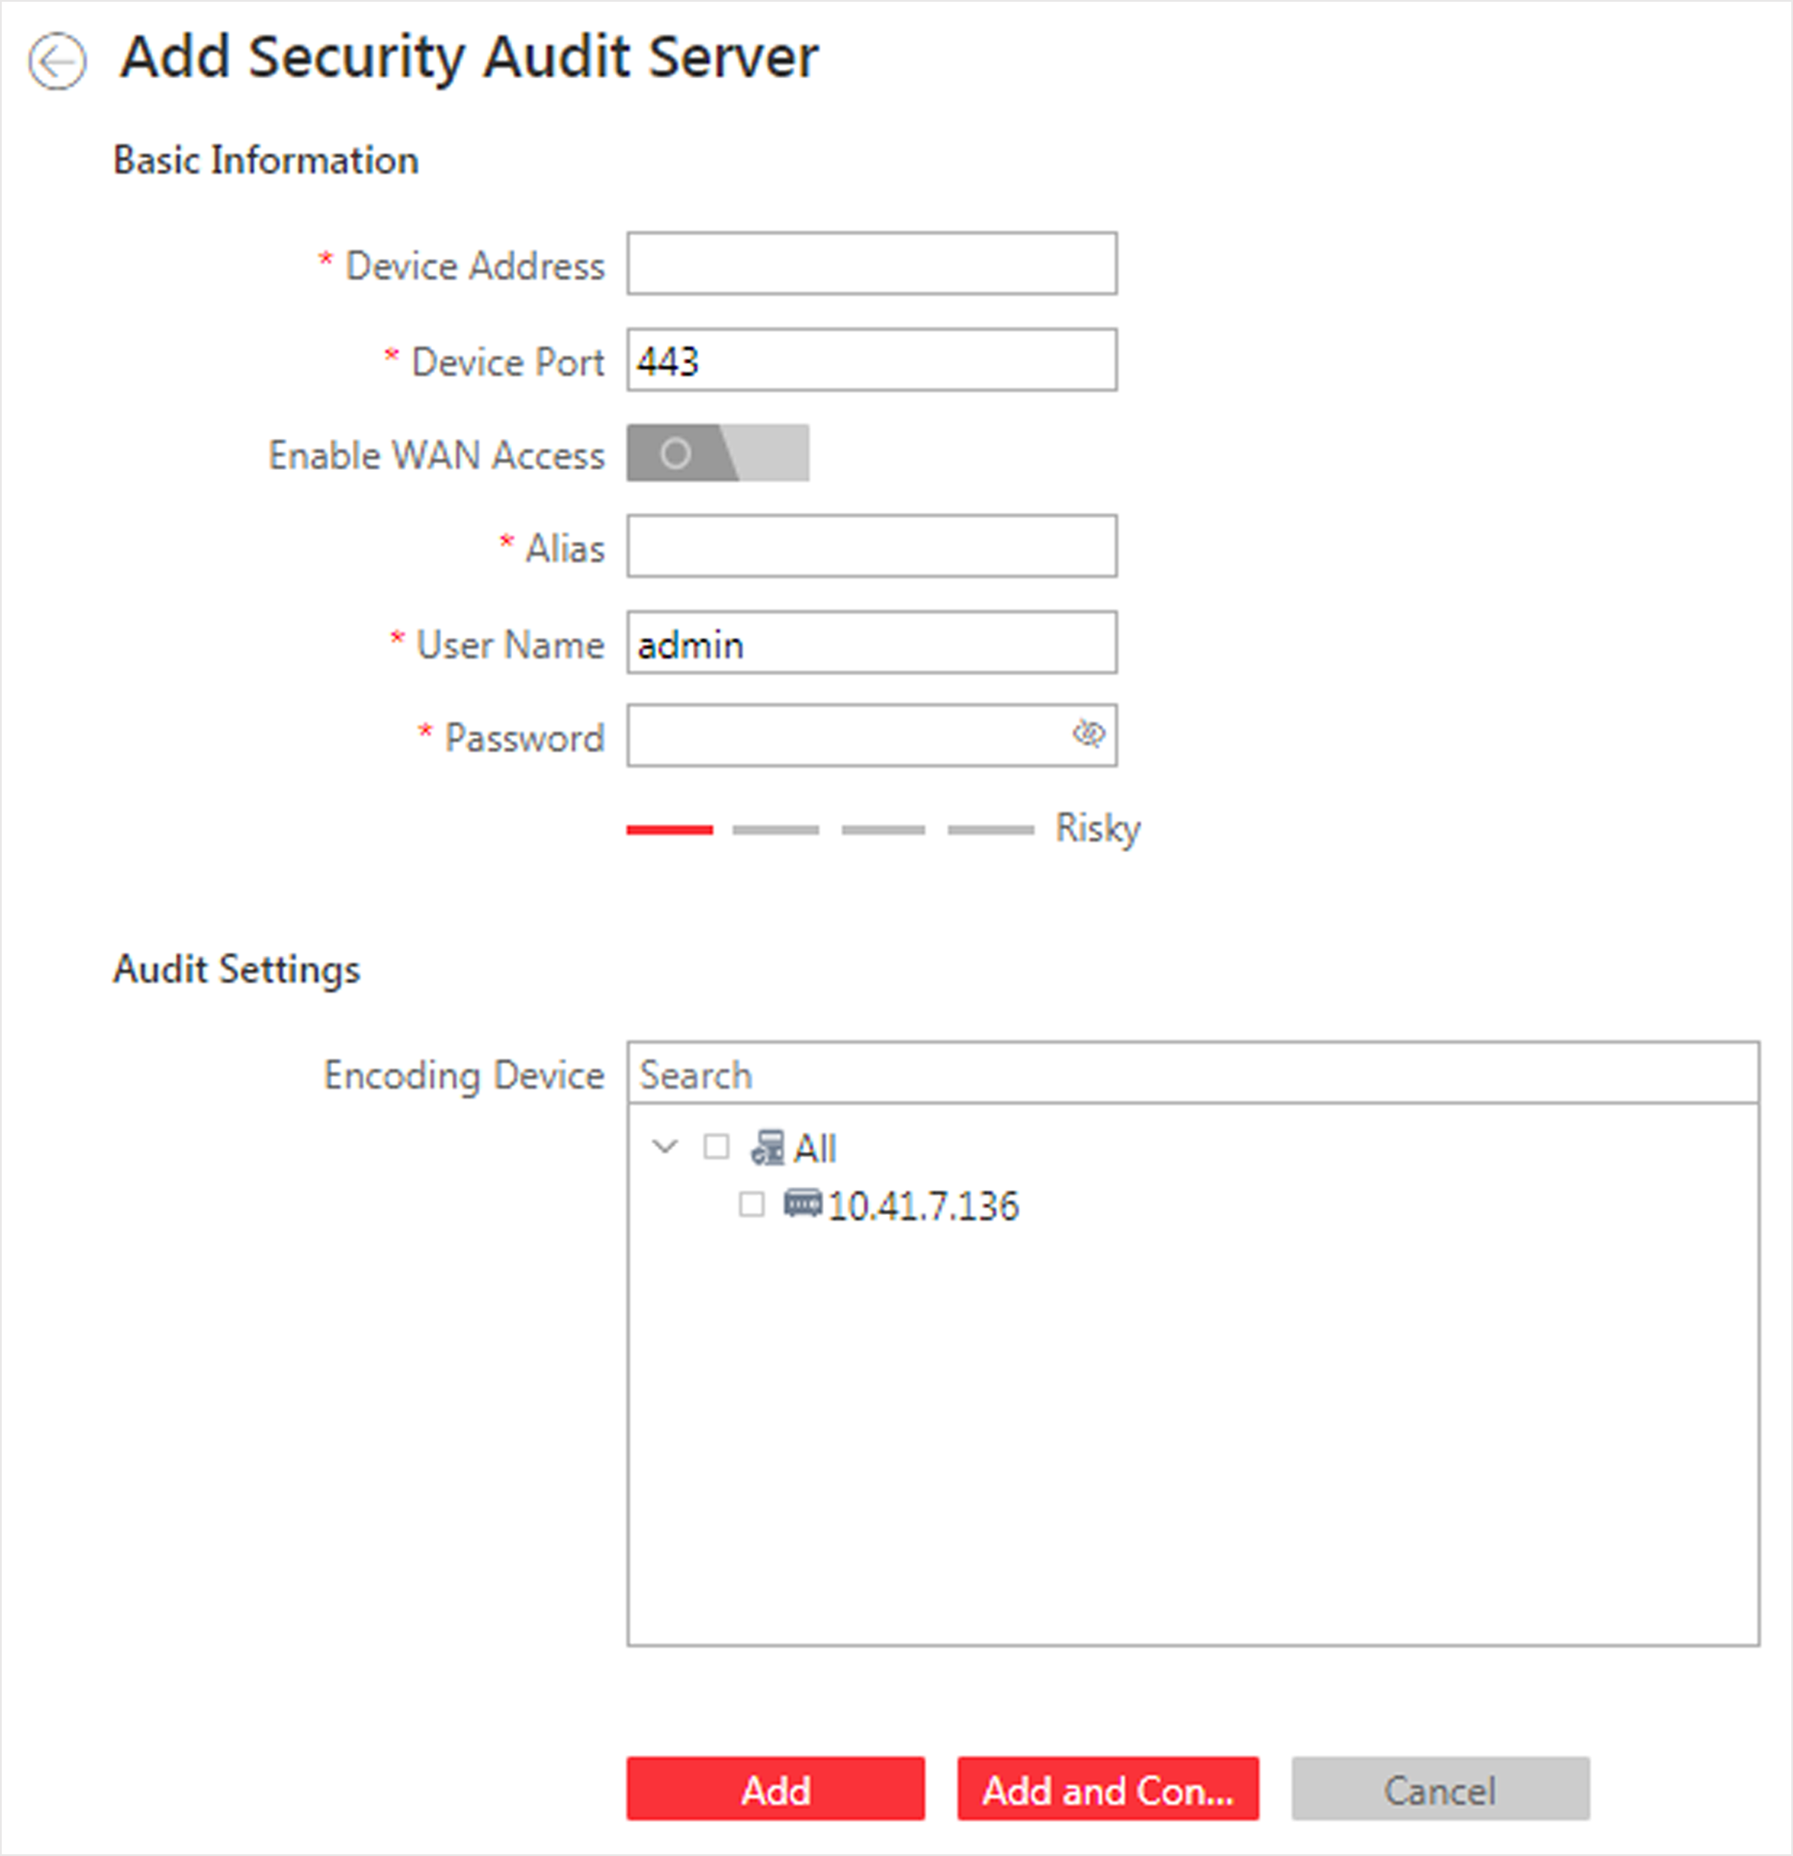
Figure 6-24 Add Security Audit Server Page
3. Set the required basic information such as device address, device port number, and WAN access.
Device Address
IP address of the Security Audit Server.
Device Port
The device port of the Security Audit Server. By default, the port is 443, which means the security audit server access to HikCentral Professional by HTTPS.
Enable WAN Access
Enable the Security Audit Server to access WAN (Wide Area Network).
Note
After enabling the WAN Access, you need to set the WAN IP address and log collection port for WAN access.

Alias
Enter an alias for the Security Audit Server.
User Name
Enter the user name that has the privilege log into the Security Audit Server.
Password
Enter the password of the user that has the privilege log into the Security Audit Server.
4. Select the encoding devices for security audit.
Note
The system can receive the security audit exception logs (e.g., injection attack logs, XSS events) of selected encoding devices from the server, and trigger related alarms in the system.

5. Finish adding the Security Audit Server.
- Click Add to finish adding the server.
- Click Add and Continue to add the server and continue to add more.

Chapter 5 Configure Recording
Recording settings are for defining when and how the recording starts with the pre-defined parameters. You can also configure the storage settings for storing imported pictures and uploaded pictures.
HikCentral Professional provides four storage locations (storing on encoding devices, Hybrid Storage Area Network, Cloud Storage Server, or pStor) for storing the recorded video files of the cameras.
Encoding Device
The encoding devices, including the DVRs, NVRs, and network cameras, should provide storage devices such as the HDDs, Net HDDs, and SD/SDHC cards for video files. The newly installed storage devices need to be formatted. Go to the remote configuration page of the device (Physical View → Configuration), click Storage → General, select the HDD, Net HDD or SD/SDHC card, and click Format to initialize the selected storage device.
Hybrid Storage Area Network
Store the video files in the added Hybrid Storage Area Network. For details about adding Hybrid Storage Area Network, refer to Add Hybrid Storage Area Network.
Cloud Storage Server
Store the video files in the added Cloud Storage Server. For details about adding Cloud Storage Server, refer to Add Cloud Storage Server.
pStor
Store the video files in the added pStor, which is the storage access service used for managing local HDDs and logical disks. For details about adding pStor, refer to Add pStor.
pStor Cluster Service
pStor Cluster Service is a service that can manage multiple pStors. When there are multiple pStors storing a large number of video files, use pStor Cluster Service to manage these pStors. For details about adding pStor Cluster Service, refer to Add pStor Cluster Service.
6.3 Configure Storage for Imported Pictures
The pictures imported by the users, such as the original undercarriage pictures imported on Vehicle page, static e-map pictures, the face pictures in the person list, can be stored on the HDD of SYS server.
Before You Start
Make sure that you have at least 1GB free space for picture storage.
Steps
Note
You can configure the storage only when the current Web Client is running on SYS server.

1. Click System → Storage → Storage on SYS Server to enter the storage on SYS server page.
The disks of the SYS server are displayed with the free space and total capacity.
2. Select the disk to store the imported pictures.
3. Optional: Set the Restrict Quota for Pictures switch to on to allocate the quota for storing the pictures.
4. Click Save.
4.9.1Configure Storage for Uploaded Pictures
The pictures uploaded from the devices, such as alarm triggered pictures, captured face pictures, and captured plate license pictures, can be stored on the HDD of SYS server, Hybrid Storage Area Network, Cloud Storage Server, pStor, or NVR (Network Video Recorder).
Steps
1. Enter the picture storage setting page.
1) Click Logical View → Cameras to enter the area management page.
2) Select an area to show its cameras.
Note
For Central System with Remote Site Management module, you can select the current site (marked with icon) from the drop-down site list to show its cameras.

3) Select a camera and click the Name field to enter the Edit Camera page.
2. Set the Picture Storage switch to on to enable the picture storage for the camera.
3. Select the storage location from the drop-down list.
Note
- If you select System Management Server, the pictures will be stored on the SYS server. Click Configuration to view the disk on SYS server and storage quota, which can be edited via the Web Client running on the SYS server. Refer to Configure Storage for Imported Pictures for details.
- You cannot configure the storage location for the captured undercarriage pictures, which are stored on the UVSS device.

4. Click Save to save the uploaded pictures to the specified location.

Chapter 7 Configure Event and Alarm
You can set the linkage actions for the detected events and alarms. The detailed information of the events and alarms can be received and checked via the Control Client.
Event
Events can be divided into:
System-Monitored Event
The signal that resource (e.g., camera, device, server) sends when something occurs. System can trigger linkage actions (such as recording, capturing, sending email, etc.) to record the received event for checking.
Generic Event
The signal that resource (e.g., other software, device) sends when something occurs, and can be received in the form of TCP or UDP data packages, which the system can analyze, and generate events if they match configured expression.

User-Defined Event
The user-defined event can be used to:
- The user can trigger a user-defined event manually in Monitoring and Alarm Center module on the Control Client when viewing the video or checking the alarm information.
- A user-defined event can trigger an alarm if configured.
- An alarm will be armed or disarmed when the user-defined event is triggered.
- An alarm can trigger a user-defined event as alarm actions.
Alarm
Alarm is used to notify security personnel of the particular situation which helps handle the situation promptly. An alarm can trigger a series of linkage actions (e.g., popping up window) for notification and alarm handling.

5.1 About System-Related Event
System-monitored event is the signal that resource (e.g., device, camera, server) sends when something occurs. System can receive and record event for checking, and can also trigger a series of linkage actions for notification. The event can also trigger an alarm for further notification and linkage actions (such as alarm recipients, pop-up window on the Control Client, displaying on the Smart Wall, etc.). You can check the event related video and captured pictures via the Control Client if you set the recording and capturing as event linkage.
The rule of a system-monitored event includes four elements, namely, "event source" (i.e., the device which detects the event), "triggering event" (specified event type), "what to do" (linkage actions after this alarm is triggered), and "when" (during specified time period, the linkage actions can be triggered).
Example
The event can be defined as intrusion (triggering event) which happens in the bank vault and be detected by cameras mounted in the bank vault (event source) on weekend (when), and trigger the camera to start recording (what to do) once happened.

5.1.1 Supported System-Related Events
Currently, the system supports system-monitored events for the following types of resources:
Camera
The video exception or the events detected in the monitoring area of the camera, such as motion detection, video loss, line crossing, and so on.
Door
The access control event triggered at the doors (doors of access control devices and video intercom devices), such as access event, door status event, etc.
Elevator
The elevator control event triggered in the elevators, such as card swiping event, elevator status event, etc.
Radar
The radar arming event and the event detected by the radars, such as auto-arming event, line crossing event, etc.
Alarm Input
The event triggered by the alarm input of the resources in the system, such as a smoke detector.
ANPR
The license plate matched event and mismatched event detected by the ANPR camera or UVSS.
Person
The face matched event and mismatched event detected by the facial recognition camera.
UVSS
The event triggered by the UVSS, including getting online or offline.
Parking Lot
The event triggered by the resources in the parking lot, such as vehicle matched or mismatched which is detected at the entrance & exit.
Remote Site
The event triggered by the added Remote Site, including site getting offline.
Device Exception
The event triggered by the exception of encoding device, access control device, video intercom device, elevator control device, security control panel, dock station, and decoding device.
Resource Group
The resource group events, including person amount more/less than the threshold and its pre-alarm triggered in the people analysis group.
Server Exception
The events triggered by Recording Server, Streaming Server, DeepinMind Server, Security Audit Server, or HikCentral Professional Server.
User
The event triggered by system users, including user login and logout.
Generic Event
The event triggered by the generic event added in the system.
User-Defined Event
The event triggered by the user-defined event added in the system.
Create Tag
Select the cameras to record video when the event occurs and set the storage location for storing the video files. The system will add a tag to the event triggered video footage for convenient search. The tagged video can be searched and checked via the Control Client.
- If the event source is a camera, you can set to trigger the source camera itself for tagged recording by selecting Source Camera.
- To trigger other cameras for tagged recording, select Specified Camera and click Add to add other cameras.
You can enter the tag name as desired. You can also click the button below to add the related information to the name.
Set the time range to define the tagged length of the video footage. For example, you can set to record the tagged video started from 5 seconds before the event and lasted until and 10 seconds after the event. The tagged video can be searched and checked via the Control Client.
Add the description to the tagged video as needed.
Capture Picture
Select one camera to capture pictures during the event, and you can view the captured pictures when checking event in the Alarm & Event Search of the Control Client.
Note
Only one camera can be set for capturing pictures.

- If the event source is a camera, you can set to trigger the source camera itself for capturing pictures by selecting Source Camera.
- To trigger other camera for capturing pictures, select Specified Camera and select one camera for capturing pictures.
Capture Picture When: Specify the number of seconds to define when the camera will capture pictures for the event. After you set the number of seconds for pre/post-event, the camera will capture one picture at three time points respectively: at the configured seconds before the event starts, at the configured seconds after the event ends, and at the middle of the event (as shown in the picture below).
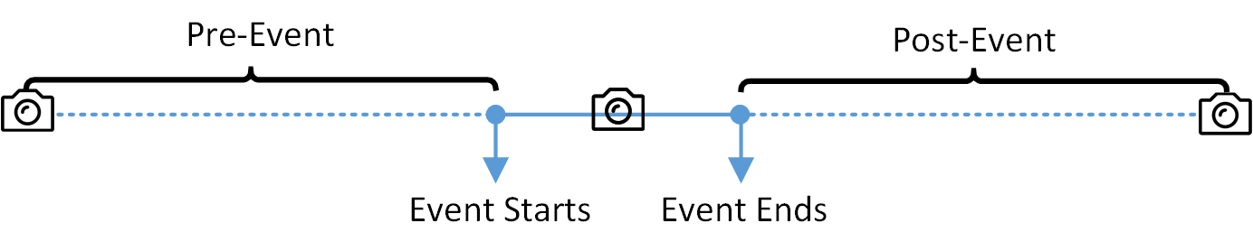
Figure 9-4 Capture Pictures
Note
The pre-event picture is captured from the camera's recorded video footage. This pre-event capture function is only supported by the camera which is set to store the video in the Recording Server (Cloud Storage Server, Hybrid SAN, or pStor).

Trigger User-Defined Event
Trigger user-defined events when the system-monitored event is triggered.
You can select the pre-defined user-defined events in the event list.
You can also click Add New below to set a new user-defined events.
Note
- Up to 16 user-defined events can be selected as event linkage.
- For setting the user-defined event, refer to Configure User-Defined Event.

Other Operations After Adding an Event
After adding a system-monitored event, you can perform the following operations if needed.
Table 9-1 Other Operation
Operation | Description
Trigger Event as Alarm | Click in the Operation column of system-monitored event settings page to set the alarm properties, recipients, actions, and other parameters.  Note  For details, refer to .
Test Event | Click in the Operation column of system-monitored event settings page to trigger the event manually, and you can check whether the linkage actions take effect.
Delete Event | Select the event(s) and click Delete to delete the selected event(s).
Manage Invalid Event | If  appears near the event name, it means the event is not supported by the device and it is invalid. You should hover the cursor over the and click Delete on the tooltip to delete the event.
Delete All Invalid Events | Click Delete All Invalid Items to delete all the invalid events in a batch.
Filter Event | Click  to expand the filter conditions. Set the conditions and click Filter to filter the events according to the conditions.

5.2 Configure Generic Event
You can customize the expression to create a generic event to analyze the received TCP and/or UDP data packages, and trigger events when specified conditions are met. In this way, you can easily integrate your system with a very wide range of external sources, such as access control systems and alarm systems.
Steps
1. Click Event & Alarm → Generic Event to enter the generic event settings page.
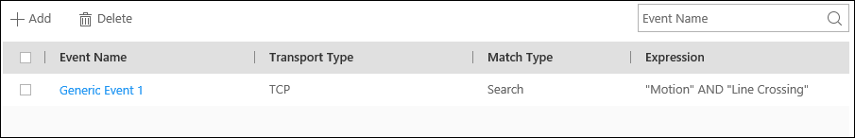
Figure 9-5 Generic Event Settings Page
2. Click Add to enter the Add Generic Event page.
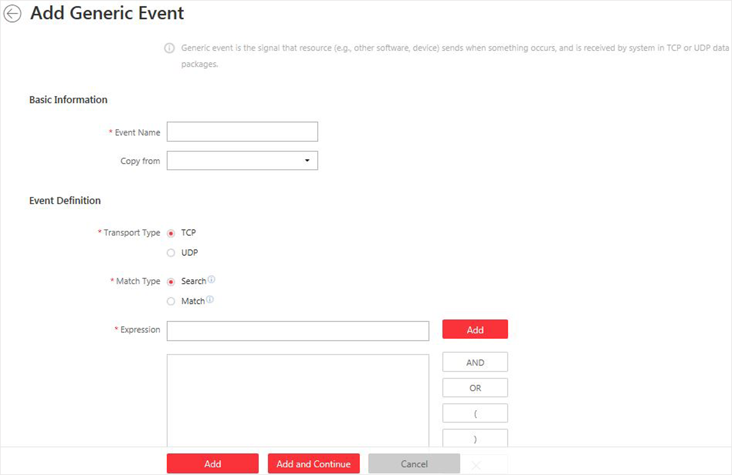
Figure 9-6 Add Generic Event Page
3. Set a name for the event in the Event Name field.
4. Optional: Copy the settings from other defined generic events in the Copy from field.
5. Select TCP or UDP to analyze the packages using TCP or UDP protocol.
6. Select the matched type which indicating how particular your system should be when analyzing the received data packages:
Search
The received package must contain the text defined in the Expression field.
For example, if you have defined that the received packages should contain "Motion" and "Line Crossing", the alarm will be triggered when the received packages contain "Motion", "Intrusion" and "Line Crossing".
Match
The received package must exactly contain the text defined in the Expression field, and nothing else.
7. Define the event rule for analyzing the received package in the Expression field.
1) Enter the term which should be contained in the expression in the text field.
2) Click Add to add it to the expression.
3) Click parenthesis or operator button to add it to the expression.
4) To add a term, parenthesis or operator to the expression, position the cursor inside the expression field in order to determine where a new item (term, parenthesis or the operator) should be included, and click Add or one of the parenthesis or operator buttons.
5) To remove an item from the expression, position the cursor inside the field in order to determine where an item should be removed, and click . The item immediately to the left of the cursor will be removed.
The parenthesis or operator buttons are described in the following:
AND
You specify that the terms on both sides of the AND operator must be included.
For example, if you define the rule as "Motion" AND "Line Crossing" AND "Intrusion", the term Motion, and Line Crossing as well as the term Intrusion must be all contained in the received package for the conditions to be met.
Note
In generally, the more terms you combine with AND, the fewer events will be detected.

OR
You specify that any term should be contained.
For example, if you define the rule as "Motion" OR "Line Crossing" OR "Intrusion", any of the terms (Motion, Line Crossing, or Intrusion) must be contained in the received package for the conditions to be met.
Note
In generally, the more terms you combine with OR, the more events will be detected.

(
Add the left parenthesis to the rule. Parentheses can be used to ensure that related terms are processed together as a unit; in other words, they can be used to force a certain processing order in the analysis.
For example, if you define the rule as ("Motion" OR "Line Crossing") AND "Intrusion", the two terms inside the parentheses will be processed first, then the result will be combined with the last part of the rule. In other words, the system will first search any packages containing either of the terms Motion or Line Crossing, then it search the results to look for the packages that contained the term Intrusion.
)
Add the right parenthesis to the rule.
8. Finish adding the event.
- Click Add to add the event and back to the event list page.
- Click Add and Continue to save the event settings and continue to add event.
9. View in the Generic Event list to check whether the event has been added successfully.
10. Optional: Perform the following operations after adding the event.
Edit Event Settings | Click the name in the Event Name column to edit the corresponding event settings.
Enable Receiving Generic Event | If appears near the event name, it means the system has not enabled receiving generic event. You should hover the cursor over the and click Configuration on the tooltip to enable receiving generic event for the system. For details, refer to Enable Receiving Generic Event.
Delete Event Settings | Check the event(s) and click Delete to delete the selected event settings.
Delete All Event Settings | Check the checkbox in the heading row, and click Delete to delete all the event settings.

5.3 Configure User-Defined Event
If the event you need is not in the provided system-monitored event list, or the generic event cannot properly define the event received from third-party system, you can customize a user-defined event.
Steps
1. Click Event & Alarm → User-Defined Event to enter the user-defined event management page.
2. Click Add to open the following window.
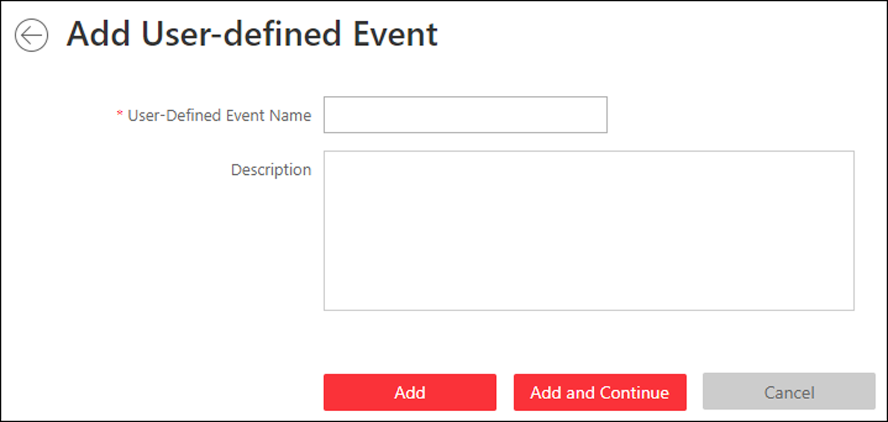
Figure 9-7 Add User-Defined Event
3. Create a name for the event.
4. Optional: Enter the description information to describe the event details.
5. Finish adding the event.

- Click Add to add the event and go back to the event list page.
- Click Add and Continue to add the event and continue to add other events.
With the customized user-defined event, it provides the following functions:
- The user can trigger a user-defined event manually in Monitoring and Alarm Center module on the Control Client when viewing the video or checking the alarm information.
- A user-defined event can trigger an alarm if configured.
- You can define the arming time period by the user-defined event: An alarm's arming schedule will start or end when the user-defined event is triggered.
- An alarm can trigger a user-defined event as alarm actions.
- Integrate other third-party systems with HikCentral Professional by using the data received from the third-party system. You can trigger the user-defined events outside the HikCentral Professional. For details, contact our technical support.
Note
- For configuring the alarm source, arming schedule, and alarm action, refer to .
- For triggering the user-defined event on the Control Client, refer to User Manual of HikCentral Professional Control Client.

Chapter 6 Manage Map
Two types of map are available: GIS map and E-map. On the GIS map, you can set and view the current site, Remote Site, and element's geographic location. On the e-map, which is a static map, you can set and view the geographic locations of the installed cameras, alarm inputs, and alarm outputs, etc.
With GIS map, you can see the geographic locations of your surveillance system. This type of map uses a geographic information system to accurately show all the hot spots' (resources (e.g., camera, alarm input) placed on the map are called hot spots) geographic locations in the real world. GIS map lets you view and access cameras at multiple locations around the world in a geographically correct way. If the resources locate in multiple locations (e.g., different cities, different countries), GIS map can give you a single view to show them all and help you quickly go to each location to view video from the cameras. With the hot region, you can link to the e-map to view the detailed monitoring scenario, for example, the monitoring scenario of a building.
E-map is a static image (it does not have to be geographical maps, although they often are. Depending on your organization's needs, photos and other kinds of image files can also be used as e-maps) which gives you a visual overview of the locations and distributions of the hot spots (resources (e.g., camera, alarm input) placed on the map are called hot spots). You can see the physical locations of the cameras, alarm inputs, and alarm outputs, etc., and in what direction the cameras are pointing. With the function of hot region, e-maps can be organized into hierarchies to navigate from large perspectives to detailed perspectives, e.g., from floor level to room level.
After configuring the e-map via Web Client, you can view the live video and playback of the elements via Control Client, and get a notification message from the map via Control Client when an alarm is triggered.

Chapter 6 Manage Person List
You can add person information to the system for further operations such as access control (adding the person to access group), face comparison (adding the person to face comparison group), time and attendance (adding the person to attendance group), etc. After adding the persons, you can edit and delete the person information if needed.

6.1 add Person Group
When there are large amount of persons managed in the system, you can put the persons in different person groups. For example, you group employees of a company to different departments.
Steps
1. Click Person → Person List to enter the Person List page.
The existing person groups will be displayed on the left panel, while all the persons will be displayed on the right panel.
2. Click to enter the Add Person Group page.
3. Set person group information, including parent group, group name, etc.
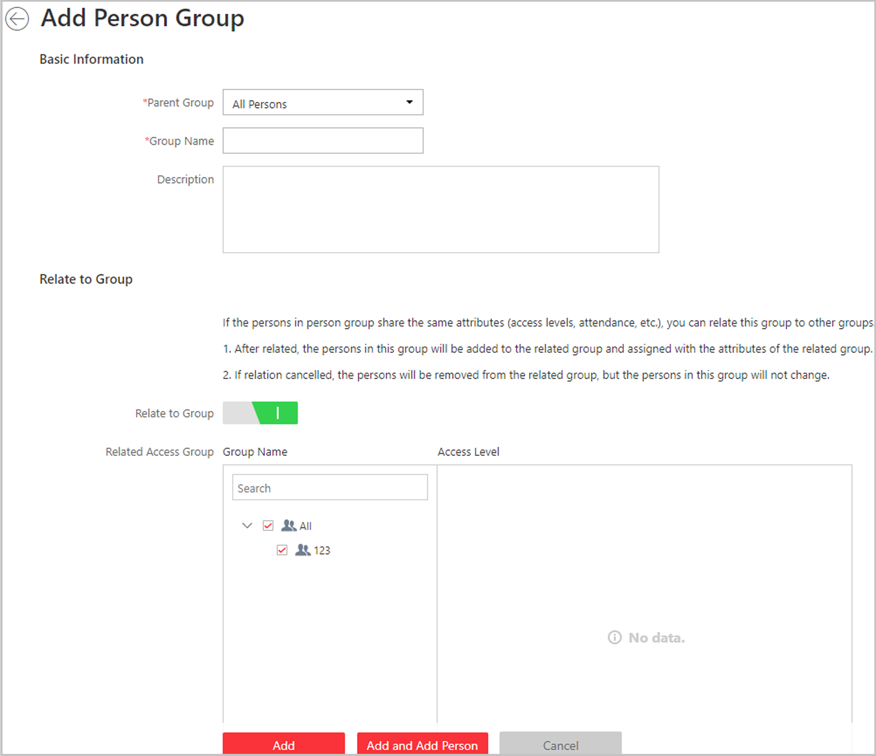
Figure 11-1 Add Person Group Page
4. Optional: If the persons in the person group share the same attributes (access levels, attendance, etc.), you can relate this group to existing access group(s).
1) Switch Relate to Group on.
2) Select existing access group(s).
After related, the persons added to this group will also be added to the related access groups and attendance groups, so that the persons will be automatically assigned with attributes of the related access groups and attendance groups.
5. Confirm to add the person group.
- To save the person group first and add persons to this group later, click Add to finish this task and go back to Person List page.
- To add persons to this person group, click Add and Add Person to finish this task and enter the Add Person to Person Group page to add a person to this person group.
Note
You cannot relate a person group to an access group which contains singly-added persons.

6.2 Add a Person
You can add the person information to the system one by one.
Steps
1. Click Person → Person List and click Add to enter the adding person page.
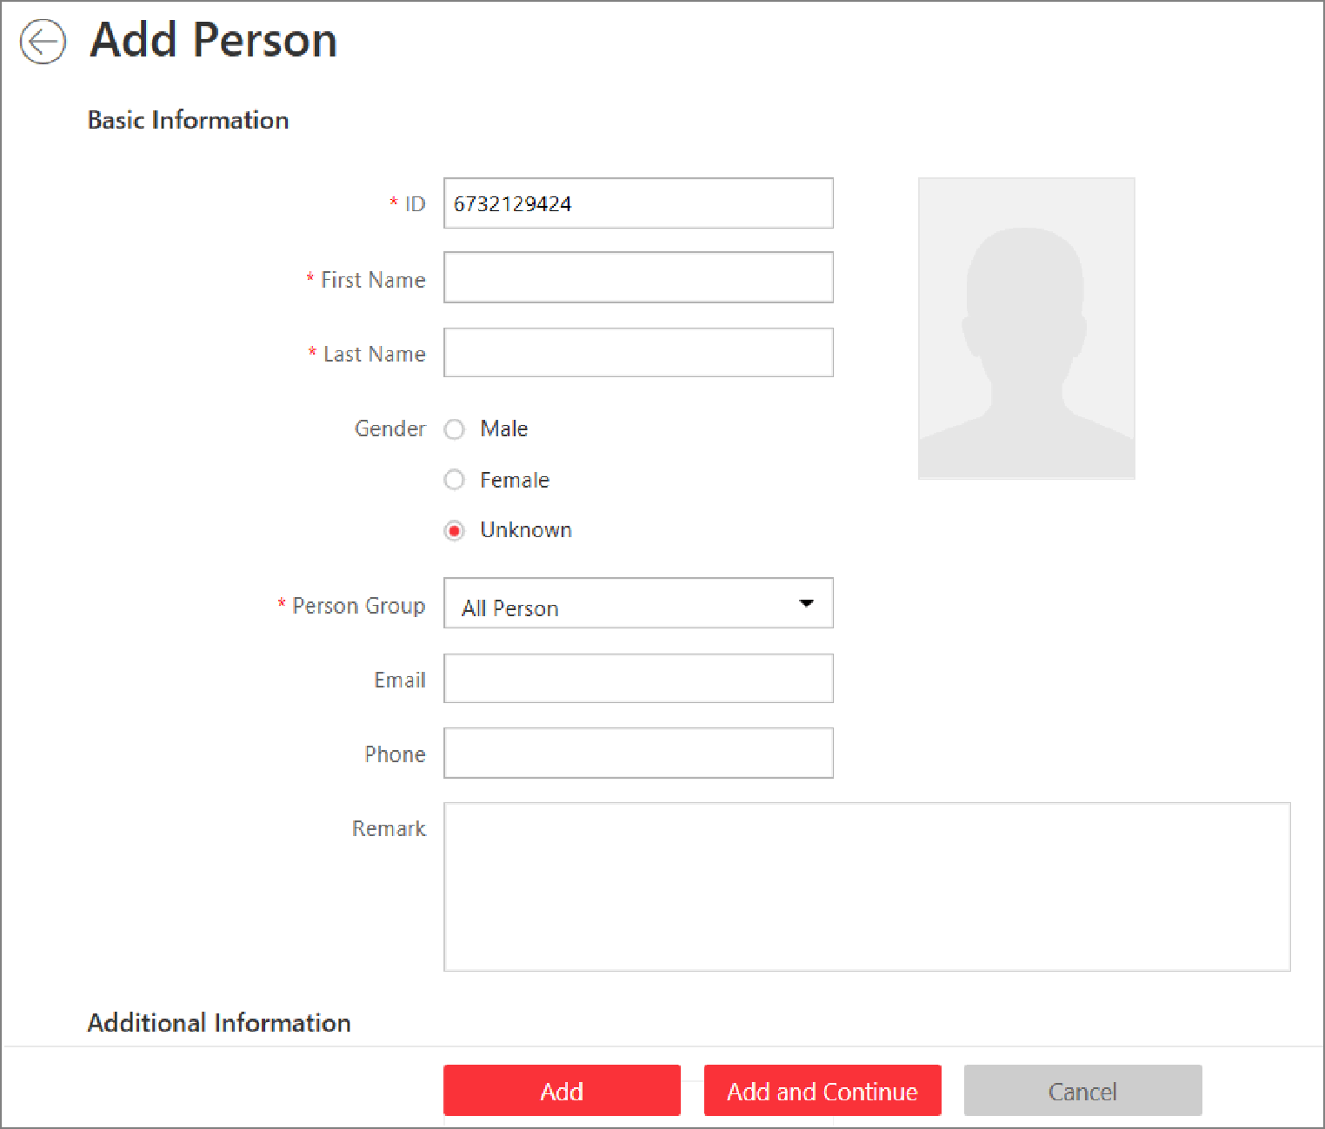
Figure 11-2 Add a Person
2. Set the person basic information.
ID
The default ID is generated by the system. You can edit it if needed.
Note
If the person is police officer or security guard with body cameras, make sure the person ID is same with the police ID configured on the body camera.

Person Picture
Hover the cursor on the person picture field to show the three picture-adding modes.
From Device
Select Access Control Device or Enrollment Station to collect the face picture. This mode is suitable for non-face-to-face scenario that the person and the system administrator are in different locations.
Note
- For access control device, only face recognition terminals (including DS-K5671, DS-K1T671, DS-K1T331, DS-K1T341, DS-K1T672, DS-K1T642, etc.) are supported.
- For enrollment station, you need to set related parameters, including device address, port, user name, password, face anti-spoofing, and security level.

Take a Picture
Click Take a Picture to use the PC's webcam to take a picture.
Upload Picture
Click Upload Picture to select a picture in your PC.
Note
- It is recommended that the face in the picture should be in full-face view directly facing the camera, without a hat or head covering.
- You can drag the picture to change its position or zoom in/out before cutting it.
- You can switch Verify Face Quality by Device to on and select a device to check its quality. Click Save to start checking. You will be informed if the picture is not qualified, while the cut picture will be put in the profile position if it is qualified.

3. Select a person group for the person. See Add Person Group for details about adding a person group.
4. Optional: Set the person's additional information.
Note
You can customize these items according to actual needs as the person's additional information. For details, refer to Custom Additional Information.

5. Optional: Add the person to the existing face comparison group(s) which will be used for face recognition and comparison.
Note
After adding the person to the face comparison group, you should apply the face comparison group to a device to make the settings effective. For details about applying face comparison group to the device, refer to Apply Face Comparison Group to Device.

6. Optional: Set the access control and time & attendance information.
Effective Period
Set the effective period for the person in access control application and time & attendance application. For example, if the person is a visitor, his/her effective period may be short and temporary.
Access Group
Add the person to the existing access group(s) which can be linked with access level(s). The linkage of access level and access group defines the access permission that which person(s) can access which access point(s) in the authorized period.
You can click the access group name to view its linked access levels.
Move the cursor to the access level to view its access point(s) and access schedule.
Note
You can click Add New to add a new access group. For details, refer to Add Access Group.

Super User
If the person is set as a super user, he/she will be exempted from remaining locked (credential failed) restrictions, all anti-passback rules, and first card authorization.
Note
For details about setting these functions, refer to Edit Door for Current Site.

Extended Access
When the person accessing door, grant this person more time to pass through doors which have been configured with extended open duration. Use this function for the persons with reduced mobility.
Note
You should set the door's extended open duration in Logical View. For details, refer to Edit Door for Current Site.

Attendance Group
Add the person to the existing attendance group if your need to monitor the person's working hours and absenteeism.
Note
You can click Add New to add a new attendance group. For details, refer to Add Attendance Group.

Note
The extended access and super user functions cannot be enabled concurrently.

7. Set the person's credential information, including PIN, face credential, card number, fingerprint, and duress credentials.
PIN Code
The PIN code must be used after card or fingerprint when accessing. It cannot be used independently.
Note
It should contain 1 to 8 digits.

Set Profile as Face Credential
If you want to use turnstile with face recognition function, you need to set the person's profile picture as her\his face credential so that the person can scan her\his face on the face recognition terminal when he/she wants to access the turnstile. Make sure you have uploaded a picture as the person profile.
Card
Issue a card to the person to assign the card number to the person. You can enter the card number manually, or swipe a card on the card enrollment station, enrollment station, or card reader to get the card number, and then issue it to the person.
- Click + in the Card field.
- Place the card that you want to issue to this person on the card enrollment station, enrollment station, or on the card reader and the card number will be read automatically. Or you can enter the card number manually
Note
You can click Configuration to set the issuing mode. For details, refer to Set Card Issuing Parameters.

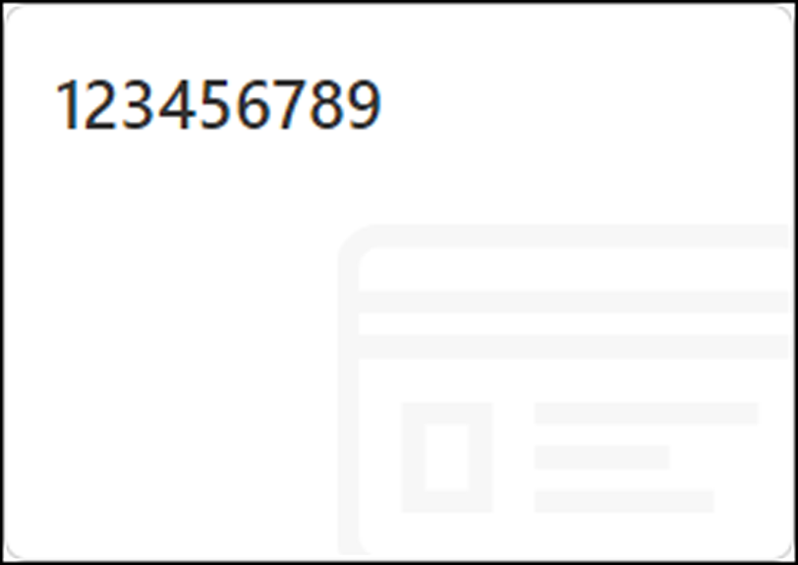
Figure 11-3 Card Number Read
Note
Up to 5 cards can be issued to one person.

Fingerprint
System provides three ways to collect fingerprint: via a USB fingerprint recorder, via an enrollment station or via a fingerprint and card reader.
Click Configuration to set the collection mode as follows.
USB Fingerprint Recorder
Collect fingerprint via a USB fingerprint recorder connected to the PC running the Web Client, which is plug-and-play and doesn't require any settings. This mode is suitable for face-to-face scenario that the person and the system administrator are in the same location.
After connecting the fingerprint recorder to your PC, click +, place and lift your fingerprint on the recorder following the prompts and it will collect your fingerprint automatically.
Note
After collecting a fingerprint by a USB fingerprint recorder, the quality of the fingerprint will be displayed. A new fingerprint is required if the quality is too low.

Enrollment Station
You need to specify the device IP address, port number, user name and password to access the enrollment station. Then click +, place and lift your fingerprint on the device and it will enroll your fingerprint automatically.
Fingerprint and Card Reader
Collect fingerprint via the fingerprint scanner of an access control device which is managed in the system. This mode is suitable for non-face-to-face scenario that the person and the system administrator are in different locations.
Select an access control device from the managed device list and select a fingerprint and card reader.
Click +, place and lift your fingerprint on the selected fingerprint and card reader following the prompts and it will collect your fingerprint automatically.
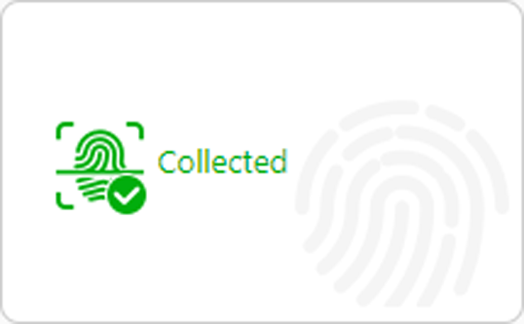
Figure 11-4 Fingerprint Recorded
Note
Up to 10 fingerprints can be added to one person.

Special Credential
Set the Special Credential switch to on, and select the following two usages for card or fingerprint credential.
Credential under Duress
Set the credentials (card number and fingerprint) so that when you are under duress, you can swipe the card or scan the fingerprint configured here. The door will be unlocked and the Control Client will receive a duress alarm (if configured) to notify the security personnel.
Note
When the person accesses with credentials under duress, he/she cannot be exempted from remaining locked (credential failed) restrictions, all anti-passback rules, and first card authorization. Extended access is not allowed as well.

Credential for Dismiss
Set the credentials (card number and fingerprint) so that when an alarm is triggered, you can swipe the card or scan the fingerprint configured here. The alarm will be dismissed.
8. Optional: Add the person to the existing dock station group(s) and set the login password which is used for the dock station(s) in the group to log into the body cameras.
Note
- You can click Add New to add a new dock station group. For details, refer to Add Dock Station Group.
- By default, the login password is 123456.

The videos and pictures stored on the person's body camera can be copied to the person's linked dock station(s).
9. Set resident information to link the person with the indoor station and room number.
Note
Make sure the room number is consistent with the actual location information of the indoor station.

10. Finish adding the person.
- Click Add to add the person and return the person list.
- Click Add and Continue to add the person and continue to add other persons.
The person will be displayed in the person list and you can view the details.
11. Optional: After adding the person, you can do one or more of the followings:
Edit Person | Click the person name to edit the person details.
Delete Person | Select the person(s) and click Delete to delete.
Delete All Persons | Click near Delete button and click Delete All to delete all the persons in the person list.
Export Added Person Information | Click Export All to export all the added person information and you can save the file in your PC. For data security, you are required to set a password before exporting which is required when decompressing the downloaded ZIP file.

6.3 Batch Add Persons by Importing Person Information File
You can add the information of multiple persons to the system by importing an excel file with person information. Also, by entering the name of a person group/access group/face comparison group/attendance group/dock station group of multiple persons in the excel file, you can add them to a group in a batch.
Steps
1. Click Person → Person List/Face Comparison Group/Access Group/Attendance Group/Dock Station Group → Import → Import an Excel File.
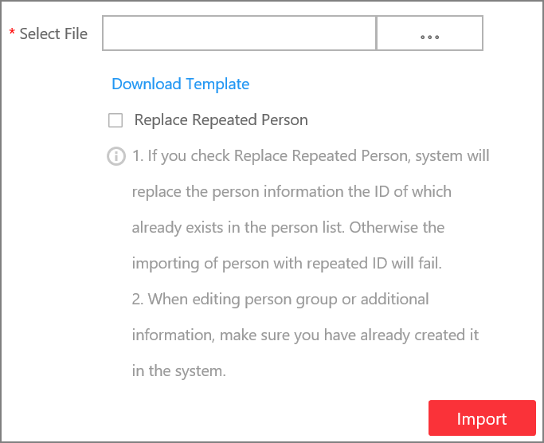
Figure 11-5 Import Person Information
2. Click Download Template to save the template file in your PC.
3. In the downloaded template, enter the person information following the rules in the template.
4. Optional: Check Replace Repeated Person to replace the person's information if the imported ID is the same with an existing person in the list.
5. Click Import → Import an Excel File to enter the Import Person Information page.
6. Select the excel file with the person information
7. Click Import to start importing.
Note
- The importing cannot stop once started.
- You can issue cards to persons in a batch by importing the excel file with card No. entered.

The importing progress shows and you can check the results.

Note
You can export the person information which failed to be imported, and try again after editing.

8. Optional: Perform the following operation(s).
Edit Person | Click the person name to edit the person details.
Delete Person | Select one or more person and click Delete to delete the person(s).
Export Added Person Information | Click Export All to export all the added person information and you can save the file in your PC. For data security, you are required to set a password before exporting which is required when decompressing the downloaded ZIP file.
Filter Person | Click to filter persons by setting conditions, after which click Export All to export information of the filtered persons.

6.4 Import Domain Persons
You can import the users in the AD domain in a batch to the system as persons. After importing the person information (including person name and account name) in the AD domain, you can set other information for the persons, such as credentials.
Before You Start
You should configure the active directory settings. See Set Active Directory for details.
Steps
1. Click Person → Person List to enter the Person List Management page.
2. Click Import → Import Domain Persons to enter the following page.

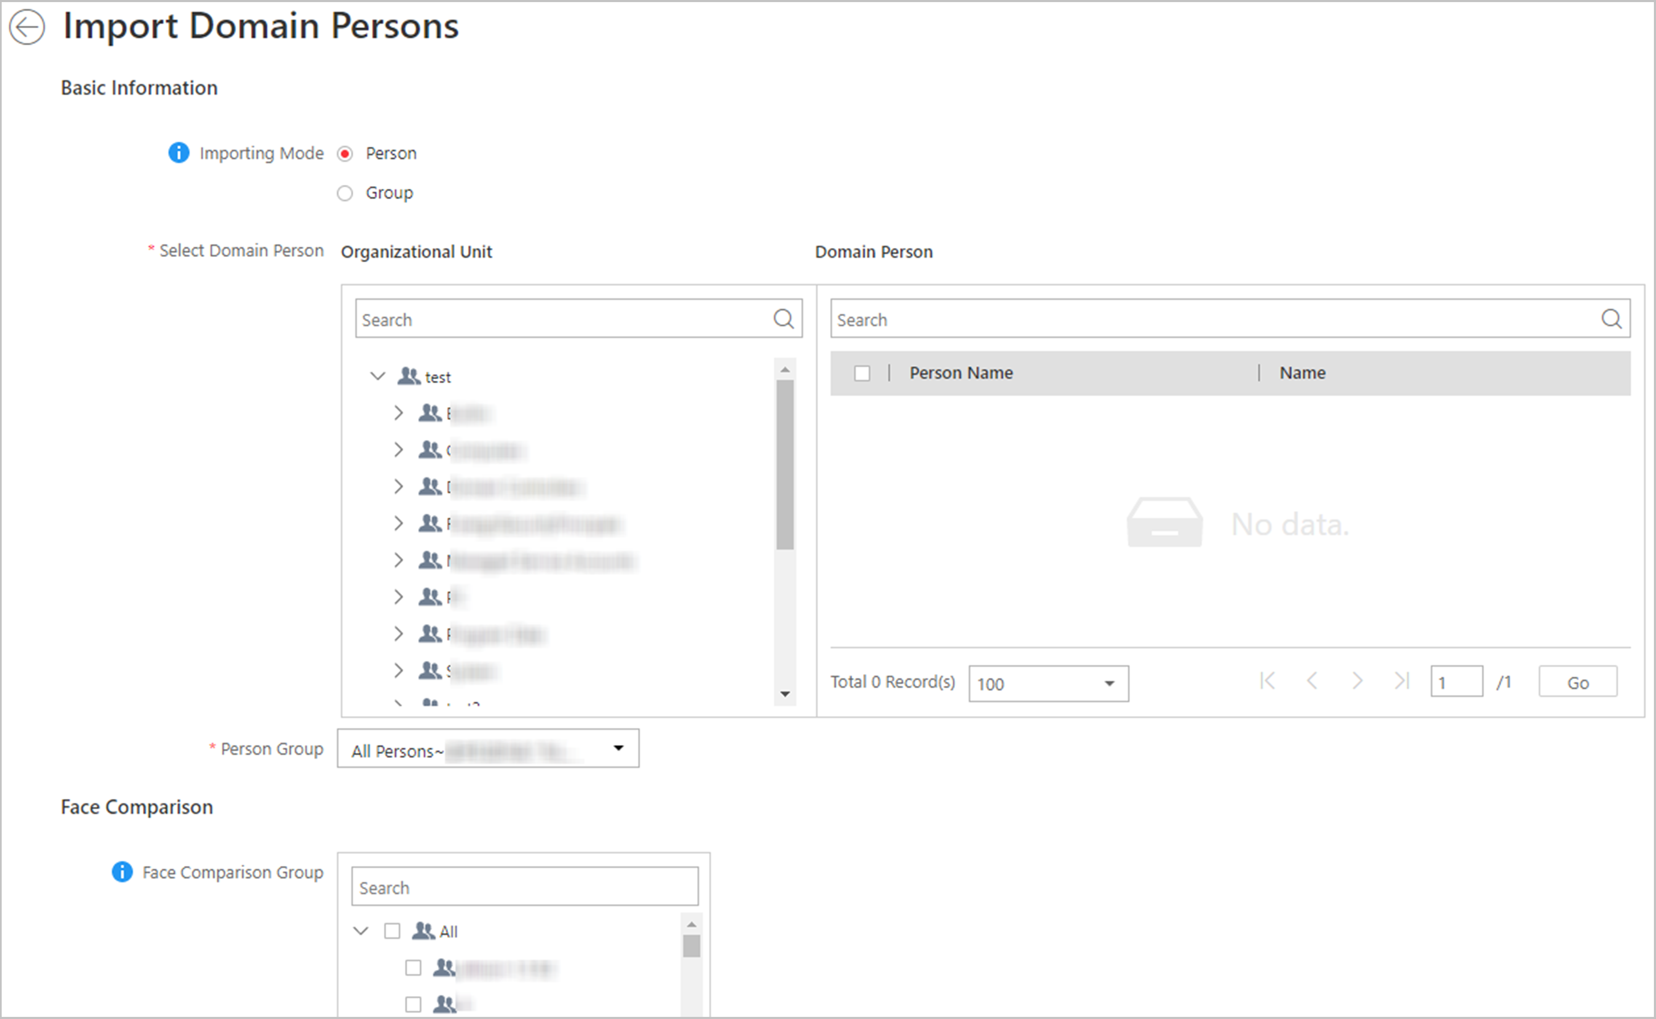
Figure 11-6 Import Domain Persons

3. Select the importing mode.
Person
Import the specified persons. Select the organization unit and select the persons under the organization unit which are displayed in the Domain Person list on the right. It will synchronize person information based on each person.
Group
Import all the persons in the organization unit. It will synchronize person information based on each group.
4. If you select Person as the importing mode, select a person group to import the persons to.
5. Add the persons to the existing face comparison group(s) which will be used for face recognition and comparison.
Note
After adding the persons to the face comparison group, you should apply the face comparison group to a device to make the settings effective. For details about applying face comparison group to the device, refer to Apply Face Comparison Group to Device.

6. Set the access control and time & attendance information.
Effective Period
Set the effective period for the person in access control application and time & attendance application. For example, if the person is a visitor, his/her effective period may be short and temporary.
Access Group
Add the persons to the existing access group(s) which can be linked with access level(s). The linkage of access level and access group defines the access permission that which person(s) can access which access point(s) in the authorized period.
You can click the access group name to view its linked access levels.
Move the cursor to the access level to view its access point(s) and access schedule.
Note
You can click Add New to add a new access group. For details, refer to Add Access Group.

Super User
If the persons are set as super users, they will be exempted from remaining locked (credential failed) restrictions, all anti-passback rules, and first card authorization.
Note
For details about setting these functions, refer to Edit Door for Current Site.

Extended Access
When the persons accessing access point, grant these person more time to pass through doors which have been configured with extended open duration. Use this function for the persons with reduced mobility.
Note
You should set the access point's extended open duration in Logical View. For details, refer to Edit Door for Current Site.

Attendance Group
Add the persons to the existing attendance group if your need to monitor the persons' working hours and absenteeism.
Note
You can click Add New to add a new attendance group. For details, refer to Add Attendance Group.

Note
The extended access and super user functions cannot be enabled concurrently.

7. Complete importing the domain persons.
- Click Add to add the persons.
- Click Add and Continue to save the settings and continue to add persons.
8. Optional: After importing the person information in the domain to the system, you can click the person name to view and edit her/his details.
Note
- If the profile/email in the domain is linked to the profile/email in the system, the persons' profile/email will be imported to the system from the domain as well. You can view the profile/email in the person details page but you cannot edit it.
- If the profile/email in the domain is NOT linked to the profile/email in the system, you can take a picture or upload a picture as the person's profile and enter the email address.
- For linking the person information in the domain to the person information in the system, refer to Set Active Directory.

9. Optional: After importing the person information in the domain to the system, if the person information in domain is changed, click Synchronize Domain Persons to get the latest information of the persons imported to the system. If the persons are imported by group, it will synchronize the latest person information from the domain group (including added persons, deleted persons, edited persons, etc., in the group).

6.5 Batch Add Profiles
You can add multiple person pictures to the system. If you access the system via the Web Client running on the SYS server, you need to specify a path where the profiles are stored. If you access the system via the Web Client running on other computers, you can import a ZIP file containing person pictures. In this way, you can also add these person to specific face comparison group(s).
Steps
Note
If the ID in the profile name is duplicate with the person's in the system, it will edit the existing person's ID. If the ID in the profile name doesn't exist in the system, or the profile name only contains person name, the system will create a new person with the profile, person name, or ID.

1. Name the profile photos according to the person name or person ID.
Note
- The naming rule of photo is: Person Name, Person ID, or Person Name_ID. The person name should contain first name and then last name, separated with a plus sign.
- Recommendation for each photo: Dimensions: 295×412. Size: 60 KB to 100 KB.
- The photos should be in JPG, JPEG, or PNG format.

2. Optional: If you access the system via the Web Client running on the SYS server, packet these photos in one folder and compress it in ZIP format.
Note
The ZIP file should be smaller than 4 GB, or the uploading will fail.

3. Click Person → Person List to enter the person list page.
4. Click Import → Import by Importing Profiles.
5. Select the profiles.
- If you access the system via the Web Client running on the SYS server, select a path where the profiles are stored.
- If you access the system via the Web Client running on other computers, select the ZIP file containing the person photos.
Note
You can hold CTRL key and select multiple ZIP files. Each file should be no larger than 4 GB.

6. Optional: Select a person group from the Person Group drop-down list if you are importing profile pictures for newly added persons.
7. Optional: Perform the following operations if required.
Verify Face Quality by Device | Set the Verify Face Quality by Device switch to on and then select an access control device for verifying the face quality.  Note  You should have added the access control devices which support face recognition. For details about adding access control device, see Manage Access Control Device for details.
Add to Face Comparison Group | Set the Add to Face Comparison Group switch to on and select the face comparison group(s) to add the persons to these group after importing.

8. Click Import to start importing.
The importing progress shows and you can check the results.
9. Optional: After importing profiles, click Export Failure Details to export the Excel file to the local PC and view the failure details including department, person name and person ID.

Chapter 7 Dock Station
The dock station is a data collector which can automatically detect and back up law-enforcement data and evidence data from body camera(s) connected to it. The dock station can also be used to charge the body cameras.
After adding dock stations to the system, you can search the data (video footage, pictures, and audio files) backed up on the dock stations and download the data via the Control Client for convenient management. You can also monitor the online status of the dock stations, and perform other operations such as playing video footage backed up on the dock stations.
Note
- For more details about dock station, see the user manual of the device.
- For details about searching video footage of the dock stations, see the User Manual of HikCentral Professional Control Client.

7.1 Manage Dock Station
You can add a dock station to the system by IP/domain. You can also add multiple dock stations to the system by IP segment, port segment, or importing a pre-defined template which contains the required dock stations' information.

7.1.1 Add Dock Station by IP/Domain
When you know the IP address or domain name of the to-be-added dock station, you can add the device to the system by specifying the IP address, user name, password, and other related parameters.
Before You Start
Make sure the access control devices you are going to use are correctly installed and connected to the network as specified by the manufacturers. Such initial configuration is required in order to be able to connect the devices to the HikCentral Professional via network.
Steps
1. Click Physical View → Dock Station to enter the dock station management page.
2. Select IP/Domain as the adding mode.
3. Enter the required information.
Device Address
IP address or domain name of the dock station.
User Name
User name of the dock station.
Password
Password of the dock station.
4. Optional: Set time zone for the dock station.
1) Select a time zone in drop-down list of Time Zone of Device.
2) Set time zone of the dock station via the dock station's web page, and make sure the device's time zone is the same with the time zone selected in the previous sub-step.
5. Configure the dock station group.
Note
Dock station group is a group of persons (usually policemen or policewomen). Only when the persons are added to the dock station, can the data in their body cameras be backed up to the dock station.

- Click Add New in the Dock Station Group drop-down list to add a new dock station group.
Note
For details about adding dock station group, see Add Dock Station Group.

- Select a dock station group from the Dock Station Group drop-down list.
6. Finish adding the dock station.
- Click Add to add the dock stations and back to the dock station list page.
Click Add and Continue to save the settings and add more dock stations by port segment.
7. Optional: Perform the following operations after adding the dock station.
Edit Dock Station | Click the dock station alias on the device list to edit the dock station.
Delete Dock Station | Select dock station(s) and then click Delete to delete them.

7.1.2 Add Dock Stations by IP Segment
When multiple dock stations have the same port number, user name and password, but have different IP addresses, which are within a range, you can select this adding mode and specify the range of IP address, port number, user name, password, and other related parameters to add them.
Before You Start
Make sure the dock stations you are going to use are correctly installed and connected to the network as specified by the manufacturers. Such initial configuration is required in order to be able to connect the devices to the HikCentral Professional via network.
Steps
1. Click Physical View → Dock Station to enter the dock station management page.
2. Click Add to enter the Add Dock Station page.
3. Select IP Segment as the adding mode.
4. Enter the required information.
Device Address
Enter the start IP address and the end IP address. For example, if five dock stations need to be added, and their IP address are "10.41.7.231", "10.41.7.232", "10.41.7.233", "10.41.7.234", and "10.41.7.235" respectively, you should enter 10.41.7.231 and 10.41.7.235.
5. Optional: Set time zone for the dock station.
1) Select a time zone in drop-down list of Time Zone of Device.
2) Set time zone of the dock station via the dock station's web page, and make sure the device's time zone is the same with the time zone selected in the previous sub-step.
6. Finish adding the dock stations.
- Click Add to add the dock stations and back to the dock station list page.
- Click Add and Continue to save the settings and continue to add more dock stations.
7. Optional: Perform the following operations after adding the dock stations.
Edit Dock Station | Click the dock station alias on the device list to edit the dock station.
Delete Dock Station | Select dock station(s) and then click Delete to delete them.

7.1.3 Add Dock Stations by Port Segment
When multiple to-be-added dock stations have the same IP address, user name and password, but have different port numbers, which are within a range, you can select this adding mode and specify the port range, IP address, user name, password, and other related parameters to add them at a time.
Before You Start
Make sure the devices you are going to use are correctly installed and connected to the network as specified by the manufacturers. Such initial configuration is required in order to be able to connect the devices to the HikCentral Professional via network.
Steps
1. Click Physical View → Dock Station to enter the dock station management page.
2. Click Add to enter the Add Dock Station page.
3. Select Port Segment as the adding mode.
4. Enter the required information.
Device Address
The same IP address where the devices are located.
Device Port
Enter the start port number and the end port number. For example, if there are five dock stations need to be added, and their port number are 80, 81, 82, 83, and 84 respectively, you should enter 80 and 84.
User Name
The same user name of the dock stations.
Password
The same password of the dock stations.
5. Optional: Set time zone for the dock station.
1) Select a time zone in drop-down list of Time Zone of Device.
2) Set time zone of the dock station via the dock station's web page, and make sure the device's time zone is the same with the time zone selected in the previous sub-step.
6. Finish adding the device.
- Click Add to add the dock stations and back to the dock station list page.
Click Add and Continue to save the settings and add more dock stations by port segment.
7. Optional: Perform the following operations after adding the dock stations.
Edit Dock Station | Click the dock station alias on the device list to edit the dock station.
Delete Dock Station | Select dock station(s) and then click Delete to delete them.

7.1.4 Add Dock Stations in Batch
When there are multiple dock stations need to be added to HikCentral Professional, you can download a predefined template and fill in the required information about the dock stations, and then import the template to the system to add multiple dock stations at a time.
Before You Start
Make sure the dock stations you are going to use are correctly installed and connected to the network as specified by the manufacturer. Such initial configuration is required in order to be able to connect the device to the HikCentral Professional via network.
Steps
1. Click Physical View → Dock Station to enter the dock station management page.
2. Click Add to open the Add Dock Station page.
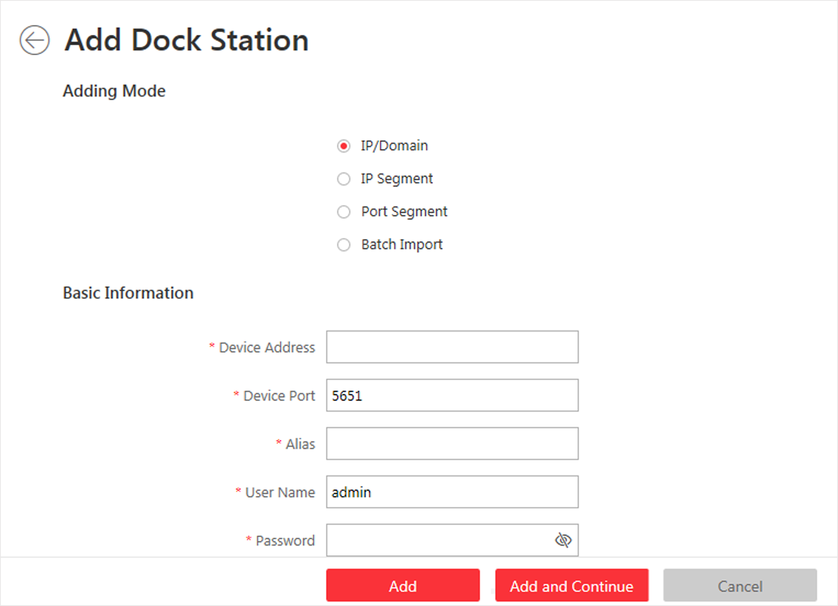
Figure 18-1 Add Dock Station Page
3. Select Batch Import as the adding mode.
4. Click Download Template and save the predefined template (CSV file) on your PC.
5. Open the template file and enter the required information of the devices to be added on the corresponding column.
6. Click and select the template file.
7. Optional: Set time zone for the dock station.
1) Select a time zone in drop-down list of Time Zone of Device.
2) Set time zone of the dock station via the dock station's web page, and make sure the device's time zone is the same with the time zone selected in the previous sub-step.
8. Finish adding the dock stations.
- Click Add to add the dock stations and back to the dock station list page.
- Click Add and Continue to save the settings and continue to add more dock stations.
9. Optional: Perform the following operation(s) after adding the dock stations.
Edit Dock Station | Click the dock station alias on the device list to edit the dock station.
Delete Dock Station | Select dock station(s) and then click Delete to delete them.

7.2 Add Dock Station Group
Dock station group is a group of persons who are linked to the same dock station(s). After linking persons to dock station(s), the videos and pictures on the persons' body cameras can be copied to these dock station(s).
Steps
Note
Up to 64 dock station groups can be added.

1. Click Person → Dock Station Group → Add to enter the adding dock station group page.
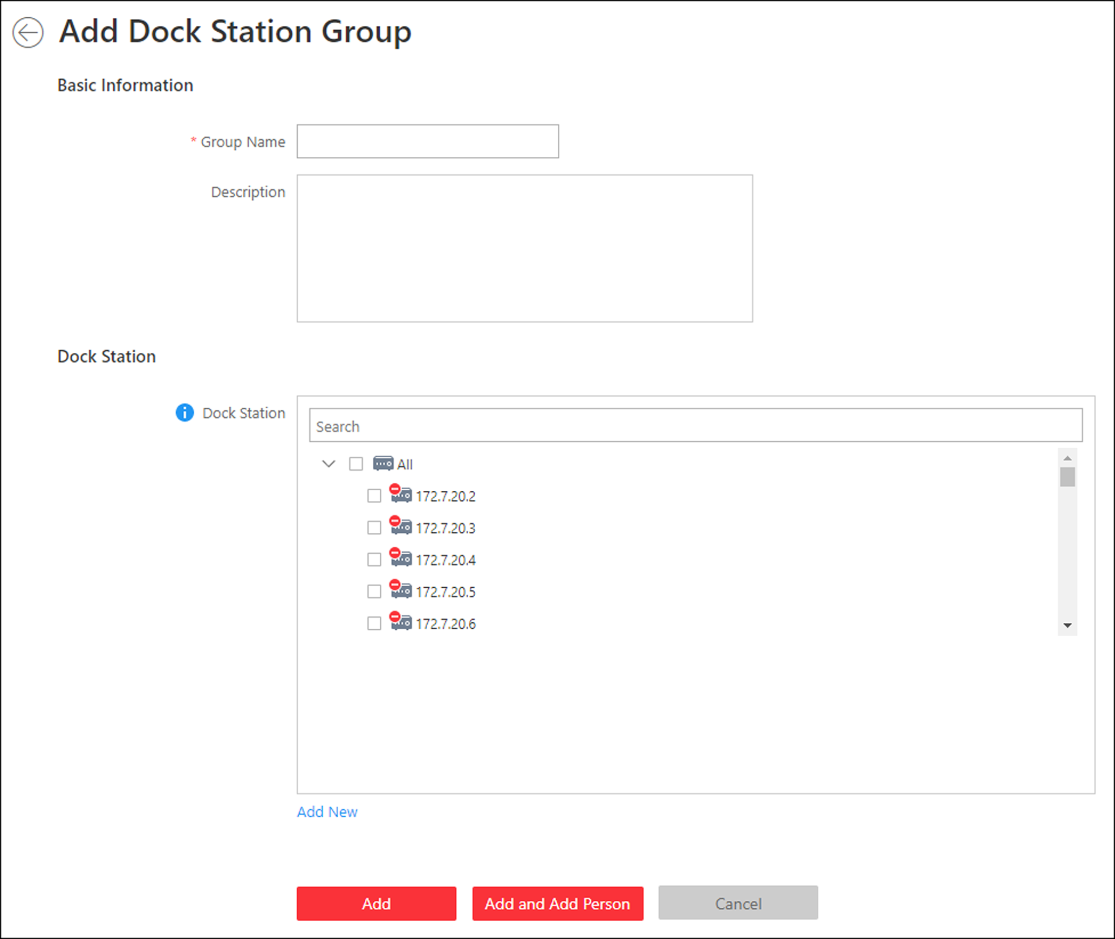
Figure 18-2 Add Dock Station Group
2. Set the basic information.
Group Name
Create a name for the dock station group.
Description
Enter the descriptive information for the group. E.g., This dock station group is for security guards in Team A.
3. Select the dock station(s) to link them to the selected persons.
Note
You can click Add New to add a new dock station to the system. For details, refer to Manage Dock Station.

4. Confirm to add the dock station group.
- To add persons to the dock station group, click Add and Add Person and perform the following steps.
- To save the dock station group first and add persons to the dock station group later, click Add to finish this task and return to the dock station group list.
5. Optional: If you click Add and Add Person, you will enter the next page to add persons to this dock station group.
Note
Up to 20 persons can be added to one dock station group.

1) In the Add from field, choose to add existing persons or add a new person to this group.
Existing Person
Add existing persons in the system to this dock station group.
Add New Person
Add a new person to this dock station group. The person will be added to the person list as well.
2) Optional: If you select Existing Person, you can filter persons in the person list by entering keywords of person name, person group name, or additional information.
Note
You can click Additional Information to enable the custom additional information as search condition.

6. Click Add to add the selected persons to the dock station group.
7. Optional: After adding the dock station group, you can do one or more of the followings.
Edit Dock Station Group | Click  in the Operation column to edit its details.
Manage Persons in Dock Station Group | Click the added dock station group and the persons in this group will be displayed on the right.  You can add more persons into this group, or perform other operations such as issuing cards, importing and exporting persons. For details, refer toManage Person List.
Delete Dock Station Group | Select one dock station group and click Delete to delete it.
Delete All Dock Station Groups | Click Delete All to delete all the added dock station groups.

Chapter 8 Manage Security Control
A security control device detects people, vehicles, etc., entering a pre-defined region, triggers events and alarms, and reports events/alarms information (such as location) to security personnel.
On the Web Client, after adding a security control device to the system, the administrator needs to group the device's alarm inputs into security control partitions in the system. You also need to set one defense schedule for the alarm inputs in a security control partition which defines when and how to arm the alarm inputs in this security control partition.
For example, area 1 is created for the first floor, and all the resources on the first floor are managed in area 1. If there is one security control device mounted on the first floor, you should add its zones (alarm inputs) into area 1 first, then link the zones into security control partitions and set a defense schedule to these security control partitions. After that, the zones can be armed according to the schedules respectively.

8.1 Manage Security Control Device
You can add the security control devices to the system for managing partition, zone, arming/disarming, handling alarms,etc.
The security control device includes the security control panel, panic alarm station, Axiom wireless security control panel, security radar etc., which are widely applied to many scenarios. You can also add the channels (including cameras, alarm inputs, alarm outputs and radars) of the security control device to the area.
A security control panel is used for monitoring arming zones, handling alarm signal from the triggers, and uploading alarm reports to the central alarm monitoring station. The security control panel is very important for preventing robbery, theft or other accidents.
A panic alarm station is mainly installed in the areas with the crowd or high incidence of cases, such as school, square, tourist attraction, hospital, supermarket gate, market, station, parking lot, etc. When the emergency happens or someone asks for help, the person can press panic button to send alarm to the monitoring center, and the operator in the center will take the appropriate actions. The panic alarm station helps to realize alarm aid in emergency.
Security radar is an detecting device used to detect the target by electromagnetic wave. Security radar event will be triggered when the security radar detects object(s) entering the radar zone, and the calibration camera(s) will start to work to capture more details about this event.

8.1.1 Add Detected Online Device
The active online security control devices in the same local subnet with the current Web Client or SYS server will be displayed on a list. You can add one online device one by one, or add multiple online devices in a batch.
Note
You should install the web control according to the instructions and then the online device detection function is available.

Add a Detected Online Security Control Device
You can add the detected online security control devices, and here we introduce the process for adding single one device.
Before You Start
- Make sure the security control devices you are going to use are correctly installed and connected to the network as specified by the manufacturers. Such initial configuration is required in order to be able to connect the devices to the system via network.
- The devices to be added should be activated. Refer to Create Password for Inactive Device(s) for detailed operation about activating devices.
Steps
1. Click Physical View → Security Control Device to enter the Security Control Device Management page.
2. In the Online Device area, select a network type.
Server Network
As the default selection, the detected online devices in the same local subnet with the SYS server will list in the Online Device area.
Local Network
The detected online devices in the same local subnet with the current Web Client will list in the Online Device area.
3. In the Online Device area, select Hikvision Private Protocol or Hikvision ISUP Protocol to filter the detected online devices.
4. In the Online Device area, select the active device to be added .
5. Click to open the Add Online Device window.
6. Enter the required information.
Note
The device's IP address and port number can be automatically shown in Device Address field and Device Port field.

Caution
The password strength of the device can be automatically checked. We highly recommend you change the password of your own choosing (using a minimum of 8 characters, including at least three kinds of following categories: upper case letters, lower case letters, numbers, and special characters) in order to increase the security of your product. And we recommend you change your password regularly, especially in the high security system, changing the password monthly or weekly can better protect your product.
Proper configuration of all passwords and other security settings is the responsibility of the installer and/or end-user.

7. Optional: Select a time zone for the device in drop-down list of Time Zone of Device.
Note
You can check Apply to Device so that when the time zone of the device and the system are not consistent, the system will automatically apply the time zone settings to the device.

8. Optional: Set the Add Channel to Area switch to ON to import the channels (including cameras, alarm inputs, alarm outputs and radars) of the added security control device to an area.
Note
- You can select Specified Alarm Input and Radar and select the specified alarm inputs and radars to import to the area.
- System will generate security control partitions in the area, based on the settings on the device.
- You can create a new area by the device name or select an existing area.
- If you do not import channels to area, you cannot perform the further configurations for the channels.

9. Click Add.
10. Optional: Perform the following operations after adding the online device.
Remote Configurations | Click to set the remote configurations of the corresponding device.  Note  For details about remote configuration, see the user manual of the device.
Change Password | Select the added device(s) and click to change the password for the device(s).  Note  - You can only change the password for online HIKVISION devices currently.  - If the devices have the same password, you can select multiple devices to change the password for them at the same time.

Add Detected Online Security Control Devices in a Batch
For the detected online security control devices, if they have the same password for the same user name, you can add multiple devices at a time.
Before You Start
- Make sure the security control devices you are going to use are correctly installed and connected to the network as specified by the manufacturers. Such initial configuration is required in order to be able to connect the devices to the system via network.
- The devices to be added should be activated. Refer to Create Password for Inactive Device(s) for detailed operation about activating devices.
Steps
1. Click Physical View → Security Control Device to enter the Security Control Device Management page.
2. In the Online Device area, select a network type.
Server Network
The detected online devices in the same local subnet with the SYS server will list in the Online Device area.
Local Network
The detected online devices in the same local subnet with the Web Client will list in the Online Device area.
3. In the Online Device area, select Hikvision Private Protocol or Hikvision ISUP Protocol to filter the detected online devices.
4. In the Online Device area, select the active devices to be added.
5. Click to open the Add Online Device window.
6. Enter the required information.
Caution
The password strength of the device can be automatically checked. We highly recommend you change the password of your own choosing (using a minimum of 8 characters, including at least three kinds of following categories: upper case letters, lower case letters, numbers, and special characters) in order to increase the security of your product. And we recommend you change your password regularly, especially in the high security system, changing the password monthly or weekly can better protect your product.
Proper configuration of all passwords and other security settings is the responsibility of the installer and/or end-user.

7. Optional: Select a time zone for the device in drop-down list of Time Zone of Device.
Note
You can check Apply to Device so that when the time zone of the device and the system are not consistent, the system will automatically apply the time zone settings to the device.

8. Optional: Set the Add Channel to Area switch to on to import the channels (including cameras, alarm inputs, alarm outputs and radars) of the added security control device to an area.
Note
- You can select Specified Alarm Input and Radar and select the specified alarm inputs or radars to import to the area.
- System will generate security control partitions in the area, based on the settings on the device.
- You can create a new area by the device name or select an existing area.
- If you do not import channels to area, you cannot perform the further configurations for the channels.

9. Click Add.
10. Optional: Perform the following operations after adding the online devices in batch.
Remote Configurations | Click to set the remote configurations of the corresponding device.  Note  For details about remote configuration, see the user manual of the device.
Change Password | Select the added device(s) and click to change the password for the device(s).  Note  - You can only change the password for online HIKVISION devices currently.  - If the devices have the same password, you can select multiple devices to change the password for them at the same time.

8.1.2 Add Security Control Device by IP Address
When you know the IP address of the security control device to add, you can add the devices to your system by specifying the IP address, user name, password, and other related parameters.
Before You Start
Make sure the security control devices you are going to use are correctly installed and connected to the network as specified by the manufacturers. Such initial configuration is required in order to be able to connect the devices to the system via network.
Steps
1. Click Physical View → Security Control Device to enter the Security Control Device Management page.
2. Click Add to enter the Add Security Control Device page.
3. Select Hikvision Private Protocol as the Access Protocol.
4. Select IP Address as the adding mode.
5. Enter the required the information.
Note
- By default, the device port is 8000.
- For wireless security control panel, the default port is 80.

Caution
The password strength of the device can be automatically checked. We highly recommend you change the password of your own choosing (using a minimum of 8 characters, including at least three kinds of following categories: upper case letters, lower case letters, numbers, and special characters) in order to increase the security of your product. And we recommend you change your password regularly, especially in the high security system, changing the password monthly or weekly can better protect your product.
Proper configuration of all passwords and other security settings is the responsibility of the installer and/or end-user.

6. Optional: Select a time zone for the device in drop-down list of Time Zone of Device.
Note
You can check Apply to Device so that when the time zone of the device and the system are not consistent, the system will automatically apply the time zone settings to the device.

7. Optional: Set the Add Channel to Area switch to on to import the channels (including cameras, alarm inputs, alarm outputs and radars) of the added security control device to an area.
Note
- You can select Specified Alarm Input and Radar and select the specified alarm inputs or radars to import to the area.
- System will generate security control partitions in the area, based on the settings on the device.
- You can create a new area by the device name or select an existing area.
- Up to 64 alarm inputs can be imported in one area. If you don't import channels to area, you cannot perform further operations for the channels.
- Up to 10 radars can be imported in one area. If you don't import radars to area, you cannot perform further operations for the radars.

8. Finish adding the device.
- Click Add to add the security control device and back to the security control device list.
- Click Add and Continue to save the settings and continue to add next security control device.
9. Perform the following operations after adding the devices.
Remote Configurations | Click to set the remote configurations of the corresponding device.  Note  For details about remote configuration, see the user manual of the device.
Change Password | Select the added device(s) and click to change the password for the device(s).  Note  - You can only change the password for online HIKVISION devices currently.  - If the devices have the same password, you can select multiple devices to change the password for them at the same time.

8.1.3 Add Security Control Device by Hik-Connect
You can add the security control devices which have been added to the Hik-Connect account to the system.
Before You Start
Make sure the security control devices you are going to use are correctly installed and connected to the network as specified by the manufacturers. Such initial configuration is required in order to be able to connect the devices to the system via network.
Steps
1. Click Physical View → Security Control Device to enter the Security Control Device Management page.
2. Click Add to enter the Add Security Control Device page.
3. Select Hikvision Private Protocol as the Access Protocol.
4. Select Hik-Connect as the adding mode.
5. Select a device source.
New Device
Add a new device to both Hik-Connect and the system.
Hik-Connect Device List
Add devices managed by Hik-Connect to the system in a batch by getting the device list.
6. Set required parameters.
Hik-Connect Server Address
Enter the address of the Hik-Connect service. By default, it's https://open.ezvizlife.com.
Note
If you select Hik-Connect Device List as source type, you can click Get Device List to get the device list in the account.

Serial No.
For adding new device, enter the serial No. of the device.
Verification Code
For adding new device, enter the verification code of the device.
7. Optional: Select a time zone for the device in drop-down list of Time Zone of Device.
Note
You can check Apply to Device so that when the time zone of the device and the system are not consistent, the system will automatically apply the time zone settings to the device.

8. Optional: Set the Add Channel to Area switch to on to import the channels (including cameras, alarm inputs, alarm outputs and radars) of the added security control device to an area.
Note
- System will generate security control partitions in the area, based on the settings on the device.
- You can create a new area by the device name or select an existing area.
- If you do not import channels to area, you cannot perform the further configurations for the channels.

9. Finish adding the device.
- Click Add to add the security control device and back to the security control device list page.
- Click Add and Continue to save the settings and continue to add next security control device.
10. Optional: Perform the following operations after adding the devices.
Remote Configurations | Click to set the remote configurations of the corresponding device.  Note  For details about remote configuration, see the user manual of the device.
Change Password | Select the added device(s) and click to change the password for the device(s).  Note  - You can only change the password for online HIKVISION devices currently.  - If the devices have the same password, you can select multiple devices to change the password for them at the same time.

8.1.4 Add Security Control Devices by IP Segment
If the security control devices having the same port No., user name and password, and their IP addresses are between the IP segment, you can specify the start IP address and the end IP address, port No., user name, password, and other related parameters to add them.
Before You Start
Make sure the security control devices you are going to use are correctly installed and connected to the network as specified by the manufacturers. Such initial configuration is required in order to be able to connect the devices to the system via network.
Steps
1. Click Physical View → Security Control Device to enter the Security Control Device Management page.
2. Select Hikvision Private Protocol as the Access Protocol.
3. Click Add to enter the Add Security Control Device page.
4. Select IP Segment as the adding mode.
5. Enter the required the information.
Note
By default, the device port No. is 8000.

Caution
The password strength of the device can be automatically checked. We highly recommend you change the password of your own choosing (using a minimum of 8 characters, including at least three kinds of following categories: upper case letters, lower case letters, numbers, and special characters) in order to increase the security of your product. And we recommend you change your password regularly, especially in the high security system, changing the password monthly or weekly can better protect your product.
Proper configuration of all passwords and other security settings is the responsibility of the installer and/or end-user.

6. Optional: Select a time zone for the device in drop-down list of Time Zone of Device.
Note
You can check Apply to Device so that when the time zone of the device and the system are not consistent, the system will automatically apply the time zone settings to the device.

7. Optional: Set the Add Channel to Area switch to on to import the channels (including cameras, alarm inputs, alarm outputs and radars) of the added security control device to an area.
Note
- System will generate security control partitions in the area, based on the settings on the device.
- You can create a new area by the device name or select an existing area.
- If you do not import channels to area, you cannot perform the further configurations for the channels.

8. Finish adding the device.
- Click Add to add the security control device and back to the security control device list page.
- Click Add and Continue to save the settings and continue to add next security control device.
9. Perform the following operations after adding the devices.
Remote Configurations | Click to set the remote configurations of the corresponding device.  Note  For details about remote configuration, see the user manual of the device.
Change Password | Select the added device(s) and click to change the password for the device(s).  Note  - You can only change the password for online HIKVISION devices currently.  - If the devices have the same password, you can select multiple devices to change the password for them at the same time.

8.1.5 Add Security Control Devices by Port Segment
If the security control devices having the same user name and password, and their port No. are between the port segment, you can specify the start port No. and the end port No., user name, password, and other related parameters to add them.
Before You Start
Make sure the security control devices you are going to use are correctly installed and connected to the network as specified by the manufacturers. Such initial configuration is required in order to be able to connect the devices to the HikCentral Professional via network.
Steps
1. Click Physical View → Security Control Device to enter the Security Control Device Management page.
2. Click Add to enter the Add Security Control Device page.
3. Select Hikvision Private Protocol as the Access Protocol.
4. Select Port Segment as the adding mode.
5. Enter the required the information.
Caution
The password strength of the device can be automatically checked. We highly recommend you change the password of your own choosing (using a minimum of 8 characters, including at least three kinds of following categories: upper case letters, lower case letters, numbers, and special characters) in order to increase the security of your product. And we recommend you change your password regularly, especially in the high security system, changing the password monthly or weekly can better protect your product.
Proper configuration of all passwords and other security settings is the responsibility of the installer and/or end-user.

6. Optional: Select a time zone for the device in drop-down list of Time Zone of Device.
Note
You can check Apply to Device so that when the time zone of the device and the system are not consistent, the system will automatically apply the time zone settings to the device.

7. Optional: Set the Add Channel to Area switch to on to import the channels (including cameras, alarm inputs, alarm outputs and radars) of the added security control device to an area.
Note
- System will generate security control partitions in the area, based on the settings on the device.
- You can create a new area by the device name or select an existing area.
- If you do not import channels to area, you cannot perform the further configurations for the channels.

8. Finish adding the device.
- Click Add to add the security control device and back to the security control device list page.
- Click Add and Continue to save the settings and continue to add next security control device.
9. Perform the following operations after adding the devices.
Remote Configurations | Click to set the remote configurations of the corresponding device.  Note  For details about remote configuration, see the user manual of the device.
Change Password | Select the added device(s) and click to change the password for the device(s).  Note  - You can only change the password for online HIKVISION devices currently.  - If the devices have the same password, you can select multiple devices to change the password for them at the same time.

8.1.6 Add Security Control Device by Device ID
For the security control devices supporting ISUP Protocol, you can add them by specifying a predefined device ID, key, etc. This is an economic choice when you need to manage a security control device in the public network but without fixed IP address by HikCentral Professional.
Before You Start
Make sure the security control device you are going to use are correctly installed and connected to the network as specified by the manufacturers. Such initial configuration is required in order to be able to connect the devices to the HikCentral Professional via network.
Steps
1. Click Physical View → Security Control Device to enter the Security Control Device Management page.
2. Click Add to enter the Add Security Control Device page.
3. Select Hikvision ISUP Protocol as the Access Protocol.
4. Select Device ID as the adding mode.
5. Enter the required information, including device ID, key, and device name.
6. Optional: In the Recording Settings field, set the Video Storage switch to on, and select the storage location from the drop-down list to store videos.
7. Optional: Select a time zone for the device in drop-down list of Time Zone of Device.
Note
You can check Apply to Device so that when the time zone of the device and the system are not consistent, the system will automatically apply the time zone settings to the device.

8. Optional: Set the Add Channel to Area switch to on to import the channels (including cameras, alarm inputs, alarm outputs and radars) of the added security control device to an area.
Note
- System will generate security control partitions in the area, based on the settings on the device.
- You can create a new area by the device name or select an existing area.
- If you do not import channels to area, you cannot perform the further configurations for the channels.

9. Finish adding the device.
- Click Add to add the security control device and back to the security control device list page.
- Click Add and Continue to save the settings and continue to add next security control device.
10. Perform the following operations after adding the devices.
Remote Configurations | Click to set the remote configurations of the corresponding device.  Note  For details about remote configuration, see the user manual of the device.
Change Password | Select the added device(s) and click to change the password for the device(s).  Note  - You can only change the password for online HIKVISION devices currently.  - If the devices have the same password, you can select multiple devices to change the password for them at the same time.

8.1.7 Add Security Control Device by Device ID Segment
If you need to add multiple security control devices which have no fixed IP address and support ISUP Protocol to HikCentral, you can add them to HikCentral Professional at a time after configuring a device ID segment for the devices.
Before You Start
Make sure the security control device you are going to use are correctly installed and connected to the network as specified by the manufacturers. Such initial configuration is required in order to be able to connect the devices to the HikCentral Professional via network.
Steps
1. Click Physical View → Security Control Device to enter the Security Control Device Management page.
2. Click Add to enter the Add Security Control Device page.
3. Select Hikvision ISUP Protocol as the Access Protocol.
4. Select Device ID Segment as the adding mode.
5. Enter the required information, including the start device ID and the end device ID, and the key.
6. Optional: In the Recording Settings field, set the Video Storage switch to on, and select the storage location from the drop-down list to store videos.
7. Optional: Select a time zone for the device in drop-down list of Time Zone of Device.
Note
You can check Apply to Device so that when the time zone of the device and the system are not consistent, the system will automatically apply the time zone settings to the device.

8. Optional: Set the Add Channel to Area switch to on to import the channels (including alarm inputs and radars) of the added security control device to an area.
Note
- System will generate security control partitions in the area, based on the settings on the device.
- You can create a new area by the device name or select an existing area.
- If you do not import channels to area, you cannot perform the further configurations for the channels.

9. Finish adding the device.
- Click Add to add the security control device and back to the security control device list page.
- Click Add and Continue to save the settings and continue to add next security control device.
10. Perform the following operations after adding the devices.
Remote Configurations | Click to set the remote configurations of the corresponding device.  Note  For details about remote configuration, see the user manual of the device.
Change Password | Select the added device(s) and click to change the password for the device(s).  Note  - You can only change the password for online HIKVISION devices currently.  - If the devices have the same password, you can select multiple devices to change the password for them at the same time.

8.1.8 Add Security Control Devices in a Batch
You can edit the predefined template with the security control device information to add multiple devices at a time.
Before You Start
Make sure the security control devices you are going to use are correctly installed and connected to the network as specified by the manufacturers. Such initial configuration is required in order to be able to connect the devices to the system via network.
Steps
1. Click Physical View → Security Control Device to enter the Security Control Device Management page.
2. Click Add to enter the Add Security Control Device page.
3. Select Hikvision Private Protocol or Hikvision ISUP Protocol as the Access Protocol.
4. Select Batch Import as the adding mode.
5. Click Download Template and save the predefined template (excel file) in your PC.
6. Open the exported template file and edit the required information of the devices to be added on the corresponding column.
7. Click and select the template file.
8. Optional: In the Recording Settings field, set the Video Storage switch to on, and select the storage location from the drop-down list to store video.
Note
This field displays when you select Hikvision ISUP Protocol as the access protocol.

9. Optional: Select a time zone for the device in drop-down list of Time Zone of Device.
Note
You can check Apply to Device so that when the time zone of the device and the system are not consistent, the system will automatically apply the time zone settings to the device.

10. Finish adding devices.
- Click Add to add the devices and go back to the device list page.
- Click Add and Continue to save the settings and continue to add other devices.
11. Perform the following operations after adding devices in a batch.
Remote Configurations | Click to set the remote configurations of the corresponding device.  Note  For details about remote configuration, see the user manual of the device.
Change Password | Select the added device(s) and click to change the password for the device(s).  Note  - You can only change the password for online HIKVISION devices currently.  - If the devices have the same password, you can select multiple devices to change the password for them at the same time.

8.2 Link Alarm Inputs to Security Control Partition
After adding the security control device's zones to the system (called "alarm inputs" after added to the system), you should link them to different security control partitions in the system according to the relation between zones and partitions configured on the device.
Before You Start
Make sure the security control device's zones are added to the system and grouped into areas. For details, refer to Add Alarm Input to Area.
Steps
1. Click Logical View on the home page.
2. Choose one of the following methods to enter the area's resource group page.
- Select one area and click  to enter the editing area page.
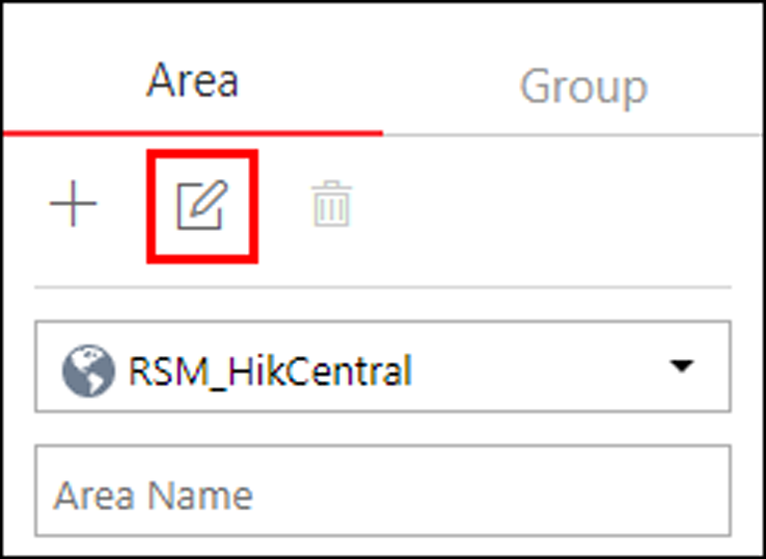
Figure 19-1 Enter Area Editing Page
- Select Group tab on the left to display all the resource groups of different areas.
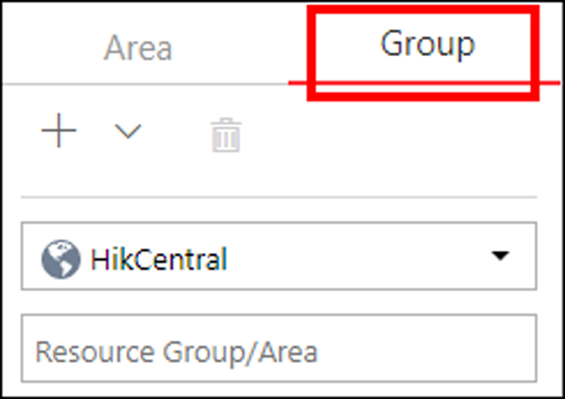
Figure 19-2 Enter Resource Group Page
3. In the Security Control Partition field, click Add.
4. Create a name for the security control partition.
5. In the drop-down list of Alarm Input field, select a security control device.
The alarm inputs of the security control device added to this area and haven't been added to any security control partitions are displayed.
6. Select the alarm inputs which you want to add to the security control partition.
7. Select a security control partition No. in the drop-down list which is gotten from the device you selected in Step 5.
8. Optional: Set a defense schedule for this partition, which defines how and when to arm the alarm inputs in the security control partition.
Note
For setting a new defense schedule, refer to Configure Defense Schedule Template.

9. Click Add.
10. Optional: Perform one or more of the following operations after linking alarm inputs to security control partition.
Edit Security Control Partition | Click to edit the partition settings. You can uncheck the alarm input(s) to remove the added alarm input(s) from the security control partition.  Note  After removing the alarm input(s) from the security control panel, the zones will be removed from this partition on the device, too.
Delete Security Control Partition | Click to delete the added security control partition.

8.3 Configure Defense Schedule Template
The defense schedule defines the arming mode in different time periods for the partitions of the added security control devices. You can set a weekly schedule to schedule time periods for stay arming, instant arming, or away arming in one week. The system predefines two default defense schedule templates: All-day Template and Weekday Template. You can also add a customized template according to actual needs.
Steps
1. Click System on the home page and enter Schedule → Defense Schedule Template page.
2. Click Add to enter the adding defense schedule template page.
3. Set the required information.
Name
Set a name for the template.
Copy from
Optionally, you can select to copy the settings from other defined templates.
4. Select an arming mode and drag on the time bar to draw a time period.
Note
By default, the Time-based is selected.

Instant Arming
It is used when people leave the detection area. The zone will be immediately triggered when it detects event or alarm with no delay and notify the security personnel.
Away Arming
It is used when people leave the detection area. Event or alarms will be activated when the zone is triggered or tampered. For delayed zone, the alarm will not be activated when the zone detects triggering event during entry/exit delay.
Stay Arming
It is used when people stay inside the detection area. During stay arming, all the perimeter burglary detections (such as perimeter detector, magnetic contacts, curtain detector in the balcony) will be turned on. Meanwhile, the detectors inside the detection area are bypassed (such as PIR detectors). People can move inside the area and not trigger an event or alarm.
Note
Up to 8 time periods can be set for each day.

5. Optional: Click Erase and click on the drawn time period to clear the corresponding drawn time period.
6. Finish adding the defense schedule template.
- Click Add to add the template and back to the defense schedule template list page.
- Click Add and Continue to add the template and continue to add other template.
The defense schedule template will be displayed on the defense schedule template list.
7. Optional: Perform the following operations after adding the template.
View Template Details | Click the template to view its details.
Edit Template | Click  in the Operation column to edit template details (except the template(s) in use).
Delete Template | Click  in the Operation column to delete the template.
Delete All Templates | Click Delete All to delete all the schedule templates (except the default templates and the template(s) in use).

Chapter 9 Manage Role and User
The system allows you to add users and assign user's permissions for accessing and managing the system. Before adding users to the system, you should create roles to define the user's access rights to system resources and then assign the role to the user for granting the permissions to the user. A user can have many different roles.

9.1 Add Role
You can assign the permissions to the roles as required, and the users can be assigned with different roles to obtain different permissions.
Steps
1. Click Security → Roles to enter the Role Management page.
Note
The system pre-defines two default roles: administrator and operator. You can click the role name to view the details and operations. But you cannot edit or delete the two default roles.
Administrator
The role that has all the permission of the system.
Operator
The role that has all the permission for operating the Control Client and has the permission for operating the Applications (Live View, Playback, and Local Configuration) on the Web Client.

2. Click Add to enter the Add Role page.
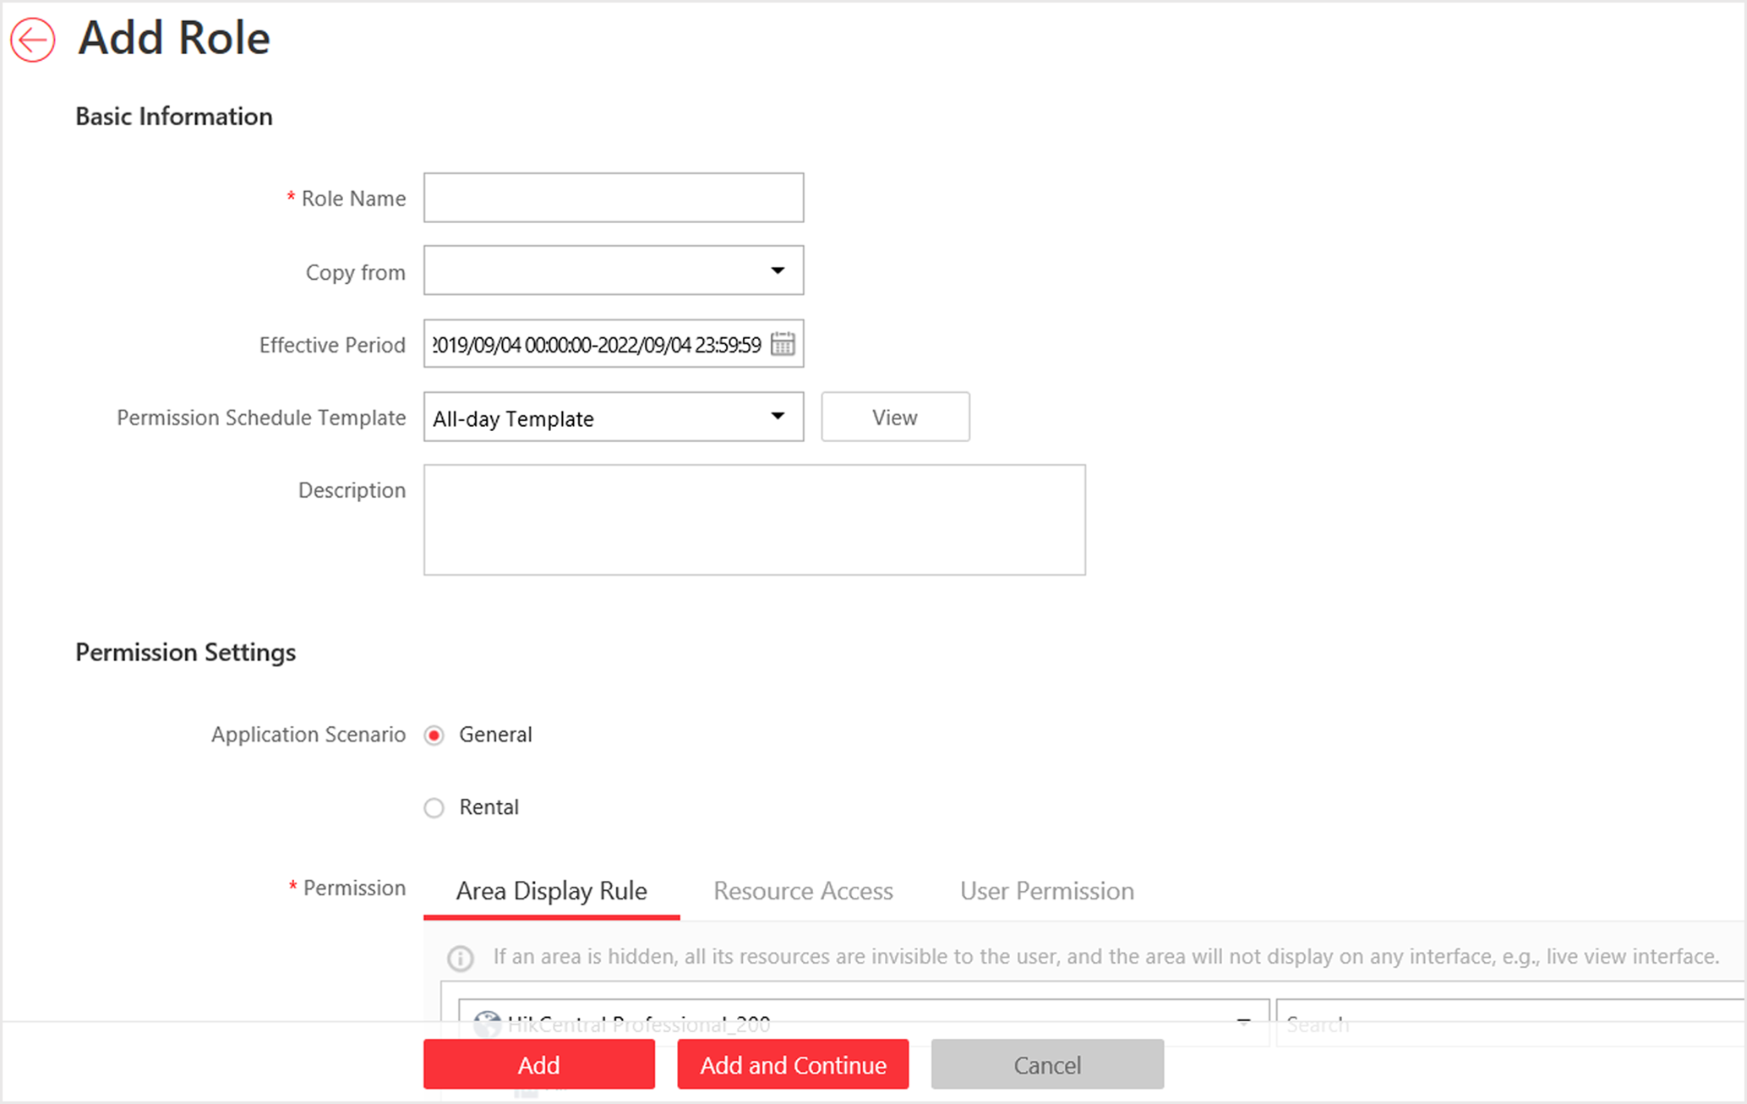
Figure 20-1 Add Role Page
3. Set the role name, effective period, permission schedule template, and description as desired.
Effective Period
The date that this role takes effective and turns invalid.
Permission Schedule Template
Set the authorized time period when the role's permissions are valid. Select All-day Template/Weekday Template/Weekend Template as the permission schedule of the role, or click Add New customize a permission schedule for the role.
Note
- The role's permissions will expire when the current time is not in the authorized time period of the permission schedule.
- When the permissions expire, the role will be logged out and not allowed to login.
- The permission schedule's time zone is consistent with that of the system.
- If the role's permissions are invalid after editing the permission schedule, the role will be forced to login to the system again.
- By default, the role will be linked with All-day Template after updating the system.
- The permission schedule also goes for RSM client and OpenSdk client.

4. Set the permission for the role.
- Select the default or pre-defined role from the Copy from drop-down list to copy the permission settings of selected role.
- Select Application Scenario for the role. If you select General, you need to assign the permissions to the role; if you select Rental, you need to select access groups for the rental so that the role can be verified by the devices of the selected access groups.

Note
For a rental role, only Person module, person list, and access group are available.

Area Display Rule
Show or hide the specific area(s) for the role. If the area is hidden, the user with the role cannot view and access the area and its resources on any interface.
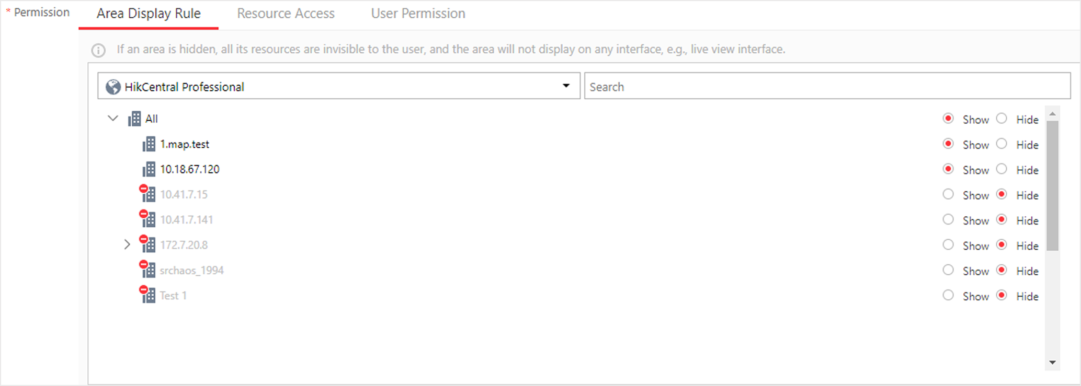
Figure 20-2 Area Display Rule
Resource Access Permission
Select the functions from the left panel and select resources from right panel to assign the selected resources' permissions to the role.
Note
If you do not check the resources, the resource permission cannot be applied to the role.

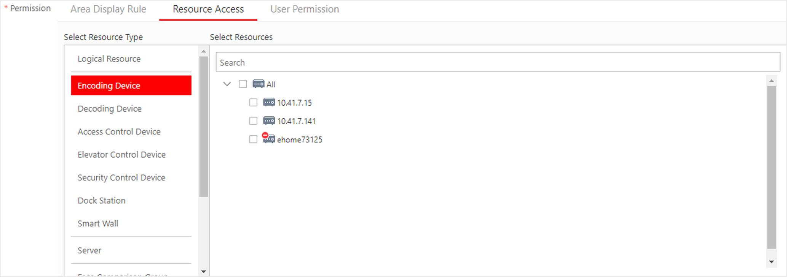
Figure 20-3 Resource Access Permission
User Permission
Assign the resource permissions, configuration permissions on the Web Client, and the control permissions on the Control Client to the role.
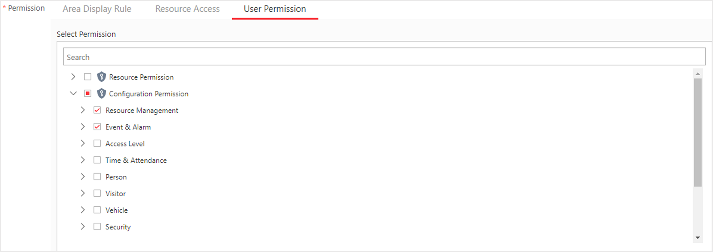
Figure 20-4 User Permission
5. Complete adding the role.
- Click Add to add the role.
- Click Add and Continue to save the settings and continue to add roles.
6. Optional: After adding the role, you can do one or more of the following:
Edit Role | Click the Name field to edit the settings of the role.
Refresh Role | Click Refresh All to get the latest status of the roles.
Delete Role | Click Delete to delete the role.
Filter Role | Click to expand the filter conditions. Set the conditions and click Filter to filter the roles according to the set conditions.

9.2 Add Normal User
You can add normal users for accessing the system and assign role to the normal user. Normal users refer to all the users except the admin user.
Steps
1. Click Security → Users to enter the User Management page.
2. Click Add to enter the Add User page.
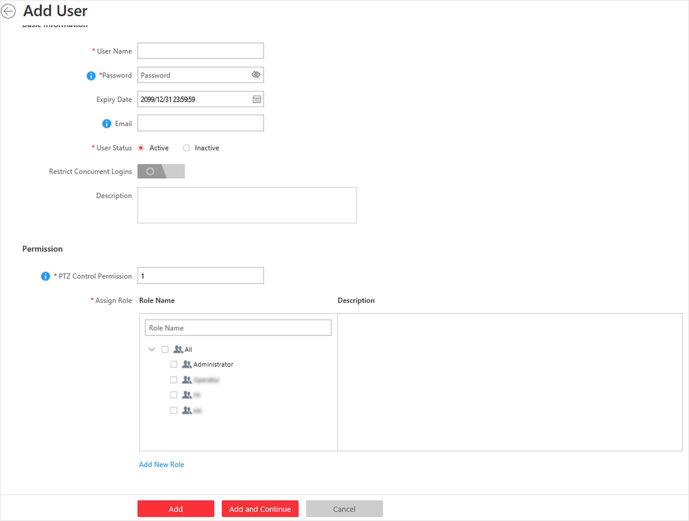
Figure 20-5 Add User Page
3. Set the required parameters.
User Name
For user name, only letters(a-z, A-Z), digits(0-9), and "-" can be contained.
Password
Create an initial password for the user which should be changed by the user for first time login.
Note
We highly recommend you to create a strong password of your own choosing (using a minimum of 8 characters, including at least three kinds of following categories: upper case letters, lower case letters, numbers, and special characters) in order to increase the security of your product. And we recommend you change your password regularly, especially in the high security system, changing the password monthly or weekly can better protect your product.

Expiry Date
The date when this user account becomes invalid.
Email
The system can notify user by sending an email to the email address. If the normal user forget his/her password, he/she can reset the password via email.
Note
The email address of the admin user can be edited by the user with the role of administrator.

User Status
Two kinds of status are available. If you select freeze, the user account is inactive until you set the user status to active.
Restrict Concurrent Logins
If necessary, switch Restrict Concurrent Logins to on and enter the maximum number of concurrent logins.
4. Set the permission level (1-100) for PTZ control in PTZ Control Permission.
Note
The larger the value is, the higher permission level the user has. The user with higher permission level has the priority to control the PTZ unit.

Example
When user1 and user 2 control the PTZ unit at the same time, the user with higher PTZ control permission level will take the control of the PTZ movement.
5. Check the existing roles to assign the role(s) for the user.
Note
- If no role has been added, two default roles are selectable: administrator and operator.
Administrator
The role that has all permissions of the system.
Operator
The role that has all permissions of the system Control Client.
- If you want to add customized roles, you can click Add New Role to quickly enter the Add Role page. See Add Role for details.

6. Complete adding the user.
- Click Add to add the user.
- Click Add and Continue to save the settings and continue to add users.
Note
You will be asked to change the password when logging in for first time. See First Time Login for Normal User for details.

7. Optional: Perform the following operations after adding the normal user.
Edit User | Click the Name field of the user to edit the information
Reset Password | In the Edit User page, click Reset to enter a new password for the user.  Note  The admin user can reset the passwords of all the other users (except domain user). Other users with Security permission (in Configuration and Control Permission) can reset the passwords of the users without Security permission. For changing the password, refer to Change Password for Reset User.
Delete User | Select one or multiple users and click Delete to delete the selected user(s).
Force Logout | You can also select the online user and click Force Logout to log out the online user.
Inactive/Active User | The admin user or user with administrator permission can perform the following operations to inactive or activate the non-admin users in a batch.  - Select one or multiple active users and click Inactive to inactivate the user(s)  - Select one or multiple inactive users and click Active to activate the user(s)
Refresh All | Click Refresh All to get the latest status of the users.
Filter User | Click to expand the filter conditions. Set the conditions and click Filter to filter the users according to the set conditions.

Note
The administrator user named admin was pre-defined by default. It cannot be edited ,deleted, or forced to log out.

9.3 Import Domain Users
You can import the users in the AD domain in a batch to the system (including user name, real name, and email) and assign roles to the domain users.
Before You Start
You should configure the active directory settings. See Set Active Directory for details.
Steps
1. Click Security → Users to enter the User Management page.
2. Click Import Domain Users to enter the Import Domain Users page.
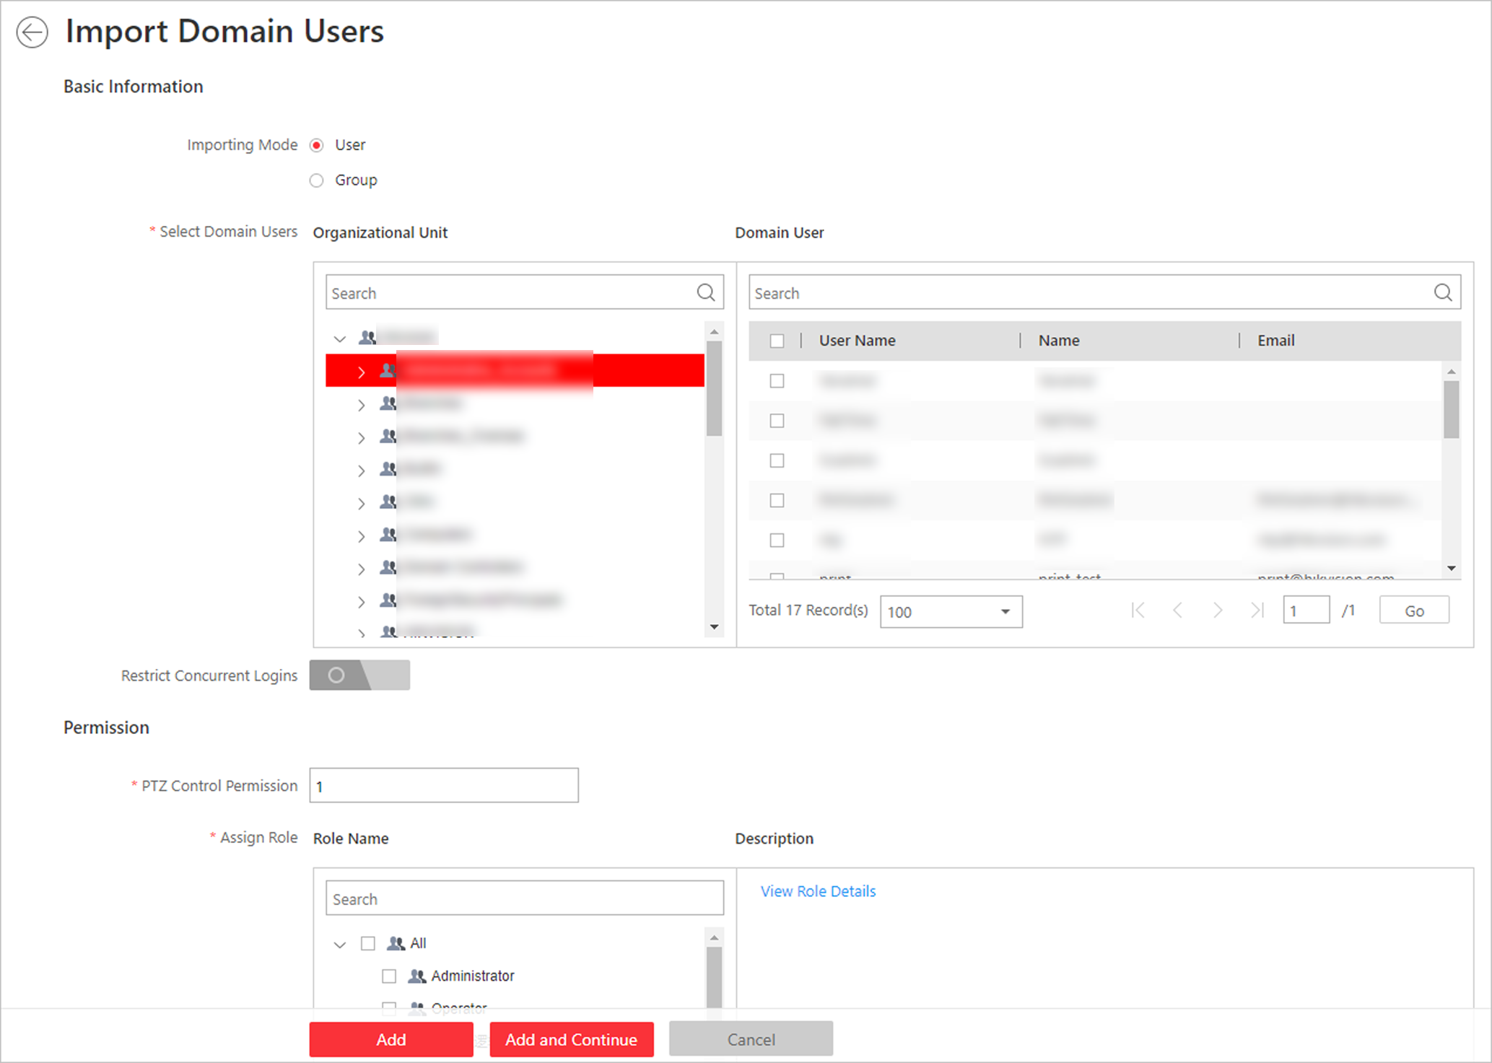
Figure 20-6 Import Domain Users
3. Select the importing mode.
User
Import the specified users. Select the organization unit and select the user accounts under the organization unit which are displayed in the Domain User list on the right.
Group
Import all the users in the group.
4. Optional: Set Restrict Concurrent Logins switch to ON and enter the maximum number of concurrent logins.
5. Set the permission level (1-100) for PTZ control in PTZ Control Permission.
Note
The larger the value is, the higher permission level the user has. The user with higher permission level has the priority to control the PTZ unit.

Example
When user1 and user2 control the PTZ unit at the same time, the user who has the higher PTZ control permission level will take the control of the PTZ movement.
6. Check the existing roles to assign the role(s) for the selected domain user.
Note
- If no role has been added, two default roles are selectable: administrator and operator.
Administrator
The role that has all permissions of the HikCentral Professional.
Operator
The role that has all permissions of the HikCentral Professional Control Client.
- If you want to add customized roles, you can click Add New Role to quickly enter the Add Role page. See Add Role for details.

7. Complete importing the domain user.
- Click Add to add the user.
- Click Add and Continue to save the settings and continue to add users.
8. Optional: After importing the user information in the domain to the system, if the user information in domain is changed, click Synchronize Domain Users to get the latest information of the users imported to the system. If the users are imported by group, it will synchronize the latest user information from the domain group (including added users, deleted users, edited users, etc., in the group).
Result
After successfully adding the domain users, the users can log in to the HikCentral Professional via the Web Client, Control Client and Mobile Client by their domain account and password.

9.4 Change Password of Current User
When you log in via Web Client, you can change your password as desired.
Steps
1. Move the cursor on the name of the current user at the top-right corner of the system.
2. From the drop-down list, select Change Password to open the Change Password dialog.
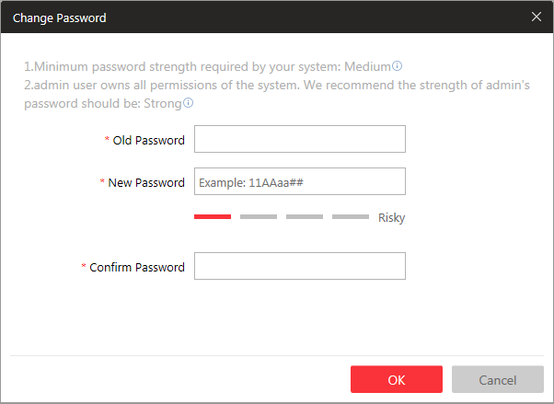
Figure 20-7 Change Password Dialog
3. Enter the old password, new password, and confirm password.
Caution
The password strength of the device can be checked by the system. We highly recommend you change the password of your own choosing (using a minimum of 8 characters, including at least three kinds of following categories: upper case letters, lower case letters, numbers, and special characters) in order to increase the security of your product. And we recommend you reset your password regularly, especially in the high security system, resetting the password monthly or weekly can better protect your product.
Proper configuration of all passwords and other security settings is the responsibility of the installer and/or end-user.

4. Click OK to change the password.

9.5 Reset Password for Admin User
When you forgot the password of admin user, you can reset the password and set a new password for admin user.
Steps
1. In the address bar of the web browser, enter the address of the PC running SYS service and press Enter.
Example
If the IP address of PC running SYS is 172.6.21.96, you should enter http://172.6.21.96 in the address bar.
Note
You should configure the SYS's IP address in System → Network → WAN Access before accessing the SYS via WAN. For details, refer toSet WAN Access.

A login page will pop up.
2. Optional: When you log in via current Internet Explorer browser for the first time, you should install the plug-in before you can access the functions.
Note
If a new version of plug-in is detected, you should update it to ensure the proper usage and better user experience.

1) Click OK in the pop-up dialog to install the plug-in. Or click Download Plug-in to download it.
2) Save the plug-in file to your PC and close the web browser.
3) Find the plug-in that stores on your PC and install the plug-in according to the prompt.
4) Re-open the web browser and log in to the SYS (step 1).
Note
Please allow the browser to run the plug-in in the pop-up prompt.

3. Input admin in the User Name field.
4. Click Forgot Password to open the Reset Password dialog.
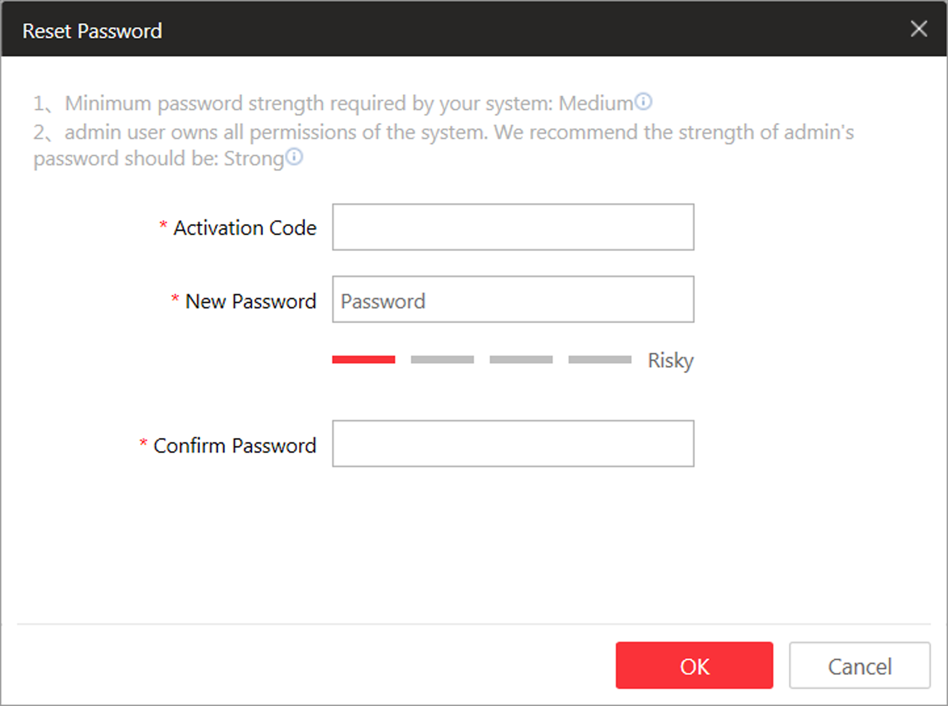
Figure 20-8 Reset Password
5. Enter the required parameters in the pop-up dialog, including activation code, new password, and confirm password.
Note
The password strength can be checked by the system and should meet the system requirements. If password strength is lower than the required minimum strength, you will be asked to change your password. For detailed settings of minimum password strength, refer to Manage System SecuritySecurity.

Caution
The password strength of the device can be checked by the system. We highly recommend you change the password of your own choosing (using a minimum of 8 characters, including at least three kinds of following categories: upper case letters, lower case letters, numbers, and special characters) in order to increase the security of your product. And we recommend you reset your password regularly, especially in the high security system, resetting the password monthly or weekly can better protect your product.
Proper configuration of all passwords and other security settings is the responsibility of the installer and/or end-user.

6. Click OK to reset the admin password.
Note
If you forgot the password of other users, contact the administrator user to reset the password and then change the password for login.

9.6 Reset Password for Normal User
If the user forgot the password, he/she can contact the users with administrator role to reset the password.
Steps
Note
The admin user can reset the passwords of all the other users. Other users with administrator role can reset the passwords of the users without administrator role. See Add Normal User for details about user's role settings.

1. Click Security to enter the Security Management page.
2. Click Users on the left.
3. Select one user and click the Name field to enter the user details page.
4. Click Reset to enter a new password of the user.

9.7 Configure Permission Schedule
The permission schedule defines when the role's permissions are valid. During the authorized time periods, the permissions will be valid. In unauthorized time periods, the user with the role will be forced to logout and he/she cannot login again. The system predefines three default permission schedule templates: All-day Template, Weekday Template, and Weekend Template. You can also add a customized template according to actual needs.
Steps
1. Click System on the home page.
2. Click Schedule → Permission Schedule Template tab on the left.
3. Click Add in the Permission Schedule page to enter the adding permission schedule template page.
4. Set the required information.
Name
Create a name for the template.
Copy from
Optionally, you can select to copy the settings from other defined templates.
5. Draw a time period on the time bar.
Note
Up to 8 time periods can be set for each day.

6. Optional: Click Erase and click on the drawn time period to clear the corresponding drawn time period.
7. Optional: Set the holiday schedule. The priority of holiday schedule is higher than the weekly schedule which means the predefined holidays will adopt the holiday schedule rather than the weekly schedule.
1) Click Add Holiday.
2) Select the predefined holiday(s), or click Add New to create a new holiday (see Set Holiday for details).
3) Click Add.
4) Draw a time period on the time bar.
Note
Up to 8 time periods can be set for each day.

5) Optional: Click Erase and click on the drawn time period to clear the corresponding drawn time period.
8. Finish adding the permission schedule template.
- Click Add to add the template and back to the permission schedule template list page.
- Click Add and Continue to add the template and continue to add other template.
The permission schedule template will be displayed on the permission schedule template list.
9. Optional: Perform the following operations after adding the template.
View Template Details | Click the template to view its details.
Edit Template | Click in the Operation column to edit template details.
Delete Template | Click in the Operation column to delete the template.
Delete All Templates | Click Delete All to delete all the schedule templates (except the default templates and the template(s) in use).

Chapter 10 Maintenance
The system provides Service Manager to manage the installed services on the SYS server. You can check the service's running status, edit the service port, start/stop service via the Service Manager.
The system also provides backup of the database, so that your data can be well protected and recovered when an exception occurs.
You can also export the system's configuration data and save it to the local PC.

10.1 Service Manager
After successfully installing the service module(s), you can run the Service Manager and perform related operations of service, such as starting, stopping, or restarting the service.
Steps
1. Right-click  and select Run as Administrator to run the Service Manager.
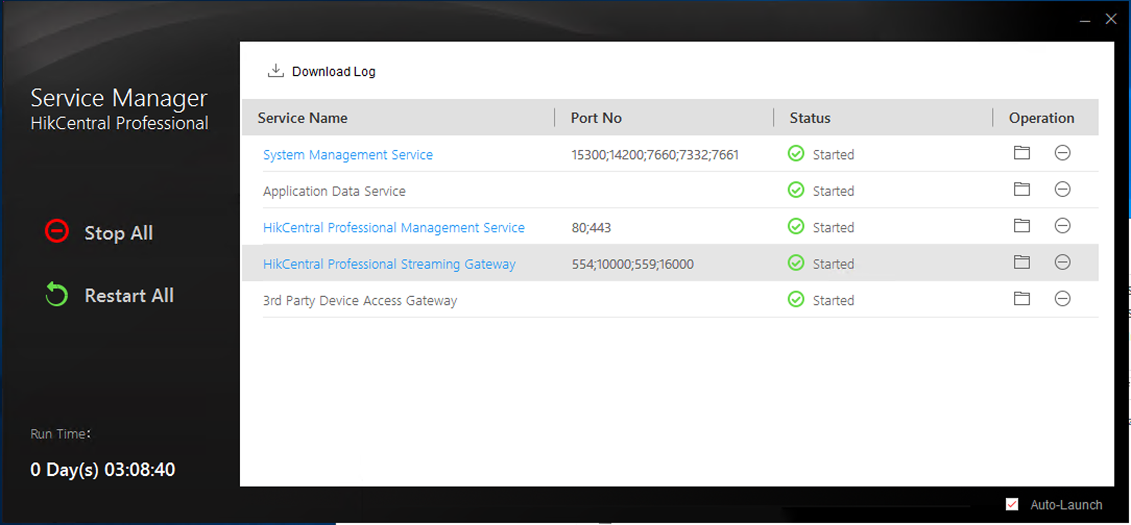
Figure 21-1 Service Manager Main Page
Note
The displayed items vary with the service modules you selected for installation.

2. Optional: Perform the following operation(s) after starting the Service Manager.
Stop All | Click Stop All to stop all the services.
Restart All | Click Restart All to run all the services again.
Stop Specific Service | Select one service and click  to stop the service.
Edit Service | Click the service name to edit the port of the service.  Note  If the port number of the service is occupied by other service, the port No. will be shown in red. You should change the port number to other value before the service can work properly.
Open Service Location | Select one service and click  to go to the installation directory of the service.

3. Optional: Check Auto-Launch to enable launching the Service Manager automatically after the PC started up.

10.2 Set System Data Backup
For purpose of restoring the original system data after a data loss event or recovering data from an earlier time, you can manually back up the data in the system, or configure a schedule to run the backup task regularly. The system data includes data configured in the system, pictures configured in the system, received events and alarms, face comparison data, card swiping data, maintenance data, etc.
Perform this task when you need to configure the schedule to run the system data backup task regularly or manually back up the data.
Steps
Note
The backups are stored in the SYS server. If you want to edit the default saving path, you should enter Back Up and Restore System Data page via the Web Client running on the SYS server.

1. Click Back Up and Restore System Data on the home page.
2. Click Back Up.
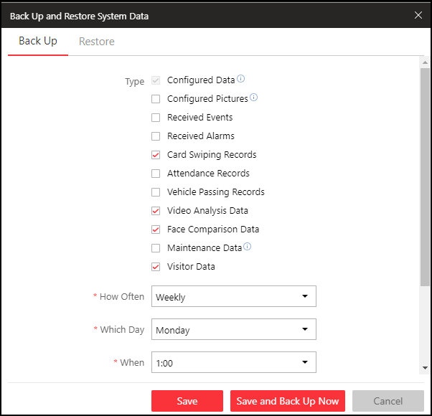
Figure 21-2 Set System Data Backup
3. Select the system data type for backup.
Configured Data
The data configured via the Web Client, including physical resources, logical resources, user permissions, etc. It is selected by default.
Configured Pictures
The pictures uploaded when setting maps, persons, vehicles, etc.
Maintenance Data
The maintenance data includes service's logs, cameras' online/offline status, recording status, encoding devices' online/offline status, etc.

4. Set the backup schedule to run backup regularly.
1) Select the frequency to back up the system data.
Note
- If you select the data type besides configured data, you cannot set the frequency as Daily.
- If you select Weekly or Monthly for running the backup task, select which day to run.

2) Select what time of the day to start backup.
3) Set the Max. Number of Backups to define the maximum number of backup files available on the system.
Note
The value ranges from 1 to 5.

5. Optional: Click Save and Back Up Now if you need to perform the backup immediately.
6. Click Save.

10.3 Restore Database
When an exception occurs, you can restore the database if you have backed up the database.
Before You Start
You should have backed up the database. Refer to Set System Data Backup for details.
Perform this task when you need to restore the database.
Steps
Note
Database recovery will restore the database to an earlier state. Thus the data added after that state will be lost.

1. Click Back Up and Restore Database on the home page.
2. Click Restore in the pop-up dialog to enter the database restore page.
3. Select a backup file to restore the database to an earlier state.
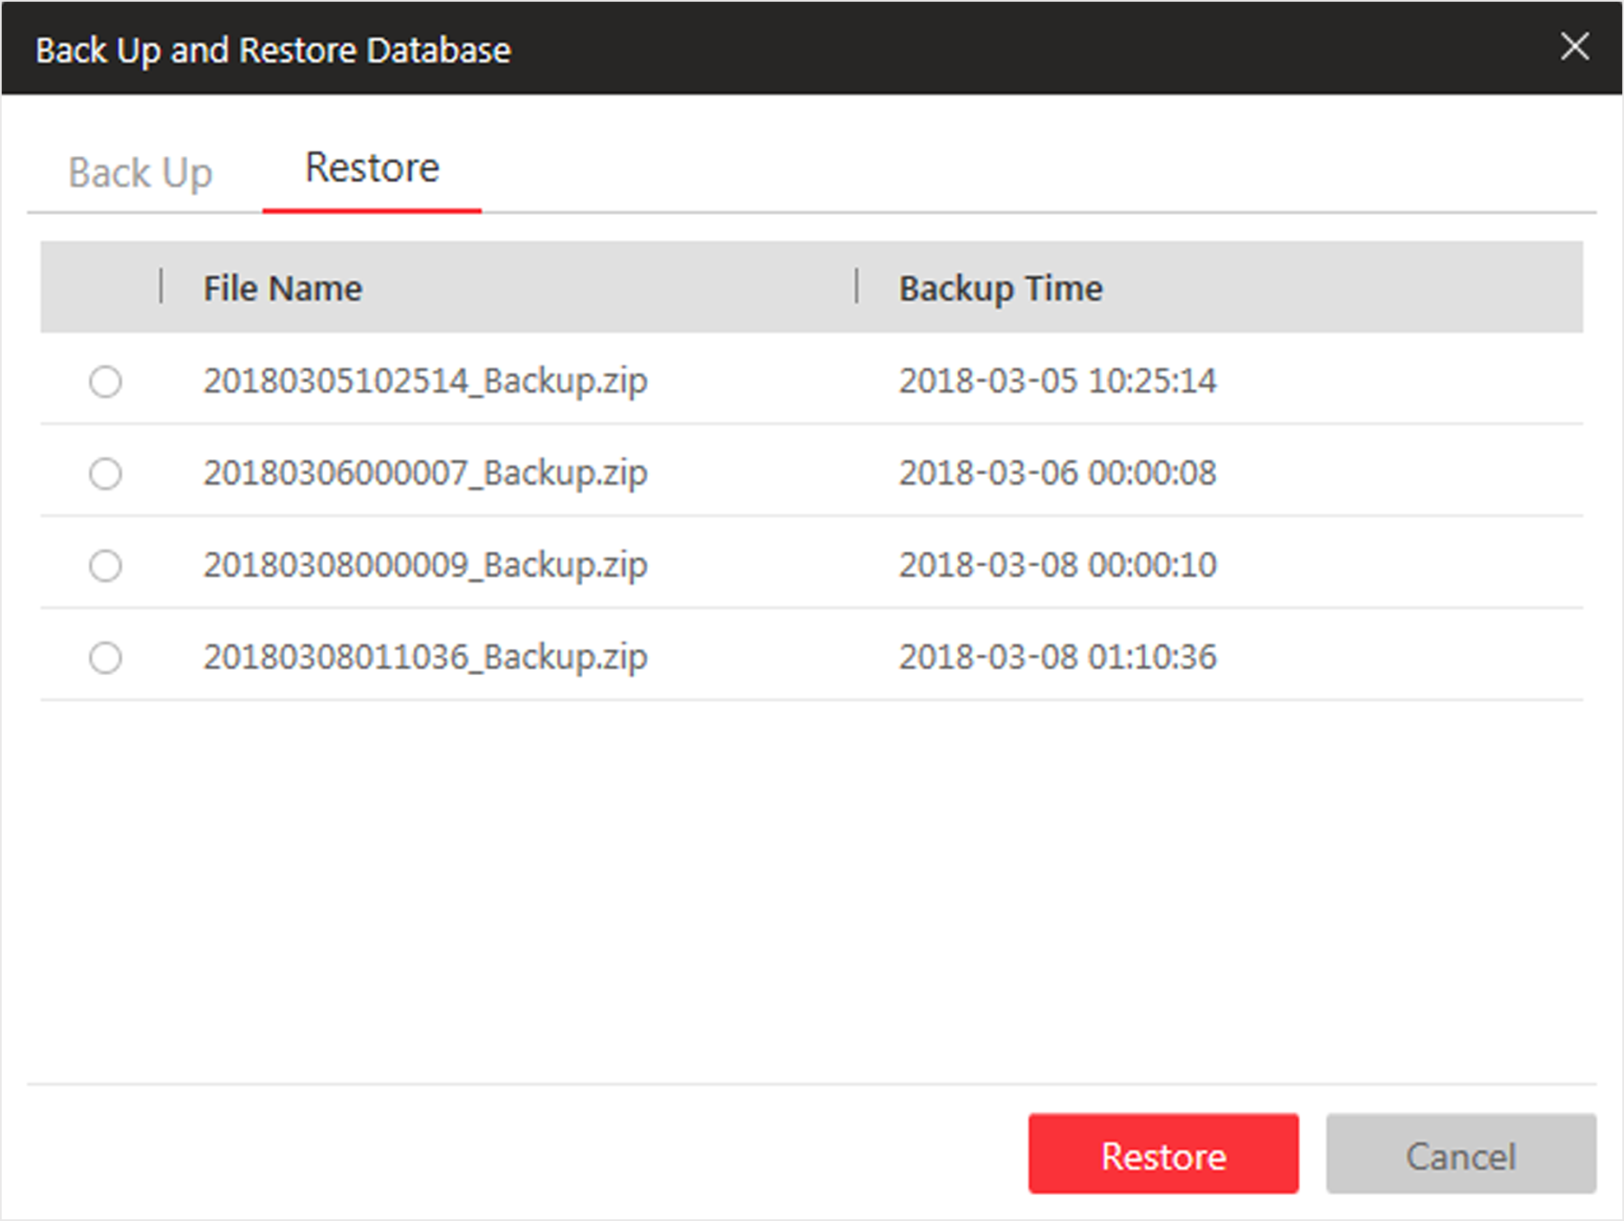
Figure 21-3 Database Restore
4. Click Restore to confirm the database recovery.
What to do next
After restoring the database, you must reboot the SYS service via Service Manager and log in again via Web Client.

10.4 Export Configuration File
You can export and save configuration data to the local PC, including Remote Site, recording settings and etc.
Perform this task when you need to export configuration data.
Steps
1. Click Export Configuration Data on the home page to open the Export Configuration Data dialog.
2. Select the configuration data type to export.
3. Click Export to save the data to your local PC.
Note
- You can set the saving path by following the prompt of the browser.
- The configuration data file is in CSV format.

Chapter 11 Manage System Security
System security is crucial for your system and property, you can set the password strength and lock IP address to prevent malicious attacks, and set other security policies to increase the security of the system.
Perform this task to set the minimum password strength, IP address locking, and other security policy settings to prevent malicious attacks.
Steps
1. Click Security → Security Settings to open the Security Settings page.
2. Set Lock IP Address switch to ON and the number of failed login attempts is limited.
1) Select the allowable login attempts for accessing HikCentral Professional.
Note
Failed login attempt includes failed password attempt and failed verification code attempt.

2) Set the locking duration for this IP address. During the locking duration, the login attempt from this IP address is not allowed.
The number of login attempts is limited.
3. Select the Minimum Password Strength to define the minimum complexity requirements that the password should meet.
4. Set the maximum password age.
1) Set Enable Maximum Password Age switch as ON to force user to change the password when password expires.
2) Set the maximum number of days that the password is valid.
Note
After this number of days, you will have to change the password. You can select the pre-defined time length or customize the time length.

5. Configure the settings to automatically lock the Control Client after a time period of inactivity on the Control Client.
1) Set Auto Lock Control Client switch to ON to lock the Control Client after a time period of inactivity on Control Client.
2) Select time period for user inactivity. You can select the pre-defined time period or customize the time period.
6. Click Save.

Chapter 12 System Configuration
The System page allows you to set basic parameters for the system, such as defining a customized name for your site, setting the WAN IP address for allowing to access your system via WAN (Wide Area Network), and configuring NTP (Network Time Protocol) settings to synchronizing the time between the system and the NTP server.
- For the system with Remote Site Management module, you can enable it to receive the registration from Remote Site.
- For the system without Remote Site Management module, you can set to register it to the Central System as a Remote Site.

12.1 Set Site Name
You can set a name for the current system.
Steps
1. Click System → Normal → Site Name on home page.
2. Edit the site name for the current system.
3. Click Save.

12.2 Set User Preference
Due to the difference of nation, region, culture and enterprise background, the user preference might be different. You can set the user preference according to the actual scene, including the first day of week and the unit of temperature.
Click System → Normal → User Preference to enter the setting user preference page.
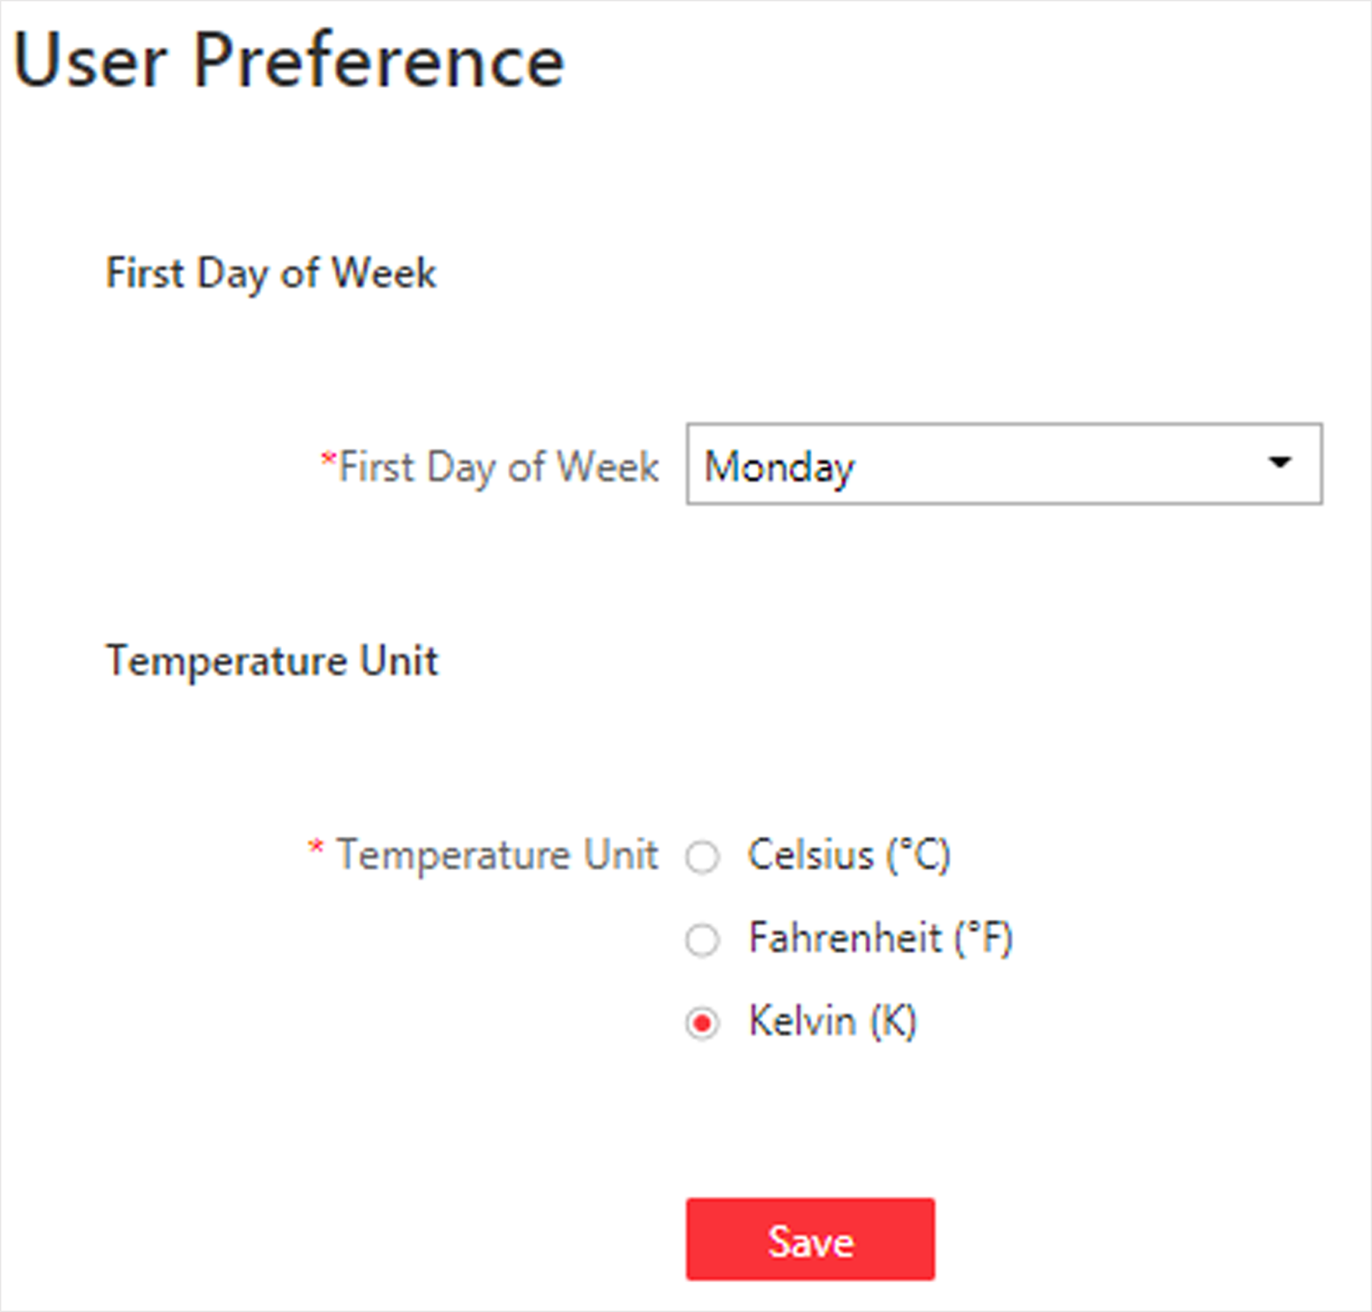
Figure 23-1 User Preference
Set the following parameters:
First Day of Week
Set the first day of week according to the custom of the actual scene.
Note
The first day of week is used in the intelligent analysis report generation, live view and playback, attendance settings, etc.

Temperature Unit
Set the temperature unit according to the custom of the actual scene.
Note
The temperature unit is used in the temperature analysis report generation, etc.

12.3 Set Warning Threshold for Server Usage
You can enable the system to trigger an alarm if the SYS server's CPU usage and RAM usage reaches a pre-defined warning threshold and lasts for a pre-defined time. The related threshold value can be checked via the Control Client.
Steps
1. Click System → Normal → Server Usage Thresholds on the home page.
2. Drag the  to adjust the CPU and RAM threshold value.
3. Define the duration in the Notify if Value Exceeds for (s) field for CPU Usage and RAM Usage.
Example
- If you set warning threshold as 60%, and set 20 in the Notify if Value Exceeds for (s) field of CPU Usage, you can view the CPU status changes to Waring in Health Monitoring in Control Client when the CPU usage reaches the warning threshold and lasts for 20 seconds.
- If you set 60% as the warning threshold, and set 20 in the Notify if Value Exceeds for (s) field of CPU Usage, and set an alarm for CPU Warning (see ), the alarm will be triggered when the CPU usage reaches the warning threshold and lasts for 20 seconds.

12.4 Set NTP
You can set the NTP server for syncing the time between the SYS and the NTP server.
Steps
Note
For devices added via ONVIF protocol, time synchronization will fail. Please configure the time on the device locally and make sure the device's NTP settings are the same with the system's.

1. Click System → Network → NTP Settings.
2. Set the Time Synchronization switch to ON to enable the NTP function.
3. Set the NTP server address and NTP port.
4. Enter the interval for the auto time synchronization.
5. Optional: Click Test to test the communication between the SYS and NTP server.
6. Click Save.

12.5 Set Active Directory
If you have the AD (Active Directory) domain controller which contains the information (e.g., user data, computer information), you can configure the settings to get the related information. In this way, you can add the users that belong to an organization unit (OU) (e.g., a department of your company) to HikCentral Professional conveniently.
Perform this task when you need to set active directory.
Steps
1. Click System → Network → Active Directory on the home page.
2. Configure the basic information parameters to connect to the AD domain controller.
Domain Name
The domain name of the AD domain controller.
Note
- HikCentral Professional only supports the NetBIOS format: e.g TEST\user and not the DNS Domain name format.
- To get the NetBIOS domain name, open the CMD window and enter nbtstat – n.
The NetBIOS domain name is the one in GROUP type.
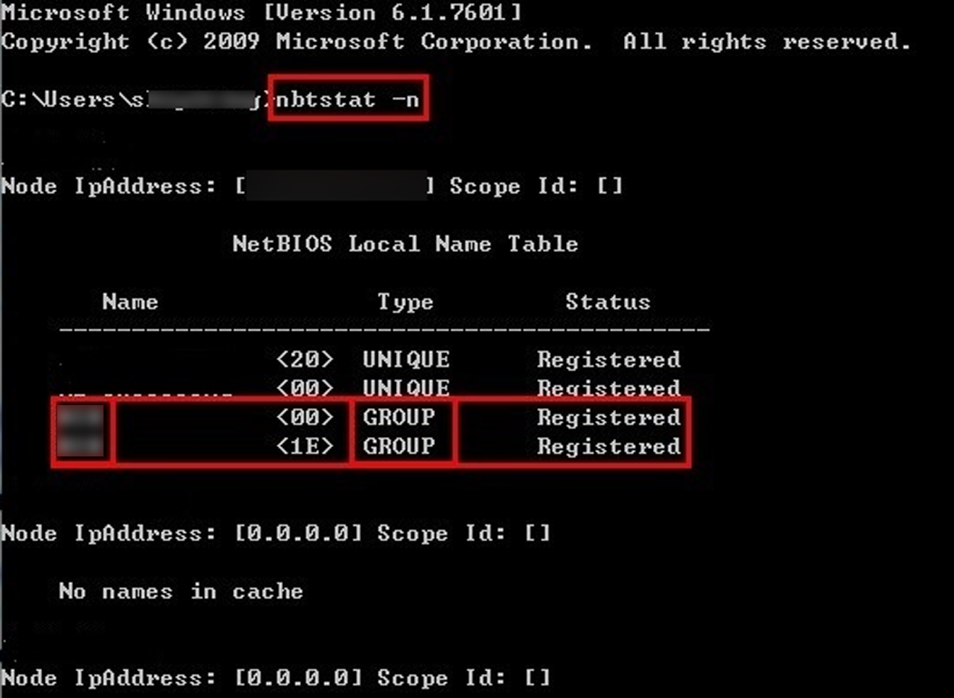
Figure 23-2 How to Get NetBIOS Domain Name

Host Name
The DNS server's IP address. You can get it in Network Connection Details.
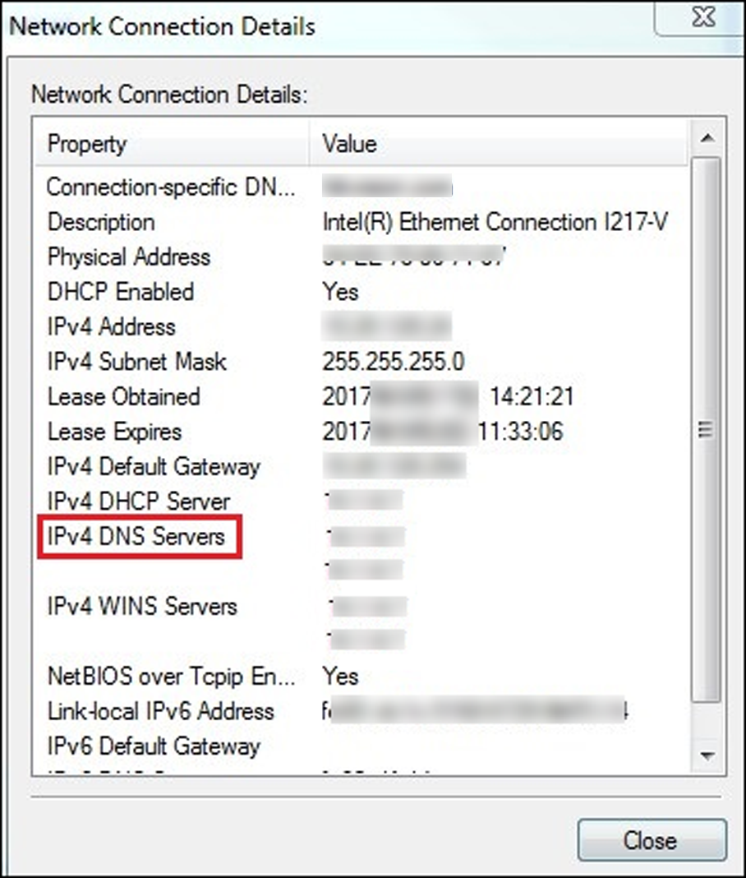
Figure 23-3 How to Get Host Name
Port No.
The port No. of the AD domain controller. By default, it is 389.
Enable SSL (Optional)
Enable SSL if required by the AD domain controller.
User Name
The user name of the AD domain controller. This needs to be the domain administrator.
Password
The password of the AD domain controller.
Base DN (Distinguished Name)
Enter the filter condition in the text filed if you are familiar with the format. Or you can click Fetch DN to get the filter condition entered automatically.
Note
- Only users found within an Organizational Unit (OU) in the domain can be imported. Click Fetch DN to have the filter condition entered automatically.
- If you enter the Base DN manually, you need to define the root node as desired. If you click Fetch DN, then the entire structure stored on the AD domain controller will be obtained.

3. Optional: Link the person information you concerned stored in the domain to the person information in the system.
1) Set the Link Person Information switch to ON.
The default and custom additional information items ( see Custom Additional Information) are displayed in the Person Information area by default. You can set the link relationship for those or add new person information items as you desired.
2) Optional: Click Add New to add a person information item you concerned.
Note
- You needn't add the basic person information items, including ID, First Name, Last Name, Phone, and Remark) manually, which has the default link relationship with the domain.
- The new person information item is also displayed on Custom Additional Information page, where you can edit or delete the items. Refer to Custom Additional Information for details.
- The person information item is case-sensitive.

3) Optional: Click ＋ to show the person information items stored in the domain.
4) Check the checkbox in the domain to link it to the added person information items when importing the domain persons.
5) Optional: Hover over the linked person information in domain and click × to remove the relationship. You can also change the link relationship among each other by clicking and dragging the one item to anther.
4. Click Save.
After the configuration, the organization unit and domain user information will be displayed when you click Import Domain User on User Management page.
If the Link Person Information function is enabled, the corresponding person information in the system will match the linked person information in the domain and cannot be edited.

12.6 Enable Receiving Generic Event
After creating a generic event to analyze the received TCP and/or UDP data packages from a very wide range of external systems, you can enable the receiving generic event function so that the system can receive the configured generic events.
Steps
1. Click System → Network → Receiving Generic Event.
2. Check Receiving Generic Event to enable this function.
3. Click Save.
Note
You can configure the system's port No. for generic event: Open Service Manager (installed on the PC running SYS service), and click HikCentral Professional System Management Service to edit.

12.7 Allow for Remote Site Registration
This page allows the system with Remote Site Management module (as we called Central System) to receive the registration from Remote Sites. Remote Site is the system that does not have Remote Site Management module and can register to Central System to form a larger-scale union. The purpose of joining Central System and Remote Sites is to allow Central System's users to view and manage resources belonging to multiple Remote Sites simultaneously as if they were on the same system.
Before You Start
If a remote site needs to register to the Central System, it should open the Remote Site's Web Client and enter Registering to Central System to configure the Central System's parameters. See Register to Central System for details.
Steps
Note
Allowing for Remote Site registration is only available for the system with Remote Site Management module.

1. Click System → Network → Receiving Site Registration.
2. Check Receiving Site Registration to enable this function.
3. Click Save.

12.8 Register to Central System
This page allows the system without Remote Site Management module (as we called Remote Site) to register to the Central System. Central System is the system that has Remote Site Management module and can join multiple Remote Sites together to form a larger-scale union. The purpose of joining Central System and Remote Sites is to allow Central System's users to view and manage resources belonging to multiple Remote Sites simultaneously as if they were on the same system.
Before You Start
For Central System, it should enable the receiving site registration function so that it can receive the Remote Site registration. See Allow for Remote Site Registration for details.
Steps
Note
Registering to Central System is only available for the system without Remote Site Management module.

1. Click System → Network → Registering to Central System.
2. Set the Registering to Central System switch to ON to enable this function.
3. Enter the IP address and port No. of Central System.
Note
Open Service Manager (installed on the PC running central system's SYS service), and click HikCentral Professional System Management Service if you need to view or edit the Central System's port.

4. Click Save.

12.9 Device Access Protocol
Before adding devices supporting ISUP 2.6/4.0 protocol to the system, you need to set related configuration to allow these devices to access the system.
Click System → Network → Device Access Protocol to enter the Device Access Protocol page.
Check Allow ISUP of Earlier Version.
Click Save.
Note
The device may be attacked when accessing the system by ISUP of earlier versions.

12.10 Set WAN Access
In complicated network environments, you need to set a static IP address or a domain name and ports for HikCentral Professional to enable it to access the SYS server via WAN (Wide Area Network). For example, if the SYS server is in a local area network, and you need to visit the system via the Web Client or Control Client running in WAN, you should enable WAN access and set a static IP address or domain name and ports for HikCentral Professional.
Steps
1. Click System → Network → WAN Access.
2. Set the WAN Access switch to ON to enable the WAN access function.
3. Enter a static IP address or domain name of the server for WAN access.
4. Set the following ports, including HTTP, HTTPS, RTSP (Real Time Streaming Port), video file streaming port, and WebSocket port.
Client Communication Port
Used for Web Client and Control Client to access the system in HTTP protocol. By default, it is 80.
Client SSL Communication Port
Used for Web Client and Control Client to access the system in HTTPS protocol. By default, it is 443.
Real Time Streaming Port
Used for getting stream for live view via Control Client. By default, it is 554.
Video File Streaming Port
Used for getting stream for playback via Control Client. By default, it is 10000.
Web Client Streaming Port
Used for getting stream via Web Client (for web browser of Google Chrome, Firefox, or Safari). By default, it is 559.
5. Optional: If you adopts generic event to integrate HikCentral Professional with external sources, you need to set the TCP port and UDP port to receiving the TCP and/or UDP data packages.
Note
For setting the generic event, refer to Configure Generic Event.

6. Optional: For the system with Remote Site Management module, set the port to receive the registration from a Remote Site.
Note
This configuration item is only available for the Central System with a Remote Site Management module based on the License you purchased.

7. Optional: If you need to manage devices accessing in ISUP protocol, you can set the ports for these ISUP devices such as registration port, alarm receiving port, streaming port, etc.
8. Click Save.

12.11 Set Network Timeout
Network timeout duration refers to the default waiting time for the configurations on the Web Client. The configuration will be regarded as failure if no response within the configured timeout time.
The minimum default waiting time of the interactions between the configurations and SYS server is 60s, the minimum time between SYS server and devices is 5s, and the minimum time between the configurations and devices is 5s.
Note
This parameter affects all the Web Clients accessing the current SYS server.

12.12 Set Device Access Mode
Device Access Mode page allows you to define how the system accesses all the added encoding devices and decoding devices.
Perform this task to define how the system accesses all the added encoding devices and decoding devices.
Steps
1. Click System → Network → Device Access Mode.
2. Set the device access mode as automatically judge or proxy mode.
Automatically Judge
The system will automatically judge the condition of network connection and then set the device access mode accordingly as accessing directly or accessing via Streaming Gateway and Management Service.
Proxy
The system will access the device via Streaming Gateway and Management Service. It is less effective and less efficient than accessing directly.
3. Click Save to confirm the settings.
System accesses all the added encoding devices and decoding devices via the selected mode.

12.13 Set Server NIC
You can select the NIC of the current SYS server so that the system can receive the alarm information of the device connected via ONVIF protocol.
Steps
1. Click System → Network → Server NIC.
2. Select the currently used NIC name of SYS in the drop-down list.
The NIC information including description, MAC address, and IP address will display.
3. Click Save.

12.14 Set Data Retention Period
The data retention period specifies how long you can keep the events, logs, and some records SYS server, such as recording tags, face comparison data, vehicle entering/exiting records, etc.
Steps
1. Click System → Storage → Data Retention Period.
2. Set the data retention period from the drop-down list for the required data types.

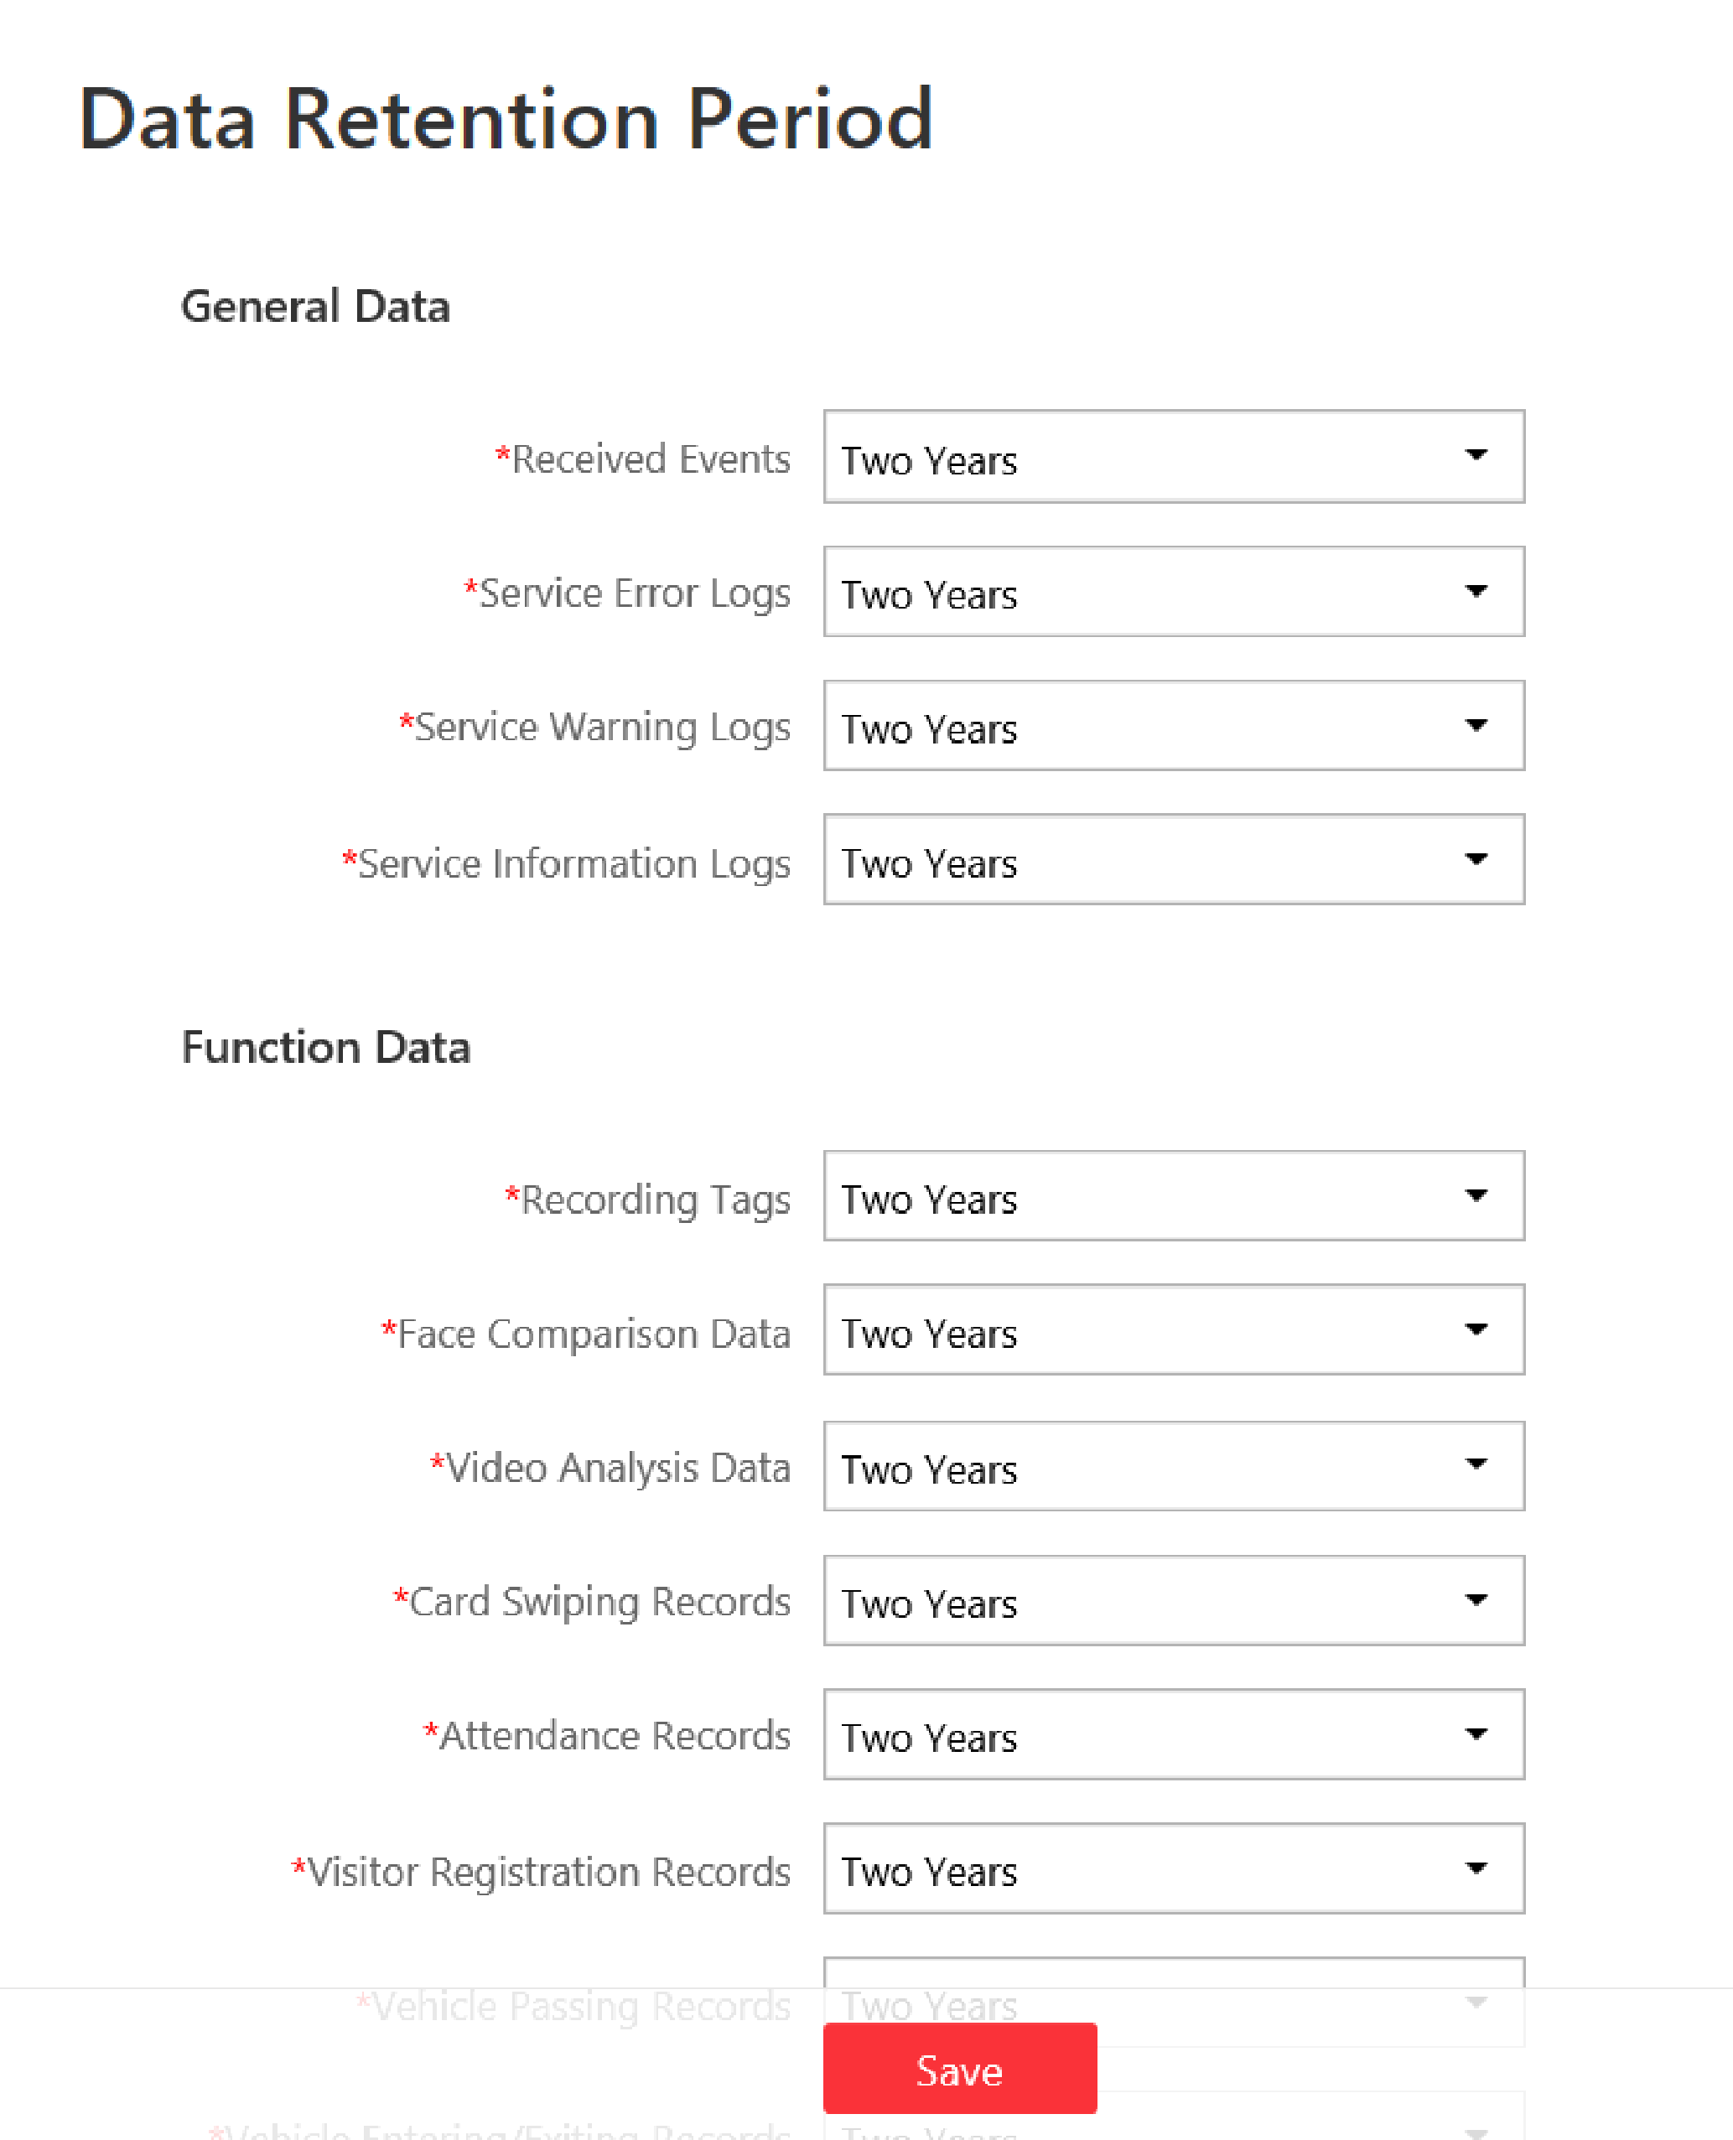
Figure 23-4 Set Data Retention Period
Note
The card swiping records are saved as the configured period. The user with the permission can search the persons' swiping records and view related information during this period, even if the searched persons have been deleted from the SYS server.

3. Click Save.

12.15 Enable Evidence Collection
Only when evidence collection is enabled, can the operators save specific video footage as evidence and search the saved evidence on the Control Client. Evidence collection can help to settle issues such as traffic disputes and criminal cases.
Before You Start
You should have configured a SFTP (Secure File Transfer Protocol) server.
Steps
Note
Operator is the role that has all the permission for operating the Control Client and the permission for operating the Applications (Live View, Playback, and Local Configuration) on the Web Client. For details about configuring users and roles, see Manage Role and User.

1. Click System → Evidence Collection to enter the Evidence Collection page.
2. Set the Evidence Collection switch to ON.
The required information for enabling evidence collection will be displayed.
3. Set the required SFTP parameters.
SFTP Address
Enter the IP address of the SFTP server.
Port
Enter the port number of the SFTP server.
User Name
Enter the user name of the SFTP server.
Password
Enter the password of the SFTP server.
4. Set other required parameters for the evidence.
Evidence Type
Define the evidence types that the operators can select when they edit evidence information on the Control Client.
Organization on Site
Define the type(s) of organization on site that the operators can select when they edit the evidence information on the Control Client.
Organization on site refers to the organization or personnel (e.g., police, fire department) on the site of the accident or criminal incident.
Result/Conclusion
Define the evidence-related incidents' results or conclusions that the operators can select when they edit evidence information on the Control Client.
5. Click Save to enable evidence collection.

12.16 Set Transfer Protocol
You can set the SYS server's transfer protocol to define the access mode for the SYS (via Web Client, Control Client, or Mobile Client) as HTTP or HTTPS. The HTTPS protocol provides higher data security. For system with distributed deployment License, you can also enable encrypted transmission to encrypt the data transmission between Application Data Server and System Management Server, thus enhancing the system security.
Steps
Note
Setting transfer protocol is only available when accessing the Web Client on the SYS server locally.

1. Click System → Security → Transfer Protocol.
2. In the Clients and SYS Transfer field, select HTTP or HTTPS as the transfer protocol between the clients (Web Client, Control Client, and Mobile Client) and the SYS servers.
3. If you select HTTPS, you are required to set the certificate. You can use the system provided certificate, or select New Certificate and click 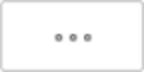 to select a new certificate file.
Note
- The new certificate should be in PEM format.
- The public key and private key should be in the same certificate file.

4. Optional: Check Encrypted Transmission to encrypt the data transmission between Application Data Server and System Management Server.
Note
This field will show when the system's License support server distributed deployment.

5. Click Save.
- The SYS server will reboot automatically after changing the clients and SYS server transmission settings.
- All the users logged in will be forced logout during reboot. The reboot takes about one minute and after that, the users can login again.

12.17 Set Camera ID
When displaying live view on smart wall, you may use a keyboard for convenience operations such as starting live view on smart wall, PTZ control, etc. If you want to display certain camera's live view on smart wall, you should press the camera's identifier number on the keyboard, which is called Camera ID. As a result, HikCentral Professional provides this module for you to set a unique ID for each camera.
Click System → Advanced → Camera ID to enter the camera ID settings page.
You can filter the cameras by setting the site and area, or entering keywords of camera name or camera ID.
The system provides a default ID for each camera. You can edit the default value for the cameras if needed.
Note
The camera ID should be unique in the system.

12.18 Export Service Component Certificate
For data security, before adding the Streaming Server, Application Data Server or Cloud Storage Server to the system, you should generate the service component certificate stored in the SYS server and input the certificate information to the Streaming Server or the Application Data Server you want to add, or export the service component certificate stored in the SYS and import the certificate to the Cloud Storage Server, so that the certificates of the Streaming Server, Cloud Storage Server or the Application Data Server and SYS server are the same.
Steps
Note
Exporting SYS server's service component certificate is only available when you access the Web Client on the SYS server locally.

1. Click System → Security → Service Component Certificate.
2. Click Generate beside Certificate between Services in System to generate the security certificate for Streaming Server verification and Application Server verification.
Note
On the Service Manager of the Streaming Server or the Application Data Server you want to add, input the certificate information you generate. For the following operations, see Manage Application Data Server and Add Streaming Server for details.

3. Click Export beside Certificate between System and Recording Server to export the service component certificate in XML format and save it in the local PC.
Note
On the Cloud Storage Server you want to add, import the service component certificate you export. For more details, see Manage Cloud Storage Server.

12.19 Set Database Password
You can set the database password of the system on the Web Client running on the SYS server.
Note
Setting database password is only available when you access the Web Client on the SYS server locally.

Click System → Security → Database Password.
Enter the password and then click Verify to generate the verification code and enter the verification code.

12.20 Set Health Check Frequency
The SYS server will perform health check to the resources managed in the system, including devices, servers, and configurations. The system will display the health check results in the Health Monitoring module on the Control Client, including the devices' online/offline status, recording status, etc. You can set the frequency which controls how often the system gets the latest status of the devices, servers, and configurations.
Enter System → Advanced → Health Check Frequency.
Device Health Status
You can set the health check frequency for the devices managed in the system, including encoding devices, access control devices, elevator control devices, video intercom devices, security control devices, and dock stations. It controls how often the system pings these devices to determine if they're online.
After disabled, the system will not update the status of the managed devices. You need to refresh manually to get the latest status.
Server Health Status
You can set the health check frequency for the managed Recording Servers and facial recognition servers. It controls how often the system pings these servers to determine if they're online.
After disabled, the system will not update the status of the managed servers. You need to refresh manually to get the latest status.
Others
- Device Capabilities: Set how often the system gets the managed devices' capabilities. After disabled, the system will not update the capability changes of all the managed devices. You need to refresh manually to get the latest status.
- Recording: Set how often the system checks the camera's recording status. After disabled, the system will not update the cameras' recording status.
- Alarm/Event Enabled or Not: Set how often the system checks whether the events and alarms are enabled or not. After disabled, the system will not update the configured event and alarm rules status.
- Remote Alarm Enabled or Not: Set how often the system checks whether the events and alarms configured on the Remote Sites are enabled or not. After disabled, the system will not update the configured alarm rules status configured on the Remote Sites.

12.21 Add Fuzzy Matching Rules for License Plate Search
When searching vehicles by license plate number on the Control Client, the system supports fuzzy matching. You can first set the fuzzy matching rules according to actual needs. By default, the system provides 6 ready-made rules including 0<=>Q, 0<=>O, Q<=>O, 1<=>I, G<=>6, and D<=>O.
Steps
1. Enter System → Advanced → Plate Fuzzy Search.
2. Click Add.
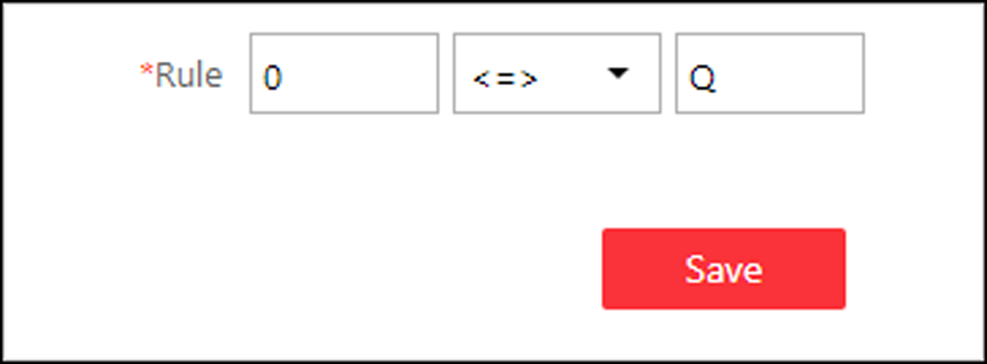
Figure 23-6 Add a Fuzzy Matching Rule
3. Set the rule.
<=>
Enter an uppercase letter or a digit before and after this symbol respectively.
For example, 0<=>Q means: If you enter 0 or Q for search, the recognized license plate numbers with 0 and the ones with Q will be filtered.
=>
Enter an uppercase letter or a digit before and after this symbol respectively.
For example, G=>6 means: If you enter G for search, the recognized license plate numbers with G and the ones with 6 will be filtered. But if you enter 6 for search, the ones with G will not be filtered.
Note
- By default, 6 rules are added when you log in for the first time.
- Up to 16 rules can be added.

4. Click Save.
5. Optional: After adding the rules, you can do one or more of the followings.
Edit Rule | Click in the Operation column to edit this rule.
Enable/Disable Rule | Click / in the Operation column to enable/disable this rule.
Delete Rule | Click in the Operation column to delete this rule.

12.22 Configure System Hot Spare
A hot spare is used as a failover mechanism to provide reliability for your system. If you build the hot spare system when installing the SYS service, you can enable the hot spare function and configure the hot spare property of the current SYS server as host server or spare server. When the host server fails, the spare server switches into operation, thus ensuring the stability of the system.
Steps
1. Click System → Advanced → Hot Spare.
2. Set the Hot Spare Configuration switch to ON to enable the hot spare function.
The current SYS server's server name and available IP address will be displayed.
3. Set the server as host server or spare server in Hot Spare Property.
4. Click Save.

12.23 Set Third-Party Integration
HikCentral Professional supports integrating third-party resources (such as camera, door, etc.) via Optimus. Also, the system provides open platform to integrate the third-party system. By the Open APIs (application programming interface) provided on the open platform, the third-party system can obtain some functions (such live view, playback, alarm, etc.) of HikCentral Professional, to develop more customized features.
Click System → Advanced → Third-Party Integration.
Third-Party Integration
Note
- Setting open platform is only available when you access the Web Client on the SYS server locally.
- Only admin/administrator users have the permission to perform this function.

Turn Integrate via Optimus to ON.
Configure related parameters in the Optimus software. For details, refer to the User Manual of Optimus.
The default icons of resources integrated from the third-party will be displayed. Click Edit to change the resource icons according to your need.
Open Platform
Note
Setting open platform is only available when you access the Web Client on the SYS server locally.

Turn Open API to ON, set the IP address of the open platform, management port of the open platform and select the partner user.
Note
- The open platform should be deployed in the same network with the SYS server.
- The third-party system integrates the HikCentral Professional by the partner user(s) you select, which defines the permission(s) of resources and operations in the HikCentral Professional.

Click Test to test the service availability of the open platform.
Click Save to save the settings.

12.24 Data Interchange
The card swiping data recorded in HikCentral Professional can be used by the third-party system for pay calculation or other applications. You can apply the card swiping records or dump the records as CSV files for data synchronization with the third-party system.

12.24.1 Synchronize Card Swiping Records to Third-Party Database
You can enable synchronization function to apply the card swiping records of specified resources from HikCentral Professional to the third-party database automatically.
Steps
1. Click System → Advanced → Data Interchange to enter the Data Interchange page.
2. Set Data Synchronization switch to on to enable synchronization function.
3. Click Add and select the resource(s) for card swiping records synchronization.
Note
You can click on Operation column to delete the resource or click Delete All to delete all added resources.

4. Select Database Synchronization.
5. Set the required parameters of the third-party database, including database type, server IP address, server port, database name, user name and password.
6. Click Test Connection to test whether database can be connected.
7. Set table parameters of database table and table fields according to the actual configurations.
1) Enter the table name of the third-party database.
2) Set the mapped table fields between the HikCentral Professional and the third-party database.
8. Click Save.
The attendance data will be written to the third-party database.

12.24.2 Dump Card Swiping Records to Third-Party Database
The card swiping records of specified resources can be dumped as a CSV file and the third-party system will read the CSV file (instead of accessing database and mapping the table fields) for further applications, such as attendance calculation and pay calculation.
Before You Start
- You need to log into the Web Client running on SYS server.
- The third-party system should be installed in the same server with HikCentral Professional to read the CSV file directly in the local disk.
Steps
1. Click System → Advanced → Data Interchange to enter the Data Interchange page.
2. Set Data Synchronization switch to on to enable synchronization function.
3. Click Add and select the resource(s) for card swiping records synchronization.
Note
You can click on Operation column to delete the resource or click Delete All to delete all added resources.

4. Select Access Record Dump.
5. Set the required parameters.
File Name
The name of CSV file which the card swiping records are dumped as.
Saving Path
The path where the CSV file is saved.
Content
The display items and data in the dumped CSV file.
Dump Every
The frequency for dumping card swiping records.

6. Click Save.

12.25 Reset Device Network Information
When system network domain changes (such as server migration), you must reset the network information of the added device to adapt to the new network environment. Otherwise the device live view, playback and other functions will be affected.
Perform this task when you need to reset the network information of the added device.
Steps
1. Click System → Advanced → Reset Network Information.
2. Click Reset to one-touch reset the device network information.

12.26 Set SUP Upgrade Prompt
SUP (Software Upgrade Program ) refers to the system's maintenance time, which has an expire date and needs to be upgraded before expiration. You can set SUP upgrade prompt in the system. After that, when the SUP is going to expire, you can receive an email reminding the expiration every day during the set period.
Click System → Advanced → SUP Upgrade Prompt.
Turn Upgrade Prompt to ON, and set the days when you will receive the prompt email before expiration.
Note
- You should enter an integer between 1 to 365.
- By default, the system will send a prompt email 30 days before expiration.

Click Add User to add user(s) who can receive upgrade prompt.
Note
- You should configure the users' email addresses before adding them as recipients. The added users can receive upgrade prompt via the bound email addresses.
- Up to 64 recipients can be added.
- You can click to delete the added user(s).

Click Add Email to add email address(es).
Note
You can add email of both the system user(s) and other user(s). The system will send upgrade prompt to the added email address(es).

Click Save to save the settings.

Chapter 13 Playback
The HikCentral Professional provides functionalities of live view, playback, and local configuration through web browser.
Note
- If the SYS's transfer protocol is HTTPS, the Monitoring module (including Live View, Playback, and Local Configuration) is available only when accessing the Web Client via Internet Explorer.
- If the SYS's transfer protocol is HTTP, the Live View and Playback modules are available for Internet Explorer, Google Chrome, Firefox, and Safari 11 and above. But Local Configuration module is available for Internet Explorer only.

13.1 Playback
The video files stored on the local storage devices such as HDDs, Net HDDs and SD/SDHC cards or the Recording Server can be searched and played back remotely through the web browser.

13.1.1 Search Video File
You can search the video footage of cameras and filter the searched video footage by video type or by storage location.
Steps
1. Click Monitoring → Playback on home page to open the Playback page.
2. Optional: Enter a keyword of camera name or area name in the search field and click Search in All Sites or Search in Current Site to search the cameras or areas.
All the search results display.
Note
You can move the cursor to the camera name to view the image thumbnail.
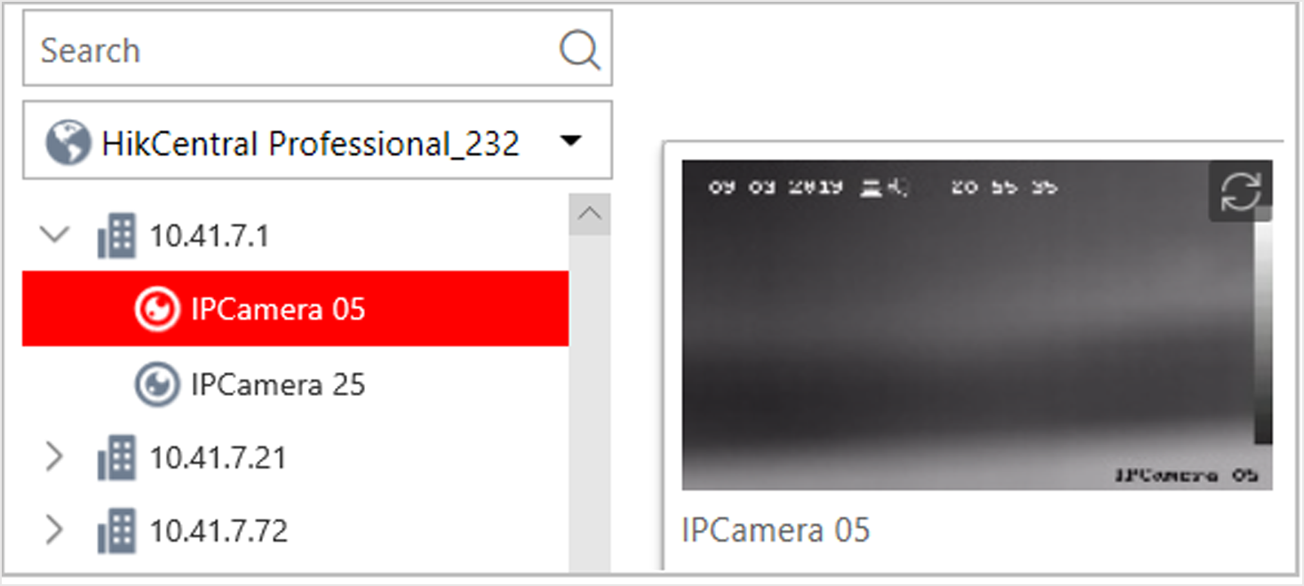
Figure 24-6 Thumbnail

3. Drag the camera to the display window, or double-click the camera to start the playback.
Note
If the system is central system with Remote Site Management module, you can also play back the recorded video of the cameras imported from remote site. For managing remote site's cameras in areas, refer to Manage Area.

4. Optional: Click the date and time on the toolbar to select the date and time to search the video files.
Note
- In the calendar panel, the date with video files will be marked with a triangle.
- The calendar is not supported by cameras on remote site.

5. Optional: Click  on the playback toolbar to select the video file type for playback.
6. Optional: Select the storage location and the stream type of the video files for playback.
For camera configured with auxiliary storage: | Select the storage location of the video files for playback.
For camera configured with dual-stream recording: | Select the stream type of the video files for playback.

Note
For setting the storage location of recording, refer to Configure Recording.

13.1.2 Play Video File
After searching the video footage, the playback starts. You can control the video playback via timeline. The timeline indicates the time duration for the video footage.
Steps
1. Click Monitoring → Playback on home page to open the Playback page.
2. Search the video file of cameras for playback. For details, refer to Search Video File.
The playback starts.
3. Click the icons on the toolbar to control the playback.
4. Click on the timeline or drag the timeline to play back the video of the specific time.
5. Optional: Click  or  or use the mouse wheel to scale up or scale down the timeline bar.
6. Optional: Move the cursor to the display window in playback to access further functions, including capture, clipping, and other functions.
Open Digital Zoom | Click  to enable the digital zoom function and draw a rectangle on the video. Click again to disable the function.  Note  When in software decoding mode, you can also capture the zoomed in picture after enabling digital zoom function.
Camera Status | Click  to show the camera's recording status, signal status, connection number, etc.
Stream Switch | Click , , or  (if supported) to switch the live view stream to main stream, sub-stream, or smooth stream (if supported).  Note  The smooth stream will show if the device supports smoothing function. You can switch to smooth stream if in low bandwidth situation to make live view more fluent.
Audio Control | Click or to turn off/on the sound.  Note  You can adjust the volume when moving the cursor on .

13.2 Local Configuration
HikCentral Professional provides live view and playback functions via the Web Client. You can set the related network transmission parameters (such as hardware decoding, stream type, etc.) for the performance of live view and playback via the current Web Client. You can also view the saving path of video files and captured pictures on your current PC.
Steps
Note
The parameters in Local Configuration only affect the current Web Client.

1. Click Monitoring → Local Configuration on home page to enter the Local Configuration page.
2. Click Network Transmission tab on the left.
3. Set the following parameters as desired.
GPU Hardware Decoding
Enable the GPU decoding for live view and playback to save CPU resources.
Note
- Your PC must support GPU hardware decoding.
- After enabling GPU hardware decoding, restart live view and playback to take effect.
- If the client shows a blurred screen after enabling GPU hardware decoding, disable it.

Global Stream
The default stream type for global usage in the current Web Client.
If the device doesn't support smooth stream, it will use sub-stream. If the device doesn't support sub-stream, it will use main stream.
If the network is in good condition, select main stream or sub-stream. If the network is in poor condition, select smooth stream.
Threshold for Main/Sub-Stream
If a window's proportion of the displaying area is larger than the configured threshold, the stream type will be main stream. If the proportion is smaller than the threshold, it will be switched to sub-stream.
For example, if you set the threshold as ¼, when the window division turns to 5-window, the camera's stream type will be switched from main-stream to sub-stream.
Note
This parameter is only available when the Global Stream is set as Main Stream.

Network Timeout
The default waiting time for the operations in Applications on the current Web Client. The operations will be regarded as failure if no response within the configured time.
The minimum default waiting time of the interactions between the Applications and SYS server is 60s, the minimum time between SYS server and devices is 5s, and the minimum time between the Applications and devices is 5s.
Video Caching
Video caching should be determined based on network performance, computer performance, and bit rate. You can set is as Small (1 Frame), Medium (6 Frames), or Large (15 Frame). Larger frame caching will result in better video performance.
Picture Format
Set the file format for the captured pictures during live view or playback. Currently it supports BMP and JPEG formats.
Device Access Mode
Restore Default
Restore the device access mode as configured in the System → Device Access Mode on Web Client.
Automatically Judge
Judge the device access mode according to the current network.
Directly Access
Access the device directly, not via HikCentral Professional Streaming Service.
Proxy
Access the device via HikCentral Professional Streaming Gateway and HikCentral Professional Management Service.
Note
By default, the system will judge the device access mode according to the current network. If you change to other mode, it only affects the client you logged in currently.

4. Optional: Click Default Value to restore the defaults of the settings.
5. Click Save.
6. Optional: Click Saving Path on the left to view the saving path of the recorded or clipped video files and captured pictures during live view or playback in your local PC.

Chapter 14 Important Ports
HikCentral Professional uses particular ports when communicating with other servers, devices, and so on.
Make sure that the following ports are not occupied for data traffic on your network and you should forward these ports on router for WAN access or open these ports in the firewall in case you may need to access the system via other networks.

Destination | Port No. | Description
System Management Service (SYS) Port
NGINX | 80 (HTTP/WebSocket) | Used for web browser access in HTTP protocol.
NGINX | 443 (HTTPS/WebSocket over TLS) | Used for web browser access in HTTPS protocol.
SYS | 14200 (HTTP/HTTPS) | Used for Remote Site registration to central system.
SYS | 15300 (TCP and UDP) | Used for receiving generic event.
SYS | 7332 (TCP) | Used for receiving alarms from ISUP device.
SYS | 7660 (TCP) | Used for receiving registration from ISUP device.
SYS | 7661 (TCP) | Used for getting stream from ISUP device via Streaming Server
SYS | 30051 (HTTP) | Used for communication between SYS and ADS in server distributed deployment.
SYS | 30053 (HTTPS) | Used for communication between SYS and ADS in server distributed deployment, after encrypted transmission enabled.
Streaming Gateway | 554 (RTSP) | Used for getting stream (real time streaming port).
Streaming Gateway | 559 (WebSocket) | Used for getting stream for Google Chrome or Firefox (WebSocket port).
Streaming Gateway | 10000 (TCP) | Used for getting stream for playback (video file streaming port).
Streaming Gateway | 16000 (TCP) | Used for getting stream from ISUP device via plugin.
Streaming Gateway | 6001 | Used for getting the status of Streaming Gateway.
Streaming Gateway | 6678 | Used for setting the certificate.
Keyboard Proxy Service (KPS) | 8910 (HTTP) | Used for network keyboard to access the Keyboard Proxy Service.
NTP Service | 123 (UDP) | NTP port used for time synchronization.
PostgreSQL | 5432 (TCP) | Used for database access
Application Data Service (ADS) Port
ADS | 30054 (HTTPS) | Used for communication between SYS and ADS in server distributed deployment, after encrypted transmission enabled.
ADS | 30052 (HTTP) | Used for communication between SYS and ADS.
ADS | 19999 (HTTP) | Used for communication between SYS's NGINX and ADS.
ADS | 19443 (HTTPS) | Used for communication between SYS's NGINX and ADS.
WDS | 6208 (WebSocket) | Listen port for Service Manager.
WDS | 8208 (WebSocket over TLS) | Listen port for Service Manager after encrypted transmission enabled.
PostgreSQL | 5432 (TCP) | Used for real-time data synchronization between Application Data Server and Application Data Standby Server.  Note  This port is available in distributed deployment.
Streaming Service Port
Streaming Service | 554 (RTSP) | Used for Streaming Service to get stream (real time streaming port).
Streaming Service | 559 (WebSocket) | Used for getting stream for Google Chrome or Firefox (WebSocket port).
Streaming Service | 10000 (TCP) | Used for Streaming Service to get stream for playback (video file streaming port).
Streaming Service | 6001 (TCP) | Used for getting the status of Streaming Service.
Streaming Service | 16000 (TCP) | Used for getting stream from ISUP device via plugin.
Streaming Service | 8208 | Used for security certificate authentication.
Streaming Service | 6678 | Used for setting the certificate.
pStor Cluster Service
pStor Cluster Service | 9012 | Used for accessing the pStor Cluster Service via Web Browser.
pStor Cluster Service | 6300 | Used for signaling gateway.
OpenAPI
OpenAPI Service | 443 | Used for third-party system accessing OpenAPI service.
OpenAPI Service | 8208 | Listen port for Service Manager after encrypted transmission enabled.

