

**HikCentral Professional Control Client**

**User Manual**

**Legal Information**

©2019 Hangzhou Hikvision Digital Technology Co., Ltd. All rights reserved.

**About this Manual**

The Manual includes instructions for using and managing the Product. Pictures, charts, images and all other information hereinafter are for description and explanation only. The information contained in the Manual is subject to change, without notice, due to firmware updates or other reasons. Please find the latest version of this Manual at the Hikvision website (  ***[https://](https://www.hikvision.com/en/)*** [***www.hikvision.com/en/*** ).](https://www.hikvision.com/en/)

Please use this Manual with the guidance and assistance of professionals trained in supporting the

Product.

**Trademarks**

and other Hikvision's trademarks and logos are the properties of



Hikvision in various jurisdictions.

Other trademarks and logos mentioned are the properties of their respective owners.

**Chapter 1 About Control Client**

**1.1 Overview**

As one of the key components of the system, Control Client provides multiple operating functionalities, including real-time live view, PTZ control, video playback and download, alarm receiving, log query, and so on.

This user manual describes the function, configuration, and operation steps of the Control Client. To ensure the proper usage and stability of the client, refer to the contents below and read the manual carefully before operation.

**Note**



The functions on the Control Client vary with the License you purchased. For detailed information,

contact our technical support.

**1.2 Control Panel Overview**

The control panel provides an overview of navigation and menu about the function modules. It contains multiple sections for the modules, such as Surveillance, Investigation, Intelligent Analysis, Maintenance, Tool, and Management. You can access to the function modules you want quickly and conveniently via control panel.

The HikCentral Professional Control Client is composed of the following function modules by default.

**Note**



You can custom and adjust the module arrangement as you desired. For details, refer to ***Customize***

***Module Arrangement on Control Panel*** .

**Table 1-1 Function Module on Control Panel**

|  |  |  |
| --- | --- | --- |
| **Section** | **Module** | **Description** |
| Surveillance | Monitoring | The Monitoring module provides live view, playback, smart wall (graphic card), view management, map management, and supports some basic operations, such as PTZ control, picture capturing, etc. |
| Alarm Centre | | For more details, refer to ***Live View*** , ***Playback*** , ***Map***  ***Management*** , and ***Manage Smart Wall (Graphic Card).*** |

|  |  |  |
| --- | --- | --- |
| **Section** | **Module** | **Description** |
| Alarm Centre | | The Alarm Center module provides the display and management of alarm/event information received by Control Client.  For more details, refer to ***Check Alarm and Event*** . |
| Investigation | Video Search | The Video Search module provides searching video footage, video on device, or VCA event related video.  For more details, refer to ***Video Search*** . |
| Alarm/Event | The Alarm/Event Search module provides searching alarm/event logs.  For more details, refer to ***Search Event/Alarm Logs*** . |
| Search |
| Evidence Search | The Evidence Search module provides searching video footage which evidence information.  For more details, refer to ***Search Evidence*** . |

|  |  |  |
| --- | --- | --- |
| Maintenance | Health Monitoring | The Health Monitoring module provides real-​time overview and history overview of the resources and service status.  For more details, refer to ***Real-Time Overview*** and  ***History Overview*** . |
| Audit Trail | The Audit Trail module provides searching, viewing, and backing up the log files.  For more details, refer to ***Log Search*** . |

|  |  |  |
| --- | --- | --- |
| **Section** | **Module** | **Description** |
| Maintenance | Health Monitoring | The Health Monitoring module provides real-​time overview and history overview of the resources and service status.  For more details, refer to ***Real-Time Overview*** and  ***History Overview*** . |
| Audit Trail | The Audit Trail module provides searching, viewing, and backing up the log files.  For more details, refer to ***Log Search*** . |
| Tool | VSPlayer | Via VSPlayer module, you can run the software and play video files stored in the local PC.  For more details, refer to ***Play Video via VSPlayer*** . |
| Broadcast | The broadcast function supports distributing audio content to the added device if the device has an audio output.  For more details, refer to ***Broadcast to Connected Devices*** |

**3**

|  |  |  |
| --- | --- | --- |
| **Section** | **Module** | **Description** |
| Management | Download Center | The Download Center module supports viewing and managing the downloading tasks.  For more details, refer to ***Manage Downloading Tasks*** . |
| Local Picture | The Local Picture module provides the search and management of local pictures. |
| Local Recording | The Local Recording module provides the search and management of local video files. |
| System | The System module provides basic settings and  application settings.  For more details, refer to ***System Settings*** . |
| Help | The Help module provides help information, such as user manual, license details and software version of Control Client. |

**1.3 Customize Module Arrangement on Control Panel**

You can customize the modules arrangement displayed on the control panel. The control panel is divided into two areas: common area on the left and uncommon area on the right. For the frequently-used modules, you can arrange them on the common area, which contains five sections: Surveillance, Investigation, Intelligent Analysis, Maintenance, and Others. The other modules which are not used so frequently, can be arranged on the uncommon area. The module's section and order is fixed. You can only drag the module from the common area to uncommon area, or from uncommon area to common area, but you cannot adjust the fixed section and arrangement order in one section.

Drag the module to the desired area to customize the module arrangement.

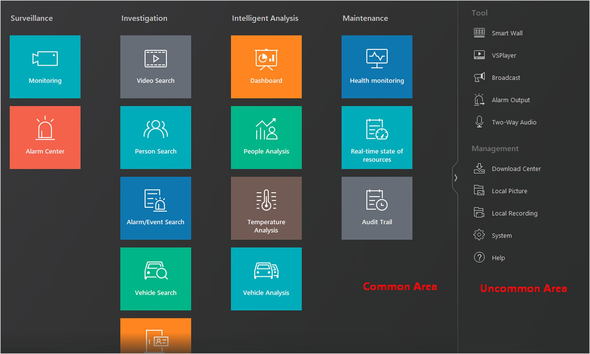

**Figure 1-1 Module Arrangement on Control Panel**

**Note**



• If there are no modules in one section, the section will not be displayed in the area.

• If you drag the modules in Tool section and Management section of uncommon area into

common area, they will be grouped into Others section in common area.

Central server with remote clients connected via WAN

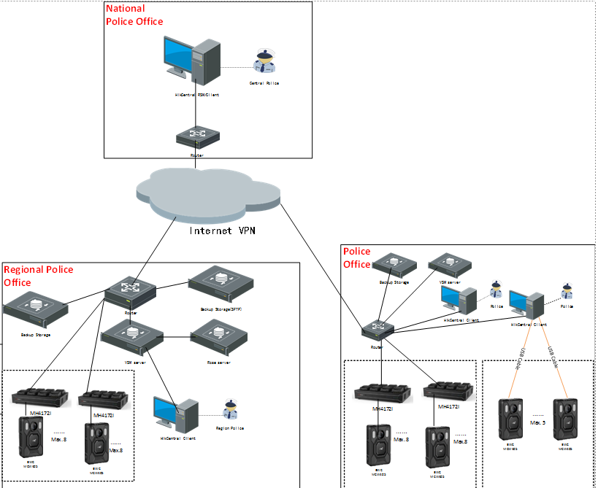

Central Server with Control Client

**Chapter 2 Login**

Log in to the system via the Control Client for operations.

**2.1 First Time Login**

When normal user (except admin user) logs in to the system for the first time, he/she should change the initial password and set a new password for login.

**Before You Start**

When you log in to the system for the first time, you are required to create a password for the

system pre-defined administrator user (named admin) on the Web Client before you can properly

configure and operate the system.

Perform the following steps when you access the system via the Control Client for the first time as a normal user (except admin).

**Steps**

**1.** Double-click on the desktop to run the Control Client.

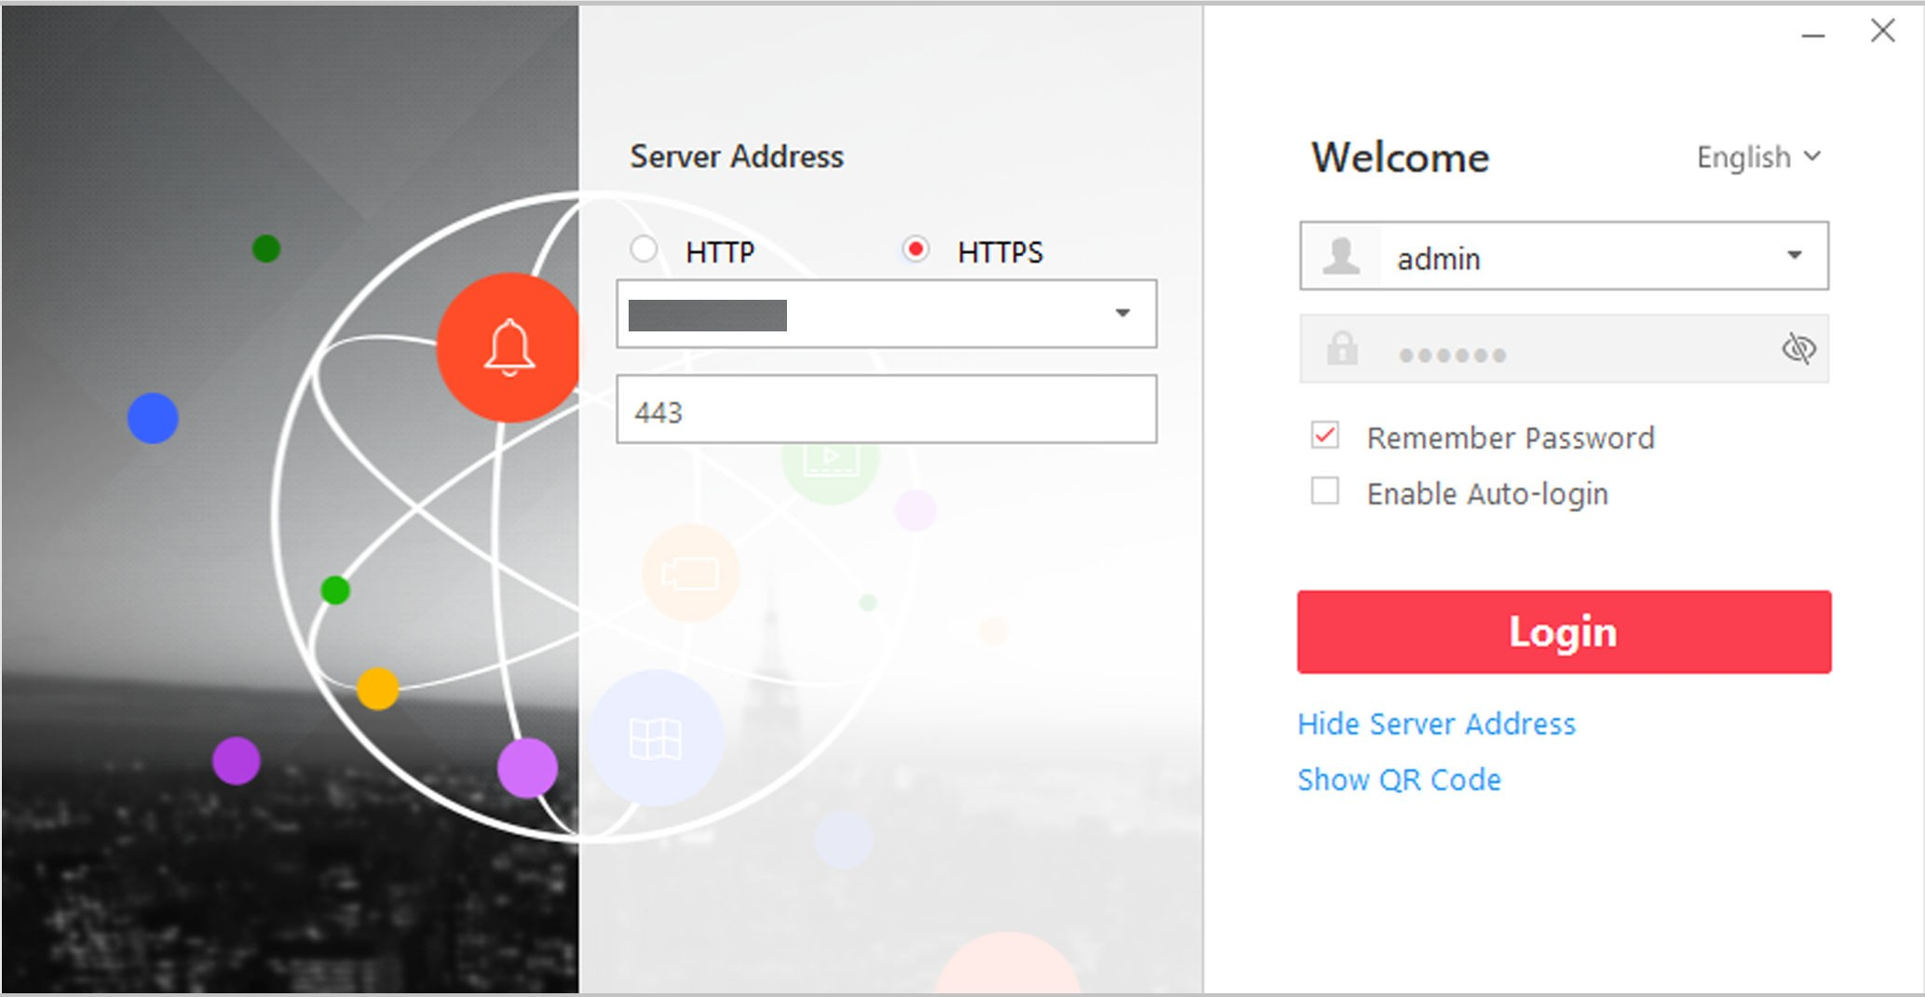

**2.** Enter the server parameters.

**Figure 2-1 Login Page**

**Note**



You can click **Hide Server Address** or **Show Server Address** to hide or show the server network

information.

**Transfer Protocol**

Select the transfer protocol. You can select **HTTP** or **HTTPS** as configured on the Web Client.

**Server Address**

Enter the address (IP address or domain name) of the server that running the SYS service you want to connect to.

**Port**

Enter the port number of the server that running the SYS service. By default, it's 80 for HTTP

and 443 for HTTPS.

**3.** Enter the user name and password of the HikCentral Professional.

**Note**



• Contact the administrator for the user name and initial password.

• For domain user account, you can check **Auto-Launch** so that you will not need to manually

start the Control Client next time you start your computer.

**4.** Click **Login**.

**5.** Click **Close** in the pop-up dialog to continue.

**6.** Set a new password and confirm the password.

**Caution**



The password strength of the device can be checked by the system. We highly recommend you change the password of your own choosing (using a minimum of 8 characters, including at least three kinds of following categories: upper case letters, lower case letters, numbers, and special characters) in order to increase the security of your product. And we recommend you reset your password regularly, especially in the high security system, resetting the password monthly or weekly can better protect your product.

Proper configuration of all passwords and other security settings is the responsibility of the installer and/or end-user.

**7.** Click **Login** to change the password.

You enter the Control Client home page after you change the password.

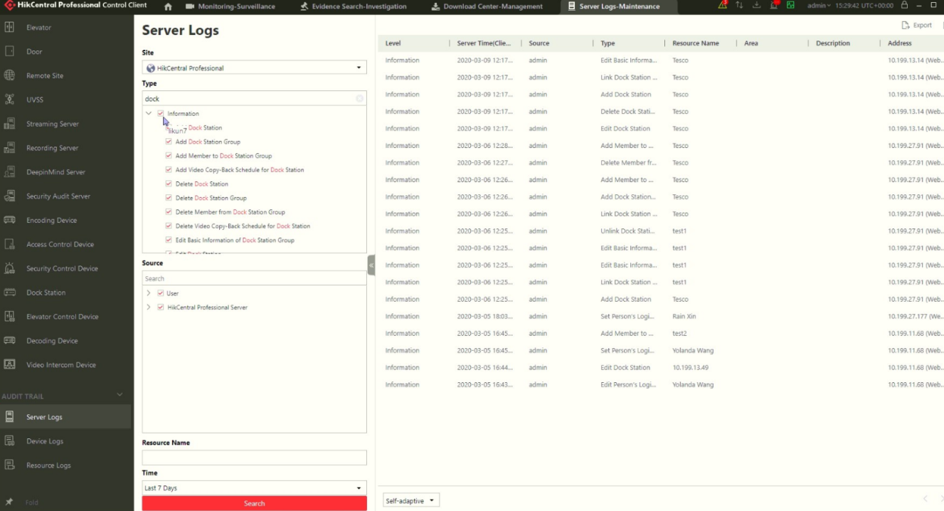**8.** The actions of the operators for the users can be logged.

**2.2 Normal Login (Not First Time)**

Normally, you can log in to the system with the user name and password of HikCentral Professional as a normal user.

**Steps**

**1.** Double-click on the desktop to run the Control Client.



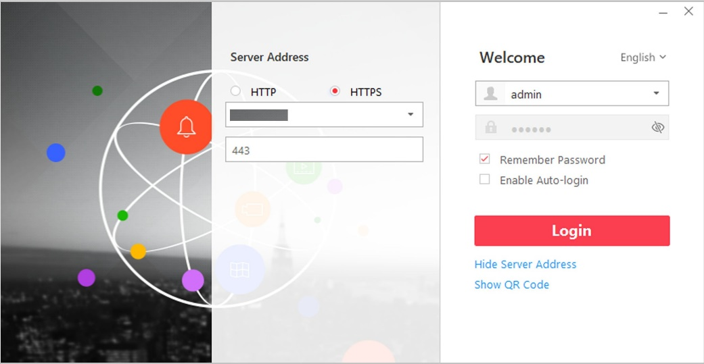

**2.** Enter the server parameters.

**Figure 2-2 Login Page**

**Note**



You can click **Hide Server Address** or **Show Server Address** to hide or show the server network

information.

**Transfer Protocol**

Select the transfer protocol. You can select **HTTP** or **HTTPS** as configured on the Web Client.

**Server Address**

Enter the address (IP address or domain name) of the server that running the SYS service that you want to connect to.

**Port**

Enter the port number of the server that running the SYS service. By default, it's 80 for HTTP

and 443 for HTTPS.

**3.** Enter the user name and password of the HikCentral Professional.

**4. Optional:** Check **Remember Password** checkbox to keep the password.

**5. Optional:** Check **Enable Auto-login** checkbox to log in to the software automatically for the next

login.

**Note**



For domain user account, you can check **Auto-Launch** so that you will not need to manually start the Control Client next time you start your computer.

**6.** Click **Login**.

**Note**



• If failed password attempt of current user is detected, you are required to input the verification code before you can log in. The failed password attempt from current client, other client and other address will all require the verification code.

• The failed password attempt from current client, other client (e.g., Control Client) and other address will all be accumulated. Your IP address will be locked for a specified period of time after specific number of failed password or verification code attempts. For detailed settings of failed login attempts and locking duration, refer to the *User Manual of HikCentral Professional Web Client*.

• The account will be frozen for 30 minutes after 5 failed password attempts. The failed password attempt from current client, other client (e.g., Control Client) and other address will all be accumulated.

• The password strength can be checked by the system and should meet the system requirements. If password strength is lower than the required minimum strength, you will be asked to change your password. For detailed settings of minimum password strength, refer to the *User Manual of HikCentral Professional Web Client*.

• If your password has expired, you will be asked to change your password when login. For detailed settings of maximum password age, refer to the *User Manual of HikCentral Professional Web Client*.

Enter the Control Client home page.

**2.3 Change Password for Reset User and Login**

If the normal user's password is reset to the initial password by the administrator, he/she should change the initial password and set a new password when logging in again.

Perform this task when you need to access the system via Control Client by normal user whose password has been reset to the initial one.

**Steps**

**1.** Double-click on the desktop to run the Control Client.



**2.** Enter the server parameters.

**Figure 2-3 Login Page**

**Note**



You can click **Hide Server Address** or **Show Server Address** to hide or show the server network

information.

**Transfer Protocol**

Select the transfer protocol. You can select **HTTP** or **HTTPS** as configured on the Web Client.

**Server Address**

Enter the address (IP address or domain name) of the server that running the SYS service you want to connect to.

**Port**

Enter the port number of the server that running the SYS service. By default, it's 80 for HTTP

and 443 for HTTPS.

**3.** Enter the user name and password of the HikCentral Professional.

**Note**



• Contact the administrator for the user name and initial password.

• For domain user account, you can check **Auto-Launch** so that you will not need to manually

start the Control Client next time you start your computer.

**4.** Click **Login**.

**5.** Click **Close** in the pop-up dialog to continue.

**6.** Set a new password and confirm the password.

**Caution**



The password strength of the device can be checked by the system. We highly recommend you change the password of your own choosing (using a minimum of 8 characters, including at least

three kinds of following categories: upper case letters, lower case letters, numbers, and special characters) in order to increase the security of your product. And we recommend you reset your password regularly, especially in the high security system, resetting the password monthly or weekly can better protect your product.

Proper configuration of all passwords and other security settings is the responsibility of the installer and/or end-user.

**7.** Click **Login** to change the password.

You enter the Control Client home page after you change the password.

**8.** All the settings (automatic upload, docking-station enrollment, PVR enrollment, setting up of recording retention time, export, back-up, edit video recordings, etc.) will be made by an operator, strictly only from the dedicated PC with dedicated PVR management software.

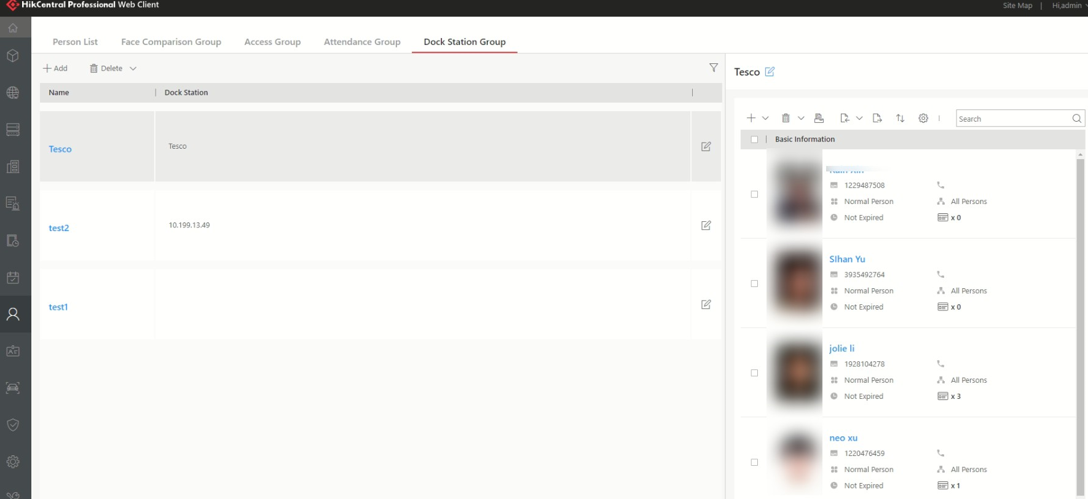

Configuration and assignment, by an operator, for recording devices

**Chapter 3 Manage View**

A view is a window division with resource channels (e.g., cameras and access points) linked to each window. View mode enables you to save the window division and the correspondence between cameras and windows (or correspondence between map and window) as favorite so that you can quickly access these channels and (or) map later. For example, you can link camera 1, camera 2,

and camera 3 located in your office to the certain display windows and save them as a view called ***office***. Next time, you can access the view ***office*** and these cameras will display in the linked window quickly.

Perform this task when you need to get quick access to a certain set of channels for live view or playback.

**Note**



• For live view, the view mode can save resource type, resource ID, stream type, position and scale

after digital zoom, preset No., and fisheye dewarping status.

• For playback, the view mode can save resource type, resource ID, position and scale after digital

zoom, and fisheye dewarping status.

**Steps**

**1.** Click **Monitoring** on control panel to enter Monitoring page.

**2.** Click to enter the View page.



**3. Optional:** Add a custom view group.

1) Select **Public View** or **Private View** to add the view group.

**Note**



The view groups and views belonging to the private view group are hidden from the other user.

2) Click .



3) Create a name for the group or use the default name.

4) Click **OK** to add this view group.

**4. Optional:** Select a view group.

**5.** Add a view.

1) Click .



2) Create a name for the view or use the default name.

3) Click **OK** to add this view.

**6.** Select a view name for setting window division mode and linked resource channels.

**7.** Click (Logical Resource) tab.



**8.** Drag the channels to the window or double-click the channels to start live view or playback.

**Note**



For detailed operations about live view and playback, refer to ***Live View*** and ***Normal Playback*** .

**9.** Save the view with the displayed view division and channels.

**-** Click **→ Save** to save the current window division mode and displayed channels and (or)



map as the selected view.

**-** Click **→ Save as** to save the current window division mode and displayed channels and (or)



map as a new view by creating view name (optional) and selecting the view saving path.

**Note**



If the added view is not selected before, you can also save the current window division and displayed channels as a new view.

**10. Optional:** Perform the following operations after adding the view.

**Edit View** Edit the view settings (such as window division, correspondence between channels and display windows, etc.), click and edit the view name.



**Add Camera and (or) Map to the Existing View**

**Delete Camera(s) and (or) Map from View**

**Delete View or View**

**Group**

a. Go to **Logical Resource**. b. Select camera(s) or map.

**Note**



You can click **Ctrl** on the keyboard to select multiple cameras. c. Click **→ Save to View** to save the camera(s) or map to an



existing view.

a. Select camera(s) and (or) map under a view.

b. Click **→** to delete the selected camera(s) and (or) map.



Click to delete the custom view or view group.



**Result**

**Reset** If you did other operations on this view, click **reset** to restore to the initial view settings

After adding a view, you can start live view or playback in view mode. See ***Start Live View in View***

***Mode*** and ***Start Playback in View Mode*** for details.

11. Ability to search, classification and marking of records

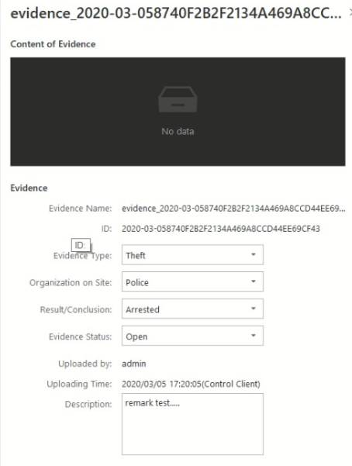

12. The application must import records and associated metadata: BWC device’s unique ID , date and time of the video recording, date and time when the video was imported.

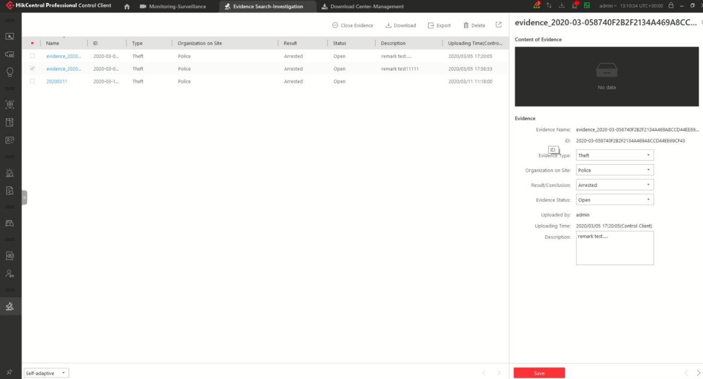

13. The application can allow editing the recordings (cutting recording) in the same time maintaining the authenticity of the file. It has to be able to export the video file in a format that allows you to view the file with free players (Ex. VLC).

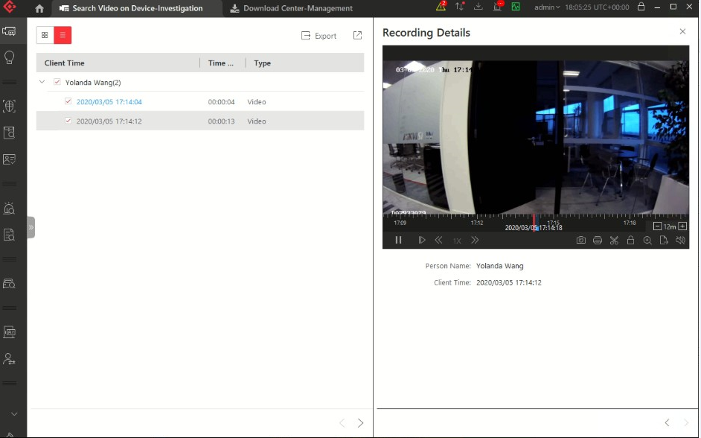

**Chapter 4 Recordings**

**4.1 Recording and Capture**

You can record video files and capture pictures manually during live view.

**Manual Recording**

Record the live video during live view if needed and store the video files in the local PC.

**Capture**

Capture pictures during live view if needed and store the pictures in the local PC.

**4.2 Manual Recording**

While watching live video, you can record the video manually if you see something of interest and you can export the video as video evidence.

**Steps**

**1.** Click **Monitoring → Live View** to enter the live view page.

**2.** Move the mouse to the live view display window to show the toolbar.

**3.** Click in the toolbar of the display window to start the manual recording. The icon turns to .



**Note**



During the manual recording, **Recording** will display in the upper-right corner of the display window.

**4.** Click to stop the manual recording.



The recorded video file will be saved automatically and a dialog with the saving path of the file

will open.

**Note**



• The saving path of video files can be set on the Local Configuration interface. For details, see

***Set File Saving Path*** .

• The video cannot be stored if the free space is less than 2 GB.

**5. Optional:** Perform the following operations after manual recording.

**Open Folder** Click **Open Folder** on the dialog to verify the video file.

**Save as**

**Evidence**

Click **Save as** and check **Save as Evidence**, and then set the required

information to save the video footage as evidence.

**Note**



See ***Save Found Video Footage as Evidence*** for details.

a. Click **Save as** on the dialog to open the Save as panel.

**Set Saving**

**Path**

Set saving path for the recorded video files.

a. Click **Save as** on the dialog to open the Save as panel. b. Click **Browse** to select a directory as the saving path.

**4.3 View Manually Recorded Videos**

The manually recorded files in live view are stored on the PC on which the Control Client is running. You can view the video files.

**Steps**

**1.** On the Control Panel, click **Local Recording** to enter the Local Recording page.

**2.** Click to select the camera(s) to be searched from the camera list and click **Close** to close the



camera selection window.

**3.** Set the time period for search in the Time field.

**4.** Click **Search**.

The video files recorded between the start time and end time will display.

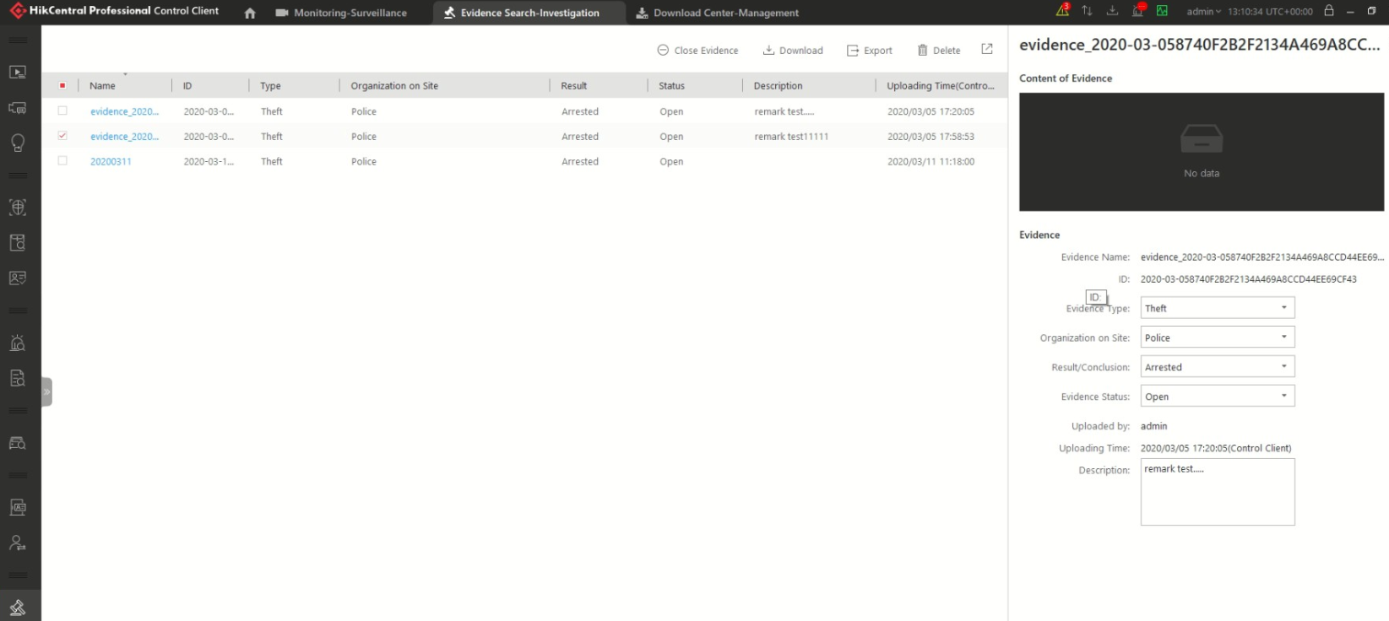

**Figure 4-4 Local Recording**

**5.** To play a video file using the VSPlayer, click on the video file.



**Note**



For detailed instructions about VSPlayer, click and select **User Manual** to view the VSPlayer user manual.



**6.** Select the files or check **All** to select all the found video file(s). You can:

**Save Video File to**

**Local PC**

Click **Save as** and then specify a local path to save the selected video

file(s).

**Delete Video File** Click **Delete** to delete the selected video file(s).

**Save Video File as** a. Click **Save as** to open the Export panel.

**Evidence** b. Check **Save as Evidence** and then set the required information to

save the video file as evidence

**Note**



For details, see ***Save Found Video Footage as Evidence*** for details.

**4.4 Capture Pictures**

During playback, you can take a quick snapshot of an image for the live video manually via the

Control Client if you want to save or share a still image.

Perform the following steps to capture picture during live view.

**Steps**

**1.** Click **Monitoring** on control panel and then enter the live view page.

**2.** Move the cursor to the live view display window to show the toolbar.

**3.** Click in the toolbar of the display window to capture a picture.



The captured picture will be saved automatically and a dialog with the saving path will open.

**Note**



• The saving path of the captured picture can be set on the Local Configuration interface. For details, see ***Set File Saving Path*** .

• The picture cannot be saved if the free space is less than 512 MB.

**4. Optional:** Click **Open Folder** on the dialog to verify the picture or click **Edit** to edit the picture.

**Note**



For details about editing the captured picture, refer to ***Edit Captured Picture*** .

**5. Optional:** Click **Search by Picture** to open video search window. Refer to ***Search Captured Face***

***Picture and Related Video*** for more details.

**4.5 Edit Video Recordings**

During playback of the video recordings, you can edit the video recordings to actual needs and save the edited picture.

**Before You Start**

Playback the video recordings, and a dialog with the saving path of the video recordings will

pop up.

Perform the following steps to edit the video recordings.

**Steps**

**1.** Click **Monitoring** on control panel and then enter the video recordings playback page.

**2.** Click **Edit** on the dialog with the saving path of the captured video recordings to pop up the

following window.

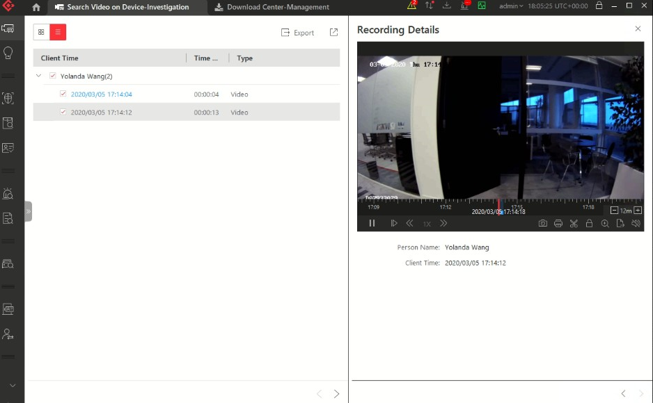

**Figure 4-5 Edit Video Recordings**

**3.** Drag on the edited video recordings to draw as desired.

**4. Optional:** Click **Browse** to select the saving path and click **Save**.

**Note**



The picture cannot be saved if the free space is less than 512 MB.

**4.6 View Captured Pictures**

The captured pictures in playback are stored on the PC on which the Control Client is running. Perform the following steps to view the captured pictures.

**Steps**

**1.** On the Control Panel, click **Local Picture**to enter the Local Picture page.

**2.** Click to select the camera(s) to be searched from the camera list, and click **Close** to close the



camera selection window.

**3.** Set the time period for the search in the Time field.

**4.** Click **Search**.

The pictures captured between the start time and end time will display.

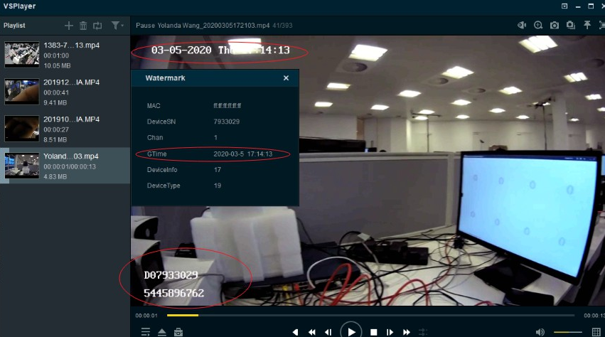

**Figure 4-6 Local Picture**

**5. Optional:** Double-click the captured picture to enlarge it for a better view.

**6. Optional:** Select the picture(s) or click **All** to select all the found picture(s). You can:

**Print Pictures** Click **Print** to print the selected pictures to a printer connected via the network.

**Save Picture to Local**

**PC**

**Delete Picture**

Click **Save As** and then specify a local path to save the selected picture(s).

Click **Delete** to delete the selected picture(s).

**4.11 More Functions**

There are some other functions supported in the live view, including auxiliary screen preview, digital zoom, two-way audio, camera status, and arming control.

**Auxiliary Screen Preview**

Live video can be displayed on different auxiliary screens to monitor multiple scenes. Click above the display window area to open an auxiliary screen. Up to four auxiliary screens for live view are supported.



**Digital Zoom**

Digital zoom is a useful feature for cameras that do not have their own optical zoom capabilities. It lets you zoom a portion of a given image to have a closer look at it.

Move the mouse to the live view display window and click on the tool bar. Click a place or scroll up the mouse wheel to zoom in. Drag the mouse to the upper-left direction or scroll down the mouse wheel to zoom out. Click to switch to dragging mode, which means you can drag the image to another direction after zooming in. Click to resume the zoomed-in image to the original one.



**Camera Status**

Move the mouse to the live view display window and click . The camera status, such as



recording status, signal status, connection number, bitrate (including camera's real-time bitrate and

the constant bitrate configured on the connected NVR), etc., can be detected and displayed. The

default inspection interval for the camera status is 3 minutes.

**Arming Control**

Move the mouse to the live view display window and click . The status of the enabled event detection (e.g., motion detection, video loss) of the camera displays, such as arming status, alarm name and alarm level. You can click **Disarm** or **Disarm All** to disable the event detection and set the disarming duration. You can also click **Arm** or **Arm All** to enable the event detection.



**Save Tagged Video Footage**

Move the mouse to the live view display window and click to display the Add Tag panel. And then set the information such as the time range of the to be saved video footage to save the tagged video footage.



One can export the audit log and checks the integrity / authenticity of the records

**4.12 Customize Icons on Playback Window**

You can customize the icons shown on the toolbar of the display window and other display settings

for live view control.

**Steps**

**1.** Click **System** on the control panel to enter the System page.

**2.** Click **Application Settings → Live View** to enter the Live View Settings page.

**3.** Customize the live view toolbar.

**-** Click an icon in the list to add it to the gray frame below to hide the icon. Icons in the gray frame will be hidden in the toolbar of the live view window.

**-** Click the icon in the gray frame to add it back to the live view toolbar to show an icon on the toolbar.

**4.** Drag the icons in the icon list to adjust icon positions.

**Table 4-1 Icons on Live View Toolbar**

|  |  |  |
| --- | --- | --- |
|  | Audio Control | Turn off/​on the sound and adjust the volume. |
|  | Capture | Take a snapshot of the current video and save in the current PC.  **Note**  After capturing a picture, a thumbnail will pop up on the upper-right corner. You can click **Search by Picture** to search the captured picture, archive, and identity verification related with the captured picture. |
|  | Print | Take a snapshot of the current video and print it. You can enter some descriptive information. |
|  | Record | Record the video files for current live view and save in the current PC. |
|  | Playback | Switch to instant playback to view the recorded video  files. |
|  | Digital Zoom | Zoom in or out the video for cameras that do not have their own optical zoom capabilities. Click again to disable the function. |

|  |  |  |
| --- | --- | --- |
|  | Camera Status | Show the camera's recording status, signal status,  connection number, etc. |
|  | Edited Transcoded Stream | Switch the live view stream to main stream, sub-stream  (if supported), or smooth stream (if supported).  **Note**  The smooth stream will show if the device supports smoothing function. You can switch to smooth stream if in low bandwidth situation to make live view more fluent. |
|  | VCA Playback | Display the VCA Search window. You can set VCA rule to search video files and filter the videos by VCA event types. Refer to ***Search VCA Event Related Video*** for more details. |
|  | Add Tag | Add tag for a video footage of a selected time period during live view. See *Save Tagged Video Footage* in ***More Functions*** for details. |
|  | Visual Tracking | Track an individual (such as a suspect) across different areas without losing sight of the individual. See *User Manual of HikCentral Professional Web Client* and ***Visual***  ***T racking*** for details about setting and performing visual tracking. |

**Note**



The icons shown on the toolbar in the display window will vary with the device's capabilities.

**5. Optional:** Set the **Always Display Toolbar** to **ON** to always display the toolbar on the live view window.

**6.** Click **Save.**

**Chapter 5 Playback**

You can view the recorded video files on the Monitoring module of the Control Client.

**5.1 Normal Playback**

You can search video files by area or camera for the Normal Playback and download found video

files to local PC. You can also add a tag to mark important video footage, and so on.

**Note**



• You can search video files by the time of the time zone where the device locates in, or by the

time of the time zone where the PC running the Control Client locates in.

• Automatically converting daylight saving time to standard time is supported, or vice versa.

• Synchronous playback or asynchronous playback of devices in different time zones are

supported.

**5.1.1 Search Video File**

You can search video files by camera, by area, or by time for normal playback. And you can also

filter the searched video files by video type or by storage location.

**Steps**

**1.** Click **Monitoring → Playback** to enter the playback page.

**2.** Drag the camera or area to the display window, or double-click the camera or area to play the

recording of the specified camera(s) in selected window.

**Note**



The playback window supports up to 16 channels. If exceeding the limit in live video display window, select the channels within 16 before switching to playback.

Today's recorded video files of the selected camera will be played.

**3.** Click on the toolbar to set the date and time to search video files by time.



**Note**



In the calendar, the date with video files will be marked with a triangle.

After selecting the date and time, the matched video files will start playing in the display window.

**4. Optional:** Click on the toolbar to select video type and storage location for playback.



**Note**



To set the storage location for recording, refer to *User Manual of HikCentral Professional Web*

*Client*.

**5.1.2 Play Video File**

After searching the video files for the normal playback, you can play the video via timeline or thumbnails.

**Steps**

**1.** Click **Monitoring → Playback** to enter the playback page.

**2.** Select a date with videos to start playing video and show the timeline after searching the video

files.

**Note**



The video files of different types are color coded.

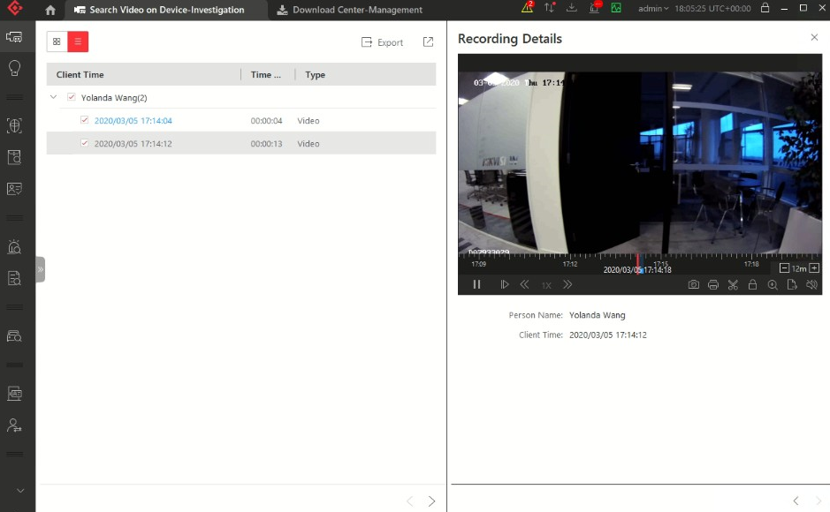

**Figure 5-1 Play Video Files**

**3.** Play video in specified time period by timeline or thumbnails.

**-** Drag the timeline forward or backward to position the desired video segment.

**-** Move the cursor over the timeline to take a quick view of video thumbnails (if supported by the device) and click the appearing thumbnail to play the specific video segment.

**Note**



• Click the icon / on the right of the timeline bar, or use the mouse wheel to zoom in or zoom out on the timeline



• Click / to show or hide the thumbnail bar.



• Move the cursor to the top border of the thumbnail bar and drag to adjust the height of the

thumbnails when the cursor changes into . You can also click to lock the thumbnail bar



above the playback timeline, and click to hide the thumbnail bar automatically



**4. Optional:** Move the mouse to the lower edge of the playback window to access the icons for further operations.

**Note**



For details, refer to ***Customize Icons on Playback Window*** .

**5.2 Start Playback in View Mode**

You can quickly access the playback of the cameras managed in a view.

**Steps**

**1.** Click **Monitoring** on the control panel to enter Monitoring page.

**2.** Click  to enter the view mode.

**3.** Click the **Playback** tab to enter the playback page.

**4. Optional:** Add a view if no view is available. Refer to ***Manage View*** for details.

**5.** Click a view to quickly start the playback of all the cameras related to the view.

**Note**



You can also quickly switch the added view from the drop-down view list above the displaying windows.

**5.3 Synchronous Playback**

You can play the video files of different cameras synchronously.

**Steps**

**Note**



Video files from up to 16 cameras can be played simultaneously.

**1.** Click **Monitoring → Playback** to enter the playback page.

**2.** Start normal playback of at least two cameras.

**Note**



For detailed configuration about normal playback and playback control, refer to ***Normal***

***Playback*** . Some icons may not be available for synchronous playback.

**3.** Click  on the playback toolbar to enable the synchronous playback.

The cameras displayed in Playback will start synchronous playback.

**4. Optional:** Click  on the playback toolbar to disable synchronous playback.

**5. Optional:** Move the mouse to the lower edge of the playback window to access the icons for

further operations.

**5.4 Customize Icons on Playback Window**

You can customize the icons shown on the toolbar of the display window for playback control.

**Steps**

**1.** Click **System** on the control panel to enter the System page.

**2.** Click **Playback** to enter the Playback Settings page.

**3.** Customize playback toolbar.

**-** Click an icon in the list to add it to the gray frame below to hide the icon. Icons in the gray frame will be hidden in the toolbar of the playback window.

**-** Click the icon in the gray frame to add it back to the playback toolbar to show an icon on the toolbar.

**4.** Drag the icons in the icon list to adjust icon positions.

**Table 5-1 Icons on Playback Toolbar**

|  |  |
| --- | --- |
| Capture | Take a snapshot of the current video and save in the current PC. |
| Capture | Take a snapshot of the current video and save in the current PC. |
| Print | Take a snapshot of the current video and print it. You can enter some descriptive information. |
| Clip | Clip the video files for current playback and save in the current PC. You can save the clipped video as evidence, and set the saving path for the clipped video files. For details about saving video files as evidence and setting saving path, see ***Manual Recording*** . |
| Tag Control | Add custom tag for the video file to mark the important video point. You can also edit the tag or go to the tag position conveniently. |
| Lock Video | Lock the video file and set the locking duration to avoid deleting the video file and protect the video file from being overwritten when the HDD is full.  **Note**  For the camera imported from Remote Site, if the video files are stored on the encoding device locally, you cannot lock the video files. |
| Digital Zoom | Zoom in or out the video for cameras that do not have their own optical zoom capabilities. Click again to disable the function.  **Note**  When in software decoding mode, you can also capture the zoomed in picture after enabling digital zoom function. |

|  |  |
| --- | --- |
| Export Video File | Export the video files of the camera and save them to your PC or connected USB device. You can also save the video file as evidence, and set saving path for the video files. For details about saving video files as evidence and setting saving path, see ***Manual Recording*** . |
| Camera Status | Show the camera's recording status, signal status,  connection number, etc. |
| Stream Switch | Switch the stream to main stream, sub-stream (if supported), or smooth stream (if supported).  If the device supports transcoding playback, start transcoding and you need to set the resolution, frame rate and bitrate for transcoding.  **Note**  • The smooth stream will show if the device supports smoothing function. You can switch to smooth stream if in low bandwidth situation to make live view more fluent.  • Only video files stored in DVR and I-series NVR support transcoding playback. |
| Frame-​Extracting Playback | Extract frames from the video and play the extracted images (frames) one by one. |
| Visual Tracking | Track an individual (such as a suspect) across different areas without losing sight of the individual. See *User Manual of HikCentral Professional Web Client* and ***Visual Tracking*** for details about setting and performing visual tracking. |

**Note**



The icons shown on the toolbar in the display window will vary with the device's capabilities.

**5. Optional:** Set the **Always Display Toolbar** switch to **ON** to always display the toolbar on the playback window.