DS-MH4172I/2T Dock Station

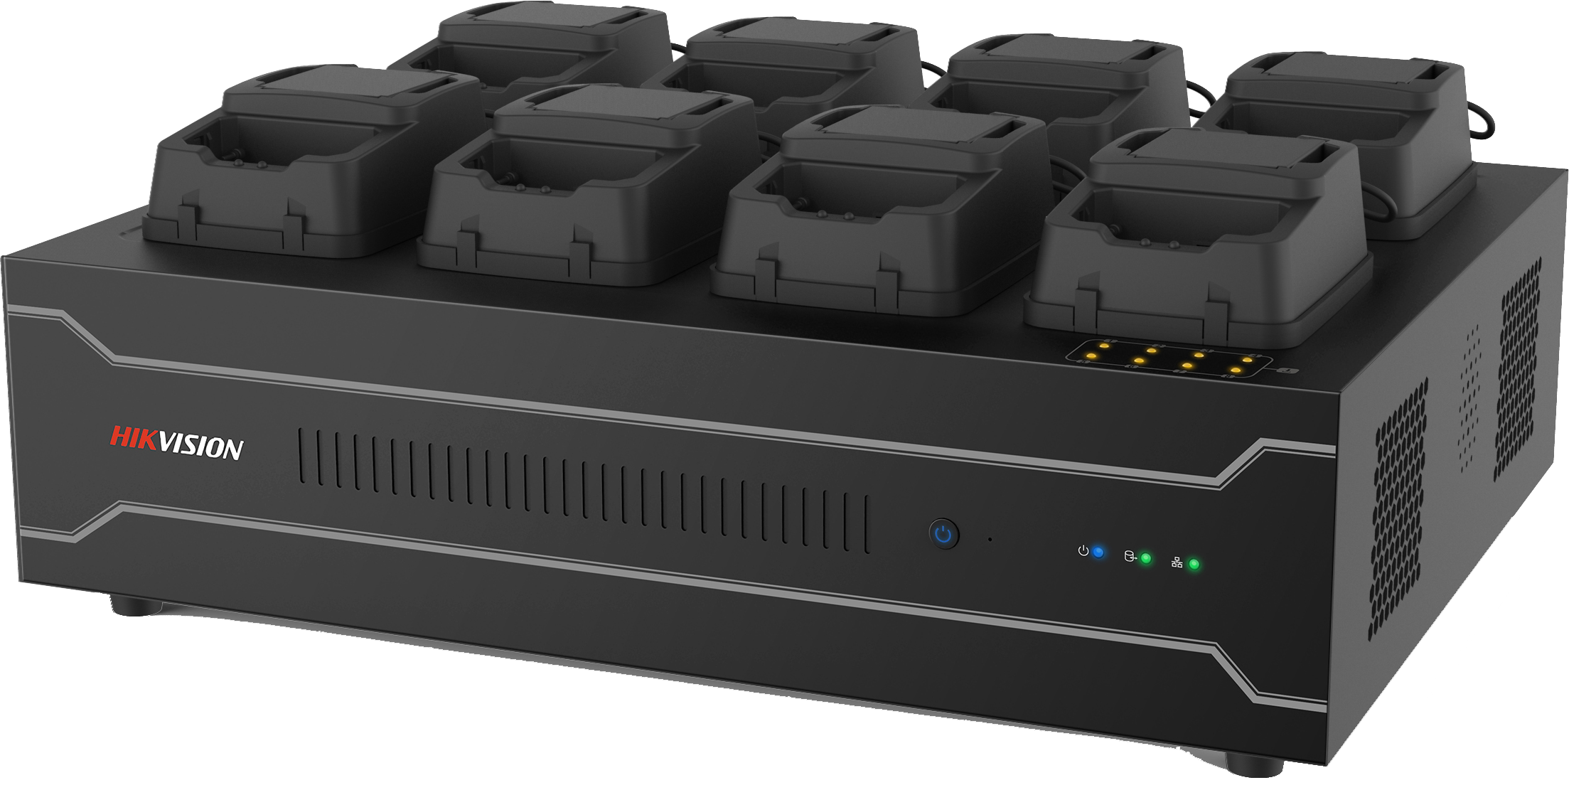

Introduction
The dock station provides a simplified way to access and automatically back up law-enforcement data from Hikvision body camera.
Available Model
DS-MH4172I/2T
Key Feature
- Simultaneously collect data from up to 8 body cameras automatically.
- Obtain date, serial No., police ID, and remaining data of the body camera.
- (Optional) clear data in body camera after data is successfully collected.
- Log management.
- Data overwriting.
- Lock collected files to prevent it from being overwritten.
- In case data collection is suddenly broken off, dock station will resume data collection from the breakpoint at next collection.
- Search collected data by time, by file type, by device No., etc.
- The body camera cradles on the dock station can be changed according to the body camera model.
- Embedded WEB server.

Specification
Model |  | DS-MH4172I
Data Collection | Average Speed | 8 MB/s
Appearance | Dimension | 400 × 300 × 110 mm (15.7 × 11.8 × 4.3”)
Appearance | No. of Slots | 8 ports for body warn cameras
Appearance | System indicator | 1 × power indicator, 1 × HDD indicator, 1 × network connection indicator, 1 × network transmission indicator, 8 × status indicator
Appearance | Button | 1 × power switch, 1 × reset button
Hardware | CPU | Quad core CPU
Hardware | Memory | 4 GB
Hardware | HDD | 4 × 3.5 inch HDD. 2 TB to 6 TB for each HDD
Hardware | Charging Duration for Body Camera | 4 to 5.5 hours
Hardware | Power Consumption | 200 W
Interface | USB Interface | 2 × USB 3.0 interface, 2 × USB 2.0 interface
Interface | HDMI Interface | 2
Interface | Audio Input/output | 1/1
Interface | VGA Interface | 1
Interface | Network Interface | 2 × 10M/100M/1000M Ethernet interface
Interface | Loudspeaker | 2
General | Weight | Approx. 9 kg (19.8 lb)
General | Working Temperature | -10 °C to +55 °C (+14 °F to +131 °F)
General | Working Humidity | 10% to 90%

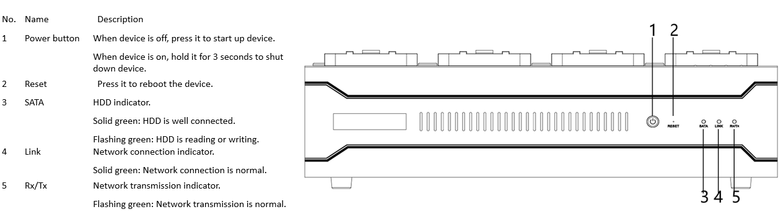
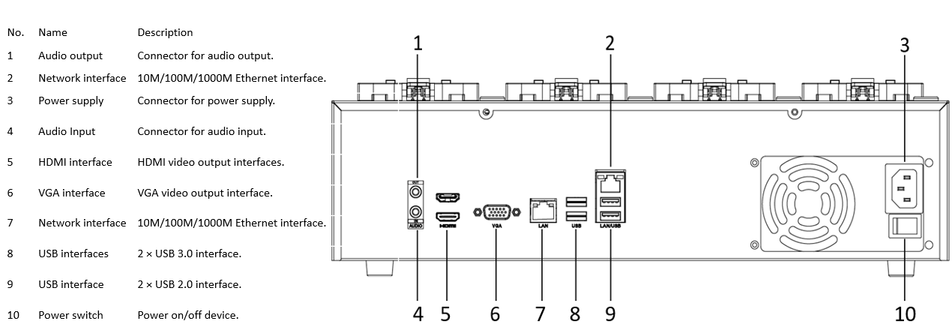
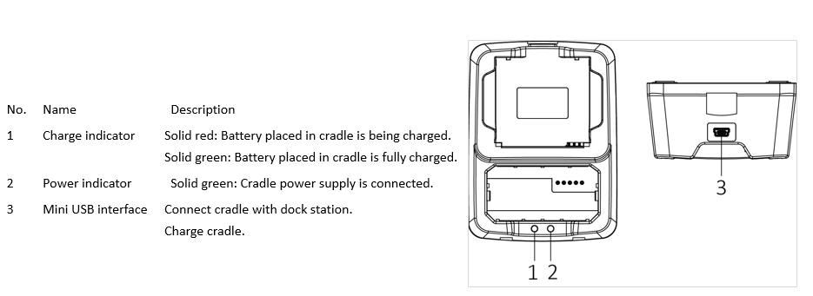
Dimension

