**Tools Manager V1.0.0.3 Build20190416**

**Release Notes**

密级级别：[内部公开]

生效时间： 2019年4月19日

保密期：2年

杭州海康威视数字技术股份有限公司 版权所有

**V1.0.0.3 Key Feature**

1. The Tools Manager integrates various Hikvision software and player, it provides the convenient way of software download, update, use and management. It is easy for you to find the links of the updated tools and documents anytime, anywhere.

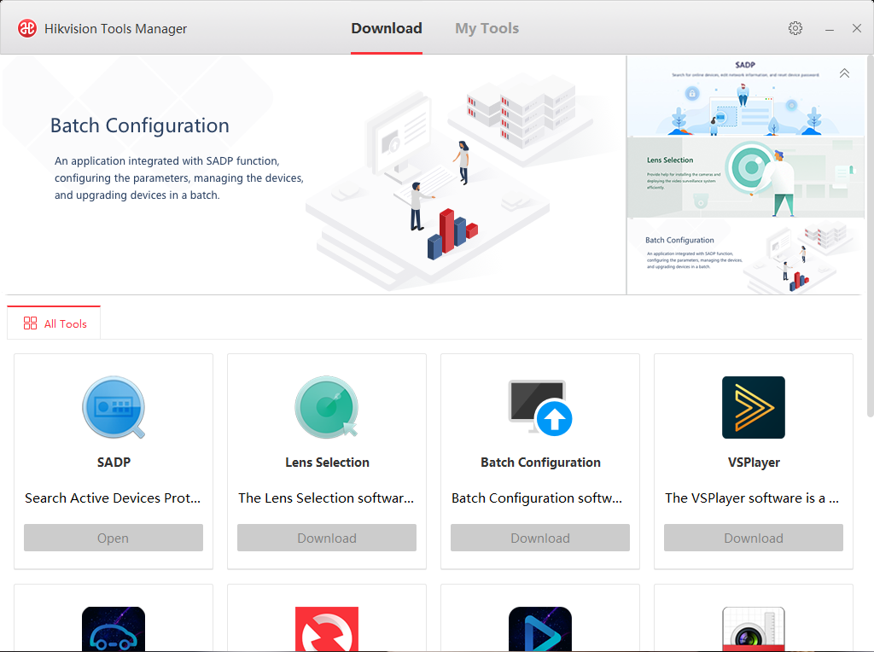

**Search Active Devices Protocol** software is user-friendly and installation-free online device search tool. It searches the active online devices within your subnet and displays the information of the devices. You can also modify the basic network information of the devices using this software.

**Lens Selection** software provides help for creating the camera deployment on the map according to your requirement, and calculate the installation parameters, such as field of view and pixel density.

**Batch Configuration** software is a versatile device management software for the DVRs, NVRs, IP Cameras, encoders, and so on. You can configure the parameters, manage the device, upgrade devices in a batch using this tool.

**VSPlayer** software is a media player designed for Windows operation system. It provides an intuitive, convenient way for playing media file and video control, and supports multiple audio and video formats.

**MVA** software is installed on PC to analyze and handle the video files from the disk of the mobile devices or the specified folder in the local PC. It provides multiple functions, such as viewing vehicle driving information, evidence playback, pattern playback, log search.

**Remote Backup** software can back up the video files stored in the devices and save the video files to the local disk. It supports manual backup and schedule backup. The schedule backup refers to backup task is started automatically according to the schedule.

**Local Playback** software is used to play and download the video files in the local PC and the disks of the devices. It is applicable for the record files stored in iVMS-4200 storage server and the disks of the devices and downloaded from the Remote Backup Software.

**Hik Design Tool** is a graphical drawing application for surveillance solution with multiple Hikvision products. You can search and select a desired product to draw system diagram with product shapes. You can also edit the device quantity according to the actual needs. After the diagram is completed, you can export the diagram.

**Storage and Network Calculator** software can calculate the saving time and required disk space for the recorded video files, and the bandwidth for transferring the video streams. After adding the device with parameters, including channel name, channel number, video standard, scenarios complexity, resolution, frame rate, encoding mode, and recommended bitrate, you can get the related result automatically.