**BatchConfigTool for Mac V1.0.0.4** **Build20190227**

**Release Notes**

**(2019-03-18 )**

**V1.0.0.4 Key Updates**

1. Fixed the issue that accessing a device web client through batch configuration tool failed when the HTTP port was not 80;

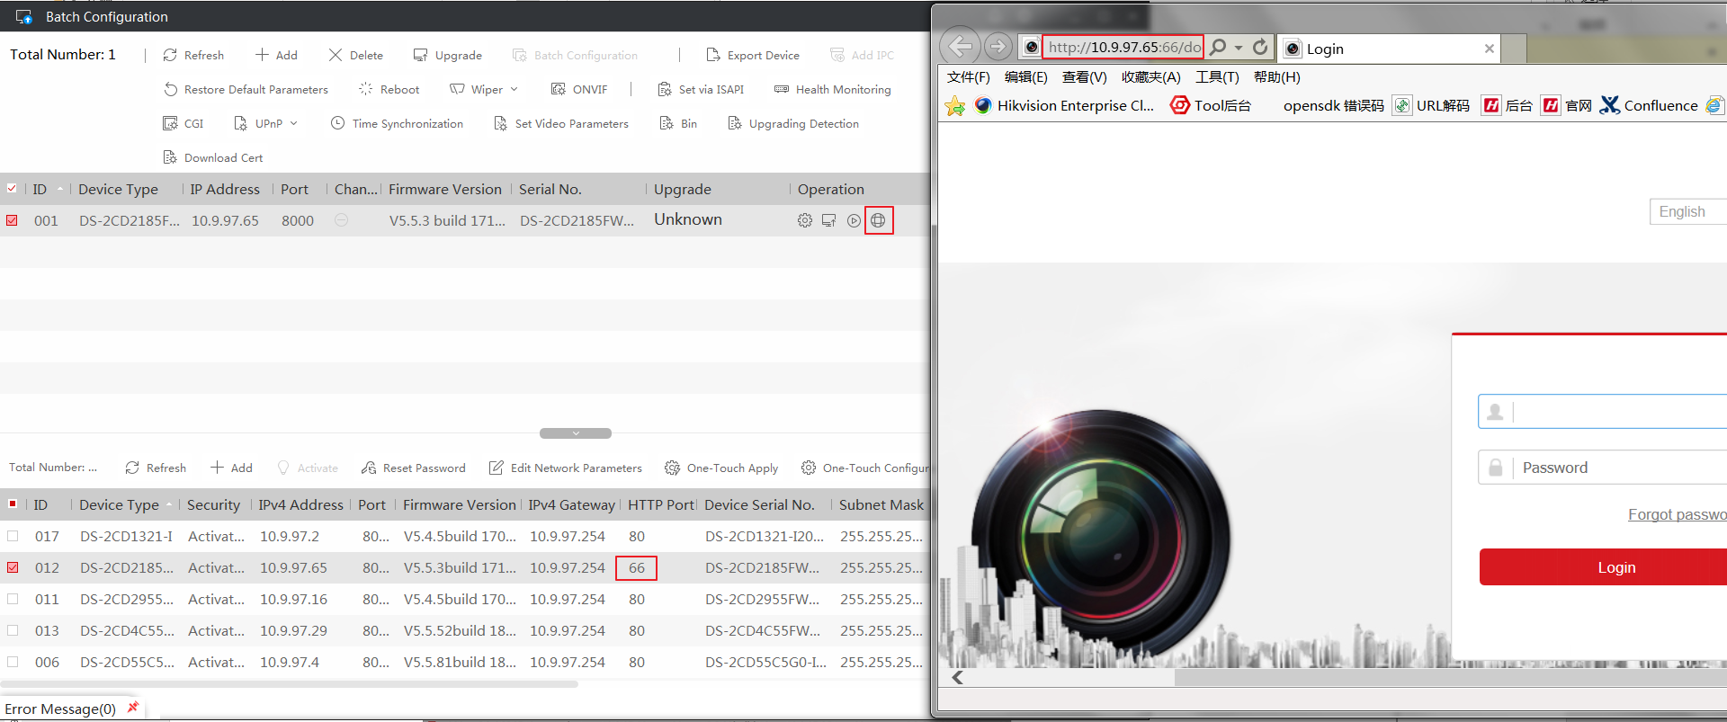

1. Fixed the issue that network parameter failed to be modified through Batch Configuration tool.
2. Fixed the issue that inactive devices failed to modify parameters using One-Touch Configuration.

