**Lens Selection V2.0.3.2** **Build20200102**

**Release Notes**

**(2019-01-02 )**

**V2.0.3.2 Key Updates**

### New Features

1. Newly support Corridor mode, click to enable/disable corridor.

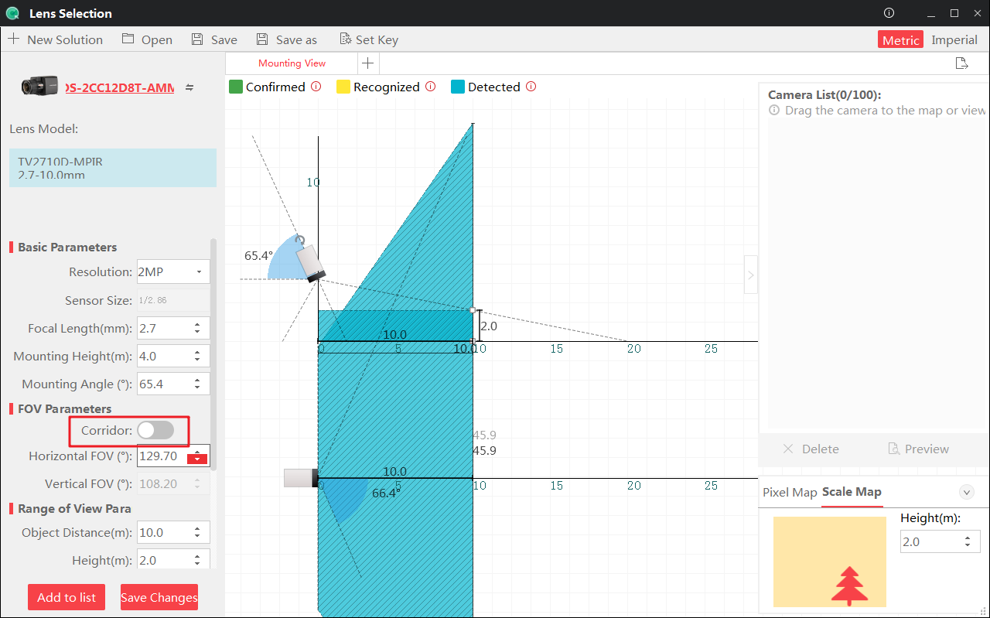

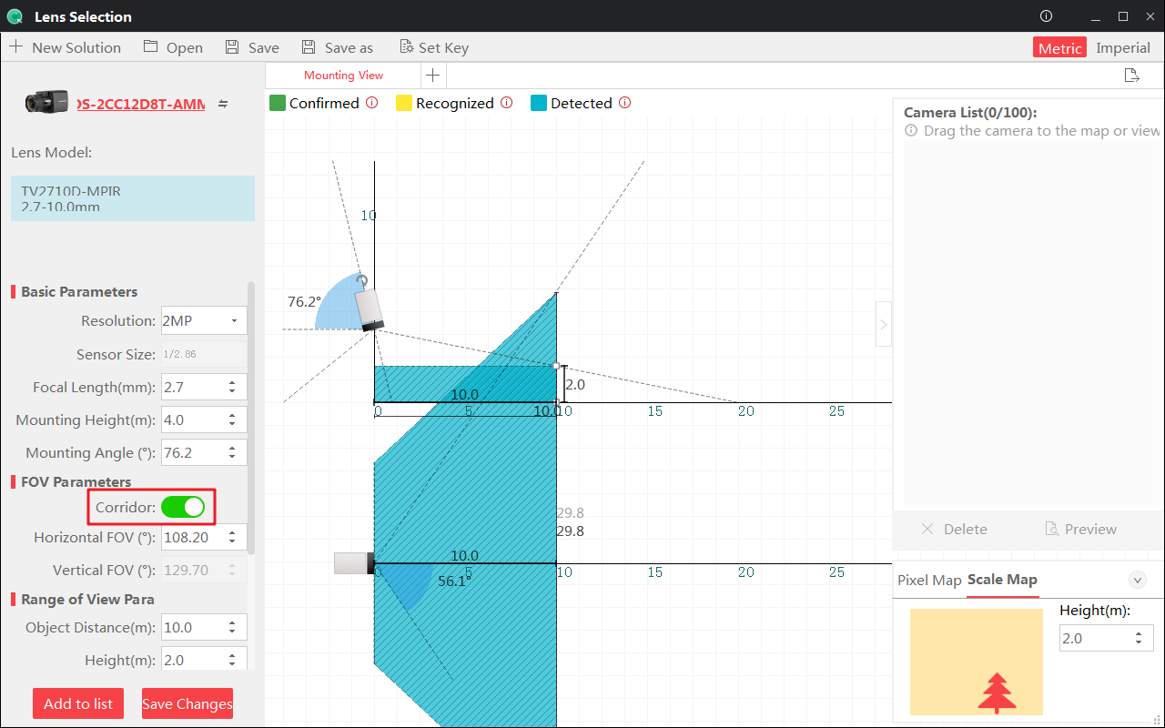

1. Newly support to modify the pixel density, area color and description of the custom area.

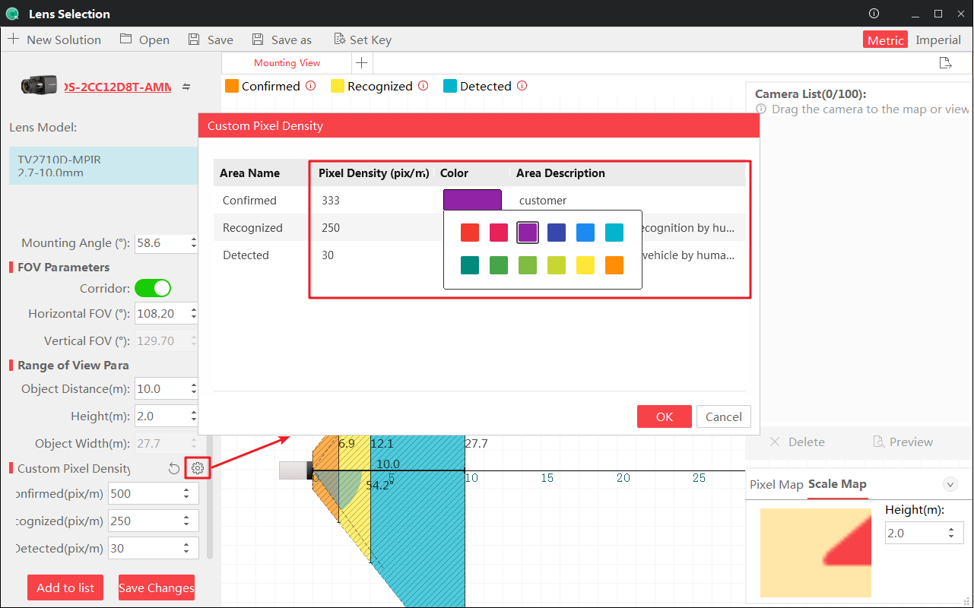

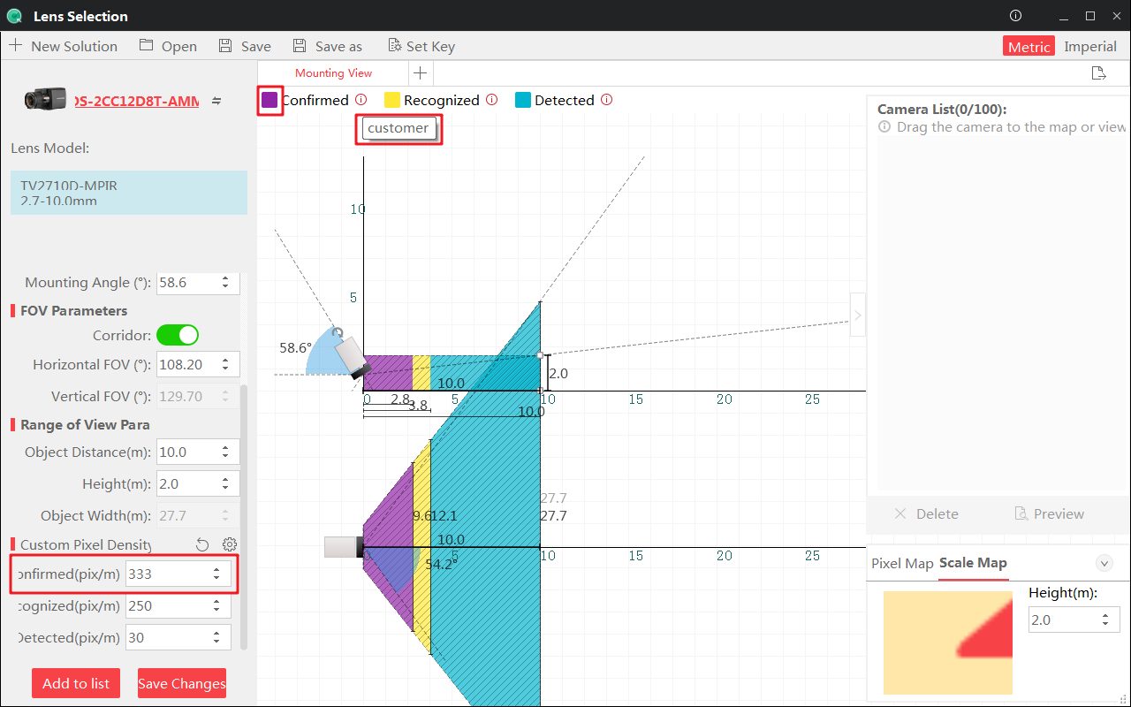

1. Newly support Google Key application description.

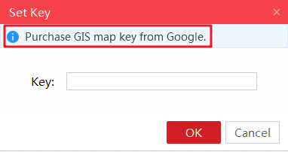

1. Newly support the configuration of detect and update prompts when the software starts for the first time.

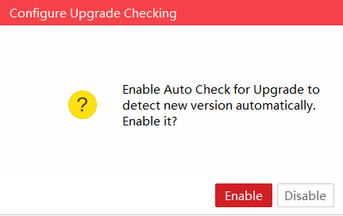

### Improved Features

1. Optimize the calculation method of the pixel density value of the near and far scenes, so that it is closer to the common computing habits of the customers.
2. Modify the default description of the custom area:

1) Confirmed: Face and license plate recognition by software.

2) Recognized: Face and license plate recognition by human eye.

3) Detected: Distinguish human and vehicle by human eye.

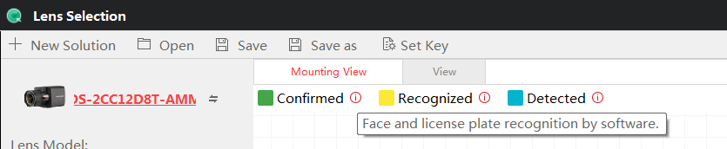

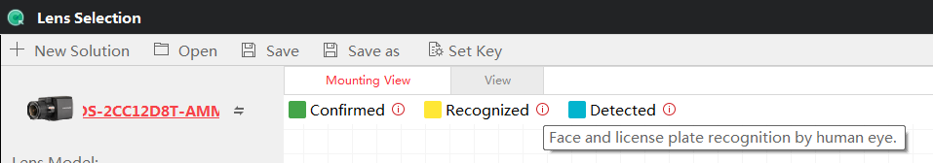

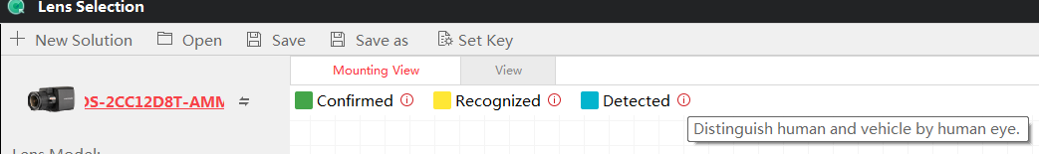

1. Translation optimization, the name of the imported background image was changed to Import Floorplan.

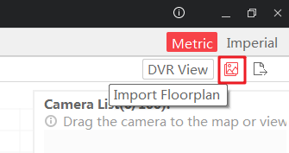

1. Increase the sensor size setting when adding a custom camera.

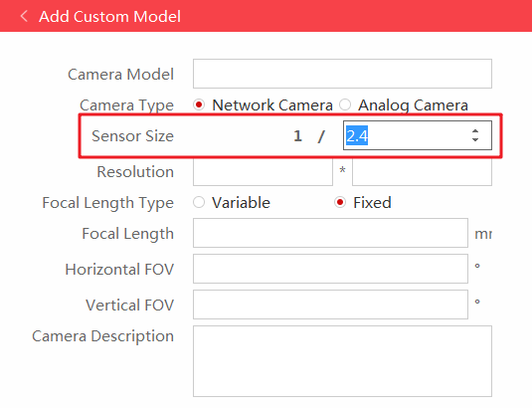

1. Fixed the issue of losing custom camera after restarting the software.