**SADP V3.0.2.4** **Build20191227**

**Release Notes**

**(2020-01-06 )**

**V3.0.2.4 Key Updates**

### New Features

1. Newly support search function, support fuzzy search.

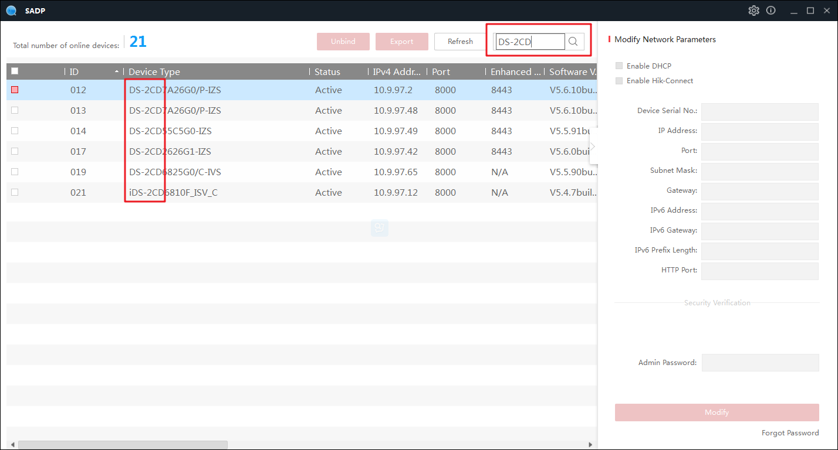

1. Newly support for Chinese and English language switching.

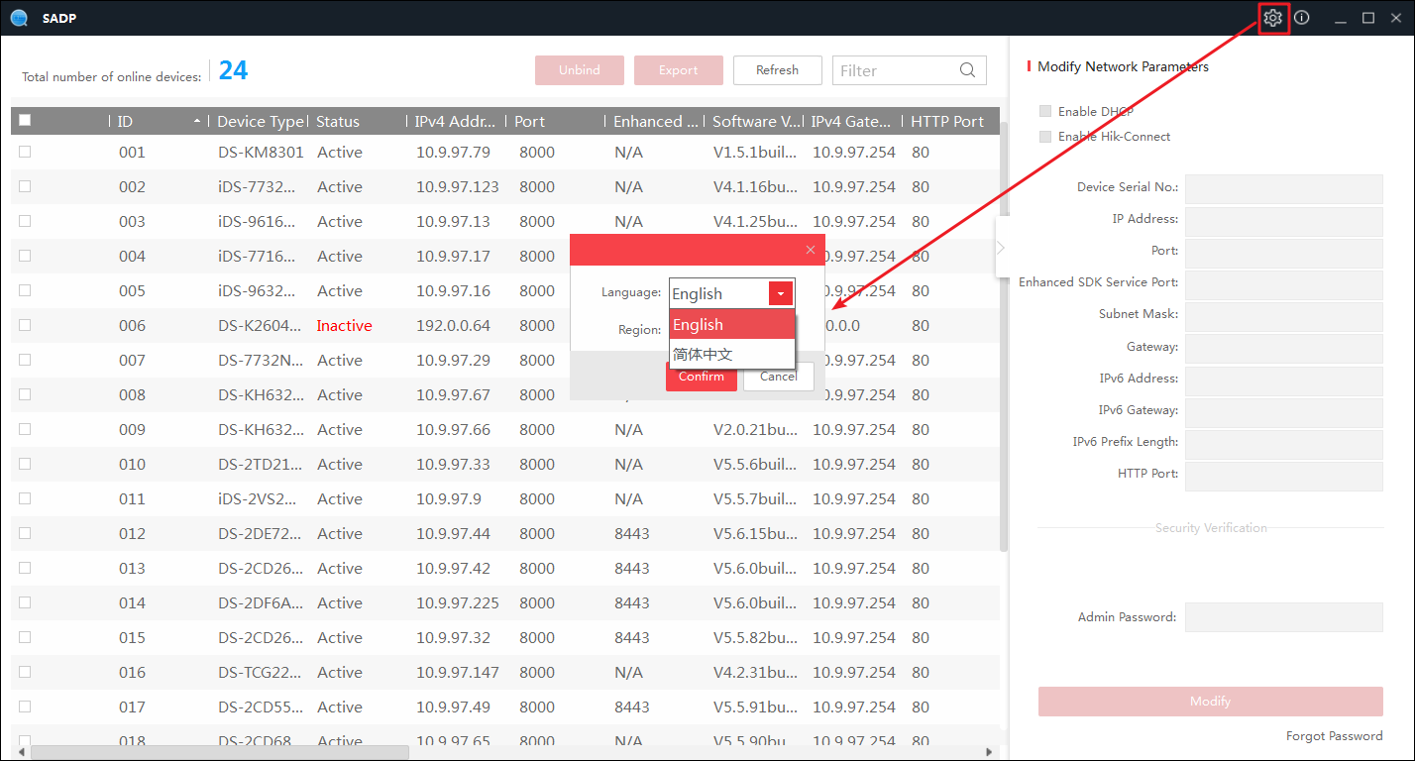

1. Unbind function supports region modify, you can switch between Russia and Other regions.

