Thermal design tool

Release Notes

(2021-10-29)

General Information:

Only on Chrome

Address: https://tools.hikvision.com/#/lensSelection-thermal

**New Features:**

1. Increase the products of 256x192 resolution.

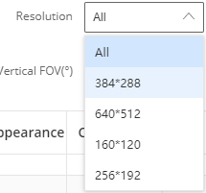

1. Increase the German version

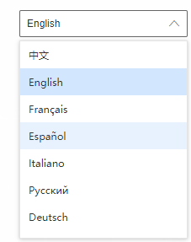

1. Increase the FOV filter when choosing the cameras.

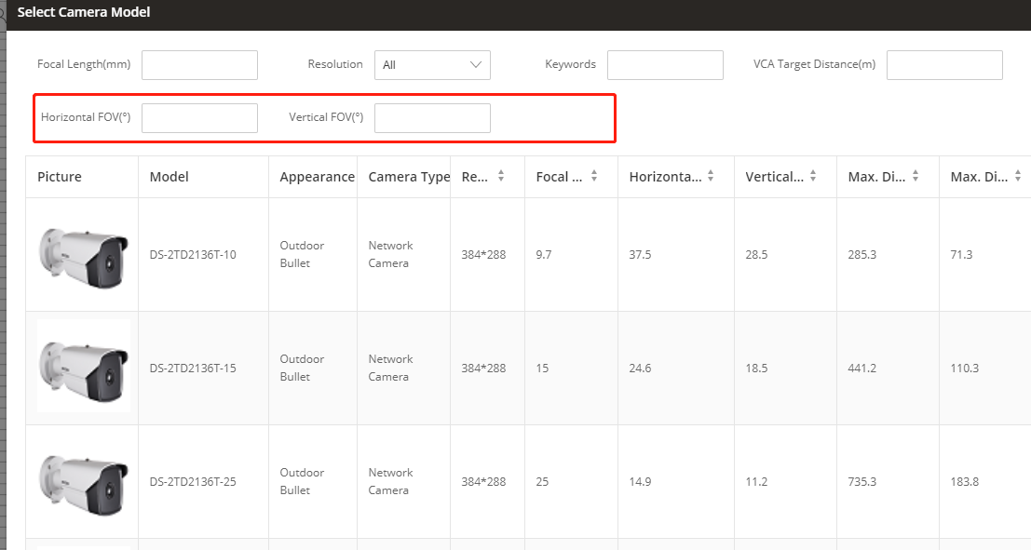

1. For the auto-focus thermal cameras only display the maximum focal length.

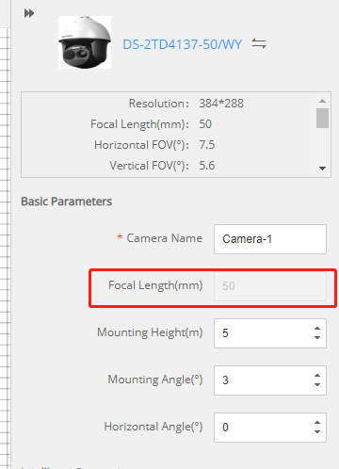

1. The pixel density information on the export report.

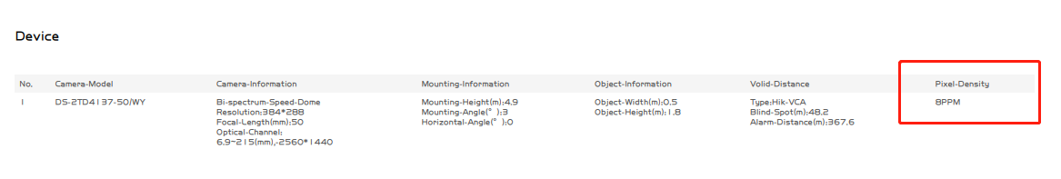

1. Display the DRI distance in the basic information box.

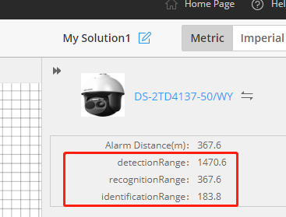

1. Display the pixel density in the furthest place(also in the report, same as the Point 5).

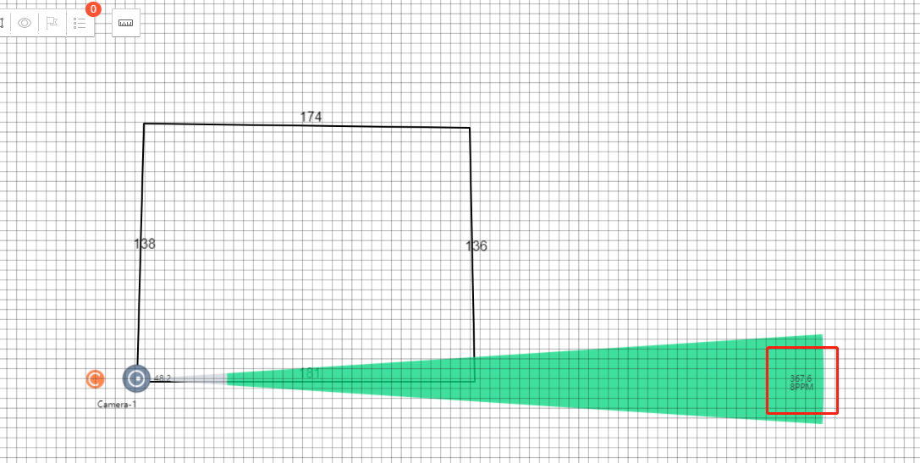



1. Support to modify the name of camera1, and the modified name can be displayed in the camera list that the user added.

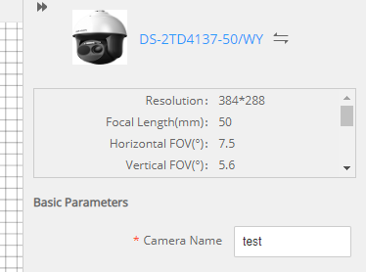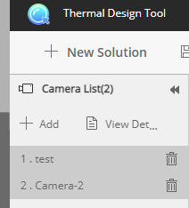

1. Support the self-adaptive logo size in the export report.
2. Change the location of the smart function icon to the left

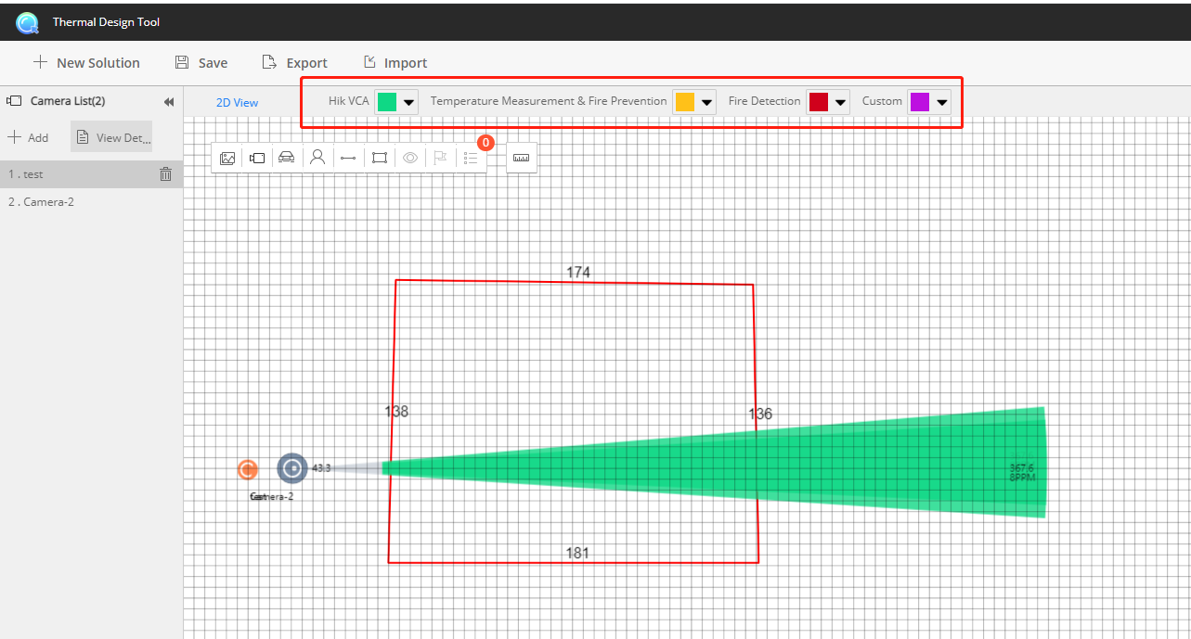

**Optimizations:**

1. Fixed the bug for the size displaying in the vehicle.



1. Modify the temperature measurement to temperature measurement & Fire prevention.

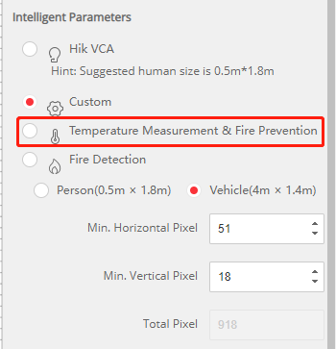

1. French translation: Prévention incendie.
2. When doing the metric-imperial switch, only the digital needs to be redesigned, the drawn region remains the same.
3. It only supports to switch metric and imperial by reloading the web page.

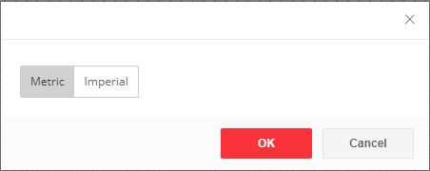

1. Improved the resolution of the picture in the export report

**Remained issue:**

1. The picture in the export report cannot display in full-page

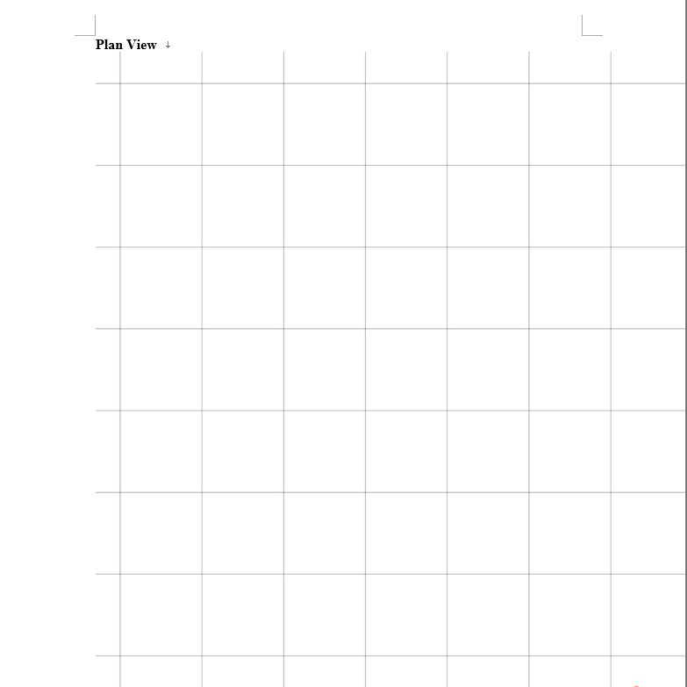

1. The smart function icon will disappear if the Chrome is displayed in 150%.

**Compatibility :**

Can only use Chrome.

**Remarks:**

* Please use this Document with the guidance and assistance of professionals trained in supporting the Product.
* Pictures, charts, images and all other information hereinafter are for description and explanation only.
* HIKMICRO reserves the right to change, alter or withdraw the above notification without prior notice.
* Product design and specifications are subject to change without prior notice.
* The HIKMICRO firmware may contain errors known as errata, which may cause the product to deviate from published specifications. Current characterized errata are available on request.
* HIKMICRO is not liable for any typing or printing errors.

**Hangzhou Microimage Software Co., Ltd**

Room 313, Unit B, Building 2, NO.399 Danfeng Road,

Xixing Subdistrict,Binjiang District, Hangzhou, Zhejiang **http://www.hikmicrotech.com/en/**

<Tel:+86+571-8807-5998>