**Android Indoor Station**

**V 2.1.8 Build 200515 Release Note**

**(2020-06-01)**

|  |  |
| --- | --- |
| Device Model | DS-KH9510-WTE1、DS-KH9310-WTE1 |
| Firmware Version | Indoor Station: V2.1.8_build200714 |
| iVMS-4200 Version | V3.3.1.4 build 200806 |
| Hik-Connect APP | V4.6.2.0724 |

**Function Description**

1. New Android UI interface.

2. Languages

a) Support multi-language in 5 countries, language types include English, French, Spanish, German, and Italian;

b) Support local switching and remote switching of different languages, effective immediately.

3. Local configuration wizard

a. Activation interface

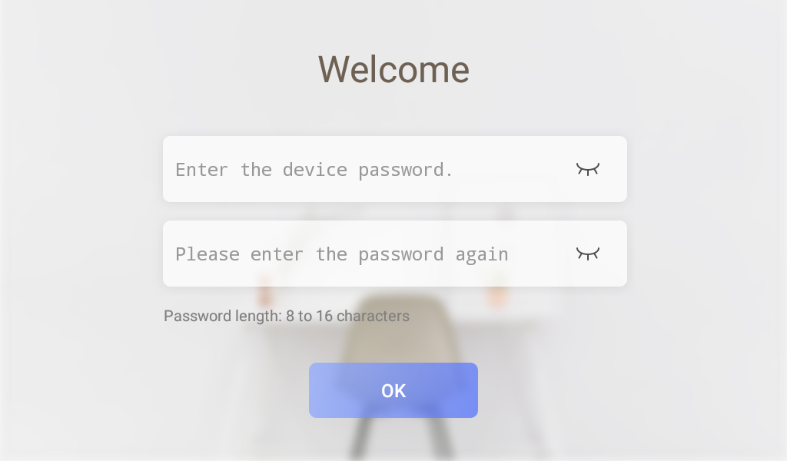

b. Language interface

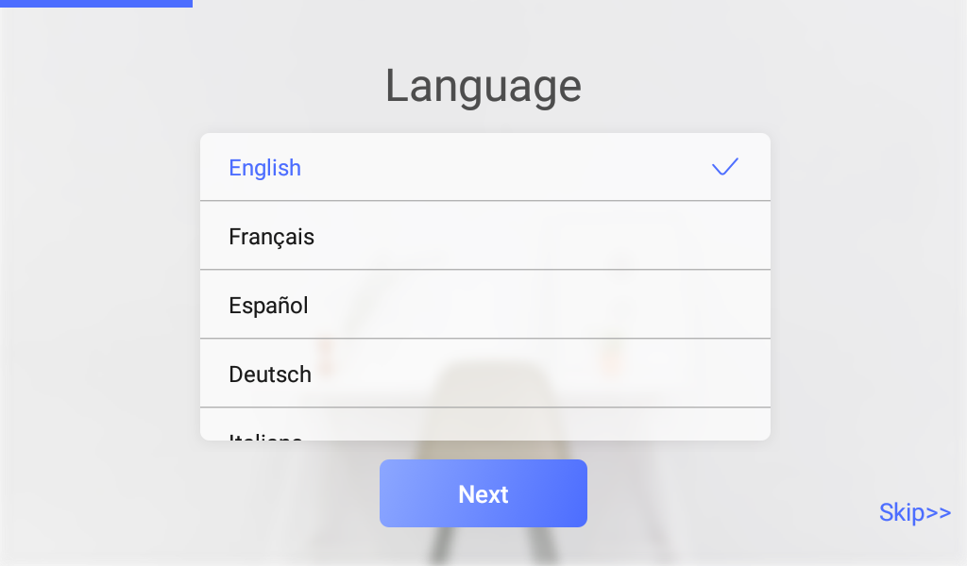

c. Network Setting interface

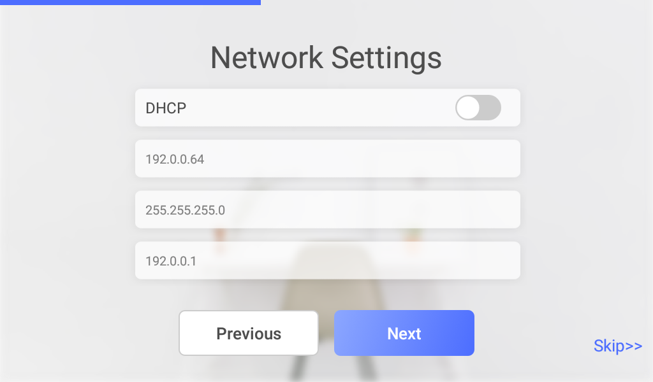

d. Indoor Station Parameter Settings

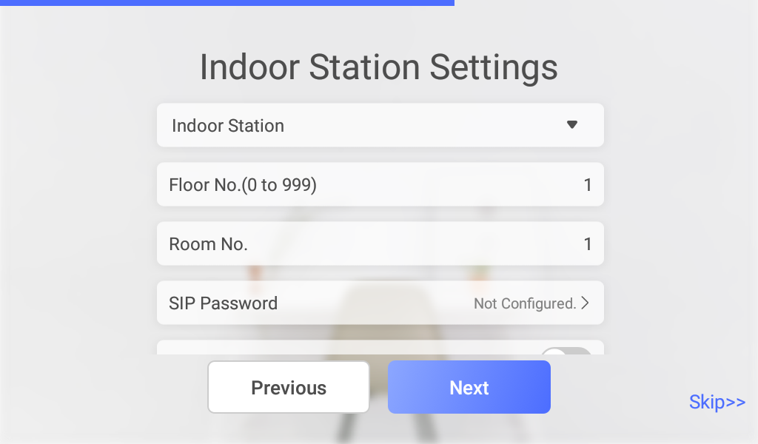

SIP password is actually Register Password, which is suitable for our security 2.0 protocol. They can communicate normally only when the **SIP passwords (Register passwords)** of the door station, indoor station and indoor extension are the **same**.

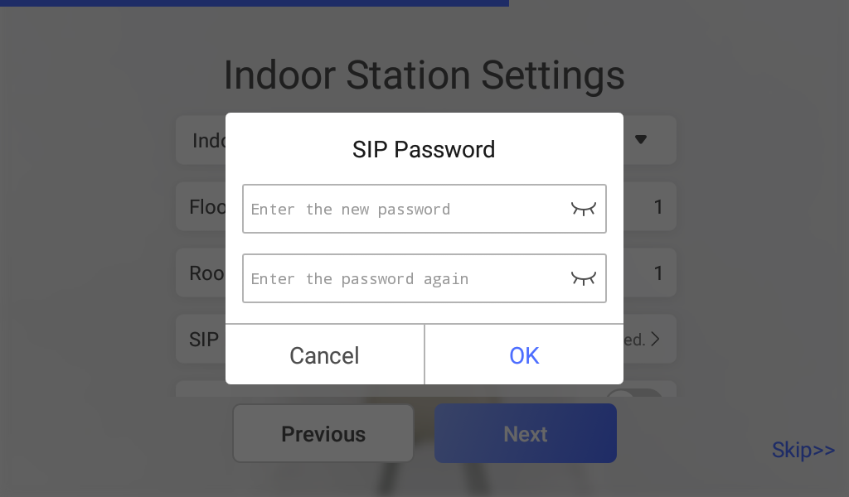

e. Indoor extension Parameter Settings

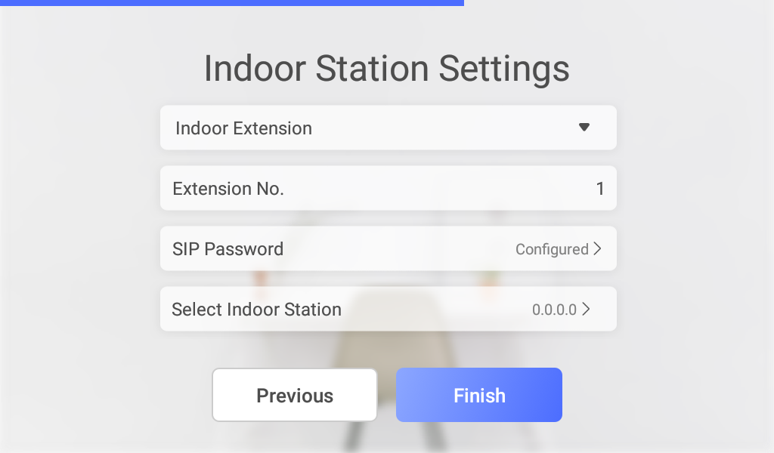

f. Activate and connect door station

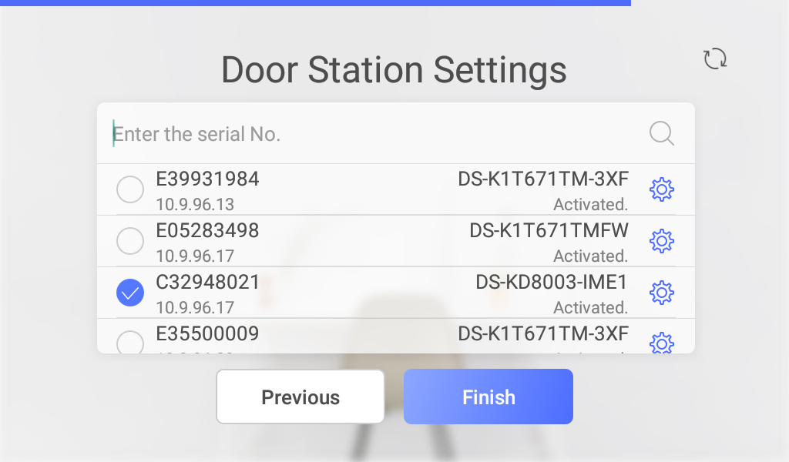

g. Local main interface

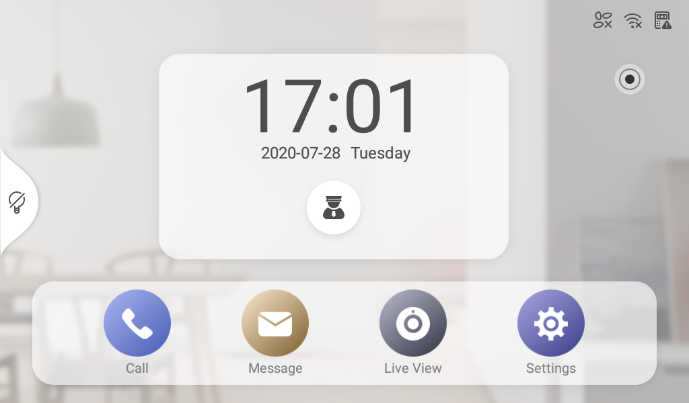

4. Support decoration light on or off, but only supports local modification

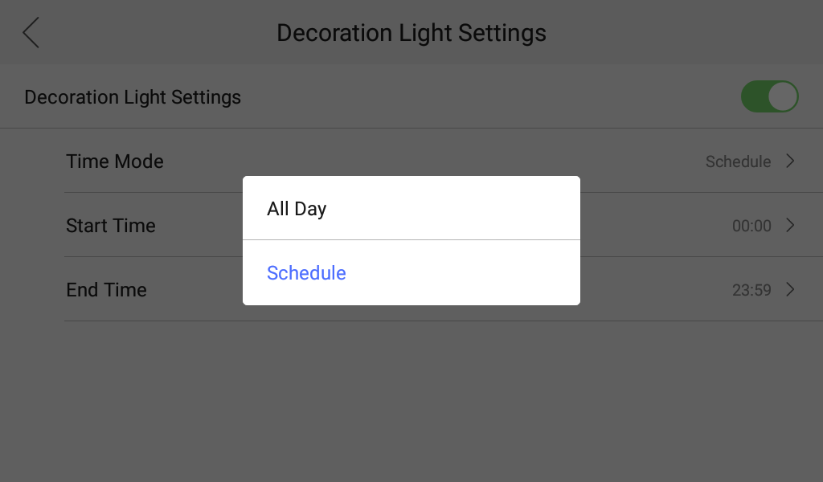

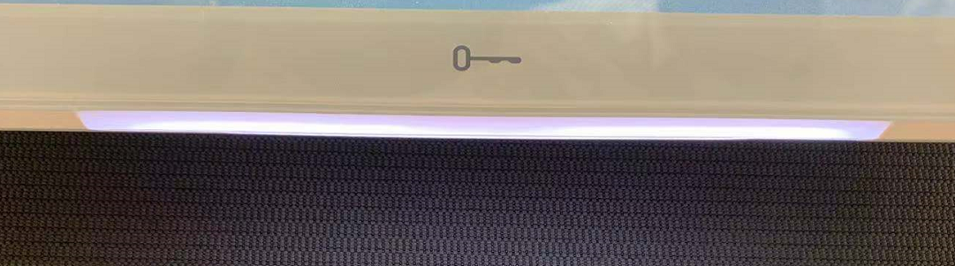

5. Tamper alarm function

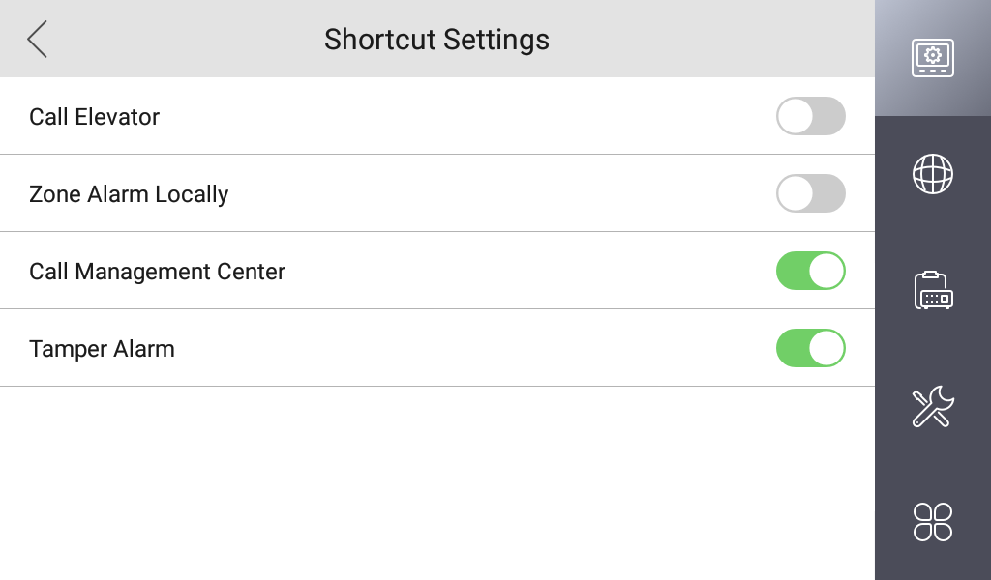

6. Local interface login Hik-Connect App function

a. Hik-Connect function is hidden in this position by default.

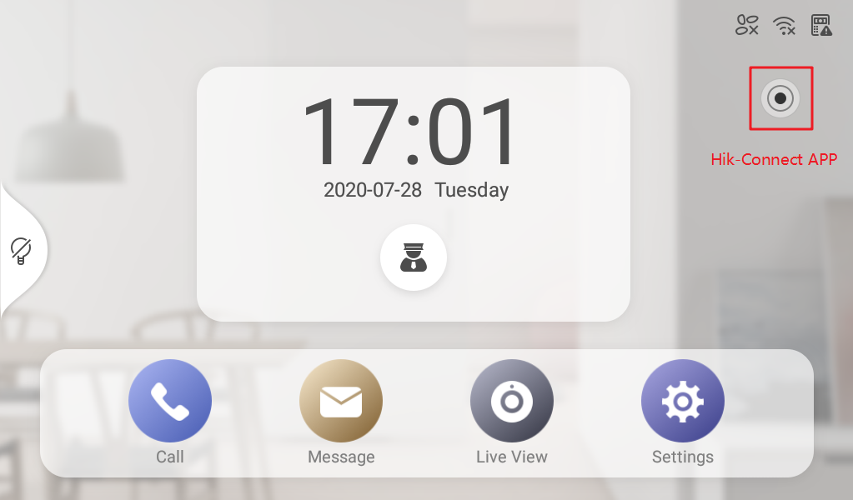

b. If you are not logged in, it will show ‘Login the Hik-Connect’.

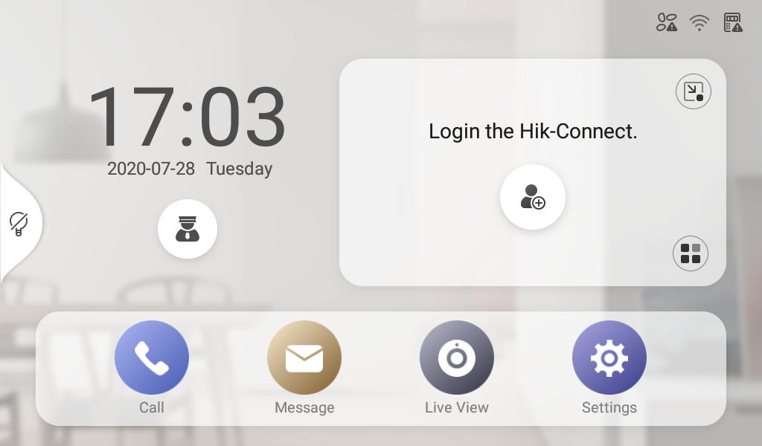

c. Android indoor station does not support online registration, you need to prepare the account password of Hik-Connect in advance.

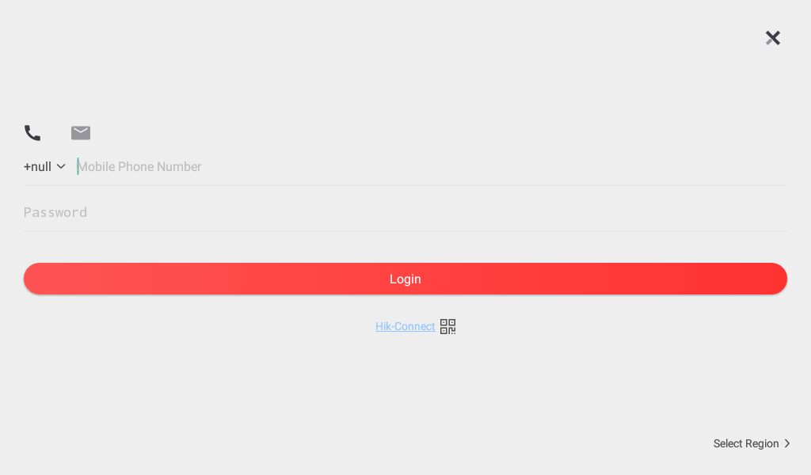

d. Function display: you can arm and disarm the alarm device or preview the playback back-end device, etc.

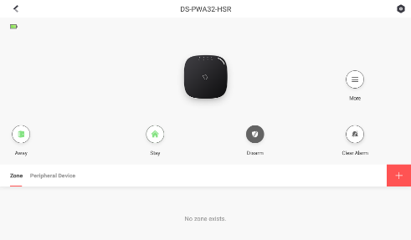

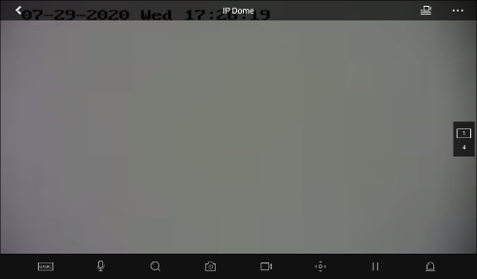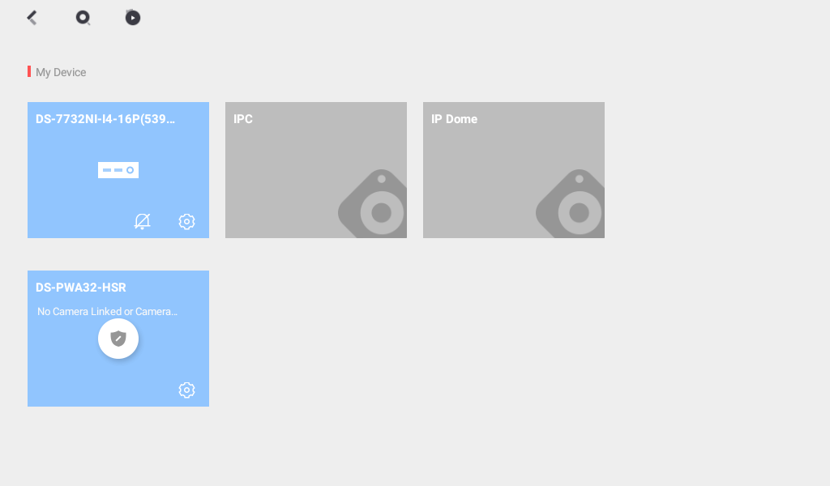

7. The device supports the use of Hikvision certified Android APP

a. Android APP can be imported through iVMS-4200

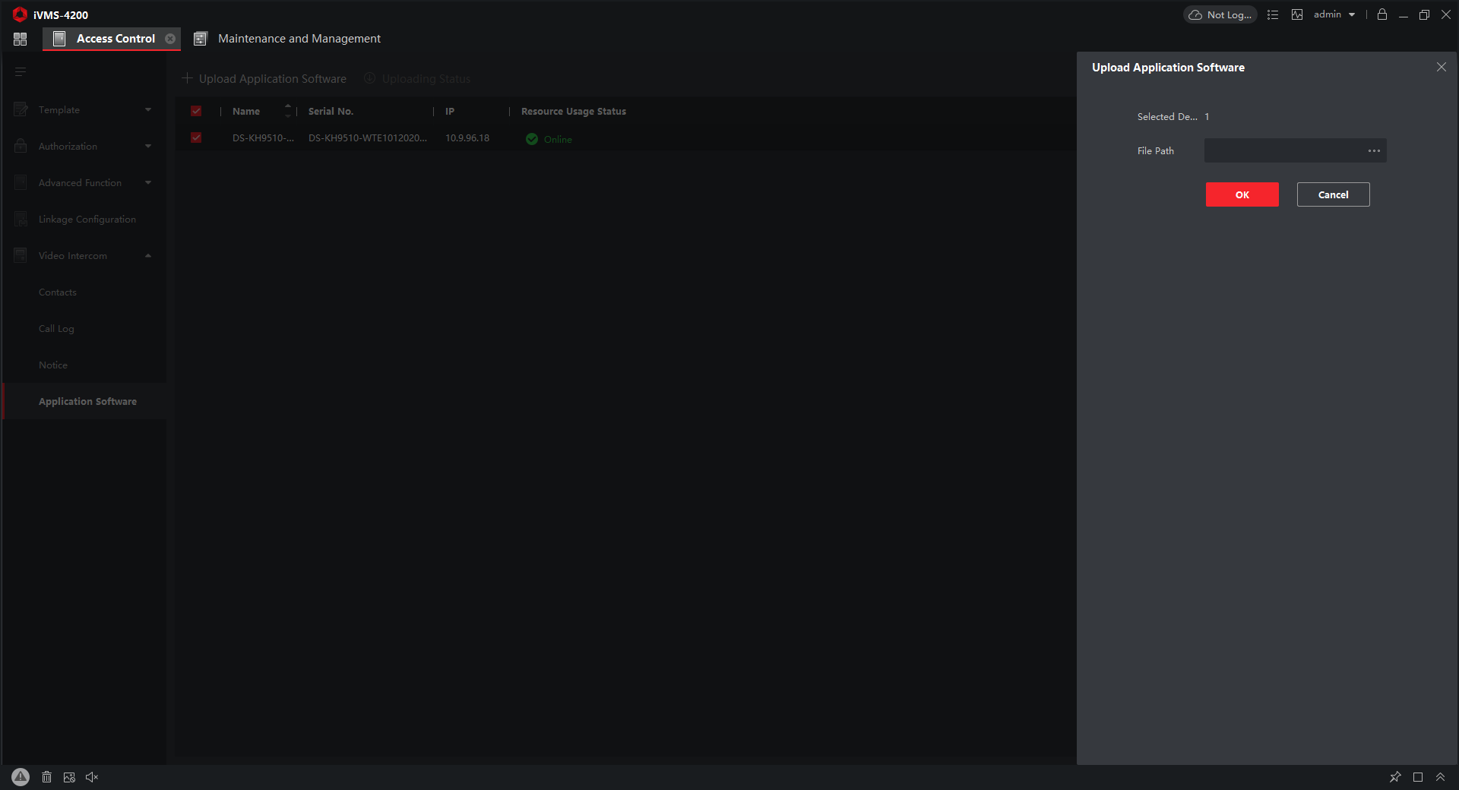

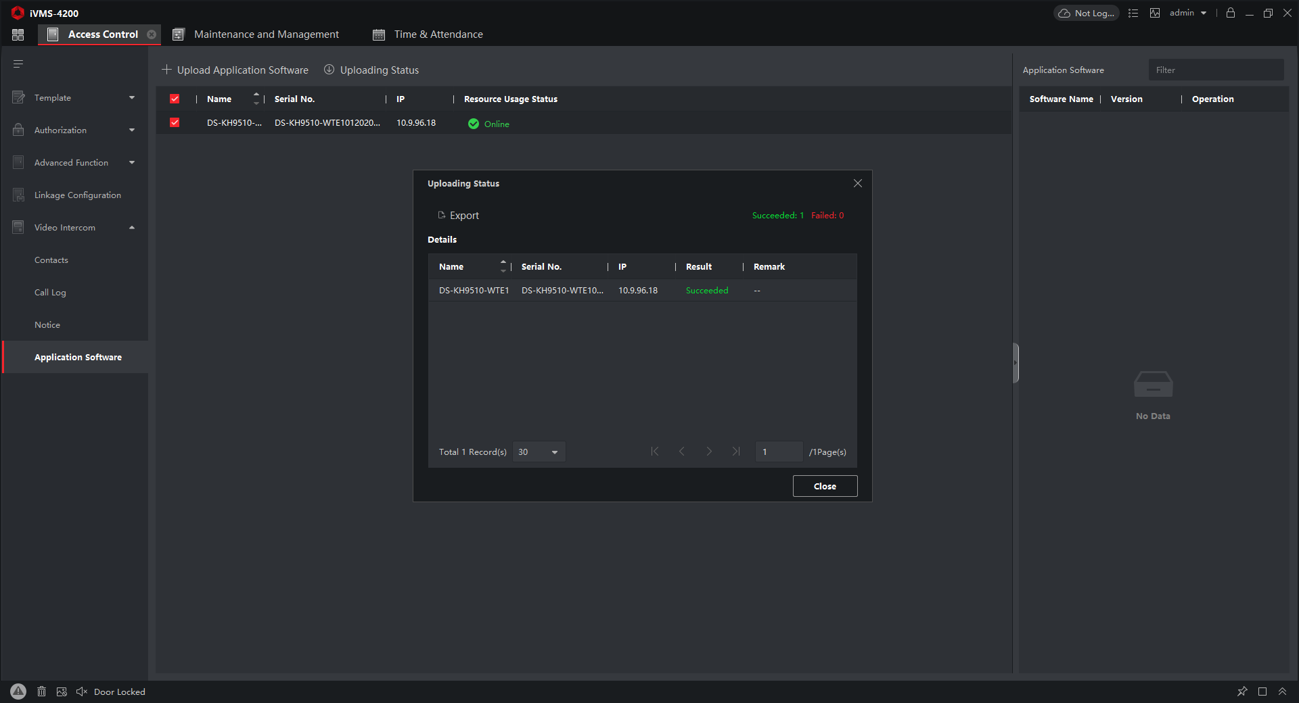

b. The installed third-party APP will be displayed on the right side of Setting.

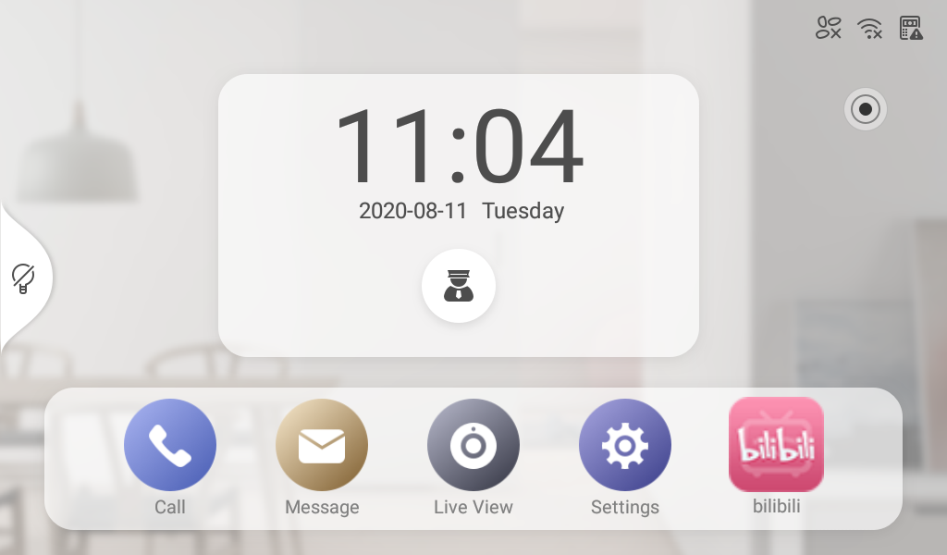

**NOTE：**

1. This version does not support DST function

2. Indoor station Local Hik-Connect will not display the video intercom system or receive any push of the video intercom system.

3. The Android indoor station can only be used with the Android indoor station as Main and Indoor Extension.