**KV Firmware**

**V2.2.53_210907 Release Note**

**(2021-09-07)**

|  |  |
| --- | --- |
| Device Model | DS-KV6103-PE1(B)、DS-KV6113-PE1(B)、DS-KV6113-WPE1(B)、DS-KV8113-WME1(B)、DS-KV8213-WME1(B)、DS-KV8413-WME1(B) |
| Firmware Version | V2.2.53_210907 |
| iVMS-4200 Version | Latest version |
| Hik-Connect APP | Latest version |

**Modify**

1. Fix bugs, enhance products quality and meet customers’ requirements.

**KV Firmware**

**V2.2.52_210817 Release Note**

**(2021-08-17)**

|  |  |
| --- | --- |
| Device Model | DS-KV6103-PE1(B)、DS-KV6113-PE1(B)、DS-KV6113-WPE1(B)、DS-KV8113-WME1(B)、DS-KV8213-WME1(B)、DS-KV8413-WME1(B) |
| Firmware Version | V2.2.52_210817 |
| iVMS-4200 Version | Latest version |
| Hik-Connect APP | Latest version |

**Modify**

1、 HiK-Connect is disabled and Verification code is empty by default.

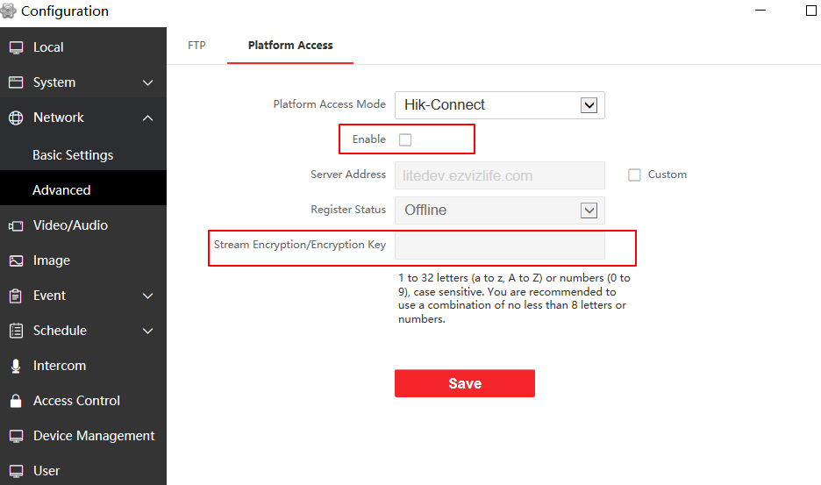

**KV Firmware**

**V2.2.50_210630 Release Note**

**(2021-07-12)**

|  |  |
| --- | --- |
| Device Model | DS-KV6103-PE1(B)、DS-KV6113-PE1(B)、DS-KV6113-WPE1(B)、DS-KV8113-WME1(B)、DS-KV8213-WME1(B)、DS-KV8413-WME1(B) |
| Firmware Version | V2.2.50_210630 |
| iVMS-4200 Version | Latest version |
| Hik-Connect APP | Latest version |

**Modify**

1、 **Since V2.2.50_210630, remote degradation of devices is not supported in all subsequent versions.** When degradation occurs, it will prompt Upgrading failed.

**Notice: Although the device can be degraded by serial port, the device will fail to start and cannot change the version by using serial port again, which means that the device will be completely unusable.**

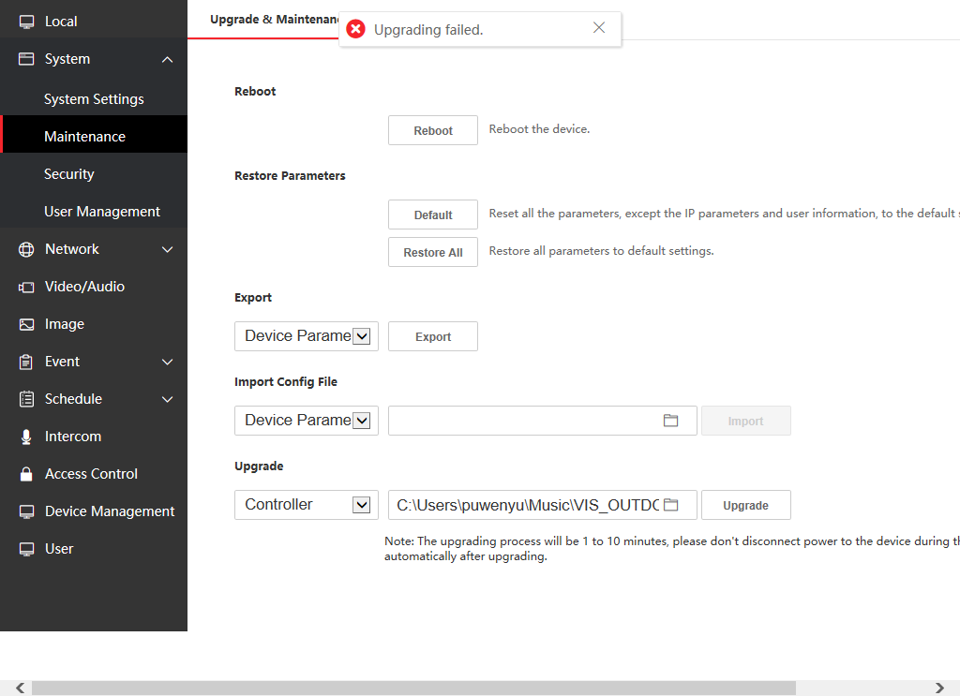

2、Newly support for French voice prompt "calling", "the line is busy" and "the door is open"

3、The method of adding sub door station is changed to the same method as protocol 1.0. (Fill in the Main Door Station IP and Registration Password in the configuration interface of Sub Door Station)

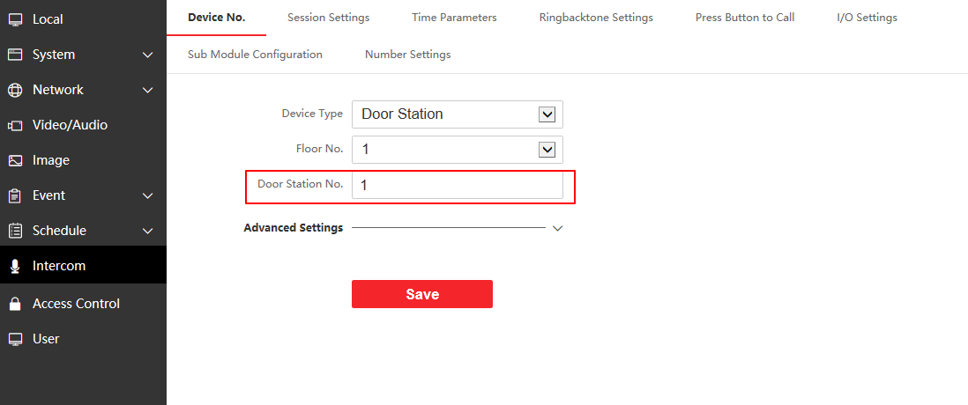

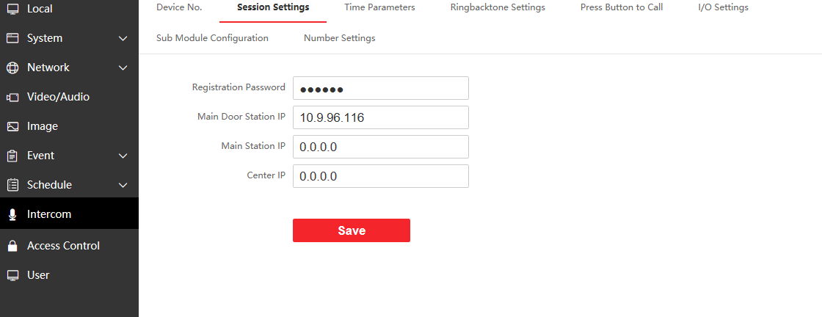

Note: you can refer to the attached file below about how to add a Sub door station.



4、Hik-Connect function is disabled by default.

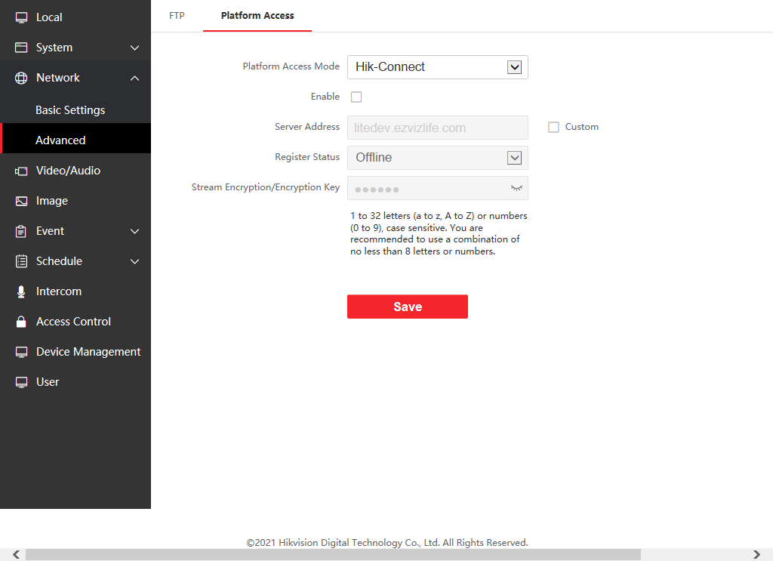

**KV Firmware**

**V2.2.45_210430 Release Note**

**(2021-04-30)**

|  |  |
| --- | --- |
| Device Model | DS-KV6103-PE1(B)、DS-KV6113-PE1(B)、DS-KV6113-WPE1(B)、DS-KV8113-WME1(B)、DS-KV8213-WME1(B)、DS-KV8413-WME1(B) |
| Firmware Version | V2.2.45_210430 |
| iVMS-4200 Version | Latest version |
| Hik-Connect APP | 4.13.1 or above |

**NOTE**

Registration password will correspond to the serial number to prevent other devices from invading the system

**New Function**

1. The changed name of the door station will be displayed on the call interface or live view interface of the indoor station

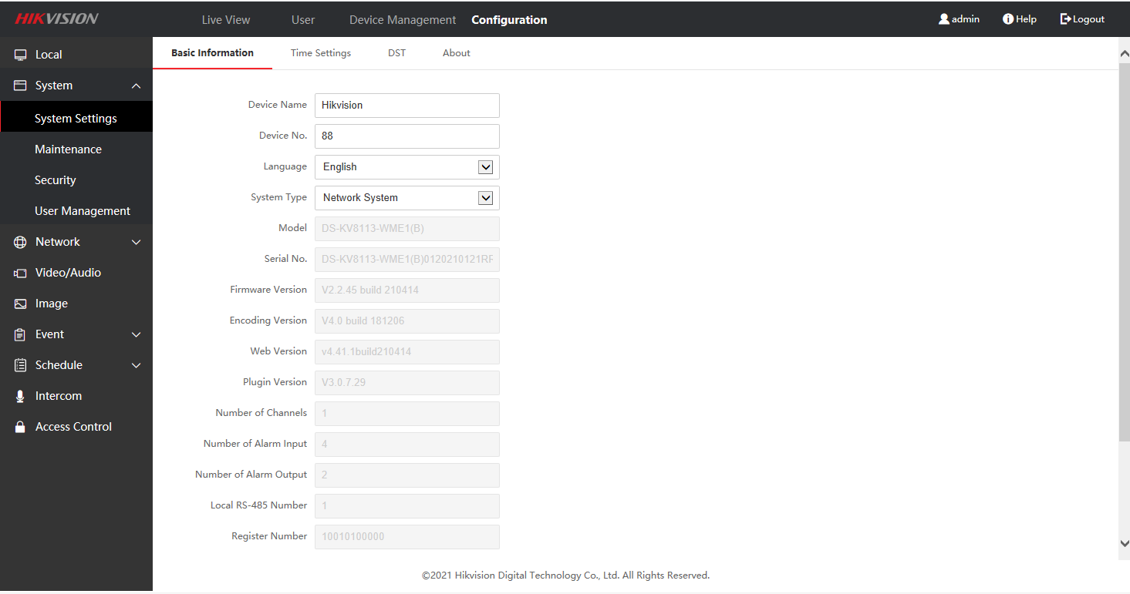

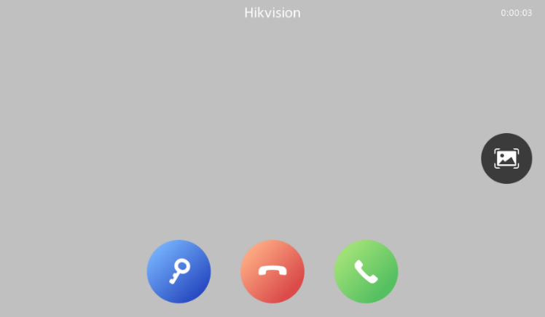

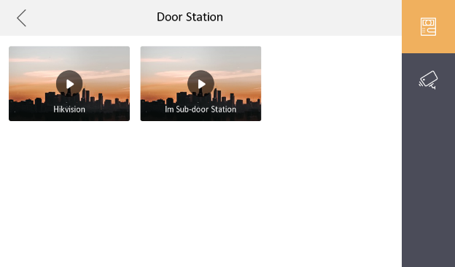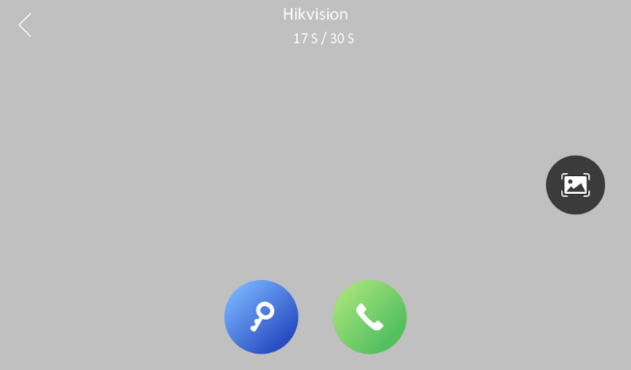

1. Add indoor station or sub-door station to iVMS-4200 or WEB to add default value

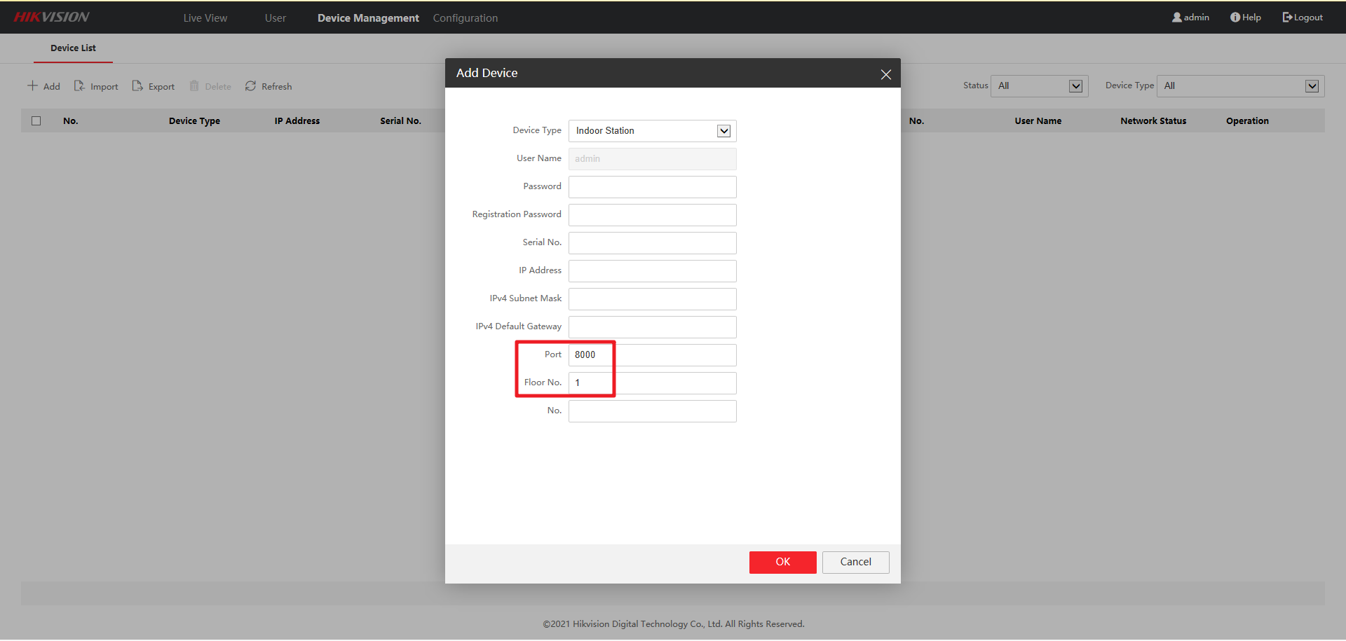

1. If the Registration Password in the door station WEB interface has been configured, it will be displayed in cipher text
2. Video Intercom Server IP (Private SIP server IP) naming changed to Center IP

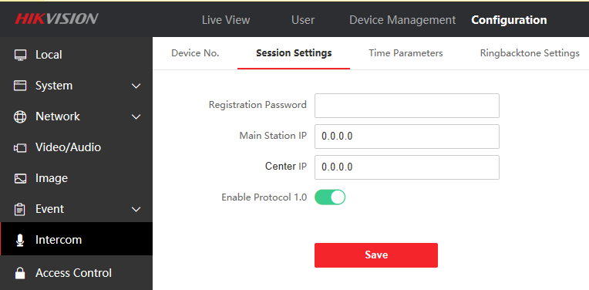

1. The WEB or iVMS-4200 interface community number, building number, and unit number of the door station will be stored in the advanced settings column instead of being displayed directly

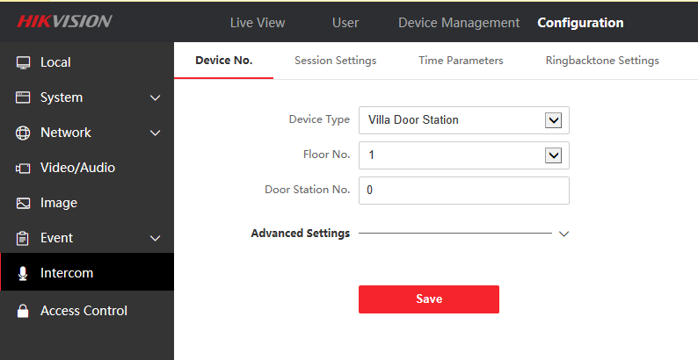

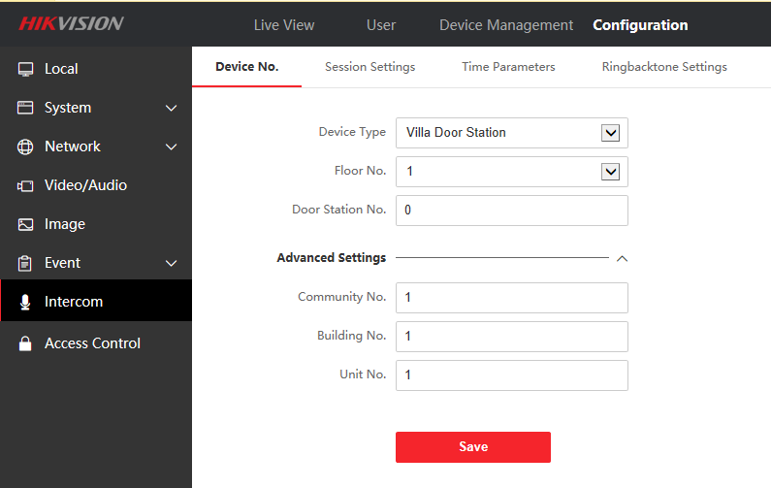

1. Support doorphone mode, when this function is enabled, the door station will no longer actively synchronize the information of the indoor station

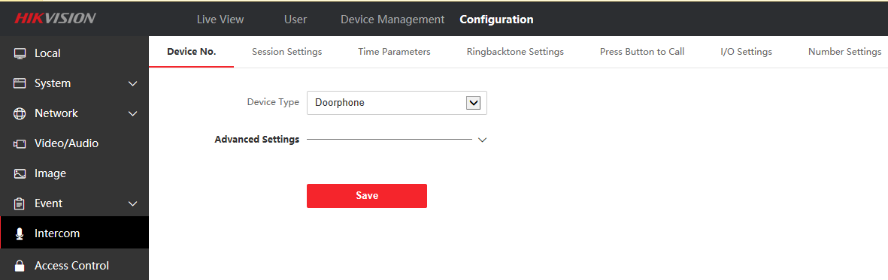

1. Both Lock 1 and Lock 2 support custom names

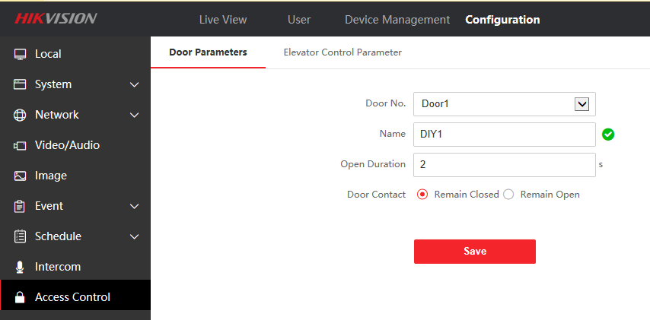

**Modify**

1. Change the Regist Password to the Registration Password in the export excel

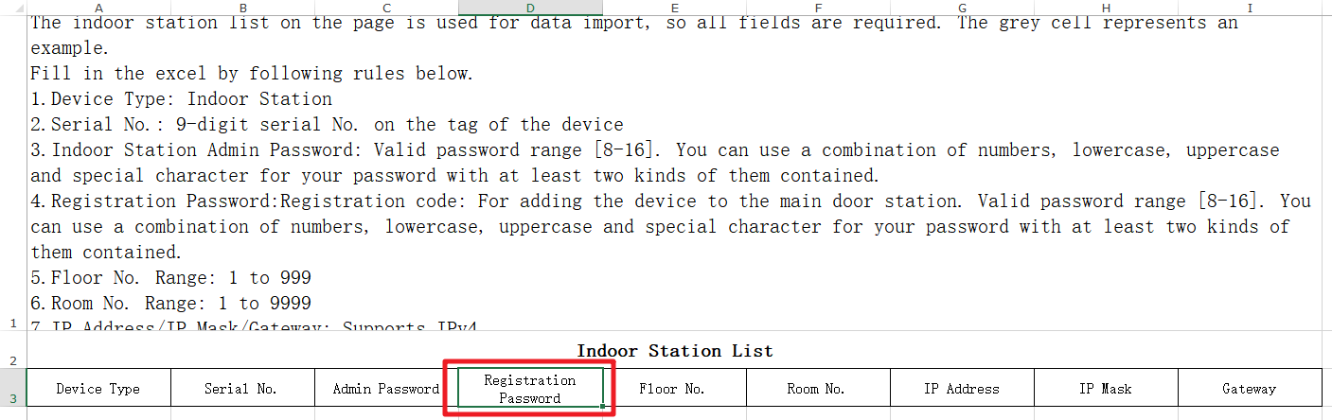

1. Regardless of lock 1 or lock 2, when the security module is connected, the security module is first enabled to control the lock
2. The synchronization function is enabled by default. Enabling this function means that the door station will periodically synchronize the parameters to all indoor stations or sub door stations connected to this door station (Synchronized content includes network parameters, community number, building number, unit number)

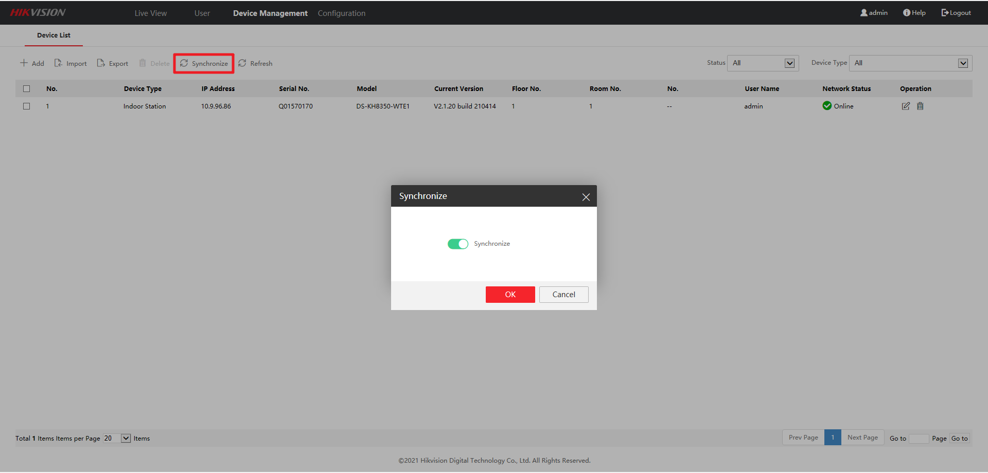

**KV(B) Firmware**

**V2.2.13_201222 Release Note**

**(2021-01-05)**

|  |  |
| --- | --- |
| Device Model | DS-KV6103-PE1(B)、DS-KV6113-PE1(B)、DS-KV6113-WPE1(B)、DS-KV8113-WME1(B)、DS-KV8213-WME1(B)、DS-KV8413-WME1(B) |
| Firmware Version | Villa Door Station (B) : V2.2.13_201222 |
| iVMS-4200 Version | 3.4.0.10 Build201214 |
| Hik-Connect APP | 4..11.0.927220 |

**New Function**

1. New refresh button is used to refresh the status of added devices

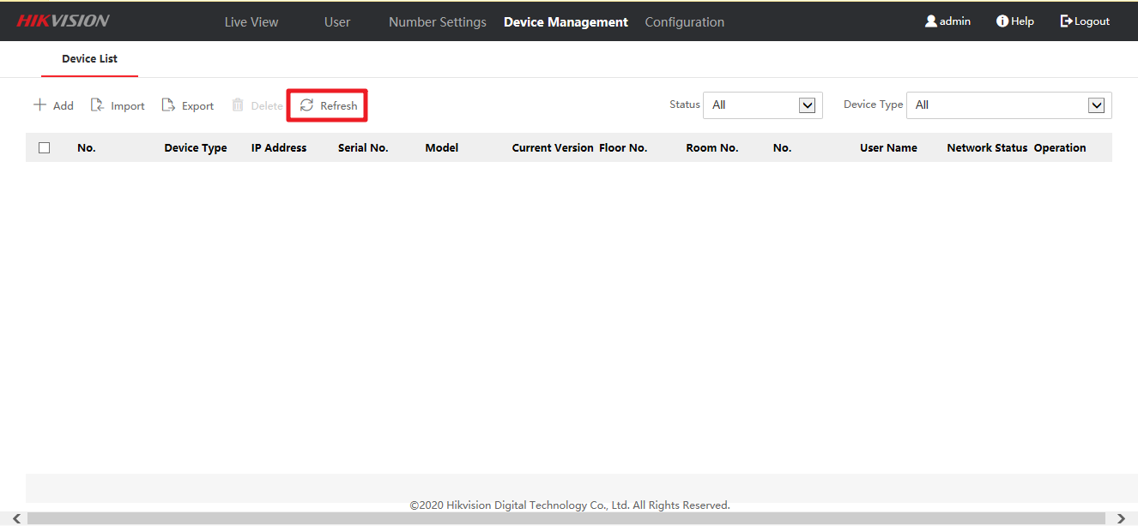

2. Added ‘All’ option, indoor station and sub-door station will be displayed together.

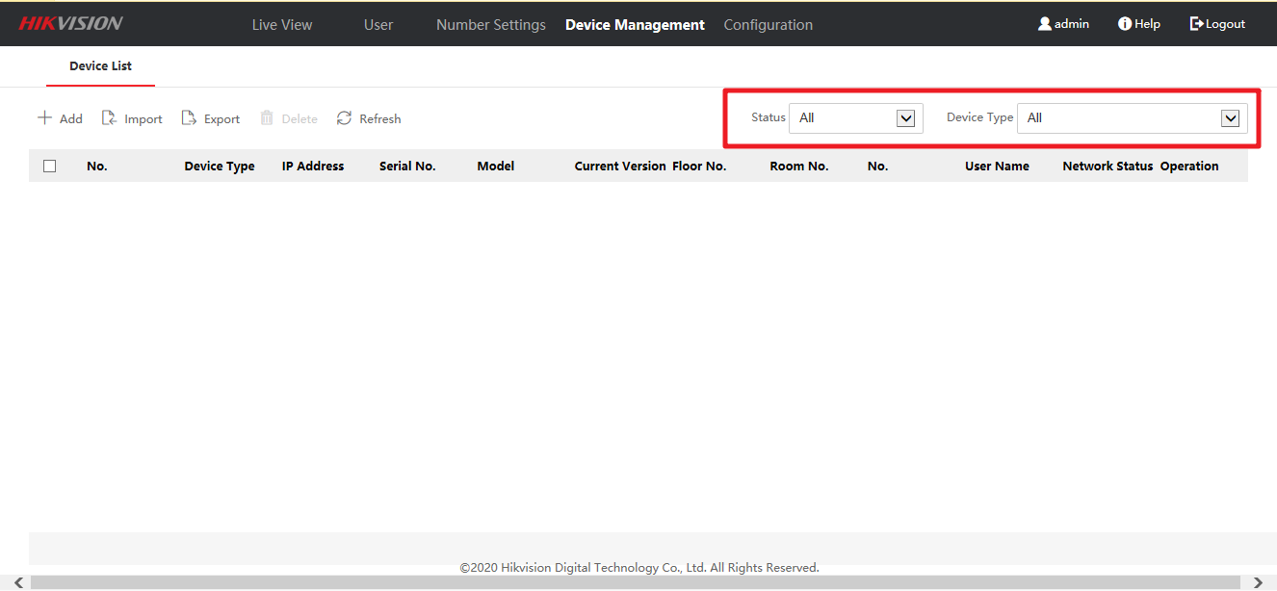

**Modify**

1. Modify the language display of some errors

**Villa Door Station Firmware V2.2.10_201126**

**(2020-12-08)**

|  |  |
| --- | --- |
| Device Model | DS-KV6103-PE1(B)、DS-KV6113-PE1(B)、DS-KV6113-WPE1(B)、DS-KV8113-WME1(B)、DS-KV8213-WME1(B)、DS-KV8413-WME1(B) |
| Firmware Version | Villa Door Station: V2.2.10_build201126 |
| iVMS-4200 Version | 3.4.0.9 Build20201119 |
| Hik-Connect APP | V4.11.0.1204 |

**New Function**

1. Modify the default unlocking time to 2 s, and supporting unlocking time can be configured with 1-255 s

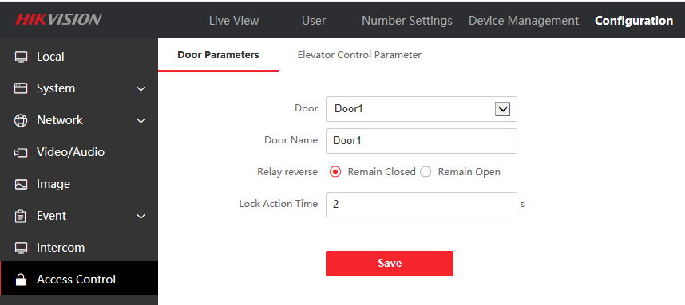

2. When villa door station adding Wi-Fi, support special symbols as password

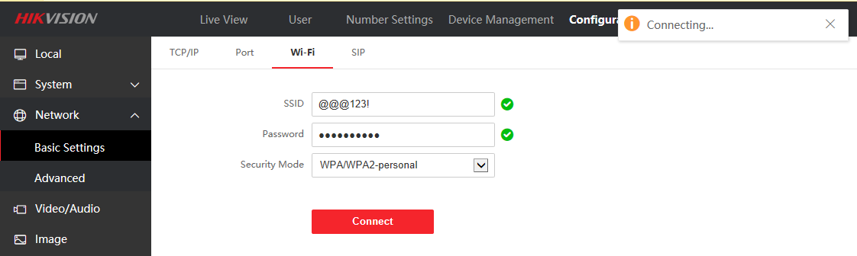

**Fix**

1. Fix the bug that the villa door station cannot communicate with Hik-Connect when connecting the doorbell and indoor station via Wi-Fi

2. Fix the bug of Hik-Connect receiving switch automatically turning off after villa door station power off

3. Fix the bug that there is no sound when calling the indoor station when the villa door station is connected via Wi-Fi

4. Fix the bug that villa door station cannot communicate with Hik-Connect

5. Fix the bug that the villa door station cannot be connected to Hik-Connect after power off and restart when connecting via Wi-Fi

**Modular & Villa Door Station Firmware V2.2.3_200805 Release Note**

**(2020-08-12)**

|  |  |
| --- | --- |
| Device Model | DS-KD8003-IME1、DS-KD8003-IME2 、DS-KV6103-PE1(B)、DS-KV6113-PE1(B)、DS-KV6113-WPE1(B)、DS-KV8113-WME1(B)、DS-KV8213-WME1(B)、DS-KV8413-WME1(B) |
| Firmware Version | Villa Door Station: V2.2.3_Build200805  Modular Door Station: V2.2.3_Build200805 |
| iVMS-4200 Version | 3.2.0.10 Build200727 |
| Hik-Connect APP | 4.6.2.0724 |

**Note:**

1. When the old version of the door station is upgraded to the new version of the firmware, the device will be **Restore Automatically**. This is because new firmware’s data structure is not compatible with old firmware. Please make a backup when you upgrade the device

2. When configuring the video intercom system, the registration password is the password that must be configured for the activated device. When the door station adds an activated sub-door station, the registration password of the sub-door station must be known. The inactive sub-door station can be directly assigned by door station. 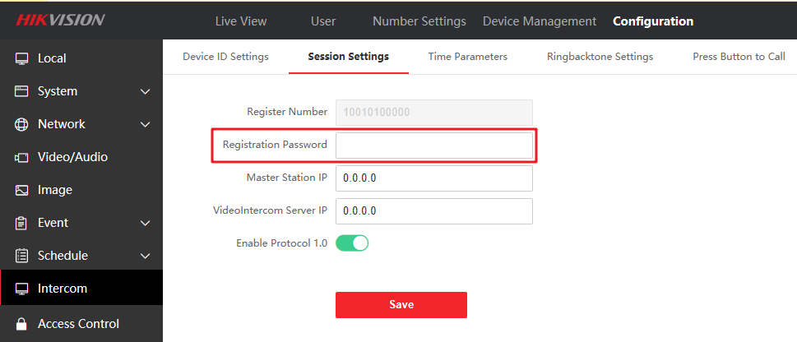

3. It is forbidden to upgrade the villa door station without (B) model, it will cause the device voice issue.

**New Function**

1. Modular & Villa Door Station support 19 languages: English, French, Portuguese (Brazil), Spanish, Russian, German, Italian, Polish, Arabic, Turkish, Vietnamese, Hungarian, Dutch, Romanian, Czech, Bulgarian, Ukrainian, Croatian, Serbian

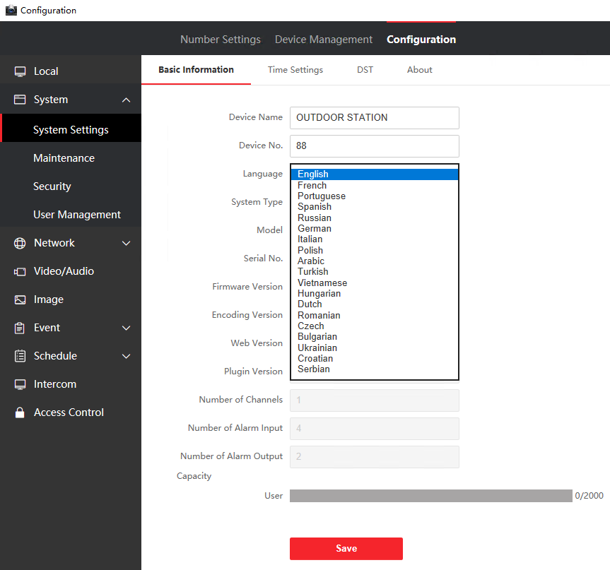

2. Support 16 sub-door station

3. The public password rules have been updated

a. Public passwords: up to 16 with 4 to 6 digits each, only supporting numbers

b. Unlock method "#public password#" (Only Modular Door Station with Keypad module support this function)

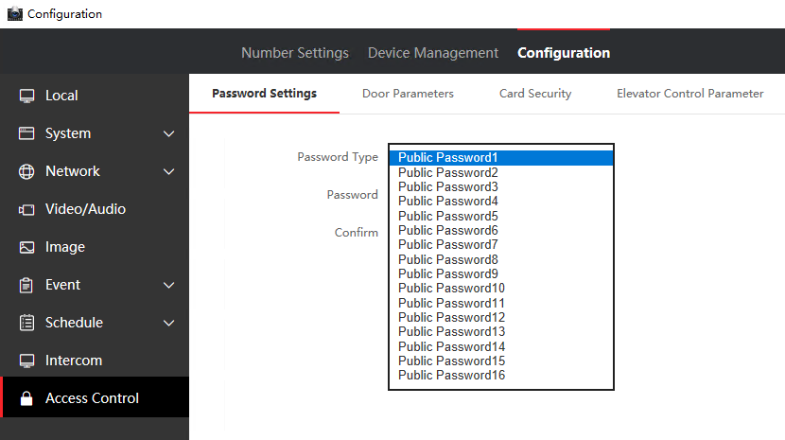

4. Support new style WEB (Modular Door Station does not support WEB, it can be opened only through iVMS-4200)

a. Browser type: 1. Support IE, Chrome 2. Not support mobile browser

b. Plug-ins:

The browser only supports 32-bit version

IE browser: IE11 and above

Google Chrome (v31~v44)

c. No plug-in:

Google v45 and above

Firefox v52 and above

5. The door station supports screen cutting on the WEB

a. After cutting, the calling indoor station only displays the specified screen, and the screen supports restoration;

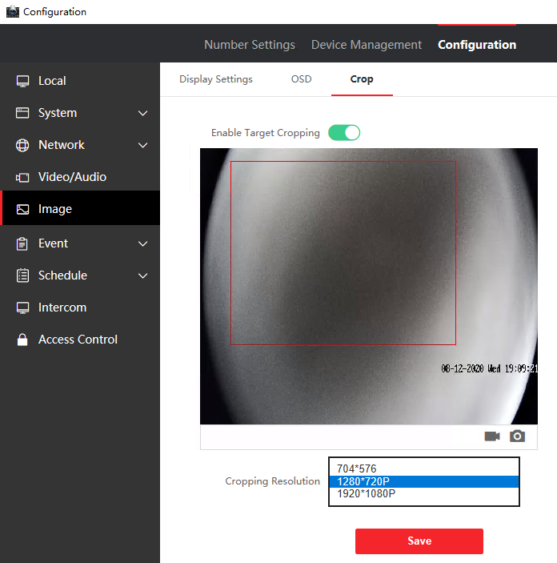

6. Door Station supports ONVIF Profile S protocol

a. Onvif device service related functions: http://device IP address/onvif/device_service

b. Onvif streaming media related functions: http://device IP address/onvif/Media

c. Onvif image parameter related functions: http://device IP address/onvif/Imaging

7. DS-KV6103-PE1(B), DS-KV6113-PE1(B), DS-KV6113-WPE1(B), DS-KV8113-WME1(B) support direct addition into Hik-Connect.

a. The user can configure the device's summer time switch, school time, and global time zone selection through Hik-Connect

b. The user can adjust the input volume, output volume and intercom volume of the device through Hik-Connect

c. The users can choose to turn on or off the upload of alarm information through Hik-Connect

8 Convenient configuration of multi-unit scenarios;

a. Support the remote export/import of files (Excel) from the WEB, and automatically activate the indoor station through the door station and configure the basic information of the indoor station. For the basic information field of the indoor station, please refer to the [channelConfig] table; 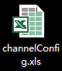

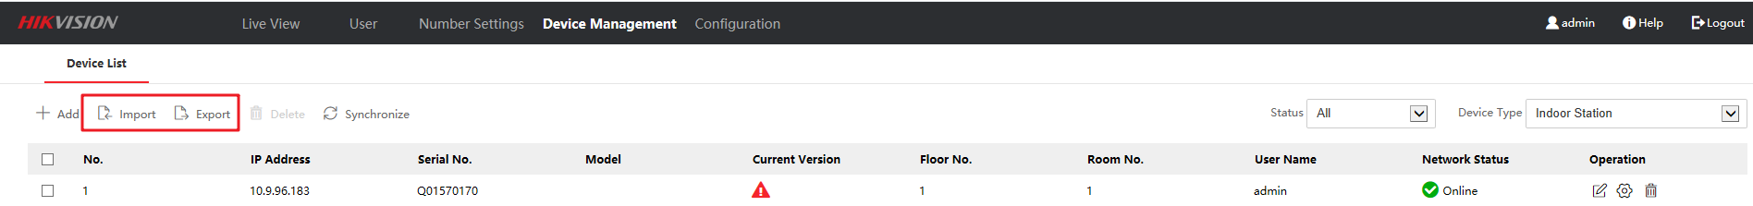

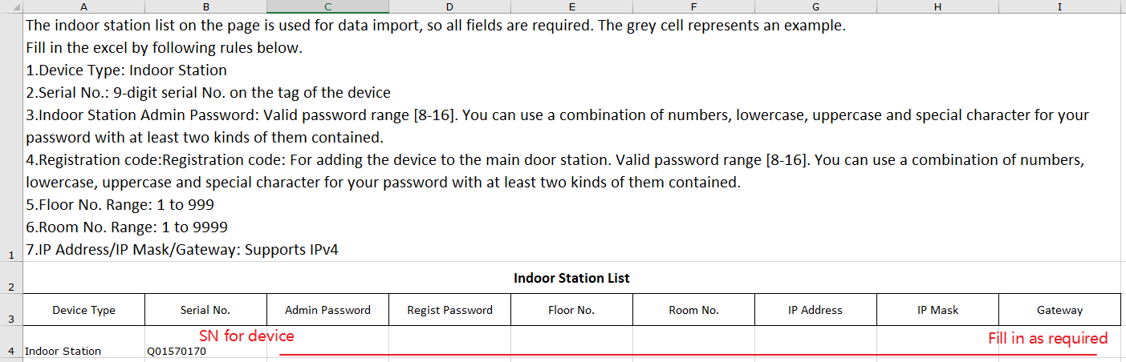

b. Support remote management of indoor station on the WEB, and support separate addition and deletion of indoor station;

c. Support remote modification of the user password/network information/number of the indoor station on the WEB. The registered indoor station information will be overwritten after modification.

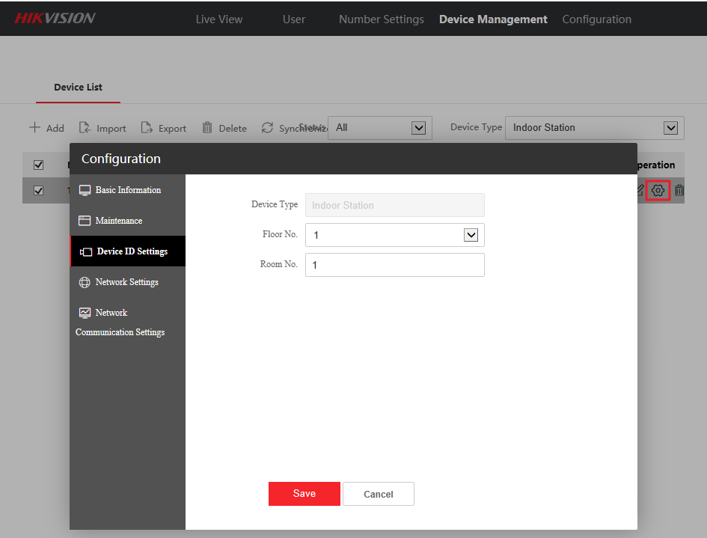

9. Support Call Schedule configuration;

a. Call weekly plan, holiday plan support configuration: 1. Time period 2. Button call object of each time period: indoor station or iVMS-4200 (Master Station)

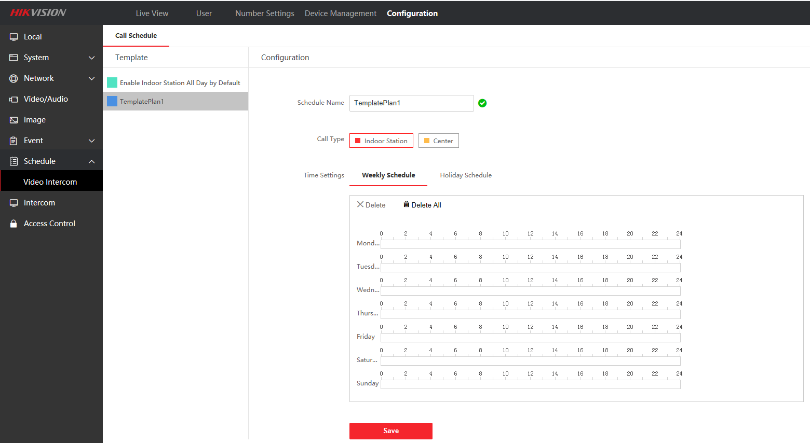

b. Support 1 holiday group and 16 holiday plans

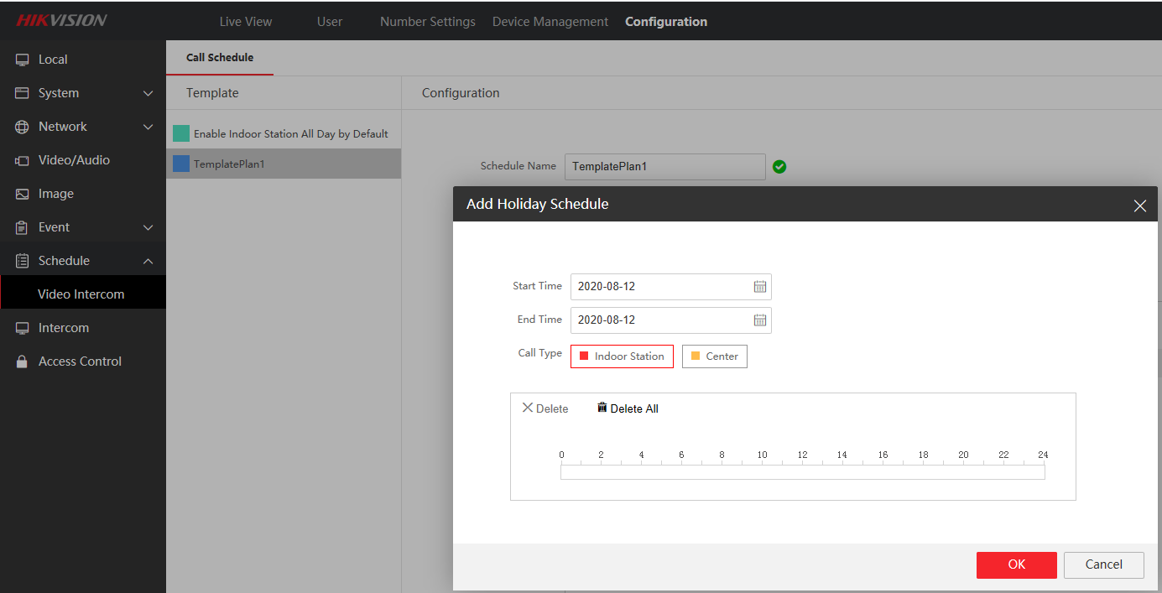

c. The call logic priority of the Call Schedule is the highest;

10. The door station supports ring back tone

a. File format: only supports WAV, no more than 600KB

b. Quantity: Only support one ring back tone import, if it has been already uploaded, the newly uploaded ring back tone will overwrite the old ringtone

c. Channel: support mono

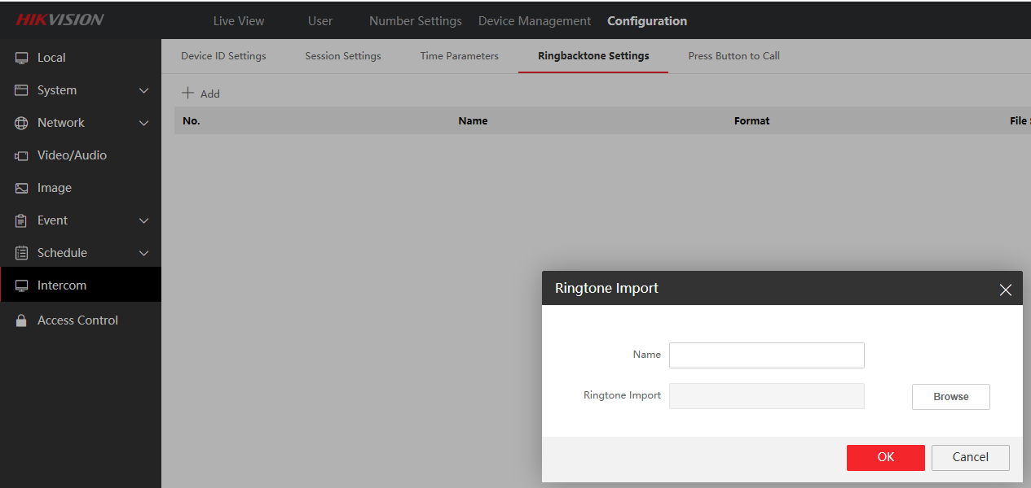

11. The Outer Door Station call rule changed (Only Modular Door Station support this function)

a. Three combinations of calling the Period 1, Building 2, Unit 3 and Room 1:

1#2#3#0001#

2#3#0001#

2#0001#

12. External card reader controls lock 1 or lock 2 respectively

a. The door station can open different locks through the external card reader (or card reader module KD-M, KD-E) different DIP Switch dial codes. When the dial code is not 2, open lock 1, and when the dial code is 2, open lock 2.

b. The local card reader of the door station only opens the lock 1 by default

**Function optimization**

1. The door station supports key hang up; because the user will use the device as a doorbell and keep pressing, so the default call can be hang up after 5s after a successful call;

After swiping an invalid card or entering an invalid password to try to open the door, the event record is uploaded to 4200;

2. The default position of the OSD is adjusted to the lower right corner. When performing intercom with the master station and indoor station, the default OSD will not block the existing key information;

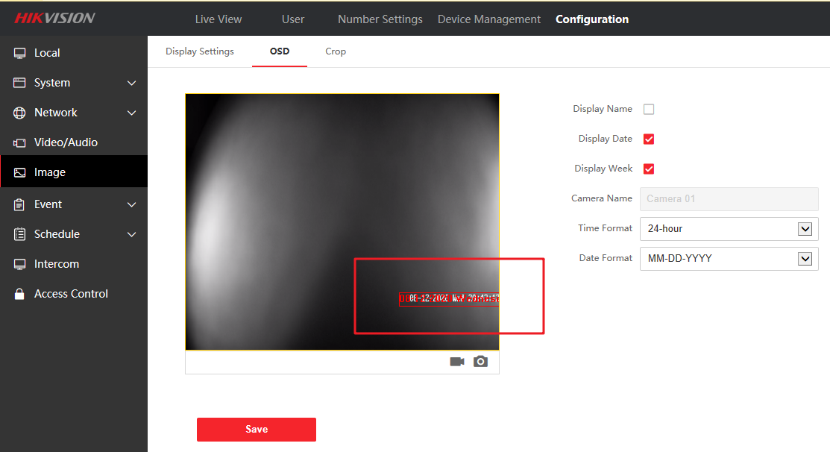

3. The user can remotely open the device SSH function through the WEB;

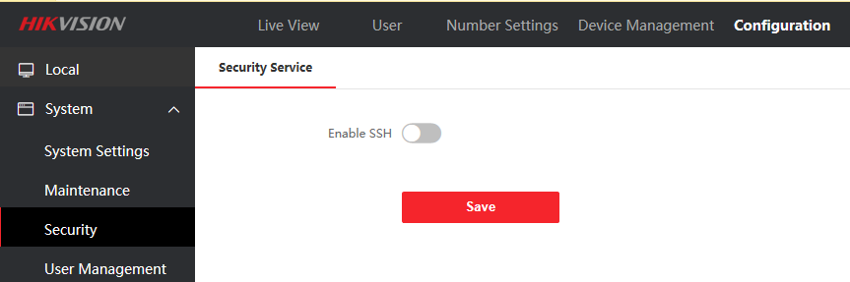

4. Support to actively unbind Hik-Connect account through WEB configuration

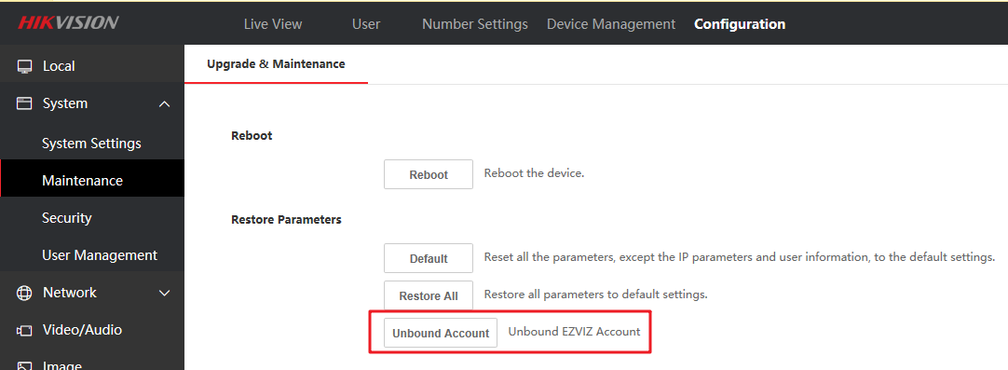

5. Lock 2 does not need to be configured, only open or close. If you want to use a security module, enable lock 2, and the device will automatically recognize it after the security module is connected. After confirming that the security module is correctly connected, lock 2 is actually the lock on the security module.

