**KD9203 Firmware**

**V2.2.37_210812 Release Note**

**(2021-08-12)**

|  |  |
| --- | --- |
| Device Model | DS-KD9203-E6、 DS-KD9203-FE6、 DS-KD9203-TE6、 DS-KD9203-FTE6 |
| Firmware Version | V2.2.37_210812 |
| iVMS-4200 Version | Late version |
| Hik-Connect APP | 4.13.1 or above |

**Modify**

1、 HiK-Connect is disabled and Verification code is empty by default.

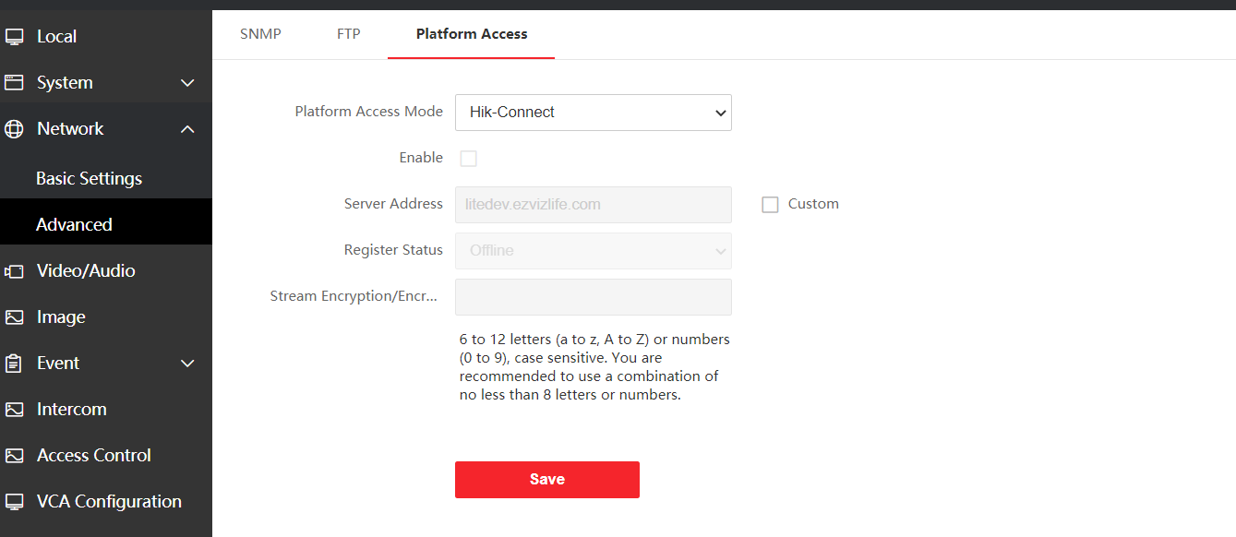

**Face Recognize Door Station Firmware V2.0.0_210120 Release Note**

**(2021-02-01)**

|  |  |
| --- | --- |
| Device Model | DS-KD9203-E6、DS-KD9203-FE6  DS-KD9203-TE6、DS-KD9203-FTE6 |
| Firmware Version | Value Indoor Station : V2.0.0_210120 |
| iVMS-4200 Version | 3..4.0.10 Build201214 |

**New Function**

1. Support address book function

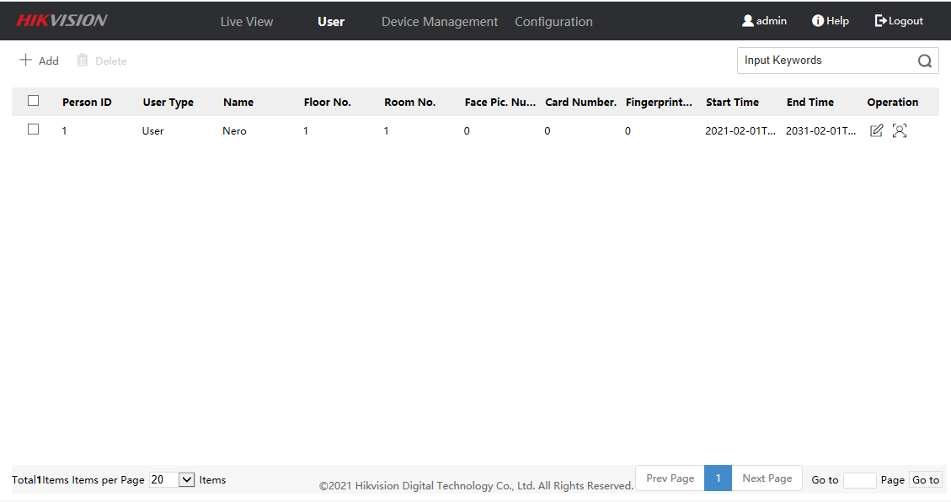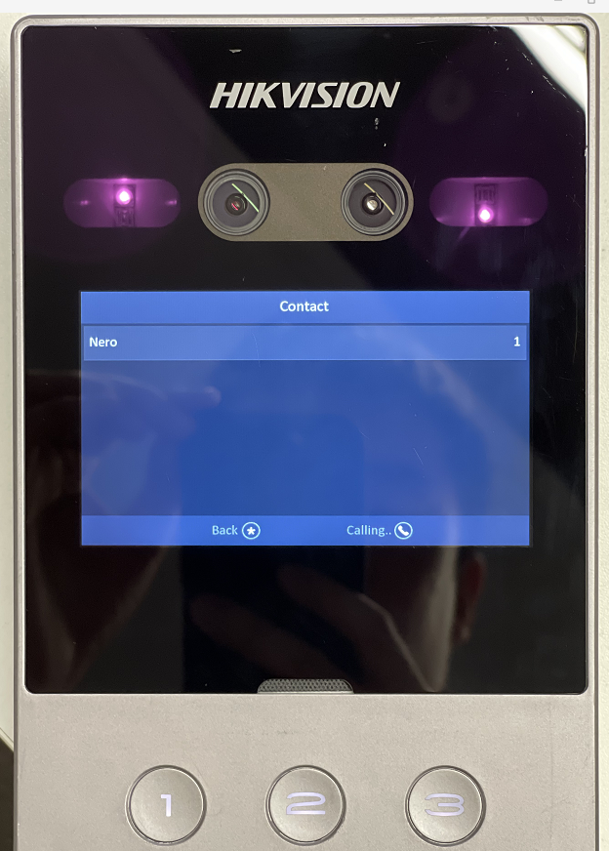

2. Support DST function

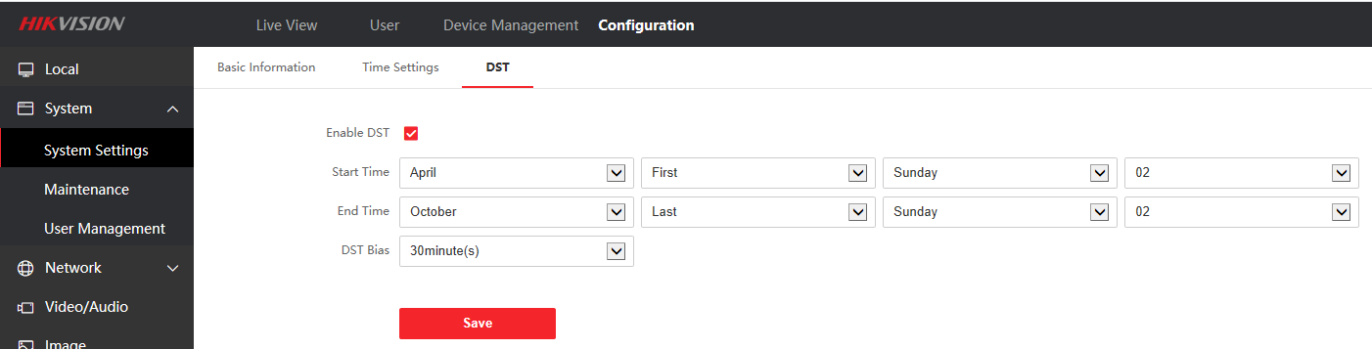

3. Multi-language support increased to 8 countries: English, Traditional Chinese, Portuguese (Brazil), Russian, Spanish, Turkish, Arabic and Vietnamese

**Fix Bugs**

1. Fix the problem that iVMS-4200 cannot get the card number

