**Modular Firmware**

**V2.2.50_210728 Release Note**

**(2021-07-15)**

|  |  |
| --- | --- |
| Device Model | DS-KD8003-IME1、DS-KD8003-IME2 |
| Firmware Version | Modular Door Station: V2.2.50_210728 |
| iVMS-4200 Version | Latest version |
| Hik-Connect APP | Latest version |

**Modify**

1、 **Since V2.2.50_210728, remote degradation of devices is not supported in all subsequent versions.** When degradation occurs, it will prompt Upgrading failed.

**Notice: Although the device can be degraded by serial port, the device will fail to start and cannot change the version by using serial port again, which means that the device will be completely unusable.**

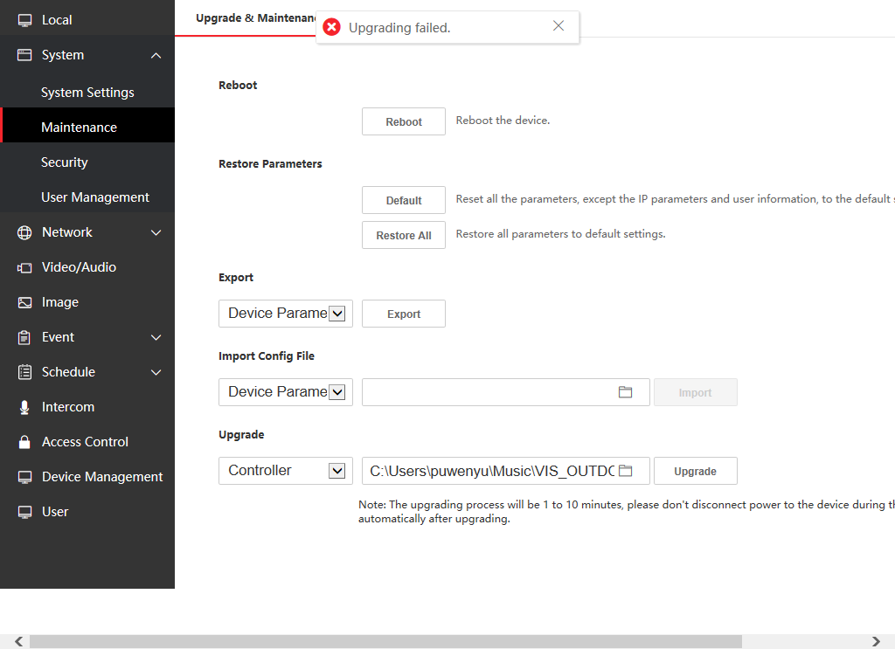

2、Newly support for French voice prompt "calling", "the line is busy" and "the door is open"

3、The method of adding sub door station is changed to the same method as protocol 1.0. (Fill in the Main Door Station IP and Registration Password in the configuration interface of Sub Door Station)

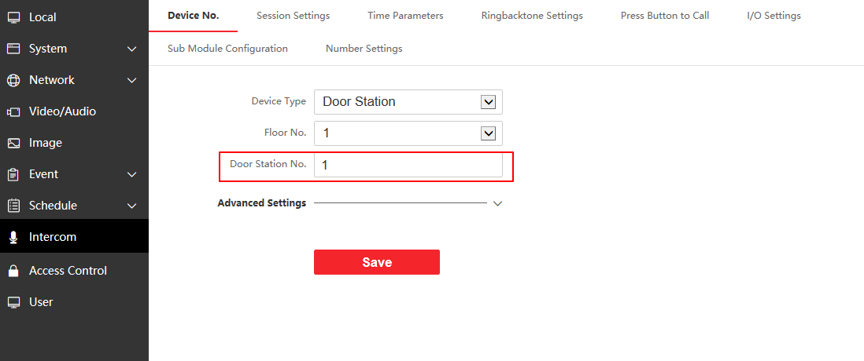

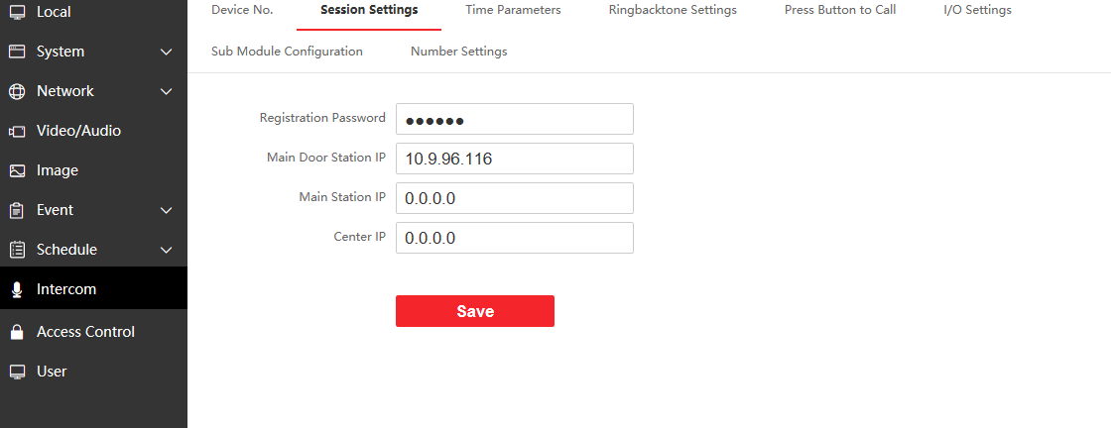

Note: you can refer to the attached file below about how to add a Sub door station.



**Modular Firmware**

**V2.2.13_210129 Release Note**

**(2021-02-07)**

|  |  |
| --- | --- |
| Device Model | DS-KD8003-IME1、DS-KD8003-IME2 |
| Firmware Version | Modular Door Station: V2.2.13_210129 |
| iVMS-4200 Version | Latest version |
| Hik-Connect APP | Latest version |

**Modify**

1. Optimize RS485 communication efficiency with sub-module

**Modular Firmware**

**V2.2.13_201222 Release Note**

**(2021-01-05)**

|  |  |
| --- | --- |
| Device Model | DS-KD8003-IME1、DS-KD8003-IME2 |
| Firmware Version | Modular Door Station: V2.2.13_201222 |
| iVMS-4200 Version | 3..5.x.x Build21xxxx |
| Hik-Connect APP | 4..11.0.927220 |

**New Function**

1. New refresh button is used to refresh the status of added devices

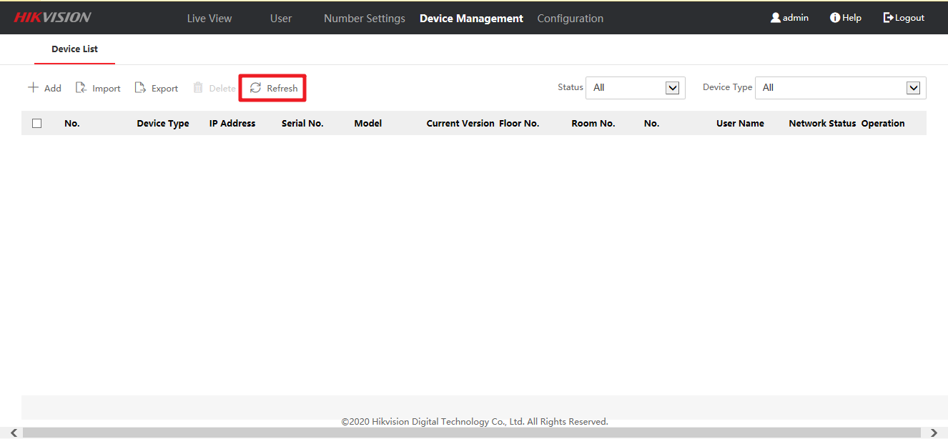

2. Added ‘All’ option, indoor station and sub-door station will be displayed together.

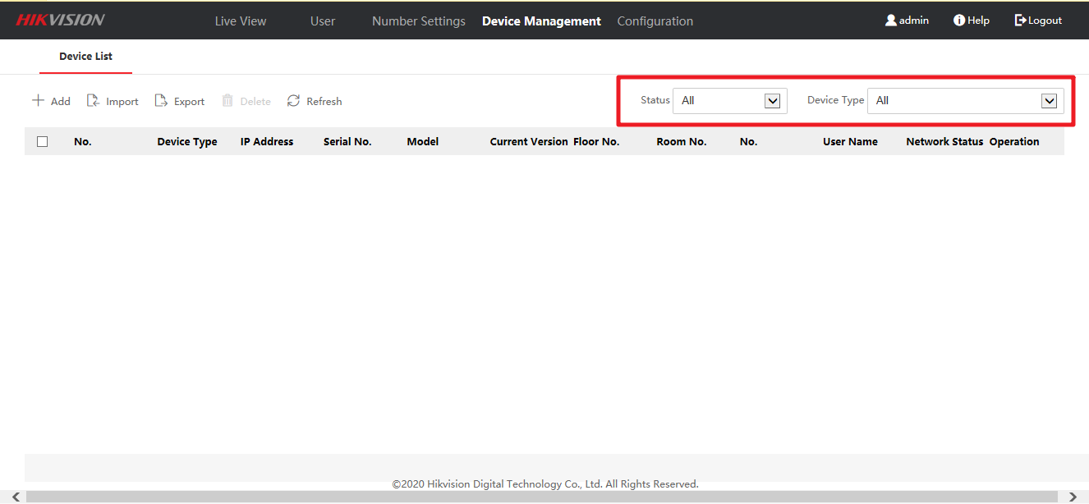

**Modify**

1. Modify the language display of some errors