**V2.2.32_210812 Release Note**

**(2021-08-12)**

|  |  |
| --- | --- |
| Device Model | DS-KD3003-E6、 DS-KD8023-E6、 DS-KD8103-E6 |
| Firmware Version | V2.2.32_210812 |
| iVMS-4200 Version | Late version |
| Hik-Connect APP | 4.13.1 or above |

**Modify**

1、 HiK-Connect is disabled and Verification code is empty by default.

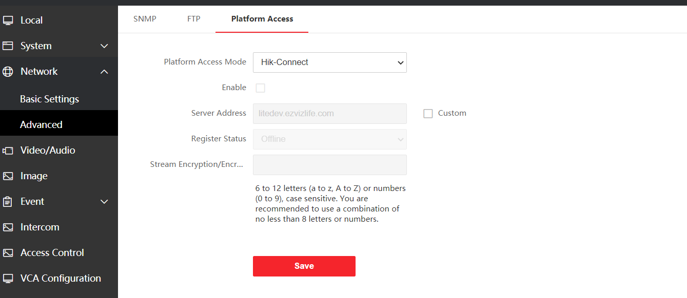

**FIX**

1、The device does not support standard SIP and the standard SIP configuration interface has been cancelled since this version