**DS-KB8113-IME1 Vandal-Resistant Doorbell**

**V2.2.1 Build 200526 Release Note**

**(2020-06-09)**

|  |  |
| --- | --- |
| Device Model | DS-KB8113-WTE1 |
| Firmware Version | Indoor Station: V2.1.8_200515 |
| iVMS-4200 Version | V3.3.1.4 build20200806 |
| Hik-Connect APP | V4.6.1 |

**Web interface display**

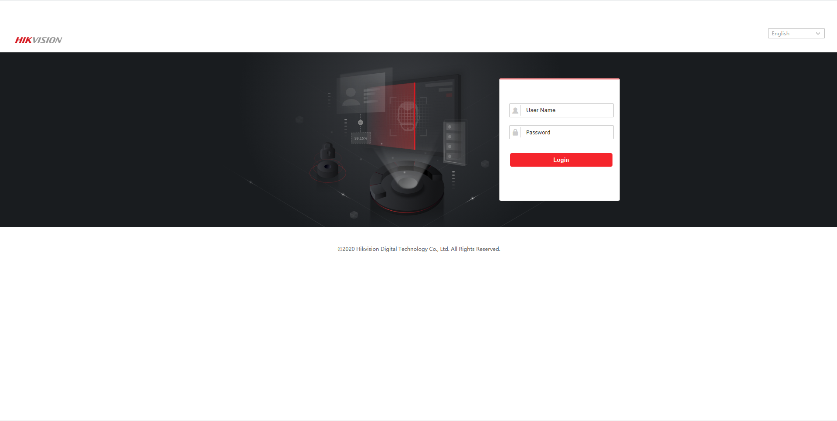

**Function Description**

1. Support RTSP port configuration

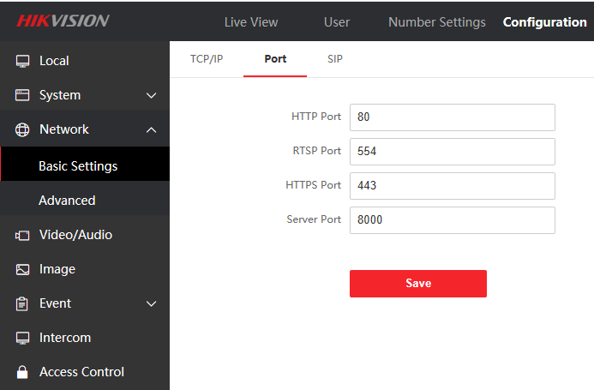

2. Support SIP call timeout time configuration

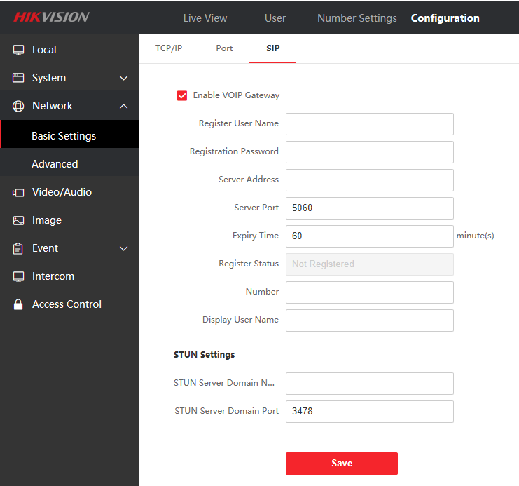

3. The standard SIP account length is extended to 32 bits

4. The relay can be configured as a mechanical doorbell or electric lock

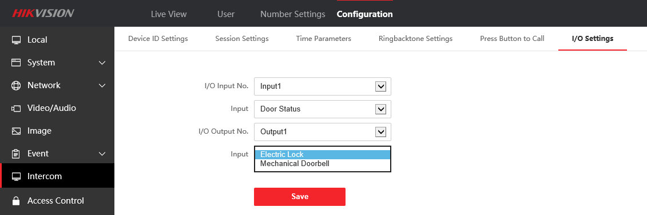

5. Support Hik-Connect

(1) Hik-Connect supports call record query

(2) Support synchronized time

(3) Support volume adjustment

(4) Support Hik-Connect remote unlocking

(5) Motion detection area and sensitivity configuration

6. Support multi-language in 19 countries

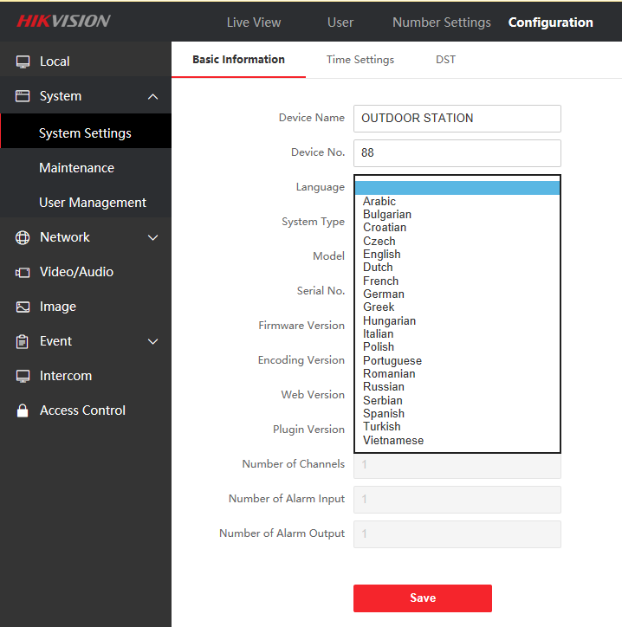

8. Device can automatically activate/configure the indoor station (when the indoor station is inactive)