**Second Generation Video Intercom Firmware Build 200528 Release Notes (2020-06-01)**

|  |  |  |
| --- | --- | --- |
| **Device Model:**  DS-KH8350 Series  DS-KH6320 Series  DS-KH8520 Series  DS-KD8003 Series | Firmware Version | Indoor Station: V2.1.2build200528  Door Station: V2.0.8build200528  Sub-module: v1.0.0_build200518  Display module: v1.0.1_build200518 |
| iVMS4200 | V3.2.1.6 |

**Reason of Upgrade**

Improve product functionality.

**New Features**

1. “Do Not Disturb Device” is set to “indoor station” by default. This way if DND function is enabled on this device it will be valid only for this device and not the other indoor extensions.

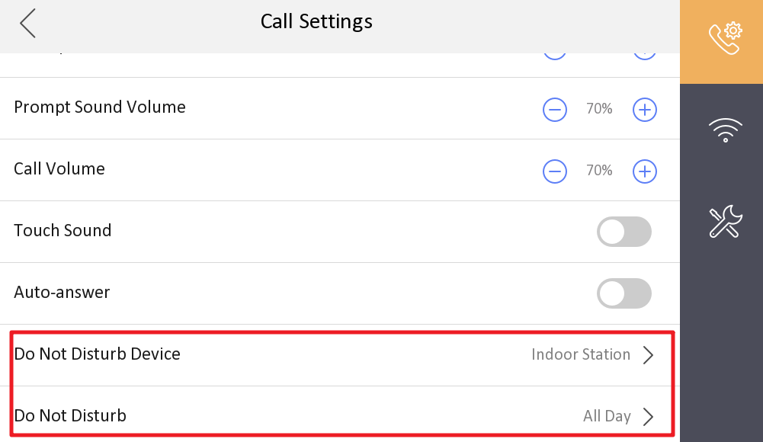

1. Main door station can support up to 16 sub-door station;
2. Improved the image quality of infrared light at night;
3. Fix the Bug that the door station will repeat the audio after speaking with indoor station or Hik-connect.
4. The calling format for “outer door station” mode changed to just “building No. + Room No.”. In button configuration now it is possible to input building number and the room number. Dialing apartment 1 in building one from the keypad and display requires to input **1#1#** (building number # room No #). Display and others modules firmware needs to be upgraded.

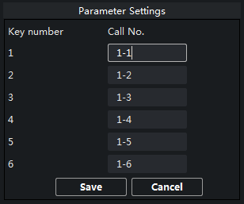 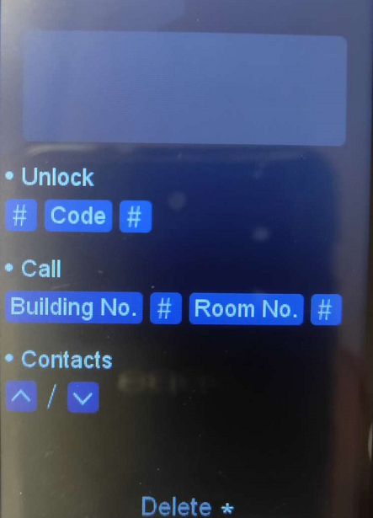

1. Fixed some translation mistakes.

**Customer Impact and Recommended Action**

This new firmware upgrade is to improve product performance, and will take effect automatically after upgrading from previous versions. We’d like to inform you the above changes. Also, we are sorry for any possible inconvenience of use-habit changes caused by this action.

For questions or concerns, please contact our local technical support team.

Note:

* Hikvision has all rights to alter, modify and cancel this notice.
* Hikvision doesn’t give any guarantee for old models’ stock.
* Hikvision is not liable for any typing or printing errors.
* For special model’s change details, please contact our local technical support team.

Hikvision Digital Technology CO., Ltd.

No. 555 Qianmo Road, Binjiang District, Hangzhou 310052, China

Tel: +86-571-8807-5998

FAX: +86-571-8993-5635

Email: support@hikvision.com