**Second Generation Video Intercom Firmware Build1910 Release Notes**

**(2019-10-28)**

|  |  |  |
| --- | --- | --- |
| **Device Model:**  DS-KH8350 Series  DS-KH6320 Series  DS-KH8520 Series  DS-KD8003 Series | Firmware Version | Indoor Station: V2.1.2build1919025  Door Station: V2.0.8build191023  Sub-module: v1.0.0_build191009  Display module: v1.0.1_build190814 |
| SDK Version | HCNetSDK V6.1.0.45_build201909 |
| iVMS4200 | 3.1.0.5_build191011 |

**New Features**

1. Indoor station supports to add IPC via ONVIF protocol.

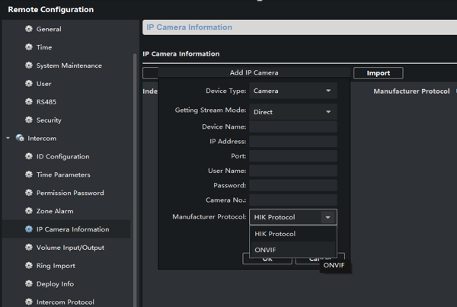

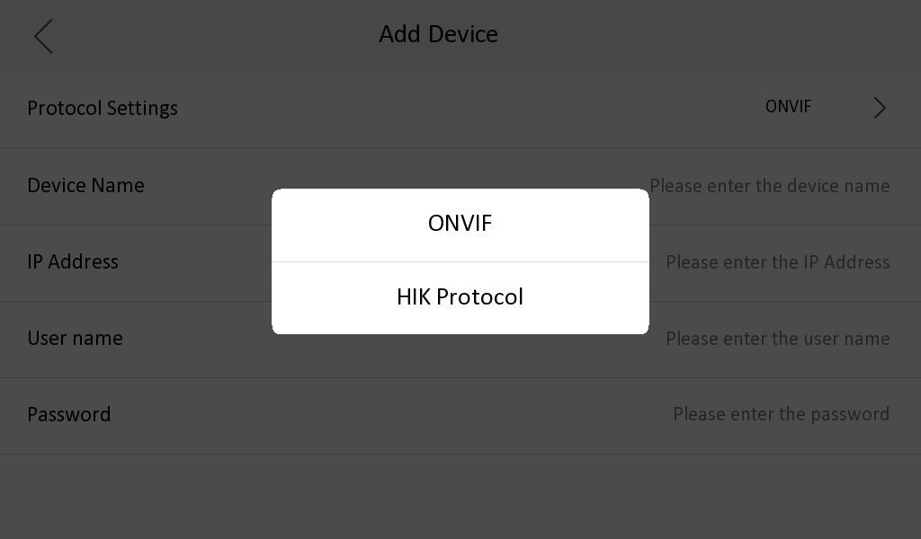

1. Door station supports Outer Door Station mode;

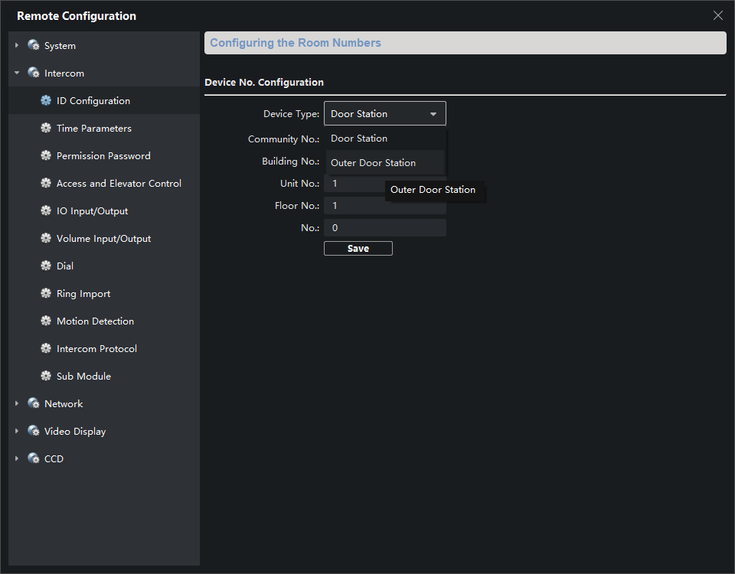

1. Door station supports to import one ringtone;

Format requirement is same as indoor station: wav format; less than 300K；Sample rate: 8KHz single track, 128Kbps.

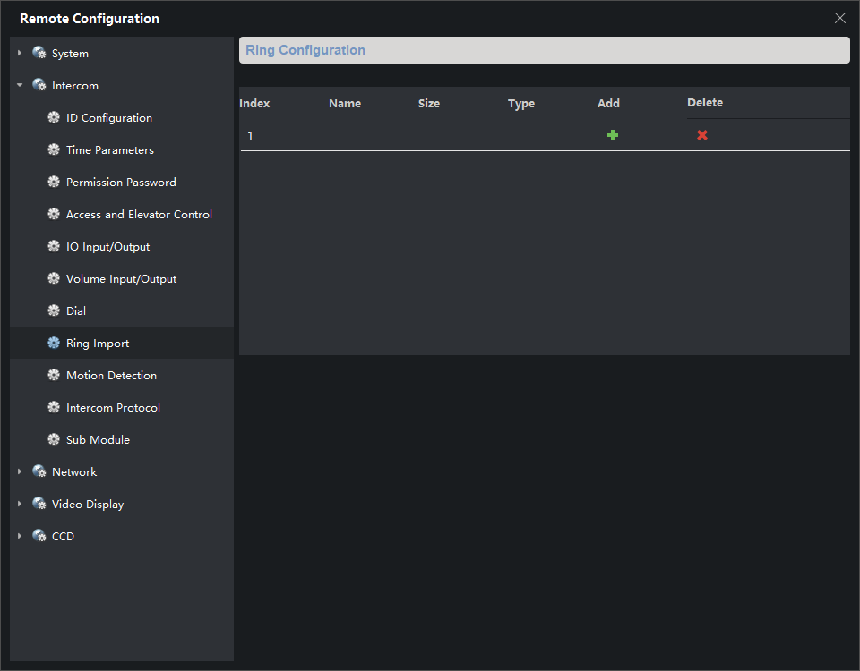

1. Door station can connect Hikvision’s card reader via RS485. External card reader supports swiping card and password unlocking

Card reader models: DS-1101M/K, DS-1102M/K, DS-1103M/K, DS-1104M/K, DS-1107M/K and DS-1108 M/K;

1. Door station supports security module. After connect security module, you need choose door 2 output as SecurityModule, and the second relay for door station itself will be disabled. Currently door station only support to connect security module as the second door;

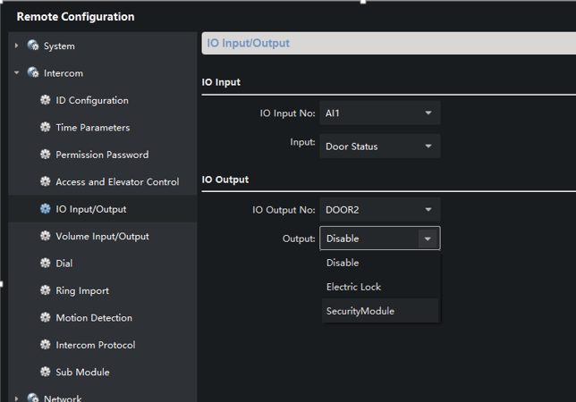

1. Cable SAP code ( for connecting card reader or security module):

101512130 RS485, PHS4 to 2OPEN, 150mm, yellow/orange

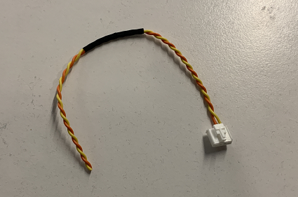

1. OSD supports name, location and time format configuration;

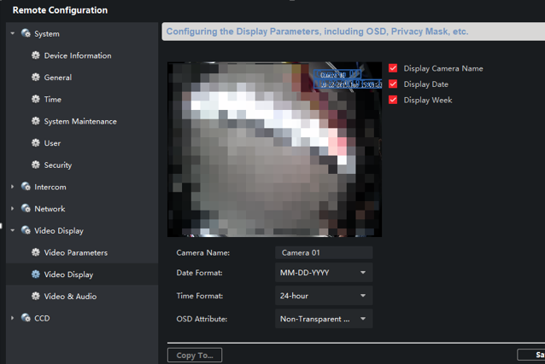

1. Door station supports manually change day and night mode.

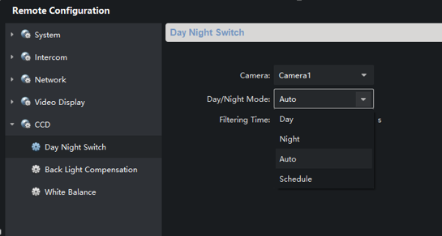

1. Add white balance mode configuration

AWB 1 mode means auto mode; Fluorescent Lamp mode is used to solve the image purple problem caused by large green background.

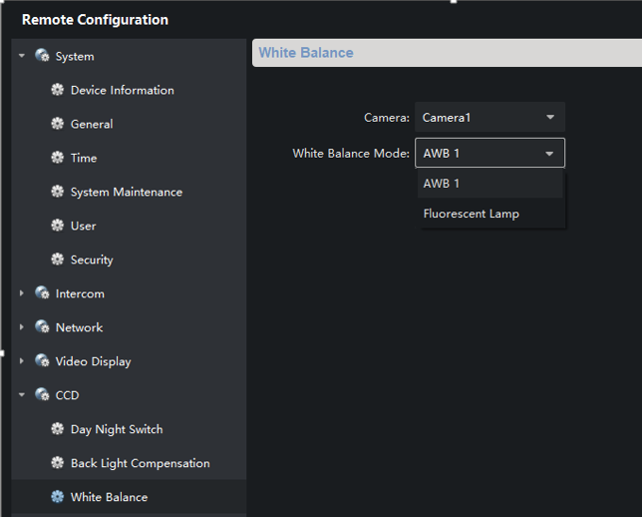

1. 2-wire indoor station supports to change NIC type: 10M, 100M or AUTO mode. Maximum distance between indoor station and distributor: 100M mode: 65m, 10M mode: 100m.

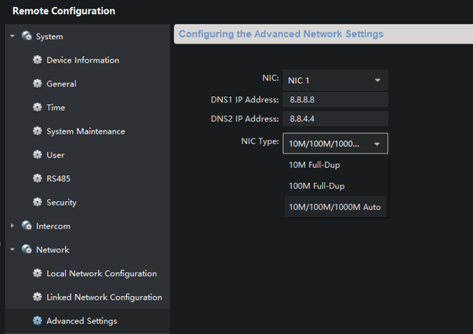

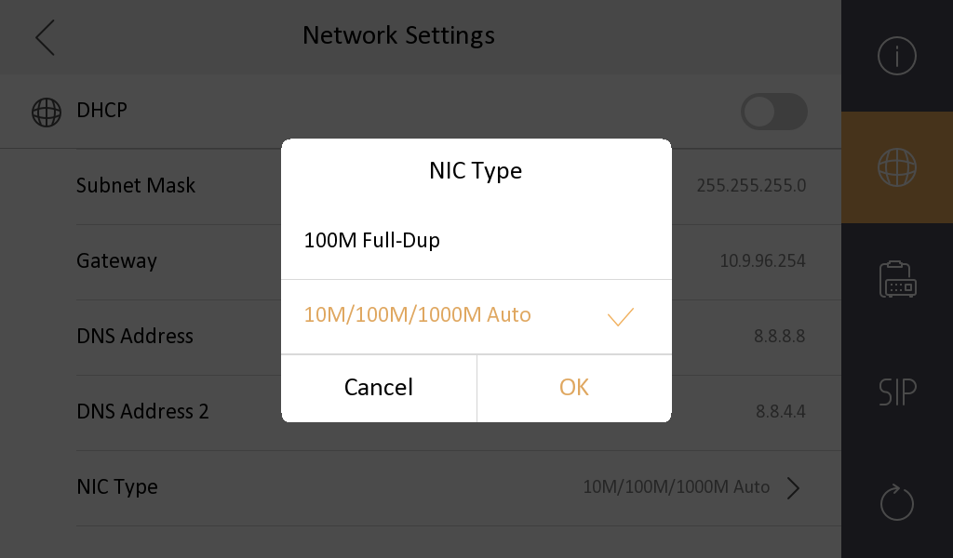

**Modified Features**

1. The indoor station wizard selects the first door station by default. If the door station is in inactive state, and directly clicks Finish, and the door station will be directly activated using the indoor station password;

2. The default indoor station DNS address is corrected to DNS1: 8.8.8.8 DNS2: 8.8.4.4;

3. The indoor station local admin password is changed to the activation password, which is no longer the 888999. The arming and disarming password cancels the default value. When there is no password, the iVMS-4200 and the local need to configure the new password. (Note: if the indoor station device already activated, after upgrading the firmware, the admin password is still 888999; it need to restore factory settings to take effect).

**Customer Impact and Recommended Action**

This new firmware upgrade is to improve product performance, and will take effect automatically after upgrading from previous versions. We’d like to inform you the above changes. Also, we are sorry for any possible inconvenience of use-habit changes caused by this action.

For questions or concerns, please contact our local technical support team.

Note:

* Hikvision has all rights to alter, modify and cancel this notice.
* Hikvision doesn’t give any guarantee for old models’ stock.
* Hikvision is not liable for any typing or printing errors.
* For special model’s change details, please contact our local technical support team.

Hikvision Digital Technology CO., Ltd.

No. 555 Qianmo Road, Binjiang District, Hangzhou 310052, China

Tel: +86-571-8807-5998

FAX: +86-571-8993-5635

Email: support@hikvision.com