**FAQ of Minmoe**

Menu

1 、Configuration 3

1. What do these icons on the right top side of main interface mean ？ 3

2. What is length limit of different parameters person information？ 3

3. When minmoe is connected with access controller as card reader, do we need to apply person information to minmoe？ 3

4. Why super user can not pass remain-closed access point with their face？ 4

5. How does M1 card encryption work ？ 4

6. Can we realize multi door anti passwing back between different minmoes？ 4

7. What is the difference between indoor and others in application mode？ 4

8. What does face recognition interval in Biometrics parameters mean？ 4

9. How much time it takes to recognize stranger, is the time adjustable？ 4

10. What is the difference between two interval parameters:Authentication interval in ACS parameters and Face Recognition interval in Biometrics parameter？ 5

11. Does minmoe support one button call indoor station function without press indoor station room No.？ 5

12. Can we hide call, qr code and password icon on main interface if we don’t need it？ 5

13. What is the difference between normal user and administrator in user role？ 5

14. What is the difference between administrator in user role on local menu and device operator in 4200 person access control information ？ 5

15. Does minmoe support modify voice prompt after authentication？ 6

16. Does minmoe support modify UI text prompt on main interface？ 6

17. What does the Appellation in prompt settings mean？ 6

18. What is the difference between normal mode and deep mode？ 6

19. What is the difference between 1:1 and 1:N threshold? 6

20. How does ECO mode work? 7

21. Will threshold of ECO mode effect normal face recognition? 7

22. What does the Margin in face reconition parameters mean 7

23. Why I cannot edit password/pin code in person information of local menu 7

24. What is pin code length limit 8

25. What is the difference between current/real-time deploy and client deploy？ 8

26. How does attendance status work？ 8

27. When choose attendacne status mode as AUTO, how does it work？ 8

28. What is requirement of USB drive when exporting/importing data？ 8

29. Can we export person data from one model and import to another model？ 9

30. Is data exported encrypted？ 9

31. How to check exported data？ 9

32. What is requirement of uploaded pictures for advertisment mode？ 9

33. What is the time range of the alarm output configuration？ 9

34. Can minmoe suppiort one alarm triggering its own buzzer ？ 10

35. What is the soft linkage and the hard linkage of the fire alarm？ 10

36. Minmoe connects withcard reader,choose peripheral as access controller，485 address as 1，why it does not work？ 10

37. Can one thermal minmoe connect with 2 KC001？ 11

38. When in combined authentication mode like card+face, if only swipe card without face, will the card number be uploaded？ 11

2 、System 11

1. What is the difference between ARM and MCU？ 11

2. How to upgrade thermal module？ 11

3. What is the difference between net.bin and serial.bin？ 12

4. How to use serial cable to upgrade？ 12

5. How to upgrade MCU of terminmal with serial cable？ 12

6. Why there is chinese voice prompt after serrial cable upgrade？ 12

7. What does it mean when you connect seral cable:Not compatible MAC. The server supports these MACs:hmac-sha2-256？ 13

8. What does the err code mean when do seral upgrade:eth_na51000 Waiting for PHY auto negotiation to complete......... TIMEOUT !？ 13

9. What does it mean when upgrade with serial cable:ARP Retry count exceed; starting again？ 13

10. Can controller connect with secure module？ 13

11. Can 5671 connect with fingerprint card reader？ 13

12. If one terminal is connected with secure module, can its wiegand interface work normally？ 13

3 、Application 14

1. Why card reader of minmoe and 485 reader read different card number with the same card？ 14

2. Why I can not remote collect card number with thermal minmoe？ 14

3. How do we prevent NFC？ 14

4. Why does it not work after enabling anti-passing back rule for thermal minmoe？ 14

4 、Parameters 15

1. What is database type of minmoe？ 15

2. What is OS of minmoe？ 15

3. What are RAM and FLASH parameters？ 15

4. What is AWG specification of minmoe cable？ 15

5. Lithium battery parameters ？ 15

6. What is relay specification？ 16

7. How do DS-K1T604/605/606/607 and DS-K5603/5604 connect with turnstile as a card reader？ 16

5 Update records 16

# 、Configuration

## What do these icons on the right top side of main interface mean ？

 If temperature measurement function is enabled and temperature module connected

 if device is armed/deployed by platform

 if device enable hik-connect function and connected with hik-connect server

 if device is connected with network

## What is length limit of different parameters person information？

Employee ID: 1-32 characteristics

Name：1-128 characteristics

Card NO.：1-20 characteristics

Pin code:4-8 characteristics

## When minmoe is connected with access controller as card reader, do we need to apply person information to minmoe？

It needs. Minmoe does not support simply card reader mode, what minmoe supports it cardNO./employee id output mode. Difference between above two mode is that in cardNo. /employee ID output mode, minmoe needs to do verification first. If person fail to authenticate, minmoe won’t output ID/card No.

## Why super user can not pass remain-closed access point with their face？

Super user can use card/fingerprint to verify, face is not supported to be used as super credential

## How does M1 card encryption work ？

Enable M1 card encryption when issue card，card issuer can write encryption code into card sector. Then enable M1 card encryption of access controller, only card been encrypted can pass

## Can we realize multi door anti passwing back between different minmoes？

No. Minmoe only supports single door anti passing back.

## What is the difference between indoor and others in application mode？

If you install the device indoors near the window or the face recognition function is not working well, select **Others**.

## What does face recognition interval in Biometrics parameters mean？

It means interval between continuous face recognition, no matter the same or different perso.by default 3s, ranges from 1-10s

## How much time it takes to recognize stranger, is the time adjustable？

By default it takes 3s to give stranger authentication result. The time can be modified and time range is 1 -20s

Modify it by change Face Recognition Timeout Value in smart parameters

## What is the difference between two interval parameters:Authentication interval in ACS parameters and Face Recognition interval in Biometrics parameter？

Authentication interval means interval between duplicate authentication for all the authentication mode(card, fingerprint, face and so on)，ranges from 0 to 65535s

face recognition interval means interval between continuous face recognition, not only duplicate recognition, ranges from 1 to 10s

## Does minmoe support one button call indoor station function without press indoor station room No.？

Yes. shortcut key in basic settings, change call type as special room No. and it can realize one key call special room

## Can we hide call, qr code and password icon on main interface if we don’t need it？

These three icons can be hidden by disable them in shortcut key function in basic parameters

## What is the difference between normal user and administrator in user role？

Administrator can enter local menu by face/card/fingerprint, and normal user can only login by password

## What is the difference between administrator in user role on local menu and device operator in 4200 person access control information ？

They are then same thing

## Does minmoe support modify voice prompt after authentication？

You can modify voice prompt by typing in text in video/audio parameters on web page. It only support English by now

## Does minmoe support modify UI text prompt on main interface？

Not supported. Only voce prompt can be modified. When it comes to UI modification, customization is needed

## What does the Appellation in prompt settings mean？

Not supported yet

## What is the difference between normal mode and deep mode？

Normal mode is for normal situation

In deep mode, minmoe collects picture with both white light and IR light camera, there are some points need to pay attention to

1. when you apply person information, normal pictures will fail to be applied to device. You need to use pictures collected by devices in deep mode as well
2. If you change from normal mode to deep mode , pictures collected before are not compatible any more

## What is the difference between 1:1 and 1:N threshold?

There are 2 kinds of face recognition threshold: 1:1 and 1;N, been used in combined authentication mode and single authentication mode respectively

1:N is used when authentication mode is face only. Minmoe compares your face(1) with all the faces stored inside(N) and get resemblance with each face. If resemblance percentage is over the 1:N threshold, you can pass face recognition

1:1 is used in combined authentication mode. For example, card +face mode, you have to swipe card first, then Minmoe can recognize person information linked with this card. when you use face to authenticate, minmoe will only compare your face with face linked with theis card

## How does ECO mode work?

Minmoe uses white light camera to do face recognition only normally. When in dim environment, it can use ECO mode and use IR camera to help face recognition

## Will threshold of ECO mode effect normal face recognition?

ECO Threshold decides when minmoe enter ECO mode. The bigger it is, the more easily it enters ECO mode

Only use ECO mode 1:1 and 1:N threshold when in ECO mode

## What does the Margin in face reconition parameters mean

Margin means face recognition area accounting for the percentage of the camera's original image area

## Why I cannot edit password/pin code in person information of local menu

This pin code can be used to open door. Now this code can only be edited with platform like 4200

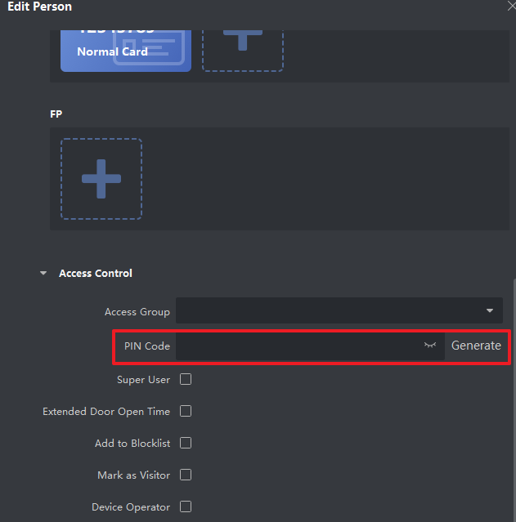

## What is pin code length limit

pin code can set from 4 to 8 characteristics

## What is the difference between current/real-time deploy and client deploy？

Minmoe supports one channel client deploy and multiple channel real time deploy. Platform like 4200 and HCP uses client deploy

The client arming channel supports resumable upload. It will upload offline event to platform when network is connected

Real time arming channel only uploads event after arming

## How does attendance status work？

After enabling attendance status, staff need to choose attendance status when authenticate, the device will upload this attendance status to plat form and platform can use this status to calculate attendance report

## When choose attendacne status mode as AUTO, how does it work？

The following table is auto attendance status rule and it does not support next-day attendance record

If check in before check in time, in this case is time before 9:00, it depends if you set must check. If must check, you need to choose attendance status manually, if ,must check is not enabled, it won’t record attendance status

|  |  |  |  |  |  |  |
| --- | --- | --- | --- | --- | --- | --- |
| Set time | check in | break out | break in | check out | overtime in | overtime out |
|  | 9:00 | 12:00 | 13:00 | 18:00 | 19:00 | 22:00 |
|  |  |  |  |  |  |  |
| Check time | 9:00-11:59 | 12:00-12:59 | 13:00-17:59 | 18:00-18:59 | 19:00-21:59 | 22:00-23:59 |
| Result | check in | break out | break in | check out | overtime in | overtime out |

## What is requirement of USB drive when exporting/importing data？

Format：FAT32 or exFAT

Size：1G-32G , remaining space over 512M

## Can we export person data from one model and import to another model？

Data exported with USB drive can only transfer to the same model

## Is data exported encrypted？

For event data, it is decided by customer

If you export without typing in password, then event data is not encrypted and you can open it directly

It you input password , the data is encrypted and need special tool to decrypt

Person /face data have to input password and encrypt

## How to check exported data？

The encrypted event table can be viewed through the event table decryption tool. Specific tools can be obtained by contacting the headquarters technical support

The face data and user data are encrypted databases, which are only used for data transfer between devices and cannot be viewed by customers

If you need to view it is recommended to use the platform to obtain face and user data

## What is requirement of uploaded pictures for advertisment mode？

3.2 version：format: JPG，size :less than 1M, Width：100 ~ 3072, Height：100 ~ 3072

## What is the time range of the alarm output configuration？

Alarm output can be configured with time range 0-5999s

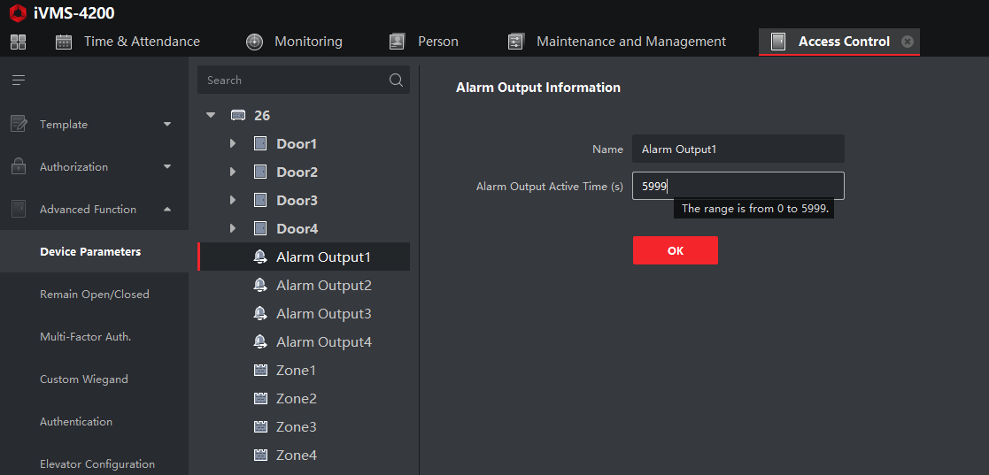

## Can minmoe suppiort one alarm triggering its own buzzer ？

Minmoe does not have a buzzer, so it is not possible to configure event linkage buzzer sound To realize the function of buzzer ringing, an external card reader (the card reader comes with a buzzer) or the alarm output directly connects to the buzzer

## What is the soft linkage and the hard linkage of the fire alarm？

Fire alarm signal linkage door opening can be divided into two types of linkage: soft linkage and hard linkage

Soft linkage: Configure the access control device, and link the access control point to open the door after the alarm input is triggered. Corresponding access control events will be generated, and the type of NC/NO lock is not restricted。

Hard linkage: Currently only the controller supports it, and it needs to be equipped with a fire alarm relay and a special fire alarm interface. There is no need to configure the device, as long as the fire alarm interface is triggered, the fire alarm relay will immediately cut off the power to the relay that controls the door to achieve the purpose of opening the door.

Because the door is opened directly without the control of the controller, no access control event is generated, and the door can only be opened by power off, so it is only applicable to the lock connected in NC mode。

## Minmoe connects withcard reader,choose peripheral as access controller，485 address as 1，why it does not work？

In 485 settings，peripheral parameters external device type but not minmoe working type，so when minmoe need to connect external reader , we should choose phripheral parameter as card reader

## Can one thermal minmoe connect with 2 KC001？

Yes , but need to set KC001 main and extension mode，max 4 KC001 supported

## When in combined authentication mode like card+face, if only swipe card without face, will the card number be uploaded？

No, you have to finish full combined authentication to pass authentication

# 、System

## What is the difference between ARM and MCU？

ARM is main software, upgrade type is controller.

MCU is microcontroller unit, upgrade type is extension module，it is used to control hardware interface(keypad, screen and so on)

MCU software has 2 types: net.bin and serial.bin，ARM has only onepackage:digicap.dav

## How to upgrade thermal module？

Normally we can upgrade with 4200 remote configuration interface. Upgrade type is controller

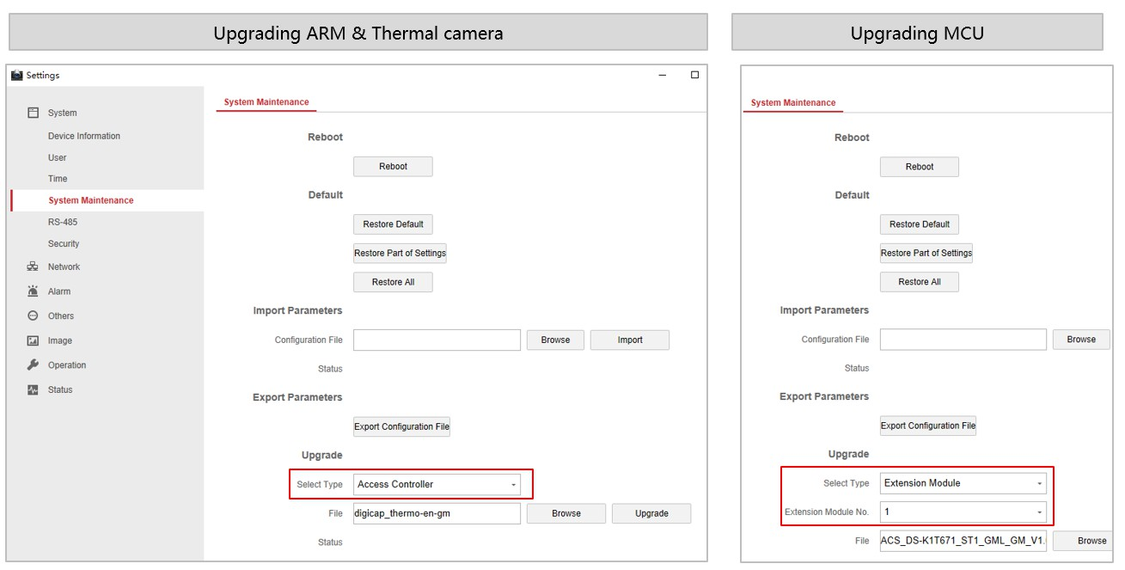

## What is the difference between net.bin and serial.bin？

Net.bin is used when upgrade method is network（4200，SDK）

Serial.bin is used when upgrade method is serial cable

## How to use serial cable to upgrade？

Follow document in this linkage：

ftp://hikftp.hikvision.com:400/Product File(Overseas)/00 Oversea Products/05 Access Control_Intercom/11 Installation & How to/How-to document/02 Video Intercom/How to upgrade the device by serial port.pdf

## How to upgrade MCU of terminmal with serial cable？

Insert serial cable to ARM serial interface, press U on keypad and power on, keep the device in uboot mode. Then open device back cover and insert serial cable to MCU serial interface, input reboot and press U on keypad to enter upgrade mode.

## Why there is chinese voice prompt after serrial cable upgrade？

This is normal phenomenon

Reboot the device and it will become normal

## What does it mean when you connect seral cable:Not compatible MAC. The server supports these MACs:hmac-sha2-256？

Securecrt version is too old and does not support sha2-256, need to use version later than securecrt 8.0

## What does the err code mean when do seral upgrade:eth_na51000 Waiting for PHY auto negotiation to complete......... TIMEOUT !？

Network cable is not connected with device

## What does it mean when upgrade with serial cable:ARP Retry count exceed; starting again？

Usually network is not connected well.

Change network cable

## Can controller connect with secure module？

No

## Can 5671 connect with fingerprint card reader？

No，5671 does not support fingerprint so fingerprint data cannot be transferred to fingerprint reader

## If one terminal is connected with secure module, can its wiegand interface work normally？

No, once terminal is connected with secure module, you can only connect card reader or other external devices with secure module

# 、Application

## Why card reader of minmoe and 485 reader read different card number with the same card？

For 7 byte card, different versions have different reading rules

Upgrade minmoe and card reader to the latest version should solve this problem

## Why I can not remote collect card number with thermal minmoe？

1. Full card reading progress contains reading card and temperature screening. If you only swipe card without front face to the screen, thermal module cannot detect temperature and card reading is not complete. So thermal minmoe won’t upload card to platform

2.If you enable temperature only mode, thermal module only do temperature screening ,so it won’t upload card number

## How do we prevent NFC？

New project can use M1 card encryption function

Access control🡪advanced function🡪more parameters, enable M1 card encryption and select sector ID. When issue card on person page with card enrollment station, enable M1 card encryption as well and choose the same sector, so that card can be encrypted

## Why does it not work after enabling anti-passing back rule for thermal minmoe？

Thermal module does not support anti-passing back and multi factor authentication

# 、Parameters

## What is database type of minmoe？

|  |  |
| --- | --- |
|  | Database type |
| MinMoe | SQLite |
| Ivms-4200 | SQLite |
| HCP | PostgreSQL |

## What is OS of minmoe？

L;inux 4.1.0

## What are RAM and FLASH parameters？

|  |  |  |
| --- | --- | --- |
|  | RAM/GB | FLASH/GB |
| A70 | 1 | 8 |
| K1T671T | 1 | 8 |
| K1T671 | 1 | 4 |

## What is AWG specification of minmoe cable？

|  |  |  |
| --- | --- | --- |
|  | Power cable | Other signal cable |
| K1T671 | AWG22 | AWG28 |

## Lithium battery parameters ？

|  |  |
| --- | --- |
|  | K1T671 |
| Quantity | 1 |
| Name | ML614R |
| Shape | Button battery |
| Weight | 0.29g |
| Lifetime | Charge and discharge time 300(One of the number of charging and discharging times refers to: the battery is fully charged-the battery is discharged below 10%-the battery is fully charged) |

## What is relay specification？

1 ${10}^{5}$*次（2A 30VDC)）

1 ${10}^{5}$*次（0.5A 125VAC）

## How do DS-K1T604/605/606/607 and DS-K5603/5604 connect with turnstile as a card reader？

DS-K1T604/ 607/341A/642/671/672/680——485/Wiegand；

DS-K1T605/DS-K1T606——Wiegand；

DS-K5603——485/232；

# Update records

|  |  |  |
| --- | --- | --- |
| **Date** | **Contents** | **Updater** |
| 2021.6.29 | Increase the numbered catalog, update the content | Derek |
| 2021.7.7 | 12 new FAQ questions | Morgen |
| 2021.7.19 | 12 new/errata FAQ questions | Derek |
| 2021.9.2 | Englishization | Derek |
|  |  |  |