**DS-K5671 Series MinMoe Terminal**

**Release Notes (2022-03-09)**

|  |  |  |
| --- | --- | --- |
| **Device Model:**  DS-K5671-ZV/ZH/ZU | Firmware Version | ARM: ACS_671_AI3_EN_STD_V3.2.0_build220210  ACS_671_AI3_EN_NEU_V3.2.0_build220210 |
| SDK | Latest version |
| iVMS-4200 Version | Latest baseline |

**Reason of Upgrade**

Fix bugs, enhance products quality and meet customers’ requirements.

**Modified Features**

1. Fix the problem that the occasional screen backlight cannot be turned off;

**DS-K5671 Series MinMoe Terminal**

**Release Notes (2021-11-15)**

|  |  |  |
| --- | --- | --- |
| **Device Model:**  DS-K5671-ZV/ZH/ZU | Firmware Version | ARM: ACS_671_AI3_EN_STD_V3.2.0_build211110  ACS_671_AI3_EN_NEU_V3.2.0_build211110 |
| SDK | Latest version |
| iVMS-4200 Version | Latest baseline |

**Reason of Upgrade**

Fix bugs, enhance products quality and meet customers’ requirements.

**Modified Features**

1. Fix the device offline issue caused by searching device event from iVMS4200 client through ISUP5.0 protocol;
2. Fixed some issues about ISAPI protocol.
3. Optimize the connection with HikCentral Professional platform;

**DS-K5671 Series MinMoe Terminal**

**Release Notes (2021-09-09)**

|  |  |  |
| --- | --- | --- |
| **Device Model:**  DS-K5671-ZV/ZH/ZU | Firmware Version | ARM: ACS_671_AI3_EN_STD_V3.2.0_build210731  ACS_671_AI3_EN_NEU_V3.2.0_build210731 |
| SDK | Latest version |
| iVMS-4200 Version | Latest baseline |

**Reason of Upgrade**

Add new function, fix bugs, enhance products quality and meet customers’ requirements.

**New Features**

1. Add Hik-Connect menu in device UI Menu🡪Comm. The function is disabled in default.

**Modified Features**

1. Optimize the wake-up distance of the device screen through the face, and the wake-up distance is consistent with the recognition distance

**DS-K5671 Series MinMoe Terminal**

**Release Notes (2021-06-28)**

|  |  |  |
| --- | --- | --- |
| **Device Model:**  DS-K5671-ZV/ZH/ZU | Firmware Version | ARM: ACS_671_AI3_EN_STD_V3.2.30_build210609  ACS_671_AI3_EN_NEU_V3.2.30_build210609 |
| SDK | Latest version |
| iVMS-4200 Version | Latest baseline |

**Reason of Upgrade**

Fix bugs, enhance products quality and meet customers’ requirements.

**Modified Features**

1. Optimize the function of exporting data to U disk.
2. Optimize the working mechanism of infrared fill light

**DS-K5671 Series MinMoe Terminal**

**Release Notes (2021-02-08)**

|  |  |  |
| --- | --- | --- |
| **Device Model:**  DS-K5671-ZV/ZH/ZU | Firmware Version | ARM: ACS_671_AI3_EN_STD_V3.2.0_build210203  ACS_671_AI3_EN_NEU_V3.2.0_build210203  MCU: ACS_DS-K1T671_ST1_GML_GM_V1.0.1_build210104 |
| SDK | Latest version |
| iVMS-4200 Version | Latest baseline |

**Reason of Upgrade**

Add new features, fix bugs, enhance products quality and meet customers’ requirements.

**New Feature**

1. Support https feature

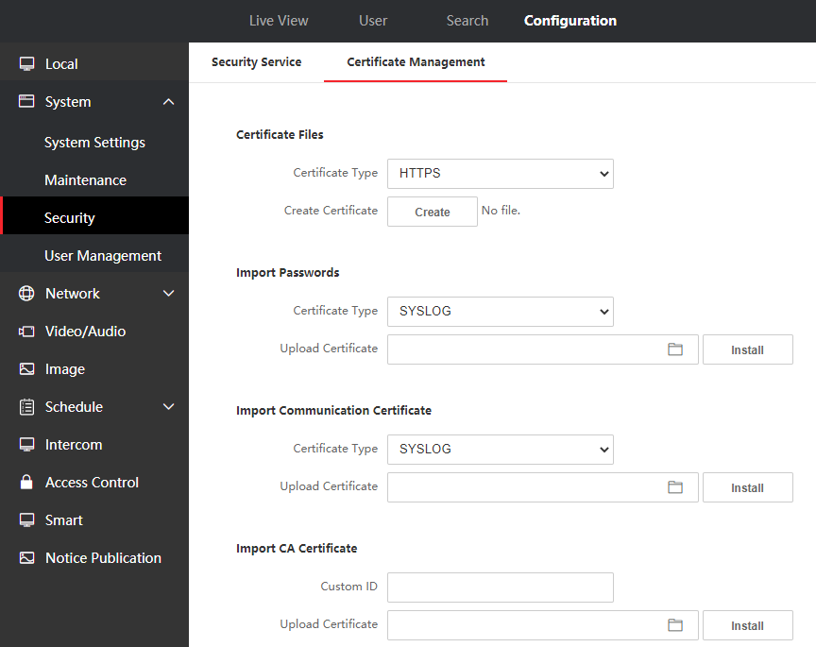

1. Support English, Spanish (South American), Arabic, Thai, Indonesian, Russian, Vietnamese, Brazilian Portuguese
2. Add Hik-ProConnect platform docking
3. Add advertisement mode, after enable, the wallpaper will be fixed to be displayed on the top of main interface.

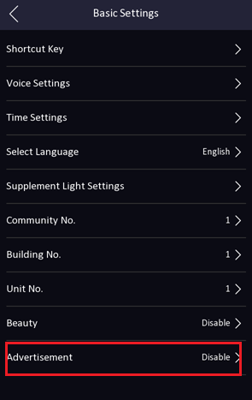 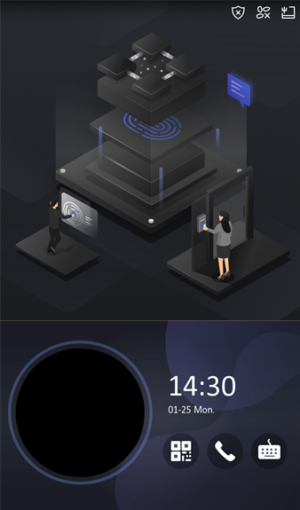

1. Add device operation log query function

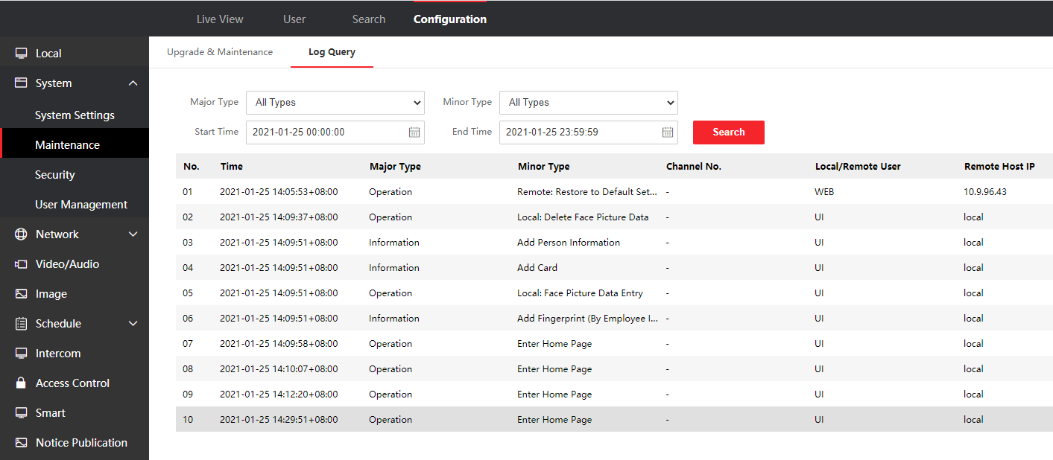

1. Add ISAPI event monitoring upload (HTTP listening) function

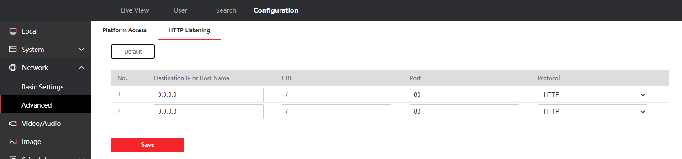

1. Support PIN code to open the door (disabled in default)

Note：PIN code should be configured from software, iVMS4200 already support, HikCentral Pro will support PIN code configuration in V2.1 expected to be released in June

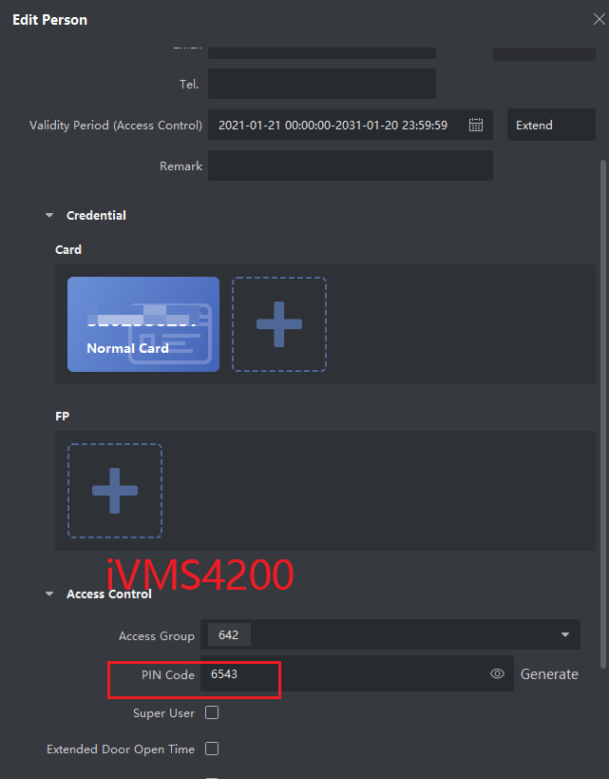 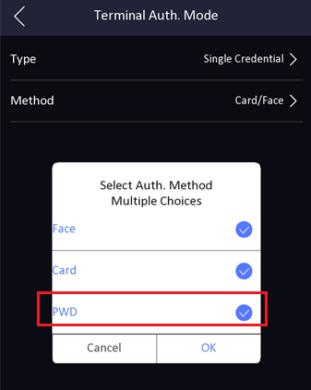

1. Support unbind device with hik-connect account on SADP tool, local UI and web interface

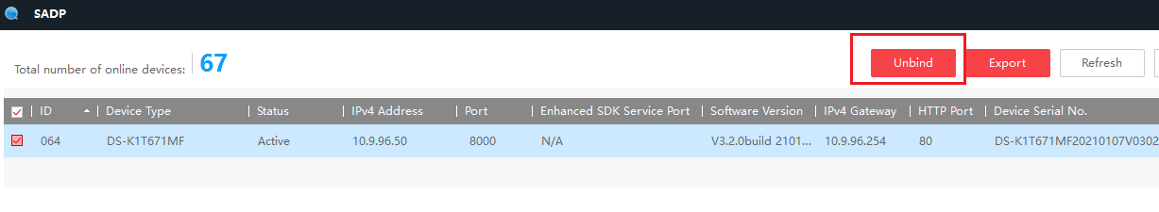

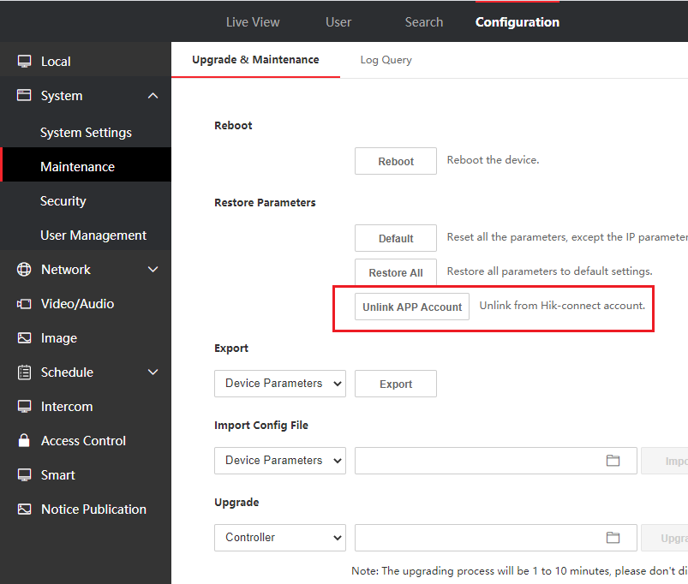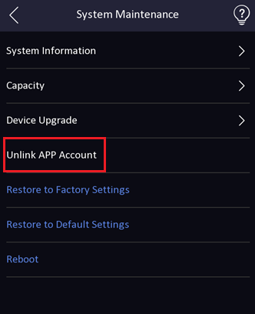

1. Add beauty function to adjust smooth and whiten parameter.

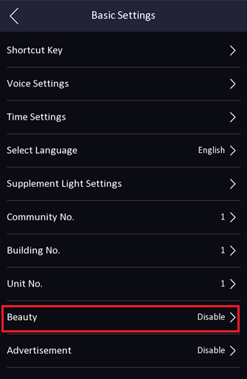 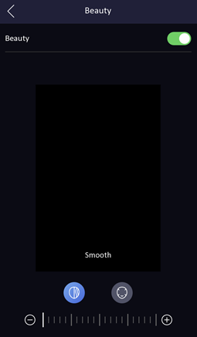

1. Add help interface to check system module version for technical support (long press for 3s).

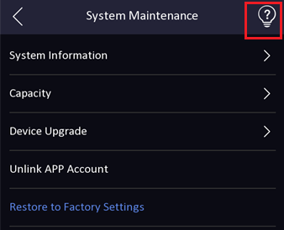 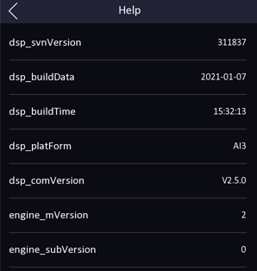

1. Add privacy protection, customer can define the privacy related parameter, such as Event Storage Settings, Picture Uploading and Storage, Clear All Pictures in Device

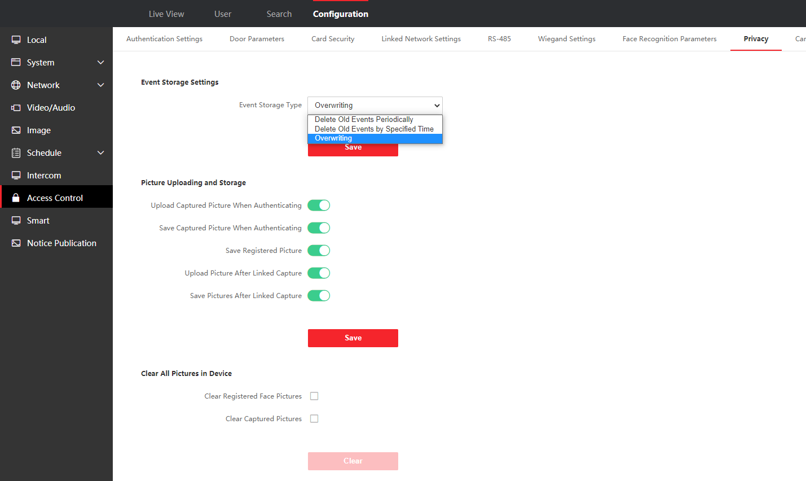

1. Configure the time period when the white light fill light is turned on and off in device local menu or web interface

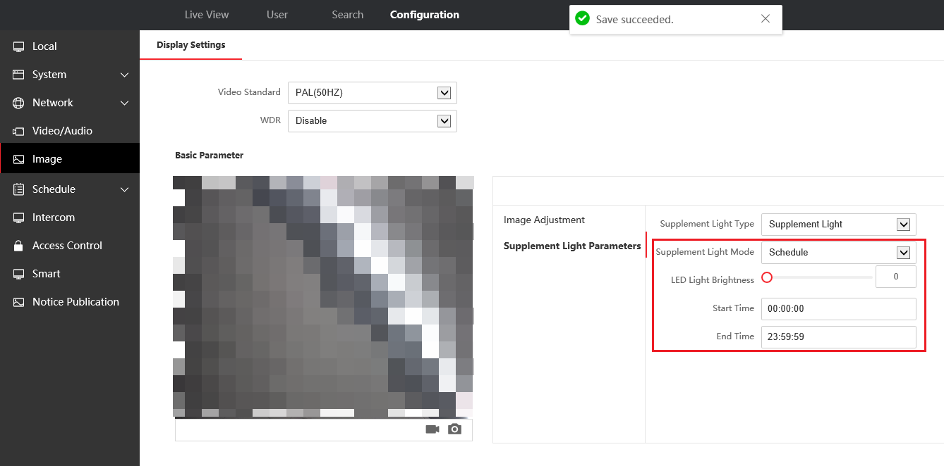

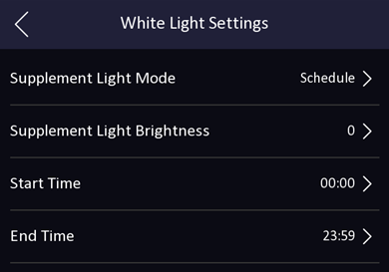

1. Add audio prompt ‘The door is open’ when open door on iVMS4200, HikCentral Pro, Hik-Connect App, and device UI will show prompt

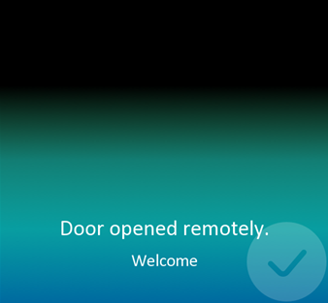

**Modified Features**

1. Hik-Connect function is turned off in default for privacy protection, if customer want to manage device from App, please turn on manually in the web.

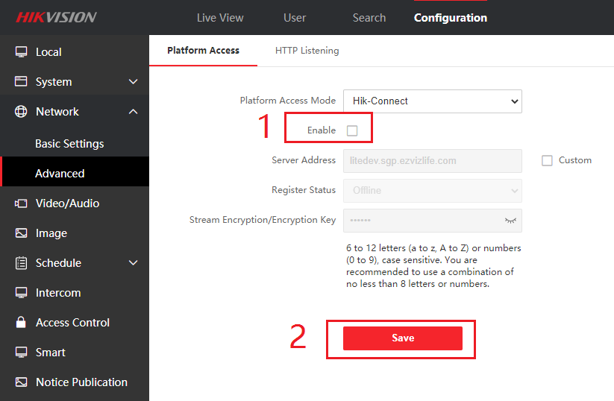

1. The face matching algorithm is upgraded. Improve the speed and accuracy of face recognition. Improved the recognition effect of dark masks
2. DNS can be configured from device UI in menu🡪Comm.-->Wired Network

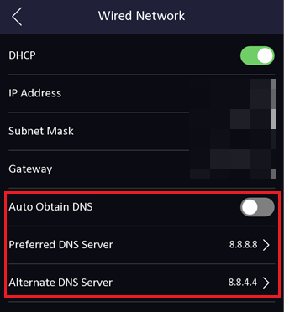

1. Optimized the ISUP and Hik-Connect event upload mechanism.
2. Add stranger authentication timeout time configuration

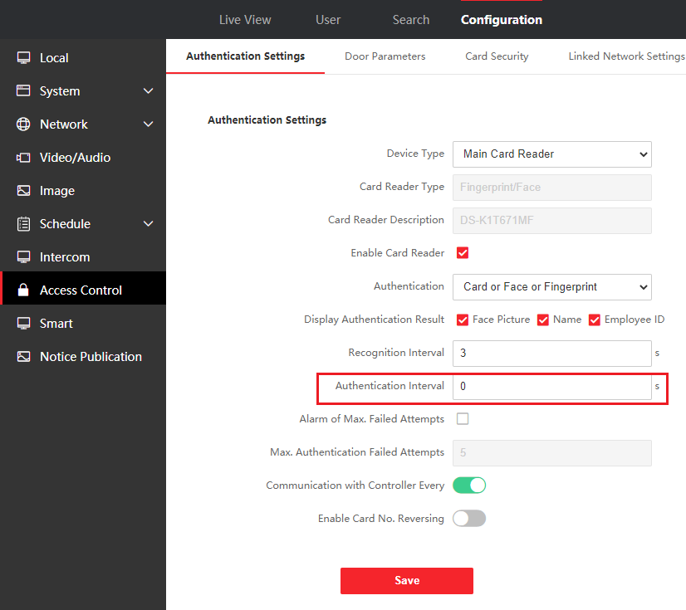

1. Add advertisement/wallpaper play schedule configuration, slide show interval.

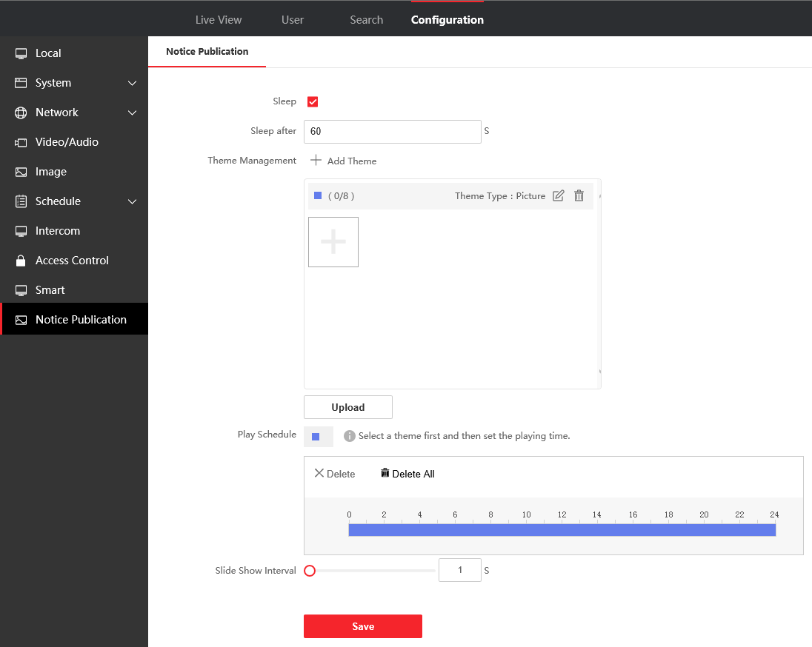

1. Optimize the firmware upgrade mechanism to ensure possible problems caused by power outage during the upgrade process.

**Customer Impact and Recommended Action**

This update refers to function/compatibility improvement and will take effect automatically after the Date of Change. We are very sorry for any inconvenience of use-habit changes caused by this action.

For any questions and request for this firmware, please contact our local technical support team.

Note:

* Hikvision reserves the right to change, alter or withdraw the above notification without prior notice.
* Product design and specifications are subject to change without prior notice.
* The Hikvision firmware may contain errors known as errata, which may cause the product to deviate from published specifications. Current characterized errata are available on request.
* Hikvision is not liable for any typing or printing errors.

Hikvision Digital Technology CO., Ltd.

No. 555 Qianmo Road, Binjiang District, Hangzhou 310051, China

Tel: +86-571-8807-5998

FAX: +86-571-8993-5635

Email: overseabusiness@hikvision.com