**DS-K5671 Series MinMoe Terminal**

**Release Notes (2020-04-09)**

|  |  |  |
| --- | --- | --- |
| **Device Model:**  DS-K5671-ZV/ZH/ZU | Firmware Version | **ARM**:ACS_671_AI3_EN_GM_V3.1.0_build200331  **MCU**:ACS_DS-K1T671_ST1_GML_GM_V1.0.1_build200331 |
| SDK | HCNetSDKV6.1.0.25_build20190718_Win32_EN  HCEhomeSDKV2.2.1.1_build20190410_win32 |
| iVMS-4200 Client Version | iVMS-4200 AC(V1.0.3.11_E).exe |

**Reason of Upgrade**

Add new features, fix bugs, enhance products quality and meet customers’ requirements.

**New Features**

1. Increase face(user) capacity

|  |  |  |
| --- | --- | --- |
|  | **Face** | **Event** |
| **DS-K5671 series** | 50,000 before (20,000) | 100,000 |

1. Multiple languages: English, Thai, Indonesian, Spanish, Russian and Arabic

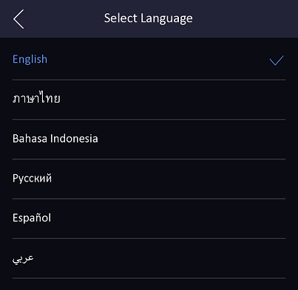

1. Login and configure device in web client via browser to realize person management, parameter configuration, log search and system maintenance;

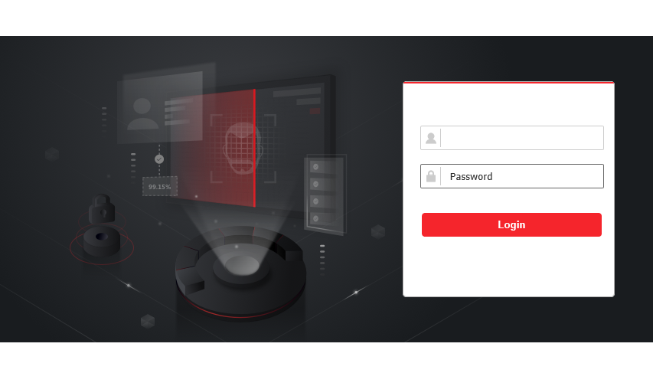

1. Support encryption (4 to 6 characters, optional) for USB import and export data.

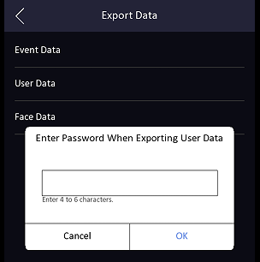 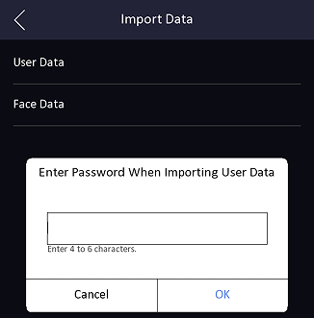

1. Support ISUP 5.0(EHome 5.0) protocol to manage devices located in different locations;

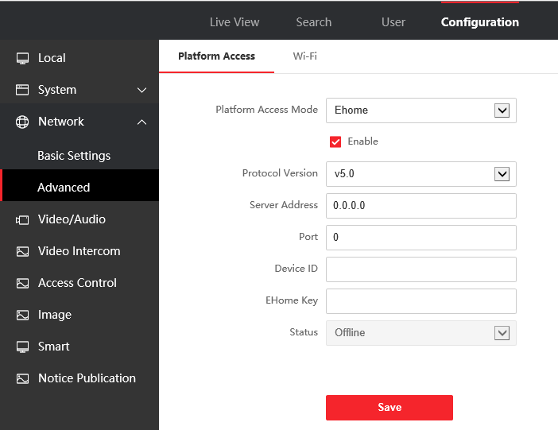

1. Import background pictures, the device will play pictures during standby status

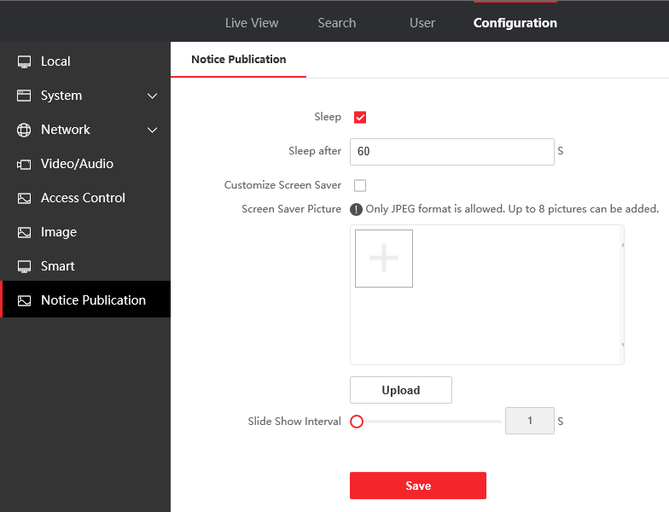

1. Self-defined screen display info (user ID, name and face picture) for authentication result.

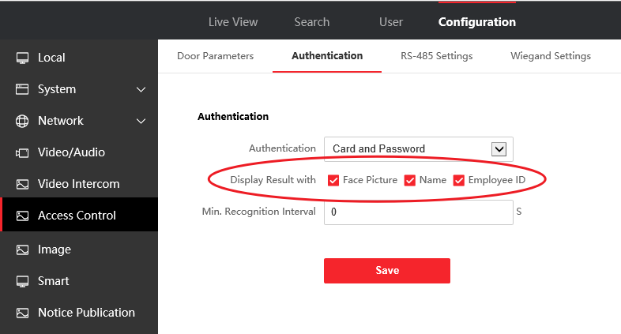

1. Self-defined shortcut key (QR Code, Call and Password) on main interface, user can select to call room, call center or specified room number after press call button on main screen.

 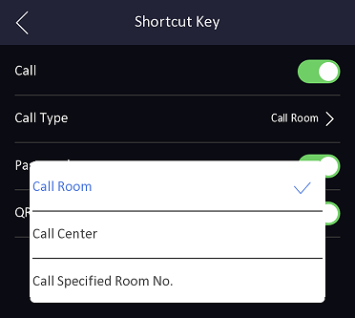

1. Status bar shows device status in real time, including network status, deployment/arm status, Hik-Connect server connection status.

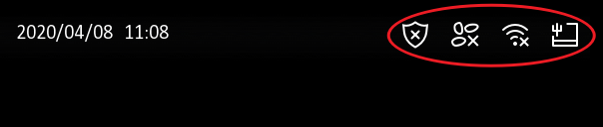

**Modified Features**

1. Optimize new UI style

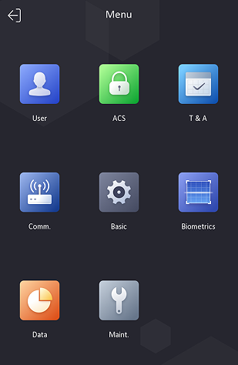

**Customer Impact and Recommended Action**

This update refers to function/compatibility improvement and will take effect automatically after the Date of Change. We are very sorry for any inconvenience of use-habit changes caused by this action.

For any questions and request for this firmware, please contact our local technical support team.

Note:

* Hikvision reserves the right to change, alter or withdraw the above notification without prior notice.
* Product design and specifications are subject to change without prior notice.
* The Hikvision firmware may contain errors known as errata, which may cause the product to deviate from published specifications. Current characterized errata are available on request.
* Hikvision is not liable for any typing or printing errors.

Hikvision Digital Technology CO., Ltd.

No. 555 Qianmo Road, Binjiang District, Hangzhou 310051, China

Tel: +86-571-8807-5998

FAX: +86-571-8993-5635

Email: overseabusiness@hikvision.com