**DS-K1T804B Series Terminal V1.3.3_build210224**

**Release Note (2021-03-18)**

|  |  |  |
| --- | --- | --- |
| **Device Model:**  DS-K1T804BF  DS-K1T804BMF  DS-K1T804BEF | Firmware Version | ACS_1T804B_J1_EN_STD_V1.3.3_build210224  ACS_1T804B_J1_EN_NEU_V1.3.3_build210224 |
| SDK Version | Latest baseline |
| iVMS 4200 Version | Latest baseline |

**Reason for Upgrade:**

DS-K1T804B series fingerprint access control terminal first time released.

**Note:**

DS-K1T804B firmware does not compatible with DS-K1T804A and DS-K1T804.

**New Features**

1. Device capacity

|  |  |  |
| --- | --- | --- |
| Card | Fingerprint | Event |
| 3,000 | 3,000 | 100,000 |

1. Support ISAPI protocol (port 80);
2. Support ISUP5.0 and not compatible with Ehome 4.0 and below version;
3. Support 11 language: English, Spanish, Italian, French, Portuguese (Brazilian), Vietnamese, Arabic, Thai, Turkish, Indonesian, Ukrainian;
4. Support authentication with pin code only (Need V3.2.1 or later version iVMS4200 );

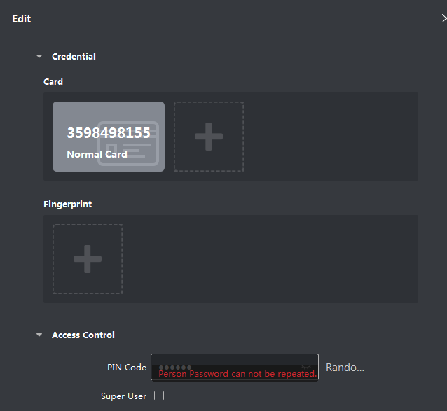

1. Connect card reader through Wiegand protocol.
2. DO NOT support RS485 communication, not support secure module and DS-K1201 fingerprint reader.
3. DO NOT support M1 card encryption.
4. Support export local device access records (must be encrypted) to USB drive and import to iVMS4200 (Need V3.2.1 or later version iVMS4200);

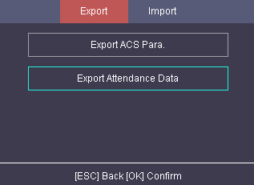 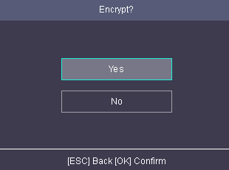

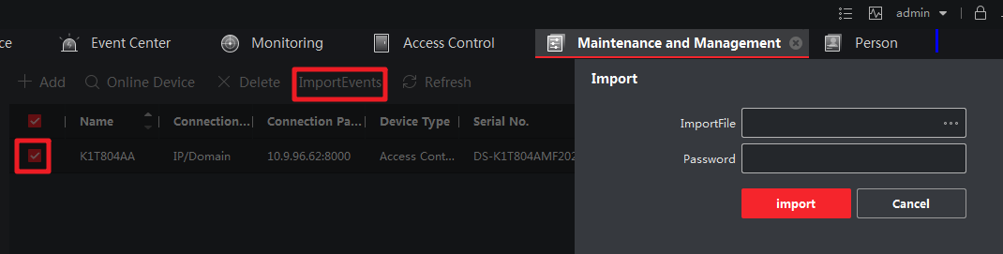

**Customer Impact and Recommended Action**

This new firmware upgrade is to improve product performance, and will take effect automatically after upgrading from previous versions. We’d like to inform you the above changes. Also, we are sorry for any possible inconvenience of use-habit changes caused by this action.

For questions or concerns, please contact our local technical support team.

Note:

* Hikvision has all rights to alter, modify and cancel this notice.
* Hikvision doesn’t give any guarantee for old models’ stock.
* Hikvision is not liable for any typing or printing errors.
* For special model’s change details, please contact our local technical support team.

Hikvision Digital Technology CO., Ltd.

No. 555 Qianmo Road, Binjiang District, Hangzhou 310052, China

Tel: +86-571-8807-5998

FAX: +86-571-8993-5635

Email: support@hikvision.com