**K1T8003 Series Access Control Terminal**

**Release Notes (2019-03-15)**

|  |  |  |
| --- | --- | --- |
| **Device Model:**  DS-K1T8003F DS-K1T8003EF  DS-K1T8003MF | Firmware Version | ACS_1T_EN_GM_V1.0.2_build190314 |
| SDK | HCNetSDKV6.0.0.20_build20181207_win32_EN  HCEhomeSDKV2.1.3.1_build20181210_win32 |
| iVMS-4200 Client Version | V3.1 or updated version |

**Reason of Upgrade**

New model DS-K1T8003F, DS-K1T8003EF and DS-K1T8003MF released.

**Features**

1. 2.4 inch display screen, available appearance color: Silver in default;
2. Optional model for ID & Mifare 1 card; Optical fingerprint reader, verification speed less than 1s;
3. Support surface mounting and flush mounting;
4. User capacity: 1,000; Card capacity: 1,000; Fingerprint capacity: 1,000;

Event Capacity: 100,000 (including 80,000 attendance logs & 20,000 event logs);

1. Interface: Lock*1, Exit button*1, Doorbell*1, Tamper button*1;
2. Support SSR report (Self Service Recorder) function, self-defined time attendance on device local and export XLS report to USB flash;

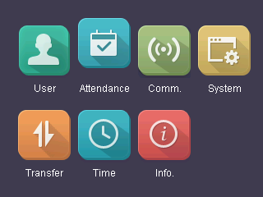 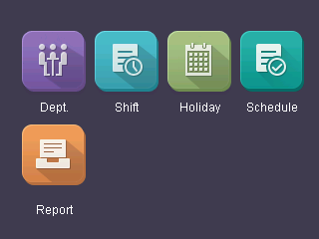 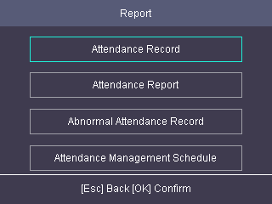

1. Support attendance status(check in/check out/break in/break out/overtime out/overtime in);

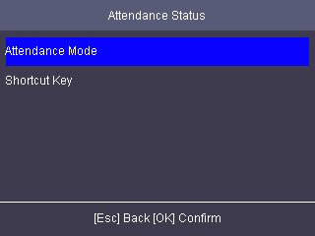 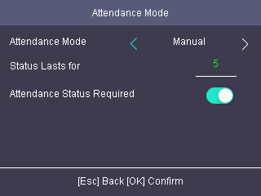 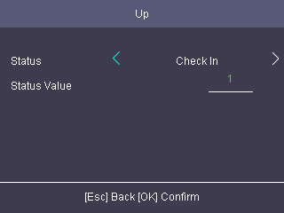

1. Multiple verification modes: Card, FP, Card/FP, Card&PWD, Card&FP, FP&PWD, ID&PWD, Card&FP&PWD;
2. Export and Import device configuration file through USB;

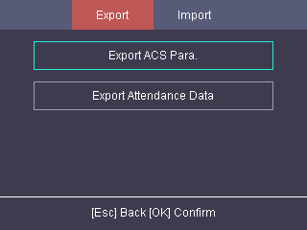

1. Multiple languages and voice prompts: English, Brazilian Portuguese, Spanish, French, Vietnamese, Italian, Arabic, Thai.

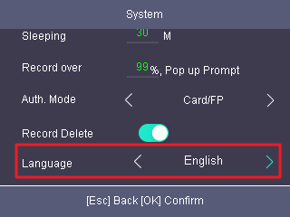

1. Support Ehome 5.0 features. Used to connect to the public network. Automatically upload events to the software.

Receive the user data including user name, card number, fingerprint from software.

Configure Ehome server IP address and port No. from device local interface.

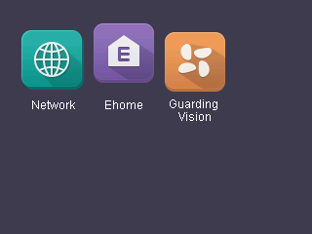 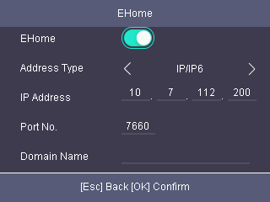

1. Support open door and check device log from Hik-Connect APP on mobile phone or pad.

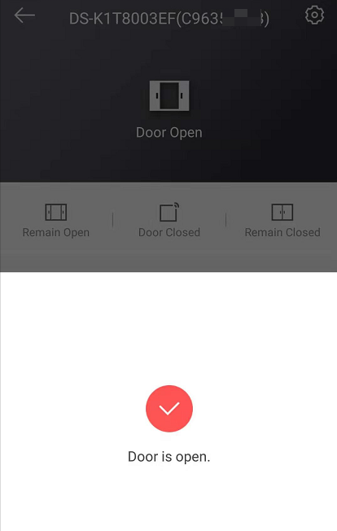 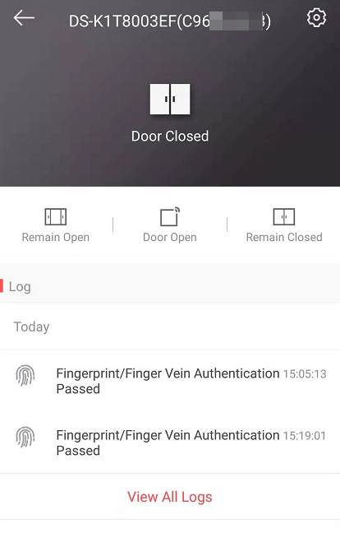

**Customer Impact and Recommended Action**

This new firmware upgrade is to improve product performance, and will take effect automatically after upgrading from previous versions. We’d like to inform you the above changes. Also, we are sorry for any possible inconvenience of use-habit changes caused by this action.

For questions or concerns, please contact our local technical support team.

Note:

* Hikvision has all rights to alter, modify and cancel this notice.
* Hikvision doesn’t give any guarantee for old models’ stock.
* Hikvision is not liable for any typing or printing errors.
* For special model’s change details, please contact our local technical support team.

Hikvision Digital Technology CO., Ltd.

No. 555 Qianmo Road, Binjiang District, Hangzhou 310052, China

Tel: +86-571-8807-5998

FAX: +86-571-8993-5635

Email: support@hikvision.com