**K1T607 Series Face Recognition Terminal**

**Release Notes (2019-05-10)**

|  |  |  |
| --- | --- | --- |
| **Device Model:**  DS-K1T607E/EF/MW/MFW  DS-K1T607PE/PEF/PMW/PMFW  DS-K1T607TE/TEF/TMW/TMFW  **Naming Rule:**  E for EM card, M for M1 card,  W for WIFI | Firmware Version | ACS_01_H10_EN_STD_V1.0.0_190410 |
| SDK | HCNetSDKV6.0.2.5_build20190105_win32 EhomeSDK_V1.2.1.13_build20180803_win32 |
| iVMS-4200 Client Version | iVMS-4200_EN.exe(V2.6.10.20 build20190328) |

**Reason of Upgrade**

New model DS-K1T607 series, DS-K1T607P series, DS-K1T607T series face recognition terminals first time released.

**New Features**

1. 7 inch LCD touch screen with large screen ratio, 2 MP wide-angle dual-lens
2. Connect external card reader or access controller via RS485 or Wiegand protocol
3. Face recognition duration ＜ 0.5 s/User; face recognition accuracy rate ≥ 99%
4. **Face, card, fingerprint, event capacity**

|  |  |  |  |  |
| --- | --- | --- | --- | --- |
|  | **Face** | **Card (EM or M1)** | **Fingerprint** | **Event** |
| **DS-K1T607 series** | 6,000 | 6,000(model with E/M) | 5,000(model with F) | 10,000 |
| **DS-K1T607P series** | 10,000 | 50,000(model with E/M) | 5,000(model with F) | 50,000 |
| **DS-K1T607T series** | 20,000 | 50,000(model with E/M) | 5,000(model with F) | 50,000 |

1. **Network**

Support TCP/IP, adapt to LAN(network) or WAN(ehome) network environment

Optional WIFI function(model with W)

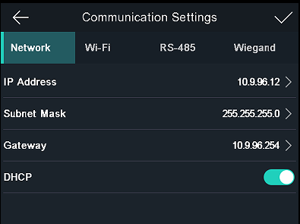

1. **Video intercom;**
2. Video intercom with platform or client software;
3. Video intercom with indoor station
4. Video intercom with master station

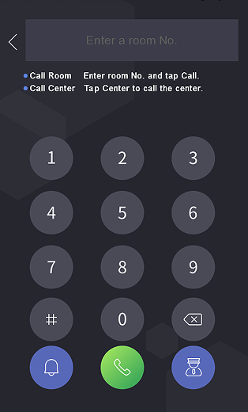

1. **Function**
2. Face recognition in dark environment
3. Multiple verification modes: QR code, card, fingerprint and face
4. Remote live view via RTSP protocol; encoding mode: H.264
5. Optional fingerprint recognition module(model with F)
6. Face pictures and fingerprints can be applied to the device via client software or uploaded to the device via the USB flash drive.

**Customer Impact and Recommended Action**

This new firmware upgrade is to improve product performance, and will take effect automatically after upgrading from previous versions. We’d like to inform you the above changes. Also, we are sorry for any possible inconvenience of use-habit changes caused by this action.

For questions or concerns, please contact our local technical support team.

Note:

* Hikvision has all rights to alter, modify and cancel this notice.
* Hikvision doesn’t give any guarantee for old models’ stock.
* Hikvision is not liable for any typing or printing errors.
* For special model’s change details, please contact our local technical support team.

Hikvision Digital Technology CO., Ltd.

No. 555 Qianmo Road, Binjiang District, Hangzhou 310052, China

Tel: +86-571-8807-5998

FAX: +86-571-8993-5635

Email: support@hikvision.com