**DS-K1T341A Series MinMoe Terminal**

**Release Notes (2020-10-16)**

|  |  |  |
| --- | --- | --- |
| **Device Model:**  DS-K1T341AM  DS-K1T341AMF  **Naming Rule:**  M for M1 card, F for fingerprint | Firmware Version | ACS_641_AI3_EN_GM_V3.1.7_build200927 |
| SDK | Latest version |
| iVMS-4200 Client Version | Latest version baseline |

**Reason of Upgrade**

Add new features, fix bugs, enhance products quality and meet customers’ requirements.

**New Features**

1. Support one key call Hik-Connect mobile App

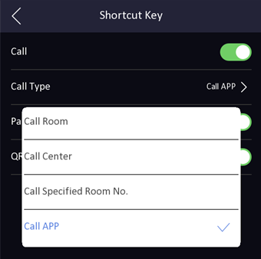

**Modified Features**

1. Fix the display problem of web multilingual translation;
2. Fix ISUP5.0 event upload problem
3. Fix the problem of fingerprint enrollment in web

**Customer Impact and Recommended Action**

This update refers to function/compatibility improvement and will take effect automatically after the Date of Change. We are very sorry for any inconvenience of use-habit changes caused by this action.

For any questions and request for this firmware, please contact our local technical support team.

Note:

* Hikvision reserves the right to change, alter or withdraw the above notification without prior notice.
* Product design and specifications are subject to change without prior notice.
* The Hikvision firmware may contain errors known as errata, which may cause the product to deviate from published specifications. Current characterized errata are available on request.
* Hikvision is not liable for any typing or printing errors.

Hikvision Digital Technology CO., Ltd.

No. 555 Qianmo Road, Binjiang District, Hangzhou 310051, China

Tel: +86-571-8807-5998

FAX: +86-571-8993-5635

Email: overseabusiness@hikvision.com