**DS-K1T341A Series Face Recognition Terminal**

**Release Notes (2020-02-06)**

|  |  |  |
| --- | --- | --- |
| **Device Model:**  DS-K1T341AM  DS-K1T341AMF  **Naming Rule:**  M for M1 card, F for fingerprint | Firmware Version | **ARM：**ACS_641_AI3_EN_GM_V3.0.0_build200117  **MCU：**  ACS_DS-K1T64X_ST1_GML_GM_V1.0.0_build200107_Mifare |
| SDK | Latest baseline version |
| iVMS-4200 Version | V1.0.3.9 build200116 |

**Reason of Upgrade**

New model DS-K1T341A series face recognition terminals first time released.

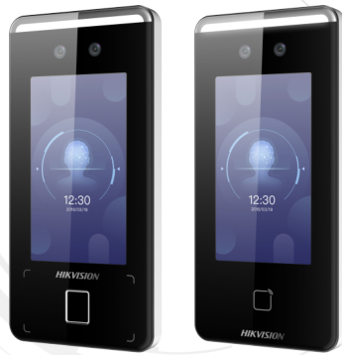

**New Features**

1. 4.3 inch capacitive touch screen with large screen ratio, 2 MP wide-angle dual-lens camera with WDR feature;
2. Connect external card reader or access controller via RS485 or Wiegand26/34 protocol
3. Face recognition duration ＜ 0.2 s/User; face recognition accuracy rate ≥ 99%
4. **Face, card, fingerprint, event capacity**

|  |  |  |  |  |
| --- | --- | --- | --- | --- |
|  | **Face** | **Card (M1)** | **Fingerprint** | **Event** |
| **DS-K1T341AM** | 1,500 | 1,500 | Not support | 150,000 |
| **DS-K1T341AMF** | 1,500 | 1,500 | 1,500 | 150,000 |

1. ISAPI protocol makes it easier for integration with third-party software;
2. Remote video intercom and unlock door from Hik-Connect App on your mobile/Pad
3. Support ISUP 5.0(EHome 5.0) protocol to manage devices located in different location;
4. Self-defined shortcut key (QR Code, Call and Password) on main interface;
5. New UI design for device menu interface;
6. Login and configure device in web client via browser;
7. Self-defined voice prompt (TTS function, English only) and screen display info(user ID, name and face picture) for verification;
8. **Network**

Support TCP/IP, adapt to LAN(network) or WAN(ISUP 5.0) network environment

1. **Function**
2. Video intercom with indoor station, master station and platform;
3. Multiple verification modes: Face, card, fingerprint(DS-K1T341AMF only) and QR code;
4. Face recognition distance ranges from 0.3 to 1.5 meters;
5. Support check in/check out/break out/break in/overtime in/overtime out status;
6. Optional fingerprint recognition module(model with F)
7. Support custom standby background image
8. IP65 protection level
9. Supports face recognition in low illumination
10. Supports live view on the platform, H.264

**Customer Impact and Recommended Action**

This update refers to function/compatibility improvement and will take effect automatically after the Date of Change. We are very sorry for any inconvenience of use-habit changes caused by this action.

For any questions and request for this firmware, please contact our local technical support team.

Note:

* Hikvision reserves the right to change, alter or withdraw the above notification without prior notice.
* Product design and specifications are subject to change without prior notice.
* The Hikvision firmware may contain errors known as errata, which may cause the product to deviate from published specifications. Current characterized errata are available on request.
* Hikvision is not liable for any typing or printing errors.

Hikvision Digital Technology CO., Ltd.

No. 555 Qianmo Road, Binjiang District, Hangzhou 310051, China

Tel: +86-571-8807-5998

FAX: +86-571-8993-5635

Email: overseabusiness@hikvision.com