# V3.2.30_210818

New features :

1, Add 10 langugaes supported, including English, French, German, Polish, Hungarian, Czech, Bulgarian, Slovenia, Serbian,Albanian

2, disable the face recognition by default

# V3.0.1_200602

# enroll faces to the smart card(Use DS-K1F60X-S to do the enrollment)

Device firmware should be V3.0.1_build200602

1. Insert fsim card into the PSAM card slot in the back of device, if fsim card doesn’t exist, you will see below picture.(ErrorCode: FF40)

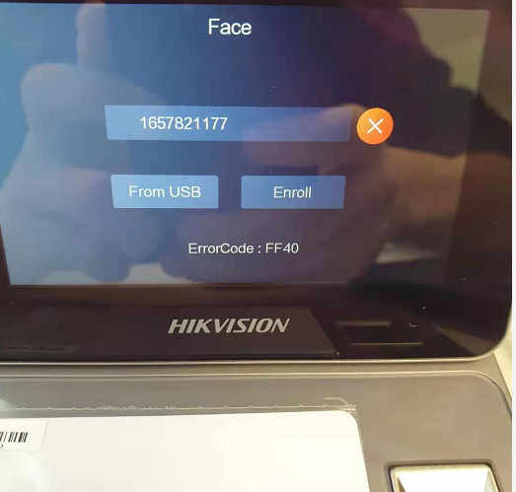

1. Click face, Enter the face information enrollment page

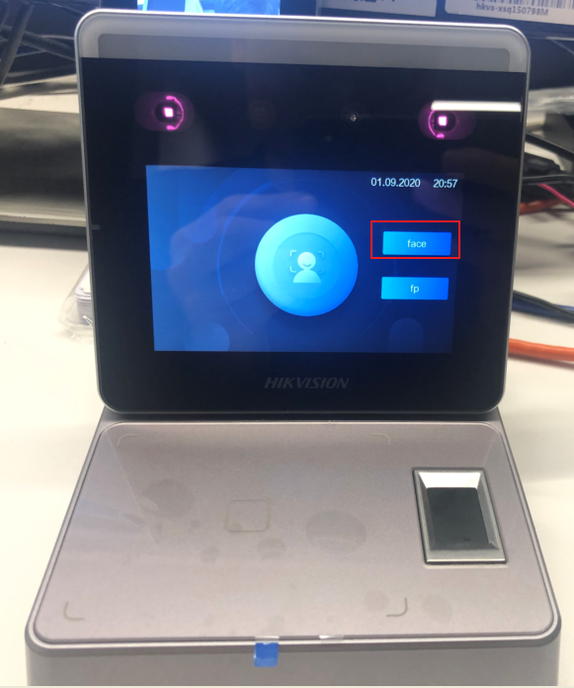

1. Put the card in the RF area of the face issuer **(Do not move the card after the card is placed, otherwise it will fail to be issued)**

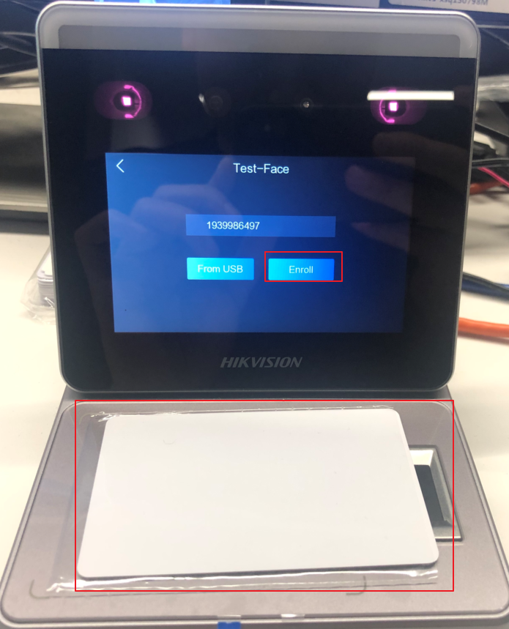

1. Click enroll to enter the face collection page, click the capture button to start the enrollment, after the collection, click the “√” button to start the download.

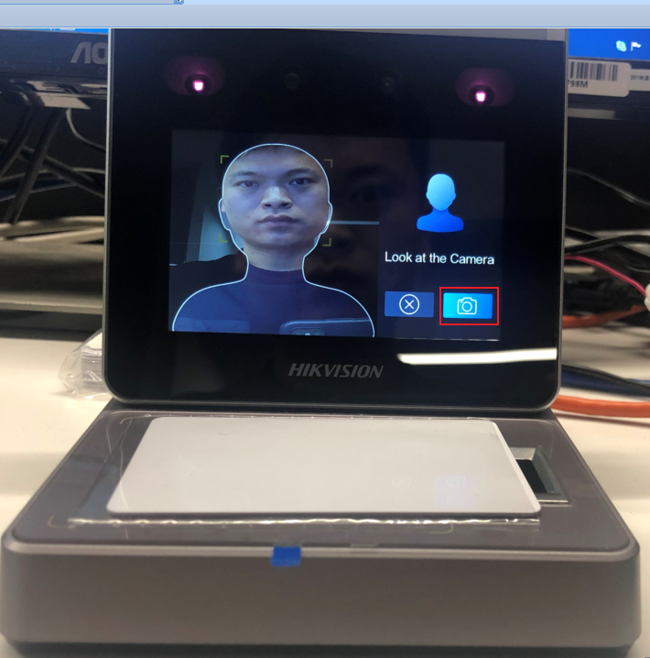

1. Download completed (green √ indicates download successfully, red × indicates download failure)

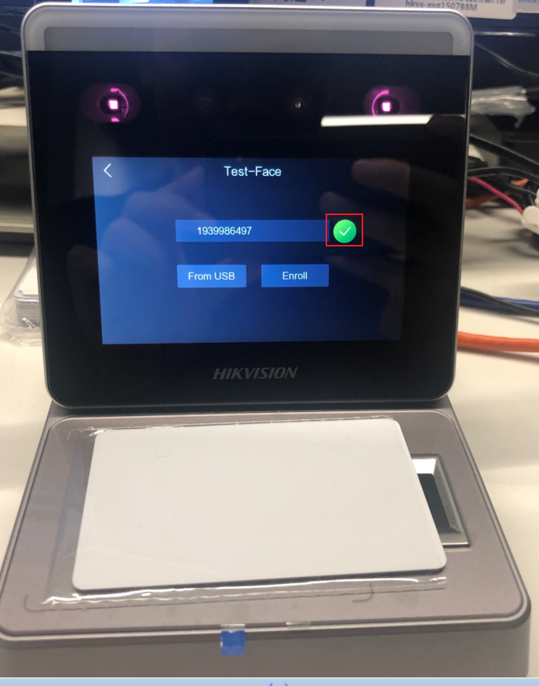

# Biometric identification (DS-K1T341A)

1. Enter the device management page, select ACS. Set the device authentication mode (Terminal Auth.Mode) to Face & Card

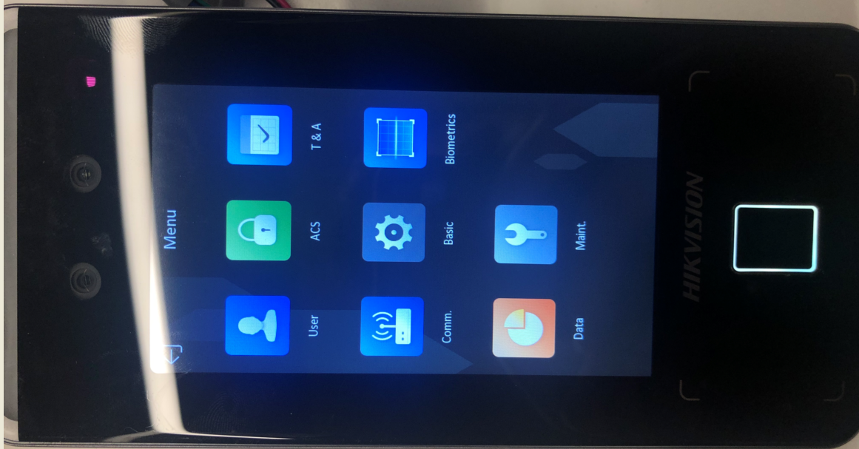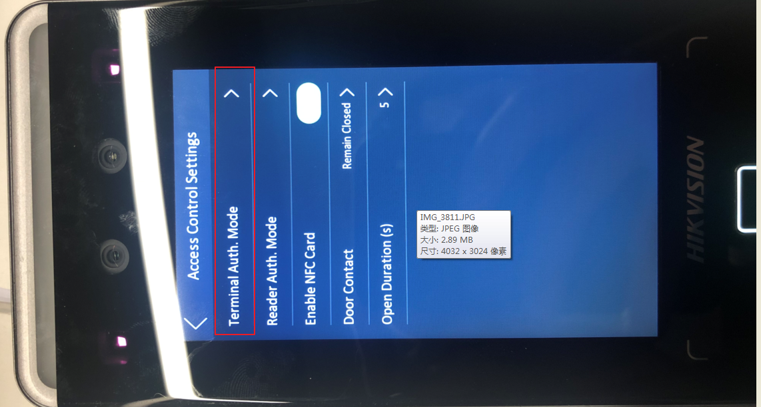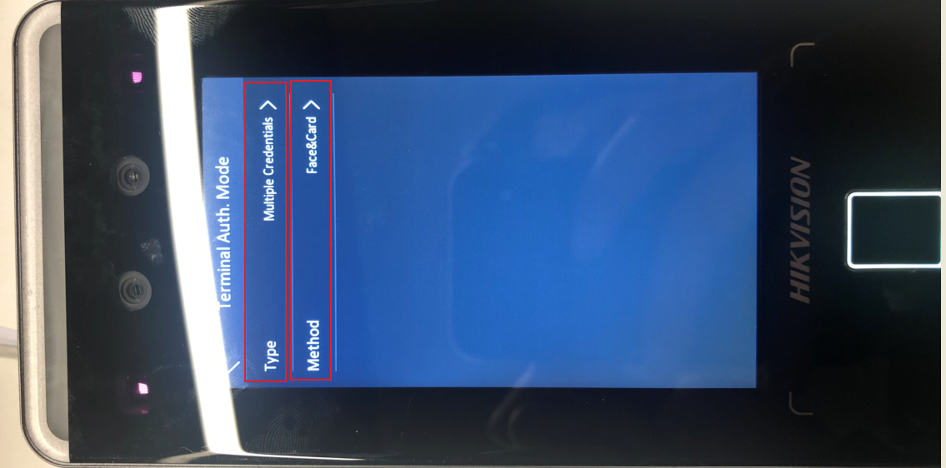

1. Add user (click User after entering the menu), select the "+"button in the upper right corner to add a user, set the Name, add a Card

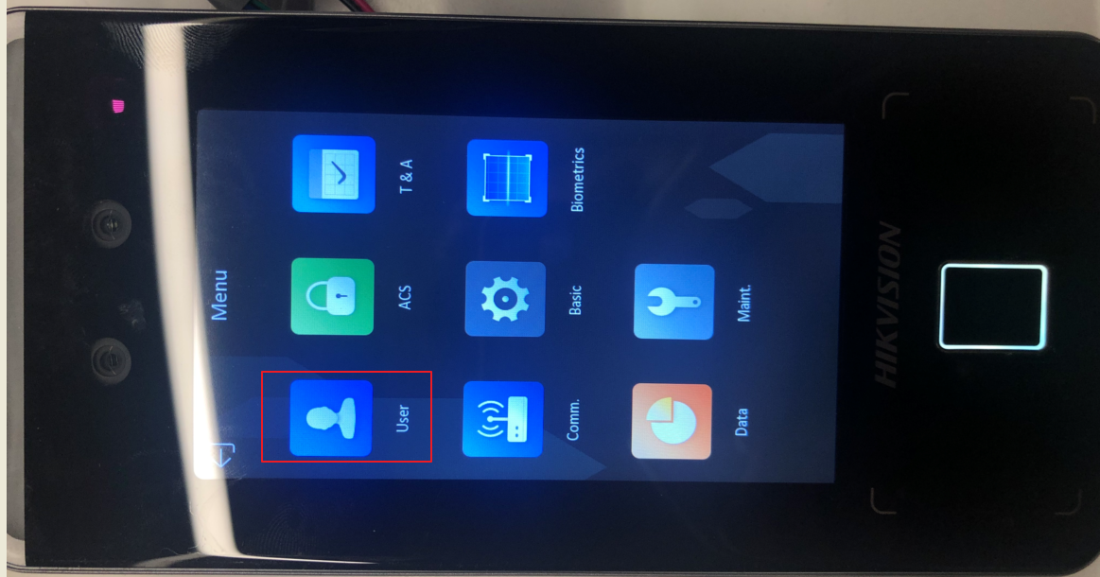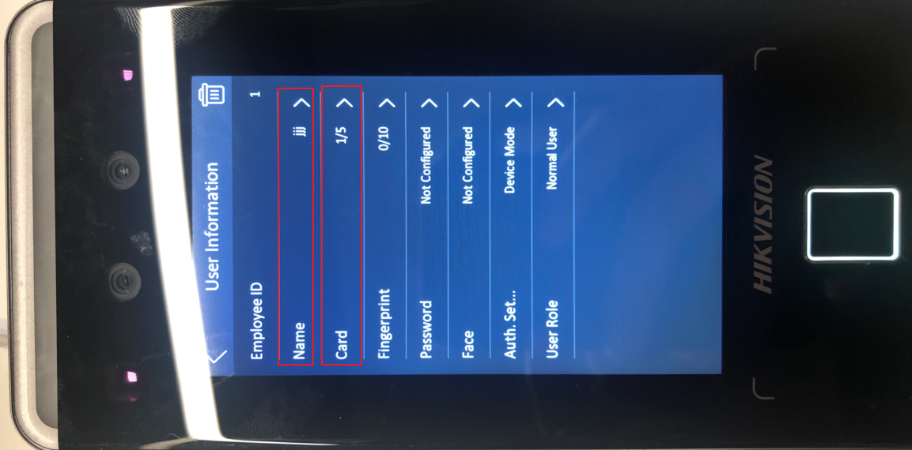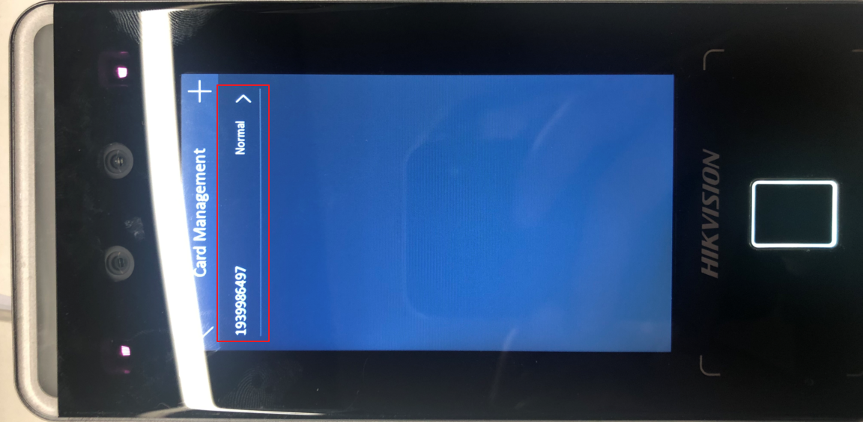

# Authentication performance

