K1A802 Series Time Attendance Terminal V1.1.1_build180619 Release Notes

|  |  |  |
| --- | --- | --- |
| **Device Model:**  DS-K1A802F  DS-K1A802EF  DS-K1A802MF  DS-K1A802F-B(new)  DS-K1A802EF-B(new)  DS-K1A802MF-B(new)  DS-K1A802F-1  DS-K1A802EF-1  DS-K1A802MF-1 | Firmware Version | ARM：ACS_1A_EN_GM_V1.1.1_build180619 |
| SDK Version | HCNetSDK V5.3.5.40_build20180417_win32 |
| 4200 Version | V2.6.8.8 build20180424 |
| Ehome Version | EhomeSDK_V1.2.1.5_build20171101 |

Note:

1. Device models with -B are release for the first time, it means these devices support backup battery.

Reason of Upgrade

Add or modify functions, fix bugs, enhance products quality and meet customers’requirements.

Modified Features

1. **K1A802 Series Time Attendance Terminal**
2. 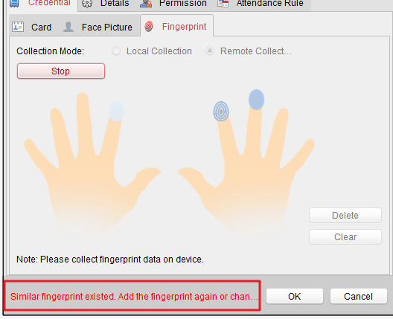Add Finger ID function (for checking duplicate finger when register fingerprint from device local 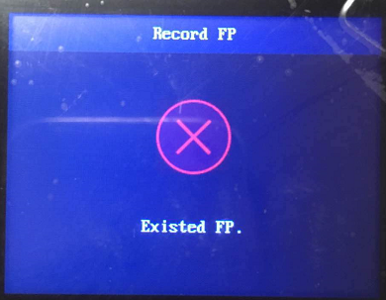 or remote on software).
3. Input method interface background color adjustment, optimize contrast, enhance the experience;
4. Optimize IP conflict checking function;
5. Support backup battery(device model DS-K1A802F-B, DS-K1A802EF-B, DS-K1A802MF-B)

Customer Impact and Recommended Action

This new firmware upgrade is to improve product performance, and will take effect automatically after upgrading from previous versions. We’d like to inform you the above changes. Also, we are sorry for any possible inconvenience of use-habit changes caused by this action.

For questions or concerns, please contact our local technical support team.

Note:

* Hikvision has all rights to alter, modify and cancel this notice.
* Hikvision doesn’t give any guarantee for old models’ stock.
* Hikvision is not liable for any typing or printing errors.
* For special model’s change details, please contact our local technical support team.

Hikvision Digital Technology CO., Ltd.

No. 555 Qianmo Road, Binjiang District, Hangzhou 310052, China

Tel: +86-571-8807-5998

FAX: +86-571-8993-5635

Email: [support@hikvision.com](mailto:support@hikvision.com)