**DS-K1F600-D6E(-F) Enrollment Station**

**Release Notes (2020-04-17)**

|  |  |  |
| --- | --- | --- |
| **Device Model:**  DS-K1F600-D6E  DS-K1F600-D6E-F  **Naming Rule:**  -F for fingerprint module | Firmware Version | AIS_FRACS_AI2_EN_STD_V1.0.2_build200401 |
| SDK | HCNetSDKV6.1.3.6_build20191011_Win32 |
| iVMS-4200 Client Version | iVMS4200 V3.2.0.10 or later  iVMS4200 AC V1.1.0.10 or later |

**Reason of Upgrade**

Fix bugs, enhance products quality and meet customers’ requirements.

**Modified Features**

1. Modify the naming method of database U disk export file, name the export file according to the customized device model (only available for OEM customer)

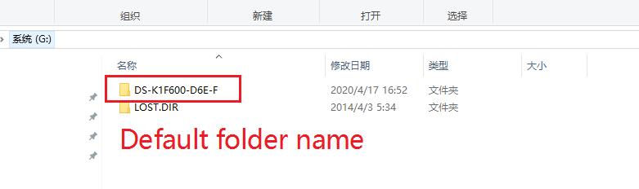

**Customer Impact and Recommended Action**

This update refers to function/compatibility improvement and will take effect automatically after the Date of Change. We are very sorry for any inconvenience of use-habit changes caused by this action.

For any questions and request for this firmware, please contact our local technical support team.

Note:

* Hikvision reserves the right to change, alter or withdraw the above notification without prior notice.
* Product design and specifications are subject to change without prior notice.
* The Hikvision firmware may contain errors known as errata, which may cause the product to deviate from published specifications. Current characterized errata are available on request.
* Hikvision is not liable for any typing or printing errors.

Hikvision Digital Technology CO., Ltd.

No. 555 Qianmo Road, Binjiang District, Hangzhou 310051, China

Tel: +86-571-8807-5998

FAX: +86-571-8993-5635

Email: overseabusiness@hikvision.com