**H92 AcuSense NVR V4.40.410 Build200902 Release Notes**

**(2020-09-4)**

|  |  |  |
| --- | --- | --- |
| **Firmware**  **Basic Information** | Firmware Version: | V4.40.410 build 200902 |
| SDK Version: | V6.1.4.45_build20200525 |
| Play Library (PlayCtrl.dll) | V7.3.8.45 |
| Web version | V4.0.1 build200803 |
| Client version | V3.3.2.2 build20200728 |

**Reason of Upgrade**

Add new features and optimize product performance.

**New features**

**1. Support video perimeter protection analysis by sub stream.**

Support video perimeter prevention analysis

1) Maximum support for 4 channels 1080P local smart detection, and the maximum resolution of single channel local smart detection is 4K;

2) Maximum support for 4 channels D1 (704 * 576 / 704 * 544) sub stream local smart detection;

3) Adaptive local smart detection. If there is sub stream in the accessed IPC, the video perimeter will use sub stream to analyze. If there is no sub stream, it will use the main stream;

4) The total decoding capacity of local smart detection is no more than 4-ch 1080P, and the user will be prompted if the limit is exceeded;

5) The resolution of the alarm picture is not more than 1080P, if it is lower than 1080P, it will capture the original resolution; if it is greater than 1080P, it will capture 1080P.

**2. Support “high resolution mode” in video perimeter protection.**

**High resolution mode of video perimeter protection**:

The high-resolution mode is selected by default. When the high-resolution mode is turned on, the detection distance and effect are better, and it will use the main stream to analyze.

1) Maximum support for 4 channels 1080P local smart detection, and the maximum resolution of single channel local smart detection is 4K;

2) Local smart detection supports resolution of 720P ~ 4K;

3) The resolution of the alarm picture is not more than 1080P, if it is lower than 1080P, it will capture the original resolution; if it is greater than 1080P, it will capture 1080P;

**General mode of video perimeter protection**:

The high-resolution mode is not selected. The detection distance and effect are slightly poor, and it will use the sub stream to analyze.

1) Maximum support for 4 channels D1 (704 * 576 / 704 * 544) sub stream local smart detection;

2) Adaptive local smart detection. If there is sub stream in the accessed IPC, the video perimeter will use sub stream to analyze. If there is no sub stream, it will use the main stream;

3) The total decoding capacity of local smart detection enabled is no more than 4-ch 1080P;

4) The resolution of the alarm picture is not more than 1080P, if it is lower than 1080P, it will capture the original resolution; if it is greater than 1080P, it will capture 1080P.

**Local configuration:**

[GUI] Configuration: Go to Smart Analysis > Smart Event Settings > Perimeter Protection and select “High Resolution Mode”.

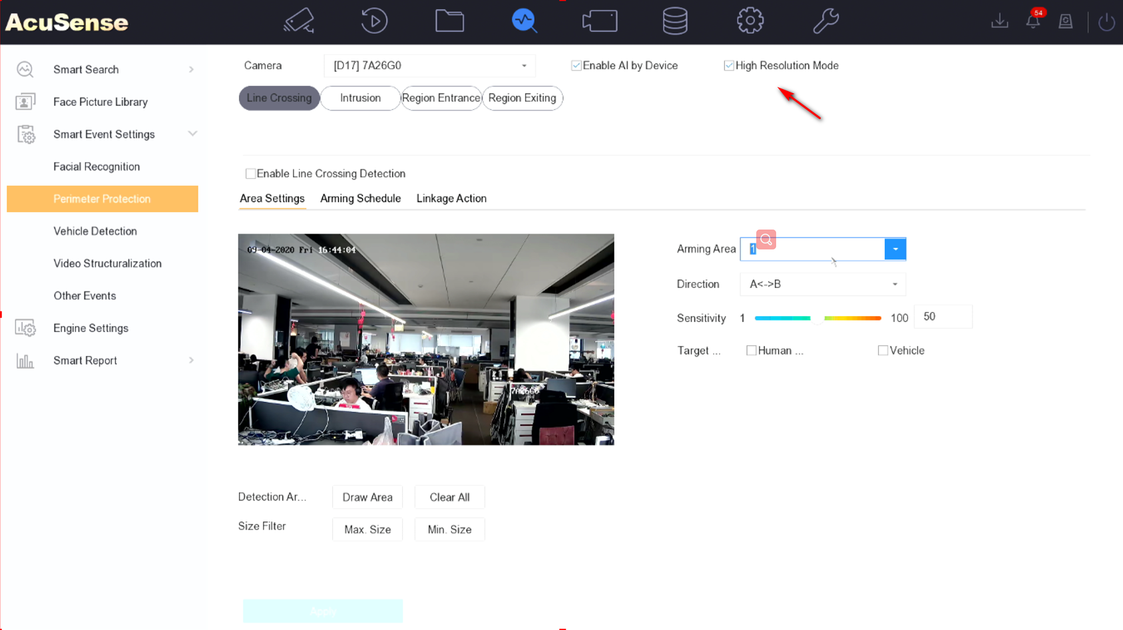

**Modified functions**

Asynchronous import specification change of face database

1. The number of H92 import tasks is 1

2. One task can issue 1W faces at most

3. The maximum of XML support to 10M (still claiming the 6M)

4. The maximum number of deleted faces in a single database is 10

**Related product list:**

|  |  |
| --- | --- |
| AcuSense NVR | Overseas:  DS-79(08/16/32)NXI-I4/S  DS-79(08/16/32)NXI-I4/16P/S  DS-77(08/16/32)NXI-I4/S  DS-77(08/16/32)NXI-I4/(16P)/S  DS-76(08/16)NXI-I2/S  DS-78(08/16)NXI-I2/S  DS-7808NXI-I2/8P/S  DS-7608NXI-I2/8P/S  DS-7816NXI-I2/16P/S  DS-7616NXI-I2/16P/S |

**Customer Impact and Recommended Action**

This new firmware upgrade is to improve product performance, and will take effect automatically after upgrading from previous versions. We’d like to inform you the above changes. Also, we are sorry for any possible inconvenience of use-habit changes caused by this action.

For questions or concerns, please contact our local technical support team.

Note:

* Hikvision has all rights to alter, modify and cancel this notice.
* Hikvision doesn’t give any guarantee for old models’ stock.
* Hikvision is not liable for any typing or printing errors.
* For special model’s change details, please contact our local technical support team.

Hikvision Digital Technology CO., Ltd.

No. 555 Qianmo Road, Binjiang District, Hangzhou 310052, China

Tel: +86-571-8807-5998

FAX: +86-571-8993-5635

Email: support@hikvision.com