How to use heat map via iVMS-4200
[Preparation]
- iVMS-4200(V2.3.0.4 or above) client + storage server
- DS-2CD6362/6332FWD fisheye camera(V5.0.9 141009 or above)
[Step]
- Add fisheye camera and storage server into iVMS-4200;
- Enable heat map, then draw heat map area, set related parameters&arming schedule, click button;
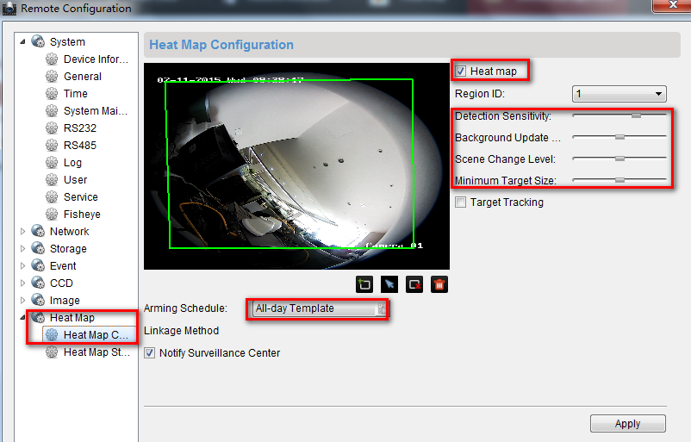
Figure-1 Heat Map Configuration
- Format HDD, then configure quota in storage server remote configuration or right click on storage server icon; quota ratio for additional information includes heat map and people counting quota;
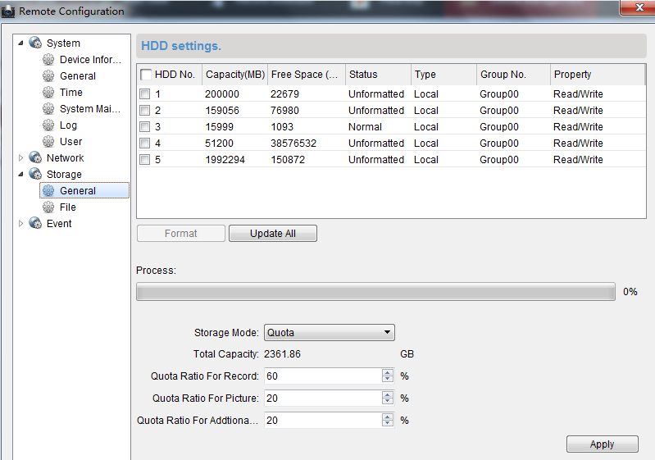
Figure-2 Storage Server Remote Configuration
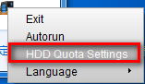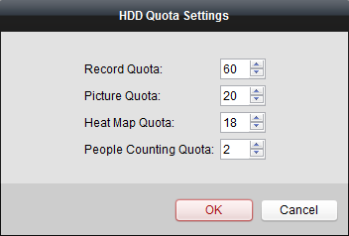
Figure-3 HDD Quota Settings
- Configure record schedule on fisheye channel. Additional Information Storage must be selected;
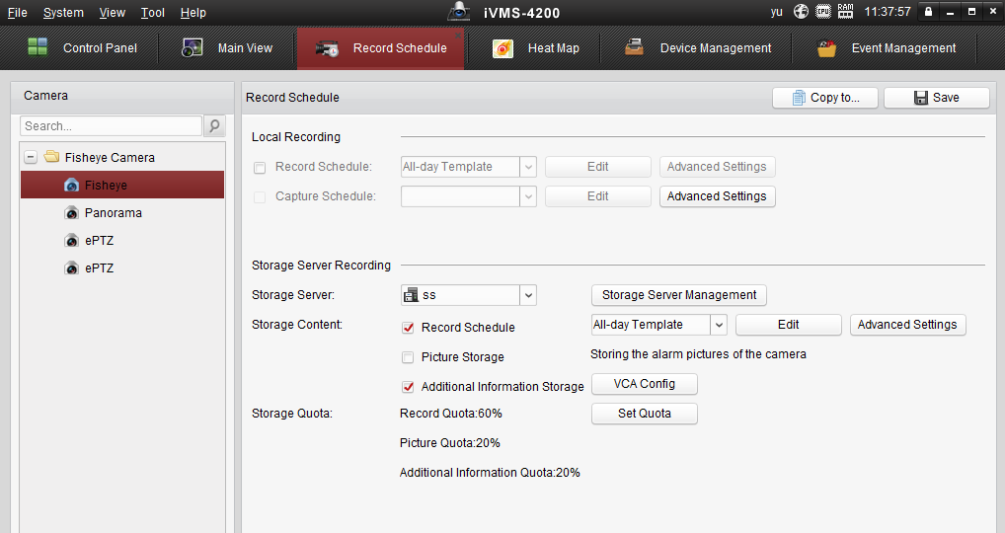
Figure-4 Record Schedule
- After 30min, you can generate heat map result via line chart or picture mode on fisheye channel.
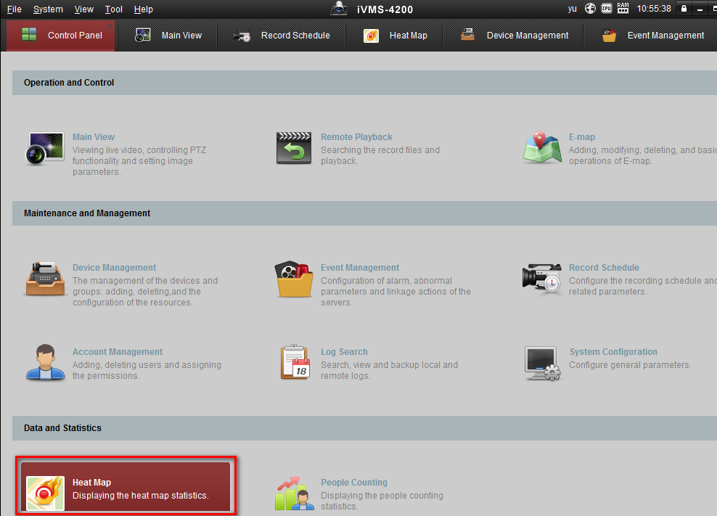
Figure-5 Heat Map in Control Panel
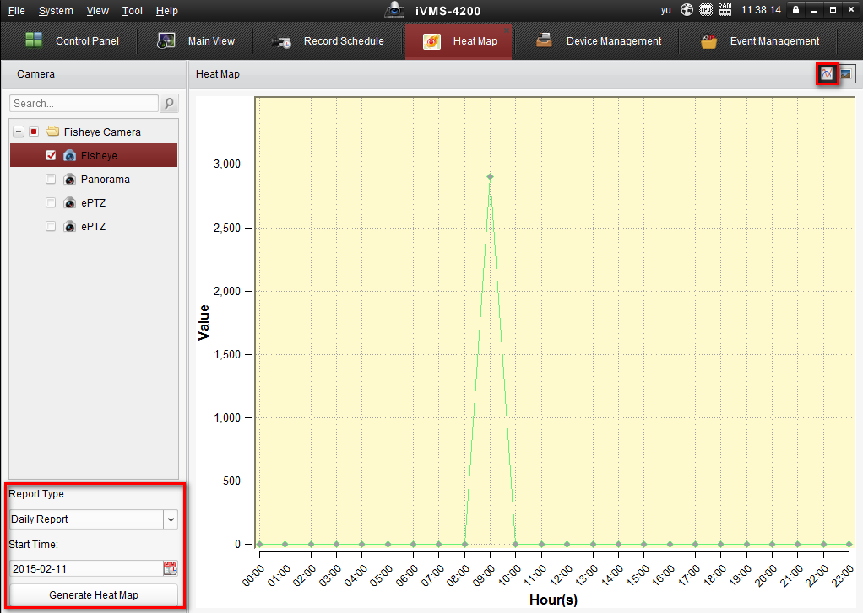
Figure-6 Line Chart Mode
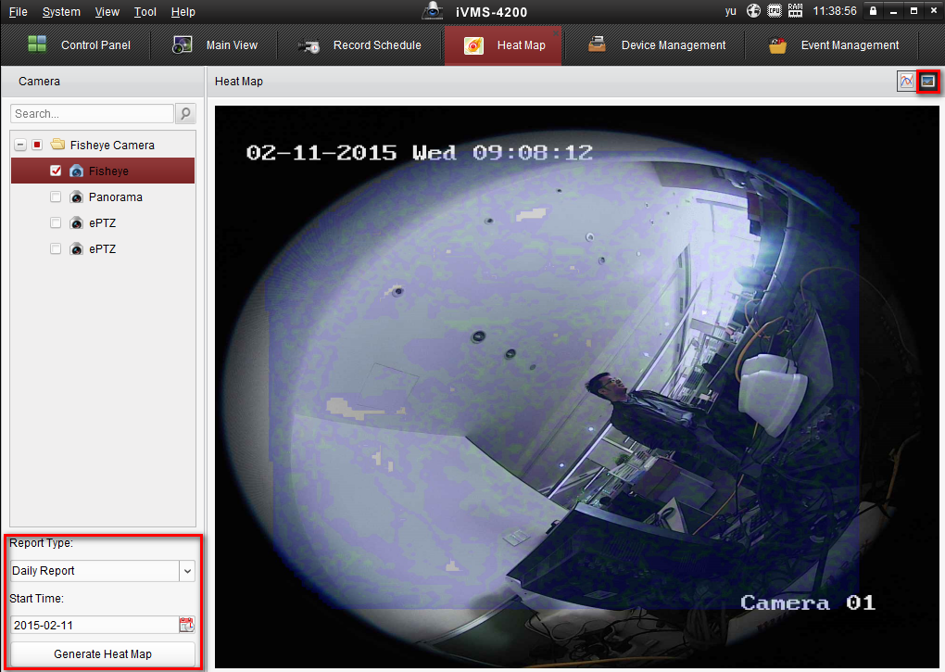
Figure-7 Picture Mode
[Note]
- The 63 series fisheye cameras don’t need micro SD card;
- The heat map result can not be exported in this client version;

